

CHANGE & STABILITY MANAGEMENT
Case Study of ARGOS UNITED KINGDOM
Code: BMMB7000

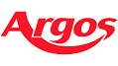

By Theodore Toko Manzambi
ID-1904060

THE UNIVERSITY OF WALES TRINITY SAINT DAVID
Date of submission: May 5th, 2023
Lecturer: Marie Pitson
Words count: 3677

Executive Summary
Change management is viewed as an essential tool by all organisations since it contributes to the growth of processes and organisations. Organisational growth necessitates change. The report names Argos UK as the organisation that will be responsible for creating the change management procedures. Argos stores have been relocated inside of Sainsbury's stores, which signifies a change in the organisation. The analysis of this change process was carried out in the current study, which was started in 2016. As one of the biggest retailers in the UK, Argos runs a successful business. By removing them from high streets, a change was made to include these retail sector businesses in supermarkets. Three different change management models that have been referenced in prior literature looked into the change. The change process has been effectively evaluated by Kottler's eight change management steps. The Unfreezing, Change, and Refreezing levels of the Change Management Process are further explained in detail by Kurt Lewin's Change Management Model. The forces preventing change and the forces causing it has been clarified by Kurt Lewin's Force Field Analysis. These are crucial elements for comprehending the organisational change process. In addition, transformational leadership, which is the best leadership style for change management procedures, was a defining characteristic of the organisation. The cultural web application has further explained the culture and demonstrated how it is advantageous for the change management practiced in Argos. The investigation of environmental factors has utilised several environmental investigation tools, including PESTEL and SWOT. These are explaining the current situation within the company. For a better understanding, the report also discusses how Argos can overcome its various resistances to change. The company enjoyed higher sales and customer attraction after the change for about one year, but then in 2018, it faced negative sales and development activities within the company. Thus, the change process was not very efficient for the long-term orientation. However, Sainsbury has taken steps to get more effective outcomes from the change process, just as it did with Argos inside its supermarket centers. Change is necessary for any organisation to be developed and thus, it is considered a critical application to make effective measures by proper forecasting to gain maximum benefits in change management applications effectively.

Table of Content
1. Introduction 6
1.1 About Report 6
1.2 About Argos UK 6
2. Key Change Management Models 7
2.1 Kurt Lewin’s Force Field Analysis 7
2.2 Kurt Lewin’s Change Management Model 8
2.3 Kottler’s Eight-Step Model 10
3. Drivers for Change Management 12
3.1 Leadership 12
3.2 Culture 14
3.3 Power and Politics 15
4. Environmental Factors 16
4.1 PESTEL 16
4.2 SWOT 18
4.3 Stakeholder Analysis 19
5. Resistance to Change 20
6. Conclusion 22
7. Recommendation 24
8. References 26
9. Appendix 29
9.1 Force Field Analysis 29

List of Figures
Figure 2-1: Change Management Model 9
Figure 2-2: Kottler’s Eight Steps Change Management Model 9
Figure 2-3: Kottler’s Eight-Step Model Application 10
Figure 3-1: Leadership and performance management for Change 12
Figure 3-2: Cultural Web Application 13
Figure 3-3: Cultural Web Application 14
Figure 4-1: PESTEL Analysis 15
Figure 4-2: Mendelow’s Power and Interest Matrix 18
Figure 6-1: Sainsbury’s quarterly group sales growth by sector (%) 21
Figure 6-2: Sales growth after the relocation of Argos 22
Figure 7-1: ADKAR Model 23

List of Tables
Table 2-1: Drivers Resistorstors for the change management 8
Table 2-2: Kurt Lewin’s Change Management Model 8
Table 5-1: Overcoming the Resistance to Change 19

Introduction

About Report

Applying change management techniques in organisational settings is necessary to grow organisational operations and create successful strategies. To implement the change as best as possible, managing effective change management practices is identified as a requirement. For the change management application, the report has chosen the Argos United Kingdom. It has been determined that the relocation of Argos stores inside Sainsbury's stores represents a change in business practices.
Additionally, the report clearly explains the different change management models that can be applied, including Kottler's eight-step model, Kurt Lewin's change management model, and Kurt Lewin's force field analysis. Furthermore, the report includes drivers of change management. Tools like PESTEL, SWOT, and stakeholder analysis have been used, and environmental factors have also been considered. Additionally, the report provides an effective explanation of resistance to change before concluding.

About Argos UK

Argos UK is one of the most famous toy retailers. The largest toy retailer in the UK also sells a wide range of other products, including electricals, furniture, and home goods. More than 30 000 people work for the company. Furthermore, with over a billion visits to websites every year, more than 70% of sales are conducted online. As of 2022, the company, which was founded in 1972, offers over 60 000 products for purchase. The company is one of the oldest and most developed in the UK, and it consistently makes money.
However, effective development of the outcomes requires change management. Argos stores have been moved inside of Sainsbury's stores, which is a significant change that has been implemented within the organisation. To gain a clear understanding of the organsation's change management procedures, an investigation of this change using the pertinent change management models is being conducted here.

Key Change Management Models
Several factors need consideration in the change management models. Understanding each of the change management models relevant to the relocation of the Argos stores inside Sainsbury’s stores is critical for significant change management development. Three change management models have been used in the present study and these are well explained as follows.

Kurt Lewin’s Force Field Analysis
Force Field analysis is a necessary application to understand the forces that are favorable for the change and the forces that are restraining the change (Hussein, et al., 2022). This is a well-established change management model used by many scholars in the past. The following table is providing the forces that are favorable for the change practice and the forces that are not favorable for the change practice (Kobtsev, 2020).
Table 2-1: Drivers and resistors for the change management
Source: Author created
Drivers for change | Resistors for change
Higher customer demand | Limited accommodation in Sainsbury supermarkets
Having a larger population knows the brand | Reduction of staff in-store/tills
Brand awareness and strength are higher | Unsatisfied customers/ customers’ behavior
The increase in the social image of the organisation | Investment is higher than expected
Lower advertising/lower catalogs | Building customer trust
Reduction of overheads / rent-water | Forecasting can change due to unfavorable market and environmental conditions
Easy for customers to collect at any opening time | Cultural and political impacts on the change management practice
Customers purchase more products | Higher competition in the organisation

The analyses' applicability is detailed in the appendix. It has been demonstrated that the drivers for the change are greater than the resistors for the change. Thus, the effectiveness level of change management can be viewed as gained in the organisation's current change management practice.

  - Kurt Lewin’s Change Management Model
Change management models are widely available in the literature, and Kurt Lewin's Change Management Model is very useful in many practical scenarios (Archer, et al., 2019). There are three stages in Kurt Lewin’s change management model. These three stages are unfreezing, changing, and refreezing. The model is well explained as shown in the following figure (Mahmud, et al., 2022).

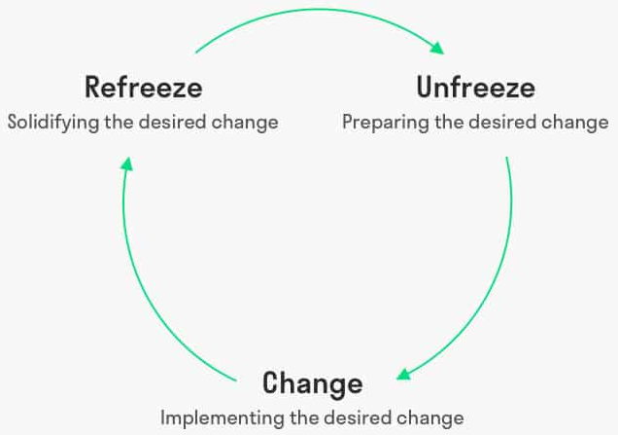
Figure 2-1: Change Management Model
Source: (Abd El-Shafy, et al., 2019)

The application of the change management paradigm is critical for change at Argos United Kingdom, and this is described below.

Table 2-2: Kurt Lewin’s Change Management Model
Source: Author Created
Unfreezing | Change | Refreezing
Argos members were made aware of the impending change and helped understand and accept its necessity. These justifications were provided for the decisions to switch from paper catalogs to iPads, relocate stores inside of Sainsbury's, and send staff members with tablets to the sales floor to enhance customer interactions. | CEO Mike Coupe's explanation that there wouldn't be any job losses if any Argos stores closed serves as an example of maintaining consistent leadership communication. The number of Argos locations that may be moved into a Sainsbury's store nearby and how the leases of Argos' United Kingdom outlets can help the company Consider including the workforce in the transformation. | Acceptance of change, ongoing training offered, potential future changes identified, challenges faced, advantages and disadvantages already attained as a result of the change, and supportive feedback

Kottler’s Eight-Step Model
Kottler has introduced eight steps in a change management model as shown in the following figure (Pollack & Pollack, 2015).
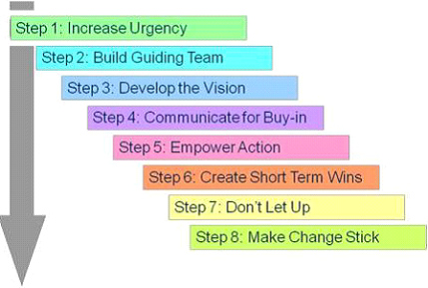

Figure 2-2: Kottler’s Eight Steps Change Management Model
Source: (Laig & Abocejo, 2021)

This is one of the models that is explaining well the management of the change in the center of the organisation. It is highly important for the successful development of change management practices within an organization effectively.
Application of the change management as per the eight steps is provided as follows.
Figure 2-3: Kottler’s Eight Step Model Application
Source: Author Created

By efficiently implementing Kottler's change management model, Argos has successfully gone through several stages. However, the change management process's effectiveness fell short of expectations. For almost a year, the company experienced sales success, but since that time, sales and customer attraction have regularly shown negative trends. During the transformation process, this was not anticipated as the lack of clear monitoring and future forecasting during the change process may be the primary factor contributing to Argos' change management application's long-term failure. Following the implementation of this modification after 2016, certain Argos stores were shuttered to reopen inside Sainsbury's outlets. The effectiveness of the transition process has not been great thus far.
Sainsbury's is attempting to save this brand name even if the transition was not very successful at the time by opening stores inside of its supermarket chains and removing them from high streets. In 2024, Sainsbury intends to open 430–460 outlets inside the supermarkets that would operate under the Argos name (Johnson, 2023).

Drivers for Change Management
Change can happen for a variety of reasons. The development of change management was required based on the positive and negative variables. Additionally, these elements must be developed and understood to have a good impact on change management practices. This report explains the three key sections that serve as change management's driving forces.

3.1 Leadership
For any activity to develop more effectively, leadership is required. No matter the type of industry, leaders are essential for the growth of change management practices within every firm (Mansaray, 2019). It has been noted that Argos heavily values transformational leadership. This kind of leadership works well with any organization's change management procedures. Successful change management depends heavily on comprehending these measures and putting them to use in change management practices. Argos' leaders demonstrated a capacity for controlling employee self-interest while fostering change. The following list includes some of the standards that were outlined by the Argos leaders.

- Corporation among each member and having the best communication to have better decisions
- System-wide strategy development of the leaders leading to the change development
- Brainstorming in decision-making actions
- Matching the change management practices with the culture of the organisation

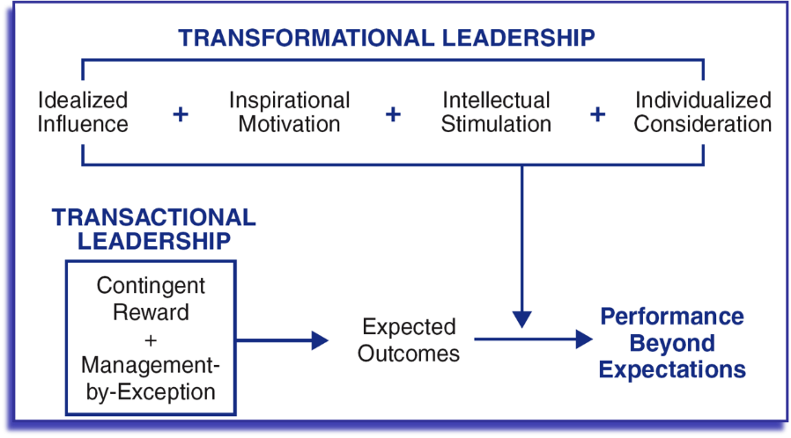
The following gives a framework for the impact of transformational and transactional leadership in change and performance management that is important in application in the present organisation as well.

Figure 3-1: Leadership and performance management for change
Source: (ElNour, 2023)

3.2 Culture
A key requirement for improved change management procedures is organisational culture. The decision-making process can be significantly improved by identifying each of the various variables that make up organisational culture (Alvesson & Sveningsson, 2015). The change management application fits well with Argo's culture as various well-known tools and models can be used to understand the culture of any organisation. The cultural web is one such illustration, the cultural web's contributing factors are shown in the following figure (Mossop et al., 2013).

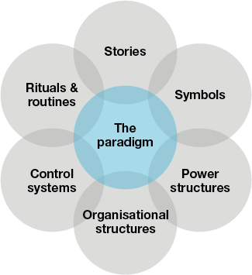
Figure 3-2: Cultural Web Application
Source: (Doherty & Stephens, 2020)

The cultural application in the organization is provided as follows.

Power and Politics
Figure 3-3: Cultural Web Application
Source: Author Created
Power and politics, more specifically, the effective management and maintenance of organisational actions to produce the desired results, Argos is providing the necessary employee management to deal with the political measures in the internal businesses and local businesses. Additionally, the organisation is managing the relocation decisions by exerting its influence over the stakeholders (UddinAhmed, et al., 2020). Furthermore, internal politics within the company are supportive of change management, and employees are persuadable when given a good justification. Although there is more competition among the employees, there have been positive developments. Within the organisation, power, and politics are favorable, making it possible to record ease in the application of change management. Politics and power are crucial and necessary factors to consider (Hodgins, et al., 2020). This is crucial for managing change applications successfully.

Environmental Factors
Several environmental factors are needed to be considered once identifying the outcomes effective. Environmental conditions are needed in explaining to manage the necessity of change management. These factors are necessary to be favorable to apply the change management actions in the organisational contexts.

PESTEL
PESTEL is one of the famous tools that has been used in understanding the external environment of any organisation. There are six factors explained in this tool and these are shown in the following figure (Cox, 2021).

Figure 4-1 : PESTEL Analysis
Source : (Pan, et al., 2019)

Application of the PESTEL analysis is provided as follows.
- Political: A nation with an oil and gas industry needs to have political stability. The political environment favors preferred trading partners and government support for retail development. The country runs taxes and labor laws, and these are applicable in the organisation to have a better operation. There is a good political climate in the nation (Pan, et al., 2019).
- Economic: The country's economic conditions have improved recently. Argos is also experiencing profitable growth. The UK is currently experiencing some inflation that is slightly rising which might affect businesses as employees will need a higher income to pay for daily expenses and requesting for a pay rise. The income per person is still good but has increased by 6% for some of the businesses since last April 2023. Thanks to a good economy, the organisation can function at a major development level (Cox, 2021).
- Social: The population of the nation is growing, and even older generations can observe a subtle but noticeable increase. The positive trends society is observing in online retailing make it simpler for Argos to implement change management strategies successfully. The increased use of technology in society can influence organisational change management strategies (Wajid & Zafar, 2021).
- Technology: New technological advancements are accelerating the UK's growth. Understanding this development is important because it led to the successful delivery of new organizational operations (Pan, et al., 2019). Argos uses several technological strategies to draw customers and thereby expand its customer base. Additionally, the process of change management calls for this.
- Environmental: Using green practices can change how development is done. The sustainability initiatives required for environmental protection are being implemented at Argos. One of the key elements is managing applications better and reducing the carbon footprint. There are sustainable development goals in Argos concerning environmental protection (Cox, 2021).
- Legal: Several business operation legislations are in place within the organisation that is needed for understanding. Worker legislation, business operations legislation, international business legislation, and food-related legislation are needed to be considered in the organisation with change management practices (Pan, et al., 2019).

SWOT Analysis
SWOT analysis is considered in understanding the internal environment and external environment effectively. There are strengths, weaknesses, opportunities, and threats (Benzaghta, et al., 2021). Understanding each makes significant development in the understanding of necessary outcomes of the decision-making. The following gives the SWOT analysis application effectively.
Strengths;
- Rich history of the organisation
- Well-trained employee pool
- Brand name and brand awareness
- Positive leadership pattern favorable for change management
- One of the largest retailers in the UK
- Huge customer pool of over 130 million customers
Weaknesses;
- Working on Sundays
- Pricing in Ireland has impacted its brand
- Limited market shares due to extremely tough market competition
- Global presence is lesser compared to competitors
Opportunities;
- 25 % of the sales are mainly from the online sales
- Growing economies in the market
- Technology development is significant
Threats;
- Price war with other brands in the retail industry
- Competition is very higher
- Government policy changes related to the retail industry.

Stakeholder Analysis
Stakeholders are the individuals and groups who have an impact on and are affected by an organisation. Every organization's ultimate objective is to maximise stakeholder wealth (Serravalle, et al., 2019). Stakeholder management is therefore a crucial tool for every business to use to achieve optimum development. Stakeholders have been impacted by change as well, making it imperative to manage the change in a way that benefits all stakeholders.
There are several stakeholders in the organization and these are as follows.
- Shareholders
- Investors
- Management and administration
- Strategic partners
- Government
- Society
- Contractors
- Suppliers
- Employees
Understanding the power and interest of the stakeholders is a necessary application. Along with this identification, Mendelow’s Stakeholder Matrix of Power and Interest has been created and shown in the following figure. This is having four quadrants.
High
Influence/power
Low
Low
Interest
High
Investor
Employees
Management and Administration
Customers
Society
Government
Partner
Suppliers
Shareholders
Contractor
Keep Satisfied
Engage and Influence
Monitor
Keep Informed

Figure 4-2: Mendelow’s Power and Interest Matrix
Source: Author Created

With these identifications, it is evident that a large number of stakeholders are effectively influencing organisational actions and even change management practices. To make significant advancements at an efficient level, this is required. Understanding the stakeholders is necessary to properly preserve the outcomes.

Resistances to Change
Once the change management method was implemented within the company, several resistances to it were apparent, and these were also seen at Argos United Kingdom. To overcome these and improve the implementation of change, it is vital to comprehend the resistance to change. Here are a few of the resistances that were found.
- Misunderstanding the purpose of change management and having less trust in the change management outcomes
- Self-interests are higher than the change management outcomes (Change can make the working pattern complex and employees do not like to make the working pattern complex)
- There can be different levels in the evaluations among employees and managers
- The employees are afraid of the impacts of the change management process on their daily working pattern
- The tolerance level in the change at the first stage of implementation can be lower within the employees
- Less awareness of the actual outcome and the reasons for the change implementation
Overcoming these resistances is a necessity. Thus, the following table gives the methods to overcome the resistances identified in the above section.

Table 5-1: Overcoming the Resistance to Change
Source: Author created
Identified resistance | Methods to overcome | Strategies and tactics to use
Misunderstanding the purpose of the change | The future of the change implementation must be visible to the staff. To get around this, the change management process must be explained, along with its motivations. | Awareness campaigns before the adoption of changes, formal and informal communication, and open dialogue
Self-interests are higher than company interest | Increasing employee commitment and creating a corporate culture inside the organisation. It is important to cultivate among employees a desire for change. | Employee training initiatives. workshops on change management and its future advantages for them.
Having less tolerance for change | It is necessary to explain the challenging scenarios to the staff in advance because doing so gives them time to get ready before the implementation. | Word-of-mouth, two-way communication, formal and informal communication, intranet.
Lacking awareness about change | The benefits of the change should be conveyed to the employees in the future because they are unsure of the change's outcomes. This is crucial for the transformation of healthy practices. | Notice boards can be used for seminars, training sessions, and explanations of processes.
Different views of different employees | Similar interests and viewpoints towards the transformation must exist between managers and lower-level personnel. Consequently, regular interactions and contact with the staff should be practised. | Awareness of the workforce and formal and informal communication with them

Conclusion
The changes related to the relocation of Argos stores inside Sainsbury’s stores have been explained in the present report in a significant manner. To effectively manage changes in businesses, change management procedures are required (Arefazar, et al., 2022).
Argos UK was established in 1972 and has since been profitable. As part of the identification of Argos UK's growth, it was mentioned that there will be 1096 stores across four nations by 2023 (UddinAhmed, et al., 2020). Retail sales suffered as a result of the COVID-19 pandemic, according to BRC reports. These environmental factors had a significant impact on the retail industry, increasing online sales because more people are engaging in online shopping while decreasing offline sales because fewer people are moving around as much (Colley & Spyridonidis, 2022).
Argos was acquired by Sainsbury in 2016, and reports indicate that up until 2017, Argos was the company to watch. There was a sales development of 4.1 percent as compared to retail sales at Sainsbury's in 2016 (Retail Insight Network, 2023).
However, the performance covered a shorter time frame, and sales declines continued to be reported after 2018. According to the reports on this change management, the change implemented in Argos wasn't very successful (Atkins, et al., 2022). The organisation implemented the change to improve performance, and it worked well for about a year before causing persistent dropouts as a result of management and strategic mistakes in both Argos and Sainsbury's (Colley & Spyridonidis, 2022). The evidence for this downtown is provided by the ensuing statistics.
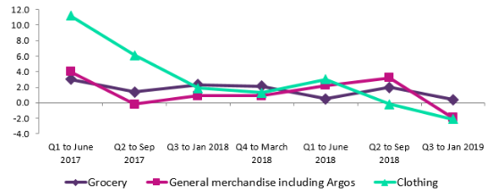
Figure 6-1: Sainsbury’s quarterly group sales growth by sector (%)
Source: (Retail Insight Networ , 2023)
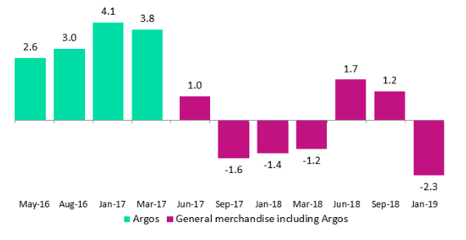
To comprehend the change management practices used in the organisation, a variety of tools and models have been used in this study. These are tools for managing change, such as the Force Field Analysis Model, Kurt Lewin's change management models, and Kottler's eight-step change management model. The extensive research conducted for the report has also revealed the factors that are driving change in leadership, culture, and power.
Figure 6-2: Sales growth after relocation of Argos
Source: (Retail Insight Networ , 2023)
Through SWOT and PESTEL studies, environmental issues were also identified, and stakeholder analysis was done to understand how changes will affect stakeholder interests and wealth maximisation. The causes that led to change resistance were successfully recognised as the change was being implemented.
According to the reports, it is evident that the change was successful for a brief time before running into problems. Therefore, advice is required to create the best change management procedure to achieve successful outcomes in the future. Since the change was unsuccessful for a variety of reasons, it is more important than ever to revisit these issues and develop effective change management procedures.

Recommendation
The change began in Argos UK with the relocation of stores to Sainsbury's stores, and it was only later that the complexity of the change management process became apparent. There are many situations where difficulties were faced, and these challenges are needed to be faced by the management to have success in change implementation. The initial change implementation was a success, and it has continuously reported sales developments for more than one year. As per the success, it can be seen that certain decisions were taken with proper leadership, but a strategic view and future orientation were lacking. Following better structure in the change management process and understanding the shortcomings are considered critical in applying the change management practices within the organization (Doeze Jager, et al., 2022).
Resistance to change is a main challenge, and there should be better practices in the organisation to overcome this for significant change implementation. The following is a Prosci ADKAR Model implemented by Jeff Hiatt in 2006. It gives a simple structure for overcoming resistance to change which is effective in any organisation (Kaminski, 2022).
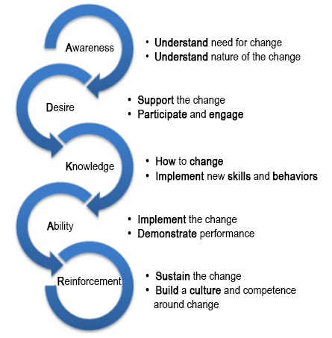
Figure 7-1 : ADKAR Model
Source : (Antoniades, et al., 2022)

Thus, a strong recommendation is to apply the ADKAR model for overcoming resistance to change that makes a clear impact on the change management development. Further, the following recommendations can be applied for a better change management process within the organisation in the future.
- Development of a clear vision and objective for the change management practices within the organisation. This should be clear to everyone who is incorporated with the change management within the organisation.
- There should be clear awareness among the personnel within the organisation regarding the change and the reasons for applying the change. This is reducing the resistance and can gain the support of every employee
- Experts in the field can be hired or can outsource some of the processes to gain effective utilisation of the change management practices and avoid errors in the change management process
- Monitoring is a must. Every stage needed to be monitored well and errors should be identified right on the spot to make less damage to the change management process
- Open communication is required. There are different areas that the organisations that should be connected. These areas need communication about the change management practice and it is highly important to manage the communication in an unbiased manner
- To ensure a low rate of human error and efficient change implementation, the relevant staff should get training in the change management process.

References
Abd El-Shafy, I. et al., 2019. Decreased pediatric trauma length of stay and improved disposition with the implementation of Lewin's change model. Journal of Trauma Nursing| JTN, 26(2), pp. 84-88.
Alvesson, M. & Sveningsson, S., 2015. Changing organizational culture: Cultural change work in progress, s.l.: Routledge.
Antoniades, N., Constantinou, C., Allayioti, M. & Biska, A., 2022. Lasting political change performance: knowledge, awareness, and reinforcement (KARe). SN Business & Economics, 2(2), p. 14.
Aoetpah, R. L., Ismanto, B. & Wasitohadi, W., 2022. Implementasi PPDB Zonasi dalam Perspektif Teori Perubahan Kurt Lewin. SAP (Susunan Artikel Pendidikan), 7(2), pp. 229-235.
Archer, M., Fuller, M., Cox, K. & Swearingen, N., 2019. Regional Stroke Program Coordinator Nurses Standardize EMS Feedback Utilizing Kurt Lewin’s Change Model.
Arefazar, Y., Nazari, A., Hafezi, M. R. & Maghool, S. A. H., 2022. Prioritizing agile project management strategies as a change management tool in construction projects. International Journal of Construction Management, 22(4), pp. 678-689.
Atkins, J., Barone, E. & Maroun, W., 2022. The (not-so) Great British Weather? Exploring corporate weather accounting by the UK food retail industry.
Benzaghta, m. A. et al., 2021. SWOT analysis applications: An integrative literature review. Journal of Global Business Insights, 6(1), pp. 55-73.
Colley, J. & Spyridonidis, D., 2022. Creating the Capacity for Strategic Leadership. In Unprecedented Leadership: Learning to Lead in Turbulent Times (pp. 119-138). Cham: Springer International Publishing.
Cox, J., 2021. The higher education environment driving academic library strategy: A political, economic, social and technological (PEST) analysis. The Journal of Academic Librarianship, 47(1), p. 102219.
Doeze Jager, S. B., Born, M. P. & van der Molen, h., 2022. The relationship between organizational trust, resistance to change, and adaptive and proactive employees' agility in an unplanned and planned change context. Applied Psychology, 71(2), p. 436.
Doherty, O. & Stephens, S., 2020. The cultural web, higher education, and work-based learning. Industry and Higher Education, 34(5), pp. 330-341.
ElNour, M., 2023. LEADERSHIP STYLES: The Impacts of Transformational Leadership and Transactional Leadership on Organisational Performance and Changend Transactional Leadership on Organisational Performance an, s.l.: https://www.linkedin.com/pulse/leadership-styles-impacts-transformational-change-mohammed-hamed.
Hodgins, M., MacCurtain, S. & Mannix-McNamara, P., 2020. Power and inaction: Why organizations fail to address workplace bullying. International Journal of Workplace Health Management, 13(3), pp. 265-290.
Hussein, M., Pavlova, M. & Groot, W., 2022. An evaluation of the driving and restraining factors affecting the implementation of hospital accreditation standards: a force field analysis. International Journal of Healthcare Management, pp. 1-9.
Johnson, S., 2023. Argos set to shut handful of high street stores within months - full list and when they will close. [Online]
Available at: https://www.yorkshireeveningpost.co.uk/read-this/argos-closures-full-list-4040826
[Accessed 02 04 2023].
Kaminski, J., 2022. Theory applied to informatics–The Prosci ADKAR Model. Editorial. Canadian Journal of Nursing Informatics, 17(2).
Kobtsev, I. F., 2020. An elliptic billiard in a potential force field: classification of motions, topological analysis. Sbornik: Mathematics, 211(7), p. 987.
Laig, R. B. D. & Abocejo, F. T., 2021. Change management process in a mining company: Kotter’s 8-Step change model. Journal of Management, Economics, and Industrial Organization, 5(3), pp. 31-50.
Mahmud, M. E., Baharun, H., Asykur, M. & Rochmatin, Z., 2022. Increasing Teacher Professionalism Through Change Management in Madrasah: Kurt Lewin's Perspective. Southeast Asian Journal of Islamic Education, 5(1), pp. 47-63.
Mansaray, H. E., 2019. The role of leadership style in organizational change management: a literature review. Journal of Human Resource Management, 7(1), pp. 18-31.
Mossop, L., Dennick, R., Hammond, R. & Robbé, I., 2013. Analyzing the hidden curriculum: use of a cultural web. Medical education, 47(2), pp. 134-143.
Pan, W., Chen, L. & Zhan, W., 2019. PESTEL analysis of construction productivity enhancement strategies: A case study of three economies. Journal of Management in Engineering, 35(1), p. 05018013.
Pollack, J. & Pollack, R., 2015. Using Kotter’s eight-stage process to manage an organisational change program: Presentation and practice. Systemic practice and action research, Volume 28, pp. 51-66.
Retail Insight Network, 2023. Argos fails to fast-track Sainsbury’s sales. [Online]
Available at: https://www.retail-insight-network.com/comment/sainsburys-argos-acquisition/
[Accessed 02 04 2023].
Roşca, V. I., 2020. Implications of Lewin’s field theory on social change. Proceedings of the International Conference on Business Excellence (Vol. 14, No. 1, pp. 617-625).
Rosdiana, N. & Aslami, N., 2022. The Main Models of Change Management in Kurt Lewin's Thinking. Jurnal Akuntansi, Manajemen dan Bisnis Digital, 1(2), pp. 251-256.
Serravalle, F. et al., 2019. Augmented reality in the tourism industry: A multi-stakeholder analysis of museums. Tourism Management Perspectives, Volume 32, p. 100549.
UddinAhmed, J., Mazid, t. & Ahmed, A., 2020. Argos: Revolution in Non-Food Retailing. In SAGE Business Cases. SAGE Publications: SAGE Business Cases Originals.
Wajid, m. A. & Zafar, A., 2021. Pestel analysis to identify key barriers to smart city development in India. Neutrosophic Sets and Systems, Volume 42, pp. 39-48.

Appendices
9.1 Force Field Analysis
Resistors for Change
Relocation of Argos stores inside Sainsbury’s stores
Forces to Change
Lower advertising/lower catalogues
Reduction of overheads / rent-water
Easy to customers to collect at any opening time
Customers purchase more products
Higher customer demand
Having larger population knowing the brand
Brand awareness and strength is higher
Increasing social image of the organization
03
03
05
03
05
05
04
04
Limited accommodation in Sainsbury super
Reduction of staff in store/tills
Unsatisfied customers/ customers’ behavior
Investment is higher than expected
Building customer’s trust
Forecasting can change due to the unfavorable market and environmental conditions
Culture and political impacts on the change management practice
Higher competition towards the organization
04
04
04
02
02
03
04
03

Forces to Change | 32
Resistors for Change | 26

