Student Name: Oleh Vasylyshyn
Student Id Number: 1917016
Module Title: Global Business Environment LCBB5002
Module Assignment Title: Assessment 1 (1500 Words) Written Report
Module Lecture’s Name: Winifred Soribe

UNIVERSITY OF WALES
TRINITY SAINT DAVID

March 2021

MANAGEMENT ACCOUNTING ANALYSIS, AND EVALUATION OF THE HARRIOT HOTELS SCENARIO

Contest : Page no.

Background………………………………………………… 2
- Introduction- Management Accounting ………………… 4
- Relevance of Management Accounting ………………. 5
- Cost Behaviour Analysis ………..………………………… 7
- Main Body …………………………………………… 8
  - Covid-19, Impact on Industry …………… 8
  - Scenario Costs Evaluation ………………….......… 9
- Conclusion …………………………………………… 10
- References …………………………………………….. 11

BACKGROUND
The Globalization and other factors, as technology development and changes in organizational structures e.g., decentralization corporate governance and hierarchical structure according to Johnson and Kaplan (1987), Yazdifar and Tsamenyi (2005), has contributed in the last decades to the appearance of different opportunities but principally has shaped new tests, for all those diverse companies in the market, the newfangled requirements, directed to a larger request in management accounting services. In this essay the figure of the management accountant will be particularly stated, with a careful analysis of the role played within the organization, ensued by the critical evaluation, provided in the hypothetical scenario within the extant Covid-19 pandemic, listed below. (Fig.1-Fig.2, Moodle ‘M. Accounting’,2021) (W.Hadid,M.Al-Sayed,2021) (Goyal,2014)

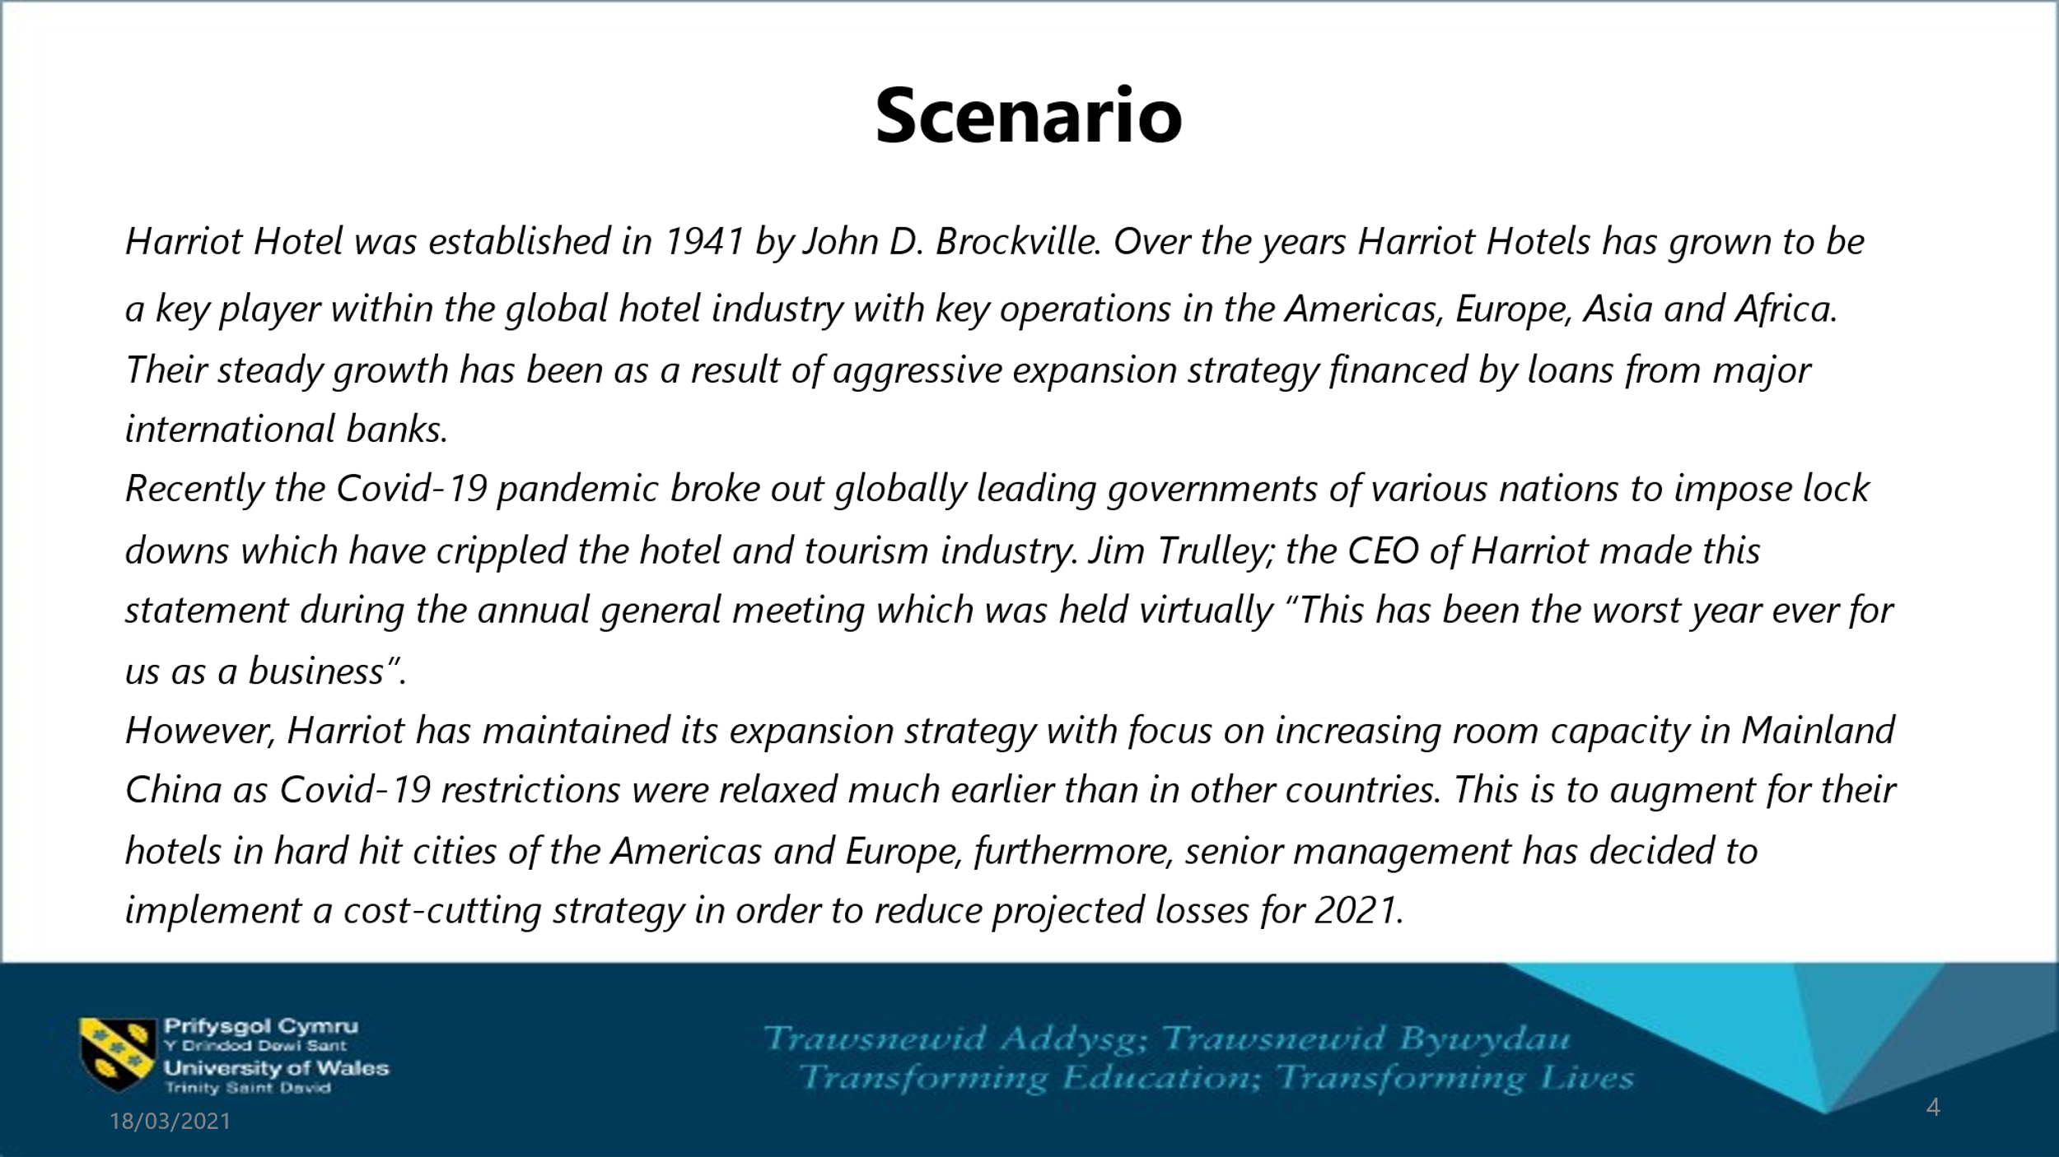
(Fig.1)
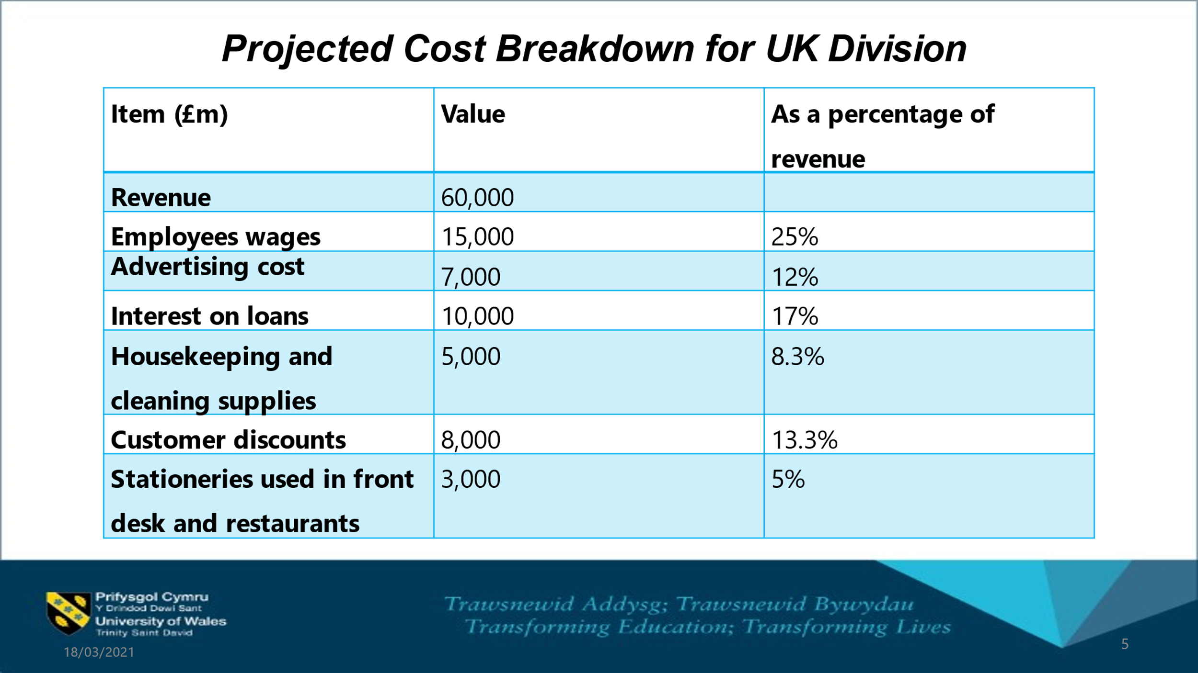

(Fig.2)

INTRODUCTION - Management Accounting
Management accounting, managerial accounting or cost accounting are all the idioms accustomed to delineate the different techniques of estimating, categorizing and supplying qualitative financial data and measures to the managers within the organization, aimed to the effective forecasting of actionable process in decision making. (Bhasin,2020)(Goyal,2014)(McLean,2018) (Byod,2019) (CFI,2021) (Tuovila,2021)
Management accounting despite employing financial statistics, highlights major divergences with financial accounting, and the main difference is the aim, in the financial accounting setup, it is designed to provide and monitor detailed financial information to external shareholders, further discrepancies are:

- Requirements: Financial Accounting is forced to comply with a set of international regulations and standards, as ‘IAS’ or ‘GAAP’. (IAS,2021)

- Subject: Financial Accounting fulfil a set of annual criteria in the whole organization used by external users; however, Management Accounting processes are designed for internal enduring purposes, which tend to transform, in order to display effectively the qualitative data required for decision making procedure in each department within the business, over a different period of time.

Relevance of management accounting
The reputation of management accounting arises from the role played in the business, i.e., with the usage of all that sequences of technological and financial information, such as costing, economics, statistics, etc., essential for the simplification and achievement of prearranged objectives in the short/long-term period; aimed to create effective decision-making process)
The benefit of Management Accounting in creating an effective decision-making can be summarized in following procedures:

- Cost Analysis: Management accountant in this phase examine the aspects liable in generating existing total expenses in the business production, with all the variable cost incurred in each step and the market, to evaluate and recommend all the possible future actions, needed to encounter upcoming opportunities and create value by satisfying customer needs and wants, subsequently create a long-term revenue by minimizing the costs.

- Cash Flow Analysis: Present a role of management accountant to execute and determinate the costs related to cash and their impact to the decision process making. In this stage is familiar to employ the methodology of accrual accounting, which is responsible on providing a broader and precise information on business financial position but highlight the inability to display the single units; the managerial accountant in this case to effectively determine and implement the capital management strategies, reflect on all the unlike circumstances on purchasing goods and services i.e loans, rent etc.

- Product Cost: The phase where the managerial accountant proposes to identify the most effective policies on product realization, determining on it, the nature of the cost: manufacturing or merchandising; his behaviour: fix, variable, direct and indirect; quantifying the total expenses incurred in production and their impacts on business by adding spare units: total cost is divided to the total indirect cost per unit produced.

- Inventory Analysis: In this stage management accountants are liable to highlight and evaluate, a set of costs associated to the storage of products, i.e., ‘Cost of Goods Sold’, with the aim of an effective management of cost, and an increase in cash flow.

- Planning: Is an incessant stage when managerial accountants evaluate the data and atone for planning future activities, with the crucial development strategies aimed to achieve a leadership position in the market. The analysis of provided information create a short- long term business policies, capable to control the workforce and advantageously accomplish business objectives.

- Budget: In this stage, management accountant assesses and review the previous and existing business performances and his adjustment reflect the budget value, created by predicting future trends and providing competitive edges in the market, furthermore, successfully bout the organizational planned objectives.

- Controlling: In this phase internal managers analyse the organization effort, based on singular departments evaluation, succeeding the production a financial prospects report, which estimation correlated to the previous data-report, permit to effortlessly categorise and determinate complications related to business in his financial presentation.

- Constraint Analysis: In this stage management accountants are estimating all the inadequacies incurred in product production or sales activity and incorporate the vital strategies to fulfil the efficiency in manufacturing or merchandising process.

- Accounts Receivables: The managerial accountant aim to satisfy planned objectives within the organization, which drive towards an attentive evaluation of shareholders performances, those reports are liable of offering detailed statistics in the credit risk assessment, highlighting the value of each shareholder.

Cost behaviour analysis
Managerial accountants as previously cited, are predominantly focusing on evaluate fixed cost and variable costs accrued on single product unit within his production process, with the purpose of evaluate business total expenses and forecast effective future strategies. (Tuovila,2021)(Murphy,2020)(CFI,2021) (Finance Management,2021) (Theintactone,2019)(KFL,2020)
Costs behaviour evaluation is concerned in recognition to a set of costs:
- Variable Costs: Costs directly related to the production activity levels i.e., Direct Labour, Direct Material, Direct Expenses; these costs have a propensity to change with production alternations, however the analysis based on product unit highlight the constant tendency subsequent to a rising of activity level, in long term period.

- Fixed Costs: Expenses that remain constant in production, nevertheless, display the ability of mutate, when emphasized on unit costs related to increased range in business activities.

- Mix Costs: Expenditures which demonstrating qualities of both, fixed and variable expenses. Those cost adjust indirectly to the range of production activity. i.e., ‘Step Variable costs, behave as steps, shifting from variable to fixed features.

MAIN BODY - Covid-19, Impact on Industry

As previously quoted in the background frame, the scenario provided by Harriot Hotels, highlights the immediate cessation of the expansionist strategies of the organization, mainly expected to the beginning of the COVID-19 pandemic and the ensuing immobility of the domestic and global market.
The various government measures taken i.e., 'social distancing, smart working, job support scheme, furlough-scheme' have had the advantage of reducing the spread of the virus, however, engender the intermission of activities in all economic sectors:
(Gaba,2021) (FraserofAllender,2021) (Cision,2020) (ONS,2021)

- Primary Sectors:
- Agriculture: Demand and consequently production have dropped harshly, latterly the global recession in the Tourism and Hospitality sector.

- Oil: decay of oil production, triggered by minor demand.

- Secondary Sectors:
    - The governments procedures have shaped logistical problems, having contributed to the decrease or temporary termination of manufacturing processes of corporations in developed countries; in contrast, it has assisted to enormous bankruptcies of businesses in developing countries.

- Tertiary Sectors:
          - Hospitality and Tourism: The sector has been most affected, both by the pandemic and by the inadequacy of government measures.

          - Education: Government standards have negatively exaggerated the students' social mobility, increasing the component of social exclusion.

          - Pharmaceutical Industry: The only sector able to display economic opportunities, with the vaccines research and development in the beginning of 2021, ensuing present difficulties resultant from new Covid variants.

Scenario Costs Evaluation
Following the hypothetical recruitment to the Harriot Hotels, with the role of managerial accountant, I will provide my critical analysis on activity base costs, exhibited in the Fig.2 in the background structure.
- Employee wages: Are a set of costs directly related to the production of services within Harriot Hotels business; they exhibit the 25% of cost in business revenues, an enormous part of profits, which is problematic with current pandemic situation and is meant to be reduced; those cost present a fixed and variable nature associated to the different hourly base paid workforce with variable elements and to the senior management team, with element of fix contracts. In this scenario I will advise a reduction of fixed costs, with the aid of government schemes as furlough or redundancy packages.

- Advertising Cost: Costs related to the Administrative overheads or Indirect Costs within the organization; they impact on the 12% of Harriot Hotels revenues and offer a variable nature with alternations based on business activity level, their impact is suitable to face a planned reduction in the short term period, until the government travel limitations will be erased.

- House Keeping and Cleaning Supplies: Are a set of incessant and operational costs or Indirect Materials expenses; their impact is calculated on 8,3% of business revenue, which present a fixed and variable elements, as discretionary costs related to the management decisions and changes in business range of activities. Is prudent to suggest their reduction in the short period, awaiting the possible incoming favourable trends, such as the implementation of current vaccines.

- Customer Discounts: Are a set of costs connected to the services provided within Harriot Hotels, which represent a 13,3% impact on organizational profits, with a variable nature that tend to transform directly with business activity level; Is sensible to reduce this cost in order to face efficiently the demand absence of required services.

- Stationeries used in front desk and restaurant: A set of indirect materials cost employed to deliver company services, exemplify the 5% of business cost revenue, with elements of fix nature. The current pandemic situation indicate the futility of this practice, with strong recommendation of reduce or completely eliminate their usage for a short term period.

CONCLUSION
In Conclusion as the internal managerial accountant in Harriot Hotels organization the costs evaluations exhibit a protective trend in the short term period, aimed to reduce the various costs and a propensity to manage effectively the present budget, to obtained capability to face effectively future opportunities and maintain a competitive edge on rivals, awaiting the future opportunities related to the pharmaceutical industry with the production and implementation of vaccines.

REFERENCES
Bhasin(2020) Management Accounting Definition, Objectives And Types. Available at: URL Management Accounting Definition, Objectives And Types | Marketing91. (Accessed 10 March 2021)
Byod(2019) What is management accounting and why is it important for business. Available at: URL Why management accounting is important for any business (myob.com) (Accessed 10 March 2021)
CFI(2021) What is managerial accounting. Available at: URL Managerial Accounting - Definition and Techniques Used (corporatefinanceinstitute.com) (Accessed 10 March 2021)
CFI(2021) What is Cost Behaviour Analysis. Available at: URL Cost Behavior Analysis - Analyzing Costs and Activities, Example (corporatefinanceinstitute.com) (Accessed 10 March 2021)
CISION(2020)Impact of Covid-19 on the Global Manufacturing Industry,2020. Available at: URL https://www.prnewswire.com/news-releases/impact-of-covid-19-on-the-global-manufacturing-industry-2020-301042150.htm (Accessed 10 March 2021)
Finance Management(2021) Cost Behaviour, Meaning, Importance, Types and more. Available at: URL Cost Behavior – Meaning, Importance, Types and More (efinancemanagement.com) (Accessed 11 March 2021)
Fraser of Allender Institute(2021) Covid-19 Impact on the tourism and hospitality sector, an insight from the latest Economic Commentary. Available at: URL Covid-19 impact on the Tourism and Hospitality Sector, an insight from the latest Economic Commentary | Fraser of Allander Institute (Accessed 11 March 2021)
Gaba(2021) Impact of coronavirus pandemic on the global economy. Available at : URL Impact of the coronavirus pandemic on the global economy | Countercurrents (Accessed 11 March 2021)
Goyal (2014) Role of management accounting and its evolution. Available at: URL Role of management accounting and its evolution (projectguru.in) (Accessed 13 March 2021)
IAS(2021) International Accounting Standards. Available at: URL International Accounting Standards (iasplus.com) (Accessed 15 March 2021)
KFL(2020) Types of cost and cost behaviour. Available at: URL Chapter 4: Types of cost and cost behaviour (kaplan.co.uk) (Accessed 15 March 2021)
McLean(2018) 6 reasons why management accounting is important for decision making. Available at: URL 6 Reasons Why Management Accounting Is Important for Decision Making | Dominion Systems | Dominion Blog (Accessed 15 March 2021)
Murphy (2020) Types of cost accounting. Available at: URL What Are the Types of Costs in Cost Accounting? (investopedia.com) (Accessed 20 March 2021)
ONS (2020)Coronavirus and the economic impacts on the Uk Available at. URL Coronavirus and the economic impacts on the UK - Office for National Statistics (ons.gov.uk) (Accessed 20 March 2021)
Theintactone(2019) Cost classification and elements of cost. Available at: URL Cost classification and elements of cost (theintactone.com) (Accessed 20 March 2021)
Tuovila(2021) Managerial Accounting. Available at: URL Managerial Accounting Definition (investopedia.com). (Accessed 20 March 2021)
Tuovila(2021) Cost Accounting. Available at: URL Cost Accounting Definition (investopedia.com) (Accessed 20 March 2021)
W.Hadid,M.Al-Sayed(2021) Management accountants and strategic management accounting: The role of organizational culture and information systems. Available at: URL Management accountants and strategic management accounting: The role of organizational culture and information systems - ScienceDirect (Accessed 20 March 2021)

