CertHE Skills for the workplace.

Effective teamwork and communication.

A report to demonstrate my understanding of the models of communication.

Toni Fowle (2016145)

BMSW4002

Akinseye Aluko

Contents.
- Introduction – Page 3
- Models of communication – Page 3
2.1 Shannon and Weaver Model – Page 3 - 4
2.2 Schramm Model – Page 4 -5
2.3 Berlo Model – Page 5
3. Communication skills – Page 5 – 6
3.1 Verbal communication – Page 6
3.2 Nonverbal communication – Page 6 – 7
3.3 Listening – Pages 7 – 9
4. Conclusion – Page 9
References – Page 10
Appendix – Page 11

- Introduction.
This is a report to show my understanding and knowledge of effective communication. I will be reflecting on some of the models of communication which we learned during class. I will also be discussing the different types of communication we use daily alongside verbal communication. I will be considering some of the models we discussed in class, giving some good and poor communication examples and examining how communication can be improved by applying some of the methods we looked at during class.
I will be discussing some examples of good and bad communications I have experienced, looking at what could have been done different to improve the situation and what methods of communication could have been used in those examples. I will be referring to different theories that could have been used and explaining what those methods are.

- Models of communication.
2.1 Shannon and Weaver.
Claude Elwood Shannon and warren Weaver wrote an article in 1948 called “The mathematical theory of communication” which later became known as the Shannon and Weaver model.
The concepts of the Shannon and Weaver model is as follows:
- Sender – The person who makes the message and chooses which channel to send it.
- Encoder (Transmitter) – Is the person who uses the machine, sometimes the machine itself is referred to as the encoder. This converts the message into binary data or in code.
- Channel – Is the chosen path used to send the message.
- Decoder (Receiver) - The machine used to convert the data and signals into message or the receiver which translates the message from signals.
- Receiver (Destination) – The person who gets the message. They provide feedback corresponding to the message.
- Noise – Is the physical disruption which interrupts the message.
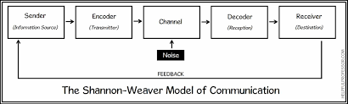
A simple explanation of the Shannon weaver model is that the sender will encode the message and send to the receiver through a channel such as technology, for example an email. The receiver will have to decode the message before being able to understand it. The major disadvantage with this theory would be the noise element which could interrupt the original message along the way which could severely impact the communication process. As the Shannon Weaver model was a mathematical theory, some people feel that it is not representative of human communication.
We looked at a case study on Maria and Pedro in lesson which points out that we should recognise that problems exist in order to look for an effective way to improve communication. This is exactly what the Shannon and Weaver Model has done by showing that noise can affect the feedback of the message. As the manager of a recruitment agency and I would find that many of my European drivers would struggle within certain transport companies as the noise was a language barrier. The delivery notes were all in English and the driver’s rues were also written in English. Nothing was done to overcome this noise and resulted in the drivers being unhappy and would no longer work for these companies
2.2 Schramm.
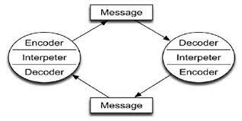
The Schramm model is based on the concept that communication is a two-way process. The model emphasizes that communication is not complete until the sender receives feedback from the recipient. If feedback is not received the message is deemed as ineffective communication.
Schramm also took into consideration other elements into his theory for instance; Culture, religion and background can impact on the way the message is received.
2.3 Berlo.
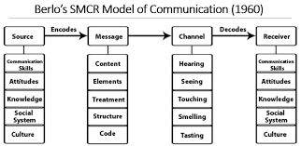
In 1960 David Berlo developed on Shannon Weavers’ model and created the Sender-Message-Channel-Receiver (SMCR) Model.
In the Berlo’s model he describes the different factors that could impact the method of communication process. He took into consideration all the different aspects that could be the noise element in Shannon Weaver’s model and elaborated on it as you can see from the diagram.
3. Communication skills.
Communication is the process of interacting with others. It is a combination of non-verbal and verbal skills, both as important as each other.
In order to communicate effectively we need to make sure that our non-verbal communication matches the words which are spoken. If our body language is closed and our facial expression is blank, yet the words we use are happy it does not get interpretated correctly, Equalling poor communication. In order to have effective communication it is vitally important to be able to correctly interpret non-verbal communication in addition to the ability to actively listen.
A great example of this I have experienced lately was when I was holding interviews at a job centre. A candidate came in and introduced himself. He told me how grateful he was for the opportunity, his facial expressions were blank with no eye contact made, before taking a seat. The words he used led me to believe he could be a great candidate as he had all the relevant experience written on paper. Shortly he showed me that his body language and posture conflicted the words in which he spoke. When he sat down, he was slumped in the chair, gave me no eye contact and proceeded to pull out his mobile phone and send text messages mid-interview. This was poor communication and rude. If his posture was upright, his body language was open and he gave me eye contact and appeared to be interested in what I was saying, the outcome of this interview would have been very different. Upon reflecting on this situation, I believe I could of adapted my communication method to entice the potential candidate to become more engaged.
Another aspect to take into consideration when trying to communicate effectively with someone, especially in the workplace, would be the style of communication best fitted to your intended audience. There are 4 main styles of communication that most people fit into: The analytical, The personal, The intuitive and the functional communicator. For example, if you were talking to an analytical communicator and was over friendly and personal with no mention of facts or figures it would lead to them being confused, uncomfortable equalling poor communication.
There are barriers and obstacles to overcome when communicating which are all pointed out in the models as noise. Being aware of possible obstacles can make you communicate more effectively. Upon reflection of my own levels of communication, I am aware of how noise disrupts my levels of communication. My barrier is mostly my phone as it is used mostly for work, it is constantly ringing. The lessons this term has made me aware of how I can impact my levels of communication and how to overcome any noise obstructions that may occur.
The consequences of ineffective communication can ultimately lead to a breakdown in the way that the original message was intended, subsequently this can impact on relationships. In the workplace this can be catastrophic and can severely impact productivity and the organisational structure. For example, if a company has an important message about compliance that does not get relayed to all the staff properly it could possibly lead to legal implications.
3.1 Verbal communication.
Verbal communication is the language we speak with our mouths. It can also be what we write. In short, verbal communication is delivered by words.
3.2 Non-verbal communication.
Non-verbal communication is the way we communicate without the use of words but by using our body and signals in order to communicate. Harrison and Crouch (1975) said that “non-verbal communication precedes and perhaps structures all subsequent communication.” This is suggestive that communicating verbally Is just the tip of the spear. Non-verbal communication is what the receiver uses to decode the message from the sender.
There are different ways to communicate non-verbally. These include:
- Eye contact.
- Posture.
- Facial expressions.
- Posture.
- Appearance.
- Gestures.
- Proximity.
There are more ways in which we can non-verbally communicate such as the tone and pitch of our voices when we speak. In reality we use our whole bodies to communicate non-verbally.
Body language can help you communicate in four ways. It can either help re-iterate the verbal message you are trying to convey, contradict the message, add to the meaning of the message or replace it completely.
It is imperative that our non-verbal communication matches our verbal communication so that the message is received the way we intend it to be. For example, if we were to congratulate someone, then a smile, eye contact and maybe a gesture would be used. If we were to congratulate someone with a burrowed eyebrow, folded arms or a raised top lip, it would be condescending to the words spoken. Therefore, both verbal and non-verbal communication should be used in harmony and are both equally important to achieve successful communication.
3.3 Listening.
In order to achieve ultimate communication, we must have the ability to listen. There are two types of listening, active listening and empathy listening.
The average person retains 25 to 50 percent of what they hear. (Crockett, 2011)
Active Listening.
Active listening means exactly that, listening with full concentration to what is being said as opposed to passively hearing. To listen effectively you must be self-aware. You must not allow yourself to get distracted or think about other things. You must remain fully engaged and show interest in what is being said. We have tendencies to have thought process in which we can respond to the person speaking, this is not considered active listening and is a distraction in the mind. As quoted by Steven Covey, “Most people do not listen with the intent to understand; they listen with the intent to reply”. He points out that we can miss important information being said therefore not being able to fully understand whilst our mind is distracted while thinking of a response.
There can be many distractions that can impair your ability to actively listen:
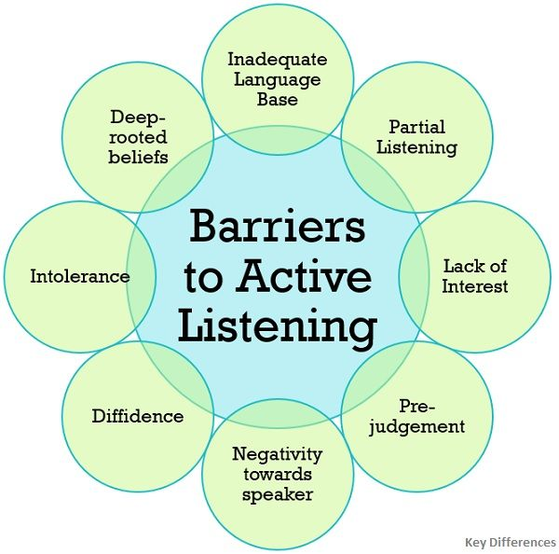

In order to engage in actively listening and to understand the message fully, we must let go of any preconceptions or any opinions along with physical distractions such as a mobile phones or other thoughts in our minds.
Empathic listening.
Emphatic listening is to be able to comprehend the other persons thoughts and feelings. It is a process in which you must show compassion, be open minded and non-judgemental, making them feel comfortable and safe with being open to sharing their thoughts and feelings. There are responses that should not be said when participating in empathic listening:
- Giving advice.
- Sympathising.
- Evaluating.
- Interrogating.
- Consoling.
- Using it as an opportunity to speak about a personal experience.
The empathetic listener would stay engaged, show with body language they are listening and understanding. The fundamental part is to allow the speaker to feel as though a burden has lifted. By being given the ability to speak and having someone that listens empathically, it allows the speaker to gain clarity for themselves through this process.
Conclusion.
To summarise, effective communication is vital to get the intended message across clearly and as intended, it can also help develop interpersonal skills. Verbal, non-verbal and listening are all key elements and are equally as important as each other.
In the workplace effective communication is key to productivity and to ensure the business is functioning to the best of it’s ability. Poor communication will lead to a drop in morale among the workforce equalling a high staff turnover and poor productivity.
It is imperative that we listen to one another appropriately without noise. Noise would be the distractions such as mobile phones or other thoughts in our minds as described in the models of communication. By looking into my own experiences with poor communication I have been able to evaluate how I can develop my own interpersonal skills and improve my quality of communication by implementing the knowledge gained while doing this study. In particular, the fact that we use our whole body for communication and that it amounts to a higher percentage than words, we must be more conscious of our non-verbal communication to help improve the overall effectiveness of our communication skills.

References.

- Covey, S.R., 1989. The 7 habits of highly effective people (Vol. 1). New York: Simon & Schuster.
- Crockett, R.O., 2011. Listening is critical in today’s multicultural workplace. Harvard Business Review.
- Difference Between Active Listening and Passive Listening (with Barriers to Active Listening, Examples and Comparison Chart) - Key Differences
- https://www.youtube.com/40dc4a92-dac7-4b13-a052-81f7f71ccb39
- https://www.youtube.com/watch?v=slq1nAhZuqE
- https://youtu.be/Al3L6cnCmMU.
- Martinho, M.H. and Ponte, J.P.D., 2009. Communication in the classroom: Practice and reflection of a mathematics teacher.
- Maund, A. Shriek, M. and Tinkler, P. (2017) Certificate in Higher Education: Skills for the Workplace Student Yearbook. London. Sage.
- Miller, W.R., 2018. Listening well: The art of empathic understanding. Wipf and Stock Publishers.
- Morgan, P., (2017) The Business Student’s Guide to Study and Employability; London. Sage.
- Narula, U., 2006. Communication models. Atlantic Publishers & Dist.
- O'Reilly P: Barriers to effective clinical decision making in nursing. [http://www.clininfo.health.nsw.gov.au/hospolic/stvincents/1993/a04.html]
- Rani, K.U., 2016. Communication barriers. Journal of English Language and Literature, 3(2), pp.74-76.

Appendix.
COMMUNICATION: A CASE STUDY adapted from The University of Iowa Food Safety Project
In class we looked at a case study about a food hygiene issue within a restaurant and the problems that Barry the manager found. Below is the questions which I answered in class. Pointing out the barriers, solutions and alternative effective communication methods.
Questions:
- What are the communication challenges and barriers Barry faces?
The main communication barriers that Barry faces is language and cultural differences. I would also claim that noise plays a huge part in the communication breakdown as his training can be interrupted. Instead of eliminating the noise, he allows it to take over completely.
- What solutions might Barry consider in addressing each of these challenges and barriers?
Firstly, Barry could consider putting up signage in different languages so that it can be easily read and understood for all. Secondly, he should arrange the initial training at a time when the noise is minimum so that there are no distractions. He could do this by having the new employees start work before it opens for business for example. Lastly, he should address the issues underlying that leads to a high turnover of staff. It appears there may be some breakdown in communication between management and lower staff that could be the issue or maybe some disfunction in the organisational structure, consequently leaving staff feeling undervalued, hence why they leave this employment.
- What are some ways Barry might use effective communication as a motivator for employees to follow safe food handling practices?
I think firstly Barry should actively listen to employees’ feedback, he should enquire into the reasons why people are leaving so quickly and see if he can rectify this so that more quality and thorough training can be given.
Secondly, he should establish the most effective way of communicating with the team and ensuring that the communication is a two-way process.

