2019

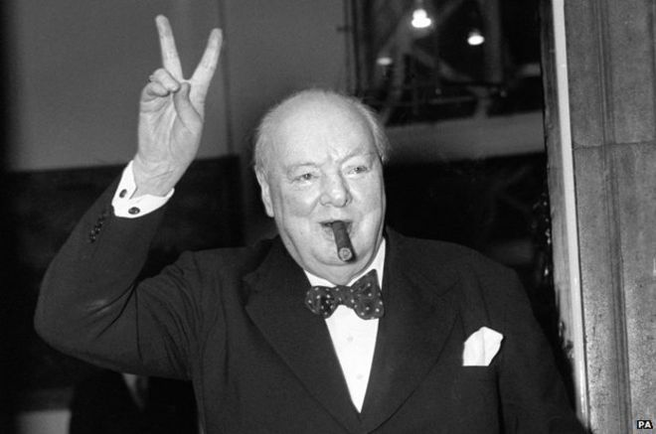

Mosamaa Marjana Khatun
(1704984)
BMSW6101_SWAN

Word Count: 5500?

What makes a great leader?
University of Wales Trinity Saint David
Contents
Introduction 3
Task 1 4
Who is Winston Churchill? 4
Early years 4
A young politician 4
Journalist for the military 4
Rise to power 5
World War two 5
Task 2 6
Leadership theories and models 6
Contingency theories 6
Kurt Lewin (1939) – Leadership styles 6
Tannenbaum and Schmidt (1958, 1973) – Continuum of leadership 7
House (1971) – Path -goal theory 8
Situational theories 9
Hersey and Blanchard (1984) - Situational leadership 9
Trait theories 10
Kirkpatrick and Locke (1991) 10
Zaccaro, et al, (2004) 10
Task 3 add 400 word 11
Managing change 11
Traits 12
Leadership motivation 12
“Churchillisms” 13
Task 5 15
What is my leadership style? 15
Leadership style questionnaire 15
Conceptualising leadership questionnaire 15
Self-reflection 15
Task 6 17
Change leaders 17
How I would implement change 17
Appendices 19
Appendix one 19
Appendix two 19
Appendix three 19
Appendix four 19
Appendix five 19
Task 3 19
References 22

Introduction
Leadership is a relationship wherein actions or behaviours of people are influenced by an individual. (Mullins, 2008). Without effective leadership, it is impossible for an organisation to grow. In the present day there are factors that are consistently changing such as; technology and culture and so managing change in leadership becomes even more important. An organization without effective leadership in such times will fail as we have seen in the likes of Mothercare and Thomas Cook. (Fowler, 2013; Jordan, 2019; The guardian, 2019).
In this report will be the study and dissection of the leadership style and traits of Winston Churchill using six theories to help gather a better understanding of why he is perceived as a “great” leader. Additionally, the study will discuss how the chosen leader had implemented change and if he was successful. Lastly, there will be analysis of the writers’ leadership style and the importance of change in a workplace context.

Task 1

Who is Winston Churchill?

Early years
Winston Leonard Spencer Churchill was born into a powerful and aristocratic Marlborough family in 1874. His father was the Conservative politician, Lord Randolph Churchill. His mother was Jenny Jerome, a New York business woman
Churchill and his younger brother, Jack, saw little of their parents, but were looked after by a nanny, Mrs Everest. The children led a peripatetic life, often travelling with her from their home in Ireland, the ‘Little Lodge’, to the Isle of Wight, Blenheim and to London. It is commonly knowledge that that Winston was not exposed to warmth and affection by his family as a child. (The international Churchill society, 2019 and Churchill and Manchester, 2010).
Churchill was sent to private boarding schools which include St. Georges and The misses Thomson preparatory school wherein his academic records were poor. However, when he moved to Harrow boarding school, the young Winston was seen to excel in the study of military history and affairs. Also, during the time at Harrow school, he demonstrated his ambition of entering high-ranking positions within the army. (The international Churchill society, 2019 and National Churchill Museum, 2019).
Churchill was later deemed a self-learner, he developed his own education and knowledge by reading important texts which allowed him to form his own opinions. For instance, he started reading parliamentary debates and ‘recording his own opinions’ on the matters discussed in parliament. (The international Churchill society, 2019 and Mears, 2013)

A young politician
In 1899, Churchill lost in his first attempt at election to the House of Commons. This was to be the first of many defeats in elections. Despite the rejections, he won a seat in the 1900’s General Election due to his impeccable oratory skills.
Churchill's early years in politics were characterized by an interest in the radical reform of social problems. The major intellectual achievement of this period of Churchill's life was his Liberalism and the Social Problem (1909). In this work he stated his belief in liberalism, or political views that stress civil rights and the use of government to promote social progress. Churchill was very active in the great reforming government of Lord Asquith between 1908 and 1912, and his work fighting unemployment was especially significant. (The international Churchill society, 2019; National Churchill Museum, 2019; Shelden, 2013).

Journalist for the military
Very early on Churchill demonstrated the physical courage and love of adventure and action that he kept throughout his political career. In 1895, Churchill started his military career as a soldier-journalist. He went to Cuba to write about the Spanish army for the Daily Graphic, in 1896 he was in India, and while on the North-West Frontier with the Malakand Field Force he began work on a novel, Savrola: A Tale of the Revolution in Laurania. This was followed by a book about the reconquest of the Sudan (1899), in which he had also taken part. As a journalist for the Morning Post, he went to Africa during the Boer War (1899–1902). The most romantic of his adventures as a youth was his escape from a South African prison during this conflict. (Lyons, 2018 and National Churchill Museum, 2019).

Rise to power
In September, (1939), Winston Churchill became the First-Lord of the Admiralty. The following year Neville Chamberlain lost his popularity and Winston Churchill was nominated Prime Minister and Minister of Defence by King George VI from 1940 to 1945. (Shakespeare, 2017).
During the first part of his political career, Churchill was associated with the Conservative party. Churchill’s relationship with the Conservative party grew increasingly fractious. He was an instinctive free trader, while the party was moving towards protectionism. The Conservatives, were generally resistant to social change but Churchill was all for change and all for making a name for himself. In 1904, Churchill defected to the Liberal party, to sit next to David Lloyd George, wherein he proposed free trade, founded the Free Food League, and spoke against protectionism. Soon after, Churchill had crossed over to the conservative party once again. (Henry, 1993; The international Churchill society, 2019;
Towards the end of his political career, Churchill was re-elected as Prime minister from 1951 to 1955. He frequently conducted business from his bedside, due to age and illness. It is stated that the Prime Minister’s leadership had decreased immensely since his first ruling. (Hook, 2009 and Grenberg, 2011).

World War two
The major period of Churchill's political career began when he became prime minister and head of the Ministry of Defence early in World War II, when British and American Allies fought against the axis of Germany, Italy, and Japan. (Packwood, 2017)
His finest hour and that of the British people came at the same time. His leadership, which was expressed in noble speeches and constant personal activity, stated precisely what Britain needed to survive through the years before the United States entered the war. (Packwood, 2017)
In the first volume of his account of the war Churchill had expressed;
"I felt as if I was walking with destiny, and that all my past life had been but a preparation for this hour.” – (Ratcliffe, 2017).
It is stated that Churchill made decisions and planned from both a political and military perspective which assisted in efficiency.
The astonishing leadership through World War two exemplified Churchill as courageous and tireless. He offered motivation to a nation in fear through his personality to challenge the odds, and neglected failure. (BBC, 2019 and Best, 2011).
A chronology of Churchill’s life has been included in appendix. 1. This will allow readers to gather a greater understanding of the personal and professional life of Churchill. (Churchill College Cambridge, 2019).

Task 2

Leadership theories and models
There are numerous understandings and characteristics of leadership that support in distinguishing leaders from non - leaders. The process of leadership involves influencing a set of people toward the comprehension of goals. According to the philosopher Plato, the ideal leader is one who uses reason and order to rule. Leadership theories try to make sense of various approaches to leadership as well as the development of leadership. (Stojanovic-Aleksic et al 2016).

Contingency theories

Kurt Lewin (1939) – Leadership styles
In 1939, Lewin created a framework that set the foundation for many subsequent to it. Lewin argued that there are three major styles of leadership: autocratic, democratic, and laissez – faire. The theory aims to encourage leaders to be less autocratic than they might instinctively be. (Russel, et al, 2002 and Amy, et al, 2008).

Autocratic leadership
This style magnifies the overlooking of followers input and the determining of all policies without consultation. An example of this is magnified in the leadership style of Adolf Hitler and Joseph Stalin. Although each had different motivations and visions, their ideologies were similar in many of the authoritarian aspects. Each can be described as the “enemies of liberal democracy”. Moreover, each leader had demanded unwavering obedience to authority and responded violently to groups that failed to adequately surrender to their norms, and defined those groups as outsiders (Davis, 2017; Husain and Liebertz, 2019; Roberts, 2010).

Democratic leaders
These leaders are known to make the final decisions whilst including subordinates in the decision-making process. An organisation in favour of this style are Apple, the company began their ascent after Steve Jobs established a democratic leadership style. He hired and entrusted other experienced leaders which had encouraged them to excel. (Toma and Marinescu, 2013).

Laissez-faire
The polar opposite of an authoritarian style can be seen when understanding laissez-faire. It involves very little guidance from leaders, and complete freedom for followers to make decisions. A leader who has benefited from this approach is Donna Karen. The founder of DKNY exemplifies this style by allowing employees take charge of her visions which live on in the work of other designers, inspired by her leadership. Henceforth, she has not created or focused on her individual designs since 2002 but her “fashion empire” has expanded immensely. (Amy et al, 2008; Anastasia, 2017; Sherman, 2015).

Strengths and weaknesses

Autocratic
This style is advantageous in rapid decision making, however when it is abused this can lead to a dysfunctional relationship between leader and follower and an unhappy working environment. Examples of additional negative characteristics include; absenteeism, employment tribunals, dismissals and grievances. (Joseph, 2018).

Democratic
Lewin’s study establishes this style as the most effective as people have the opportunity to be engaged, creative and are motivated further. Additionally, the style aids in building consensus and is suitable where the quality of results are prioritised not the speed. (Paul, et al, 2012).

Laissez-faire
Analysis explained by Lewin, et al, (1939) states that this particular style encourages discontent, scapegoating, inefficiency and unproductivity. Moreover, individual stress levels increase due to the lack availability of a leader, lastly the lack of ownership is evident due to no sole individual taking responsibility of both success and failure. Conversely, the style allows freedom of direction and asks of less work from group members. (King and Lawley, 2013 and Lewin et al, 1939).

Tannenbaum and Schmidt (1958, 1973) – Continuum of leadership
Similar to Lewin, (1931), the purpose of this theory is to focus on the varying behaviours of a leader through the continuum of suitable leadership styles. The theorists identified seven leadership styles; tell, sell, suggest, consult, join, delegate and abdicate. (Martin, 2005 and Holroyd, 2015, pp.08).
Each action is related to the degree of authority used by the leader and to the amount of freedom available to subordinates in reaching decisions. As visible in (figure 1.), the actions seen on the extreme right characterise leaders who release a high degree of control, contrariwise, the extreme left symbolises leaders who maintain a high degree of control. Neither is absolute which identifies that authority and freedom are never without the leaders and their followers’ restrictions. (Tannenbaum and Schmidt, 2009 and Lockett, 2015).
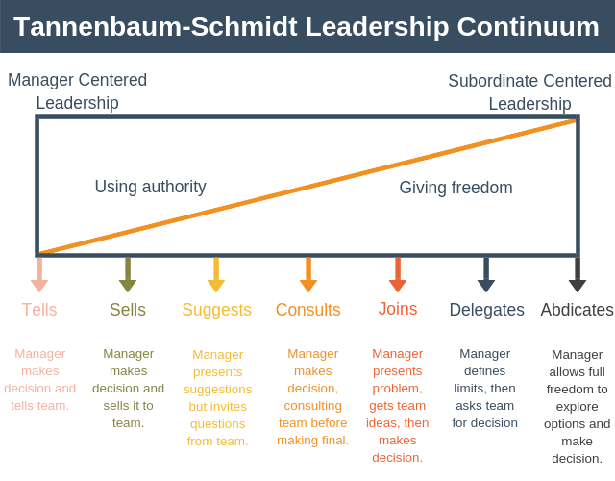
Figure.1. Tannenbaum and Schmidt – continuum of leadership
(Expert programme management, 2018. https://expertprogrammanagement.com/2018/11/tannenbaum-schmidt-leadership-continuum/,accessed on 20 October 2019).

Strengths and weaknesses
One major criticism of this model is the factors to consider when selecting a leadership style are very subjective; determining which style to use and when to use it is not clarified in the model. Further to this, the model solely examines the process of giving a task to the followers and not what happens next, it is also known to ignore soft factors such as cultural norms and office politics. (Lussier and Achua, 2012).
On the other hand, the model is advantageous as the leader has the chance to practice seven ways to understand and interact with followers. It also magnifies that approaches should change dependant on situations. Similar to Adair’s action centred leadership, the leadership continuum complements additional models and acts as a guideline when understanding individual styles and varieties. (Clayton, 2015).

House (1971) – Path -goal theory
This theory is a combination of behavioural and motivational approaches, it assumes that the leader’s purpose is to provide subordinates with anything that is missing in the situation and to help them overcome limitations in their abilities. This approach emphasizes the leaders remit in managing a “path” of subordinates, examples being rewards that help improve job satisfaction. (House and Mitchell, 1974). (Northouse, 2013
According to path-goal theory, there are four major categories of behaviours; directive, supportive, achievement-oriented and participative. (Figure.2.) The theory suggests that a leader can practice alternative behaviours at different times in varying situations. (Kessler,2013, p.580 and Mullins, 2008, p275).
Figure.2 . Path – goal theory.
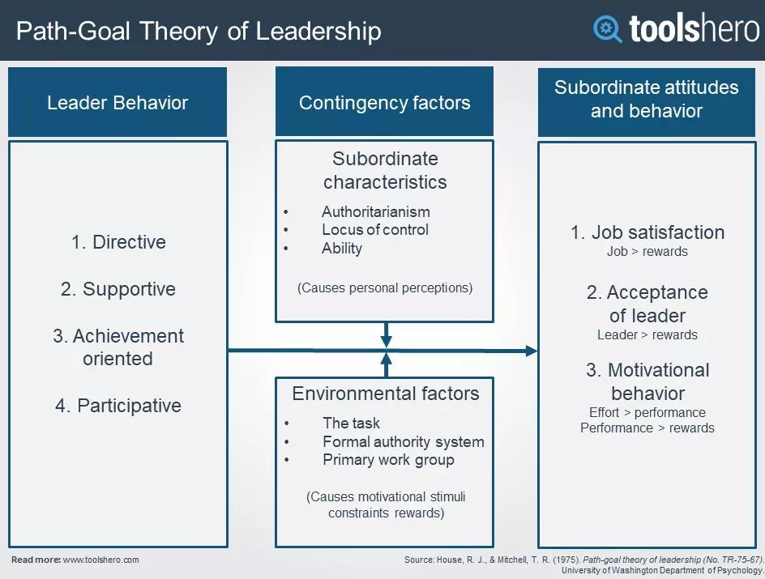

(Mulder, 2019; toolshero - https://www.toolshero.com/leadership/path-goal-theory/, accessed on 20 October 2019).
Motivation is a significant role in the Path-Goal Theory of Leadership. It assists in analysing how leaders can motivate their employees in achieving their goals. What is more, the path chosen by leaders should aim to provide focus for their employees by coaching them and keeping them on the right track. This will only increase work enjoyment. (Landy and Conte, 2010 and Farhan, 2018).

Strengths and Weaknesses
A strength discussed by Wart, (2011), iterates that the theory provides a flexible framework, it allows the establishment of new relationships regarding the style’s leaders use and the contingencies that subordinates experience can be incorporated into the theory. Northouse, 2007, claims that the theory has several identifiable weaknesses, an example is that the theory is thought to be extremely confusing due to its complexity. In addition, the theory fails to adequately explain the relationship of leadership behaviour and worker motivation. (Northouse, 2007).

Summary of Churchill
The study of the contingency theories establishes that Winston Churchill portrayed a number of characteristics and behaviours of a democratic leader. It is evident that he had behaviours of an achievement-oriented leader as well as a directive leader. Further to this, his prominent characteristics fell into environmental factors, examples being uniting Britain, winning the war and saving democracy. The theory assists in understanding how Churchill had motivated his followers and rallied them behind the war effort to fight for the country. (Best, 2011 and Lyon, 2006).

Situational theories

Hersey and Blanchard (1984) - Situational leadership
The Hersey-Blanchard Model suggests that there is no single leadership style that is better than another. Instead of focusing on workplace factors, the model implies that leaders adjust their styles to the followers and their abilities. (Graeff, 1997 and Brown and Barker, 2001).
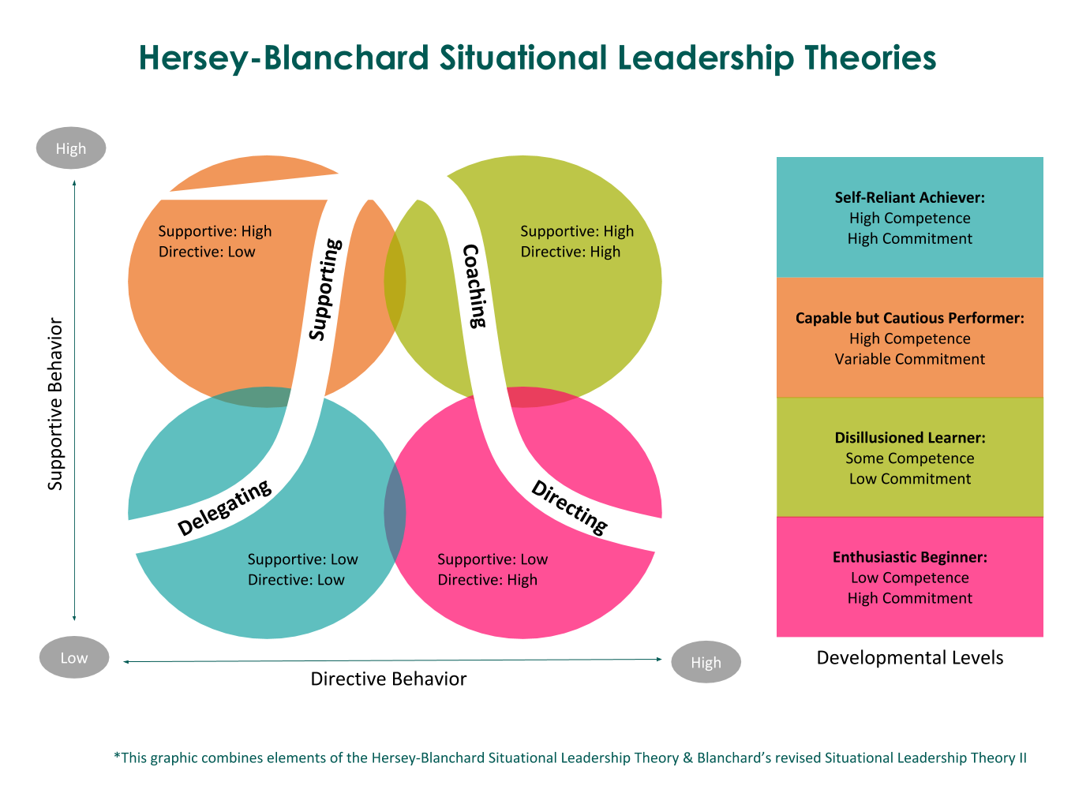
Figure. 3. Hersey and Blanchard (1984) - Situational leadership.

(Gunter, 2019, https://www.oregonbusiness.com/article/sponsored/item/18801-situational-leadership, accessed 20 October 2019).
The two theorists created four different types of leadership styles based on the task and relationships leaders come in contact with in the workplace. According to the model, the leadership styles are; delegating, participating, selling and telling. The model expresses that successful leadership is both task-relevant and relationship-relevant. (Bosse et al, 2017). According to Silverthorne, (2000), the situational leadership style has converted into an extensively used style within large organisations, especially those operating on a global scale. Various studies and researchers have recognized that the model has been applied to the training and human resource development fields. The popularity of this model among human resource professionals and trainers could result from the fact that the model can be easily applied to a variety of settings, and is relatively easy to understand (Wright, 2017; Ardichvili and Manderscheid, 2008; Mehta, 2012).

Strengths and weaknesses
Hersey and Blanchard, (1984), help us to grasp the theory as flexible whereby leaders are encouraged to consider their followers first, and then study the factors that affect the work environment before choosing an effective style. In contrary, the theory is known to focuses on immediate needs and not long-term objectives. Lastly, it may direct conflicting signals to subordinates due to individual’s ability to comprehend the alternating behaviours from one leader. (Wright, 2017 and Aluya, 2009).

Trait theories

Kirkpatrick and Locke (1991)
The theorists postulated that leaders differ from non-leaders on six traits; drive, motivation, integrity, confidence, cognitive ability and task knowledge, (Kirkpatrick et al, 1991). Conferring to the theorist’s, individuals can be born with these traits as well as learn them. Kirkpatrick and Locke (1991), declare that leadership traits make some people different from others and this difference should be recognised as an important part of the leadership process. (Northouse 2010, p18; Green and Cameron, 2017, pp12; Tassel, 2012, p64)

Zaccaro, et al, (2004)
Similarly, Zaccaro et al, (2004), reviewed prior research and summarized eighteen leadership traits and integrated them into six categories including; cognitive abilities, personality, motives/values, social appraisal skills, problem solving skills and expertise/tacit knowledge. On the basis of the influence on leadership effectiveness, they further categorized the six categories into two kinds, distal traits and proximal traits. Hoffman et al (2011) found that both characteristic types are associated with leader effectiveness, mentioning that while leaders can be born with said traits, they can also be made. To continue, cognitive competencies, personalities and motives are distal traits, and the remainder are proximal traits. Although research did not cluster leader traits from socialization, it offers exceptional insights for the study. (Xu et al, 2017; Antonakis et al, 2012; Zaccaro et al, 2018).

Churchill’s traits
There are traits that Churchill did prioritise and possess: trust, vision, courage, self – improvement, action and communication. These were magnified and challenged from the start to the end of world war two. Churchill's traits portrayed him as an extremely effective leader of millions of soldiers and citizens as each looked to him for direction and motivation. (Singer, 2012 and Heffer, 2015).

Task 3 add 400 word

Managing change
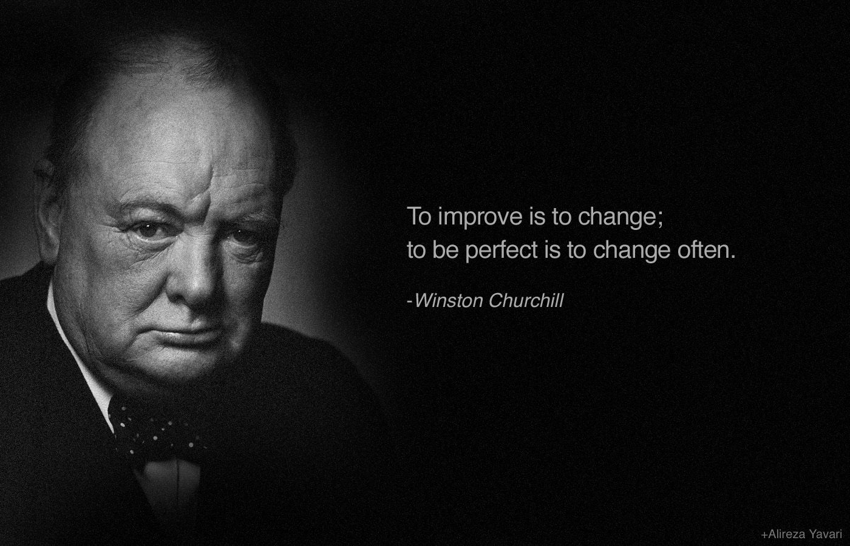

(Pinterest, 2019, https://www.pinterest.co.uk/pin/254383078922293981/, accessed 20 November 2019)
According to Hansborough and Schyns, (2018), transformational leadership appeals more to followers high in; “extraversion, agreeableness, openness, and conscientiousness”, it was hypothesized that these traits will be positively related to the appeal of democratic leadership. In addition, Northouse, (2016), states that transformational leaders often emerge and are at their most effective in times of crisis. (Northouse, 2016 and Hansborough and Schyns, 2018).
In 1967, Violet Bonham Carter described Churchill as;
“a democrat to the bone, imbued with a deep reverence for Parliament and a strong sense of human rights”. (Carter, 1976).
Before the war, Churchill stressed that the common people of democratic and nondemocratic majorities could work effectively to prevent war from descending on Britain if focus was given to attention. His call to action, like those of President Lincoln, centred around an articulation of the worthiness of the regime. His rhetoric during the second World War embodied the deep conviction that Britain was worth fighting for as it stood for something larger than itself within the world. Similar to Lincoln, Churchill believed that Britain's fate determined whether freedom could survive elsewhere.
Although, Churchills democratic leadership style was challenged during the war, he constantly persuaded and led his nation towards incapacitating destructive tendencies of modern democracy. He pointed out the shortcomings of his nation to help win a victory over them. Churchill united his people for battle as well as ingraining an understanding of why they were fighting. Churchill attempted to achieve excellence in everything he undertook and was the inspiration and incarnation of all that was best in the followers, transforming individuals into “heroes”. (Lyons, 2006)
Churchill’s steady leadership, strong communication, and empowerment of fellow politicians as well as citizens comforted and strengthened the nation's collective resolve throughout this time. The vision Churchill had created was victory and no surrender in order to achieve a “greater Britain”.

Traits

Communication
During the Second World War, to inspire his people, Churchill relied upon communication skills. Churchill had known the value of speech, and despite not being a natural orator, he worked on his skills and slowly made his influence present throughout the Allied Forces. (Discussed more under “churchilism”).

Vision
Churchill realized that having a clear vision is as vital as any weapon one could bring to war. Churchill’s vision was so strong that he convinced a nation of people to stand up against Adolf Hitler and the Nazi Germany invasion. He did not just hate tyranny, but despised it, Churchill stood out as the only man the nation trusted.

Trust
The high level of trust extended to Winston by the people of the United Kingdom is evidenced through their belief and faith in his vision. If Churchill’s people did not believe in him and trust his objectives to defend the country against invading Nazis, there is no conceivable way that Britain would have defeated Hitler and his ideology. He recognized that without transparency, there is no trust. Churchill was honest and straightforward and during that time it is what the people and society needed. He earned their trust by being trusting and clear with them and this left him highly regarded.

Self-improvement
Churchill constantly requested criticism and feedback from his subordinates. He understood the value of these opinions and encouraged those around him to speak their minds. During meetings, he expected his colleagues to express their opinions on the issues at hand, and he did not penalize those with opposing views. This type of environment allowed for the flow of open ideas and deep discussion.

Action
He knew what he and his people wanted to achieve and found ways to fulfil his goals. He had somehow realized that none of his transformational leadership qualities would mean anything, if not put into action. Churchill had a core belief that taking risks was necessary to achieve greatness. Churchill understood that not all ventures would be successful and that learning from mistakes defines success.

Leadership motivation
Motivation is a strategy that is used to inspire employees or followers with respect in turn to improve their performance (Latham and Pinder, 2005 and Ming, et al, 2018). It is provided in numerous ways by leaders, some examples include; communication, recognition, opportunities, control, performance rewards and collective goals. (Pahl, 2018 and The times 100, 2018). The effort made towards a shared goal along with the persistence to face obstacles encourage the satisfaction of individual needs. (Lauby, 2005; Taylor, 2010; Arbak and Villeval, 2013).

In contract, McClelland, (2016) contends that people will be motivated to seek out and perform well in jobs that match their needs that are identified in three categories, (appendix). These are not contingent on any progression from one category to another. (McClelland, 2016). As previously stated, House and Mitchell (1975), postulate that leaders can increase motivation by rewarding their employees.
Motivation is commonly explained as two types: intrinsic and extrinsic. Intrinsic motivation is the determination to carry out a task because it is inherently rewarding. On the other hand, extrinsic motivation is the desire to complete a task to obtain a tangible reward or evade an aversive stimulus. (Reiss, 2012).
During the war Churchill had beckoned the intrinsic motivation rooted in values, and character of his followers to help defeat the moral outrage towards Hitler. Churchill offered hardship and toil which united the nation in standing firm throughout the war. (Williams, 2010 and Kayden et al, 2014).

“Churchillisms”
Leadership is synonymous with effective communication, when applied in the correct manner, through vivid metaphors and conceptualization that transport the listener to a different dimension, it is deemed extremely effective within motivation, this is evident within this study of Churchill as he was aware of the importance inspiring a nation at war through the skill of oratory. (Shelton, 2012; The international Churchill society, 2019; Brock and Green, 2005)
Fredric Jablin comments that leadership is viewed as “an ongoing conversation between leaders and followers in which talk or communication can be conceived of as doing the work of leadership, that is, reducing uncertainty and ambiguity and facilitating a group towards accomplishing shared goals”. Through his now famous speeches, Winston Churchill showed the United Kingdom and allies what could be achieved and helped to spur on the troops to win the second World War. Furthermore, President Kennedy had commented that Winston Churchill had the ability to take the English language to war, reflecting that there was clear understanding in the power of words. In addition, Robert Rhodes James states that Churchill avoided both talking down to people and sounding pretentious. (Boe 2011; Burton, 2012; Conrad 2013; BBC, 2019).
Churchill did not employ speech writers and had prioritised public speaking through continuous practice and preparation, this allowed him to overcome the nervousness he had felt since his youth. Additionally, having extraordinary literacy skills had enabled him to achieve greatly throughout his military and political life, (discussed further in appendix), an example is the award for Nobel Prize for Literature in 1953. (Roberts, 2018 and Boe, 2011).
Churchill made it his role as Prime Minister in World War two to motivate the British people to remain optimistic and ready to fight despite the successor of the Nazi forces. He used emotive language, metaphors and powerful imagery, delivering his speeches with authority which assisted in strengthening the nation’s resolve during the “darkest of days”. Churchill had mastered the art of alliteration, often repeating the same sounding words for maximum impact. Churchill understood the effect and skill of the speeches as each had the ability to encourage the country to reach a shared goal. (Churchill and Longworth, 2013; Montalbo, 2019; Dockter, 2015).
Conversely, Toye, (2013) revealed that Churchill’s wartime speeches were actually met with considerable criticism from the British public and were better established abroad, particularly in the United States. It is alleged that the complexity of the public reaction had been obscured from historical record. (BBC News, 2013; University of Exeter, 2013; Rossi, 2013).
Churchill was always careful to downplay his own impact, and more particularly that of his speeches, insisting that he was only giving expression to the collective spirit of the British people. (Maguire, 2014).
A prosaic response was communicated to Lord Moran wherein Churchill stated;
“People say my speeches after Dunkirk were the thing. That was only a part, not the chief part. … They forget I made all the main military decisions. - Churchill 1945”
(Maguire, 2014).
Churchill's rhetoric during the war helped Britain understand the fight they must face as he believed that their way of life was important and that the country should not stop fighting or let the already ingrained incentive evaporate. The Prime minister had continued to stress that Britons should commit to the world.

Task 5

What is my leadership style?
To gather a better understanding of individual leadership styles and traits, a class of fourteen students, including myself, have completed and studied two detached questionnaires which are stimulated by Northouse (2017).

Leadership style questionnaire
Firstly, the leadership styles questionnaire, (appendix. 2.), is designed to measure three common styles of leadership: authoritarian, democratic, and laissez-faire.
The results upon accumulating scores specify that my predominant style is democratic in which the total was twenty. This is followed by an authoritarian style, scoring seventeen and lastly laissez-faire, with the summation of fifteen. The questionnaire states that scores between sixteen and twenty exemplify the individual as being in the “moderate range”.
I had predicted that the result would express that I posess a democratic leadership style, however I was flabbergasted when understanding the following styles. I had anticipated lassiez-faire as being my second dominant style.

Conceptualising leadership questionnaire
The purpose of this questionnaire, (appendix. 3.), is to identify how the individual defines and perceives different aspects of leadership. Similar to the initial survey it asks to calculate scores in six different dimensions of leadership; trait, ability, skills, behaviour, relationship and process. (Northouse, 2017).
The overall results specify that I emphasise importance through skill with the sum of seventeen. This is closely followed by emphasis given to process, wherein I scored sixteen.
The complete enumeration of my peers scores also magnified that the majority scored moderately and are democratic. The class is complete with individuals of dissimilar characteristics and so I had anticipated more results wherein authoritarian and lassiez- faire would be dominant. This has helped me to understand that they are similar to myself and question if it is the norm of this generation.

Self-reflection
My democratic leadership style has been expressed through various leadership roles such as; a project manager, and being a member of a youth led grant giving panel. I believe I maintained co-operation through each role as this had allowed the subordinates and I to share an equal voice and had eliminated any hierarchy. Moreover, the procedures and decisions were completed through teamwork which had assisted in recognising equal responsibilities towards the accomplishment of a communal goal.
To emphasise skills and process within my roles I have requested and offered consistent feedback to understand how to facilitate the learning of team members to help increase efficiency. Furthermore, I strongly accept as true that an effective leader encourages and positively interacts with followers largely through the application of soft skills such as; communication, listening and motivation.
On the other hand, when analysing my role as an events co-ordinator for family functions, an autocratic style can be evident as I control all decisions and receive little input from family members. Conversely, I believe I make conclusions based on ideas and judgments that fit the overall need which can help decrease stress and manage time without actually consulting individuals involved in the process.
I had expected the lassies- faire style to be more dominant as I had thought, like Donna Karen, that I sometimes leave the decision making to peers due to personal issues or alternative commitments. This has worked in my favour as the project team, grant giving team and I have succeeded in our set motives and this has allowed us each to instil trust in one another.

Task 6

Change leaders

In 2001, Drucker coined the term “change leaders” to refer to individuals and organizations who utilised the opportunity to proactively lead change and exploited it as an opportunity. Moreover, to apply and implement the rightful, ambiguous, change, a leader searches for alternative possibilities which are considered effective external and internal to the organization. (Drucker, 2000, and Higgs and Rowland, 2011).
Research confirms that transformational change results in substantial ambiguity for members participating in the change efforts because the organization and its members cannot rely on previous successes. (Chelsey and Wylson, 2016; Malcom and Deborah, 2011; Gioia, et al, 2012).
The ability to create and shape a solid platform for change in leadership is through inspiration and stimulation. Drive, vision and personal advocacy is also desired. It is popularly associated with large scale changes and assists in a fast and efficient process. (Forbes, 2011 and Cran, 2015).

How I would implement change
To assist in the expansion of my knowledge and understanding of effective leadership I am eager to apply Drucker’s understanding of change leaders. In addition, the SWOT and PESTLE analysis tools can assist in the documentation of internal and external factors that affect change opportunities. (Gurel & Tat, 2017 and Marmol, 2015).
Additionally, the application of Kurt Lewin’s leadership styles can support me in the assessment of my own style within an organisational context and help me to improve democratically. As a leader I would device Zaccaro, et al’s (2004), trait theory and attempt to expand on both proximal and distal characteristics to advance effective leadership.
As touched upon previously I prioritise soft skills and believe that each will significantly aid in the productivity and team work of both leader and followers. My aim is to implement and expand on an array of soft skills in the management of roles wherein I take the lead, as well as apply an amalgamation of the leadership theories and models mentioned beforehand.
Firstly, I would focus on building communication skills through the application of Tannenbaum and Schmidt’s leadership continuum and Hersey and Blanchard situational leadership. Each level can help me determine when authority should be delegated to team members. (Lockett, 2015). Within communication the focus on the skill of listening will allow me to build trust. I can implement this within conflict resolution and encouraging 360-degree feedback. (CIPD, 2019).
I believe an additional way to encourage change is through motivation. The path goal theory can aid as a guideline to empowering a workforce as well as the application of a motivational theory such as the hierarchy of needs 1943. (Northouse,2013; Pratap, 2016; Mark, 2014). Likewise, being a part of a team can allow me to inspire others through collaboration and the development of overall skills. To practice discipline will allow inspiration for the subordinates, as leaders skills are displayed in the workplace (Guest Author, 2017). I would apply discipline largely through is the management of time. Kayden et al, (2015), iterate that
“understanding the true deadline for a project or document can save stress for both leader and subordinates” – (Kaydent, et al, 2015, pp. 159).
To start, I would first attempt to encourage the application of minimalist habits within the organisation such as distributing a planner to the team solely for work purposes and creating a daily schedule of appointments. Alike Churchill, I feel that there is great importance in inspiring the workforce through the skill of oratory, for example I would utilise an array of well-known motivational speeches from historic leaders, such as Martin Luther King and Nelson Mandela, and expand on them to display that the leader and subordinates are working together and are not segregated.

Conclusion 200 words?

Appendices

Appendix one – “Sir Winston Churchill: A chronology”

Churchill College Cambridge. (2019). https://www.chu.cam.ac.uk/archives/collections/churchill-papers/sir-winston-churchill-chronology/

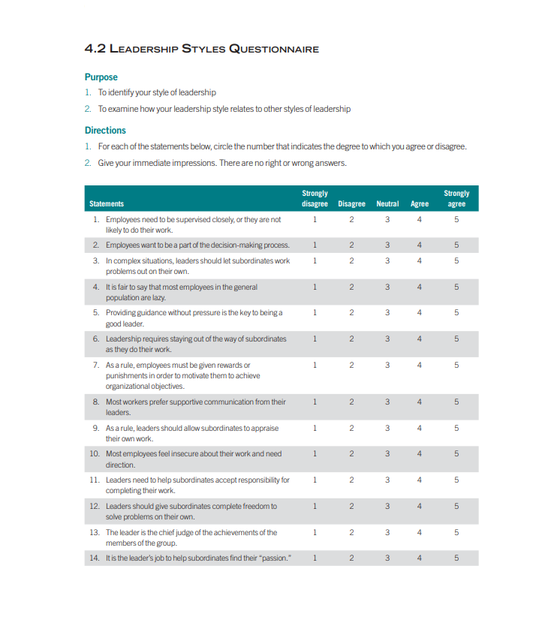
Appendix two - Leadership styles questionnaire

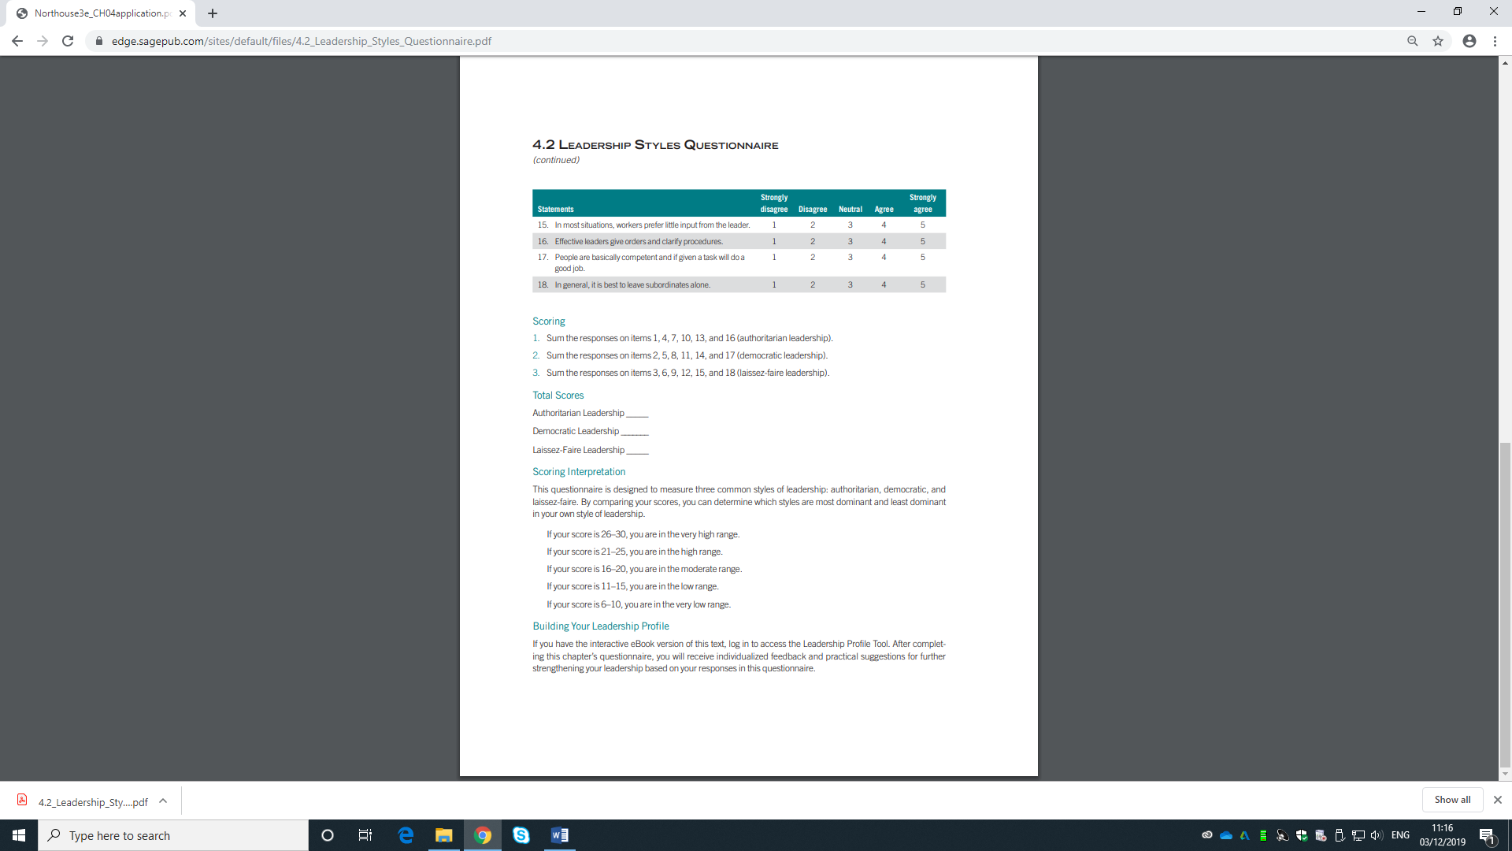

Appendix three – Conceptualising leadership questionnaire
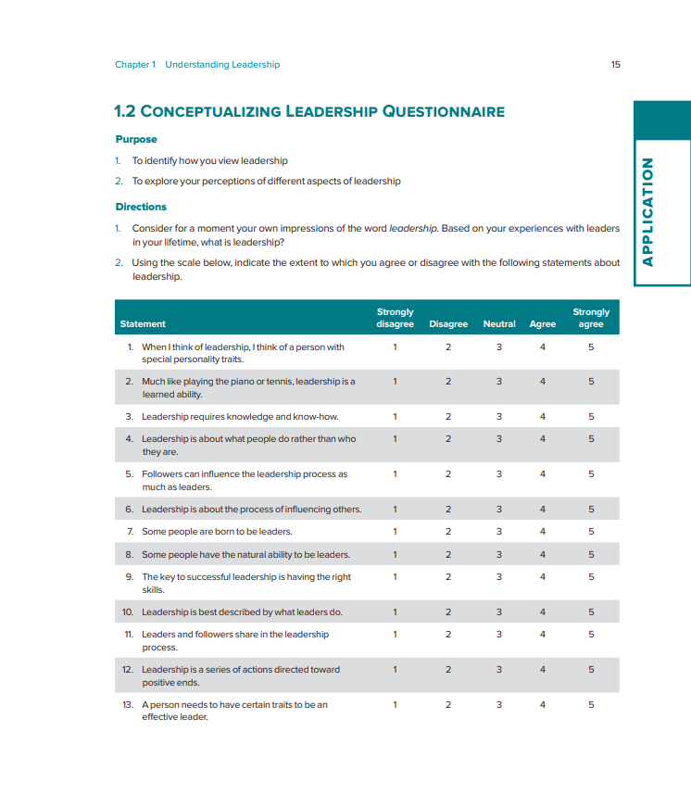

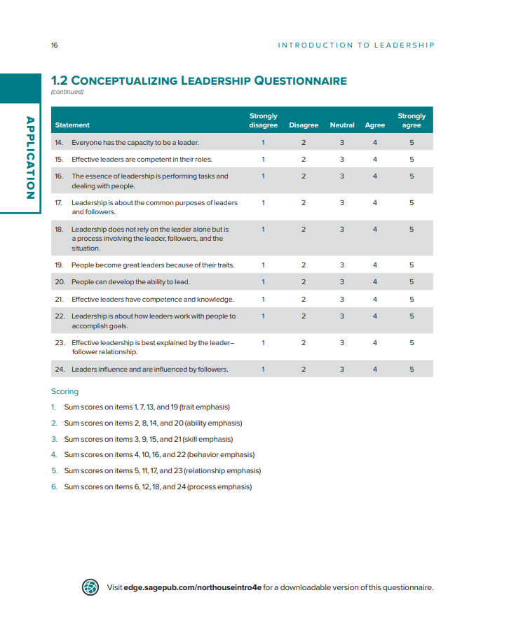
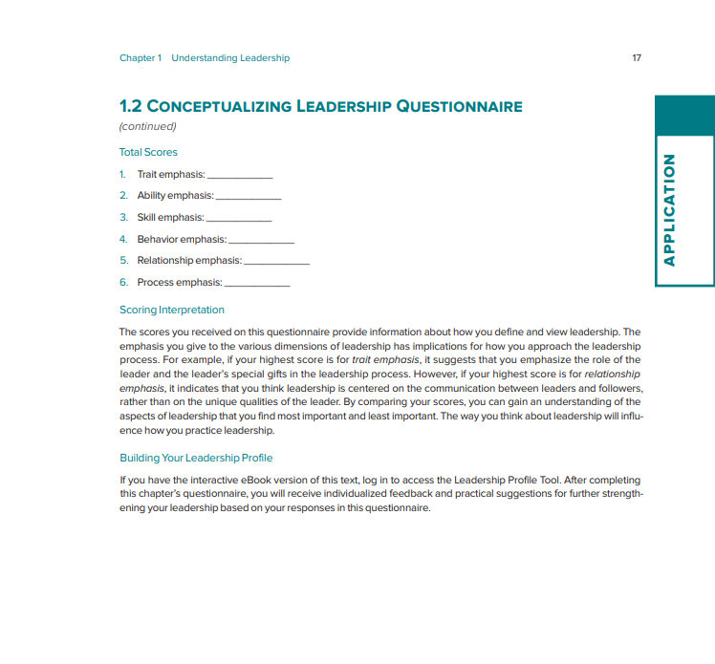

Appendix four
Trait emphasis: 13
Ability emphasis: 15
Skills emphasis: 17
Behavioural emphasis: 12
Relationship emphasis: 15
Process emphasis: 16

1 Table on page 19 https://books.google.co.uk/books?id=BiqT_CZbBegC&pg=PA18&dq=Kirkpatrick+and+Locke+1991+traits&hl=en&sa=X&ved=0ahUKEwjt6MqVp93lAhUEVRUIHcvJB4gQ6AEIMTAB#v=onepage&q&f=false
https://search-proquest-com.ezproxy.uwtsd.ac.uk/docview/2082228501?accountid=130472&rfr_id=info%3Axri%2Fsid%3Aprimo – move to bib
Churchill wrote speeches like psalms; the phrased passages helped him to maintain the right pace in his delivery. Literacy skills shown in appendix journalist in the military.
Examples are in the appendicies https://www.historyextra.com/period/second-world-war/churchills-greatest-speeches/

Edward shelto task three transformational leader chapter 1 https://books.google.co.uk/books?id=xBYSzYi3t4kC&printsec=frontcover&dq=leadership+motivation&hl=en&sa=X&ved=0ahUKEwjovPnAqvvlAhWeQxUIHVN-DGwQ6AEIMTAB#v=onepage&q=leadership%20motivation&f=false – put in reference as well

Bibliography
Antonakis, J. Day, V. D., and Schyns, B. (2012). ‘Leadership and individual differences: at the cusp of a renaissance’, the leadership quarterly, 23(4), pp. 643 – 650. Available at: https://www-sciencedirect-com.ezproxy.uwtsd.ac.uk/science/article/pii/S1048984312000422, (Accessed on November 2019).
Arbak, E. and Villeval, M. (2013). ‘Voluntary leadership: motivation and influence’, Springer -Verlag, 40(3), pp. 635–662. Available at: https://link-springer-com.ezproxy.uwtsd.ac.uk/article/10.1007/s00355-011-0626-2 (Accessed: November 2019).
Arnold, F. (2012). What makes great leaders great. Belgium: McGraw- Hill Companies, Inc. Available at: https://books.google.co.uk/books?id=LL5aAvhpaP4C&printsec=frontcover&dq=What+makes+a+great+leader&hl=en&sa=X&ved=0ahUKEwjRgauo7bTlAhWSuHEKHSZFCeEQ6AEILDAA#v=onepage&q=What%20makes%20a%20great%20leader&f=false, (Accessed:17 November 2019).
Bass, M. B. (1990). Bass and Stogdill’s handbook of leadership: theory, research, and managerial applications. 3rd edn. New York: The free press. Available at: https://books.google.co.uk/books?id=KxLizZ3aYmUC&printsec=frontcover&dq=stogdill+1974+trait+theory&hl=en&sa=X&ved=0ahUKEwiC1vP6rt3lAhVRecAKHdOFBKsQ6AEIKTAA#v=onepage&q=Stogdill&f=false, (Accessed: November 2019).
BBC News. (2013). ‘Churchill’s wartime speeches did not always inspire’, BBC, 21st August. Available at: https://www.bbc.co.uk/news/uk-england-23778816, (Accessed: November 2019).
BBC Teach. (2019). ‘WW2: did Winston’s words win the war?’, BBC. Available at: https://www.bbc.co.uk/teach/did-winstons-words-win-the-war/zjdn7nb, (Accessed: November 2019).
Boe, J. (2011). ‘Principles of persuasion’, American Salesman, 53(7), pp. 7 – 11. Available at: https://search-ebscohost-com.ezproxy.uwtsd.ac.uk/login.aspx?direct=true&db=bth&AN=33220933&site=ehost-live, (Accessed: November 2019).
Brown, A. N. and Barker, T. R. (2001). ‘Analysis of the communication components found within the situational leadership model: toward integration of communication and the model’, Journal of technical writing and communication, 31(2), pp. 135 – 157. Available at: https://journals-sagepub-com.ezproxy.uwtsd.ac.uk/doi/abs/10.2190/VMRC-YCY2-F08K-P2FQ, (Accessed November 2019).
Churchill college Cambridge. (2019). Sir Winston Churchill: a chronology. Available at: https://www.chu.cam.ac.uk/archives/collections/churchill-papers/sir-winston-churchill-chronology/ (Accessed: November 2019).
Clayton, M. (2009). Management models: pocketbook. Hants: Management Pocketbooks Ltd. Available at: https://books.google.co.uk/books?id=Rd3wCgAAQBAJ&dq=Tannenbaum+and+Schmidt+(1958,+1973)+%E2%80%93+Continuum+of+leadership+advantages&source=gbs_navlinks_s, (Accessed on November 2019).
Conrad, D. (2013). ‘Great leaders are great sales people’, Journal of Business Studies Quarterly, 4(3), pp. 223-229. Available at: https://search-proquest-com.ezproxy.uwtsd.ac.uk/docview/1450019571/fulltext/3AFD228E2F8148D6PQ/1?accountid=130472, (Accessed November 2019).
Cran, C. (2016). The art of change leadership: driving transformation in a fast-paced world. New Jersey: John Wiley and Sons, Inc. Available at: https://books.google.co.uk/books?id=bS2sBwAAQBAJ&printsec=frontcover&dq=change+leadership&hl=en&sa=X&ved=0ahUKEwi-iunEioXmAhWqXhUIHbgRDgQQ6AEIKTAA#v=onepage&q=change%20leadership&f=false (Accessed November 2019).
Crosson, R. (2014). What makes a leader great. Oregon: Harvest House Publishers. Available at: https://books.google.co.uk/books?id=xauTAwAAQBAJ&printsec=frontcover&dq=What+makes+a+great+leader&hl=en&sa=X&ved=0ahUKEwjRgauo7bTlAhWSuHEKHSZFCeEQ6AEINDAB#v=onepage&q=What%20makes%20a%20great%20leader&f=false, (Accessed: 17 November 2019).
Davis, R. C. (2017). ‘Administrator Leadership Styles and Their Impact on School Nursing’, NASN school nurse, 33(1), pp. 36-39. Available at: https://journals-sagepub-com.ezproxy.uwtsd.ac.uk/doi/abs/10.1177/1942602X17714202#articleCitationDownloadContainer, (Accessed: 31 November 2019).
Dockter, W. (2015). ‘Winston Churchill’s 10 most important speeches’, The Telegraph, 29th January. Available at: https://www.telegraph.co.uk/history/world-war-two/11363924/Winston-Churchills-10-most-important-speeches.html (Accessed: November 2019).
Drucker, P. F. (2000) ‘The Change Leader’, National Productivity Review (Wiley), 19(2), pp. 13–20. Available at: https://onlinelibrary.wiley.com/doi/abs/10.1002/npr.4040190203, (Accessed November 2019).
Gioia, D. A., Nag, R., and Corley, K. G. (2012). ‘Visionary ambiguity and strategic change: the virtue of vagueness in launching major organizational change’, Journal of Management Inquiry, 21(4), 364–375. Available at: https://journals.sagepub.com/doi/10.1177/1056492612447229 (Accessed: November 2019).
Goleman, D. (2017). What makes a leader. Massachusetts: Harvard business school publishing. Available at: https://books.google.co.uk/books?id=Um9GDgAAQBAJ&printsec=frontcover&dq=What+makes+a+great+leader&hl=en&sa=X&ved=0ahUKEwjRgauo7bTlAhWSuHEKHSZFCeEQ6AEITDAE#v=onepage&q=What%20makes%20a%20great%20leader&f=false, (Accessed: 17 November 2019).
Gurel, E. and Tat, M. (2017). ‘Swot Analysis: A Theoretical Review’, Journal of international research, 10(51). Available at: https://web-a-ebscohost-com.ezproxy.uwtsd.ac.uk/ehost/pdfviewer/pdfviewer?vid=1&sid=0fa55248-451e-40bd-8027-dfb533ff335e%40sessionmgr4010 (Accessed: 03 November 2019).
Hansbrough, T. K. and Schyns, B. (2018) ‘The Appeal of Transformational Leadership’, Journal of Leadership Studies, 12(3), pp. 19–32. Available at: https://web-a-ebscohost-com.ezproxy.uwtsd.ac.uk/ehost/detail/detail?vid=0&sid=eea8bd02-421b-441a-9886-4e46371d347a%40sdc-v-sessmgr01&bdata=JnNpdGU9ZWhvc3QtbGl2ZQ%3d%3d#AN=133893808&db=bth (Accessed: November 2019).
Heffer, S. (2015) ‘The Churchill myth’, New Statesman, pp. 18–23. Available at: https://web-a-ebscohost-com.ezproxy.uwtsd.ac.uk/ehost/pdfviewer/pdfviewer?vid=1&sid=b9123e76-7eab-4984-9ec0-4cdd46711abd%40sessionmgr4008 (Accessed: 15 November 2019).
Higgs, M. and Rowland, D. (2011). ‘What doe si5t take to implement change successfully? A study of the behaviours of successful change leaders’, The Journal of applied behavioural science, 47(3), pp. 309 – 335. Available at: https://journals-sagepub-com.ezproxy.uwtsd.ac.uk/doi/pdf/10.1177/0021886311404556 (Accessed: November 2019).
Holroyd, J., Brown, K., and Keen, S. (2015). Self – leadership and personal resilience in health and social care. London: SAGE Publications Ltd. Available at: https://books.google.co.uk/books?id=XRaJCwAAQBAJ&pg=PA9&dq=disadvantages+of+using+action+centred+leadership&hl=en&sa=X&ved=0ahUKEwjhvs7uqdjlAhUSmVwKHfyLBT0Q6AEIcTAJ#v=onepage&q=disadvantages%20of%20using%20action%20centred%20leadership&f=false, (Accessed: November 2019].
Humes, C. J. and Nixon, M. R. (2007). London: Harper Collins e- books. Available at: https://epdf.pub/the-wit-amp-wisdom-of-winston-churchill.html (Accessed: November 2019).
Hurd, R. A., Barcelona, J. R., and Meldrum, T. J. (2008). Leisure services management. Leeds: Human Kinetics. Available at: https://books.google.co.uk/books?id=liKTvdItAVoC&dq=Kurt+lewin+leadership+styles&source=gbs_navlinks_s. [Accessed on November 2019].
Husain, M. Z. and Liebertz. S. (2019). ‘Hitler, Stalin, and authoritarianism: a comparative analysis, (Part 2)’, The Journal of Psychohistory, 47(2). Available at: https://search-proquest-com.ezproxy.uwtsd.ac.uk/docview/2301886350?accountid=130472&rfr_id=info%3Axri%2Fsid%3Aprimo, (Accessed: 31 November 2019).
ITV News. (2015). Winston Churchill: the speeches that inspired a nation. Available at: https://www.itv.com/news/2015-01-24/winston-churchill-the-speeches-that-inspired-a-nation-in-pictures-and-video/ (Accessed: November 2019).
Jordan, D. (2019). What has gone wrong at Mothercare? Available at: https://www.bbc.co.uk/news/business-50288603 (Accessed 01 December 2019).
Kayden, S. et al. (2015). Emergency department leadership and management: best principles and practice. United Kingdom: Cambridge university press. Available at: https://books.google.co.uk/books?id=55gkBQAAQBAJ&dq=did+churchill+intrinsically+motivate+followers&source=gbs_navlinks_s, (Accessed: November 2019).
Kessler, H. E. (2013). Encyclopaedia of management theory. London: SAGE publications, Ltd. https://books.google.co.uk/books?id=6fCyBwAAQBAJ&printsec=frontcover&dq=path+goal+theory+of+leadership&hl=en&sa=X&ved=0ahUKEwjSz6-L_8jlAhVzQUEAHbutBiAQ6AEINDAC#v=onepage&q=path%20goal%20theory%20of%20leadership&f=false. [Accessed on November 2019].
King, D. and Lawley, S. (2013). Organisational behaviour. Oxford: Oxford university press. Available at: https://books.google.co.uk/books?id=GXycAQAAQBAJ&dq=Disadvantages+Of+kurt+lewin%27s+leadership+styles+theory&source=gbs_navlinks_s. [accessed on November 2019].
Kirkpatrick, S. A. and Locke, E. A. (1991). ‘Leadership: do traits matter?’, The Executive, 5(2), pp. 48. Available at: https://search-proquest-com.ezproxy.uwtsd.ac.uk/docview/210514732/fulltextPDF/B8CE15FA5FC940EAPQ/1?accountid=130472, (Accessed: November 2019).
Kotter, J. (2011). Change management vs. change leadership- what’s the difference? 12th July. Available at: https://www.forbes.com/sites/johnkotter/2011/07/12/change-management-vs-change-leadership-whats-the-difference/#22f770364cc6 (Accessed: November 2019).
Landy, J. F. and Conte, M. J. (2010). Work in the 21st century: an introduction to industrial and organisational psychology. 3rd edn. United States of America: John Wiley and Sons, Inc. Available at: https://books.google.co.uk/books?id=1K1rnp9uAscC&dq=Path-goal+Theory+-+motivation&source=gbs_navlinks_s, (Accessed: November 2019).
Latham, G. and Pinder, C. (2005). ‘Work motivation theory and research at the dawn of the twenty first century’, Annual Review of Psychology, 56(1), pp. 485-516. Available at: https://www.researchgate.net/publication/8023095_Work_Motivation_Theory_and_Research_at_the_Dawn_of_the_Twenty-First_Century (Accessed: November 2019).
Lockett, B. (2015). ‘Approaches to teaching the new: a level business specification’, Teaching Business & Economics, 19(1), pp. 6-8. Available at: https://search-proquest-com.ezproxy.uwtsd.ac.uk/docview/1665099514?accountid=130472&rfr_id=info%3Axri%2Fsid%3Aprimo, (Accessed: November 2019).
Lussier, N. R. and Achua, F. C. (2012). Leadership: theory, application, and skill development. 5th edn. United States of America: Cengage learning. Available at: https://books.google.co.uk/books?id=reoJAAAAQBAJ&printsec=frontcover&source=gbs_atb#v=onepage&q=tannenbaum%20&f=false. [accessed on November 2019].
Lyons, J.D. (2006). ‘Winston Churchill and the rhetorical challenges of democratic statesmanship’, Perspectives on Political Science, 35(1), pp. 4-13. Available at: https://search-proquest-com.ezproxy.uwtsd.ac.uk/docview/194708729?accountid=130472&rfr_id=info%3Axri%2Fsid%3Aprimo (Accessed: November 2019).
Maguire, L. (2014). ‘We shall fight: a rhetorical analysis of Churchill’s famous speech’, Rhetoric and public affairs, 17(2), pp. 255-286. Available at: https://muse-jhu-edu.ezproxy.uwtsd.ac.uk/article/547764 (Accessed: November 2019).
Marmol, D. T. (2015). PESTLE analysis, Namur: Lemaiture publishing
Martin, J. (2005). Organisational behaviour and management. 3rd edn. London: Thomson Learning. Available at: https://books.google.co.uk/books?id=BUDMDCAuRIoC&dq=tannenbaum+and+schmidt+continuum+of+leadership&source=gbs_navlinks_s, (Accessed: November 2019).
McClelland, C. D. (2016). The achieving society. Oxford: Pickle Partners Publishing. Available at: https://books.google.co.uk/books?id=0Yh_DQAAQBAJ&dq=mcclelland+motivation+theory&source=gbs_navlinks_s, (Accessed: November 2019).
Ming, W.W.P., Tee, N.E. and Hua, C.C. (2018). ‘Transformational leadership, motivation, and organizational commitment towards corporate social responsibility in banking service industry, Sarawak’, Global Business and Management Research, 10(2), pp. 58-70. Available at: https://search-proquest-com.ezproxy.uwtsd.ac.uk/docview/2137109504/fulltextPDF/8E8440B7A5DD4709PQ/1?accountid=130472 (Accessed November 2019).
Montablo, T. (2019). Churchill: a study in oratory. Available at: https://winstonchurchill.org/publications/finest-hour/finest-hour-069/churchill-a-study-in-oratory/ (Accessed: November 2019).
Mozes, M., Josman, Z. and Yaniv, E. (2011). ‘Corporate social responsibility organizational identification and motivation’, Social Responsibility Journal, 7(2), 310-325. Available at: https://www.semanticscholar.org/paper/Corporate-social-responsibility-organizational-and-Mozes-Josman/a9f757c4a0b85d0a3b4910e7235ef75d44617e05 (Accessed: November 2019).
Mullins, J. L. (2008). Essentials of organisational behaviour. 2nd edn. Harlow: Pearson Education Ltd. Available at: https://books.google.co.uk/books?id=7J1Zk-nx-4MC&pg=PA275&dq=path+goal+theory+four+styles&hl=en&sa=X&ved=0ahUKEwi70LbdhtvlAhUVilwKHTvPBCoQ6AEIZjAI#v=onepage&q=path%20goal%20theory%20four%20styles&f=false, (Accessed on November 2019).
Northouse, G. P. (2007). Leadership: theory and practice. 4th edn. London: SAGE publications Ltd. Available at: https://books.google.co.uk/books?id=Ctq4cZS5JfsC&pg=PA136&dq=path+goal+theory+four+styles&hl=en&sa=X&ved=0ahUKEwiWla2Pg9vlAhXUoVwKHSNHDtkQuwUIRDAD#v=onepage&q=path%20goal%20theory%20four%20styles&f=false, (Accessed on November 2019).
Northouse, G. P. (2018). Introduction to leadership: concepts and practice. 4th edn. Singapore: SAGE Publications ltd. Available at: https://books.google.co.uk/books?id=tEoSDgAAQBAJ&printsec=frontcover&dq=northouse+introduction+to+leadership+concepts+and+practice&hl=en&sa=X&ved=0ahUKEwiux7Gcw_jlAhXXQEEAHcmbCfwQ6AEIKTAA#v=onepage&q=questionnaire&f=false, (Accessed on November 2019).
Podsakoff, P., MacKenzie, R. and Bommer, W. (1996). ‘Transformational leader behaviours and substitutes for leadership as determinants of employee satisfaction, commitment, trust, and organizational citizenship behaviours’, Journal of Management, 22(2), pp. 259–298. Available at: (Accessed: November 2019).
Pradhan, S. and Jena, K. L. (2019). ‘Does meaningful work explain the relationship between transformational leadership and innovative work behaviour?’, Vikalpa: the journal for decision makers, 44(1), pp. 30-40. Available at: https://journals-sagepub-com.ezproxy.uwtsd.ac.uk/doi/full/10.1177/0256090919832434 (Accessed: November 2019).
Reiss, S. (2012). ‘Intrinsic and Extrinsic Motivation’, Teaching of Psychology, 39(2), pp. 152–156. Available at: https://journals-sagepub-com.ezproxy.uwtsd.ac.uk/doi/full/10.1177/0098628312437704#articleCitationDownloadContainer (Accessed: November 2019).
Roberts, A. (2018). Churchill: walking with destiny. United Kingdom: Penguin Books UK. Available at: https://books.google.co.uk/books?id=-4BbDwAAQBAJ&dq=churchill+nobel+prize&source=gbs_navlinks_s, (Accessed: November 2019).
Rossi, J. P. (2013). ‘Churchill reconsidered’, Society, 50(1), PP. 82-85. Available at: https://search-proquest-com.ezproxy.uwtsd.ac.uk/docview/1270351140?accountid=130472&rfr_id=info%3Axri%2Fsid%3Aprimo (Accessed: November 2019).
SAGE edge. (2019). Leadership questionnaire. Available at: https://edge.sagepub.com/northouseintro3e/student-resources-0/understanding-leadership/leadership-questionnaire (Accessed: November 2019).
Schmitter, P.C. (2011). ‘The future of real-existing democracy’, Society and Economy, 33(2), pp. 399-428. Available at: https://search-proquest-com.ezproxy.uwtsd.ac.uk/docview/1032960776?accountid=130472&rfr_id=info%3Axri%2Fsid%3Aprimo (Accessed: November 2019).
Swansburg, C. R. and Swansburg, J. R. (2002). Introduction to management and leadership for nurse managers. 3rd edn. London: Jones and Barlett Publishers International. Available at: https://books.google.co.uk/books?id=eqlziUipS28C&pg=PA398&dq=Kurt+lewin+leadership+styles&hl=en&sa=X&ved=0ahUKEwjC2-qCxt3lAhVKURUIHZ4MBU8Q6AEIQTAD#v=onepage&q=Kurt%20lewin%20leadership%20styles&f=false. [Accessed on November 2019].
The Guardian. (2019). Thomas Cook was brought down by incompetence, not boardroom greed. Available at: https://www.theguardian.com/business/2019/sep/29/thomas-cook-failure-incompetence-not-corporate-greed (Accessed: 01 December 2019).
Thomas, P. and Paul, D. and Cadle, J. (2012). The human touch: personal skills for professional success. Swindon: BCS learning and development Ltd. Available: https://books.google.co.uk/books?id=FJZ1FPrV7SMC&dq=advantages+of+kurt+lewins+leadership+styles+theory&source=gbs_navlinks_s, [Accessed on November 2019].
Toma, S. and Marinescu, P. (2013). ‘Steve Jobs and modern leadership’, Manager, 17(1), pp. 260 – 269. Available at: https://doaj.org/article/914ad8ffd5fe45919537e8f94101a886, (Accessed: 30 November 2019).
Torrance, A. (2004). ‘ What makes a leader great?’, Strategic Direction, 20(8), pp. 4-9.Available at: https://search-proquest-com.ezproxy.uwtsd.ac.uk/docview/218609240?accountid=130472&rfr_id=info%3Axri%2Fsid%3Aprimo (Accessed: November 2019).
University of Cambridge. (2019). How Churchill waged war. Available at: https://www.cam.ac.uk/ChurchillAtWar (Accessed: November 2019).
University of Exeter. (2013). Untold story of Churchill’s world war two speeches. Available at: http://www.exeter.ac.uk/news/research/title_313389_en.html (Accessed: November 2019).
Van Tassel, J. and Poe-Howfield, L. (2010). Managing electronic media: making, marketing, and moving digital content. Oxford: Elsevier, Inc. Available at: https://books.google.co.uk/books?id=7dZ5AgAAQBAJ&pg=PA64&dq=Kirkpatrick+and+Locke+six+traits&hl=en&sa=X&ved=0ahUKEwiX4vC6ut3lAhUmShUIHVV0DAAQ6AEIQTAD#v=onepage&q=Kirkpatrick%20and%20Locke%20&f=false, (Accessed: November 2019).
Van Wart, M. (2011). Dynamics of leadership in public service: theory and practice. 2nd edn. London: M. E. Sharpe. Available at: https://books.google.co.uk/books?id=LTFh2WMG0KsC&pg=PA89&dq=Path-goal+Theory+advantages&hl=en&sa=X&ved=0ahUKEwidhtb0oOflAhWTURUIHcAiBY8Q6AEIKDAA#v=onepage&q&f=false, (Accessed: November 2019).
Williams, P. and Denney, J. (2010). The leadership wisdom of Solomon: 28 essential strategies for leading with integrity. Ohio: Standard publishing. Available at: https://books.google.co.uk/books?id=PJsq0Khkk3oC&pg=PA45&lpg=PA45&dq=did+churchill+intrinsically+motivate+followers&source=bl&ots=p-SgxPDkSq&sig=ACfU3U3CzsW-pEYILE_Lx77Iw-FmaE1tGw&hl=en&sa=X&ved=2ahUKEwi1j-fC3I_mAhVcUhUIHaviCWcQ6AEwAHoECAYQAQ#v=onepage&q=%20churchill&f=false, (Accessed: November 2019) .
Xu, L., Pang, D., Ge, J. and Xi, Y. (2017). ‘Understanding the categories of leader traits in socialization: the case of Haier group's CEO in China’, Nankai Business Review International, 8(3), pp. 344-366. Available at: https://search-proquest-com.ezproxy.uwtsd.ac.uk/docview/1924850527/fulltextPDF/574CDBB81B394E5CPQ/1?accountid=130472, (Accessed: November 2019).
Zaccaro, J. S., Green, P. J., Dubrow, S., and Kolze, M. (2018). ‘Leader individual differences, situational parameters, and leadership outcomes: a comprehensive review and integration’, The leadership quarterly, 29(1), pp. 2 – 43. Available at: https://www-sciencedirect-com.ezproxy.uwtsd.ac.uk/science/article/pii/S1048984317300784, (Accessed: November 2019).
---------------------------------
https://schoolhistory.co.uk/notes/winston-churchill/
[1.] Captivating History (2017). An animated Biography of Winston Churchill. [online] Youtube. Available from: https://www.youtube.com/watch?v=rHSJFkh8WGk
https://www.notablebiographies.com/Ch-Co/Churchill-Winston.html
https://www.britannica.com/biography/Winston-Churchill/Leadership-during-World-War-II
https://www.bbc.co.uk/news/magazine-30934629
https://www.cleverism.com/laissez-faire-leadership-guide/
https://www.inc.com/erik-sherman/donna-karan-remains-a-leader-champion.html
https://search-proquest-com.ezproxy.uwtsd.ac.uk/docview/2164513224?accountid=130472&rfr_id=info%3Axri%2Fsid%3Aprimo Joseph 2018
Bosse, T. et al. (2017) ‘Computational model-based design of leadership support based on situational leadership theory’, SIMULATION, 93(7), pp. 605–617. https://journals-sagepub-com.ezproxy.uwtsd.ac.uk/doi/full/10.1177/0037549717693324
https://web-b-ebscohost-com.ezproxy.uwtsd.ac.uk/ehost/pdfviewer/pdfviewer?vid=1&sid=40e7d1da-9a2b-41f4-9406-d3c451acbd12%40pdc-v-sessmgr01 Wright, E. S. 1. wright-e@mssu. ed. (2017) ‘Dialogic Development in the Situational Leadership Style’, Performance Improvement, 56(9), pp. 27–31. doi: 10.1002/pfi.21733.
Ardichvili, A., & Manderscheid, S. (2008). Emerging practices in leadership development: An introduction. Advances in Developing Human Resources, 10, 619–631. https://doi.org/10.1177/1523422308321718
Mehta, M. (2012). Situational leadership and personal effectiveness: Managers in Indian development organizations. Abhigyan, 30, 23–34. Retrieved from http://www.fsm.ac.in/pub_abhigyan.html
Silverthorne, C. (2000). Situational leadership theory in Taiwan: A different culture perspective. Leadership & Organization Development Journal, 21, 68–74. https://doi.org/10.1108/01437730010318156
Aluya, J. (2009). Complexity of leadership, organisations and the real estate industry: distributing existing systems. Bloomington: Author House. Available at: https://books.google.co.uk/books?id=_SWqWNPdq4AC&dq=disadvantages+of+situational+leadership&source=gbs_navlinks_s, [accessed on November 2019].
https://www.cipd.co.uk/knowledge/fundamentals/people/performance/feedback-factsheet
https://www.wrike.com/blog/9-ways-develop-leadership-skills/
https://search-proquest-com.ezproxy.uwtsd.ac.uk/docview/849603149/fulltextPDF/E4C74F2A58954634PQ/1?accountid=130472
Churchill, W. and Manchester, W. (2010). My early life: 1874- 1904. New York: Simon and Schuster paperbacks. Available at: https://books.google.co.uk/books?id=ooFGl74WbXsC&printsec=frontcover&source=gbs_ge_summary_r&cad=0#v=onepage&q&f=false, [accessed on November 2019].
https://web-a-ebscohost-com.ezproxy.uwtsd.ac.uk/ehost/detail/detail?vid=0&sid=d830d2cb-325a-42f3-a6a4-99da21990e0f%40sdc-v-sessmgr03&bdata=JnNpdGU9ZWhvc3QtbGl2ZQ%3d%3d#AN=133443596&db=aph
https://search-proquest-com.ezproxy.uwtsd.ac.uk/docview/1467996765/fulltextPDF/2AEC8B9600D4C59PQ/1?accountid=130472
https://www.nationalchurchillmuseum.org/winston-churchills-education.html
Shelden, M. (2013). Young titan: the making of Winston Churchill. New York: Simon and Schuster paperbacks. Available at: https://books.google.co.uk/books?id=IgEWKjF-qVcC&printsec=frontcover&dq=winston+churchill+young+politician&hl=en&sa=X&ved=0ahUKEwjkmPSpj5zmAhXRiVwKHQ_NCIYQ6AEIKTAA#v=onepage&q=winston%20churchill%20young%20politician&f=false, [Accessed on November 2019].
Shakespeare, N. (2017). Six minutes in May: how Churchill unexpectedly became prime minister. London: Penguin random house UK. Available at: https://books.google.co.uk/books?id=VmfYDQAAQBAJ&dq=winston+churchill+rise+to+power&source=gbs_navlinks_s, [accessed on November 2019].
Packwood, A. (2018). How Churchill waged war: the most challenging decisions of the second world war. Yorkshire: Frontline books. Available at: https://books.google.co.uk/books?id=PcOIDwAAQBAJ&dq=winston+churchill+rise+to+power&source=gbs_navlinks_s, [accessed on November 2019].
Singer, B. (2012). Churchill style: the art of being Winston Churchill. New York: ABRAMS Books. Available at: https://books.google.co.uk/books?id=aFxuS54NkRoC&dq=Churchills+traits&source=gbs_navlinks_s, (accessed on November 2019).

https://www-jstor-org.ezproxy.uwtsd.ac.uk/stable/4051511?sid=primo&origin=crossref&seq=1#metadata_info_tab_contents
https://www.oxfordreference.com/view/10.1093/acref/9780191843730.001.0001/q-oro-ed5-00002969
https://www.bbc.co.uk/newsround/31043477
https://search-proquest-com.ezproxy.uwtsd.ac.uk/docview/1856096400?accountid=130472&rfr_id=info%3Axri%2Fsid%3Aprimo
Heffer, S. (2015) ‘The Churchill myth. (cover story)’, New Statesman, pp. 18–23. Available at: https://search-ebscohost-com.ezproxy.uwtsd.ac.uk/login.aspx?direct=true&db=bth&AN=100283021&site=ehost-live (Accessed: 4 December 2019). https://web-a-ebscohost-com.ezproxy.uwtsd.ac.uk/ehost/detail/detail?vid=2&sid=fdf3c0cc-8ae8-4086-81d4-32fcefcf2b56%40sessionmgr4006&bdata=JnNpdGU9ZWhvc3QtbGl2ZQ%3d%3d#AN=100283021&db=bth

