Training and Development of an HR Officer
STUDENT NAME: RAVI SUKHRANI
STUDENT ID: 1916534

Table of Contents
Introduction: 2
Determine appropriate knowledge, skills and behaviours (KSB) that are required by HR professionals across the departments. Please refer to Appendix A for an overview of HR Officer Responsibilities. 3
SKILLS 3
KNOWLEDGE 5
BEHAVIOURS 6
Conduct a personal skills audit for yourself (with the use of appendix B) and identify training and development needs considering the knowledge, skills and behaviours you identified in task (1) 8
Critically assess the potential benefits to the organisation and individual of developing you as an HR officer through effective training and development. 9
Benefits of organization providing effective training and development to HR officer: 9
Benefits of Me as an individual 10
CONCLUSION: 10
References 11

Introduction:
Human resource management is a process utilized by companies to hire, develop, and manage their employees. This practice is usually referred to as HR. It is the department's responsibility to create policies and procedures that are designed to ensure the proper relationship between the workers and the company. Human resources management (HRM) is a process that focuses on the effective use of employees. As such, it is commonly referred to as human capital (Reilly and Willia, 2020). The goal is to maximize the return on investment of the organization by developing and implementing strategies that effectively utilize the employees (Weisbord, 2019). Modern HR technology terms such as human capital management (HCM) have become more prevalent compared to the term HRM.

Determine appropriate knowledge, skills and behaviours (KSB) that are required by HR professionals across the departments. Please refer to Appendix A for an overview of HR Officer Responsibilities.

HR generalists have a wide variety of skills and responsibilities that they should have to excel in order to be successful in their roles.

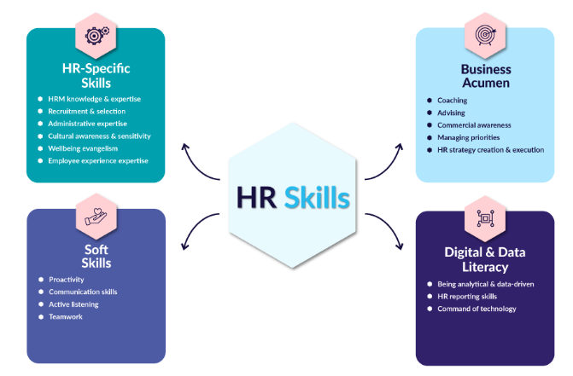

SKILLS

Communication skills:
Most of the time, candidates for HR jobs require strong communication skills. This is very useful for a person working in an organization where there are various levels of authority and stakeholder groups. This discipline can help people develop compelling stories that are informed by deep data. It can also help them communicate effectively with both their customers and the complaints they bring.
Recruitment and selection:
The selection and recruiting process is often mentioned as one of the most critical tasks in the human resources department (Reilly and Willia, 2020). This step involves finding the right candidates, interviewing them, and then selecting the best. One of the most critical elements of a successful recruitment process is ensuring that the interview is fair. This is because many countries have anti-discrimination laws that are designed to prevent discrimination.

HR reporting skills:
As the demand for HR reporting skills increases, so does the need for these skills. HR professionals with strong reporting skills can turn data into compelling messages. When onecan report on key metrics, they are more likely to make better decisions and implement more evidence-based policies (Weisbord, 2019).
Command of technology:
Being able to use technology effectively will help you complete your work more efficiently and effectively. This is especially relevant for HR professionals working in remote or hybrid environments (Ehnert, et. al, 2021). Aside from being familiar with the basic technology, HR professionals also need to learn how to use and interpret the Human Resource Information Systems (HRIS). This is the digital counterpart of HR management.
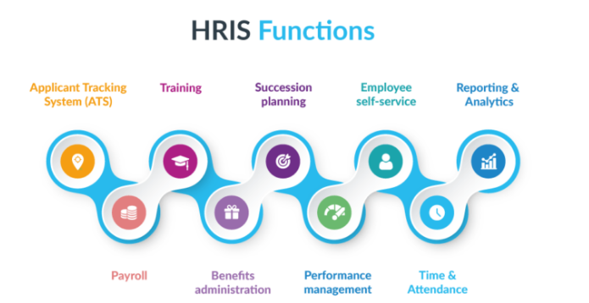
Being analytical and data-driven:
The skills related to data-driven work have become more prevalent in the last few years. As a result, many HR generalists are required to be data-driven and analytical (Ehnert, et. al, 2021). With the growing popularity of data analytics, HR departments are pushing to make better decisions using the data collected. This can involve the useof complex predictive models or the simpler use of data.

KNOWLEDGE

HRM knowledge and expertise:
Aside from having good knowledge and expertise in HRM, previous experience is also very helpful. HRM knowledge helps individuals understand the various facets of HR. It can also help them develop effective methods and systems for handling various tasks and processes (FitzRoy et. al, 2018). The Digital HR Certificate Program will help you gain the skills to lead the digital transformation of HR by equipping you with the knowledge and skills to implement and manage digital strategies and technology.

Managing priorities:
To successfully execute your projects and initiatives, you need more than just knowledge and HR skills. Even if the project is important, there is a chance that your stakeholder groups have varying interests and goals. Being able to manage these conflicting interests will help you avoid potential pitfalls and make the project a success.
Proactivity:
Although proactivity is often considered a personality trait, it can also be utilized by HR professionals. This is because, as an HR professional, you have a responsibility to help the employee avoid potential problems. Being proactive as an HR professional is very important. It can be done by staying informed about the latest trends and technologies in the industry.
Advising:
Being a credible and trusted advisor is a key skill in HR (FitzRoy et. al, 2018). This is an area where you need to excel. Sometimes, these issues can be operational, such as creating a plan for a re-entry process for an employee. They can also be tactical, such as helping a senior manager develop an email to a department. Communication skills are very important to becoming a trusted advisor.
Teamwork:
One of the core HR skills that is required is teamwork. This discipline involves working together with other HR professionals in the organization to align HR activities.

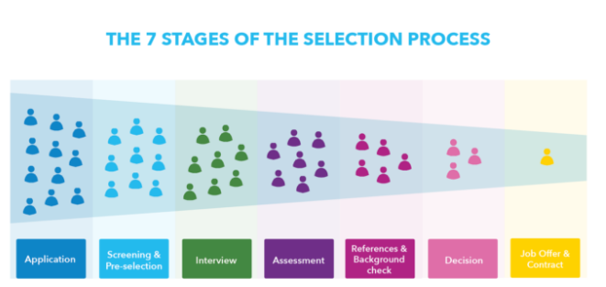

BEHAVIOURS

Employee experience expertise:
In the midst of the war for talent, employee experience is more important than ever. In 2021, 96% of HR leaders prioritize employee experience or EX (Reilly and Willia, 2020). With expertise in the field of human-centric design, HR professionals can use this knowledge to design and develop truly exceptional workplaces that are rooted in the employee lifecycle. This helps attract and retain the best talent in the world.

Commercial awareness:
Understanding how the business makes money is the key to commercial awareness. This is the reason why it is so important that organizations have commercial priorities. The value of HRM activities can be shown through the HR Value Chain (Reilly and Willia, 2020). This process helps identify the various activities that can lead to achieving goals and objectives. This skill can be learned depending on the complexity of the organization. For instance, cultural awareness is very important for large multinational companies.

Cultural awareness and sensitivity:
This skill is very important for HR professionals working in large multinational companies. It is also required for employees working in different countries. Different cultures have their own practices related to people management (Fonge et. al, 2020). For instance, in India, it is common for people to get a promotion every year. It is also not uncommon for Chinese workers to go back to their birthplace in the new year to celebrate Chinese New Year. These cultural differences will affect how you hire, retain, and promote people. The wrong communication style can result in your message not being seen as important or offensive to other people.

Wellbeing evangelism:
What is different now is the wider understanding of how important it is for employees to have a healthy and happy work environment. Even in an environment plagued by crises, employee well-being is still important. According to McKinsey, stress reduction can help lower healthcare costs. As the impact of employee well-being becomes clearer, HR professionals have a vital role to play in helping employees remain happy, healthy, or productive.

Active listening:
Active listening is a vital skill that can improve many other essential skills. Being able to listen to others without judgment or prejudice is very helpful for navigating sensitive matters (Fonge et. al, 2020). Without a strong active listening skill, navigating sensitive matters will be harder. This will also make it harder to effectively coach and manage employees.

Conduct a personal skills audit for yourself (with the use of appendix B) and identify training and development needs considering the knowledge, skills and behaviours you identified in task (1)

Most of the time, HR professionals require strong communication skills in order to perform their jobs. This discipline I have to grow in myself in work in a team of HR in Unbeliever. Currently I am working as an Intern in Unilever and Communication skill helped me developing effective ways of communicating with various stakeholder groups. I need to DEVELOP good knowledge and experience in HRM can help individuals improve MY skills in various areas of human resource management. Having the necessary skills and expertise can help me to manage the various interests of different groups within the organization. I try to be be proactive which is important to stay on top of the latest developments in the industry. The recruitment process is a vital step in the HR department's operations. It involves conducting interviews and finding the right candidates. One of the most critical factors that a successful recruitment process involves is ensuring that the interview is conducted fairly. I should take traning to be able to effectively use technology which will enable to complete my work more efficiently. This is especially true for me who work in remote or hybrid environments (Lingard, 2021). In today's competitive environment, HR leaders are more focused on developing exceptional workplaces that are built on the employee lifecycle. Through the knowledge I have gained from HR professionals, I can design and develop workplaces that are rooted on the employee lifecycle. Due to the increasing popularity of data-driven work, I need to develop analytical skills and implement data-driven strategies.
The demand for HR reporting skills is increasing. With strong reporting skills, I can use data to create compelling messages and make better decisions. I understand how the organization makes money is very important to commercial awareness. This is why it is so important that companies have commercial priorities. I have to develop this skill because it is very useful for me to work in large corporations. It also requires people management skills in different countries. For instance, cultures in different countries have their own ways of managing people. What used to be considered a luxury has become much more crucial in today's environment, where employees are more likely to feel valued and satisfied. According to a study conducted by McKinsey, stress reduction can lower healthcare costs (Lingard, 2021). I have the skill of Active listening which is a way to improve many other skills. Being able to listen without hesitation or prejudice is very helpful when navigating sensitive matters. Teamwork is a core HR skill that is required in today's fast-paced environment. This discipline I have that involves working with other HR professionals to align the activities of the organization.

Critically assess the potential benefits to the organisation and individual of developing you as an HR officer through effective training and development.

HRM is a process that bridges the gap between the people and the organization's management. It is a vital component of an effective organization. Human resource management plays a vital role in the success of an organization. It helps in attracting and retaining the best employees (Reilly and Willia, 2020). HRM is a process utilized by organizations to manage the various facets of their human resource management. This framework helps them meet their competitive challenges while creating value. Without effective HR management, an organization might not be able to realize its full potential. This is why the importance of HR goes unnoticed.

Benefits of organization providing effective training and development to HR officer:
Strategic Management: Human resource management is a strategic management practice that helps organizations achieve organizational goals and bottom-line profitability. It enhances the company's bottom-line by generating positive output.
Mission, vision, values, and goals: HRM helps employees feel like they belong within an organization by helping them identify their roles and develop their own goals.
Branding internally: Creating a positive brand image for an organization is an important step in developing a successful and efficient workforce (Reilly and Willia, 2020). A study revealed that building a strong brand helps companies attract and retain the best candidates.
Creating awareness for employees: RM helps employees understand their roles and responsibilities.
Maintaining a conducive work environment: A conducive work environment is one of the most important factors that employers consider when it comes to attracting and retaining talented individuals. This is where the HR department comes in handy.
Talent management: HRM is responsible for talent management. This includes the recruitment and selection of talent, training and development, succession planning, and career paths.
Organizational culture: HRM is an integral part of an organization’s culture (Poonamallee, 2019). It plays a crucial role in shaping the organization’s environment and making it more effective and supportive.
Conflict management: HRM helps employees manage conflicts by identifying their personalities and taking the necessary steps to resolve them.

Benefits of Me as an individual
Human resource management Traning will help me in achieving my goals and objectives. HRM turning help me feel like I belong to an organization by helping the company develop their goals and roles. Through Development of HRM, it helps me creating a strong brand image is very important for an organization to stand out and attract the best candidates (Reilly and Willia, 2020). Creating a conducive work environment is a must for employers. This can be achieved through the various steps that the HR department can take. HRM is a part of an organization's culture. So, It is important to create an environment through Training that is supportive and encourages continuous learning and development. HRM helps me managing conflicts and disputes by identifying my personalities.

CONCLUSION:

HR generalists should not allow their skills to become stagnant. This will allow them to excel and lead their organizations to excellence (Poonamallee, 2019). Extensive training only adds value if it helps individuals and teams reach their strategic goals.

References

Dirisu, J.I., Iyiola, O. & Ibidunni, O.S. 2020, "PRODUCT DIFFERENTIATION: A TOOL OF COMPETITIVE ADVANTAGE AND OPTIMAL ORGANIZATIONAL PERFORMANCE (A STUDY OF UNILEVER NIGERIA PLC)", European Scientific Journal, vol. 9, no. 34, pp. 258.
Ehnert, I., Harry, W. & Zink, K.J. 2021;, Sustainability and Human Resource Management : Developing Sustainable Business Organizations, 1st edn, Springer Berlin Heidelberg, Dordrecht.
FitzRoy, P.T., Hulbert, J.M., Ghobadian, A., eBook Library (EBL) & Ebooks Corporation 2018;, Strategic management: the challenge of creating value, 2nd edn, Routledge, New York;London;.
Fong, C., Ooi, K., Tan, B., Lee, V. & Yee-Loong Chong, A. 2020, "HRM practices and knowledge sharing: an empirical study", International Journal of Manpower, vol. 32, no. 5/6, pp. 704-723.
Lingard, T. 2021, "Unilever's strategic response to sustainable development and its implications for public affairs professionals", Journal of Public Affairs, vol. 12, no. 3, pp. 224-229.
Poonamallee, L. 2019, "Corporate citizenship: panacea or problem? The complicated case of Hindustan Unilever",The Journal of Corporate Citizenship, , no. 44, pp. 9.
Reilly, P. & Willia, T. 2020;, Strategic HR: Building the Capability to Deliver, Gower, Farnham.
Sheehan, M., Marti, V. & Roberts, T. 2019, "Ethical Review of Research on Human Subjects at Unilever: Reflections on Governance", Bioethics, vol. 28, no. 6, pp. 284-292.
Weisbord, M.R. 2019; Productive Workplaces: Dignity, Meaning, and Community in the 21st Century,3;3rd; edn, Pfeiffer, Hoboken.
Woodburn, D., Wilson, K. & Books24x7, I. 2014, Handbook of Strategic Accounting Management : A Comprehensive Resource, 1st edn, John Wiley & Sons Ltd, GB.

