

Module: Data Handling and Business Intelligence
Module code: LCBB5000
Name: AnaMaria-Doris Andrita

Assignment Title: Component 1:
Coursework: Written Report

Current Trends in Business Intelligence: A Focus on UK Retail and E-Commerce Sector

Contents
Introduction 1
Discussion 2
Evolution of Business Intelligence in UK Retail 2
Digital Transformation and Data Analytics 3
Security and Data Integrity in Retail BI 3
Agile Implementation in Retail Analytics 4
Future Prospects and Emerging Trends 5
Conclusion 7
References 8

Introduction
The aspects of retail and e-commerce providing goods and services in the United Kingdom have significantly changed during the past few years due to the growth in digital technologies, especially big data analytics. Larson and Chang (2016) have established that BI development has been innovative through data volume, variety, and velocity compounded by internet transactions and the use of smart devices. This has been most noticeable in the UK retail sector, where online retail commerce has implied over one-quarter of the total retail, posing an extreme demand for next-level business intelligence solutions.

As mentioned in this research article, BIaaS and emerging services and analytics have transformed the traditional means of retailers in the UK in their data decision-making process. This report provides a snapshot of business intelligence in the UK retail and e-commerce industry and how modern UK retailers apply modern technology, such as advanced analytics, cloud services, and agile frameworks, to improve business performance and customer satisfaction. The application of fast analytics and data science methods will be explored extensively while discussing retail security and data integrity.

Discussion

Evolution of Business Intelligence in UK Retail
The UK retail sector has noted a transformational approach in the use of BI and its implementation. Moreover, with the market value of UK e-commerce reaching up to £693 billion in 2023, as per the prediction of market research analysts, the retailer BI strategies are under pressure in terms of managing growing data complexity (Weisman-Pitts, 2024). BIaaS has gained significant importance, especially for UK retailers, as 78% of the major retail chains have already started using cloud-based BI solutions. Implementation of this shift has been instigated by the necessity to provide quick delivery of analytics and affordable implementation charges so that the retailers can adapt to the transforming consumers’ behaviours and market environment efficiently (Batsakis et al., 2023). Technology has had an impact on the implementation of the MapReduce frameworks as a way of processing and categorising large amounts of data belonging to retailers, hence enhancing decision-making dexterity and operational efficiency.

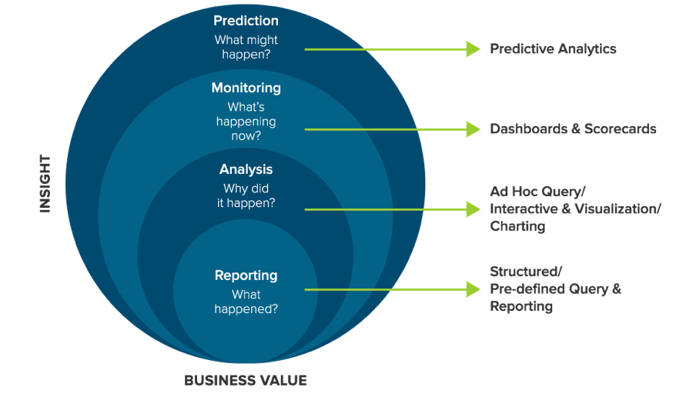
Figure: Leveraging BI in the Retail Industry (Batsakis et al., 2023)

Digital Transformation and Data Analytics
As new services and analytics are incorporated into UK retailing, the way that retailers collect and make use of customer data has evolved significantly. According to the research article, different technologies like data warehousing, machine learning, and visualisation, when integrated, have formed stronger tendencies in retail analytics. The integrated services are quickly finding favour in the UK retailers; super majors such as Tesco and Sainsbury’s utilise highly developed BI infrastructure that can analyse over 5mn points of customer data daily. The visualisation techniques have emerged as critical to deciphering intricacies (Eidizadeh, Salehzadeh and Esfahani, 2017).

Shopping patterns and trends in customer behaviours; more so, 67% of the UK retailers asserted that it had facilitated better decision-making due to improvements in data visualisations. A focus on business data science (BDS) approaches has been instrumental, as retailers have turned experimental in an effort to boost business performance based on BDS insights. This has resulted in the creation of better analytical models that blend the BI with machine learning methods (Newman et al., 2016).

Security and Data Integrity in Retail BI
The work under analysis states that security and privacy issues are some of the most significant concerns in BI with respect to which retail is significantly concerned due to customer data. UK retailers are bound by strict GDPR laws while dealing with consumer data, which makes the Cloud Computing Adoption Framework (CCAF) even more suitable. The layered security model, as described by Chang, Kuo and Ramachandran (2015), has become popular in the UK, with 89% of the big chains adopting security systems similar to these.

Managing customer data and maintaining high levels of performance has become a major competitive advantage, with dedicated UK leading retailers spending an average of £2.3m per year on data security. This has made the discussion regarding disaster recovery solutions for big data topical, and retailers now deploy scalability backup solutions and multi-site replication to enhance data quality and business availability.

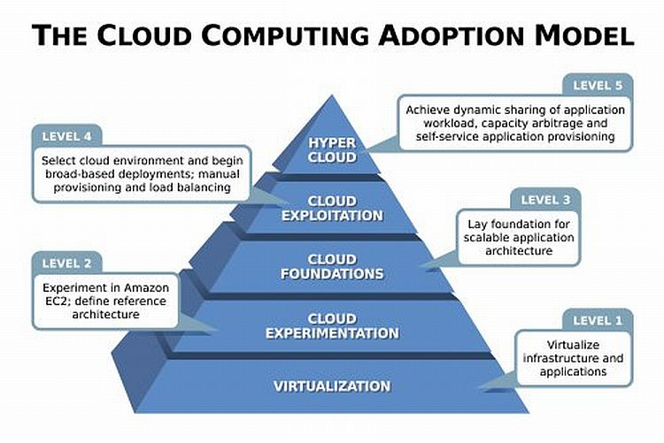
Figure: Cloud Computing Adoption Framework Model (Chang, Kuo and Ramachandran, 2015)

Agile Implementation in Retail Analytics
From exploring the research article of Larson and Chang (2016) that highlights agile methodologies, UK retailers have shifted towards implementing agile principles in BI solutions. It has found the most application in the retail sector, where needs fluctuate daily due to stock, demand or any other change in market forces. Adaptive incorporation has resulted in BI solutions deployment more frequently and in an iterative manner and retailers have claimed to have reduced on average by 45% on their time-to-market regarding new analytical attributes.

In this case, the value of engaging stakeholders and sharing responsibility, as discussed in the article, has led to a better definition of requirements and overall better quality of retail BI projects (Amajuoyi, Benjamin and Adeusi, 2024). This has proved more useful in integrating real-time analytics with conventional BI work, allowing the retailers to be as nimble as possible while remaining consistent with data responsibilities.

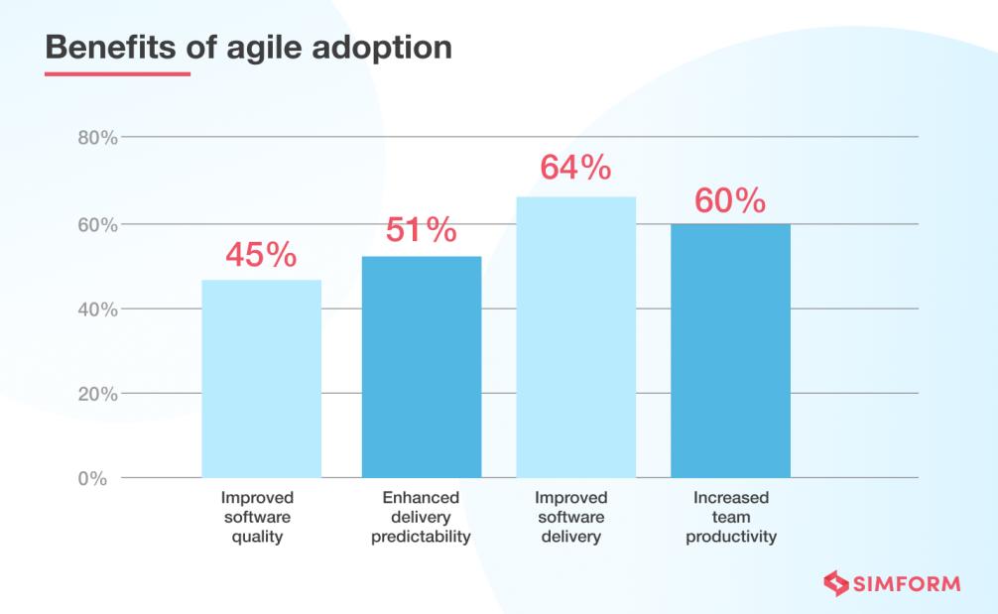
Figure: Agile adoption advantages statistics (Amajuoyi, Benjamin and Adeusi, 2024)

Future Prospects and Emerging Trends
The future of the retail industry is highly coupled with the advances in BI solutions. Such integration of fast analytics and data science is useful in the case of central London retailers as it is observed that competition is rising steeply in the UK’s digital marketplace. AI and machine learning adoption has increased by 156% among the UK retailers since 2020, and qualitative and quantitative forecasting is critical for inventory management and customer behaviour analysis (Deloitte, 2024). According to the research, 92 per cent of UK retailers are willing to increase their spending on BI and analytics in the next three years, with the biggest concentration being on real-time analytics and customer segmentation.

Everything as a Service (EaaS) approaches are discussed in the context of shifting towards integrated service models adopted by retailers that combine multiple capabilities for analysis. The evolution of novel visualisations and heightened emphasis on data accuracy, reliability, and relevance persist in influencing the BI strategies of retailers by placing increased attention on how to transform large datasets into easily understandable and actionable insights for managers at different organisational tiers (Sawkar and Vantara, 2018).

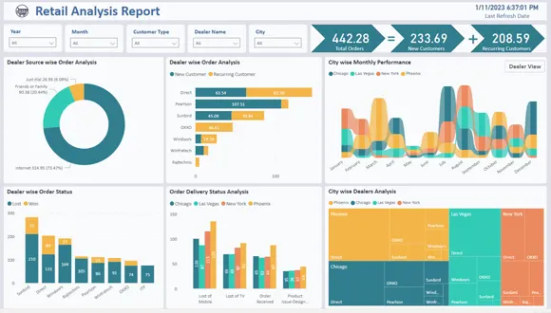
Figure: Retail analysis report using BI (Tantawy and Ismail, 2021)

Conclusion
The change in business intelligence practice in the UK retail and e-commerce society is a pivotal change that has impacted the retail industry significantly. These new trends, which are BIaaS and integrated analytics services, have become vital when companies want to survive in the market. The case studies documented in the research show that it is possible to achieve marked improvements in operational effectiveness and customer satisfaction from the adoption of these technologies, complemented by strong security and the use of flexible working practices. The prospects for the expansion of retail BI in the UK appear to lie more in real-time capabilities and extremely complex analytical applications, while the issues of security and data quality will remain paramount. Thus, the role of advanced BI tools for retailers rises as consumer behaviour evolves and technologies advance even further. These continue to be invested in the sector e, evidencing the significance BI plays in ensuring competitiveness and promoting innovation in the retail processes. This suggests that the transformation of the retail sector would remain driven by improvements in BI techniques and tools; thus, it is crucial for retailers to keep their sights set on striving for the creation of new trends in BI coupled with effective protection of the data as well as compliance.

References
Amajuoyi, P., Benjamin, L.B. and Adeusi, K.B. (2024). Agile methodologies: Adapting product management to rapidly changing market conditions. GSC Advanced Research and Reviews, 19(2), pp.249–267. doi:https://doi.org/10.30574/gscarr.2024.19.2.0181.
Batsakis, G., Theoharakis, V., Li, C. and Konara, P. (2023). Internationalization and digitalization: Their differing role on grocer and non-grocer retailer performance. Journal of Retailing, [online] 99(3). doi:https://doi.org/10.1016/j.jretai.2023.07.005.
Chang, V., Kuo, Y.-H. and Ramachandran, M. (2015). Cloud computing adoption framework: A security framework for business clouds. Future Generation Computer Systems, [online] 57, pp.24–41. doi:https://doi.org/10.1016/j.future.2015.09.031.
Deloitte (2024). Future of retail: Profitable growth through technology and AI. [online] Available at: https://www2.deloitte.com/content/dam/Deloitte/in/Documents/consumer-business/in-cb-future-of-retail-profitable-growth-through-technology-and-AI-noexp.pdf.
Eidizadeh, R., Salehzadeh, R. and Esfahani, A.C. (2017). Analysing the role of business intelligence, knowledge sharing and organisational innovation on gaining competitive advantage. Journal of Workplace Learning, [online] 29(4), pp.250–267. doi:https://doi.org/10.1108/jwl-07-2016-0070.
Larson, D. and Chang, V. (2016). A review and future direction of agile, business intelligence, analytics and data science. International Journal of Information Management, [online] 36(5), pp.700–710. doi:https://doi.org/10.1016/j.ijinfomgt.2016.04.013.
Newman, R., Chang, V., Walters, R.J. and Wills, G.B. (2016). Model and experimental development for Business Data Science. International Journal of Information Management, [online] 36(4), pp.607–617. doi:https://doi.org/10.1016/j.ijinfomgt.2016.04.004.
Sawkar, P. and Vantara, H. (2018). Why Businesses Move to Everything-As-A-Service Model. [online] CDOTrends. Available at: https://www.cdotrends.com/story/13841/why-businesses-move-everything-service-model [Accessed 15 Nov. 2024].
Tantawy, A.A. and Ismail, M.M. (2021). A Case Study on the Implementation of Business Intelligence in a Retail Company. American Journal of Business and Operations Research, [online] 3(1), pp.107–115. doi:https://doi.org/10.54216/ajbor.030204.
Weisman-Pitts, J. (2024). Transforming Retail: How Business Intelligence is Shaping Success in the UK. [online] Global Banking | Finance. Available at: https://www.globalbankingandfinance.com/transforming-retail-how-business-intelligence-is-shaping-success-in-the-uk/

