Utilising the EntreComp Framework, critically evaluate your own creativity and enterprise skills and consider how you might be able to develop the creative and enterprising skills of primary learners through your own pedagogy.

Creativity is difficult to define because it depends on each individual’s views of creativity, but despite the challenge, many researchers have offered their views which follow a similar theme. Wood and Bilsborrow (2014) say ‘Creativity is the process of creating novel and useful ideas or products’ (p. 112) while Boden (2004) says ‘Creativity is the ability to come up with new ideas or artefacts that are new, surprising and valuable’ (p. 1). For N.A.C.C.C.E. (1999) imaginative activity is the root of original and valued ideas with Robinson (2017) agreeing that ‘Creativity is putting your imagination to work’ (p. 128). These researchers all view the product of creativity as novel or original and feel that it should have value but whether imagination is at its root, is subjective. For myself, I feel that creativity is the production of a product or idea that has value to the creator, as while an idea might be known to others, it is still original to the creator, and this does not detract from its value (Craft, 2004). The subjectivity of creativity means many people can look at an idea and all have a different opinion on its value, and all are valid opinions (Torrance, 1966; Craft, 2000).

No matter how you define creativity, the way it is viewed is just as important as this impacts the views of everyone teaching or developing it. Governments promote creativity in education, but this is not always reflected in their policies (Robinson, 2001, 2017). Creativity has long been viewed as progressive and given less importance than literacy or numeracy, it is often associated with the arts and historically was considered a feminine discipline that lacked respectability (MacKinnon, 1966; Torrance, 1966; Robinson, 2001, 2017). Stereotypes of creative people saw them as hippies, geniuses and eccentrics or they were considered insane (Guilford, 1958; Torrance, 1966) and these views caused many to suppress their creativity so they did not stand out (MacKinnon, 1966; Torrance, 1966; Robinson, 2017). Today creativity is considered a 21st century skill and is desired by employers globally (Lucas, 2016; Donaldson, 2015; Robinson, 2017), however, our current education system is preparing children for jobs that are grounded in the Industrial Revolution rather than the current technological revolution (Robinson, 2001, 2017) where creativity and independent thought were unnecessary (Egan, 2010). With 80% of people seeing creativity as the root of economic, cultural and societal growth (Adobe, 2012; Smith, 2013), it is clearly an important issue that needs to be addressed in education and Wales has begun this process with the introduction of their new curriculum, while Scotland, Australia, Northern Ireland and the Netherlands have already implemented their own forward thinking curriculums incorporating areas of learning instead of traditional single subjects (Donaldson, 2015). Meanwhile, Finland has moved to a cross-curricular approach through multi-disciplinary learning and given children ownership of their learning through projects which has resulted in a more engaging curriculum (Will, 2016) in an effort to prepare children for the challenges ahead of them (Education Wales, 2019).

Despite recent moves to introduce a holistic approach to education, with creativity embedded as a wider skill (Donaldson, 2015; Education Wales, 2019), the view that schools are stifling or killing creativity still exists (Adobe, 2012; Robinson, 2007, 2013). However, Leunig (2016) disagrees with this view as he believes knowledge is the base of creativity, and knowledge is provided by schools. While researchers agree that knowledge underpins creativity, as it gives you the tools needed to move forward with ideas (N.A.C.C.C.E., 1999; Feldhusen and Goh, 1995; Sharp, 2004; Frenkel, 2012; Smith, 2013), they observe that it must not be too great a focus or creativity will be stifled (Boden, 2001), which brings the debate back to schools killing creativity and trying to find a balance. This debate sees children having their imagination and thinking suppressed on one side, but having their literacy developed to provide a foundation for all other learning, thus enabling creativity on the other side (Astle, 2018). Schools that reject a broad and balanced curriculum and work in a prescriptive way are seen as more likely to stifle creativity in children and teachers, and a lack of understanding in how creativity spans many processes, such as in cross-curricular teaching prevents connections being made across subjects, again stifling creativity (N.A.C.C.C.E., 1999; Spendlove and Wyse, 2008; Robinson, 2013; Donaldson. 2015; Astle, 2018).

Enterprise in schools takes place through social enterprise, which usually involves projects or activities with real-world context such as school fetes to gain experience in enterprise and provide a positive outlook towards innovation and problem-solving which may be of use in future jobs (Clever Tykes, 2014; Young, 2014; British Council, 2020). Delivering enterprise projects or enterprise days in schools is a ‘quality that gives an individual a positive outlook…and is a valuable attribute for the whole of life’ (Young, 2014, p. 1) and may also encourage children to consider social problems in their communities along with how local businesses might address them (British Council, 2020). For Donaldson (2015), ‘creativity and enterprise are central features of modern life’ (p. 8) and are valued highly in his recommendations for the new Welsh curriculum. Collaborative projects, as seen in social enterprise, prepare children to thrive in a world that is rapidly changing around them (Arts Council of Wales, 2015) and the use of real-world context within a supportive environment encourages exploration and critical thinking, all of which are important when supporting children to becomes ‘enterprising, creative contributors’ (Donaldson, 2015, p. 29) who take calculated risks, problem-solve and make connections when applying their knowledge (Arts Council of Wales, 2015; Education Wales, 2019). Enterprise motivates children in their learning and enables creative skills to be developed in an adventurous way, therefore it should be introduced to children early in their school life when they are more open to ideas and possibilities (Bridge and O’Neill, 2013; Young, 2014).

ENTRECOMP
The Entrepreneurship Competence Framework (EntreComp) was designed to provide a bridge between education and business and aid in understanding entrepreneurship in all settings (Bacigalupa, Kampylis, Punie and Van den Brande, 2016; McCallum, Weicht, McMillan and Price, 2018). Although entrepreneurship is not relevant to all areas of education, many of the skills it uses are applicable to enterprise and creativity, and one of the competencies is focussed specifically on creativity. The intention of the EntreComp is to allow the focus to be placed on creating objects with value in all sectors using its competencies and learning outcomes, with links being possible across the competencies (Bacigalupa, Kampylis, Punie and Van den Brande, 2016). The EntreComp is intended to be used as a launch pad for planning, and can be adapted to meet the individual needs of its users, with some competencies receiving greater priority than others depending on the type of user (Bacigalupa, Kampylis, Punie and Van den Brande, 2016; McCallum, Weicht, McMillan and Price, 2018). A key goal of the EntreComp is to ‘create value by adapting the framework to specific context’ (McCallum, Weicht, McMillan and Price, 2018, p. 21) and this is achieved by its use in evidence-based teaching and adapting it, alongside using the visual framework, to engage users in a way they can relate to and understand (McCallum, Weicht, McMillan and Price, 2018). The EntreComp is a progression model that provides four main proficiency levels and eight sub levels through the learning outcomes, demonstrating the connection between the independence of the individual and the learning outcomes (Bacigalupa, Kampylis, Punie and Van den Brande, 2016). The proficiencies start at foundation level, where the individual is reliant on others for support and go through to expert level, where the individual is completely autonomous and each individual may be at different proficiency levels in each competence (McCallum, Weicht, McMillan and Price, 2018).

The learning outcomes are a best fit model and McCallum, Weicht, McMillan and Price (2018) observed that the vagueness of the language makes it challenging to use the framework when planning, therefore adaptions are needed to relate the outcomes to real-world context for it to be meaningful for teachers. I found this to be true when assessing my creativity, especially as the base of the framework is in entrepreneurship and not creativity specifically. When using the EntreComp framework to assess my own creativity, I began with the Creativity competence and its five threads: be curious and open; develop ideas; define problems; design value and be innovative (Bacigalupa, Kampylis, Punie and Van den Brande, 2016). The first thread, I assessed myself as a level 2 as I felt that to be curious and open relates to developing creative thinking and I found I had to use creative thinking to innovate and challenge my preconceived ideas of teaching and learning (Mind Tools Content Team, 2020). This was especially relevant when teaching chemistry to a year 6 class which was a new topic for the class and indeed the school, and I was given the opportunity to be the first to teach it. There was a lot of information to impart in the first lesson, and to make sure it was understood, I chose to use practical activities to support the children (Appendix 1). The children were encouraged to ask questions during my introduction to support their understanding, and the class teacher later advised me that note taking was common in her class as it provided context for the children when looking back at their work (Appendix 2) and would have been of benefit during the introduction. This was something I had not encountered in primary schools before and found surprising but would like to develop further. To move to level 3, I need to continue to develop my innovation skills by considering new ways to develop the children’s learning that do not involve the traditional ways of teaching, such as standing at the front of the class and talking as children only hold onto small parts of what has been said, with much being lost (Enser, 2019). Additionally, the new curriculum is encouraging teachers to take the risk to leave behind this traditional lesson structure (Joubert, 2001), whether through an enquiry-based learning approach or other project-based learning which encourages children to be involved in planning and leading their work through active engagement (Seltzer and Bentley, 1999; Oral, 2008; Donaldson, 2015).

The second thread, I assessed myself as level 2 and although I feel that I meet elements of level 3, I lack the confidence to create activities without checking with the class teacher beforehand to ensure they are appropriate, and still rely on the support my class and school mentors provide (Appendix 3). I have collaborated with teachers on my professional teaching experiences (PTE), as well as worked independently, to develop ideas that will impact children’s learning. On PTE, this involved participating in weekly planning sessions and developing the ideas for subjects into activities. This would take place through verbal discussions which I would use to develop my lesson plans (Appendix 4). To move forward to a level 3, I need to build confidence in my abilities, which was observed in discussion with my year 6 class mentor in PTE2. I need to take ownership of my ideas, accepting they have value for my both myself and the children as while I can plan activities for the children, I then doubt my ability to deliver them, often changing the plan for simpler or more traditional activities. However, when I have the confidence to continue with my original idea, it makes for a very engaging lesson (Appendix 5 and Appendix 6).

The third thread, I assessed myself as level 1 as while I enjoy problems and am always happy to explore them, I feel I am limited in the number of solutions I can generate because I become focussed on one idea and ignore the rest. In this respect, my imagination is overruled by my logic and this is difficult for me to overcome. This issue relates to functional fixedness, as I find it challenging to overlook a conventional solution to problems because I cannot see beyond the original purpose of objects (Boyd, 2013; Harley, 2017). Additionally, my usual response is to search on Google for other people’s solutions and use their ideas, which reinforces Guilford’s (1958) observation that computers do our thinking for us now, as our first response to a problem is to ask someone else to solve it for us. When faced with activities involving problem solving in university, the solution has always been found by fellow students, as was the case with an unusual jigsaw puzzle. While I applied conventional methods of jigsaw puzzles to solving it, another student observed and generated numerous solutions before suggesting we turn some of the pieces over. I did not understand this idea as it did not fit with my understanding of completing jigsaw puzzles, but we tried and were successful, although without the other student, the puzzle would have taken a lot longer. To move ahead to level 2, I can use the SCAMPER approach to aid in overcoming my functional fixedness as it is simple to use and can be applied to any situation which will make it useful when planning activities and lessons (Elmansy, 2015; Exploring Your Mind, 2018). Using SCAMPER as a tool will aid me in brainstorming different ways to ‘substitute, combine, adapt, modify / magnify, purpose, eliminate / minify, rearrange / reverse’ (Mulder, 2018) different elements, objects and areas within a lesson to put more creativity into my teaching and move beyond the familiarity I have with objects, to be able to use them in new ways (Glenn, 1997).

For the fourth thread, I assessed myself as level 2. On my PTE in a year 2 class I taught a series of lessons on writing for different purposes under the Read Write Inc scheme. The children found it challenging to structure their writing so I took the idea of structure strips that I had heard about at the Aiming for Excellence conference 2017 and researched further online (Try This Teaching, 2017), using my research to create my own structure strip that was appropriate for a year 2 class (Appendix 7). Furthermore, in my year 6 class I introduced the use of a traffic light exit strategy (Appendix 8). I took the idea of asking the children to self-assess work in their books using the traffic light strategy (DCELLS, 2010a) and instead asked them to place their book on the traffic light sheet that matched their understanding of the lesson. Although self-assessing in books is common practice in schools, I felt the children did not take the time to think about their choice and used the green colour because it was recorded in a book. The exit strategy encouraged the children to be reflective about their understanding (Black and Wiliam, 1998) and this was a useful way to receive visual feedback as I was able to look at each pile, and any red or amber, I could speak to the child immediately to ask what they found challenging. This use of formative assessment to gain immediate feedback from the children enabled me to see what I needed to plan for the next lesson to support them (DCELLS, 2010b). It was extremely beneficial and is something I will continue in the future. To move forward to a level 3 in this thread, I need to develop my ideas further by developing and personalising the structure strips to be relevant to lessons, especially in KS2 where they will be beneficial when introducing new topics. Considering areas within my teaching where a strategy would enhance either the children’s understanding and reflection, or my own is something I would like to develop further as well, and innovating existing strategies or developing my own original strategies would support me in moving ahead in this thread.

The final thread, I have assessed myself as level 1. This is a thread that I found very challenging to assess myself in, as while I understand the need for innovation in education, not just in schools but throughout education, recognising these innovations is not easy for me. I think I meet elements of level 2 because I understand that the development and application of the new Welsh curriculum is a large shift in thinking and will transform current schooling, although I am having difficulty visualising it in practice. However, describing how this change will transform society eludes me, despite looking forward to being part of the transformation. When considering other innovations and their effect on society, I struggle to think of others and am unsure how else to place this within education which is why I have placed myself so low on this thread. To move to level 2, I need to engage in discussions with members of education to develop my understanding of what constitutes an innovation in education and familiarise myself with research areas that will support me in this area.

Within the EntreComp framework I also assessed myself again the Learning Through Experience competence, specifically the Reflect thread. I assessed myself as level 3 in this thread, which is higher than in creativity, as the ability to reflect is something that is encouraged throughout our lives in school and work, so is something I find easier to achieve. When attending PTE, the ability to reflect is essential in not only assessing where the children are and how to move them forward in their learning, but for myself and how to improve my abilities as a teacher. Within the FP I would work with different groups each day and reflect on the lesson before adapting it for the next group (Appendix 9 – LESSON PLAN – PICK ONE WITH ANNOTATIONS). Furthermore, I would reflect on every lesson, despite only being required to complete one official reflection sheet each day. It was noted by my school mentor that I am overly critical of myself (Appendix 10 – SUMMATIVE REPORT) which is something I am working to improve. When situations go awry, I am usually able to sit back afterwards and identify the cause in order to avoid or adapt in the future. I feel I have strong elements of level 4 and am making good progress in moving towards this level and to continue progressing I need to continue using my reflections to improve my teaching, and try to be less critical of myself when doing so.

Through my teaching PTE, I have discovered a tendency to use a teacher-led approach, as I experienced in my own schooling, with an introduction involving a lot of talking, before moving into an activity. The activity usually takes place in groups and is based at a table with a whole class plenary at the end, and while this is the style encouraged by my PTE schools, I would like to develop more engaging ways of teaching as I do not feel that I am developing my own or the children’s interests or creativity in this way. I find it challenging to be creative in my teaching and this has shown through the low levels I place myself at in the creativity competence, but as the attitude of the teacher can impact on a child’s creativity, then I need to be a positive role model, which I currently lack the confidence to do (Torrance, 1966; Craft, 2000, 2001). While I can recognise this and what is needed to move forward, I often revert to familiar ways. Although the need for adult led activities, especially in the early years, to model and question to support children in their development is important, too much adult intervention can suppress creativity (Sharp, 2004; Duffy, 2010). I am still finding this balance difficult to get right and it is something that I will continue to work on as I go into my next PTE.

DEVELOPING CHILDREN’S CREATIVITY
When discussing developing children’s creativity, most researchers agree that it is key to raising standards (Robinson, 2001; Duffy, 2010) but the agreed method of achieving this varies. Teachers are advised to teach creatively by ‘using imaginative approaches to make learning more interesting, exciting and effective’ (N.A.C.C.C.E., 1999, p. 102) while also teaching for creativity by developing children’s creative thinking through creative teaching by encouraging the children’s belief in their abilities, identifying their creative strengths and fostering their curiosity by learning through experience to empower children in their learning (Torrance, 1966; Beetlestone, 1998; N.A.C.C.C.E., 1999; Jeffrey and Craft, 2004). Wiliam (2013) says lessons should produce value for all learners which is not achieved by standing and lecturing the class as occurred in the past and the way to do this is through a cross-curricular approach as it allows connections to be made across subject areas. Imaginative approaches allowing children to lead the learning are also promoted (N.A.C.C.C.E., 1999; Sweet, Blyth, Carpenter and Apostel, 2013) and the idea of children leading the learning is supported by many researchers who state the importance of self-regulated learning and independence in developing creativity (Seltzer and Bentley, 1999; Education Scotland,2013; Wiliam, 2013; Özyaprak and Taşcilar, 2019) and encourage children to be active participants (Lucas, 2001; DCELLS, 2010b; Donaldson, 2015; Department for Education and Skills, 2015; Education Wales, 2019). However, there still needs to be input from teachers as creativity needs to be underpinned with knowledge, so that children have the tools to move forward with developing their ideas (Feldhusen and Goh, 1995; N.A.C.C.C.E., 1999; Sharp, 2004; Frenkel, 2012; Smith, 2013; Leunig, 2016).

Children are born with a natural curiosity that engenders itself to creativity as they explore their world, and this was proven by Land and Jarman (1992) who discovered that 98% of children were creative geniuses at the age 4. However, by the time these children were 15, only 12% of them still tested as creative geniuses (Land and Jarman, 1992). One of the reasons the drop could be attributed to is that children start school in a stimulating environment that encourages their curiosity, but as they move through formal schooling, the environment and expectations change and opportunities to be curious and ask questions lessens (Donald, 2012). Land and Jarman carried out their research in 1992 and technology was less prevalent, today’s children spend a lot of time on technology, often spending all day in front of a television, mobile phone or games console instead of exploring the world around them, which inhibits their curiosity and leaves them expecting to be entertained instead of wanting to explore and experiment with the world around them (Brice Heath, 2010), therefore it is possible that if the study was repeated today, the statistics could be much lower. To overcome this issue, schools, and teachers especially, need to encourage children to ask questions and offer opportunities for experimentation (Torrance, 1966, N.A.C.C.C.E., 1999; Craft, 2000; Duffy, 2010).

Another challenge when developing children’s creativity today is their fear of making mistakes and being wrong, because while they are willing to do this when younger, as they move through school, they become less willing to take risks possibly due to the emphasis on success, as testing has shown them that if there is only one right answer then anything else is a failure (Robinson, 2007; Frenkel, 2012; Chary, 2019). Children need to learn that mistakes are not failures but learning points, and by experimenting and taking risks they are developing their creativity and innovation skills, and overcoming the ‘culture of standardisation’ (Robinson, 2013) that exists in schools (Torrance, 1966; N.A.C.C.C.E., 1999; Craft, 2000; Joubert, 2001; Turak, 2011; Frenkel, 2012; Education Wales, 2019). In acknowledging that mistakes are acceptable, children will develop resilience which then builds their confidence in their abilities and in turn impacts on their motivation (Claxton, Chambers, Powell and Lucas, 2011; Education Scotland, 2013).

An important factor in the development of children’s creativity is the environment, not only the physical environment but the people in the environment and the interactions they provide (Duffy, 2010; Balke, 2012). Creativity develops when the environment is engaging and challenging and children’s ideas are valued (Torrance, 1966; Feldhusen and Goh, 1995; Seltzer and Bentley, 1999; Sharp, 2004; Özyaprak and Taşcilar, 2019). Furthermore, ideas should be valued no matter how the children express them as non-academic creations are just as creative and valid as academic creations (Craft, 2000). Returning to the environment, play is another important factor that is often overlooked, although not all play develops creativity (Craft, 2001) Furthermore, although play is disregarded as children move through primary school in favour of more academic work, creative companies like Google and Disney are encouraging their staff to be ‘playful in order to facilitate creative thinking’ thus bringing us full circle (Sharp, 2004, p. 7). The use of play has been a central element of the Foundation Phase (FP) with children using play to experiment, problem-solve, take risks and explore their world in an experiential way which is echoed in Finland’s new curriculum (Department for Education and Skills, 2015; Doyle, 2016). Experiential learning has been accepted and encouraged for younger children (Ellyatt, 2010; Department for Education and Skills, 2015) and as demonstrated by Land and Jarman (1992), younger children are considered more creative, but the intention of the new Welsh curriculum to take the pedagogy of the FP and apply it across the curriculum will aim to offer greater opportunities for older children to also share in this experience (Donaldson, 2015). As children are creative by choice, finding what they enjoy and incorporating it into their learning, through play, will support them in expressing their creativity (Sharp, 2004; Wiliam, 2013).

Many researchers are agreed that the best way to develop creativity in children is through problem-solving (Feldhusen and Goh, 1995; N.A.C.C.C.E., 1999; Wood and Bilsborrow, 2014; Özyaprak and Taşcilar, 2019), although not all problems need a creative solution and this needs to be taken into consideration (N.A.C.C.C.E., 1999). Problem-solving is an important part of social enterprise in schools as many projects require the children to find a solution to a real-world problem, thus making it more relevant to their learning (Young, 2014; British Council, 2020). The cognitive processes used when problem-solving will be applied differently depending on the type of problem but are all part of critical thinking which applies across the whole curriculum (Guilford, 1958; Feldhusen and Goh, 1995; Wiliam, 2013). Wales has recognised the importance of thinking in the classroom by advocating the use of creative thinking in a framework that holds metacognition at its heart, and promotes different thinking principles, including lateral thinking (DCELLS, 2008; DCELLS, 2010b). Going further, the new curriculum incorporates creativity and innovation, critical thinking and problem-solving into wider skills that are ‘integral to the curriculum’ (Education Wales, 2019, p. 16) and these skills are a key part of Donaldson’s (2015) four purposes, specifically ‘enterprising, creative contributors’ (p.29).

A tool to support the development of critical thinking and problem-solving skills is the use of divergent and convergent thinking (Guilford, 1958), which Craft (2000) describes as ‘possibility thinking’ (p.7) due to the need to think of the many possibilities needed to solve a problem. Divergent thinking is considered a basic skill in creativity, involves making unexpected connections and involves the use of imagination to generate ideas to find solutions to a problem (Özyaprak and Taşcilar, 2019; TeachThought Staff, 2019). SCAMPER is considered a useful tool to support divergent thinking as it supports the ‘search for ideas and solutions to concrete problems’ (Exploring Your Mind, 2018) and the seven areas each offer different ways of thinking, while forcing the mind to think in a certain way to find innovative solutions to a problem (Elmansy, 2015; Mulder, 2018). As previously discussed, SCAMPER is a tool that can be used to develop a teacher’s creativity, however, it can also be used by children, which makes it an excellent way to stimulate their creativity (Glenn, 1997). When using divergent thinking, inspiration often strikes when the individual is not sitting at a desk, this may be in the bath in the case of Archimedes (Boden, 2004), or as Nietzsche and Polt (1997) noted, ‘Only thoughts that come by walking have any value’ (Aphorism 34, p.10). Oppezzo and Schwartz (2014) discovered that walking anywhere for at least 16 minutes, produced greater creative output than sitting and that it did not matter whether you were inside or outside, had a view or not, it was the act of walking that produced the result. This can be incorporated into schools by asking the children to walk around the classroom, school or outside area during the divergent thinking phase before returning to continue their recording of ideas. It was discovered though, that walking would only increase creativity in relation to divergent thinking and it had no effect on convergent thinking (Oppezzo and Schwartz, 2014).

Convergent thinking is the use of logic to refine the ideas generated by divergent thinking until you have one or two to move forward with (Mulder, 2018; TeachThought Staff, 2019) and focusses on finding the best solution to a problem (Shrestha, 2017). You often see convergent thinking in schools, where children are asked to find the answer to a question that is not open to interpretation and they are looking for an answer decided by the teacher (Kaufman, 2012). This type of closed thinking is not conducive to creativity and both types of thinking are needed when problem-solving, although the effectiveness of them relies on children being give the time to develop and explain their ideas without being rushed through the process (Kaufman, 2012; Özyaprak and Taşcilar, 2019). When both divergent and convergent thinking are applied to solve a problem, children think outside the box and use lateral thinking, which is not always seen in current education (Sommer, 2014; TeachThought Staff, 2019).

Although divergent thinking is a good tool to generate ideas, it does create a problem when assessing the creativity of the children as assessment has to be consistent, but creativity is subjective to each individual therefore the criteria for assessment needs to be clearly stated before any activity takes place to prevent confusion for the children (N.A.C.C.C.E., 1999). The criteria may be generated from the eight elements of divergent thinking: complexity; curiosity; flexibility; fluency; risk taking; elaboration; imagination; originality (Perry, 2019), or the simpler four element of fluency; flexibility; originality; elaboration, developed by Guilford (1958) and used by Torrance (1974, cited in Sternberg and Lubart, 1999) to develop his Torrance Tests of Creative Thinking. The use of either of these would benefit teachers in selecting how to assess children’s creativity along with formative assessment throughout the creative process and peer and self-assessment to give children ownership of their learning (Joubert, 2001; Donaldson, 2015; Will, 2016). Teachers also need to be aware that the gender of a teacher can impact how they approach and asses creativity with women focussing on the personal side and depth of feeling associated with the outcome, while men focus on the novelty and outcome (Spiel and Caroline, 1998; Fryer, 1996 cited in Craft, 2001; Craft, 2004) which is why a whole school approach to creativity provides consistency for all (Craft, 2000; Lucas, 2001).

It is clear that the development of creativity in both teachers and children is a challenging process, impeded by demands on teachers’ times from outside the classroom (N.A.C.C.C.E., 1999; Spendlove and Wyse, 2008; Robinson, 2013; Donaldson, 2015) and hindered by the confidence of the teacher in respect of their own creativity (Craft, 2000, 2001; Oral, 2008), as I am well aware from my own creativity assessment. The importance of supporting teachers to develop their creativity is necessary with the introduction of the new curriculum in Wales due to the inclusion of creativity, problem-solving and enterprise within (Donaldson, 2015; Education Wales, 2019) and the move towards a more holistic approach with children taking greater ownership of their learning (Beetlestone, 1998; Donald, 2012; Education Scotland, 2013) and the EntreComp framework may be of use to do so, although it feels more appropriate for enterprise than creativity specifically. It is also clear that assessment of creativity is a complicated area due to the subjectivity of creativity and it will be interesting to watch how assessment will work practically in the new curriculum. One thing is clear though, if people are given the space, knowledge and tools to access creativity and are supported by enthusiastic, engaging people and environments, then anything is possible, and children will be well prepared to face the future.

Word count (with reference) 5402

REFERENCE LIST
Adobe (2012) State of create study. Available at: http://www.adobe.com/aboutadobe/
pressroom/pdfs/Adobe_State_of_Create_Global_Benchmark_Study.pdf [Accessed: 3rd January 2020].
Arts Council of Wales (2015) Lead Creative Schools Scheme: Handbook. Cardiff: Arts Council of Wales.
Astle, J. (2018) ‘Do schools really “kill creativity”?’, RSA, 25th April. Available at: https://
www.thersa.org/discover/publications-and-articles/rsa-blogs/2018/04/do-schools-kill-creativity# [Accessed: 8th January 2020].
Bacigalupa, M., Kampylis, P., Punie, Y. and Van den Brande, G. (2016) EntreComp: The Entrepreneurship Competence Framework. Luxembourg: Publication Office of the European Union.
Balke, E. (1997) ‘Play and the Arts: The Importance of the “Unimportant”’, Childhood Education, 73(6), pp. 355-360. DOI: 10.1080.00094056.1997.10521139. [Accessed: 8th January 2020].
Beetlestone, F. (1998) Creative Children, Imaginative Teaching. Buckingham: Open University Press.
Black, P. and Wiliam, D. (1998) Inside the black box. Brentford: GL Assessment.
Boden, M.A. (2001) ‘Creativity and Knowledge’, in Craft, A., Jeffrey, B. and Leibling, M. (eds.) Creativity in Education. London: Continuum.
Boden, M.A. (2004) The Creative Mind: Myths and Mechanisms. 2nd edn. London: Routledge.
Boyd, D. (2013) ‘Fixedness: A Barrier to Creative Output’, Psychology Today, 26th June. Available at: https://www.psychologytoday.com/gb/blog/inside-the-box/201306/
fixedness-barrier-creative-output [Accessed: 13th January 2020].
Brice Heath, S. (2010) ‘Play in nature’, in Tims, C. (ed.), Born Creative. London: DEMOS.
Bridge, S. and O’Neill, K. (2013) Understanding Enterprise, Entrepreneurship and Small Business. 4th edn. Basingstoke: Palgrave Macmillan.
British Council (2020) Resource pack brings social enterprise into the classroom. Available at: https://www.britishcouncil.org/society/social-enterprise/news-events/news-social-enterprise-resource-pack-schools [Accessed: 8th January 2020].
Chary, M. (2019) ‘We’re Born Natural Innovators, So Does School Kill Creativity?’, Gaia, 7th October. Available at: https://www.gaia.com/article/does-education-kill-creativity?
fbclid=IwAR22ajzA5Qyo0kSD2pHpv7rMegCKQq3IJwmu4pr79YDav6FOYmRdhqU2E6Y [Accessed: 9th January 2020].
Claxton, G., Chambers, M., Powell, G. and Lucas, B. (2011) The Learning Powered School. Bristol: TLO Ltd.
Clever Tykes (2014) Enterprise in Primary Schools: Is your primary school doing enough? Available at: https://clevertykes.com/enterprise-in-primary-schools/ [Accessed: 8th January 2020].
Craft, A. (2000) Creativity across the primary curriculum: framing and developing practice. Abingdon: Routledge.
Craft, A. (2001) An analysis of research and literature on creativity in education. London: Qualifications and Curriculum Authority.
Craft, A. (2004) Creativity and the Early Years Education: A lifewide foundation. London: Continuum.
DCELLS (2008) Skills Framework for 3-19-year-olds in Wales. Cardiff: Welsh Government.
DCELLS (2010a) How to develop assessment for learning in the classroom. Cardiff: Welsh Government.
DCELLS (2010b) Why develop thinking and assessment for learning in the classroom. Cardiff: Welsh Government.
Department for Education and Skills (2015) Foundation Phase Framework. Cardiff: Welsh Government.
Donald, B. (2012) ‘Where does that creative spark come from? Stanford’s Tina Seelig has some ideas’, Stanford News, 30th April. Available at: https://news.stanford.edu/news/
2012/april/ingenius-seelig-creativity-043012.html?fbclid=IwAR1ItmoSBBmqAT-VutKkwi96pAQM91K0190AS9vDRFZ5MrSWAs37kODL_B4 [Accessed: 3rd January 2020].
Donaldson, G. (2015) Successful Futures. Cardiff: Welsh Government.
Doyle, W. (2016) ‘Op-Ed: Why Finland has the best schools’, LA Times, 18th March. Available at: https://www.latimes.com/opinion/op-ed/la-oe-0318-doyle-finnish-schools-20160318-story.html [Accessed: 13th January 2020].
Duffy, B. (2010) ‘Using creativity and creative learning to enrich the lives of young children at the Thomas Coram Centre’, in Tims, C. (ed.), Born Creative. London: DEMOS.
Education Scotland (2013) Creativity Across Learning 3-18. Livingston: Education Scotland.
Education Wales (2019) A Guide to Curriculum for Wales 2022. Cardiff: Education Wales.
Egan, P. (2010) ‘Introduction’, in Tims, C. (ed), Born Creative. London: DEMOS.
Ellyatt, W. (2010) ‘A science of learning: new approaches to thinking about creativity in the early years’, in Tims, C. (ed), Born Creative. London: DEMOS.
Elmansy, R. (2015) ‘A Guide to the SCAMPER Technique for Creative Thinking’, Designorate, 4th October. Available at: https://www.designorate.com/a-guide-to-the-scamper-technique-for-creative-thinking/?fbclid=IwAR3XfgLClWyL5Q8hj-SjC3wygv
4HTfSiedCoQQ1how1SsIYo3pBwQbcWneo [Accessed: 6th January 2020].
Engels, C. (2018) We are born creative geniuses and the education system dumbs us down, according to NASA scientists. Available at: https://ideapod.com/born-creative-geniuses-education-system-dumbs-us-according-nasa-scientists/ [Accessed: 3rd January 2020].
Enser, M. (2019) ‘Why every teacher should be using dual coding’, TES, 28th March. Available at: https://www.tes.com/news/why-every-teacher-should-be-using-dual-coding [Accessed: 10th January 2020].
Exploring Your Mind (2018) The SCAMPER Method: A Useful Problem-Solving Tool. Available at: https://exploringyourmind.com/scamper-method-problem-solving-tool/?fbclid=IwAR2yxErYzVGELUPnLm_jJKKIDj_awYKxm26rHLtgvuS6g9fckyIQvjv1ys0 [Accessed: 11th January 2020].
Feldhusen, J.F. and Goh, B.E. (1995) ‘Assessing and Accessing Creativity: An Interactive Review of Theory, Research and Development’, Creativity and Research Journal, 8(3), pp. 231-247. DOI: 10.1207/s15326934crj0803_3. [Accessed: 11th January 2020].
Frenkel, K.A. (2012) ‘Tina Seelig’s Insights on Creativity’, Creativity Post, 18th April. Available at: https://www.creativitypost.com/article/tina_seeligs_insights_on_
creativity?fbclid=IwAR2CYdDIbqO2hH_JOFK3qa55YAmDdgknNe8gdXKIVVmCYhfEr0TlPfwrMkI [Accessed: 3rd January 2020].
Glenn, R.E. (1997) ‘SCAMPER for student creativity’, The Education Digest, 62(6), pp. 67-68. Available at: https://search-proquest-com.ezproxy.uwtsd.ac.uk/docview/
218170233/fulltextPDF/9D493210BD614FA7PQ/1?accountid=130472 [Accessed: 13th January 2020].
Guilford, J. (1958) ‘Can Creativity Be Developed?’, Art Education, 11(6), pp. 3-18. DOI: 10.2307/3184456. [Accessed: 4th January 2020].
Harley, A. (2017) ‘Functional Fixedness Stops You From Having Innovative Ideas’, Nielsen Norman Group, 30th July. Available at: https://www.nngroup.com/articles/functional-fixedness/ [Accessed: 13th January 2020].
Jeffrey, B. and Craft, A. (2004) ‘Teaching creatively and teaching for creativity: distinctions and relationships’, Educational Studies, 30(1), pp. 77-87. DOI: 10.1080/03055690320
00159750. [Accessed: 6th January 2020
Joubert, M.M. (2001) ‘The Art of Creative Teaching: NACCCE and Beyond’, in Craft, A., Jeffrey, B. and Leibling, M. (eds.) Creativity in Education. London: Continuum.
Kaufman, S.B. (2012) ‘How Convergent and Divergent Thinking Foster Creativity’, Psychology Today, 9th February. Available at: https://www.psychologytoday.com/gb/
blog/beautiful-minds/201202/how-convergent-and-divergent-thinking-foster-creativity?fbclid=IwAR2si2odyUaMnbQbppoy7SqqDtlAgsJWJbEvi9uzhwbdW2MqhQypm29POYI [Accessed: 5th January 2020].
Land, G. and Jarman, B. (1992) Breakpoint and Beyond: Mastering the Future Today. London: Harpercollins Publishers.
Leunig, T. (2016) Why real creativity is based on knowledge [video]. Available at: https://
www.youtube.com/watch?v=vajIsWwHEMc [Accessed: 8th January 2020].
Lucas, B. (2001) ‘Creative Teaching, Teaching Creatively and Creative Learning’, in Craft, A., Jeffrey, B. and Leibling, M. (eds.) Creativity in Education. London: Continuum.
Lucas, B. (2016) ‘A Five-Dimensional Model of Creativity and its Assessment in Schools’, Applied Measurement in Education, 29(4), pp. 278-290. DOI: 10.1080/08957347.
2016.1209206. [Accessed: 4th January 2020].
MacKinnon, D. (1966) ‘What Makes A Person Creative?’, Theory Into Practice, 5(4), pp.152-156. Available at: www.jstor.org/stable/1475125 [Accessed: 4th January 2020].
McCallum, E., Weicht, R., McMillan, L. and Price, A. (2018) EntreComp Into Action: get inspired, make it happen. Luxembourg: Publication Office of the European Union.
Mind Tools Content Team (2020) New Ideas – Strategies and Techniques. Available at: https://www.mindtools.com/pages/article/newCT_88.htm [Accessed: 10th January 2020].
Mulder, P. (2018) SCAMPER Technique by Bob Eberle. Available at: https://www.toolshero.
com/creativity/scamper-technique-bob-eberle/?fbclid=IwAR2B4rYjazf9bSb-Q5fOQy2
SXlaZR8_2QoP92yAjIMDRs7_coYX_0aCN9CE [Accessed: 6th January 2020].
N.A.C.C.C.E. (1999) All Our Futures: Creativity, Culture and Education. London: DfEE.
Nietzsche, F. and Polt, R. (1997) Twilight of the idols, or how to philosophize with a hammer. Indianapolis: Hackett Publishing Company Inc.
Oppezzo, M. and Schwartz, D.L. (2014) ‘Give Your Ideas Some Legs: The Positive Effect of Walking on Creative Thinking’, Journal of Experimental Psychology: Learning, Memory and Cognition, 40(4), pp. 1142-1152. DOI: 10.1037/a0036577. [Accessed: 4th January 2020].
Oral, G. (2008) ‘Creative Learning and Culture’, in Craft, A., Cremin, T. and Burnard, P. (eds.) Creative Learning 3-11 and How We Document It’. Stoke-on-Trent: Trentham Books Ltd.
Özyaprak, M. and Leana-Taşcilar, M.Z. (2019) ‘The Effectiveness of Self-Regulated Learning on Teaching SCAMPER Technique of Creativity’, Turkish Journal of Giftedness and Education, 9(1), pp. 16-32. Available at: https://search-ebscohost-com.ezproxy.uwtsd.ac.uk/login.aspx?direct=true&db=eue&AN=138373879&site=ehost-live [Accessed: 4th January 2020].
Perry, C. (2019) ‘Divergent Thinking: Become a Divergent Thinker’, CogniFit, 1st April. Available at: https://blog.cognifit.com/divergent-thinking/ [Accessed: 12th January 2020].
Robinson, K. (2001) ‘Mind the gap: The creative conundrum’, Critical Quarterly, 43(1), pp. 41-45. DOI: 10.1111/1467-8705.00335. [Accessed: 4th January 2020].
Robinson. K. (2007) Do schools kill creativity? [video]. Available at: https://www.youtube.
com/watch?v=iG9CE55wbtY [Accessed: 8th January 2020].
Robinson, K. (2013) How to escape education’s death valley [video]. Available at: https://
www.youtube.com/watch?v=wX78iKhlnsc [Accessed: 8th January 2020].
Robinson, K. (2017) Out of Our Minds: The Power of Being Creative. 3rd edn. Chichester: John Wiley & Sons, Ltd.
Rosen, M. (2010) ‘Foreword’, in Tims, C. (ed.), Born Creative. London: DEMOS.
Seltzer, K. and Bentley, T. (1999) The Creative Age: Knowledge and skills for the new economy. London: Demos.
Sharp, C. (2004) Developing young children’s creativity: what can we learn from research. Available at: https://www.nfer.ac.uk/developing-young-childrens-creativity-what-can-we-learn-from-research [Accessed: 11th January 2020].
Smith, D. (2013) An Independent Report for the Welsh Government into Arts in Education in the Schools of Wales. Cardiff: Welsh Government.
Smith, M. and Weinstein, Y. (n.d.) Learn How To Study Using…Dual Coding. Available at: https://www.learningscientists.org/blog/2016/9/1-1 [Accessed: 10th January 2020].
Sommer, L. (2014) ‘How to foster more creativity in 21st century education’, Forbes, 21st May. Available at: https://www.forbes.com/sites/berlinschoolofcreativeleadership
/2014/05/21/how-to-foster-more-creativity-in-21st-century-education/?fbclid=IwAR
15jnWEbyScmZZFcZt7CNuzd7OTL8K__H1979aOIXHlRerUew1cDaVH4N0#1eaa6215e93f [Accessed: 3rd January 2020].
Spendlove, D. and Wyse, D. (2008) ‘Creative Learning: Definitions and Barriers’, in Craft, A., Cremin, T. and Burnard, P. (eds.) Creative Learning 3-11 and How We Document It. Stoke-on-Trent: Trentham Books Ltd.
Spiel, C. and Caroline, V.K. (1998) ‘Implicit theories of creativity: The conceptions of politicians, scientists, artists and school teachers’, High Ability Studies, 9(1), pp. 43-58. Available at: https://search-proquest-com.ezproxy.uwtsd.ac.uk/docview/
213041504/citation/D1F79BD540694D45PQ/1?accountid=130472 [Accessed: 13th January 2020].
Sternberg, R.J. and Lubart, T.I. (1999) ‘The Concept of Creativity: Prospects and Paradigms’, in Sternberg, R.J. (ed.) Handbook of Creativity. Cambridge: Cambridge University Press.
Sumeracki, M. (n.d.) Dual Coding and Learning Styles. Available at: https://www.learning
scientists.org/blog/2019/6/6-1 [Accessed: 10th January 2020].
Sweet, C., Blythe, H., Carpenter, R. and Apostel, S. (2013) ‘Teaching Creative Thinking’, National Teaching and Learning Forum, 22(2), p. 6-8. DOI: 10.1002/ntlf.20007. [Accessed: 4th January 2020].
TeachThought Staff (2019) ‘3 Modes of Thinking: Lateral, Divergent and Convergent Though’, TeachThought, 14th October. Available at: https://www.teachthought.com/
critical-thinking/3-modes-of-thought-divergent-convergent-thinking/?fbclid=IwAR2s
Zm_XTTVp5kMO_cfxNW9UzczosJWTztk-k-h94z8ZRiMGQvMhW_9dtwk [Accessed: 3rd January 2020].
Torrance, P. (1966) ‘Nurture of Creative Talents’, Theory Into Practice, 5(4), pp. 168-173. Available at: www.jstor.org/stable/1475128 [Accessed: 4th January 2020].
Try This Teaching (2017) ‘Structure slips’, Try This Teaching [blog], 16th July. Available at: https://www.trythisteaching.com/2017/07/structure-slips/ [Accessed: 13th January 2020].
Turak, A. (2011) ‘Can Creativity Be Taught?’. Forbes, 22nd May. Available at: https://www.
forbes.com/sites/augustturak/2011/05/22/can-creativity-be-taught/#37df652f1abb [Accessed: 3rd January 2020].
Wiliam, D. (2013) Redesigning Schooling – 3: Principled curriculum design. London: SSAT.
Will, M. (2016) ‘Finland’s Education Minister Discusses New National Curriculum and PISA Scores’. Education Week, 6th October. Available at: http://blogs.edweek.org/edweek/
curriculum/2016/10/finland_education_minister.html [Accessed: 13th January 2020].
Wood, D. and Bilsborrow, C. (2014) ‘I am not a Person with a Creative Mind’: Facilitating Creativity in the Undergraduate Curriculum Through a Design-Based Research’, Electronic Journal of e-Learning, 12(1), pp. 111-126. Available at: https://search-ebscohost-com.ezproxy.uwtsd.ac.uk/login.aspx?direct=true&db=eue&AN=95292664
&site=ehost-live [Accessed: 4th January 2020].
Young, D. (2014) Enterprise for All: The Relevance of Enterprise in Education. London: Crown.

Appendix 1 – Atoms Lesson Plan – 15.11.19

 |  |  |  |  | 1B

Session Plan – Key Stage 2

Name of trainee: Claire Lewis |  | Session ref: 150119_3
Personal target(s) in relation to QTS:
S2.1 - Research teaching thoroughly and have a secure grasp of the content
S3.3.3 - Interest and motivate learners through teaching

Year group: 6 | No. of learners: 25 |  | ALN: As this is an introductory lesson, the work is not differentiated. When asked to work in their books, Xavier, Clark, Gabe, Arren and Ryan will be more closely observed and additional support offered when appropriate. A more practical example may be needed when making the sentence scientific and this will be demonstrated using the Lego.
Additional Adults: Class teacher (KC)

Learning objective(s): To gain an understanding of Chemistry |  |  | Success criteria:  -Use scientific language when describing atoms
Links to previous learning: This is a new area of learning for the children and the school

Curriculum coverage (range, skills)
English
Developing and presenting information and ideas - Collaboration and discussion
-Express opinions clearly about topics and include supporting reasons

Science
-See school’s own - overview of chemistry and meteorology

Literacy (LNF)  Range  -Use appropriate vocabulary suitable for the situation or purpose |  | Numeracy (LNF)  Developing numerical reasoning - Identify processes and connections  -Visualise size
DCF | Thinking  Plan – The children will be encouraged to ask questions about this new topic and listen before asking further questions. Where appropriate, they will make links with prior knowledge related to the context.  Develop – They will identify differences between protons, neutrons and electrons by making simple comparisons.  Reflect – They will show some of what they have learned when drawing their atom and when they describe something they have learned from the lesson | ESDGC |  | YCC
Key vocabulary (English/Welsh):  -Atoms  -Molecules  -Elements  -Chemistry  -Protons  -Electrons  -Neutrons  -Nucleus  -Repel  -Attract  -Neutral  -Orbit |  | Resources:  -Chemistry PowerPoint  -Lego  -Magnets  -Stickers

Time | Session activities, organisation and management | Key questions & Assessment for Learning opportunities
20 minutes | Introduction  When the children come into class after lunch they will be given a sticker to wear but no other information. The sticker will have either + N or -.  The children will be informed that they will be looking at chemistry this lesson. They will stick a periodic table in their books and then we will have a class discussion about what they think chemistry is.  The children’s answers will be written on the cupboard for the children to come back to at the end of the topic. | What do you know about chemistry?  Share any facts they might be aware of
 | Main activities  The children will focus on atoms this lesson and they will be introduced to this using a PowerPoint. I will give an overview of atoms and their components - electrons, protons and neutrons as well as molecules and elements.  The children will note down in their own way the fact - the width of a full stop is 20 million atoms.  When comparing atoms to Lego, the children will be provided with Lego to physically experience this. They will also be provided with magnets so that when we discuss repel and attract, they will be able to visually and physically experience this.  To continue their understanding of attract and repel, the children will be told that their sticker identifies the particle they are.  - = proton  - = electron  N = neutron  Using their knowledge, they will move around the room acting like the particle they are identified as.  Proton + proton = repel  Electron + electron = repel  Proton + electron = attract  Neutron = no response  When they are repelled, they will back away saying ‘whoa’. When they are attracted, they will shake hands. Neutrons will just ignore everyone.  There will be short video to demonstrate the distance between the nucleus and electrons in order to aid the children in understanding the distance between them on a more visual scale.  To understand the relationship between atoms, molecules and elements, they will be likened to letters, words and sentences and the children will be asked to write a scientific sentence explaining this, with a picture to support their sentence. They will not be restricted in their drawing, it will be personal to them to aid in remembering the relationship.  While the children are working, I will move around the room, looking at the children’s work, answering any questions and offering support where needed. If appropriate, I will call the children’s attention to a good example that may help them.  As we work through the PowerPoint, the children will be encouraged to ask questions about the slides to further their understanding of the subject. | What does attract / repel mean?  Attract - pulled towards each other  Repel - pushed away from each other  What can you think of that attracts and repels?  Magnets  Can you respond like your particle?  Use the actions in the game  What did you notice about the distance between the nucleus and the electrons from that video?  There is a lot of empty space between them  How would you change this to a scientific sentence?  Use the words key on the board to change  letters → atoms  words → molecules  sentences → elements  Mini plenaries
 | Plenary  The children will create their own drawing of an atom in their books and label the nucleus, proton, electron and neutron.  They will finish by completing a short quiz on google forms to test their understanding and recall of the lesson. If possible, they will not use their books to answer the questions.  Those that finish quickly will be asked to write a fact that amazed them from the lesson and several children will be asked to feedback to the class.  Books will be placed on the traffic light exit sheets to show children’s feelings about the lesson. | What do you need to include in your drawing?  Electron, proton, nucleus, neutron  Is there a fact you learnt today that made you go ‘Wow!’?  Reflect on the learning  Traffic light exit strategy

Appendix 2– Science Lesson Feedback from Class Mentor 15.1.19
LI: To gain an understanding of Chemistry.

No lesson plan, working slides document.

Date and LI written in books. - standards on presentation maintained.

Use white board to record knowledge.

Lots of teacher talk - needs to be broken up with note taking.

Pupils need to make notes, those visual learners have switched off.

Practical tasks lego, magnet and walking around.

Use of incidental welsh.

Use of ICt - Video to support learning.

Use the whiteboard to show you ‘I love atoms’ example (doing this now)

Use specific language - ask them for a scientific example.

Don’t give them too many tasks - you’ve asked them to write the sentence then draw a picture - some pupils will only hear picture.

Given a plenary task for AFL - drawing an atom with labels.

Pupils are confused with the make-up on an atom. Notes would have helped them.

Use of google quiz to assess learning.

Question:

How would you get them to write notes? Mind maps? Notes?
How do you know learning has taken place?
How could you differentiate the final diagram?
You’ve rotated around a lot at the end of the lesson giving 1:1 support, how could this be minimised?

Appendix 3 – Summative Assessment PTE1
Standards |  | Observations
 |  | 1 | 2 | 3 | 4 | 5 | 6 | 7 | 8 | 9 | 10
S1 | Professional values and practice | G | G | - | - | - | - | - | - | - | -
S2 | Knowledge and Understanding | A | G | - | - | - | - | - | - | - | -
S3.1 | Planning, expectations and targets | A | G | - | - | - | - | - | - | - | -
S3.2 | Monitoring and assessment | A | A | - | - | - | - | - | - | - | -
S3.3 | Teaching and class management | G | G | - | - | - | - | - | - | - | -

Standards |  | Observations
 |  | 1 | 2 | 3 | 4 | 5 | 6 | 7 | 8 | 9 | 10
S1 | Professional values and practice | G | - | - | - | - | - | - | - | - | -
S2 | Knowledge and Understanding | A | - | - | - | - | - | - | - | - | -
S3.1 | Planning, expectations and targets | G | - | - | - | - | - | - | - | - | -
S3.2 | Monitoring and assessment | A | - | - | - | - | - | - | - | - | -
S3.3 | Teaching and class management | G | - | - | - | - | - | - | - | - | -

S1 - Professional values and practice: Good
S2 - Knowledge and Understanding: Adequate
S3.1 - Planning, expectations and targets: Good
S3.2 - Monitoring and assessment: Adequate
S3.3 - Teaching and class management: Good

S1 - Professional values and practice: Throughout this placement Mrs Lewis has consistently demonstrated a hardworking and conscientious attitude to all aspects of her role. In her observation/planning week, she made detailed notes about the school/classroom routine in addition to notes on pupils in order to be well prepared when she began to work with pupils'. She readily accepted and acted on any advice given in order to work towards identified targets. Mrs Lewis demonstrated a commitment to the involvement in the general life of the school by helping out weekly in lunchtime Eco Club and had a lovely kind and caring manner with the pupils. Mrs Lewis demonstrated a developing ability to reflect on her own practise and the impact that her teaching had on learners. Target: To continue to develop her ability to reflect on her own practice and its impact on learners
S2 - Knowledge and Understanding: In her lessons, Mrs Lewis demonstrated a good ability to use her own subject knowledge in an appropriate way to motivate learners. Wherever possible she linked lessons very well to the class Topic/Theme, which helped engage learners and keep them on task. Mrs Lewis demonstrated a good understanding of effective learning and teaching approaches that offered breadth and diversity of provision, particularly during her time in the Foundation Phase. Mrs Lewis demonstrated an ability to use ICT within the teaching and learning of subjects however in her next placement, she now needs demonstrate her ability to use of a wider variety of programmes. Target: To develop her ability to use ICT effectively to enhance teaching and learning.
S3.1 - Planning, expectations and targets: The lessons planned by Mrs Lewis demonstrated her ability to plan activities to secure pupil engagement and enjoyment. Again, she gave great thought to linking lessons/activities to the class Theme/Topic wherever possible. Mrs Lewis was not afraid to ask for advice/support to ensure she was able to produce detailed and high-quality lesson plans. Her differentiation was clear and well planned for, demonstrating a good awareness of the individual needs and targets of learners. In the second part of her placement Mrs Lewis had developed a much better understanding that the learning intention should focus on what pupils should learn, rather than what they would do during the lesson. Taking the learning intention directly from the Foundation Phase Profile supported her in this regard. In her next placement Mrs Lewis now needs to become more confident in her own ability and to take the initiative to try out new ideas. Target: Plan with a greater degree of independence for a range of effective learning opportunities, including effective use of indoor and outdoor spaces.
S3.2 - Monitoring and assessment: Throughout her placement Mrs Lewis made use of assessment to track pupils' learning experience. She made detailed notes in order to track different groups of learners and demonstrated a growing recognition of the link between evaluation and future progression. Mrs Lewis used positive praise effectively to encourage learners and demonstrated her ability to use some assessment for learning strategies, with an awareness to involve pupils in their own learning. Mrs Lewis demonstrated a satisfactory awareness of her own progress, however at times was too harsh a critic of herself. Mrs Lewis was hard working and enthusiastic and in her next placement, she needs to work at developing her confidence. She needs to develop a more realistic awareness of her own progress, including targets for improvement and training needs. Target: To develop a more realistic awareness of her own progress, including targets for improvement.
S3.3 - Teaching and class management: Mrs Lewis demonstrated appropriate organisation and management skills; all resources were prepared in advance and were of a high quality. She made effective use of the approaches to learning adopted by her class mentors to motivate, stimulate and educate pupils. Mrs Lewis demonstrated a good ability to challenge pupils through differentiated questions. When the pupils' asked questions, rather than simply answering, she asked more questions in order to help draw out the correct answer. In her next foundation phase placement, Mrs Lewis needs to practise a range of different behaviour management skills to help manage the whole class. 'Rounding up' young learners in the foundation phase setting is quite a skill in itself! Target: To develop your ability to guide and support additional adults effectively.
Oral and written communication: The standard of Mrs Lewis' oral and written communication was good. She was a good model to pupils and made use of the Promoting Welsh Planning sheet to support her in the use of incidental Welsh. Target: Continue to develop the use of incidental Welsh for herself and pupils within the classroom.
Cause for concern: No
Actual attendance (days): 36
Possible attendance (days): 39
Reason for absence (if applicable): 1 day during KS2 - throat infection 5 days during FP - shingles However Mrs Lewis came back after the half term to work back 3 days (we had 2 day INSET that week). Therefore, total days missed was 3.

Appendix 4 – Germs Reflection – 26.11.18
GERMS REFLECTION
- The activities were different to the other year 2 class
  - During PPA we had discussed what the teachers wanted to cover and I was given the impression that I was able to come up with my own ideas for the class, but on arriving at school was given a lesson plan and worksheets
    - Explained that I’d already planned a lesson involving a carousel of activities after our discussion on friday
      - Was told that the teachers had messaged each other over the weekend and found worksheets related to germs which they had decided to use but they were fine with me carrying on with my own plan
- The children had a good idea of what germs are and some knew they were also called bacteria
  - Knew how germs are shared and that they cause illness
- Video was well received
- The children all engaged with the activities
- True / false one they didn’t discuss, just put them randomly on each side as they wanted to get on with colouring
  - With no adult to guide they weren’t bothered about the facts
- Making playdough microbes was without an adult as we were short staffed
  - No discussion on the microbes although tried to cover this in the class introduction instead
  - Children tended to make pretty patterns instead with very few using the pictures to recreate a microbe
  - They all enjoyed though even if it wasn’t quite what was expected
- Sneeze went well
  - Children all made predictions and were quite shocked when it went further than the table
  - They found it disgusting but fun
  - All able to say what could be done to prevent spreading germs
    - Cover nose with hand, arm or tissue
  - All knew handwashing was important and why
- Handwashing was run by class teacher
  - All seemed involved and able to talk about the six steps of handwashing
- Had break after all rotations
- Completed sheet when returned but was a bit rushed and a lot just did one-word answers instead of sentences
  - C was sent to redo his as he wrote ‘everything’ for each question, so he didn’t have to do anything else

Appendix 5 – Art Attack Lesson Plan 7.6.18
Name of Trainee: Claire Lewis Session ref: 070618_02 Group 1 and 2  080618_03 Group 3 and 4  Personal Training Targets:  S3.3 – Being to employ interactive teaching methods and collaborative group work.  S3.3 – Begin to promote active and independent learning. |  |  |  | Class: Year 2  No of chn: 30 Age: 6-7 |  |  | Foundation Phase Focus Plan  1B
Learning objectives/intentions:  To share activities and information to complete a task  Success Criteria:  I can work with others to create a large art piece |  |  |  |  | Meeting learner’s needs:  The children will be supported to work cooperatively and to ensure that everyone has an equal say in the decision making. Support will be given to ensure everyone stays on task.
Introduction / Plenary tasks |  | Main Activities |  |  | Resources / Key Vocabulary |  |  | Assessment for Learning (strategies and opportunities)
Introduction: 15 minutes  We will discuss art and what the children think we can use to create art such as paint, pen, pencils. Children will be randomly chosen to answer using lollipop sticks to share their ideas.  I will then introduce the idea that anything can be used to create art and we will watch a clip from Art Attack where a ‘Big Art Attack’ will be made using materials to hand to create a large picture on the ground.  Schoolgirl - https://www.youtube.com/watch?v=7QOWQcBe2EE and Mermaid - https://www.youtube.com/watch?v=bGL7QQZKuYs  The children will be encouraged to share their opinions on the clip afterwards.  Plenary: 5 minutes  The pictures taken of the different art created by each group will be shown to the class and they will explain why they chose certain materials and their feelings on the activity and the finished result. |  | Trainee focused task (purpose, outline of trainee’s role and children’s learning):  The children will be placed into four mixed ability groups randomly chosen before the lesson. There will be two groups of 7 and two groups of 8.  Main Activity: 30 minutes  Each group will be informed that they will have the opportunity to create their own ‘Big Art Attack’ within the theme of ‘By the Sea’ using the materials available in the outside area. They will have to agree on their picture and then work together to create the finished item within a time limit of 20 minutes.  When discussing possible pictures to create, images will be available for inspiration such as a lifeboat, lighthouse, fish, sandcastle and the children will need to reach a majority decision before moving forward. They will be given a maximum of 10 minutes to discuss and come to an agreement and if they have not succeeded independently then I will take a vote among the group to decide their picture.  When creating their art, the children will be encouraged to regularly stop and look down at their picture to evaluate their creation, adjusting areas where necessary and discussing where items should be placed next.  At the end of their allocated time, a photo will be taken from as far above as possible of the finished art.  Additional adult tasks (purpose, outline of additional adults’ role and children’s learning): |  |  | Resources  -Building materials  -Dominoes  -Dressing up clothes  -2D shapes  Key Vocabulary  -Create  -Cooperate  -Materials |  |  | Key Questions  -What can we use to create art?  -What do you think about using unusual materials to create art?  -What materials can be used …..?  -How can you create …..?  AfL  -Random grouping
Curriculum coverage (range and skills)
Creative Development
Range
-Be involved in activities that allow them to work in groups
-Use a wide range of resources
Skills – Art, Craft and Design
-Make choices when choosing materials and resources
-Mix, shape, arrange and combine materials to create their own images and objects that communicate and express their ideas, feelings and memories creatively
-Reflect on their own and others’ work
Language, Literacy and Communication Skills
Developing and Presenting Information and Ideas – Speaking
-Use a growing range of appropriate vocabulary in play, using variety in tone to add interest
Literacy (LNF)  Oracy – Developing and Presenting Information and Ideas – Collaboration and Discussion  -Share activities and information to complete a task |  |  | Numeracy (LNF)
ICT | Thinking  The children will develop their thinking by planning the process of creating their artwork and generating their imaginative ideas through group discussion and teamwork. |  | ESDGC  Choice and Decisions  -Work cooperatively on tasks to solve problems  The children will need to collaborate effectively to create their art, considering the best materials to represent the different parts of their picture. |  |  | YCC

Appendix – Art Attack ARC 7.6.18

Model Beirniadau Wedi Adfyfyrio (BWA)

Assisted Reflective Conclusions (ARC) Model
Dyddiad/Date: Thursday 7th June
Digwyddiad critigol (Ffocws)/Critical incident (focus): Big Art Attack on the theme Land Ahoy with two groups
Profiad/ Experience

Teimladau/  Feelings  Beth yw eich teimladau ynghylch y profiad?  What are your feelings regarding the experience? | - Excited to create a large-scale art using unconventional material  - Hopeful that the weather would co-operate as there was no back up plan if it rained  - Delighted that the children were able to work together to create their art
Cofio a Deall/  Remember and Understand  Allwch chi restru’r agweddau ar y profiad dysgu a aeth yn dda?  Can you list the aspects of the learning experience that went well?  Pa elfennau o'r profiad dysgu oedd yn siomedig?  What were the elements of the  learning experience that were disappointing? | - The children were engaged in the discussion about how we make art and came up with a good list of materials they would traditionally use  - Everyone enjoyed watching the examples of a ‘big art attack’, even clapping when it was complete, and they were very surprised at what was used  - The first group were very focused and generally worked well together with J and D taking the lead and keeping everyone on task  - Some fantastic ideas were generated, and the first group were very creative with their use of materials  - All the children had creative ideas that they wanted to express and would spend time getting a specific part ‘just right’  - The second group split into boys and girls and found it challenging to work together, both just doing their own thing unless prompted to talk to each other and discuss what they were doing  - Abdallah worked very much on his own and had plenty of ideas but would ask me if he could do something  - J spent most of the time playing by himself with the mixer and only joined in when I asked him to, he kept telling me he had nothing to do and had no input in the design of his groups art  - Due to a lack of communication in the second group, there were several clashes between children who were trying to create in the same area  - The boys in the second group found it difficult to understand that their art would be photographed from above and that anything built in a 3D way would not be seen on the photo
Gwerthuso a dadansoddi/  Evaluate and analyse  Beth fyddwch chi'n cadw'r un fath i sicrhau dysgu ac addysgu effeithiol yn y dyfodol?  What will you keep the same to ensure effective teaching and learning in the future?  Beth oedd achos yr elfen siomedig bwysicaf?  What was the cause of the most important disappointing element? | - Engaging the children in discussion to gauge their knowledge before widening that knowledge in a different direction was fun and really engaged the children and made them excited for the activity ahead  - Giving the children space to work and come together as a team where possible gave them greater ownership over the activity with me only there to step in where appropriate  - Some children found it challenging to work as a team and wanted to work individually so needed support to talk to their team and ask questions in order to participate  - Due to the second group working more as individuals or just boys and girls, there were times that they would clash because they would have no idea what the other was doing but would end up working in the same area. They needed support to communicate what they were doing and why to be able to compromise  - W spent a long time building a doorway into the sandcastle despite my explanation and demonstration of how I would be taking a photograph meant that it wouldn’t be seen. It took several tries before he understood
Casgliadau a chamau gweithredu/  Conclusions and actions  Beth yw eich atebion posibl i'r materion siomedig a nodwyd?  What are your possible solutions to the disappointing issues identified?  Beth ydych yn mynd i’w wneud nesaf?  What will you do next? | - While I stepped back initially to allow the children to work collaboratively and then stepped in when disagreements arose, I need to develop my ability of knowing when a small suggestion or comment may be appropriate to prevent a disagreement sooner  - More activities where the children work collaboratively in varying groups will help to develop their skills, especially encouraging the boys and girls to work together as opposed to two separate entities  - Developing children’s ability to discuss and compromise will benefit their team work in the future
Y profiad newydd / Transformed experience

Appendix 7 – Structure Strip

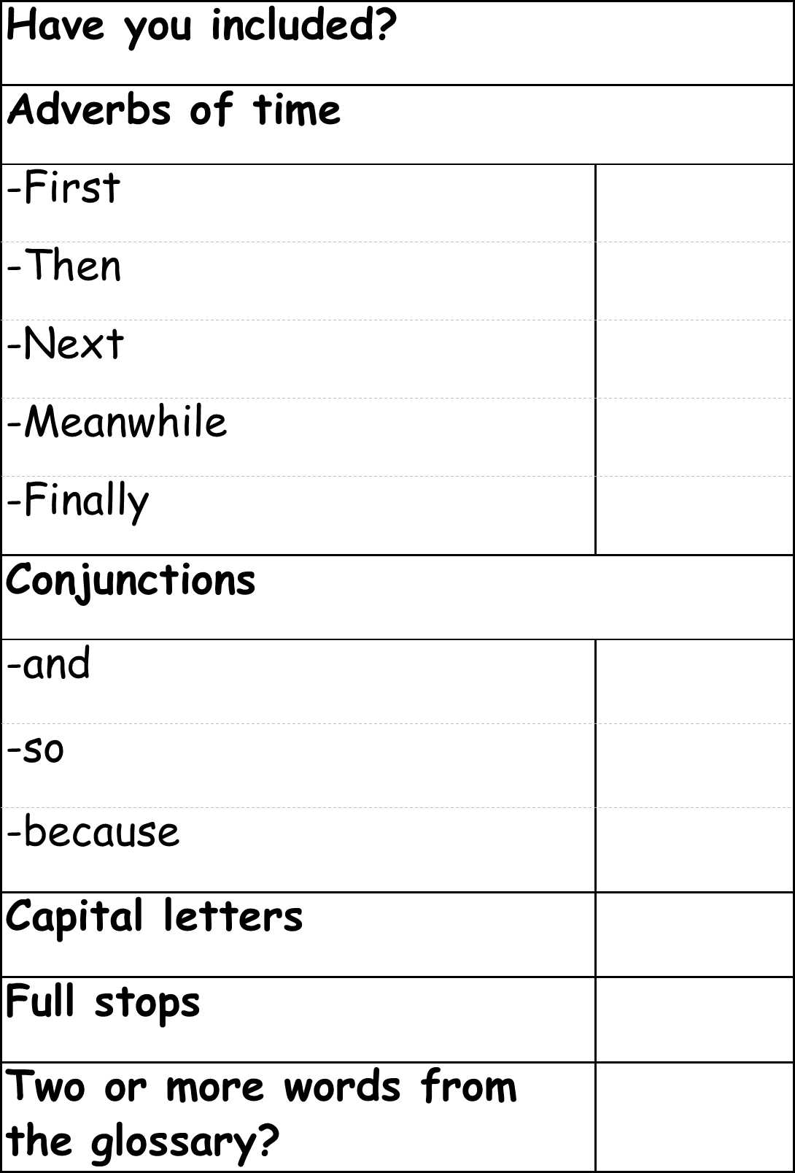

Appendix 8 – Traffic Light Exit Strategy
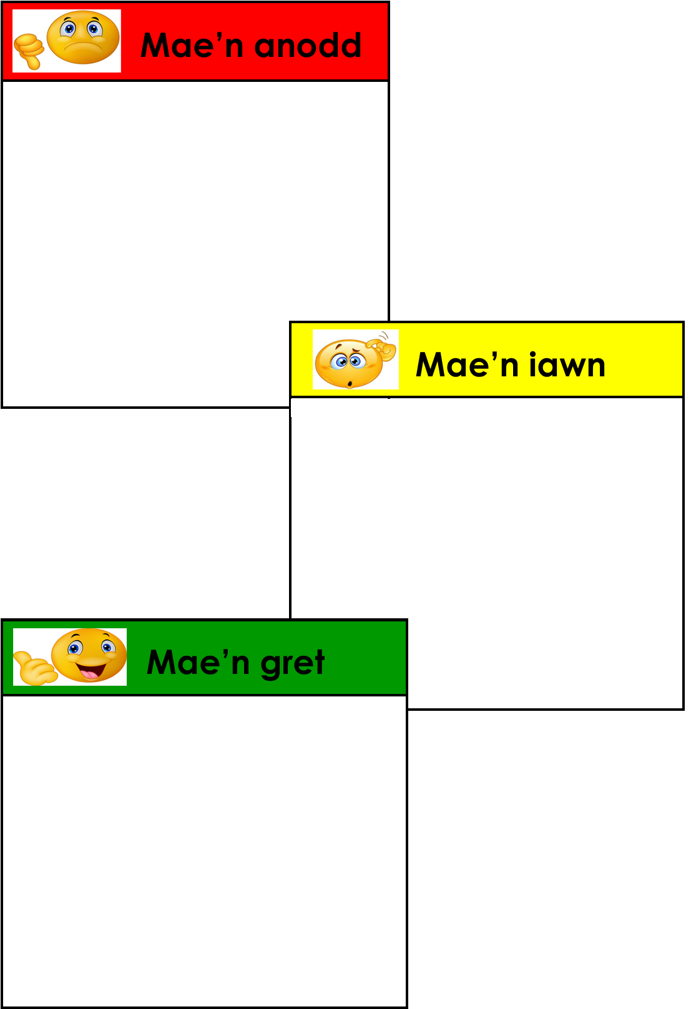

Appendix 9 – Annotated Lesson Plan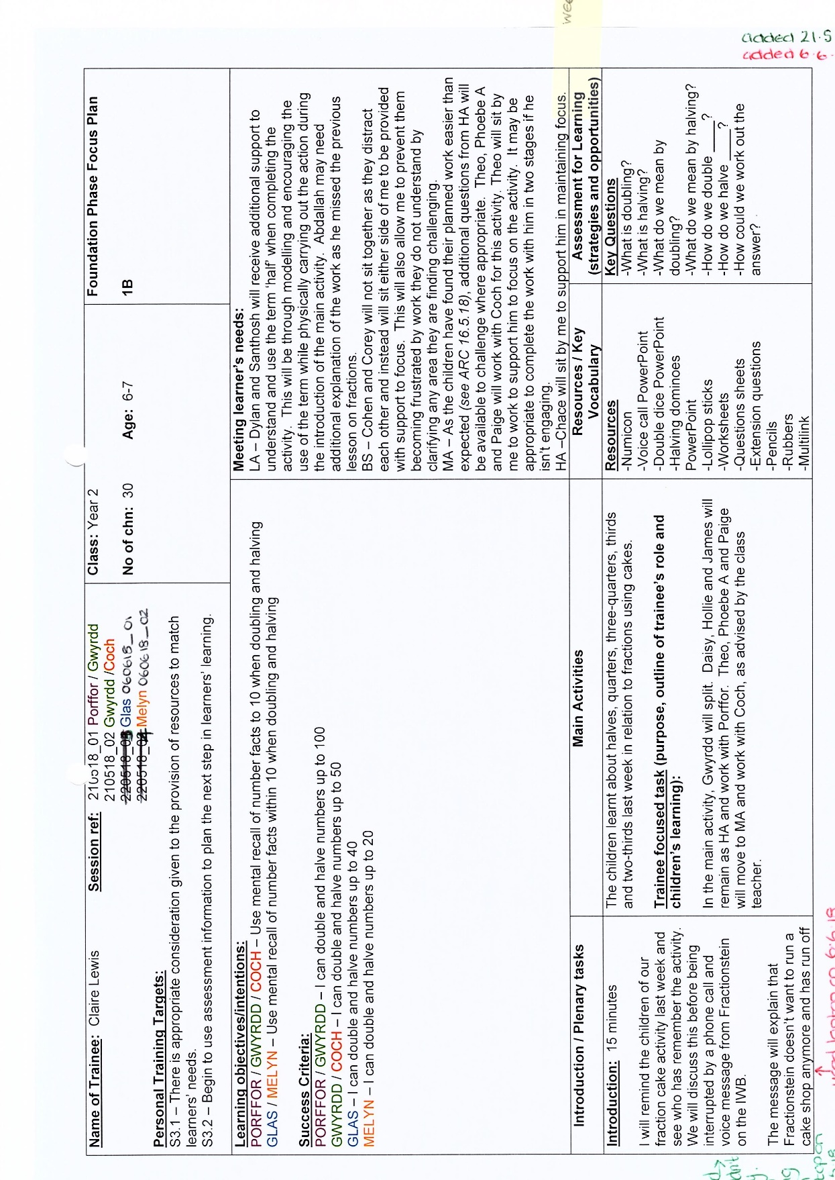
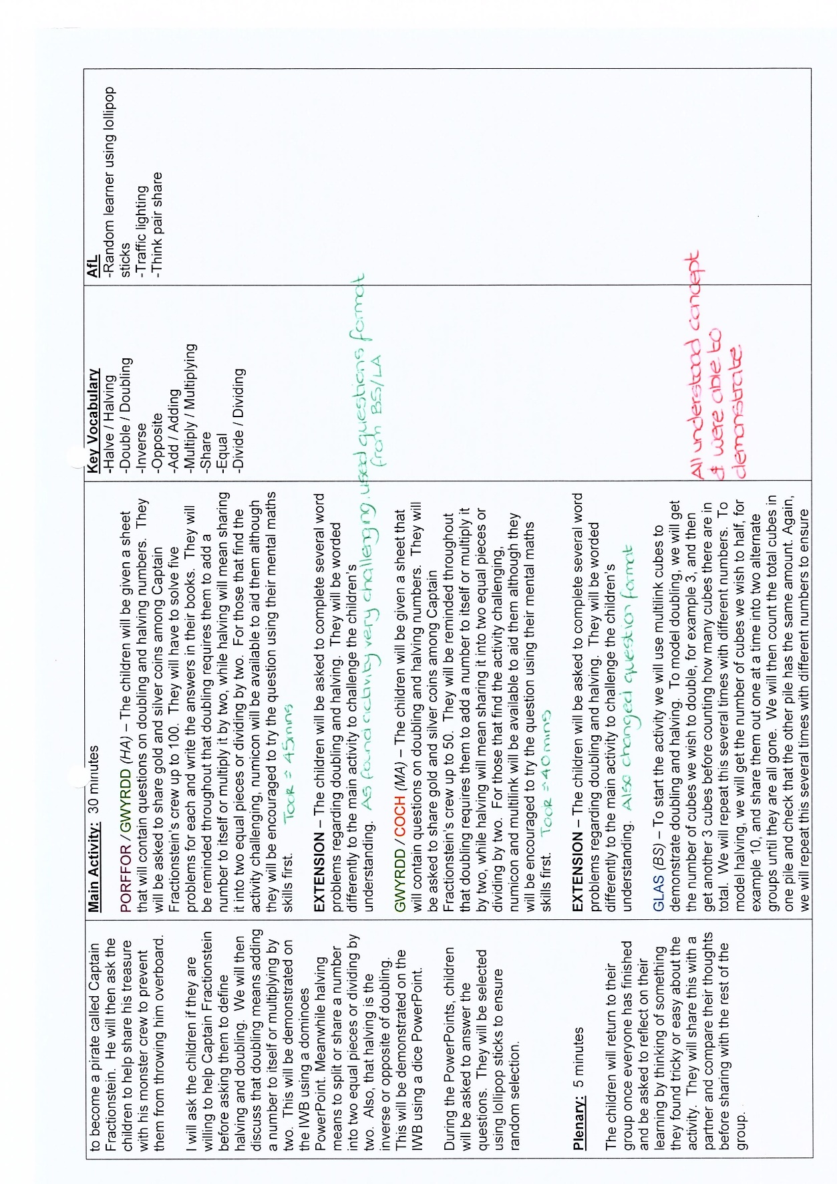

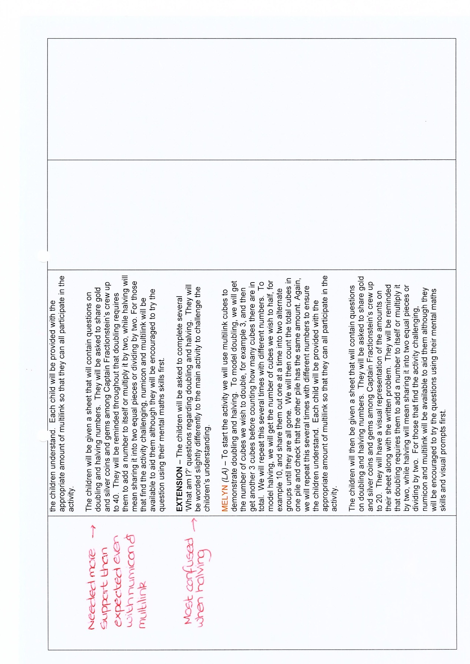

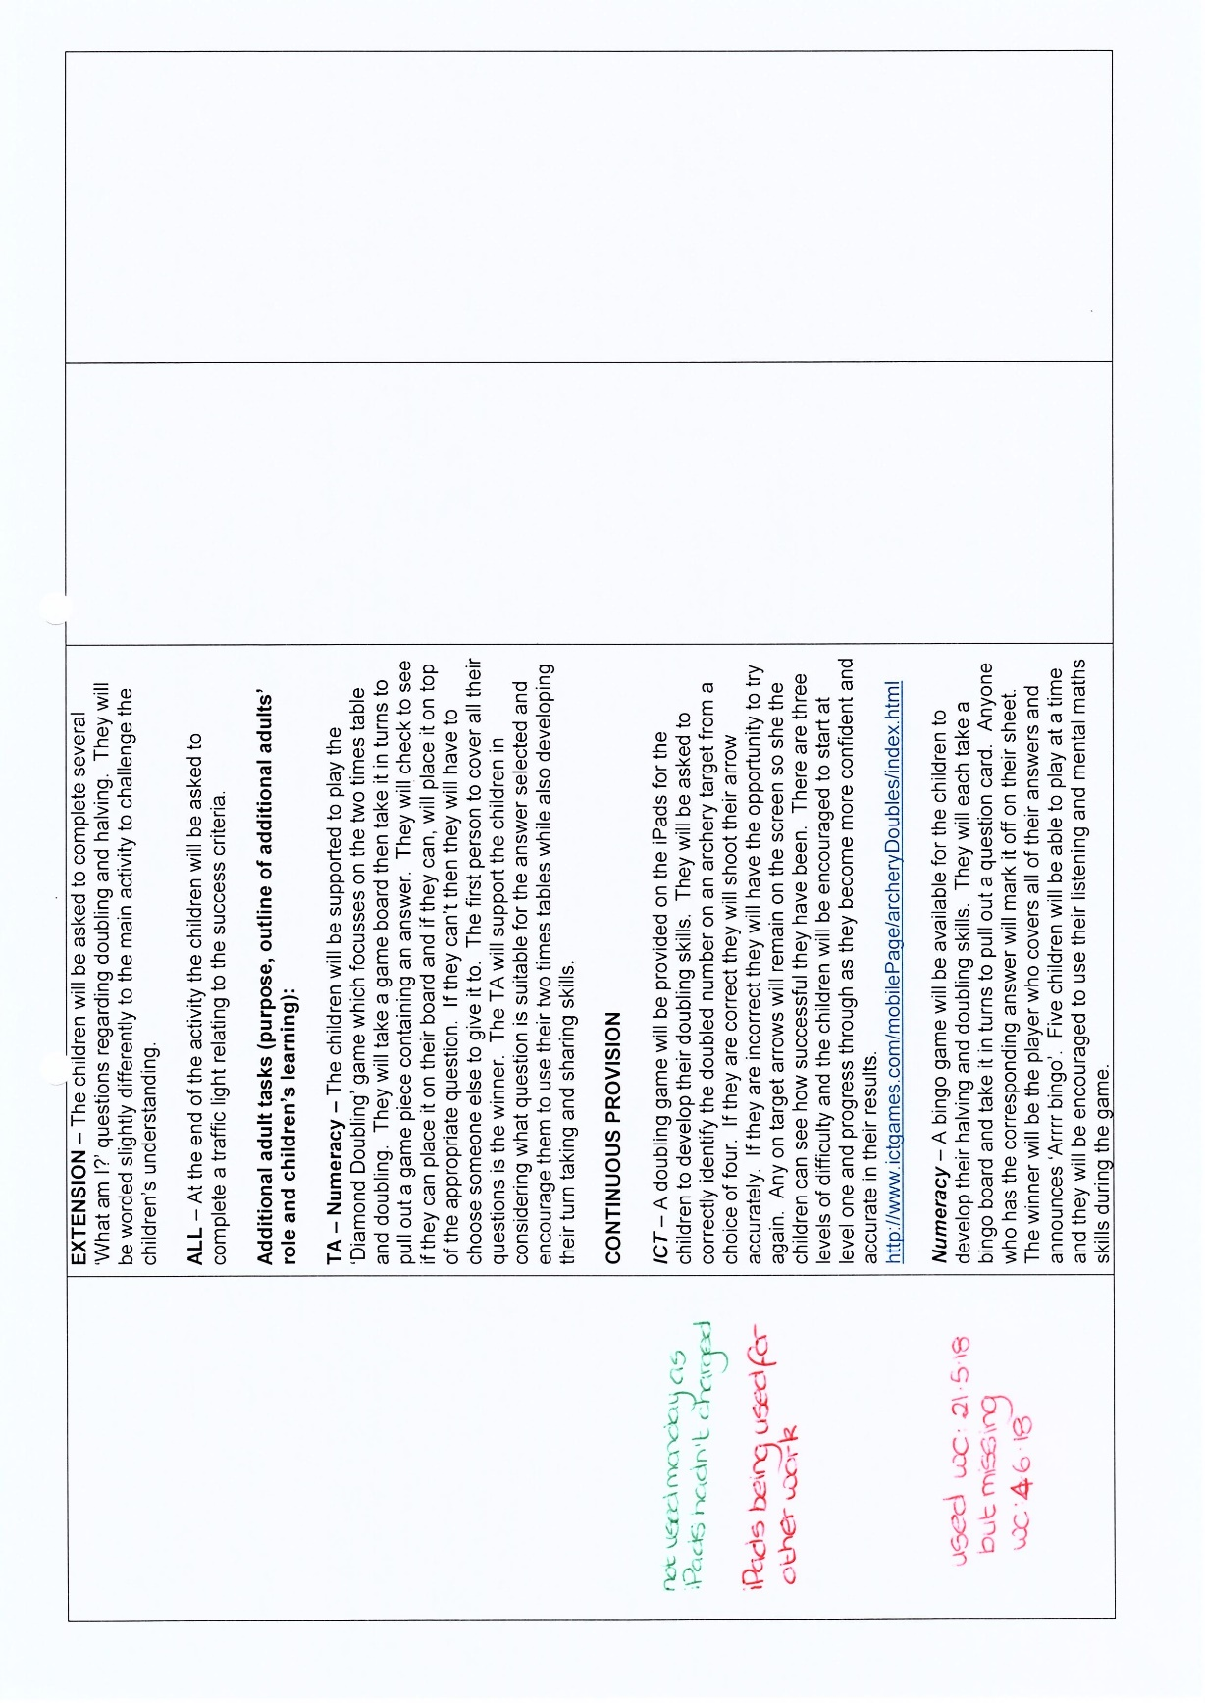

Appendix 10 – School Mentor Observation PTE2 18.1.19
Class Mentor: Katie Coleman
Observer/s: L Hodgson
No. of Pupils: 25
Class: Year 6
Additional Adults: None

Part 1 Lesson Observation (Areas of strength/Areas for development)
S1: Professional Values and Practice: Good
Comments and Evidence
Targets for improvement and suggested ways forward
Claire is always professional within school and has settled into her new year group well. Claire has a good level of independence in all aspects of teaching and monitoring. She has a good ability to reflect on her own practice and its impact on the pupils. This is one of Claire's strong features. She has a willingness to accept advice from mentors and tutors and has an ability to address her professional needs and work towards targets. Claire has the ability to recognise her needs in relation to her continuing professional development (with guidance from the mentor or tutor). Target/Way forward: to continue to reflect on her teaching and assessment of the children to develop her next steps and support her planning
S2: Knowledge and Understanding: Good
Comments and Evidence
Targets for improvement and suggested ways forward
Claire has the ability to use her own subject knowledge in an appropriate way to motivate learners. She shows an awareness of appropriate learning and teaching approaches – possibly mirroring the class teacher’s methodology. She has the ability to use ICT effectively to enhance the teaching and learning of subjects / areas of learning. Claire completes personal research to support her planning, teaching and assessments effectively. Target/Way forward: Continue to develop her knowledge of the subjects being taught. Develop her own approaches to reaching this year group in addition to mirroring that of the class teacher.
S3.1: Teaching: Planning, Expectations and Targets: Adequate
Comments and Evidence
Targets for improvement and suggested ways forward
Claire shows evidence of the integration of LNF within her planning. She demonstrates an effective approach to teaching and learning based on appropriate use of resources (including ICT). She shows an adequate awareness of individual needs and targets. This is developing each time Claire teaches/observes lessons. She is making notes and reflecting on this area for each lesson she is planning. Claire has an increasing awareness that learning objectives focus on what the children will learn rather than what they will do. She shows a good ability to plan activities to secure pupil engagement and enjoyment. She has an adequate awareness of the need for pupils to progress. Claire is able to identify next steps with minimal mentor guidance. Target/Way forward: Continue to plan effectively and think about what she wants the pupils to achieve from each session. Develop her assessment strategies to target specific pupils and specifically challenge the more able.
S3.2: Teaching: Monitoring and Assessment: Adequate
Comments and Evidence
Targets for improvement and suggested ways forward
Claire shows evidence of the use of assessment to track pupils’ learning experience. Claire has a growing recognition of the link between evaluation and future progression. She is aware of own progress – including targets for improvement and training needs. She has the use of appropriate assessment for learning strategies, with growing awareness of the need to involve the pupils in their own progress. Claire responds well to pupils' work, orally and in writing, setting targets that offer the way forward for pupils. Claire demonstrates an effective use of pupil records as a basis for further planning and teaching. Target/Way forward: Continue to use her reflections and assessment strategies to plan next steps for the pupils. Continue to involve the pupils in their progress through marking and self-assessment.
S3.3: Teaching: Teaching and Class Management: Good
Comments and Evidence
Targets for improvement and suggested ways forward
Claire demonstrates effective delivery and / or creation of the learning environment. She has effective class management / behaviour strategies. Claire demonstrates appropriate organisation and management skills within a range of physical teaching spaces, effectively using tools, materials, texts and other resources safely and effectively. She demonstrates an effective use of the approaches to learning adopted by the class teacher to motivate, stimulate and educate pupil. Evidence of ability to challenge pupils through highly effective, differentiated questions and activities. Claire has a good development of LNF skills. Target/Way forward: Continue to develop her own style of teaching within this Year group. Ensure that her presence in front of the class mirrors that of the class teacher, for example, if Claire has asked for quiet, they continue to remain quiet. She has made an excellent start in the short time she has been teaching the class.
S4: Welsh Language Standard: Good
Comments and Evidence
Targets for improvement and suggested ways forward
Good effort to introduce the Welsh language and to develop the class’ literacy skills in a relatively correct and clear manner on the whole. Claire needs to continue to ensure she uses incidental Welsh within her sessions. Target/Way forward: Continue to use incidental Welsh within all areas of the curriculum.

Part 2: Progress Review
a) Comment on progress in relation to previously set targets (including lesson evaluations and end of week reviews): Claire has made a very positive start in her KS2 placement, she has demonstrated that she has reflected on previous targets and taken these on board in this new year group. This was her first week in this phase but already she is using ICT with the pupils regularly. Her lesson was pacey, and her classroom management was good. Claire seemed at home with the children and in front of the class. She was giving clear instructions and including AFL within her session. Claire is aware of own progress – including targets for improvement and training needs.
b) Comment on quality of trainee’s reflection for ensuring progress: Claire is able to reflect on her sessions and her teaching. She makes detailed reflections in her notes and file but must ensure that these are manageable due to the detail. Claire has a growing recognition of the link between evaluation and future progression. This is developing each time she teaches and reflects. Claire has made such a great start with this year group. She is continually reflecting on the pupil’s achievement and her teaching to ensure she pitches the lessons correctly and targets the pupils.
Overall quality of PTE file: Good
Please comment on:
planning, evaluation, evidence of pupil assessment and tracking, personal literacy, organisation, presentation
Claire's file is very well organised. It is up to date with all of the evidence clearly labelled. She also keeps all of her paperwork on the shared drive for staff to access. Her planning is detailed and informative and her reflections are very informative. Claire keeps a daily record of the pupil's achievements to help her reflections and future planning.
Number of half day sessions absent from this placement to date: 0.0
Quality of trainee’s oral and written English language as appropriate. Please comment: Claire shows good ability to articulate expectations clearly in language that all the children understand. She demonstrates/ models good use of subject and age/ability-specific vocabulary. Claire promotes and supports pupils’ use of appropriate language, through the use of appropriate strategies for language development. She demonstrates a good standard of written and oral communication for a wide range of purposes.
Are there any specific areas that need intervention to ensure further progress? No
Is this a cause for concern over progress? No
Are there aspects of this session that should be filmed as examples of good practice? No
Any additional comments: Claire has made a great start to this section of her placement. She has settled into the class well and seems very comfortable with this age group. Claire is already thinking ahead of how to improve her lessons and to ensure that she differentiates and challenges the children, especially the more able. Claire has a good understanding of where the children are, and this knowledge is developing with each session she teaches and observes. Claire is researching the sessions she is teaching and looking for ways to make the lessons engaging for the children. This is a strong feature as Claire is planning from the medium-term plans and discussion with colleagues and researching/planning exciting activities to engage and motivate the children in their learning. She is reflecting on her teaching and ensuring that any issues are dealt with by the next session. Claire I am so proud of the way you have begun this placement. You have gotten to know the children and the way they work in a short space of time and really got involved. I look forward to seeing your next observation.
Oral Feedback: 17 / 01 / 2019
Written Feedback: 18 / 01 / 2019
Joint Observation: No

