

Student name: Madeleine Marie Melingui Pem Kamla

Student ID: 2228588

Module name: EMPOWERING THE OLDER PERSON

Module code: BMHP6027_LON

Lecturer’s name: DR. CHRISTOPHER MAFUVA

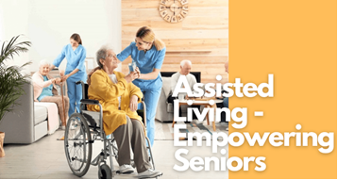caregiverguides.net  INTRODUCTION:  Caring and empowering older people in care setting, requires a clear understanding of who is defined as “Older person” in UK.  Why it is important maintaining their independence, functional ability, choice and dignity as key solution and high-quality care for person-central care and empowerment.  In the UK policy and research categorised commonly “older Adults” into three age based groups:  - Adults 65 -74 years (Young-Old)  - Adults 75-84 years (Old)  - Adults 85 and above (Old Old) ( ONS, 2023).  These distinctions are important because they reflect the diverse and changing needs, levels of frailty and patters of health and social care use across later life.  - Recognising these differences enables policymakers, research, practitioners and health services to tailor interventions that genuinely  - Support autonomy, promote wellbeing, respect for rights and privacy in health and care setting (Abdi et al…, 2019).  Current Situation and statistic of UK ageing population.  ” in 2018 ,11.9 million people in Great Britain were aged 65+, representing 18 % of the population”  - A Quarter of the Population will be 65+ and By 2040, the ageing trend becomes even more pronounced:  - Nearly one in four people will be aged 65+  - One in seven will be aged 75+  - 26% of the population will be 65+, an increase of 3.3 million older adults compared with today.  - This mean the UK will have a much larger group of older adults living with chronic illness frailty and complex care needs. Increasing pressure on health and social care systems (GOV. UK, 2021).  Accelerated ageing trajectory is increasing the prevalence of chronic illness, frailty, multimorbidity and functional decline. All of which intensify demand for long term support, enablement, and integrate care, older adults are increasingly concentrated in: Rural areas, coastal towns, region with limited public transport fewer hospital, and fewer social care providers. This creates regional inequalities to access care, support needs, and community resources. (ILC UK, 2025).  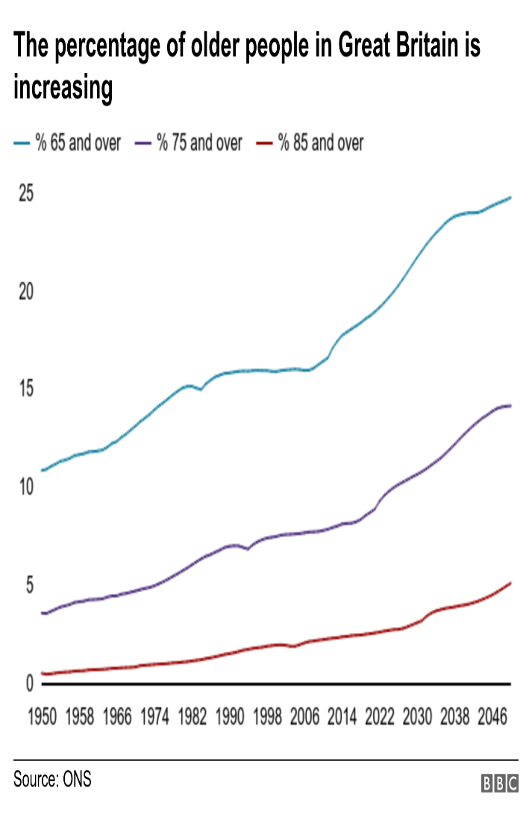www.bbc.co.uk  Old age: Why 70 may be the new 65  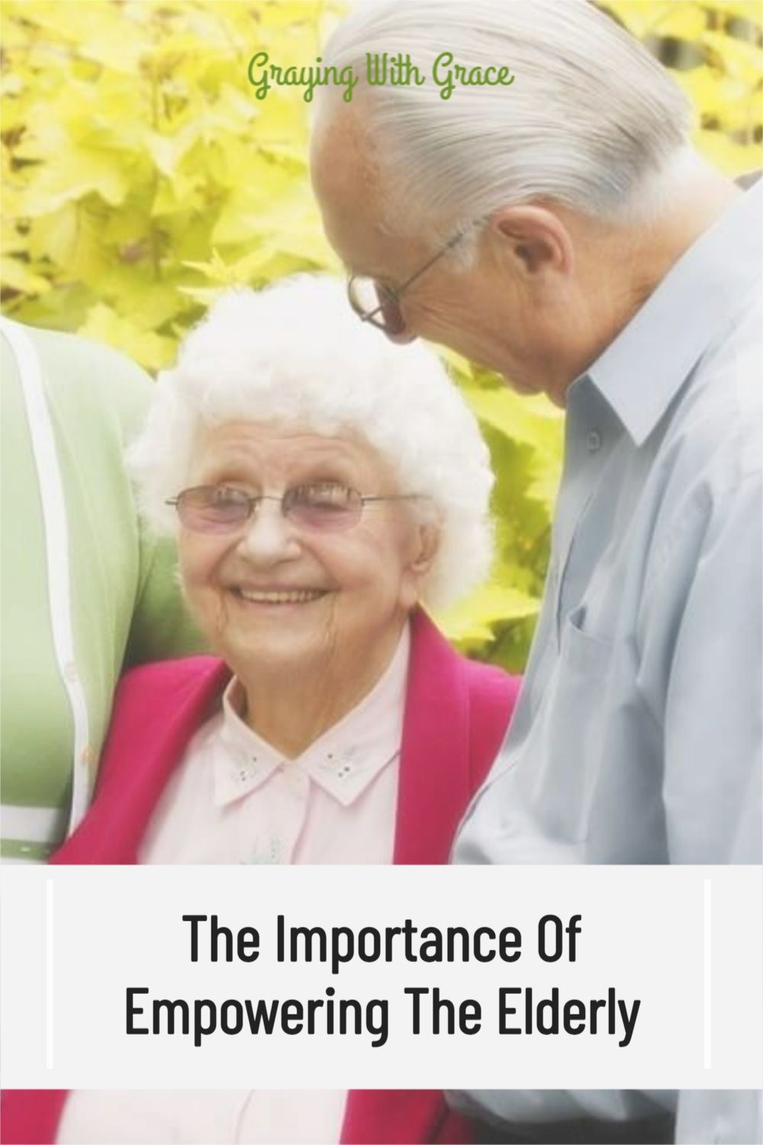  https://www.artofit.org  The importance of empowering the elderly – how to do it right |  |   Evaluation of the care, empowerment and support needs of older people:  - Empowering an older person it is not only a single daily and routine intervention, but a holistic philosophy of care that prioritises autonomy, dignity and meaningful participation.  - It is identify, evaluate the care and support needs of the older person according to their group age, health condition and living environment.  - Empower older is analyse and assessing the needs like physical, social needs, mental and emotional needs associate with activities and emergent innovations to meet their wellbeing (Care Quality Commission, 2024).  - Empowerment in care to maintain functional ability is insure that the older people receive timely, equitable health and social care including personalised their care like planning and fails prevention. Encouraging doing exercise to maintain strengths, supporting healthy food and hydration to keep body nutrient including medication management ( NHS, England, 2022).  - Preserve Independence, safety and choice is protects older dignity and identity by supported people decision, restorative care models such as to remain at home instead to hospital, home management and adaptations. Encourage assistive technology to enhance digital inclusion with support personalised training.  - Encouraging freedom, choice and community as ethical foundations of empowerment; connection vital to prevent the deep health impact of isolation and loneliness and maintain mobility, dignity and confidence  - Respect of dignity, believes and advocacy. Supports self-management, for people such as disabled in need of facilities modifications to remain in their safety home, instead to take them in hospital; that is promoting their independence and autonomy ( Care Quality Commission, 2024).  Policies and Relevant theories in places empowering older in UK  Empowerment is rooted in respect for rights, including privacy, informed consent, and supported decision-making; additionally active participation in choices through daily life and living arrangements, health and long-term care (SCIE, 2024).  This is embedded two Key legislations and empowering theories and approaches for practice in UK:  - The human Rights-Based approach (HRBA), stipule that care must uphold rights to dignity, privacy, leading to autonomy, participation and non-discrimination. This theory protects older adults from paternalistic or controlling care; ensure consent, choice and supported decision making as well.  - Person-Centred Care (PCC) from Carl Rogers, according to Carl Rogers, care should be built around the individual’s values, preferences, identity and life history. So, treats older adults as experts in their own lives, is prioritises their autonomy, choice and dignity, encourages shared decision-making and build confidence (Capacity 4dev.euro.eu. 2021).  These two approaches aligns with the Care Act 2014 and equality Act 2010 which applies the concept of Safeguarding to an individual at risk age of 18, who is or may able to protect themselves against harm or abuse due to age, illness or disabilities. For example, 61% of older person prefer remaining at home, but, only 30% receive adequate home-based their support needs ( NHS Digital, 2024).  - The Mental Capacity Act 2005 ( MCA). This legislation applies to everyone involved in the care, treatment and support of people aged 16+ living in England and Wales. The MCA aim to protect and empower individuals who may lack the ability to make their own decision. According to Age Uk, (2023,)” 40% of older adult in long-term care report having little or no control over daily routines such as meal times or activities “(GOV.UK, 2014).  Together, these principles create care environments that uphold dignity and enable older adults to maintain control over their lives. |  | Older people access to care innovation and challenges  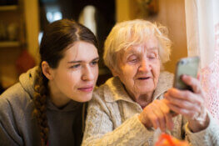  The approach of empowerment required comprehensive assessments like physical, cognitive, social and environmental factors that shape wellbeing.  - Ageing population reframes as a rights issue, not a deficit to access care, benefits, social connection and information.  - Digital literacy: many older adults lack the skills to effectively use modern technologies, leading to frustration and exclusion.  - Affordability: Such as high costs for devices and services may make them inaccessible to low income older adults.  - Resistance to change; emotional and psychological barriers like fear losing human connection that can make technology adoption difficult.  Recommendations for improvement of services to empower older people  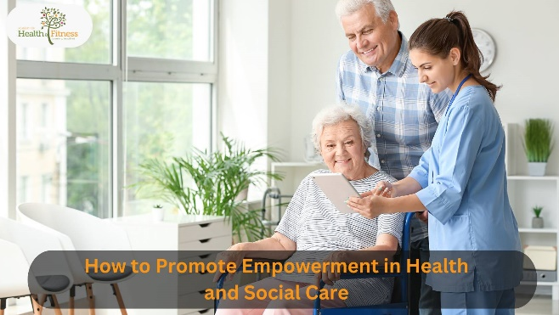  - Improvement of services is relies on multidisciplinary teamwork, bringing together nurses, social workers, care workers, psychologist, physiotherapist and other professionals to deliver coordinated care activities, personal-centred support needs and continuity of care of the older person.  - Empowering an older person is not a single intervention but a holistic philosophy of care that prioritises autonomy, dignity and meaningful participation (Thana et al, 2025).  - Early identification of functional decline through comprehensive geriatric assessment or care plan of the older determinate their needs and focus on his interest and dislike to promote care model and choice.  - Physically, encouraging regular movement or exercise like support walking around, organise and involve older person in cognitive and social activities such as card game, Christmas roll party, board game, so, create environmental factors that shape to inclusion and wellbeing ( British Geriatrics Society, 2018).  - Explain the value of technology and innovation in today care setting. Support education and learning about how to access and use them.  Conclusion:  Empowering older people in UK requires a coordinated approach across health, social care, community development and rights-based advocacy. The initiatives of Policy, Theories and practice reflect national priorities and evidence-based strategies that promote autonomy, dignity and meaningful choice.  In other hand, empowering older people in UK is assessed their needs, fosters their participation in society such as:  Involve them in decisions about their care and planning.  - Encourage them socialization, like community engagement to volunteer and engage in civic activities.  - Promote Health and care access this includes addressing inequalities in health outcomes and providing support for those who need it most.  - Creating Age-friendly communities to support older people needs and encourage their participation to positive outcome for both individual and communities ( Durand et al…, 2025)  Bark.com  Senior man, nurse and exercise with physiotherapist for physical activity, workout or balance in garden. Male person, caregiver or medical worker with elderly patient or dumbbells for stretching.

References

1- Abdi, Sarah, et al. “Understanding the Care and Support Needs of Older People: A Scoping Review and Categorisation Using the WHO International Classification of Functioning, Disability and Health Framework (ICF).” BMC Geriatrics, vol. 19, no. 1, 22 July 2019, https://bmcgeriatr.biomedcentral.com/articles/10.1186/s12877-019-1189-9, https://doi.org/10.1186/s12877-019-1189-9.( Accessed 10 July 2026).
2- Care Quality Commission. “Independence, Choice and Control - Care Quality Commission.” Www.Cqc.Org.Uk, 2024, https://www.cqc.org.uk/guidance-regulation/providers/assessment/single-assessment-framework/caring/independence-choice control (.Accessed 10 July 2026 ).
3- “Independence, Choice and Control - Care Quality Commission.” Www.Cqc.Org.Uk, 2024, https://www.cqc.org.uk/guidanceregulation/providers/assessment/single-assessment-framework/caring/independence-choice-control. (Accessed 10 July 2026).
4- Durand, Mary Alison, et al. “Evaluating the Role of Community-Based Multi-Disciplinary Teams in Integrated Health and Social Care in England: Overview of Findings from the Pioneer Evaluation and Their Implications for Health and Social Care Integration..” PubMed, vol. 30, no. 1_suppl, 1 July 2025, pp. 69S-81S, 10.1177/13558196251349398. ( 11 July 2026)
5 - GOV.UK. “Evidence Review for Adult Social Care Reform: Summary Report.” GOV.UK, 1 Dec. 2021, https://www.gov.uk/government/publications/evidence-review-for-adult-social-care-reform/evidence-review-for-adult-social-care-reform-summary-report.
(Accessed 11 July 2026).
6- Gov.uk. “Mental Capacity Act: Making Decisions.” GOV.UK, 30 Sept. 2014, https://www.gov.uk/government/collections/mental-capacity-act-making-decisions.( Accessed 11 July 2026).
7 —NHS digital. “Home - NHS Digital.” NHS Digital, 4 Apr. 2024, https://digital.nhs.uk/.
(Accessed 11 July 2026).
8 -NHS England. “Personalised Care.” England.Nhs.Uk, 8 Nov. 2022, https://www.england.nhs.uk/personalisedcare/.
(Accessed 11July 2026.)
9- ONS. “Population Estimates - Office for National Statistics.” Ons.Gov.Uk, 2023
https://www.ons.gov.uk/peoplepopulationandcommunity/populationandmigration/populationestimates
. (Accessed 11 July 2026).
10 -“Population Projections - Office for National Statistics.” Ons.Gov.Uk, 2022,
https://www.ons.gov.uk/peoplepopulationandcommunity/populationandmigration/populationprojections.
(Accessed 12 July 2026).
11 -SCIE. “Human Rights, Choice and Control in Care Planning.” SCIE, 2024, https://www.scie.org.uk/mca/practice/care-planning/human-rights-choice-control/
.( Accessed 12 July 2026).
12 - Team, Demography. “Provisional Population Estimate for the UK.” Ons.Gov.Uk, Office for National Statistics, 27 Nov. 2025, https://www.ons.gov.uk/peoplepopulationandcommunity/populationandmigration/populationestimates/bulletins/provisionalpopulationestimatefortheuk/mid2025.
(Accessed 12 July 2026.)
13 -Thana, Lavanya, et al. “Frontline Staff Perspectives on Multi-Disciplinary Team Working and the Effectiveness of Integrated Service Delivery: Findings from the Evaluation of the Integrated Care and Support Pioneers in England.” Journal of Health Services Research & Policy, vol.( Accessed 14 July 2026)
14 - “Comprehensive Geriatric Assessment (CGA) Hub | British Geriatrics Society.” British Geriatrics Society, 2018, https://www.bgs.org.uk/CGA.
( Accessed 13 July 2026)
15 -“Human Rights Based Approach - HRBA Toolbox | Capacity4dev.” Capacity4dev.Europa.Eu, https://capacity4dev.europa.eu/library/human- rights-based-approach-hrba-toolbox_( Accessed 13 July 2026).

