Artificial Intelligence
Ziyao Chen-2200438
Abstract
The MNIST handwritten digit recognition dataset was originally used to evaluate common ML algorithms, however, its overall simplicity makes it a poor choice for evaluating modern supervised classification ML algorithms. More recently this dataset has been replaced with the MNIST fashion dataset that consists of a similar number of images, pixels and classes.
In this assignment, I used the method I learned in class to solve the above database classification problem. Specifically, two machine learning algorithms were used to design and implement a system for classifying MNIST datasets. This article mainly includes an introduction to the MNIST fashion dataset, KNN, decision tree classifier, usage , performance comparison and so on.
Contents
1. Introduction 2
1.1 MNIST fashion dataset 2
1.2 KNN 3
1.2.1 Basic Principles 3
1.2.2 Description of algorithm 3
1.2.3 Distance calculation: Euclidean distance 3
1.2.4 Main parameter Settings 4
1.2.5 The key to KNN algorithm 4
1.3 decision tree 5
1.3.1 Introduction to decision tree 5
1.3.2 Construction of decision tree 5
1.3.3 Characteristics and process of decision tree 6
1.3.4 Three main algorithms for decision trees 6
1.3.5 Pruning of the decision tree 8
2. Related Work 8
2.1 KNN 8
2.2 decision tree 9
3. Experiment and result analysis 9
3.1KNN 9
3.1.1 Performance measurement method 9
3.1.2 Test set and training set partition 9
3.1.3 Performance indicators obtained under different parameters 10
3.2 decision tree 12
3.2.1 Index of evaluation 12
3.2.2 ROC curve 12
References 13
Appendix 14

Introduction

1.1 MNIST fashion dataset
MNIST fashion dataset is an image dataset that replaces the MNIST handwritten numerals set. It is provided by the research arm of Zalando, a German fashion and technology company. It includes a total of 70,000 positive images of different products from 10 categories. The size, format, and training/test set division of the MNIST fashion dataset are exactly the same as the original MNIST. 60,000/10000 training test data partition, 28x28 gray scale picture.
The classic MNIST dataset contains a large number of handwritten numbers. For more than a decade, researchers from the fields of machine learning, machine vision, artificial intelligence and deep learning have used this data set as a benchmark against which to measure algorithms. We're going to find this data set in a lot of conferences and journal papers. In fact, the MNIST data set has become one of the mandatory data sets for algorithm authors.
The purpose of this dataset is to replace MNIST as a good "detector" for evaluating various machine learning algorithms. Why not use MNIST? MNIST is relatively easy to classify in terms of current machine learning algorithms, and many machine learning algorithms can easily reach 99%. Therefore, the advantages and disadvantages of various machine learning algorithms cannot be distinguished.
In order to be compatible with MNIST, Fashion-MNIST and MNIST format, category, data volume, train and test division, exactly the same.
In the MNIST fashion dataset, the training set contains 60,000 samples, and the test set contains 10,000 samples, which are divided into 10 categories, among which the samples are from the daily wear of clothes, pants, shoes and bags, each of which is a 28×28 grayscale image, with a total of 10 categories of labels, and each image has its own label. As it shows in Figure 1.
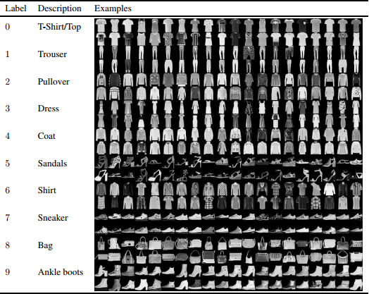
Fig.1

KNN

1.2.1 Basic Principles
The core idea of KNN algorithm is that if most of the k nearest samples of a sample in the feature space belong to a certain category, then the sample also belongs to this category and has the characteristics of samples in this category. The method determines the category of samples to be subdivided only according to the category of one or several samples nearest to it. KNN method is only related to a very small number of adjacent samples in category decision. Because KNN method mainly depends on the limited adjacent samples, rather than the method of discriminating class domain to determine the category, KNN method is more suitable for the sample set with more crossover or overlap of class domain. As it shows in Figure 2.
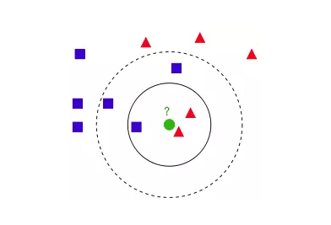
Fig.2

1.2.2 Description of algorithm
1) Calculate the distance between the test data and each training data;
2) Sort according to the increasing distance;
3) Select K points with the smallest distance;
4) Determine the occurrence frequency of the category of the first K points;
5) Return the category with the highest frequency among the first K points as the predictive classification of test data.

1.2.3 Distance calculation: Euclidean distance
For distance measurement, there are many distance measurement methods, but the most commonly used is Euclidean distance, that is, for two n-dimensional vectors x and y, the Euclidean distance of the two is defined as:
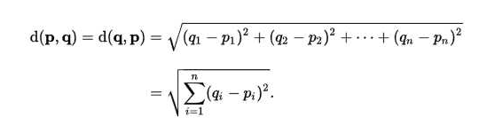

1.2.4 Main parameter Settings
- n_neighbors: indicates the k value of k-nn. The value includes the nearest k points. (Default is 5)
- The weights: argument can be uniform, distance, or a user-defined function. uniform is equal weight, and all neighboring points have the same weight. distance is an unequal weight, and the point near the distance has greater influence than the point far away. User-defined function that receives an array of distances and returns a set of weights of the same dimension. (Default is uniform)
- algorithm: Fast K-nearest neighbor search algorithm, which can be understood as the algorithm itself to determine the appropriate search algorithm. In addition, users can also specify search algorithms ball_tree, kd_tree and brute methods to search. brute is a brute force search, that is, a linear scan. When the training set is large, calculation is time-consuming. kd_tree, a tree data structure that constructs kd tree to store data for fast retrieval. kd tree is also a binary tree in data structure. The tree constructed by median shard, where each node is a hyperrectangle, is efficient when the dimension is less than 20. ball tree was invented to overcome the high latitude failure of kd tree. The construction process of ball tree is to divide the sample space by centroid C and radius r, and each node is a hypersphere. (Default is auto)
- leaf_size: specifies the size of the kd and ball trees. Setting this value affects the speed at which the tree is built and searched, as well as the amount of memory required to store the tree. You need to choose the optimal size based on the nature of the problem. (Default is 30)
- metric: Used for distance measurement, i.e., p=2 Euclidean distance (Euclidean metric). (The default metric is minkowski)

1.2.5 The key to KNN algorithm
(1) All features of the sample should be quantified comparably
If there are non-numerical types in the sample characteristics, it must be quantified into numerical values. For example, the sample features contain colors, which can be converted into gray values to achieve distance calculation.
(2) The sample features should be normalized
The sample has multiple parameters, each of which has its own definition domain and value range. They have different influences on distance calculation. For example, the influence of a larger value will outweigh that of a smaller value. Therefore, some scale processing must be done for the sample parameters. The simplest way is to adopt the normalization treatment for the values of all features.
(3) A distance function is needed to calculate the distance between two samples
Commonly used distance functions include: Euclidean distance, cosine distance, Hamming distance, Manhattan distance, etc. Generally, Euclidean distance is chosen as the distance measurement, but this is only applicable to continuous variables. In the case of discontinuous variables such as text classification, Hamming distance can be used as a metric. In general, if some special algorithms are used to calculate the metric, the classification accuracy of K-nearest neighbor can be significantly improved, such as large edge nearest neighbor method or nearest neighbor component analysis.

decision tree

1.3.1 Introduction to decision tree
Decision tree: It is a basic classification and regression method, and the decision tree of classification is mainly discussed here.
In the classification problem, it represents the process of classifying instances based on features, which can be considered as the set of if-then or the conditional probability distribution defined on the feature space and class space.
The decision tree usually has three steps: feature selection, decision tree generation and decision tree pruning.
Classification by decision tree: test a feature of the instance starting from the root node, and assign the instance to its child nodes according to the test results. At this time, each child node corresponds to a value of the feature. In this way, test and assign the instance recursively until it reaches the leaf node, and finally assign the instance to the class of the leaf node.
The following diagram (Fig.3) shows the decision tree, with dots -- inner nodes and boxes -- leaf nodes.
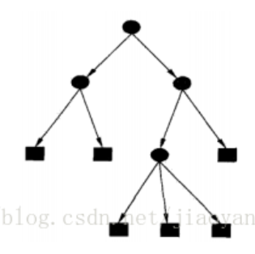
Fig.3
The figure above is a decision tree flow chart. The square represents the judgment module, the ellipse represents the termination module, indicating that the conclusion has been reached and the operation can be terminated. The left and right arrows are called branches.
The objective of decision tree learning is to construct a decision tree model according to the given training data set, so that it can correctly classify the instances and select the optimal decision tree in the sense of loss function.
The essence of decision tree learning: Summarize a set of classification rules from the training set, or estimate the conditional probability model from the training data set.
Loss functions for decision tree learning: Regularized maximum likelihood functions.
Testing decision tree learning: loss minimization functions.
K-nearest neighbor algorithm can complete many classification tasks, but its biggest disadvantage is that it cannot give the internal meaning of data. The advantage of decision tree is that the form of data is very easy to understand.

1.3.2 Construction of decision tree
The algorithm of decision tree learning is usually a process of selecting the best feature recursively and segmenting the training data according to the feature to make each sub-data set have a best classification. This process corresponds to the division of feature space and the construction of decision tree.
1) Start: Build the root node, place all the training data in the root node, select an optimal feature, and divide the training data set into subsets according to this feature, so that each subset has the best classification under the current conditions.
2) If these subsets can be classified basically correctly, then build leaf nodes and assign these subsets to corresponding leaf nodes.
3) If there are subsets that cannot be correctly classified, new optimal features will be selected for these subsets, and corresponding nodes will be constructed for segmentation. In this way, all the subsets of training data will be classified basically correctly or have no suitable features.
4) Each subset is assigned to a leaf node, that is, each subset has an explicit class, thus generating a decision tree.

1.3.3 Characteristics and process of decision tree
Advantages: Low computational complexity, easy to understand the output results, insensitive to the loss of intermediate value, can process irrelevant feature data.
Cons: Can cause overmatching problems (i.e., overfitting)
Applicable data types: numeric and nominal

Using decision trees to make predictions requires the following processes:
1) Data collection: Any method can be used. For example, if we want to build a matchmaking system, we can obtain data from matchmakers or by interviewing matchmakers. Based on the factors they consider and the final selection results, we can get some data for us to work with.
2) Data preparation: After the data is collected, we need to sort out all the collected information according to certain rules and typeset it for our subsequent processing.
3) Data analysis: Any method can be used. After the construction of the decision tree, we can check whether the graph of the decision tree meets the expectation.
4) Training algorithm: This process is the construction of the decision tree, also can be said to be the decision tree learning, is the construction of a decision tree data structure.
5) Test algorithm: Use experience tree to calculate error rate. When the error rate reaches an acceptable range, the decision tree is ready for use.
6) Use algorithms: This step can be used for any supervised learning algorithm, and the use of decision tree can better understand the internal meaning of the data.

1.3.4 Three main algorithms for decision trees
1) ID3 algorithm
The core of ID3 algorithm is to construct the decision tree recursively by selecting the characteristics of the information gain criterion at each node of the decision tree.
The specific methods are:
- Starting from the root node, the information gain of all possible features is calculated for the node, and the feature with the largest information gain is selected as the feature of the node.
- Different values of this feature are used to establish the child nodes, and then the above method is recursively called to the child nodes to construct the decision tree. Until the information gain of all features is small or there is no feature to choose from;
- End up with a decision tree.
ID3 is equivalent to the selection of probabilistic model by maximum likelihood method.
2) Generation algorithm of C4.5
Similar to ID3 algorithm, but improved, the information gain ratio is used as the criterion for feature selection.
- Recursively build the decision tree:
The working principle of the module required for constructing the decision tree algorithm from the data set is as follows: The original data set is obtained, and then the data set is divided based on the best attribute value. Since there may be more than two characteristic values, there may be more than two branches of the data set partition. After the first partition, the data will be passed down to the next node of the tree branch, where the data is divided.
- The conditions for the end of the recursion are:
The program traverses all the attributes of the partition data set completely, or all instances under each branch have the same classification. If all instances have the same classification, a leaf node or termination block is obtained. Any data reaching the leaf node must belong to the classification of the leaf node.
3) cart algorithm
CART (classification and regression tree): Classification and regression tree can be used for both classification and regression.
CART is a learning method for the conditional probability distribution of output random variable Y under the condition of given input random variable X. CART assumes that the decision tree is a binary tree. Such a decision tree is equivalent to recursively dividing each feature into a finite number of units, and determining the predicted probability distribution on these units, that is, the conditional probability distribution of output under the given conditions of input.
Gini index:
The generation of decision tree is the process of constructing binary tree recursively. The minimum square error criterion is used for regression tree and the Gini index minimization criterion is used for classification tree. I'm going to focus here on classification trees. For a given sample set D, its Gini index is: Gini(D) represents the degree of uncertainty of random variables in set D, where Ck is a subset of samples belonging to class k in D, and K is the number of classes. The smaller the Gini index is, the higher the purity of the data is; conversely, the larger its value is, the greater the uncertainty of the sample set is, which is similar to entropy. When the probability of a class in a sample set D is 0, Gini(D) gets the maximum value, and the random variable is the most uncertain at this time. For A feature with multiple values (more than 2), it is necessary to calculate the purity Gini(D,Ai) of the subset after sample D is divided with each value as the partition point (Ai represents the possible value of feature A).
It should be noted that CART is a binary tree, that is, when a feature is used to divide the sample set, there are only two sets: 1. If the sample set is equal to the given eigenvalue D1, 2. If the sample set D2 is not equal to the given eigenvalue, it is actually a binary processing of features with multiple values.
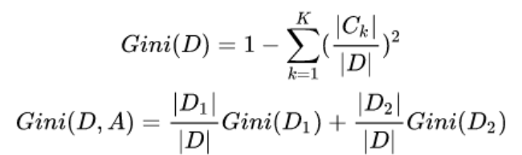
CART generation algorithm:
- Calculate the Gini index of the existing feature pair data set. For each feature A and each possible value A, calculate the Gini index when A=a.
- Among all possible A and its possible shard points a, the feature with the lowest Gini index and its corresponding shard points are selected as the optimal feature and optimal shard points. According to it, the data is distributed among the two child nodes.
- Call recursively to the two child nodes until the stop condition is met.
The stopping condition of the algorithm is that the number of samples in the node is less than the threshold value, or the Gini index of the sample set is less than the predetermined threshold value, or there are no more features.

1.3.5 Pruning of the decision tree
Pruning is to select the model with the smallest loss function, i.e. the subtree with the smallest loss function, when α is determined.
When alpha is determined
The larger the subtree, the better the fitting with the training data, but the higher the complexity of the model.
The smaller the subtree, the lower the complexity of the model, but it often does not fit well with the training data.
The loss function is just the balance between the two.
The loss function considers that the uncertainty degree of each classification endpoint (leaf node) is the loss factor of classification, while the number of leaf nodes is the complexity of the model. As a penalty term, the first term of the loss function is the training error of the sample, and the second term is the complexity of the model. The larger the loss function value of a subtree is, the worse the subtree is. Therefore, we hope to make the loss function value of each subtree as small as possible. The minimization of loss function is the process of model selection by regularized maximum likelihood estimation.
The pruning process (generalization process) of the decision tree is to recurse from the leaf node. The subtree after shrinking all the child nodes is denoted by its parent node as Tb (the classification value is the characteristic value with the largest proportion of categories), and the subtree without shrinking is T a. If Cα (T a) ≥ Cα (Tb), the loss function decreases after shrinking. Then this subtree should be shrunk and recursively until it cannot be shrunk. In this way, pruning with the idea of "greedy" can reduce the value of the loss function and also make the decision tree generalized.
It can be seen that the generation of decision tree only considers the better fitting of training data by improving information gain, while the pruning of decision tree also considers the reduction of model complexity by optimizing loss function.

Related Work

2.1KNN
1951 Evelyn Fix and Joseph Lawson Hodges Jr. The nearest neighbor rule was first proposed. But because of the social environment at the time, they did not publish this work.
in 1962, George S Sebestyen named KNN as Proximity Algorithm in his Decision-making processes in pattern recognition.
In 1965, Nils J. Nilsson wrote the book Learning Machines: Foundations of Trainable Pattern-Classifying Systems -- Classifying Systems KNN is called a Minimum Distance Classifier.
In 1967, Thomas Cover and Peter Hart officially introduced KNN in the paper Nearest neighbor pattern classification, which was the first official publication of KNN.
After the proposal of KNN, the subsequent research work mainly focuses on two aspects: efficiency and effect
Efficiency optimization: KNN comparison is suitable for problems with large sample size, but it is easy to misjudge problems with small sample size. Therefore, a major direction of KNN efficiency optimization is to reduce sample features in advance and delete attributes that have little impact on classification results. In 2006, Zhang et al., in their paper SVM-KNN: In Discriminative nearest neighbor classification for visual category recognition, it is proposed to consider visual category recognition in the framework of similarity measurement based on SVM and KNN. In 2007, in the paper ML-KNN: A lazy learning approach to multi-label learning, Zhang et al. designed a KNN algorithm for multi-label data based on limited data. In 2009, Chen et al. used two divides in the paper Fast Approximate KNN Graph Construction for High Dimensional Data via Recursive Lanczos Bisection and conquer methods to approximate the calculation of KNN.
Effect optimization: The core objective of effect optimization is to improve the classification accuracy of KNN. In 1986, Stanfill and Walt used the Value Distance Metric/VDM in their Toward memory-based reasoning. Han et al. implemented the k nearest neighbour method WAkNN in text categorization using weight adjusted k-nearest neighbour classification in 1999 (weighted adjusted k nearest neighbor) to improve the classification effect of KNN. In 2004, Li et al. believed that there were differences in the number of files of different classifications, so different k should be selected for KNN according to the number of files of various classifications in the training set. In 2004, Goldberger et al applied Mahalanobis distance to KNN in the Neighbourhood components analysis (NCA) to achieve dimension reduction. The main purpose of NCA is to maximize the accuracy of leave-one-out (LOO) classification by finding a linear change matrix.
The above is a brief introduction to the development of KNN. From the initial idea germination to the continuous optimization of efficiency and effect, researchers have continued to explore for nearly 60 years. It is worth mentioning that although KNN has gradually faded out of the public eye, it is still the first choice in most fields.

decision tree
The earliest decision tree algorithm is CLS proposed by Hunt et al in 1966. The current optimal influence algorithm is ID3 proposed by Quinlan in 1986 and C4.5 proposed by Quinlan in 1993.

Experiment and result analysis

3.1KNN
KNN：85.97%

3.1.1 Performance measurement method
Precision, Accuracy, F1 (Precision, Recall)

3.1.2 Test set and training set partition
The training set contains 60,000 samples and the test set contains 10,000 samples, which are divided into 10 categories.

3.1.3 Performance indicators obtained under different parameters
Adjust parameter k, other values default, observe the change of accuracy. A total of 10 times of training, k value from 1 to 10, draw the curve of k value about the correct rate, it is observed that the correct rate is the highest when k=4.
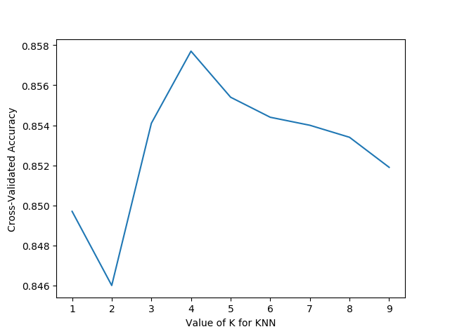

k = 4, adjust parameter weights, set parameter as distance, and the accuracy is slightly improved.
 | Change weights k=4
weights | uniform | distance
Precision | 86.04 | 86.26
Accuracy | 85.77 | 85.97

Accuracy, recall rates, F1 values for each category.
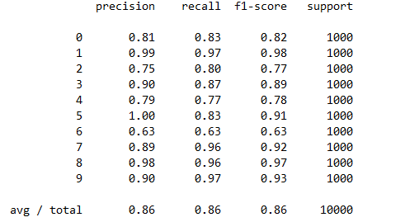

ROC curves for each category.

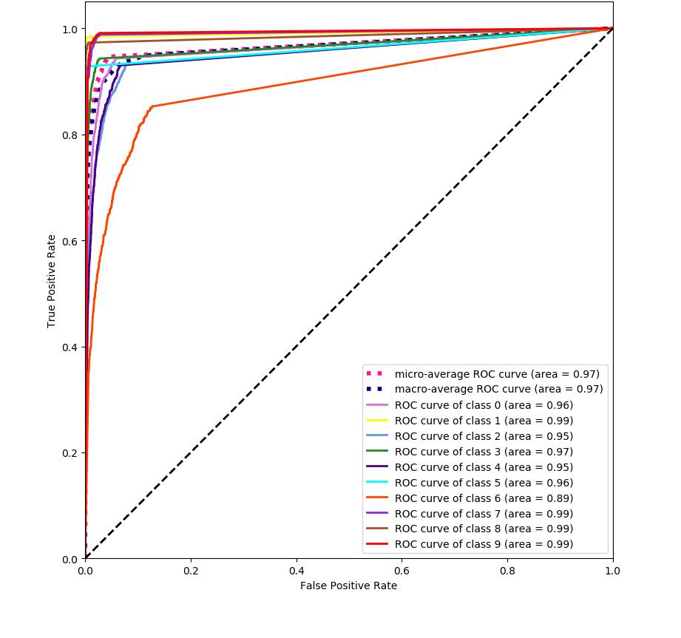

3.2 decision tree
decision tree: 83.1%

3.2.1 Index of evaluation
- accuracy: Number of samples correctly classified/total number of samples
- precision: Number of correctly classified positive samples/total number of positive samples
- recall: Number of samples that are correctly classified/number of all samples that are correctly classified

3.2.2 ROC curve
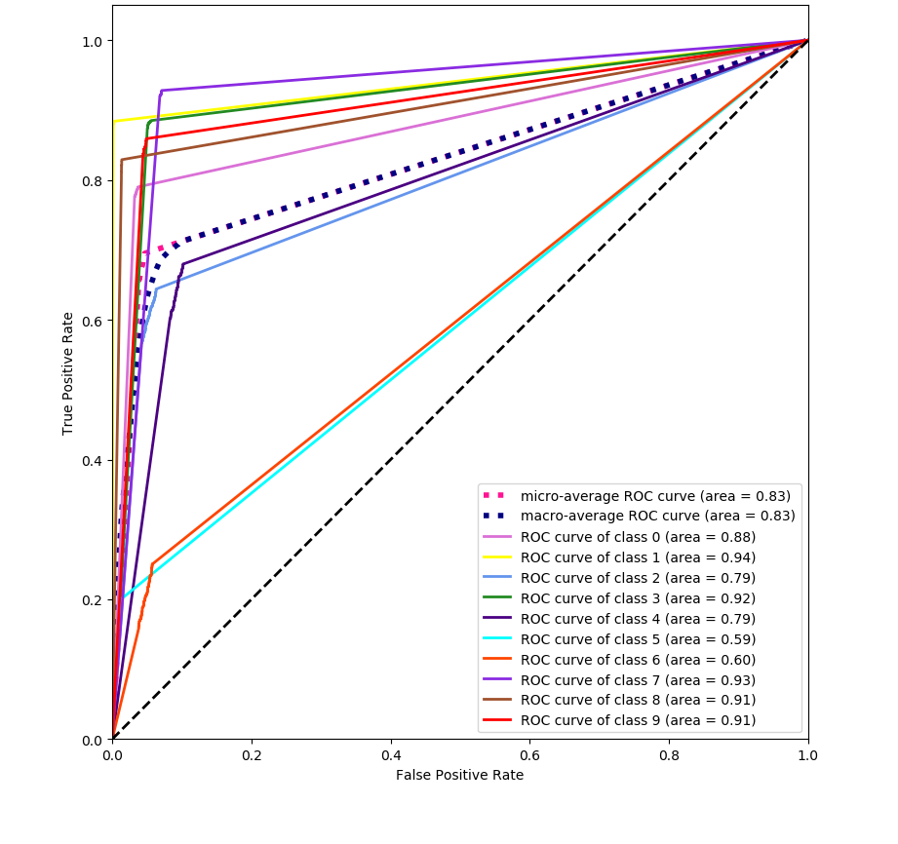

References
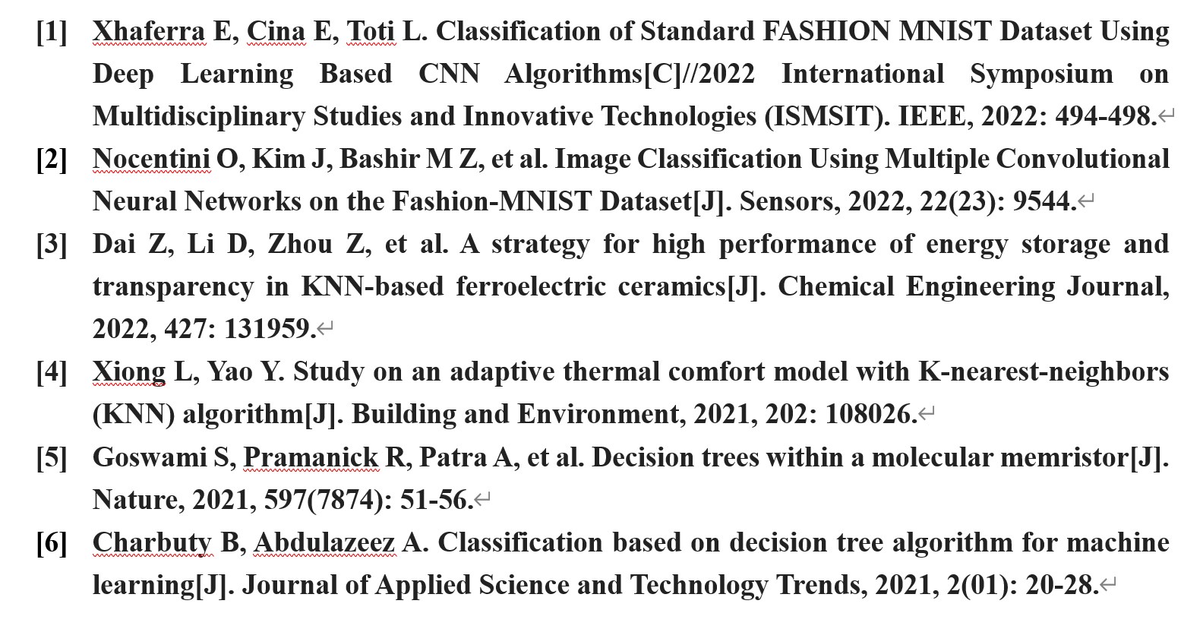

Appendix
written/edited programming code (KNN)
Run make_data.py to get the training and test set image files, training set and test set labels under fashion_mnist.
import os
from skimage import io
import torchvision.datasets.mnist as mnist
root="fashion_mnist/"
train_set = (
mnist.read_image_file(os.path.join(root, 'train-images-idx3-ubyte')),
mnist.read_label_file(os.path.join(root, 'train-labels-idx1-ubyte'))
)
test_set = (
mnist.read_image_file(os.path.join(root, 't10k-images-idx3-ubyte')),
mnist.read_label_file(os.path.join(root, 't10k-labels-idx1-ubyte'))
)
print("training set :",train_set[0].size())
print("test set :",test_set[0].size())

def convert_to_img(train=True):
if(train):
f=open(root+'train.txt','w')
data_path=root+'/train/'
if(not os.path.exists(data_path)):
os.makedirs(data_path)
for i, (img,label) in enumerate(zip(train_set[0],train_set[1])):
print(str(label)[7])
img_path=data_path+str(i)+'.jpg'
io.imsave(img_path,img.numpy())
f.write(img_path+' '+str(label)[7]+'\n')

f.close()
else:
f = open(root + 'test.txt', 'w')
data_path = root + '/test/'
if (not os.path.exists(data_path)):
os.makedirs(data_path)
for i, (img,label) in enumerate(zip(test_set[0],test_set[1])):
img_path = data_path+ str(i) + '.jpg'
io.imsave(img_path, img.numpy())
f.write(img_path + ' ' + str(label)[7] + '\n')
f.close()

convert_to_img(True)
convert_to_img(False)

Run train_minst.py to test the performance of three different machine learning classifiers.
import time
from sklearn import metrics
from sklearn.naive_bayes import MultinomialNB
from sklearn.ensemble import RandomForestClassifier
from sklearn.naive_bayes import MultinomialNB
from sklearn import tree
from sklearn.metrics import classification_report
from sklearn.neighbors import KNeighborsClassifier
from sklearn.preprocessing import label_binarize
import fashion_mnist_load as mnist_load
import plt_roc as pr
# KNN
def knn(train_x, train_y):
print('************* KNN ************')
# k的个数 uniform是均等的权重 distance是不均等的权重
model = KNeighborsClassifier(n_neighbors=4,weights='distance',n_jobs=10)
model.fit(train_x, train_y)
return model
if __name__ == '__main__':
# 加载数据集
print('reading training and testing data...')
train_x, train_y, test_x, test_y = mnist_load.get_data()
# 将标签二值化
# train_y = label_binarize(train_y,classes=[0,1,2,3,4,5,6,7,8,9])
# test_y = label_binarize(test_y,classes=[0,1,2,3,4,5,6,7,8,9])
# # 数据类型改为float32，单精度浮点数
# train_x = train_x.astype('float32')
# test_x = test_x.astype('float32')
# # 数据归一化
# train_x /= 255
# test_x /= 255
start_time = time.time()
# psum1 = 0
# asum2 = 0
# for i in range(10,50,10):
# print('k ================================ %f' % i)
model = multinomial_naive_bayes(train_x, train_y)
print('training took %fs!' % (time.time() - start_time))

start_time = time.time()
# 根据模型做预测，返回预测结果
predict = model.predict(test_x)
print('predict took %fs!' % (time.time() - start_time))
print(classification_report(test_y, predict))
precision = metrics.precision_score(test_y, predict,average='macro')
recall = metrics.recall_score(test_y, predict,average='macro')
print('precision: %.2f%%, recall: %.2f%%' % (100 * precision, 100 * recall))
accuracy = metrics.accuracy_score(test_y, predict)
print('accuracy: %.2f%%' % (100 * accuracy))
pr.plt_roc(model,test_x,test_y)

Run knn. py to find the best parameter k in KNN
from __future__ import print_function
from sklearn.datasets import load_iris
from sklearn.model_selection import cross_val_score
import matplotlib.pyplot as plt
from sklearn.neighbors import KNeighborsClassifier
import time
from sklearn import metrics
import fashion_mnist_load as mnist_load
# iris = load_iris()
# X = iris.data
# y = iris.target
k_range = range(1,10)
k_scores = []
train_x, train_y, test_x, test_y = mnist_load.get_data()
for k in k_range:
start_time = time.time()
print('k ========================= %f' % k)
knn = KNeighborsClassifier(n_neighbors=k,n_jobs=8)
# 交叉验证
# loss = -cross_val_score(knn, X, y, cv=10, scoring='mean_squared_error') # for regression
# scores = cross_val_score(knn, X, y, cv=4,scoring='accuracy') # for classification
knn.fit(train_x,train_y)
predict = knn.predict(test_x)
accuracy = metrics.accuracy_score(test_y, predict)
k_scores.append(accuracy)
print('training took %fs!' % (time.time() - start_time))
plt.figure()
plt.plot(k_range, k_scores)
plt.xlabel('Value of K for KNN')
plt.ylabel('Cross-Validated Accuracy')
plt.show()
written/edited programming code (decision tree)
import numpy as np
from sklearn.datasets import load_digits
from sklearn.model_selection import train_test_split
import _pickle as pickle
import matplotlib.pyplot as plt
mnist = load_digits()
x,test_x,y,test_y = train_test_split(fashion-mnist.data,mnist.target,test_size=0.25,random_state=40)
from sklearn.tree import DecisionTreeClassifier, export_graphviz
model = DecisionTreeClassifier(criterion="entropy")
model.fit(x,y)
z=model.predict(test_x)
print('准确率：',np.sum(z==test_y)/z.size)
#学习后识别99到105六张图片并给出预测
model.predict(mnist.data[99:105])
#实际的99到105代表的数
mnist.target[99:105]
#显示99到105数字图片
plt.subplot(321)
plt.imshow(mnist.images[99],cmap=plt.cm.gray_r,interpolation='nearest')
plt.subplot(322)
plt.imshow(mnist.images[100],cmap=plt.cm.gray_r,interpolation='nearest')
plt.subplot(323)
plt.imshow(mnist.images[101],cmap=plt.cm.gray_r,interpolation='nearest')
plt.subplot(324)
plt.imshow(mnist.images[102],cmap=plt.cm.gray_r,interpolation='nearest')
plt.subplot(325)
plt.imshow(mnist.images[103],cmap=plt.cm.gray_r,interpolation='nearest')
plt.subplot(326)
plt.imshow(mnist.images[104],cmap=plt.cm.gray_r,interpolation='nearest')

