UNIVERSITY OF WALES
TRINITY SAINT DAVID
LCBB4002
COMMUNITY ENGAGEMENT
LINDT & SPRUNGLI
ASSESSMENT 1
LECTURER: TANJA NATHAN STUDENT: 1913404
IOANA TRIFOI
MAY 2020
GROUP 2 TERM 1

Table of Contents
LINDT & SPRUNGLI 3
The Beginning 3
Operation Sector 3
Organizational Size and Structure 4
Missions and Goals 4
Customers of Lindt & Sprungli 5
SWOT analysis 5
The role of employees in an organization 6
Importance of training and development 7
Marketing Director of Lindt and Sprungli UK 7
Requisite skills and knowledge 8
Training and development needs for a marketing director 8
Conclusion 9
Reference 10

LINDT & SPRUNGLI

Chocoladefabriken Lindt and Sprungli AG is a premium chocolate organization, which has been present in the market since 175 years. Lindt & Sprungli has been recognized as a market leader for the high quality chocolates that it has been selling with a wide variety, in about 120 nations across the globe. Market analysts and consumers have highly rated and recognized its premium product quality, innovation and creativity in the sector (Manzini, Lazzarotti and Pellegrini, 2017).

The Beginning
The company came into existence with two different people who tried to manufacture two types of chocolates and later conjoined to become one. In 1845, David Sprungli & his son tried to manufacture solid chocolate in their small confectionary, which was instantly approved by the Zurich locals turning it into a company – “Chocolat Sprungli”, in the year 1899. Later in the same year, the company acquired Rudolph Lindt’s chocolate factory. Rudolph Lindt was the man to invent the melting chocolate, first of its kind. After that the company came to be known as Lindt & Sprungli (Manzini, Lazzarotti and Pellegrini, 2017).

Operation Sector
With the Food and Beverage sector chocolate has been identified as the world’s favorite food amongst others but the $103 billion industry has its largest market in Europe whereas according to the research the fastest growing market is that of Asia Pacific region. It has been forecasted that the chocolate industry will grow at a rate of 4.5% from 2016-2024. Europe has the rate of consumption for chocolate at the peak and in 2017; molded chocolate segment took over the dominant segment (Ramli, 2017). Lindt and Sprungli operate in this chocolate industry, specifically in the confectionary premium quality chocolate sellers.
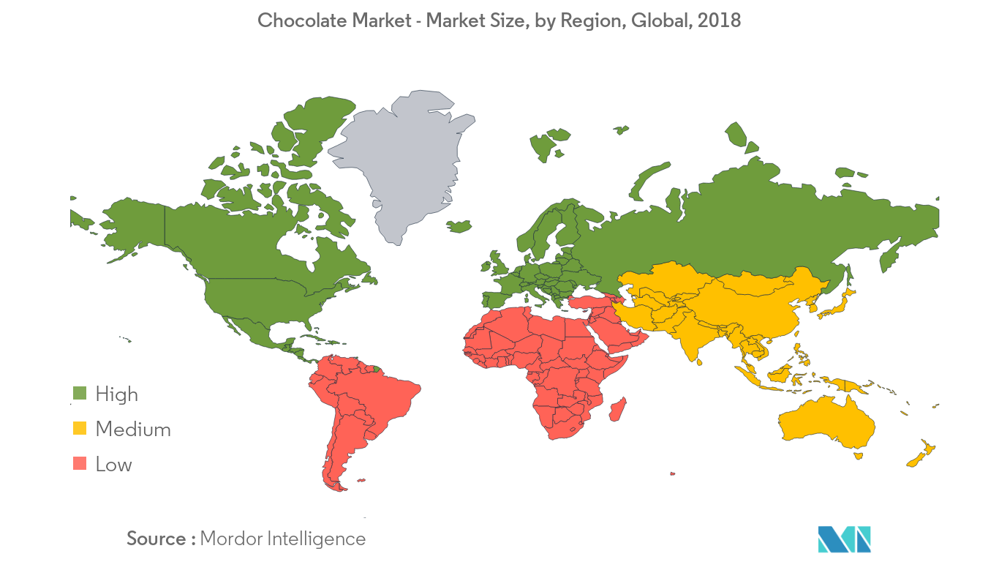

Organizational Size and Structure
Organizational size and structure are interrelated terms that affect the work culture of the firm. Often, the organizational structure of a business firm is determined with the number of individuals belonging to the business that affect its work culture highly. Structures of small businesses have been found to be flat- with limited number of people holding responsibilities of the assigned tasks whereas the structures of large corporations have been found to be vertical in nature- that display a complex work structure and various layers of management. Thus, the structure of an organization is determined with the help of the size of an organization (Hsiao and Wu, 2020). Lindt and Sprungli is a large organization and thus, it follows a vertical structure with the Board of Directors handling the management systems, strategy formation and supervising roles at the higher management levels. The CEO of the group along with group management members are to undertake and manage the operational managerial tasks with the help of extended group management with about 13,168 employees across the world (GROUP STRUCTURE AND SHAREHOLDERS, 2015).

Missions and Goals
The mission and goals of an organization help it to reach greater heights and serve its consumers as promised. This organization aims at serving the highest quality chocolates to its consumers by keeping a strong check over its manufacturing and supply chain. The company aims at striving to improve its contribution towards the sustainable future, making its stakeholders have complete trust in the organization and its products. The company promises its customers that every product that leaves the Lindt & Sprungli’s factory live up to the commitments made by the business. The mission of the organization is to produce the best premium quality chocolates giving the consumers the ultimate taste experience, creating the ultimate chocolate lovers on the planet.
Values of the organization:
- Focus
- Sustainability
- Positivity

Customers of Lindt & Sprungli
Consumers are the most important stakeholder or any business because their demand generates the idea of product and their money spent on the product generates revenue for the business to cover its operational costs and determine profits. Customers of Lindt & Sprungli are medium and high class people of all age groups who like and our aware of the Swiss chocolate taste that can satisfy their palettes. The new customers are attracted through the word of mouth of existing ones along with the organization’s premium quality product trials. The company also tries to fulfill the consumer expectations by identifying and analyzing their needs and expectations. Lindt and Sprungli have always aimed to pass through the consumer expectations helping them to innovate and launch new products in the market on regular basis. The consumers are answered directly through sales people present in over 500 shops. Customer service specialists are continuously trained and important measures are taken by the organization in order to satisfy the consumer needs and effectively handle the queries & issues.

SWOT analysis
SWOT or Strength Weakness Opportunity and Threat analysis of an organization helps to understand the market standing and upcoming marketing opportunities for the company within the industry where it operates. The competitors are also analyzed through this with the help of its strengths that make it hold its unique place in the market among the potential and existing consumers. SWOT analysis of the Lindt and Sprungli is essential to understand the company’s stand in the market and its potential to attract consumers.

The role of employees in an organization
Employees are the drivers of an organization that take forward the idea, put it into action and drive the organization by providing the product or services to the consumers. Employees are responsible to get the job done and their performance is into high consideration as it determines the outcome of an operation that is to be presented to the consumer or is part of a long process. Employees of any organization are its true assets (Preenen, van Vianen and de Pater, 2012). They contribute to an organization in the most effective manner towards its success and aim to deliver the expected results within the stipulated time of any particular assigned task. Every organization has a wide variety of employees, some of them are easy to adjust with, optimistic in nature as well as take up challenges for self growth while there is the complete opposite type that is scared of accepting challenges easily, also a third type that take their time, assess the challenges, its benefits and disadvantages according to their potential and then react. Organizations need each of these kinds of employees to develop, grow and reach their targeted goal. Employees are responsible to maintain the decorum of the workplace by striving towards healthy competition and yet focusing towards the penultimate aim of the organization. Roles and responsibilities are delegated to the workforce from the management, and it is their duty to achieve more than the expected outcome (Wolf, 2012).

Importance of training and development
Training and development is an important part of any organizational culture to ascertain the true potential of their employees as well as improve it time to time. Training has been recognized as a vital part of an organizational culture which helps to enlarge or expand the knowledge base of the workforce. This process helps the employees to gain practical knowledge about the business operations as well as understand how to face and solve the upcoming challenges within work. Training and development may be expensive in nature, yet the exercise proves to be beneficial for both organization and employees making the costs incurred and time given worth the investment that has been made. The importance of training and development of new or existing workforce cannot be over emphasized (Talwar and Thakur, 2016). The positive effect of training and development in an organization is:
- Increases employee confidence to deliver the results
- Employees react positively to the organizational changes
- Facilitates employee career growth and development
- Helps employees to grow continuously
- Improves organizational viability, flexibility and scalability
- Gives systematic knowledge and skills to the workforce along with polishing the already possessed ones
- Increase productivity and employee performance

Marketing Director of Lindt and Sprungli UK
A marketing manager is responsible to manage the marketing of the business that is, marketing of either a specific product or service or a group of them. The marketing director provides guidance, direction and leads the marketing department by supervising each and every activity related to the department. Lindt and Sprungli’s UK division appointed Kieran Danaher as the marketing director a year ago in January 2019 before which he served as the marketing manager for the organization for almost two years from April 2017 to December 2018. He is responsible to decide the sizeable marketing budgets and manage the stakeholders of the department. It is his responsibility to manage the marketing strategies of the company for UK and promote the products of the company within the region. He is also responsible jointly with the sales director for the pricing strategies of the products of Lindt & Sprungli. It is after Mr. Danaher’s order, any marketing plan is passed and thereafter implemented for increasing the profitability of the organization.

Requisite skills and knowledge
A marketing director is should be equipped with evaluation and development of marketing strategies and plans. He/she should know how to plan, direct and co-ordinate the marketing efforts as well as communicate with the marketing plan. He should know the how to co-ordinate with the sales department and strategize to fix the price rates that can maximize their profits as well as the marketing share of the company along with balancing the consumer satisfaction. He should identify the potential customers with the help of his team and develop promotional and advertising strategies with the team managers (Royle and Laing, 2014). He should advice his team for building the awareness of the brand and positions it appropriately in the market. His skills should qualify and managing a marketing project from beginning to the end along with organization of various company meetings, conferences and trade shows for promotions, branding and advertising of the company and its products. It is also his responsibility to support the sales and generating offers as well as supervising the social media marketing strategies along with the content that goes in front of the consumer representing the company.

Training and development needs for a marketing director
It is important to identify the training and development needs of the employees to provide them with the requisite skills as well as equip them with new skills that will help in their personal development along with the overall organizational development. Even though a marketing director is head of the department it is his responsibility to manage the team and whole department that falls under him as he is answerable to the chief executive officer of the organization for every marketing decision taken by the company. Thus, it is also necessary for the director to train and develop himself according the requisite needs. He is also required to update himself with the changes occurring in the market and the competitor’s strategies so that it becomes easier for him to make similar yet competitive strategies for the product promotion as well as branding. The marketing director along with his team should participate in the training activities that are based on real-time basis so that he becomes comfortable as well as understands the need of the hour and thus, becomes ready to face the challenges and worse situations while implementing his decisions in practical life.

Conclusion
Lindt and Sprungli has its headquarters in Zurich, Switzerland and almost 2 centuries old, the company has been known for the taste of Swiss chocolate and it has made the consumers differentiate it from the tastes and textures of other competitive products like toblerone, Ferrero Rocher, Mars etc. that are present in the market. The company has a lean structure alongside the rich work culture. Management of the organization has made sure to promote its products appropriately in the market making it one of the most luxurious brands of chocolates with the premium quality product that is offered in variety of range at a little high price. The brand observes high loyalty from consumers and thus, has been flourishing in the international market holding a great share of market in premium quality chocolates. Lindt and Sprungli have been working with a limited number of personnel at the managerial levels with its subsidiaries located in different countries across the globe along with the acquired firms.

Reference
Hsiao, Y. and Wu, M., 2020. How organizational structure and strategic alignment influence new product success. Management Decision, 58(1), pp.182-200.
Manzini, R., Lazzarotti, V. and Pellegrini, L., 2017. How to Remain as Closed as Possible in the Open Innovation Era: The Case of Lindt & Sprüngli. Long Range Planning, 50(2), pp.260-281.
Preenen, P., van Vianen, A. and de Pater, I., 2012. Challenging tasks: The role of employees' and supervisors' goal orientations. European Journal of Work and Organizational Psychology, 23(1), pp.48-61.
Ramli, N., 2017. A review of marketing strategies from the European chocolate industry. Journal of Global Entrepreneurship Research, 7(1).
Report.lindt-spruengli.com. 2015. GROUP STRUCTURE AND SHAREHOLDERS. [online] Available at: <https://report.lindt-spruengli.com/15/ar/en/annual_report/corporate_governance/group_structure_and_shareholders.htm> [Accessed 15 May 2020].
Royle, J. and Laing, A., 2014. The digital marketing skills gap: Developing a Digital Marketer Model for the communication industries. International Journal of Information Management, 34(2), pp.65-73.
Talwar, E. and Thakur, M., 2016. Training and Development and its Impact on Employee Performance. We'Ken- International Journal of Basic and Applied Sciences, 1(1), p.18.
Wolf, J., 2012. Improving the Sustainable Development of Firms: The Role of Employees. Business Strategy and the Environment, 22(2), pp.92-108.

