1909860 EAEE5002- Reflection on early years practice.

Element One- Evaluating the use of reflective models.

According to Whatis.com (2010) a model of reflection is a structured process that is used to guide personal improvement. They’ve also stated that models of reflection benefit individuals buy helping them to understand their own thinking and learning strategies. Reflective thinking allows individuals to relate to their knowledge to their previous understanding. A wide variety of models of reflection exist, individuals must decide which frameworks supports their work and will best assist their learning experiences.

They have also stated that reflection is often prompted by uncomfortable or negative situations where individuals need to determine what went wrong and how they can improve or fix it in the future.

Models of reflection canes used in a variety of situations but they are especially beneficial in circumstances where updates and feedback are requested, such as business meetings and behavioural interview questions. Models of reflection are also very frequently used by healthcare professionals to improve their practices. Models of reflection are also known as frameworks of reflections, reflective models and reflective practice models, they have also said.

According to Skillsyouneed (2011) reflective practice is thinking about how you do certain things as a practitioner, it is closely linked to the concept of learning from experience. It gives you the chance to think about what you did, how well you did it, if it can be performed in a better way next time or if everything went accordingly to plan. They also stated that reflective practice has huge benefits in increasing self- awareness, which is a key component of emotional development, therefore you will have a better understanding of others. Reflective practice can also help you to develop creative thinking skills and can encourage active engagement in work processes. Reflective practice is a tool for improving your learning both as a student and in relation to your work and life experiences. Reflective practice can take time to learn as you’ve got to judge yourself and your own work but once you have the hang of it it becomes a lot easier for you to spot your mistakes in activities and general day to day life.

Models of reflection help individuals pull valuable insights from their experiences, helping them improve their actions and behaviours. The benefits of models of reflection are as follows: an easy to follow structure, individuals who are unsure to begin the reflective thinking process can use a model of reflection to find a starting point, individuals can more easily assess all levels of a situation and there is a clear and defined end point for the process, says Whatis.com (2010).

Reflective thinking has benefit, it lets people have the ability to reflect on their own cognitive progress, increases self-motivation, enhances the focus on leaning goals, optimises performance monitoring and management, it helps individuals identify obstacles in their own learning and identifies gaps and skills, knowledge and development.

According to Academia.oup .com (2020) reflection has been considered good practice in medical education , in public health, while no formal training or teaching of reflection takes place, it is expected as part of continuous professional development. They also stated that a review of literature was carried out in order to identify reflective experience, either directly related to public health or in health education.
Brightknowledge (2003) have stated reflective practice is a way of studying your own experiences to improve the way you work. It is very useful for health professionals who want to carry on learning throughout their lives. They also stated that engaging in reflective practice should help to improve the quality of care you give and close the gap between theory and practice.

Professor Graham Gibbs has his own reflective cycle that occurs in six different parts, these include description, feelings, evaluation, conclusion and action plan. The first stage is description meaning that the person will ask theirselves or the person they are coaching, the questions will be along the lines of what happened?, where were you?, who was with you?, what did you do? And what was the result of the situation?. This gives the person the chance to describe the scenario and can then judge their mistakes if any.

The next stage is feelings meaning that it can encourage someone to talk about how they felt during their scenario, there will be questions that they would have to answer these would be, how did you feel before the situation occurred?, how did you feel after the situation occurred? And how do. You feel about the situation now?. This helps the person to connect with you on a more emotional level so are more likely to write down Howe they actually felt during the situation.

The third stage is evaluation, some of the questions that would be as asked would be what went well?, what didn’t go so well?, was there any positives?, was there any negatives?. This gives the person a chance to figure out what has happened during the situation and then gives them the chance to fix any problems with their activity if the chose to do it again.

The forth stage is conclusion, once the situation has been evaluated it gives the person to think about the situation again by using the information they’ve already collected, questions like if you were given the same situation again what would you do differently if anything? And what skills do you need to develop?.

The fifth section is analysis this means that if you can make sense of what happened in the situation needs to be addressed.

The final stage is action thirds means that this stage is there final stage and there needs to be a plan that has been created by the person who is reflecting the situation, this plan needs to include the changes that would take place if the person should face another situation like this again.

Professor Gary Rolfe and colleagues (2001) describe another useful framework for self-reflection in their book ‘Framework for Reflective Practice’. It is based around three simple questions; What? Meaning that the situation needs to be described, so what? Meaning that what are the reasons for the outcome of the situation and now what? Meaning what is going to change next time for the situation to be different says Futurelearn.com (no date).

Schon (1991) presented the concept of ‘reflection in action’ and ‘reflection on action’. Reflection in action is, experiencing, thinking on your feet, thinking about what to do next and acting straight away. Reflection on action is, thinking about something that has already happened, thinking about what you should do for next time and taking your time. These types of reflection are methods that take place before and after an event.

There is also a method called ‘swampy lowlands’ this is the method of raising above the “swampy lowlands” of our practice to be able to look at our situation from a different perspective.

Element two: Briefing paper
what they did well, what they did not do well on and what they can change when asked to do it again, it gives them the sense of motivation to concentrate more as it saves the self reflection even if it is beneficial.

After the student has received their feedback they can analyse it and then change anything that may need changing so not only is the teacher or lecturer reflecting on the students work the student is also reflecting on it and after both of the reflections have been complete. Their work would be complete.

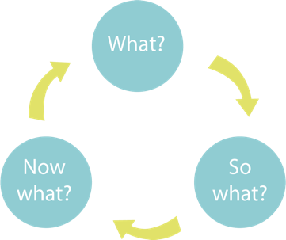
Benefits of reflection in an early years setting.

Reflective practice allows early years practitioners to develop a critical understanding of their own practice and then allowing them to be able to develop the necessary skills, knowledge and approaches to achieve the best outcomes for the children participating in their planned activity before and after.

Reflective practice has huge benefits in increasing self-awareness, which is a key component of emotional intelligence and in developing better understanding of others. Reflective practice can also help you to develop creative skills and encourages active engagements and work processes.

Not only is reflection really important for practitioners to reflect on their own skills and activities but its also really important for students to reflect on their learning after receiving criticism.

It gives students the chance to identify,

Rolfe et.al (2001) model has the simplicity and straightforwardness and is based upon three simple questions, which are what?, so what? And now what?.

According to ukessays.com (2003) Rolfe uses these three stages because it gives you the best results by answering the question what because it gives the student or practitioners a chance to find their mistakes and faults if any and then gives them a starting point to then answers the following questions.

The next question that they would have to answer for their self reflection would be so what? This question then gives them the chance to figure out what they have done wrong and then gives them the chance to decide on how to fix it and with what resources and if with anything extra members of staff. They can then identify what worked well and what did not work to then improve on their own.

The third and last question is now what? This means that they put their ideas into, they can re-do the activity if they wish with the new improvements implemented. This method works well for both students and practitioners as it breaks their work or activity down into sections which is easier to work through and find errors.

Schons theory is that there is two types of reflection. These are taken place during and after the activity or event.

These are called ‘Reflection in action’ and ‘Reflection on action’ . Reflection in action is, experiencing , thinking on your feet, thinking about what to do next and acting straight away.

Reflection on action is thinking about something that has already happened, thinking about what you should do next and taking your time.

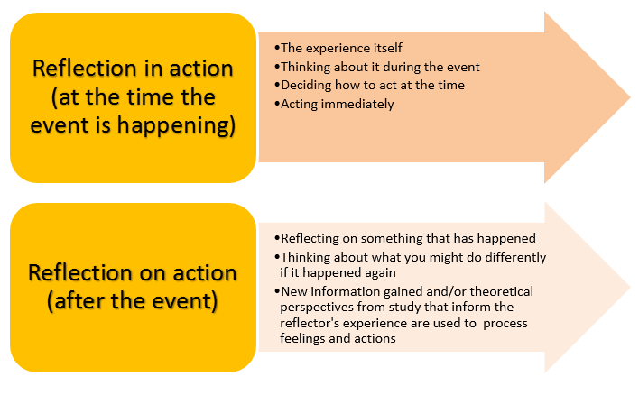
Comparison
Gibbs, Schon and Rolfe all used methods for reflection. Gibbs follows a more. Complex process, whereas schon and Rolfe use a less complex process. Gibbs’ method takes longer to go through as he uses six different points when Rolfe and schon only use two or three.

Gibbs’ model is very detailed and hits every point needed for reflection. Schon and Rolfe still hit every point but at a much less detailed manner.

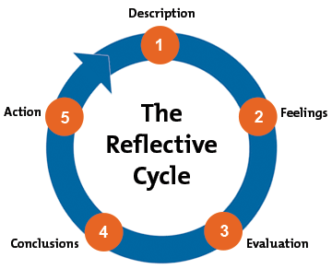

Gibbs’ (1998) model is cyclic and has six elements. The six elements include description, feelings, evaluation, analysis, conclusion and action plan.
The first section is description, this means that describe what you are reflecting on and decide what needs to be changed and made sure its appropriate. Then its feelings, this means you look back at how and what you felt during your activity/ student work. Questions like how we’re you feeling at the time? And how did you feel after completion.
Then comes evaluation, this part of the model is considered how well the situation was handled, must look for the positives and negatives and make sure to be fair to yourself. Then it’s the conclusion, after the reflection is concluded, it can be made relevant to consider possible alternatives to the course of action taken.
Once the conclusion has taken place. The action plan then comes into force this is to plan your guide for future action. This part of Gibbs’ model is very important as it has what you have identified as possible alternatives to show improvement in your work or activity.

Element Three: Reflective log
I showed the children how to keep boundaries how to listen and follow rules that were set in place and also how to mix different colours to get different colours
Children may struggle with their boundaries, how well they can play nicely with each other and how well they may not be able keep themselves to themselves.
Positive things that this activity can help with would be socialising, this skill will benefit. Them as they get older and making friends will be easier. Activity is child centred approached.
This activity will help the children to experience different textures, this activity will also help to teach the children boundaries and rules. This activity also brings out the imagination in them and how creative they can get with paint and wallpaper. This can also help to develop their cognitive skills and developed their colour mixing knowledge.

Your role within the activity:
My role was to supervise and make sure that all rules were followed correctly.
The activity is messy play, with paint and wallpaper. Wallpaper will be laid out and the children will have paint colour choices and they just do as they please.
Aim/Objective of the activity:
A different age group, instead of age two and three, I would try it with babies as they love to get messy and would love the feel of paint.

What could be done differently in the future?
What skills did you demonstrate?
What knowledge did you demonstrate?

Challenging aspects- why?
Positive aspects- why? How could these be developed in the future?
Brief description of the activity.
A skill that was shown by myself was hand-eye coordination because the activity needed to be explained and shown.
Values that were demonstrated were sharing and how to respect someone space.
What values did you demonstrate?

Element Four: Personal Development Plan

Area for further development | Why? | How? | Who/where? | When?
Work with children who experience ALN needs. | I want to be able to support every child that I work with but if I have no experience with children who have ALN it’ll make it more difficult to help them. | Volunteer to work with children at an ALN specific school. | A school local to me and I would be doing it with a partner. | End of 2021 and beginning of 2022.
Learn to speak basic welsh enough to communicate with children who attend welsh schools. | To be able to communicate to children in their preferred language. | Use online courses tho better my welsh and keep up Roth it and use it in practice. | Online and in my setting. | Between May 2021 and end of November 2021.
Learn sign language. | To be able to learn a new skill and be able to communicate with every child. | I am going to be using online courses and learning from some of the children that use sign language everyday. | I will be using online resources and having a helping hand from someone who speaks using sign language. | End of October 2021.

Reference list

Journal of Public Health (2013) Reflection as part of continuous professional development for public health professionals. Available at: https://academic.oup.com/jpubhealth/article/35/2/308/1543818 (Date accessed: 15th January 2021)

Bright Knowledge (2003) What is reflective practice?. Available at: https://www.brightknowledge.org/medicine-healthcare/what-is-reflective-practice (Date accessed 15th January 2021)

Edutopia (No date) Scaffolding reflections and sample questions. Available at: https://www.edutopia.org/discussion/scaffolding-student-reflections-sample-questions
(Date accessed: 15th January 2021)

Future Learn (no date) What, so what and now what?. Available at: https://www.futurelearn.com/info/courses/career-smart-sell-yourself/0/steps/25057
(Date accessed: 15th January 2021)

Solent Online learning (no date) Reflective models. Available at: https://learn.solent.ac.uk
(Date accessed: 15th January 2021)

Mind Tools (2019) Gibbs’ Reflective Cycle. Available at: https://www.mindtools.com/pages/article/reflective-cycle.htm
(Date accessed: 14th January 2021)

Skills you need (2011) What is reflective practice?. Available at: https://www.skillsyouneed.com/ps/reflective-practice.html
(Date accessed: 14th January 2021)

UK. Essays (2003) Reflective Practice: Models of Reflection. Available at: https://www.ukessays.com/courses/education/best-practice/reflective/1-lecture.php
(Date accessed: 13th January 2021)

Whatis (2003) Model of Reflection. Available at: https://whatis.techtarget.com/definition/model-of-reflection
(Duarte accessed 14th January 2021)

Rolfe https://www.google.co.uk/url?sa=i&url=https%3A%2F%2Fcetl.uconn.edu%2Fwhat-so-what-now-what-model%2F&psig=AOvVaw1ewBSJpoDOdS2IfdeX32Pv&ust=1610971952489000&source=images&cd=vfe&ved=0CAkQjhxqFwoTCICZuqn4ou4CFQAAAAAdAAAAABAP

Schon
https://www.google.co.uk/url?sa=i&url=https%3A%2F%2Flaurencebiro.com%2Fintapt%2Freflection-on-book-reviews%2F&psig=AOvVaw2WEfp4b7hSZ2l82dqJEoBx&ust=1610972920815000&source=images&cd=vfe&ved=0CAkQjhxqFwoTCKiJovf7ou4CFQAAAAAdAAAAABAO

Gibbs
https://www.google.co.uk/url?sa=i&url=https%3A%2F%2Fwww.mindtools.com%2Fpages%2Farticle%2Freflective-cycle.htm&psig=AOvVaw35SQPh2lmqNRvfBhh7DiEr&ust=1611003245950000&source=images&cd=vfe&ved=0CAkQjhxqFwoTCKCXtfPso-4CFQAAAAAdAAAAABAE

