Coursework Title
Module Name: Computer Architecture & OS
Module Code: ACCA4022
Student Name: Ibrahim Ahmed
Student ID: 2521603
Lecturer Name: Mr MD Shantanu Islam

Submission date:

Contents
Introduction 4
Key functions of general Operating Systems 4
Task Management: 4
Application/Program Management: 4
File/Directory Management: 5
Device Management: 5
Security Management: 6
Use of Windows OS CLI commands 7
Example 1: 7
Example 2: 7
Example 3: 8
Example 4: 8
Example 5: 8
Example 6: 9
Example 7: 9
Example 8: 10
Example 9: 10
Example 10: 11
Use of Linux OS CLI commands 11
Example 1: 11
Example 2: 12
Example 3: 12
Example 4: 13
Example 5: 13
Example 6: 14
Example 7: 14
Example 8: 15
Example 9: 15
Example 10: 16
Use of Windows OS scripts 16
Example 1: 16
Example 2: 17
Use of Linux OS scripts 18
Example 1: 18
Example 2: 19
Conclusion 20
References 20
Appendices 21

Introduction
Write a brief description of this coursework. Describe what this report contain. (100 words)
This report contains

Key functions of general Operating Systems
Write an introduction about windows operating system when it came, importance, functions. Use 1-2 references (50 words)
Windows Operating system first arrived in 1985 as a friendly add on for MS-DOS. It’s super important because it made computers easy for everyone to use [1][, not just experts. Its main jobs are running programs, handling files, and letting you click icons instead of typing hard commands.[2]
References
[1] Microsoft Corporation, About Windows Operating System, Microsoft, 2023.
[2] CompTIA, Introduction to Operating Systems, CompTIA Press, 2022.

Task Management:
Write about task management in windows. Use 1 reference minimum (100 words)
Task management in Microsoft Windows is a feature that helps the computer run different programs at the same time. Windows uses a tool called Task Manager to control and monitor the applications and background processes running on the computer. This tool is useful because it helps users check what is happening on the system and fix small problems when programs stop working.
Task Manager can be opened by pressing Ctrl + Shift + Esc on the keyboard. It shows information such as CPU usage, memory usage, disk activity, and the programs currently running. If an application freezes or makes the computer slow, the user can end the task using Task Manager. It also allows users to manage startup applications, which can improve the speed of the computer when it turns on.
Task management is important because modern computers often run many tasks together. For example, users may browse the internet, listen to music, and complete schoolwork at the same time. Windows manages these tasks in the background so the system works smoothly and efficiently. This makes the computer easier to use and improves overall performance.

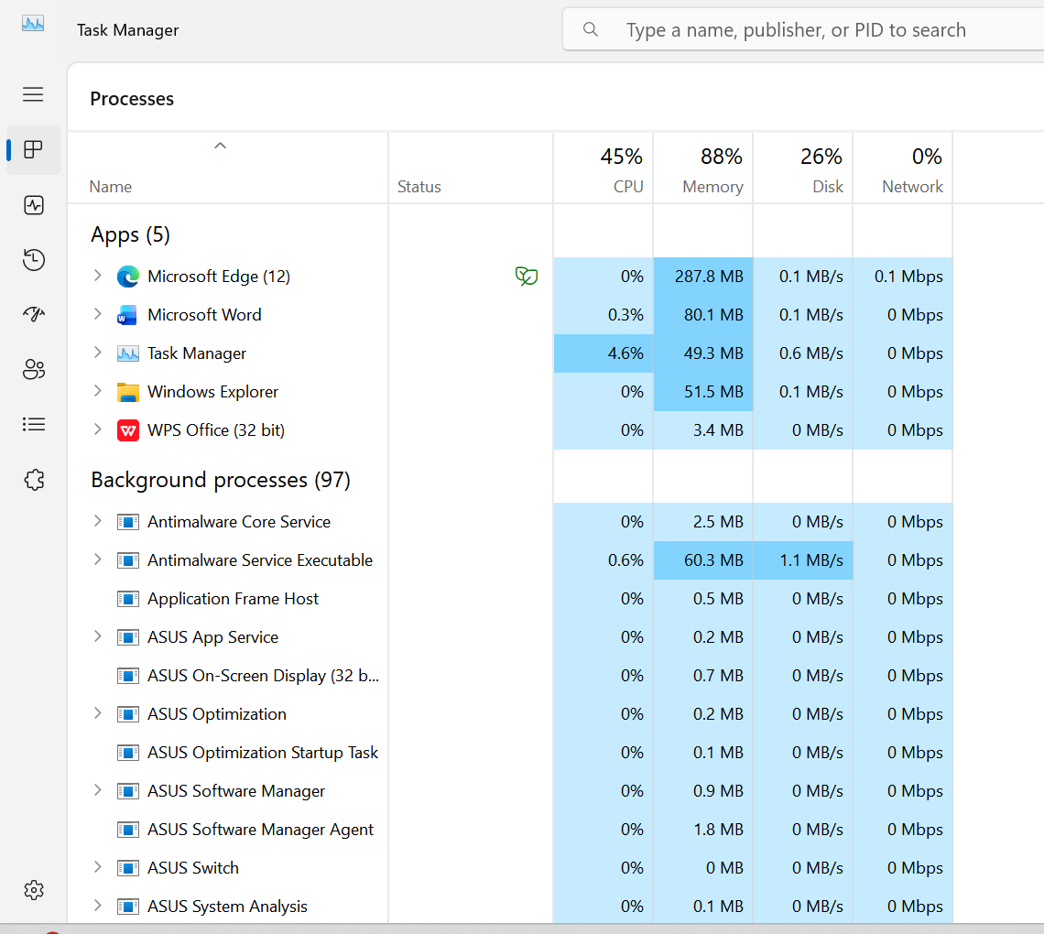
Figure 1: Task Managment

Application/Program Management:
Write about Application/Program management in windows. Use 1 reference minimum (100 words)

Managing applications and programs in Windows is just how you handle all the software you have on your PC. This includes installing new stuff, changing how things work, fixing errors, or deleting programs you don’t use anymore. You mostly do this through the Settings menu or the older Control Panel, where you can see everything that’s installed. You can uninstall things properly so they don’t leave junk files behind, or change certain features if the program lets you [1].
You also need to manage what runs when you turn the computer on. Lots of apps set themselves to start automatically, which makes your PC slow to load. Using Task Manager, you can go to the Startup section and switch off the ones you don’t need right away. This helps speed things up a lot. You can also pick which program opens certain files, like making sure documents always open with your favourite app. Doing all this keeps your system tidy, faster, and running how you want it to [1

Reference
[1] Microsoft, "Manage apps and programs in Windows", Microsoft Support, 2024. [Online]. Available: https://support.microsoft.com/en-us/windows/manage-apps-and-programs-in-windows-948c4991-9c8a-4c4c-9c8a-4c4c991948c4.

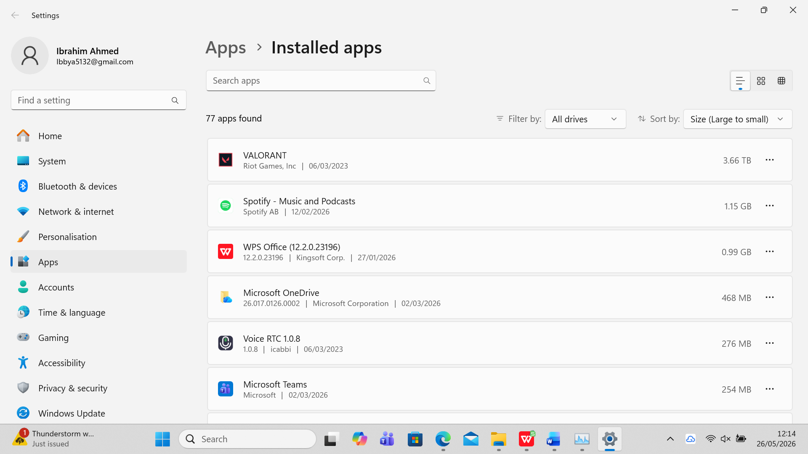
Figure 2: Application program managment

File/Directory Management:
Write about in File/Directory Management windows. Use 1 reference minimum (100 words)
File and directory management is basically how you handle all your files and folders on the computer, like creating, moving, renaming or deleting them.
The main tool you use is File Explorer, which shows you all your drives and folders in one place. You can make new folders to keep things organised, copy files to save a backup, or move stuff around so you can find it easier later [1].
You can also change file names or delete things you don’t need, but you have to be careful not to remove important system files. There are also options to sort files by name, date or size, and search tools to find things quickly if you forget where you saved them. Doing this properly keeps everything neat and stops you from losing your work [1].
Reference:
[1] Microsoft, "File Explorer in Windows", Microsoft Support, 2024. [Online]. Available: https://support.microsoft.com/en-us/windows/file-explorer-in-windows-41a5f7aa-921f-482b-bd94-97f537f79d8c

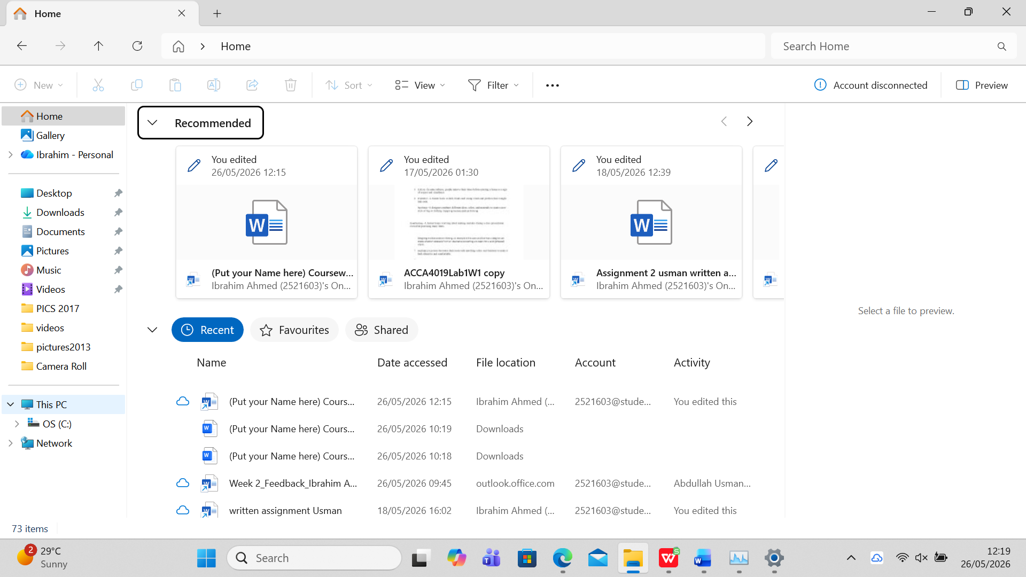
Figure 3: file managment

Device Management:
Write about device management in windows. Use 1 reference minimum (100 words)
Device management is basically how you control and look after all the hardware connected to your computer, like your mouse, keyboard, printer or graphics card. The main tool you use for this is called Device Manager, which shows you a list of every piece of hardware inside or plugged into your PC [1].
Here you can see if something isn’t working properly, update drivers to make devices run better or fix issues, and even disable or remove things you don’t use anymore. You can also scan for new hardware when you plug something in. Doing this properly means all your gadgets work correctly and helps stop errors or problems happening with your system [1].
Reference:
[1] Microsoft, "What is Device Manager?", Microsoft Support, 2024. [Online]. Available: https://support.microsoft.com/en-us/windows/what-is-device-manager-9f3a8329-68f3-4552-8c13-62851f50a7e4. [

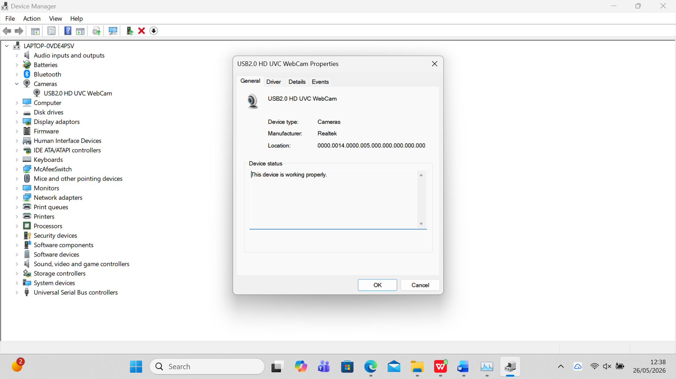
Figure 4: Device Management

Security Management:
Write about Security Management in windows. Use 1 reference minimum (100 words)
Security management in Windows is all about keeping your computer safe and protecting your files and system from viruses, hackers or mistakes.
The main thing people use is Windows Security, which has built-in tools like antivirus protection, firewall, and account controls [1]. It checks for bad software, stops unauthorised access from the internet, and lets you set up passwords or extra login steps like PINs or face recognition.
You can also control what apps are allowed to change settings or access your data. It also updates automatically to fix new risks, so you don’t always have to do it yourself. Using these features properly keeps your PC secure and your personal information safe from being stolen or damaged [1].
Reference:
[1] Microsoft, "Stay protected with Windows Security", Microsoft Support, 2024. [Online]. Available: https://support.microsoft.com/en-us/windows/stay-protected-with-windows-security-2ae0363d-0ada-436f-a1f3-e7700483d093.

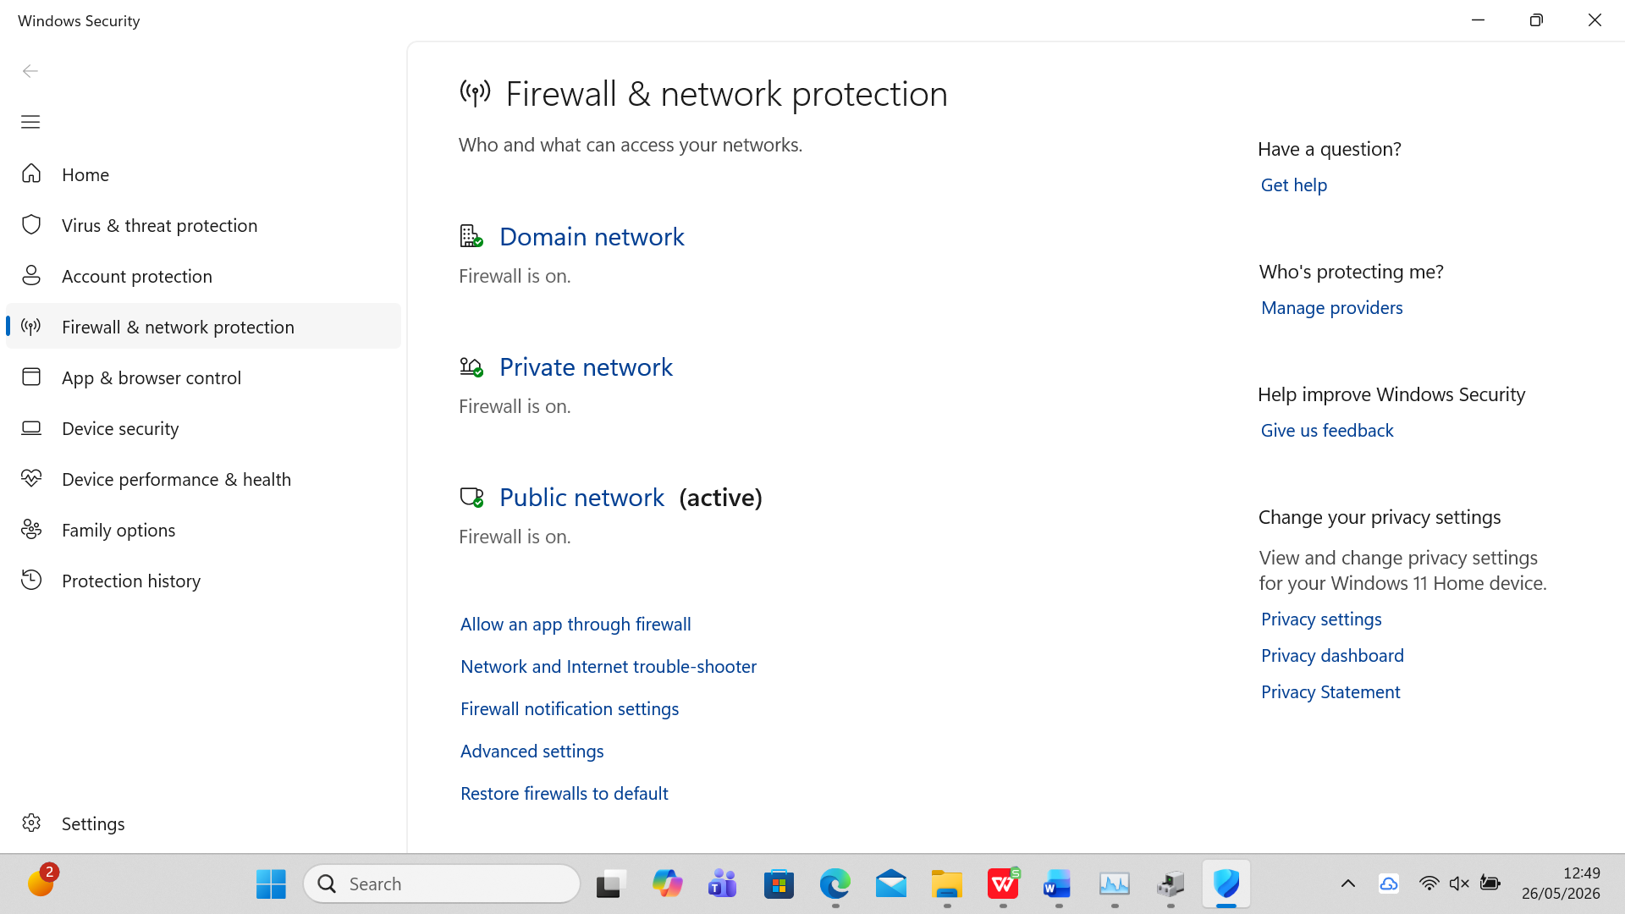
Figure 5: Security Management

Use of Windows OS CLI commands
Write about windows CLI functions and applications. Use 1-2 references. (40 words)

Example 1:
Explain the command and output. (30 words)

This `dir` command lists all folders in your user profile (`C:\Users\amina`), showing their dates, times, types, plus free drive space. No files here—just 15 directories total.

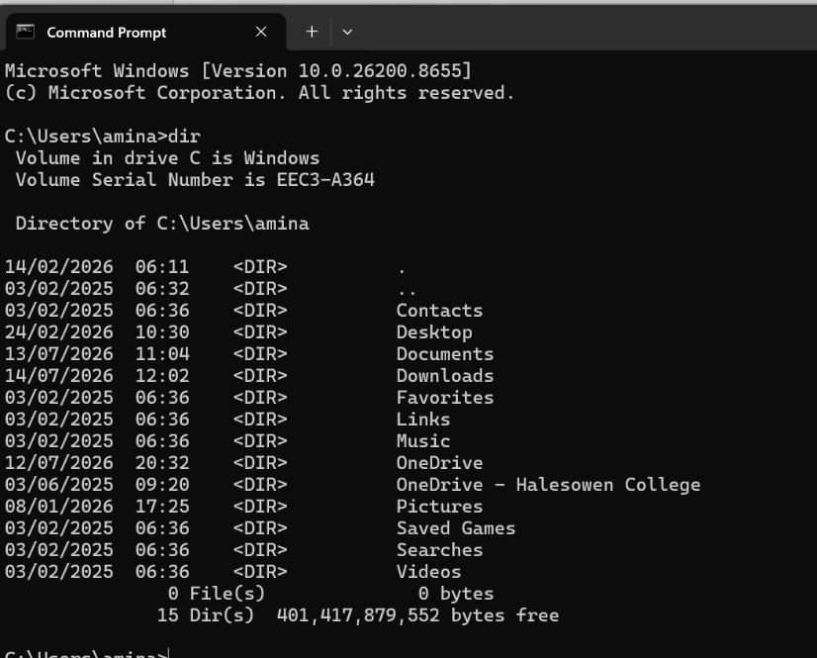
Figure 6: Description

Example 2:
Explain the command and output. (30 words)
This `cd Desktop` command moves you from your main user folder straight into the Desktop folder. The updated prompt confirms you’re now working inside `C:\Users\amina\Desktop`.
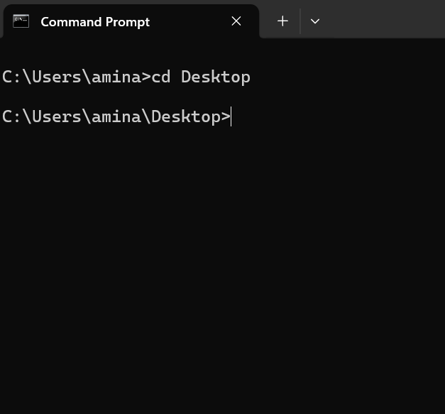
Figure 7: Description

Example 3:
Explain the command and output. (30 words)
mkdir new makes a brand-new folder named 'new' on your Desktop. `dir` then lists all files/folders there—including the new one you just made, plus file counts and drive space.
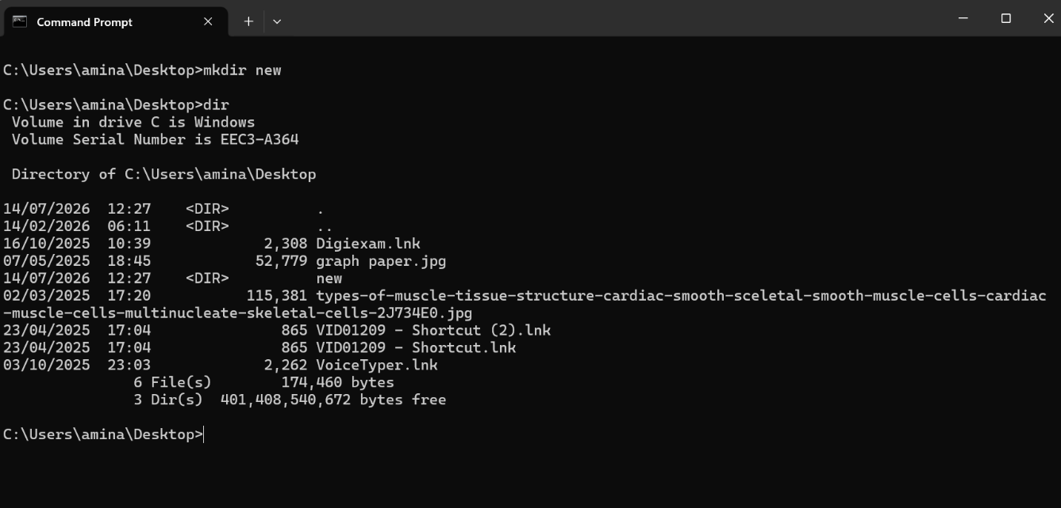
Figure 8: Description

Example 4:
Explain the command and output. (30 words)
rename new copy renames your folder from 'new' to 'copy'. The Dir check confirms the change worked—you now see 'copy' listed instead of the old name.

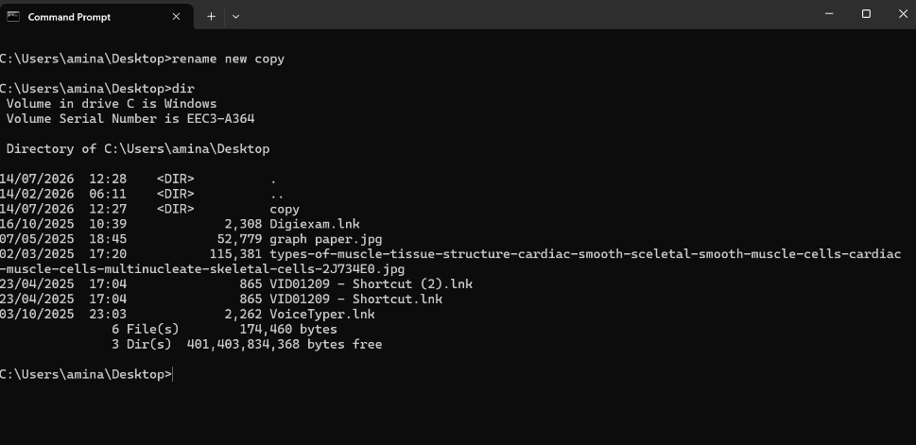
Figure 9: Description

Example 5:
Explain the command and output. (30 words)
rmdir copy deletes the empty folder named 'copy' from your Desktop. No error message appears, so the command ran successfully and the folder is gone.

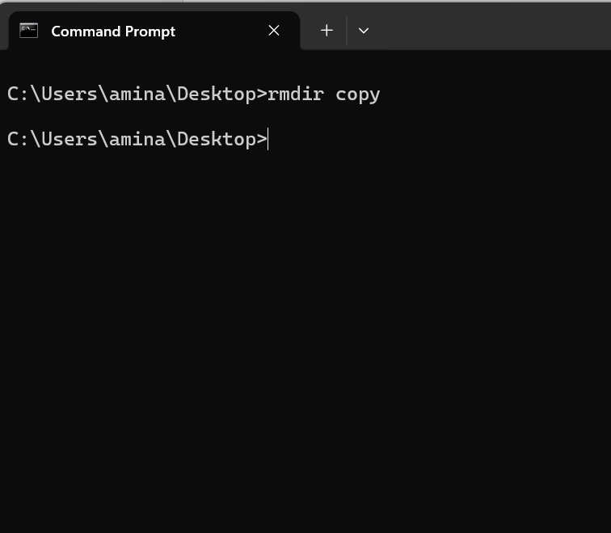
Figure 10: Description

Example 6:
Explain the command and output. (30 words)
echo hello >new.txt` creates a new text file and writes "hello" inside it. Typing new.txt opens the file to confirm the text was saved correctly.

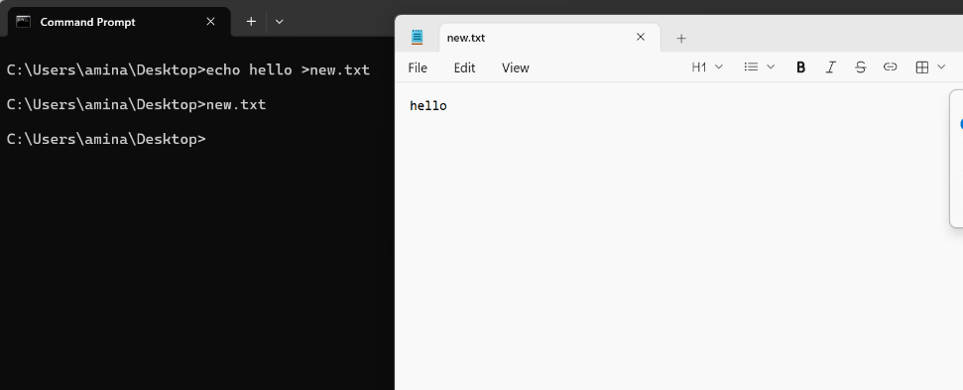
Figure 11: Description

Example 7:
Explain the command and output. (30 words)

ipconfig shows your network settings: Wi-Fi is active with IP 10.38.209.104 subnet 255.255.252.0 and gateway 10.38.208.1; other adapters are offline.
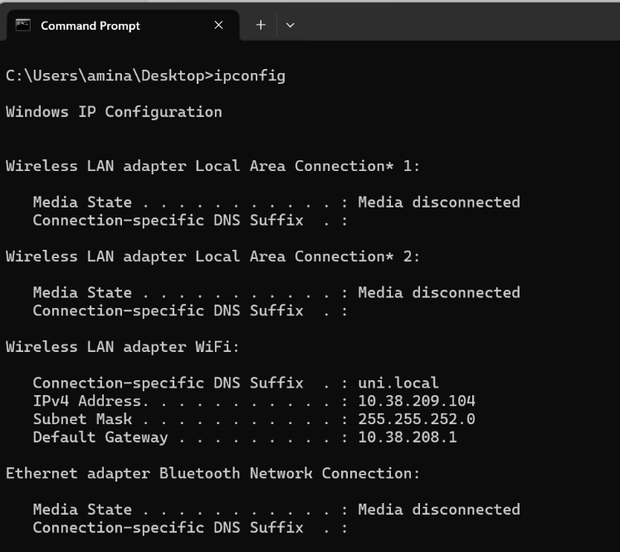
Figure 12: Description

Example 8:
Explain the command and output. (30 words)
ping www.google.com tests if you can reach Google’s server. All 4 test packets came back successfully with no loss, and response times are fast—so your internet connection works well.
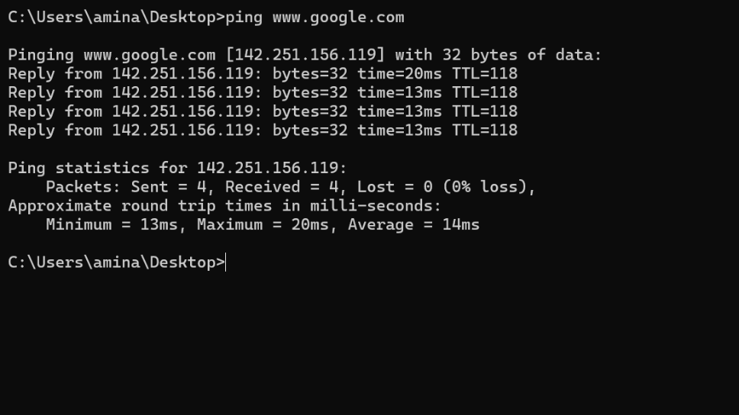
Figure 13: Description

Example 9:
Explain the command and output. (30 words)
system info pulls up full details about your PC: it runs Windows 11 Home on an HP Pavilion x360, with an Intel i5 processor, 8GB RAM, and UK English settings. All key system specs are listed clearly.
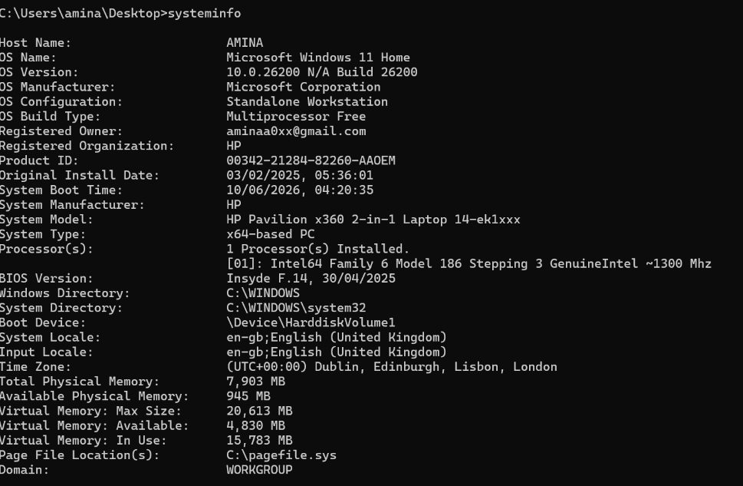
Figure 14: Description

Example 10:
Explain the command and output. (30 words)
task list lists every running program and background process. It shows each name, unique ID, session type, and memory use—so you can see exactly what’s active on your system right now.
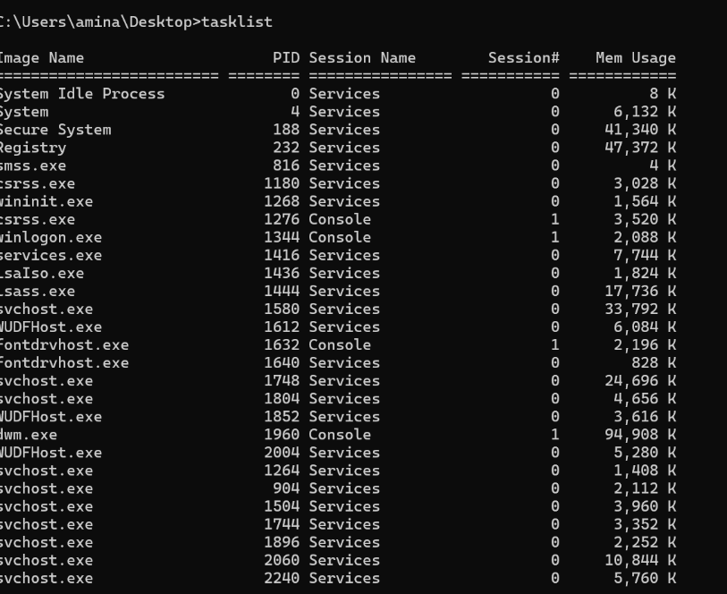
Figure 15: Description

Use of Linux OS CLI commands
Write about Linux CLI functions and applications. Use 1-2 references. (40 words)

Example 1:
Explain the command and output. (30 words)
Command: pwd
Meaning: Print Working Directory – it shows the full absolute path of your current folder/location in the Linux/Ubuntu file system.
Output: /home/sysadmin
This confirms you are currently in the home directory for the user account sysadmin.
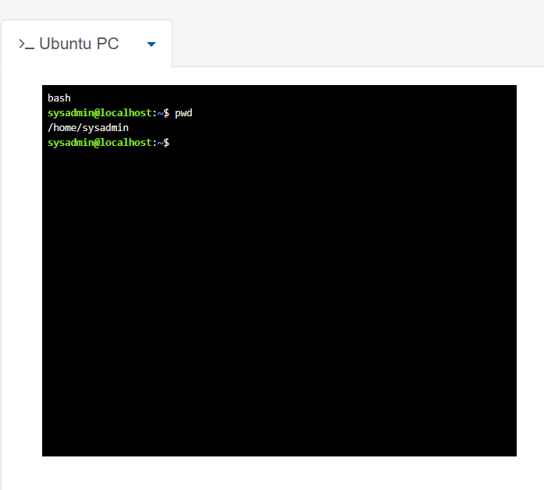
Figure 16: Description

Example 2:
Explain the command and output. (30 words).
The su command first elevates access to root after entering the password. Running su sysadmin then switches the session back to the original sysadmin user.
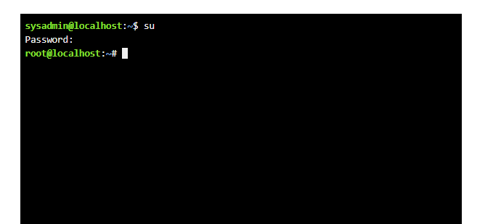

Figure 17: Description

Example 3:
Explain the command and output. (30 words)

ls shows standard visible folders. Adding -a reveals hidden system/configuration files starting with ., giving a full view of all directory contents.
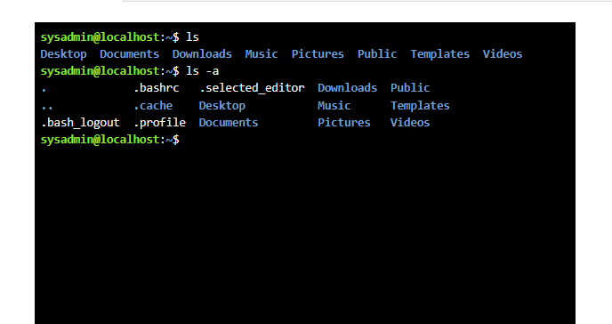
Figure 18: Description

Example 4:
Explain the command and output. (30 words)
The cd command moves you into the Desktop folder. The updated prompt ~/Desktop confirms you are now working inside the Desktop directory.
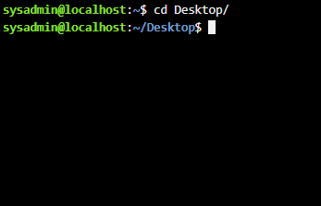
Figure 19: Description

Example 5:
Explain the command and output. (30 words)
mkdir new creates a new empty folder called new. Running ls verifies it worked, showing the newly added folder in the Desktop directory listing.
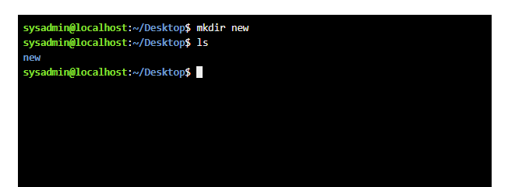
Figure 20: Description

Example 6:
Explain the command and output. (30 words)
rmdir new deletes the empty directory named new. The ls command confirms removal, returning no entry for new in the Desktop folder listing.
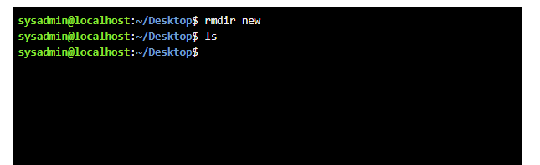
Figure 21: Description

Example 7:
Explain the command and output. (30 words
The touch command makes a blank file called new.text. Running ls confirms success by showing the new file in the Desktop folder.
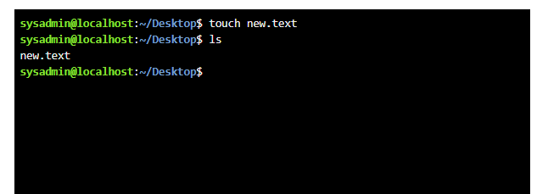
Figure 22: Description

Example 8:
Explain the command and output. (30 words
echo hello > adds text "hello" to new.txt. The cat command reads and prints the file’s content, showing "hello" as the result.
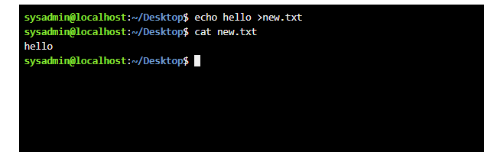
Figure 23: Description

Example 9:
Explain the command and output. (30 words)
ifconfig shows network settings: eth0 (Ethernet) has IP 192.168.1.2, and lo is the local loopback 127.0.0.1 for internal system use.
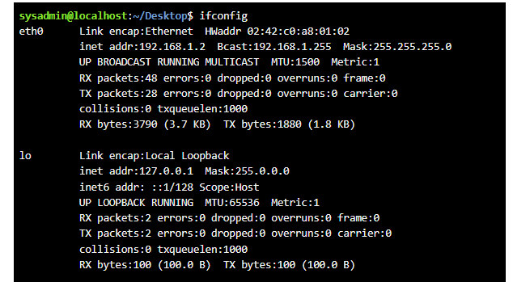
Figure 24: Description

Example 10:
Explain the command and output. (30 words)
whoami confirms the active user account is sysadmin. date prints the system’s current date, time and UTC timezone, showing the exact moment the command ran.
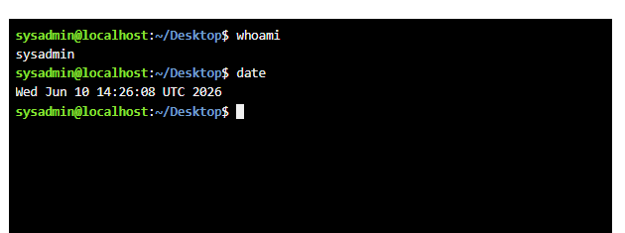
Figure 25: Description

Use of Windows OS scripts
Write about Batch scripting and its applications. Use 1-2 references. (50 words)
Batch scripting uses .bat or .cmd files to run sequences of commands automatically on Windows. It’s widely used for routine jobs like renaming groups of files, backing up folders, or checking system settings – saving time on repeated manual work (Microsoft, 2024 Stanek 2023).
References
Microsoft (2024). Batch Script Reference.
Stanek, W. (2023). Windows Command Line Guide.

Example 1:
Explain the script and output. (150 words) •
script
@echo off: Stops the commands themselves from appearing on screen, so only messages you want to show are displayed.
set /p num1=Enter the first number: Asks you to type a number and saves whatever you enter into a variable called num1.
set /p num2=Enter the second number: Does the same for the second number, storing it in num2.
set /a sum=num1+num2: The /a flag tells Windows to do maths here – it adds the two stored numbers and saves the result as sum.
echo the sum is %sum%.: Prints the final result, replacing %sum% with the actual calculated value.
Pause: Keeps the window open until you press a key, so you can read the result before it closes.
Output
when run the script first asks for your inputs. You type 6 then 8 the values are stored and added together to get 14, which is then shown on screen. The last line just waits for you to press any key before finishing.
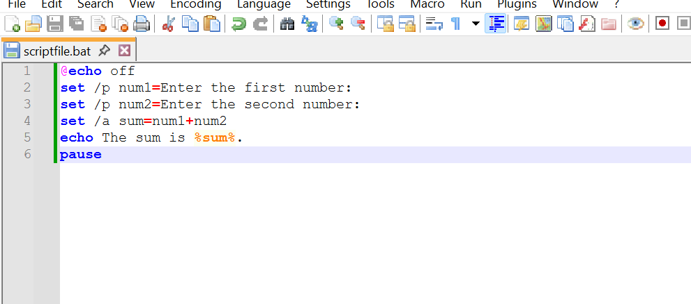
Figure 26: Description
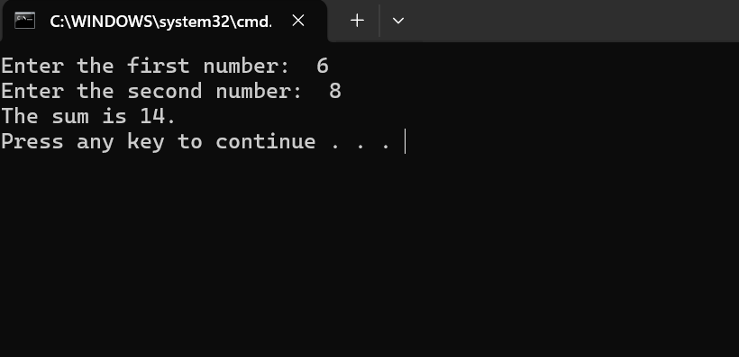
Figure 27: Description

Example 2:
Explain the script and output. (150 words)
What the script does line by line:
- @echo off: Stops the code itself from popping up on screen – only what you want to say shows.
- set /p age=Enter your age: Asks you to type your age and saves what you type as the "age" value.
- if %age% geq 18 ( Checks if your age is 18 or higher. "geq" just means "greater than or equal to".
- echo You are eligible to vote.: If you’re 18+, this message appears.
- else (: If you’re not 18+, jump to the next line.
- echo You are not eligible to vote yet.: Shows this message for anyone under 18.
- pause: Keeps the window open so you can read it, until you press any key.

output means
If you type 30and It’s over 18, so it says you can vote and If you type 10: It’s under 18, so it says you can’t vote yet.

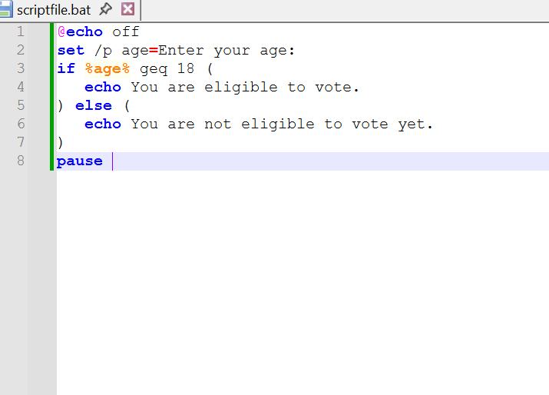
Figure 28: Script Input
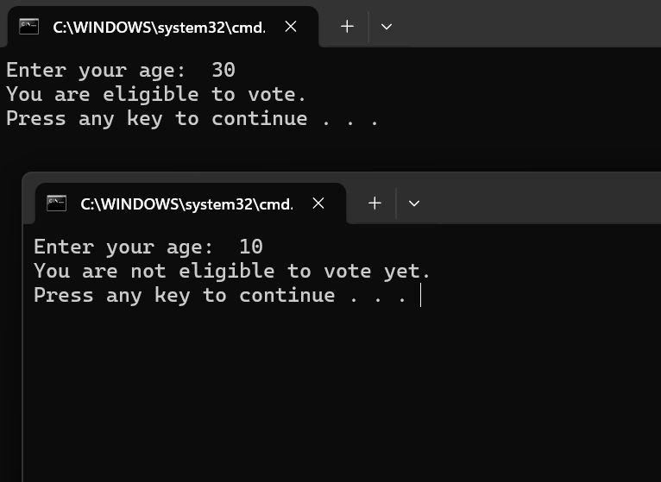
Figure 29: Script Output

Use of Linux OS scripts
Write about BASH scripting and its applications. Use 1-2 references. (50 words)
BASH Scripting & Applications
BASH scripts run lists of commands automatically on Linux computers. They’re used to do boring jobs like moving files, checking system health, or running regular tasks without you doing them one by one (Linux Foundation 2025 Sobell 2024).
References
Linux Foundation (2025). Getting Started with Bash.
Sobell, M. (2024). Linux Shell Scripts for Beginners.

Example 1:
Explain the script and output. (150 words)
The input is that the Bash script starts by showing the prompt “Enter the first number” and you type any whole number and press Enter, and the read command saves this value to the variable num1. Next it displays “Enter the second number”; you type a second integer and press Enter, which is stored as num2. The script uses these two entered values for its calculation.
The output is the line total=$((num1+num2)) adds the two numbers together and saves the result as total. The script then prints “the sum is” followed by your calculated total. For example, if you input 10 then 35, the output shown will be exactly “the sum is 45”. It only works correctly with whole integers and will run once you save the file and enable execution permissions.
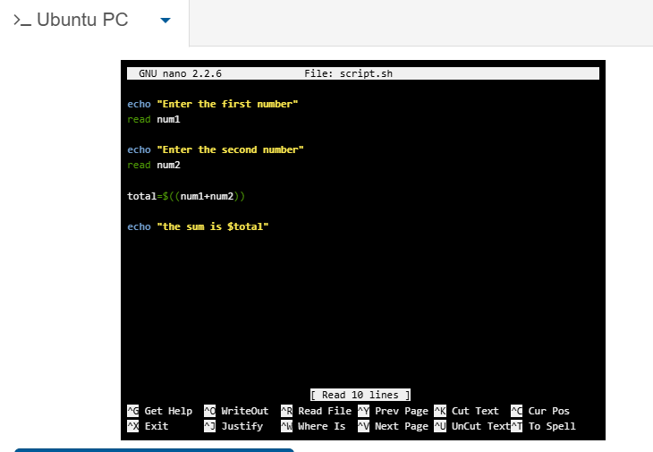
Figure 30: Description
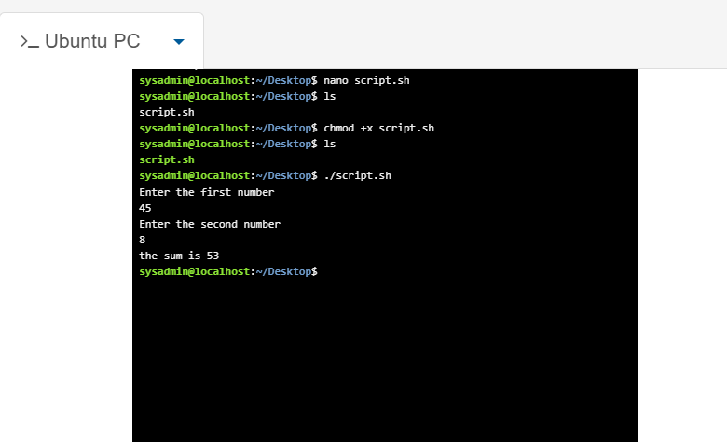
Figure 31: Description

Example 2:
Explain the script and output. (150 words)
Input
This Bash script starts by asking “How many times you want to run?”. You enter a whole number (for example 5) and press Enter; the read command saves this value to the variable count. The for loop is set to start at i=1, keep running as long as i is less than or equal to your entered count, and increase i by 1 after every full run. Before it works, you first save the file, run chmod +x script2.sh to give it permission to work, then start it with ./script2.sh.
Output
Once you enter your chosen number, the loop runs one time for each count from 1 up to your limit. Each time it prints the current value of I on its own line. If you enter 5, the output shows each number in order: 1, 2, 3, 4, 5. When it hits the last number, the loop stops automatically and returns you to the command prompt.

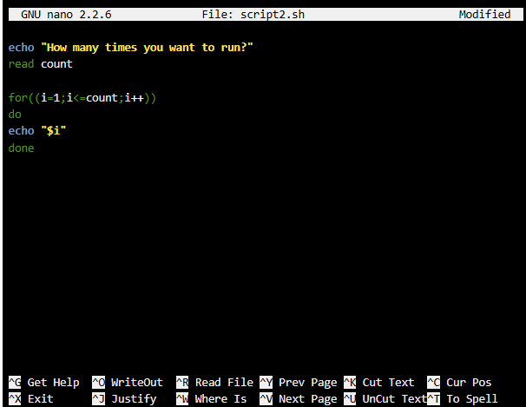
Figure 32: Loop input

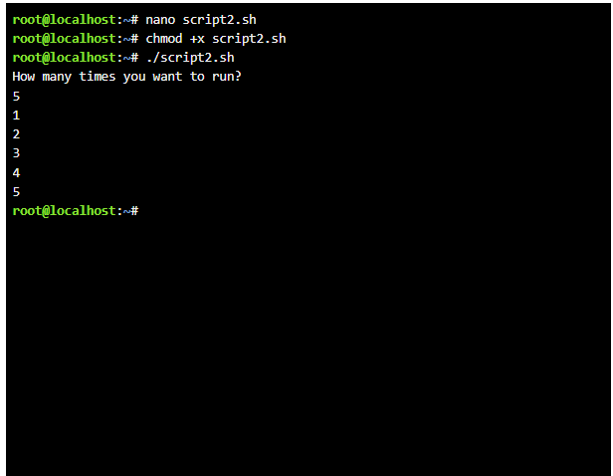
Figure 33: Loop Output

Conclusion
Summarize the report and your understanding of these tasks. (50 words)
These tasks covered core Windows commands and basic Bash scripting. I learned to navigate folders, manage files/folders, check system/network details, and write simple scripts for calculations and loops, building practical command-line skills.

References
There are no sources in the current document.

Appendices
Online Course name: Linux Unhatched


Figure 34: Certificate of completion

