🧠 Community Mental Health Services
Providing Support for Mental Wellbeing in the Community

📌 WHAT ARE COMMUNITY MENTAL HEALTH SERVICES?

Community Mental Health Services (CMHS) are specialized programs designed to support individuals experiencing mental health challenges while allowing them to live independently in their own homes or communities. Unlike traditional approaches that often rely on extended hospital stays, these services focus on providing care in familiar environments, which helps promote recovery and maintain a person’s connection to their daily life.

The main purpose of CMHS is to offer comprehensive assessment, treatment, and ongoing support tailored to everyone’s unique needs. By offering personalized care, these services aim to improve overall wellbeing and help individuals manage their conditions effectively.

A key principle of Community Mental Health Services is promoting independence. They empower people to take control of their own recovery journey, encouraging active participation in their treatment and decision-making. Early intervention is another important aspect, as addressing issues promptly can prevent symptoms from worsening.

Additionally, CMHS emphasize social inclusion and connection, recognizing that strong community ties and support networks are vital for mental health. These services provide not only emotional and psychological support but also practical assistance, helping individuals with everyday challenges such as housing, employment, and social activities.

Overall, Community Mental Health Services play a crucial role in mental health care by offering compassionate, holistic support that helps people lead fulfilling lives within their communities.

Community Mental Health Services offer assessment, treatment, and ongoing support for people facing mental health challenges while they continue living at home or within their local community. Rather than long hospital admissions, care is provided in familiar surroundings to encourage independence and aid recovery.

These services assist individuals with conditions such as:

- Depression and anxiety disorders
- Bipolar disorder
- Schizophrenia
- Personality disorders
- Eating disorders

The primary goal is to enhance wellbeing while supporting individuals to stay active and engaged in their communities.

The core principles include:

- Care focused on the individual’s needs
- Promoting independence and giving people control
- Acting early to prevent worsening issues
- Encouraging social connection and inclusion
- Providing comprehensive support that covers emotional, social, and practical aspects of life

🕰️ A SHORT HISTORY OF COMMUNITY MENTAL HEALTH SERVICES

Before the 1950s, mental health care was mainly provided in large psychiatric hospitals called asylums, where people were often separated from society for long periods, which sometimes led to loss of independence and increased stigma.
From the 1950s to the 1980s, government policies encouraged deinstitutionalisation, closing many long-stay hospitals and shifting the focus to supporting people within their own communities instead of institutions.

Since the 1990s, services have focused on recovery, dignity, and inclusion. Multidisciplinary teams now create personalised care plans tailored to each person’s needs and goals. Today, community-based care is a key part of health and social
care systems.

⚙️ HOW THE SERVICE WORKS TODAY

Community Mental Health Services today are delivered by multidisciplinary teams working together to provide coordinated care.

The professionals involved include:

- Psychiatrists
- Mental health nurses
- Social workers
- Psychologists
- Occupational therapists
- Support workers

Each team member brings their own expertise to help support the individual’s recovery and wellbeing.

Types of Support Provided - Assessment and Diagnosis

Assessment includes mental health evaluations, risk checks, and creating personalised care plans. Treatment involves talking therapies like counselling or CBT, medication management, and crisis support. Daily living help covers routines, housing, finances, and job or education advice. Recovery support focuses on coping skills, social activities, and ongoing reviews. People can access these services through GP referrals, hospitals, social services, or sometimes self-referral, depending on the area.

🌍 The significance of Community Mental Health Services

Community services are vital for enhancing both individual and public health by:

- Reducing hospital admissions
- Encouraging independence and self-confidence
- Supporting recovery in familiar surroundings
- Lowering the stigma linked to mental health issues
- Enhancing quality of life and social engagement

Receiving care within the community helps individuals keep their relationships, jobs, and daily routines while getting professional support.

⚠️ CHALLENGES FACED BY COMMUNITY MENTAL HEALTH SERVICES

Challenge 1: Rising Demand

There has been a significant increase in people seeking mental health support because of:

- Greater awareness of mental health issues
- Social and economic pressures
- Impact of the COVID-19 pandemic
This growing demand can result in longer waiting times and added strain on services.

Challenge 2: Staffing and Funding Issues
Many community mental health services face a shortage of skilled professionals and limited budgets.

This can lead to:

- Heavy workloads for staff
- Fewer available appointments
- Increased risk of staff burnout
- Challenges in delivering personalised care

Tackling these problems is crucial to ensure continued effective support for those who need it.

📊 CARE PATHWAY 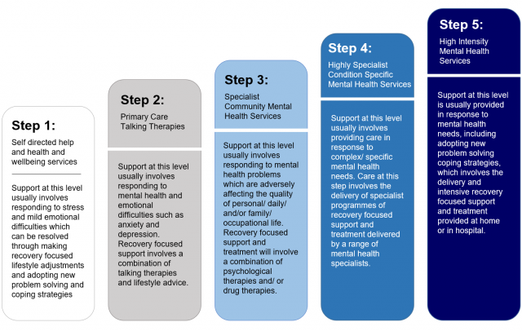

⭐ Key principles of community mental health care include:

- Focusing on the individual’s needs
- Treating people with respect and dignity
- Providing support early on
- Encouraging teamwork among professionals
- Promoting independence
- Supporting overall wellbeing in a holistic way

🧾 CONCLUSION

Community Mental Health Services play a crucial role in today’s health and social care system. The focus has shifted from institutional care to community-based support that encourages recovery, independence, and social inclusion.
Despite facing challenges like rising demand and workforce shortages, these services remain essential for helping people manage their mental health and lead fulfilling, connected lives within their communities.

Ambulance Services



Ambulance services have a rich history that began centuries ago, evolving from simple transportation of the injured to a sophisticated emergency medical system essential in modern healthcare.

The origins of ambulance services can be traced back to the 18th century during wartime. Military armies recognized the need to quickly move injured soldiers from battlefields to medical care, leading to the creation of mobile medical units called ambulances. The word "ambulance" itself comes from the French term "ambulant," meaning "walking" or "mobile," highlighting their original function as mobile care units. In the 19th century, as cities grew and industrial accidents became more common, civilian ambulance services started to develop. Advances in medical knowledge and technology, such as the invention of stretchers and better transportation methods, helped these services become more efficient. The establishment of organized ambulance services was also influenced by public health reforms and the rise of hospitals.

Today, ambulance services function as an integral part of emergency healthcare systems worldwide. They provide immediate medical care and rapid transportation for individuals experiencing urgent health issues like heart attacks, strokes, severe injuries, or other life-threatening conditions. Modern ambulances are equipped with advanced medical equipment, including defibrillators, oxygen supplies, and medications, enabling paramedics and emergency medical technicians (EMTs) to deliver critical care on the way to the hospital. Ambulance crews undergo rigorous training to assess, stabilize, and treat patients in the field. These services operate 24 hours a day, often coordinated through centralized dispatch centres that prioritize calls based on urgency to ensure the fastest response times possible.

The significance of ambulance services in improving the quality of life for service users is profound. They serve as the vital link between the scene of an emergency and hospital care, increasing the chances of survival and reducing the severity of health outcomes. Rapid intervention by ambulance staff can prevent complications, manage pain, and provide reassurance to patients and their families during stressful situations.

Furthermore, ambulance services contribute to public health by supporting community safety, participating in disaster response, and offering health education programs. By ensuring timely access to emergency care, ambulance services help individuals recover more quickly and maintain better long-term health.

In conclusion, ambulance services have evolved from their military origins into a sophisticated, essential healthcare resource. Their ability to provide prompt medical care and transportation saves lives and enhances the wellbeing of countless individuals. Despite challenges such as funding pressures and workforce demands, ambulance services remain a cornerstone of effective healthcare, significantly improving the quality of life for those they serve.

REFERENCES

Mental health services - NHS
Roles in the ambulance service | Health Careers
NHS England » Ambulance

