
Marketing Management
Marketing Strategies Portfolio

Module Name: Marketing Management
Module Code: LCMB7024
Student Name: Prince Laurence Sade
Student ID: 2525510
Programme: Master of Business Administration (MBA)
University: University of Wales Trinity Saint David
Lecturer : Taonga Kaonga Sobere- Snithers
Assessment Title: Assessment component 2:
Marketing Strategies Portfolio
Word Count: 2747 words (excluding references)
Submission Date: 01 April 2026

Table of Contents
1. Introduction 2
2. Brand Extension Strategy 2
3. STDP Analysis 3
3.1 Segmentation 4
Geographic Segmentation 5
Demographic Segmentation 5
Psychographic Segmentation 5
Behavioural Segmentation 5
3.2 Targeting 6
3.3 Differentiation 6
3.4 Positioning 7
4. Macro-Environmental Analysis (PESTLE) 8
Technological 9
Economic 9
Social 9
Political and Legal 9
Environmental 9
5. Marketing Mix Strategy (7Ps) 9
5.1 Product 10
5.2 Price 11
5.3 Place 11
5.4 Promotion 12
5.5 People 12
5.6 Process 13
5.7 Physical Evidence 13
6. Competitive Strategy 13
7. Sustainability and Societal Marketing 14
8. Reflection 15
9. Conclusion 16
References 17
Appendix…………………………………………………………………………………………………………………………19

1. Introduction
Brand development is a strategic mechanism through which firms leverage existing brand equity to generate competitive advantage and enter new markets with reduced consumer uncertainty. In saturated markets, firms must innovate beyond incremental product improvements and strategically extend brand equity into adjacent categories (Kotler and Keller, 2022).
Samsung Electronics has built strong global brand equity through its Galaxy ecosystem of smartphones, wearables, smart home devices, and AI services. As artificial intelligence and augmented reality technologies mature, wearable devices are shifting from fitness-focused accessories toward productivity-enhancing digital tools.
The global wearable technology market continues to expand rapidly as artificial intelligence and augmented reality technologies mature. According to Statista (2024), the global wearable technology market is projected to exceed $150 billion by 2028, driven by increasing consumer demand for hands-free digital interaction and connected devices. Within this category, smart glasses are emerging as a key innovation as firms integrate augmented reality, voice interaction, and AI assistance into wearable devices. This growth trajectory suggests significant commercial potential for technology firms capable of delivering practical, user-friendly smart eyewear solutions.
This portfolio proposes the launch of Samsung Galaxy AI Smart Glasses as a strategic brand extension into the smart eyewear category. The analysis applies STDP, the extended 7Ps marketing mix, macro-environmental analysis, Porter’s competitive frameworks, and sustainability principles. The objective is to evaluate whether this extension can generate sustainable growth while protecting Samsung’s brand equity and competitive positioning.

2. Brand Extension Strategy
A brand extension involves using an established brand name to enter a new product category (Kotler et al., 2020). While extensions can reduce marketing costs and increase initial consumer acceptance, they also risk brand dilution if misaligned (Aaker, 1991).
Samsung’s entry into AI smart glasses represents related diversification under the Ansoff Matrix (Hooley et al., 2020). Although Samsung already operates in wearable technology (e.g., Galaxy Watch), smart eyewear constitutes a new but complementary category.
Strategic justification includes:
- Leveraging Galaxy ecosystem integration
- Enhancing cross-device connectivity
- Responding to AI adoption trends
- Strengthening innovation leadership positioning
However, brand fit is critical. If consumers perceive the extension as inconsistent with Samsung’s core competencies, brand equity may weaken (Kapferer, 2012). Therefore, the smart glasses must reinforce Samsung’s identity as an innovation-driven, technologically advanced, and user-centric brand.
Brand extension success depends heavily on perceived category fit and consumer trust transfer. Research suggests that extensions into technologically related categories are more likely to succeed due to cognitive consistency (Kotler et al., 2020). In contrast, poorly aligned extensions risk negative spillover effects, damaging the parent brand. Samsung’s established expertise in wearable technology and AI integration increases perceived credibility in the smart eyewear space. However, if performance expectations are not met, consumer disappointment could weaken brand associations. Therefore, careful product positioning and quality assurance are essential to maintain brand equity while pursuing diversification.

3. STDP Analysis

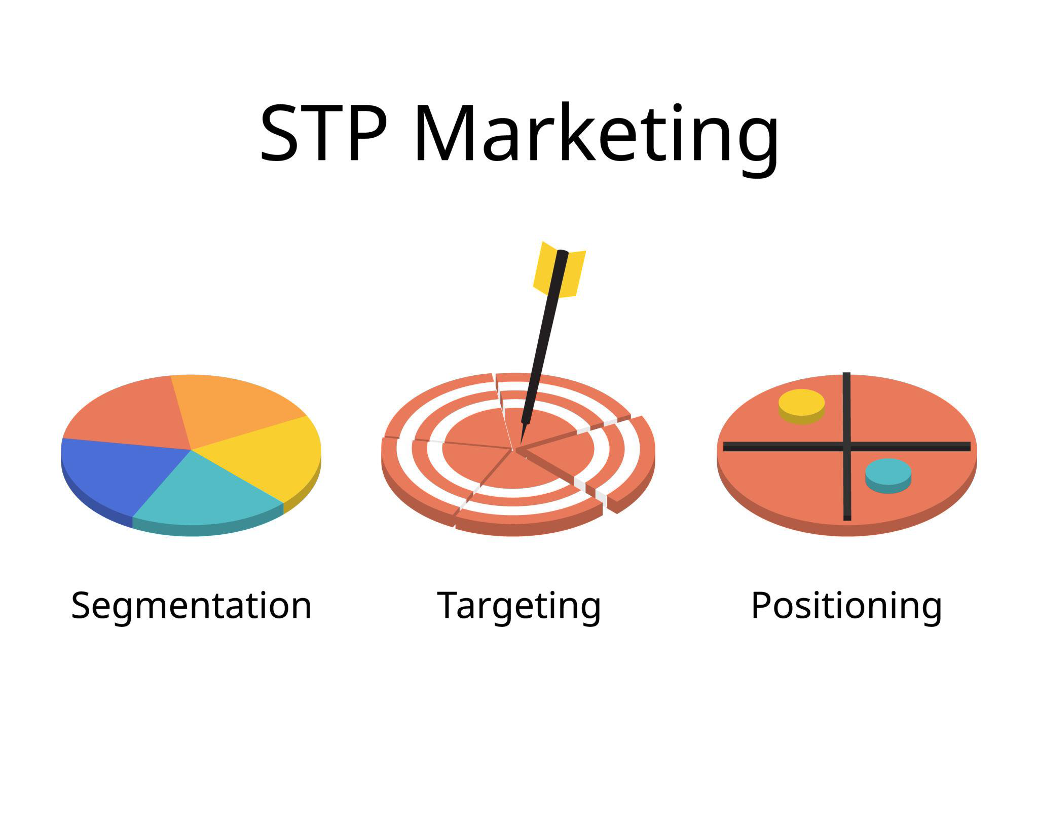

Figure 1: Segmentation, Targeting and Positioning Framework

Source: Adapted from Kotler et al. (2020)

3.1 Segmentation
Segmentation divides a market into groups with similar characteristics. (Kotler et al., 2020). In emerging technology markets, segmentation must account for behavioural readiness and innovation adoption patterns.
Diffusion of Innovation theory further strengthens this segmentation approach (Rogers, 2003). Early adopters are characterised by higher risk tolerance, technological curiosity, and social influence. Targeting this group initially allows Samsung to generate word-of-mouth credibility before expanding to the early majority. However, over-reliance on early adopters may restrict mainstream scalability. Therefore, segmentation must evolve alongside product life cycle progression. Mis-segmentation could result in positioning the product either too technically complex for mainstream consumers or too simplified for innovation-seeking users.

Geographic Segmentation
Target markets include the UK, USA, Germany, and South Korea. These regions demonstrate advanced technological infrastructure, high digital literacy, and strong early adoption patterns. Expansion into price-sensitive emerging markets should occur after economies of scale reduce production costs.

Demographic Segmentation
- Age: 18–45
- Income: Middle to upper-middle
- Occupation: Professionals, students, entrepreneurs
- Education: Digitally literate individuals
However, demographic segmentation alone is insufficient. Technological adoption is more strongly influenced by income and occupational digital engagement than by age alone.

Psychographic Segmentation
Target consumers are innovation-oriented, productivity-driven, and digitally integrated. According to diffusion of innovation theory, early adopters exhibit higher risk tolerance and influence later adoption stages.

Behavioural Segmentation
- Frequent smartphone users
- Samsung ecosystem customers
- Benefit-seekers (hands-free productivity, AI assistance)
- Brand-loyal consumers
Effective segmentation must satisfy the criteria of measurability, accessibility, substantiality, differentiability, and actionability to ensure strategic viability (Kotler et al., 2020). Over-segmentation could dilute marketing resources, whereas under-segmentation may result in generic positioning.

3.2 Targeting
Samsung will adopt a differentiated targeting strategy.
Primary segment: Young professionals aged 25–40 seeking productivity enhancement.
Secondary segment: University students and technology enthusiasts aged 18–30.
Initially focusing on early adopters reduces market education cost. However, long-term growth requires gradual expansion beyond niche segments. Therefore, targeting must evolve alongside product life cycle stages.
From a strategic perspective, Samsung could have adopted a concentrated strategy focusing solely on a niche productivity segment. However, such a narrow focus may limit long-term growth. Conversely, an undifferentiated mass strategy would reduce clarity of positioning and weaken perceived exclusivity. A differentiated strategy balances scale and clarity, allowing Samsung to tailor communication while preserving innovation-driven brand identity (Kotler et al., 2020). This approach supports gradual market expansion while protecting premium perception during early adoption stages.

3.3 Differentiation
Porter’s Generic Strategy suggests differentiation enables firms to command premium pricing through perceived uniqueness (Johnson et al., 2017).
Samsung differentiates via:
- AI-powered real-time interaction
- Seamless Galaxy ecosystem integration
- AR-based visual interface
- Premium industrial design
However, hardware innovation is easily imitated. Sustainable differentiation depends on ecosystem lock-in, software integration, and data-driven personalisation. Switching costs created by cross-device connectivity strengthen competitive defensibility beyond feature-based advantages (Porter, 1985).

3.4 Positioning
Positioning defines the product’s place in consumers’ minds relative to competitors (Kotler et al., 2020).
Positioning statement:
“Samsung Galaxy AI Smart Glasses are premium AI-powered wearables designed to enhance productivity and seamless digital connectivity for modern professionals.”
A perceptual positioning map comparing Samsung, Apple, and Meta could illustrate differentiation along dimensions of ecosystem integration and professional productivity (Hooley et al., 2020).
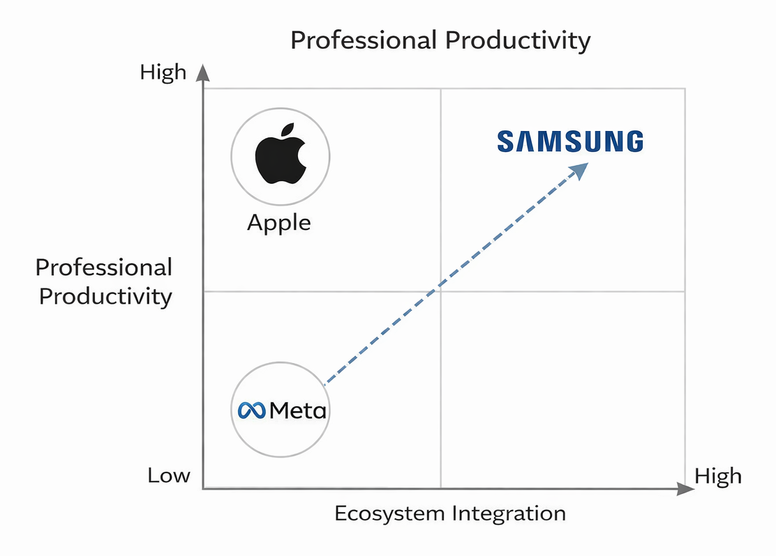
Figure 2 : Perceptual Positioning Map of Smart Glasses Competitors
Source: Author’s own illustration
Apple may position strongly on premium exclusivity, while Meta emphasises social connectivity. Samsung’s positioning should emphasise balanced innovation and cross-platform integration. However, over-positioning toward advanced functionality risks intimidating mainstream consumers. Therefore, communication must highlight simplicity and practical benefits rather than technical complexity alone.
Positioning integrates:
- Functional value (efficiency and convenience)
- Emotional value (future-oriented identity)
Table 1: Summary of STDP Strategy for Samsung Galaxy AI Smart Glasses
Source: Author’s own work
Element | Strategic Choice
Segmentation | Geographic (UK, USA), Demographic (18–45), Psychographic (innovation-driven), Behavioural (Galaxy ecosystem users)
Targeting | Differentiated targeting (Professionals + Students)
Differentiation | AI integration + Ecosystem lock-in
Positioning | Premium AI-powered productivity wearable

4. Macro-Environmental Analysis (PESTLE)
Strategic decisions must consider both opportunities and risks within the macro-environment. Economically, inflationary pressures may reduce discretionary spending, affecting premium product adoption. Socially, increasing concern about surveillance and wearable cameras may generate ethical debates. Legally, compliance with GDPR and AI governance frameworks requires transparent data management practices. Politically, sustainability regulation and carbon reporting standards are becoming stricter in the UK and EU markets.

Technological
Rapid AI development and wearable innovation create opportunity. However, short product life cycles increase obsolescence risk.
Industry forecasts also indicate strong technological momentum within the augmented reality sector. IDC (2023) predicts that global shipments of AR and VR devices will grow at an average annual rate exceeding 30 percent over the next five years. This rapid technological progression increases both opportunity and competitive pressure for firms entering the wearable computing market.

Economic
Premium pricing may face resistance during economic uncertainty. Flexible financing and bundling strategies can mitigate price sensitivity.

Social
Digital multitasking and remote work trends support adoption. However, privacy concerns regarding wearable cameras may create resistance.

Political and Legal
GDPR and global data protection laws require transparent data handling and ethical AI governance.

Environmental
Growing sustainability awareness aligns with energy-efficient and recyclable product design.
The macro-environment reinforces the need for privacy safeguards and sustainability integration.

5. Marketing Mix Strategy (7Ps)

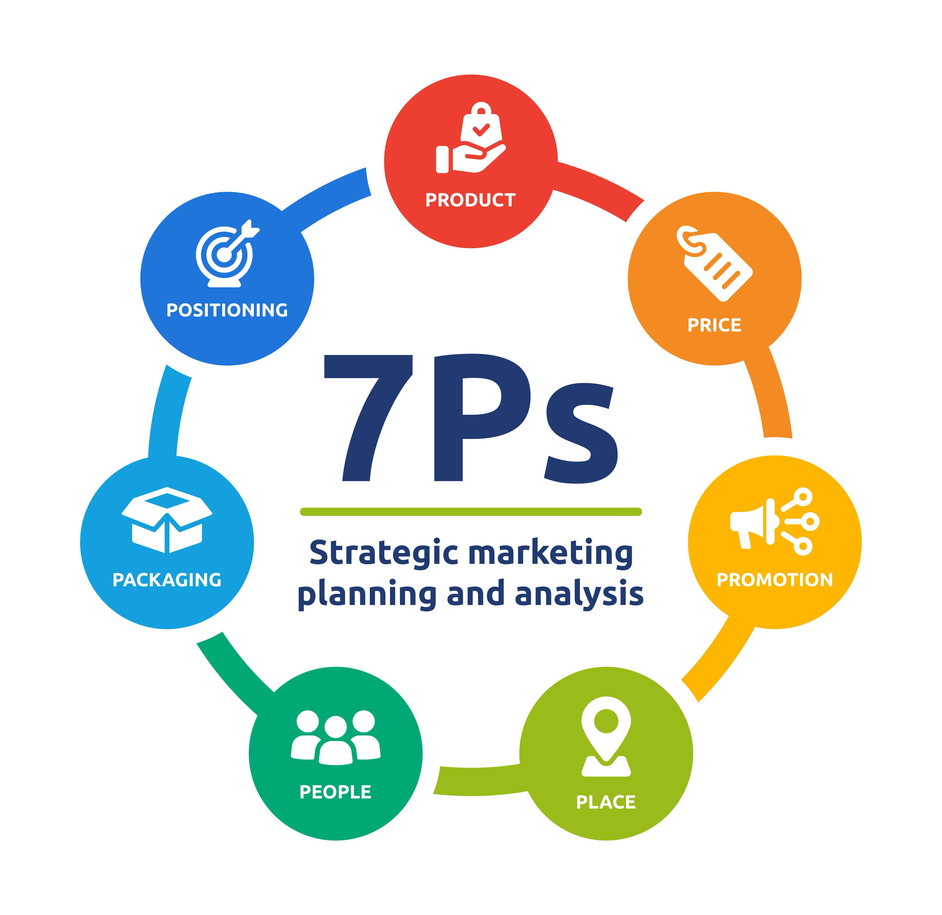

Figure 3: The Extended Marketing Mix (7Ps)

Source: Adapted from Kotler and Keller (2022)

5.1 Product
Within the Product Life Cycle framework, Samsung Galaxy AI Smart Glasses would initially operate in the introduction stage, where market awareness is limited and promotional investment is required to stimulate adoption (Kotler and Keller, 2022). During this phase, sales growth is gradual and promotional investment is high. If early adoption fails to generate sufficient awareness, the product may struggle to reach growth stage momentum. Continuous software updates and feature enhancements will be necessary to extend product relevance and avoid premature maturity.
The core product delivers hands-free AI assistance. The actual product includes AR interface, voice control, and Galaxy integration. The augmented product includes warranty, updates, and Samsung Care.

5.2 Price
Market-skimming pricing aligns with premium positioning (Kotler et al., 2020). Early adopters typically demonstrate lower price sensitivity. Research on innovation diffusion indicates that early adopters are typically willing to pay premium prices for novel technologies due to perceived status value and innovation leadership (Rogers, 2003).
However, as competitors enter, price elasticity may increase. Long-term pricing strategy may include:
- Bundle pricing
- Subscription AI services
- Installment payment options
A skimming strategy allows Samsung to capture higher margins from early adopters who demonstrate lower price sensitivity. However, overpricing may slow diffusion beyond innovators. Psychological pricing strategies, such as tiered models or bundle discounts with Galaxy smartphones, could broaden appeal without undermining premium perception (Solomon, 2020). Over time, price adjustments may become necessary as competitive rivalry intensifies.

5.3 Place
Samsung will implement a hybrid multi-channel strategy:
- Direct online sales
- Samsung flagship stores
- Electronics retailers
- Telecom partnerships
Direct channels enhance margin control; indirect channels increase reach.
Channel conflict must be managed to prevent pricing inconsistencies.
An omni-channel strategy ensures consistent brand experience across digital and physical touchpoints. However, channel conflict may arise if online pricing undercuts retail partners. Careful coordination and transparent pricing structures are essential to maintain retailer relationships while preserving direct-to-consumer profitability.

5.4 Promotion
Integrated Marketing Communication (IMC) ensures consistent messaging (Schultz and Schultz, 2004).
Promotional tools include:
- Digital advertising
- Influencer marketing
- Experiential demonstrations
- PR campaigns
The AIDA model (Attention, Interest, Desire, Action) supports structured communication planning (Kotler and Keller, 2022). Initial campaigns must capture attention through innovation-focused messaging, followed by demonstration content that builds interest and desire through practical use cases. Excessive emphasis on futuristic imagery without practical demonstration may create curiosity but not conversion. Therefore, experiential marketing and in-store demonstrations are critical for reducing perceived complexity.

5.5 People
Employees must effectively communicate technical features. Internal marketing aligns staff behaviour with innovation positioning.
Service quality influences post-purchase satisfaction. According to SERVQUAL principles, reliability, responsiveness, and assurance are particularly important for technology products (Zeithaml et al., 2018). Sales staff must effectively communicate both technical capability and ease of use to reduce perceived risk.

5.6 Process
Seamless onboarding, intuitive interface design, and AI software updates are essential. CRM systems support long-term relationship management.
Customer journey optimisation is critical. From purchase to activation and update cycles, process simplicity reduces cognitive effort and enhances perceived value. CRM systems enable personalised recommendations and long-term engagement strategies, increasing customer lifetime value.

5.7 Physical Evidence
Premium packaging and store displays reinforce quality perception. Sustainability messaging should be visible but not exaggerated.
Packaging and retail presentation serve as tangible cues of quality. Sustainable packaging materials reinforce environmental commitment while maintaining premium aesthetics. Physical evidence bridges intangible technological benefits with tangible brand credibility.

6. Competitive Strategy
Under Ansoff’s Matrix, this represents related diversification. Samsung competes with Apple’s ecosystem and Meta’s smart glasses.
Applying Porter’s Five Forces :
- Threat of New Entrants: Moderate due to high R&D costs.
- Bargaining Power of Buyers: Moderate; early adopters less price-sensitive.
- Bargaining Power of Suppliers: Moderate due to specialised components.
- Threat of Substitutes: High (smartphones perform similar functions).
- Competitive Rivalry: Increasing as AR market grows.
Table 2: Porter’s Five Forces Analysis of the Smart Glasses Market
Source: Adapted from Porter (1980)
Force | Impact Level | Justification
Rivalry | High | Apple, Meta competition
Substitutes | High | Smartphones
Buyer Power | Moderate | Premium segment
Supplier Power | Moderate | Specialised components
New Entrants | Moderate | High R&D barrier
Samsung’s competitive advantage depends on ecosystem integration and brand equity rather than hardware alone (Porter, 1985).
Despite strong growth potential, adoption barriers remain significant. Consumer concerns surrounding privacy, social acceptability, and device aesthetics have historically slowed the diffusion of smart glasses technology. Previous attempts by competitors such as Google Glass demonstrated that technological capability alone is insufficient to guarantee market success. Consequently, Samsung must ensure that the proposed smart glasses deliver clear practical value while addressing privacy and usability concerns to encourage mainstream adoption.

7. Sustainability and Societal Marketing
The societal marketing concept emphasises balancing profitability with societal well-being (Kotler et al., 2020).
Samsung can integrate:
- Recyclable materials
- Energy-efficient processors
- Transparent carbon reporting
- Ethical AI governance
Greenwashing risks must be avoided through measurable commitments.
Embedding sustainability within product design and supply chain operations strengthens long-term brand trust and organisational legitimacy while aligning with increasing regulatory and consumer expectations for responsible technology development.
The Triple Bottom Line framework emphasises balancing People, Planet, and Profit (WCED, 1987). Samsung’s strategy must therefore integrate environmental responsibility, social accountability, and financial performance. Ethical AI governance, transparent supply chains, and carbon footprint reporting enhance stakeholder trust. Sustainability should be embedded within operational decision-making rather than treated as promotional messaging. Failure to substantiate green claims risks accusations of greenwashing (Weber, 2020), which can significantly damage brand credibility.

8. Reflection
Developing this portfolio provided valuable insight into the complexity of strategic marketing decision-making within technology-driven industries. While marketing frameworks such as STDP and the marketing mix initially appear structured and linear, applying them in practice revealed that strategic decisions are highly interconnected. Segmentation decisions influenced pricing strategy, positioning affected promotional messaging, and technological capabilities shaped competitive strategy. This experience reinforced the importance of integrated strategic thinking when developing marketing strategies for innovation-driven products.
One major insight was recognising that innovation alone does not guarantee sustainable advantage. Porter’s frameworks emphasised that ecosystem integration and switching costs provide stronger competitive barriers than hardware differentiation.
Another learning outcome involved balancing profitability with ethical responsibility. The societal marketing concept challenged purely growth-oriented thinking and reinforced the importance of privacy protection and environmental responsibility.
If extended further, primary market research would strengthen segmentation accuracy and reduce strategic uncertainty. Nevertheless, this project demonstrates integration of theory with strategic reasoning and practical feasibility.
The process of critically evaluating trade-offs between premium positioning and market accessibility strengthened strategic thinking. Furthermore, integrating sustainability considerations shifted the focus from short-term profitability toward long-term brand legitimacy. These skills are directly transferable to managerial roles within technology-driven industries.
Simply applying theoretical models is insufficient at postgraduate level; evaluating their limitations and contextual relevance is essential. For instance, while Porter’s differentiation strategy emphasises uniqueness, in fast-moving technology markets differentiation may be temporary unless supported by ecosystem integration and continuous innovation.

9. Conclusion
Samsung Galaxy AI Smart Glasses represent a strategically coherent and market-relevant brand extension that aligns with the organisation’s innovation-driven identity and ecosystem capabilities. Through structured application of STDP, the analysis demonstrated that carefully defined segmentation and differentiated targeting can support effective market entry, particularly among innovation-oriented professionals and early adopters.
The extended marketing mix further illustrated that product design, premium pricing, omni-channel distribution, and integrated promotional strategy must operate as an interconnected system rather than isolated decisions. Competitive analysis using Porter’s frameworks highlighted both opportunity and vulnerability, particularly regarding substitute threats and intensifying rivalry within the wearable technology market.
Long-term success will depend on ecosystem integration, continuous innovation, and ethical responsibility. Sustainability and data governance considerations are increasingly central to consumer trust and regulatory compliance. By embedding societal marketing principles and the Triple Bottom Line approach into its strategy, Samsung can strengthen brand legitimacy while pursuing growth.
Future research involving primary consumer data and prototype testing would further strengthen the strategic validity of the proposed brand extension.
While the proposed strategy demonstrates strong strategic alignment with Samsung’s innovation-driven brand and ecosystem capabilities, several limitations should be acknowledged. The analysis is primarily based on secondary research and theoretical frameworks rather than primary consumer data. Market acceptance of smart glasses remains uncertain due to privacy concerns, usability challenges, and evolving consumer attitudes toward wearable technologies. Future research involving prototype testing, consumer surveys, and usability studies would therefore strengthen the strategic validity and commercial feasibility of the proposed brand extension.
Overall, the proposed extension is strategically viable, provided that execution remains aligned with brand identity, competitive dynamics, and evolving consumer expectations.

References
Aaker, D.A. (1991) Managing Brand Equity: Capitalizing on the Value of a Brand Name. New York: Free Press.
Ansoff, I. (1957) ‘Strategies for Diversification’, Harvard Business Review, 35(5), pp. 113–124.
Belz, F.M. and Peattie, K. (2012) Sustainability Marketing: A Global Perspective. 2nd edn. Chichester: Wiley.
Chaffey, D. and Ellis-Chadwick, F. (2020) Digital Marketing. 7th edn. Harlow: Pearson.
Johnson, G., Scholes, K. and Whittington, R. (2017) Exploring Strategy: Text and Cases. 11th edn. Harlow: Pearson.
Kapferer, J.-N. (2012) The New Strategic Brand Management. 5th edn. London: Kogan Page.
Kaplan, A.M. and Haenlein, M. (2019) ‘Siri, Siri in my hand, who’s the fairest in the land? On the interpretations, limitations and implications of artificial intelligence’, Business Horizons, 62(1), pp. 15–25.
Keller, K.L. (2013) Strategic Brand Management: Building, Measuring, and Managing Brand Equity. 4th edn. Harlow: Pearson.
Kotler, P. and Keller, K.L. (2022) Marketing Management. 16th edn. Harlow: Pearson.
Kotler, P., Keller, K.L., Brady, M., Goodman, M. and Hansen, T. (2020) Marketing Management. 4th European edn. Harlow: Pearson.
Lusch, R.F. and Vargo, S.L. (2014) Service-Dominant Logic: Premises, Perspectives, Possibilities. Cambridge: Cambridge University Press.
Porter, M.E. (1980) Competitive Strategy: Techniques for Analyzing Industries and Competitors. New York: Free Press.
Porter, M.E. (1985) Competitive Advantage: Creating and Sustaining Superior Performance. New York: Free Press.
Rogers, E.M. (2003) Diffusion of Innovations. 5th edn. New York: Free Press.
Ruiz-Mafe, C. and Vila, N. (2020) ‘Exploring consumer adoption of wearable technology’, Journal of Marketing Management, 36(5–6), pp. 578–601.
Rusch, H. (2021) ‘AI ethics: Balancing innovation and responsibility’, Information & Communications Technology Law, 30(2), pp. 173–188.
Schultz, D.E. and Schultz, H.F. (2004) IMC: The Next Generation. New York: McGraw-Hill.
Singh, A. and Trivedi, P. (2020) ‘Impact of inflation on consumer behaviour: A study of the UK market’, International Journal of Business and Economics, 27(3), pp. 289–302.
Solomon, M. (2020) Consumer Behavior: Buying, Having, and Being. 13th edn. Harlow: Pearson.
Statista (2024) Wearable technology market size worldwide. Available at: https://www.statista.com (Accessed: 3 March 2026).
WCED (1987) Our Common Future. Oxford: Oxford University Press.
Weber, L. (2020) ‘Greenwashing in the age of ESG: Risks and realities’, Journal of Business Ethics, 167(1), pp. 177–192.
Zeithaml, V.A., Bitner, M.J. and Gremler, D.D. (2018) Services Marketing: Integrating Customer Focus Across the Firm. 7th edn. New York: McGraw-Hill.

Appendix :
Samsung Galaxy AI Smart Glasses Brand Extension Poster
Source: Author’s own design (2026)


