
Applied Leadership and Management in the Workplace
Module Assignment Submission
Student Name: | Jonathon Forshaw
Student Number: | 2238303
Module No: | BMSK5014
Module Title: | Project Management

Statement of Confirmation of Authenticity
By the act of making this submission, the student declares that this is the work of the student named above. The work has not, in whole or in part, been knowingly presented elsewhere for assessment, or where assessment has been built on a previous assessment, this has been identified. Where materials have been used from other sources it has been properly acknowledged. If this statement is untrue, the student acknowledges that an assessment offence has been committed.
Attention is drawn to the plagiarism and unfair practice policies of both the University and of ILM.

Table of Contents
INTRODUCTION 2
TOOLS & TECHNIQUES 2
WATERFALL 3
ITERATIVE 4
V-MODEL 6
Project stages 8
INITIATE: 8
PLAN: 11
EXECUTE: 17
CONTROL: 17
CLOSE: 20
MY PROJECT 22
YOU AS A PM 22
CONCLUSION 27
REFERENCE LIST 27
APPENDICES 27

INTRODUCTION
My position in project management has proven to be a stimulating and fulfilling endeavour, full with chances to guide and propel achievement. Every part of the project, from establishing the scope to managing timeframes and resources, demands meticulous preparation and execution. I have prioritised the establishment of a robust project base, guaranteeing that all components are in line with the overarching goals. I am committed to ensuring the project stays on schedule and achieves effective results that align with the requirements of stakeholders and the organisation. This involves monitoring progress, maintaining quality control, and managing log requests.

TOOLS & TECHNIQUES
Vehicle sales demand various project management tools and strategies. These methods and techniques will be used to develop, execute, supervise, and manage the project for success and efficiency.
One of my main tools is Trello or Microsoft Project. Trello and Microsoft Project streamline task assignment, progress tracking, and timetable planning. These platforms identify project milestones and ensure on-time completion using Gantt charts (Lock, 2020). They assist me manage resources and adjust strategies to keep the project on schedule.
WBS: I'll manage car-buying and selling complexity with WBS. WBS divides projects into digestible sections to simplify resource and task assignment. By planning the project this manner, I can cover every aspect and reduce errors. 2016 (Heagney).
Due to operational and financial concerns, SWOT analysis is essential while purchasing and selling cars. Project risks and opportunities are identified by SWOT. This method will establish mitigation and backup plans to address project surprises (Hillson, 2017).
Communication tools (Slack, email): Project success requires communication. Slack or frequent email updates help stakeholders and team members interact. These tools update everyone on project progress and issues. Project alignment and coordination require communication (Kerzner, 2019).
Excel and ERP systems are critical for controlling project money, especially for significant transactions like car purchases and sales. Budget, track spending, and predict financial results with Excel or ERP spreadsheets. These tools provide financial transparency and management, helping the project stay under budget (Fleming & Koppelman, 2016).
Performance Monitoring and Control Strategies (e.g., Earned Value Management, KPIs): These will keep the project on track. To assess project components, KPIs will be generated. EVM compares planned and actual development to identify variances and take timely remedial action (Meredith et al., 2017).
These tools and procedures are critical for successfully project manging an operation like starting a car buying and selling business.

WATERFALL
Waterfall fulfils our car buying and selling projects' operational needs with a scientific and sequential approach. Due to its sequential nature, this methodology allows us to methodically complete each stage before moving on. Our projects benefit from the Waterfall lifecycle since our purchasing and selling processes are structured (Royce, 1970; Sommerville, 2016). (Appendix A)

ITERATIVE
An iterative lifecycle helps manage car buying and selling processes, especially in our fast-changing market. The iterative lifecycle lets us plan, execute, and improve, making project management more flexible and adaptable than Waterfall. This method works well when project needs alter or continual feedback and improvement are needed. (Appendix B)

V-MODEL

Comparison and Contrast of the V-Model Project Managing a Car Buy and Sell Business
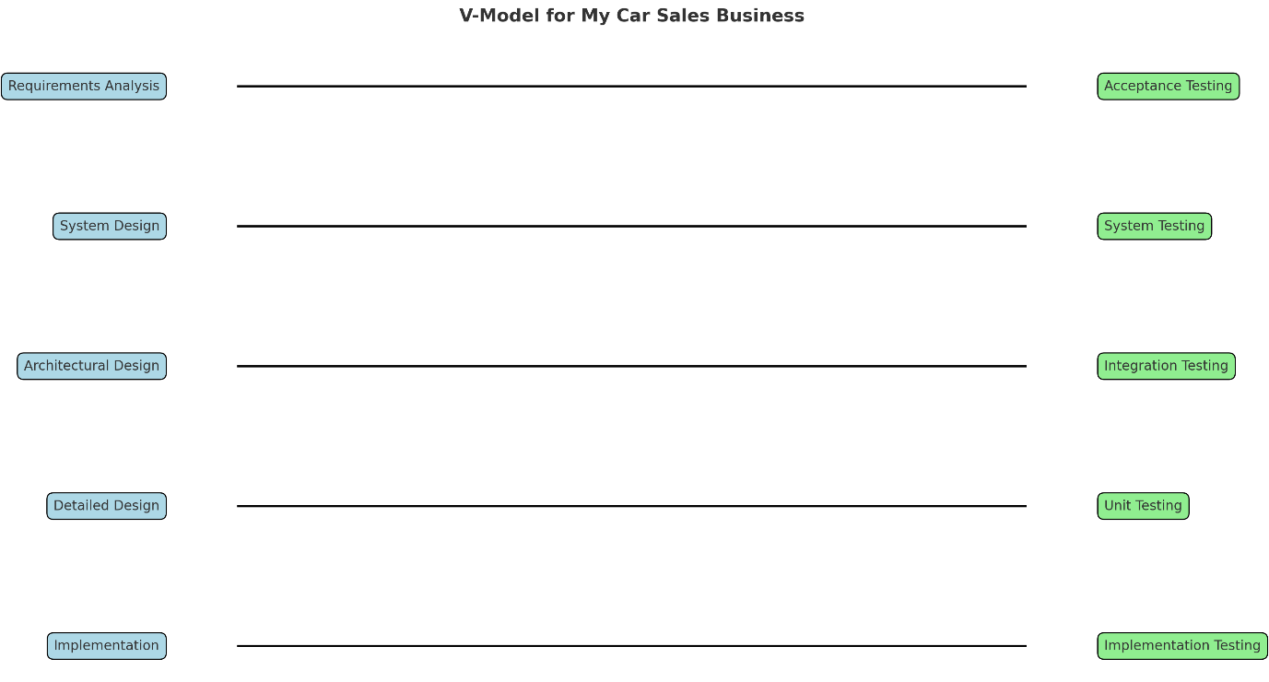

To succeed as a project manager, I must use the best method.

After thorough research, I am comparing the V-Model against Iterative and Agile approaches to determine their pros and cons.

Benefits:
1. Sequential: The V-Model organises project stages logically. This paradigm streamlines project management by specifying step tasks. The linear method considers all business issues before proceeding.
The V-Model emphasises validation at every level, which is beneficial. This lets me find and solve faults quickly in my auto sales firm, reducing severe concerns. Before launching a sales system, marketing plan, or vehicle inventory, I evaluate each component to ensure it fits criteria.
2. Thorough Documentation: The V-Model meticulously completes and documents each process before moving on. This helps because I require lots of documents to discuss business plans and maintain industry standards.
Lack of flexibility is the V-Model's biggest downside. Changes are costly and difficult after a stage. Reflexibility may affect my company in the fast-changing car sales industry, where consumer preferences and market conditions change.
3. Longer Project Durations: The V-Model demands completing and confirming each phase before moving on. In a fast-changing industry like car sales, where entry is vital, this slower pace may hurt.
The V-Model is inadequate for dynamic projects. Afterward, client needs or market changes may require considerable restructuring for effective integration.
Compared Iterative and Agile Approaches:
Pros, Flexibility and Adaptability:

- Iterative and agile methods let me adapt projects easily. Automotive sales flourish by quickly responding to market developments and using consumer feedback.
- Expedited Delivery: These solutions prioritise functional component delivery and iterative refining. This could involve quickly launching a new sales feature or marketing campaign to start sales and gather customer feedback.
- Continuous input: Agile and iterative approaches emphasise gather and implement information throughout the project. This iterative enhancement method lets me adjust my plans and operations to meet client needs.

Drawbacks:

Increased Unpredictability:

Agile and Iterative methods can make project scope, timetable, and cost more uncertain. If I have limited time or money, this task may be challenging.

2. Reduced Formal Documentation:

These approaches stress functional systems and customer interaction over thorough records, resulting in less formal documentation. This method can speed up the process, but it may be inconvenient if I need detailed documentation for regulatory compliance or future reference.

3. Scope Creep:

These methodologies are flexible, so the project may surpass its intended goals, causing delays and increased costs. Keep the project focused and well-managed to avoid this.

Selection Rationale:
Advantages of the V-Model for Car Sales: The V-Model is ideal for initiatives that require meticulous structure, documentation, and verification, such as a new sales platform or regulatory compliance.
Before launching a sophisticated online sales system that must seamlessly interface with my in-person sales activities, the V-Model's rigorous validation procedure would ensure faultless functionality.
Vehicle sales may benefit from an iterative/agile approach in a fast-paced business that requires quick response. Agile allows me to quickly build and improve a new marketing plan in response to a competitor's moves, ensuring my company's competitiveness.
My project needs will decide my strategy. This paradigm is ideal for a clear framework and extensive analysis. Iterative or Agile strategies may be advocated for velocity, adaptability, and continual input.

Project stages

INITIATE:
Our car purchasing and selling strategy begins with a solid business case. This part explains why the project is necessary and how it fits into our company plan. First, I will clearly explain the project's demand, which may involve expanding our car line or targeting a new market. Next, I will study market conditions and potential financial benefits like more revenue or lower costs. I will also evaluate many methods and explain why the chosen strategy best meets our goals (Kerzner, 2017; Lock, 2020).

Justification for business decision
The business case justifies the car buying and selling project. The paper clearly explains the project's rationale, expected benefits, and alignment with the organization's strategic goals.
• Primary tasks:
• Determine project justification, such as inventory growth or market niche targeting (Kerzner, 2017).
• Analyse market and competition conditions.
• List potential financial benefits like increased revenue or lower costs (Lock, 2020).
• Compare methods and justify your choice.
Goals
Purpose: Setting clear, quantifiable goals ensures that the project has a clear path and that all efforts are aligned to achieve them.
Main tasks:
• Set SMART goals, such as the number of cars to be bought and sold within a certain timeframe (Doran, 1981).
• Align goals with corporate strategy.
• Establish KPIs to track and evaluate success (Kerzner, 2017).
Risk of damage.
• Risk identification and management are essential to minimising project disruptions.
• Main tasks:
Risk assessments can reveal market volatility, vehicle quality issues, and regulatory changes (Hillson, 2017).
• Develop a thorough risk management plan to mitigate identified risks.
• Assign risk owners to manage risks.
The scope of something.
• Purpose: The project scope defines what is included and excluded, ensuring team focus and resource efficiency.
• Key tasks: The project's scope includes vehicle specifications, geographic regions, and sales channels (Heagney, 2016).
• Break the project down into manageable tasks with a Work Breakdown Structure (WBS) (PMI, 2017).
Set clear goals and checkpoints.
Stakeholders/Comms Plan: To build effective communication and stakeholder management methods. These tactics help garner support and keep everyone informed and in agreement.
Main tasks:
• Identify the key stakeholders, including procurement, sales, finance, suppliers, and customers (Freeman, 2010).
• Define the frequency, channels, and people responsible for information dissemination in a communication plan (Kerzner, 2017).
• Use feedback mechanisms to address stakeholder issues.
To stay within schedule, financial, and resource constraints, it is important to understand and manage constraints.
User text is bullet points. Key activities:
• Assess project constraints such finances, time, resources, and regulations (Lock, 2020).
• Prioritise work, get more resources, or change schedules to overcome these constraints.
Monitor project constraints to ensure they are managed (Heagney, 2016).
Cost-benefit analysis
• Purpose: A cost-benefit analysis compares estimated expenses to predicted benefits to determine project financial feasibility.
Main tasks:
Calculate project costs, including vehicle purchases, marketing, operations, and overhead (Fleming & Koppelman, 2016).
Measure expected benefits like sales revenue, market share, and cost savings.
• Calculate project ROI and financial feasibility (Lock, 2020).
Efficient project organisation ensures clear roles and responsibilities and a well-structured team.
User text is bullet points. Key activities:
Project managers, procurement leads, sales managers, and marketing coordinators are part of the project team structure (Kerzner, 2017).
• Establish clear communication and systematic decision-making.
• Assign assignments and ensure team members understand their role in project success.
Create a project governance framework to monitor progress and ensure business goals are met (PMI, 2017).

Summary of Project Stages:
Business Case: Justify the project and ensure it meets strategic goals.
Objective: Set clear, quantifiable project goals.
Risk: Recognise, assess, and manage hazards.
Scope: Define project components and outcomes.
Stakeholders/Communications Objective: Identify project stakeholders and develop a communication plan.
Project constraints: Identify and manage them.
Cost-benefit analysis: can determine project financial viability.
Project Organisation: Establish a project team framework and assign roles and tasks.

PLAN:

WORK/PRODUCT BREAKDOWN STRUCTURE
The Work Breakdown Structure (WBS) and Product Breakdown Structure (PBS) are separate organisational methods employed in project management.
A Work Breakdown Structure (WBS) and Product Breakdown Structure (PBS) are essential tools for efficiently managing complex projects, such as the process of purchasing and selling vehicles.
They enable the project to be broken down into smaller, achievable components, ensuring that each aspect of the project is clearly defined and systematically organised.

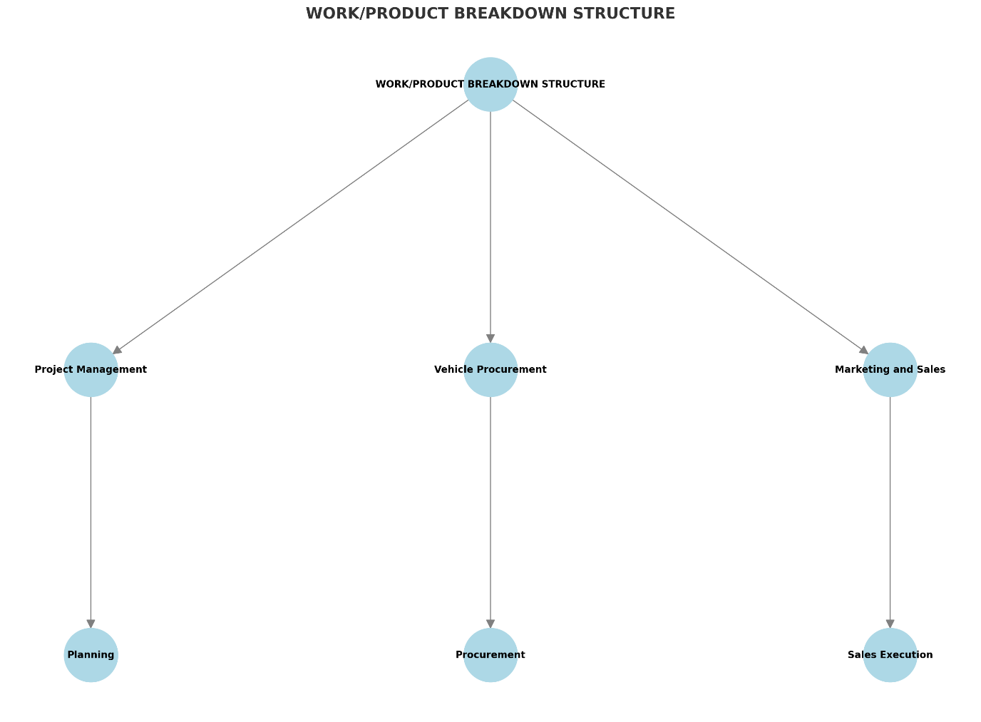

DURATION
As a project manager in the vehicle sales company, I handled numerous phases with different timelines. The detailed calendar was created to ensure that every element of the project, from planning to sales execution, was completed efficiently and on time.
1. Planning: About 1-2 weeks. I set the project's scope, objectives, and timelines and assigned resources during this time.
2. Market Research: 3–4 weeks. The assignment included analysing market trends, client preferences, and car classifications that met our sales goals.
3. Vehicle Procurement: This 4-6-week process was necessary to have the right inventory. This involves negotiating with vendors, choosing cars, and signing purchase agreements.
4. Vehicle preparation took 2-3 weeks. The vehicles were inspected, renovated, and prepared for sale to meet our quality standards.
5. Marketing and Sales: This began 3 weeks into the project and continued throughout sales. Marketing, client interactions, and sales were included.
6. Client Service: This phase began after sales but continued throughout the sales process to ensure client satisfaction and manage post-sale services.
From planning to customer servicing, the project took 12-18 weeks. I kept the project on track and met deadlines while adhering to strict quality requirements through careful project management and flexibility.

NETWORK & DEPENDENCIES
As the vehicle sales project progresses, it's crucial to understand activity interdependencies to ensure a smooth transition between phases. Current network and dependent structure:

1. Planning → All Other Phases
- Dependency: Planning establishes the project's scope, objectives, and timing. Any following phase depends on clear rules from this first step.

2. Market Research → Vehicle Procurement
Dependency: Continuous market research guides our vehicle acquisitions. For educated Vehicle purchases, we must understand customer preferences and market trends.

3. Vehicle Procurement → Vehicle Preparation
Dependency: Vehicles are examined, restored, and prepared for sale after purchase. After procurement and vehicle processing, vehicle preparation will begin immediately.

4. Vehicle Preparation → Marketing and Sales
- Dependency: Well-stocked inventory is crucial to our marketing and sales efforts. Vehicles must meet our high-quality criteria before being offered and sold. Thus, preparedness is crucial to sales activities.

5. Marketing Strategy → Sales Execution
- Dependency: Our sales execution is closely tied to our marketing strategy. Our marketing plan will pique customer interest and boost revenues. Sales will increase after the marketing approach is implemented.

6. Sales Execution → Customer Service
- Dependency: With sales starting, our customer support team is ready to answer questions and manage post-sale services. Our customer service efforts depend on sales results.

7. Continuous Monitoring and Adjustments
- Dependency: The project must be monitored throughout to ensure each phase goes as planned. To avoid delays, manage interdependencies, and keep the project on track, we are making essential changes.

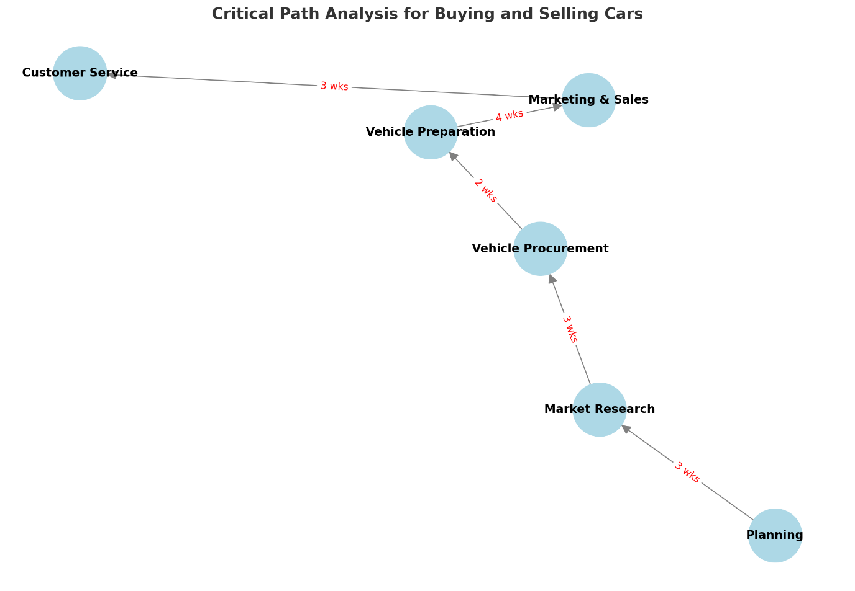

PLAN TOOLS:
I carefully plan and execute each project using Gantt charts and critical path analysis. These tools let me visualise events, track progress, and find links to allocate resources and predict difficulties. These planning tools help me manage the project, make changes, and stick to the timeline to meet our goals.

GANTT
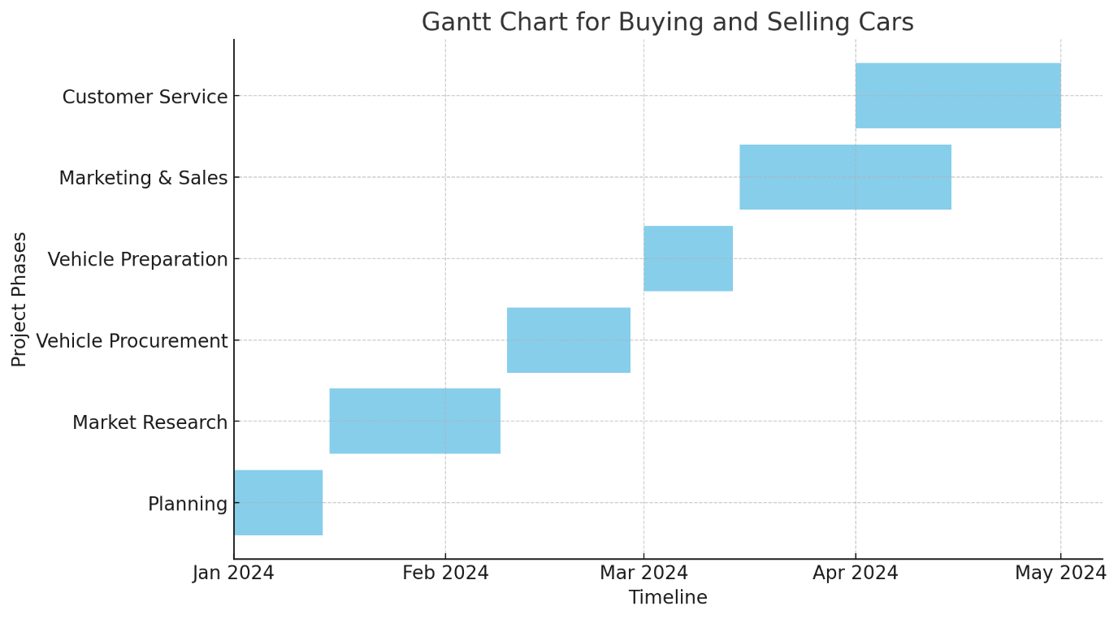

KANBAN

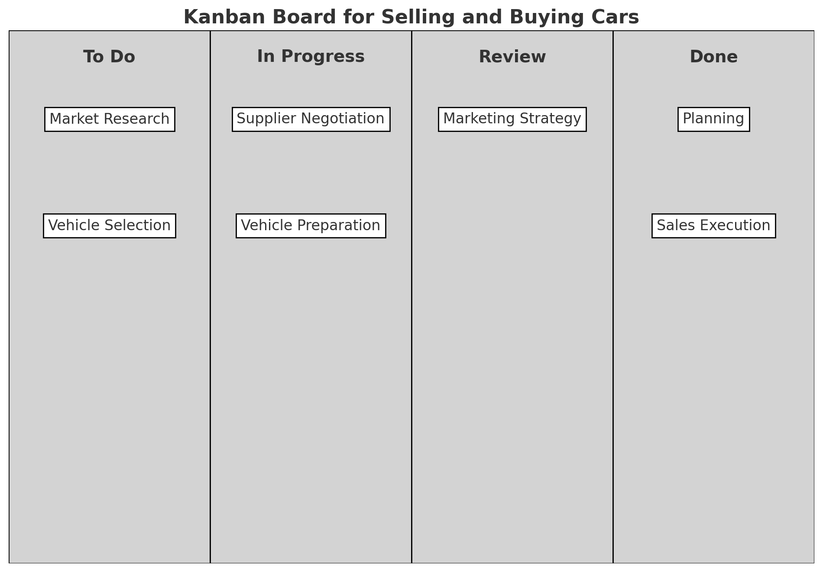

MILESTONES
Project milestones define essential tasks. Process milestones are essential for managing my car buying and selling process. They help us track progress and ensure accuracy. This project's important stages are early planning, market research, vehicle procurement, preparation, marketing campaign launch, and first significant sales targets. Every major accomplishment helps us assess project progress, adjust methods, and stay focused (Lock, 2020; PMI, 2017).

EXECUTE:

ALLOCATED PERSONS/PROJECT TEAM ROLES & RESPONSIBILITIES
The execution phase of a car buying and selling project is where the project plan is put into action. During this phase, it is crucial that all team members understand their roles and responsibilities to ensure smooth execution and successful project outcomes.

CONTROL:
Control involves monitoring the project and ensuring we meet our goals. Monitoring progress is vital, but so is making adjustments to stay on track. I need control to maintain the firm's standards, whether it's budgeting, meeting deadlines, or ensuring vehicle and customer service quality. I can ensure we meet our goals without sacrificing quality or efficiency by regularly assessing our performance against the plan and taking proactive steps to rectify issues.

MONITORING:
Being informed and in charge is crucial as the project progresses. This includes tracking sales, managing the budget, and making sure our marketing efforts are reaching the right audience. By closely monitoring all project components, I can quickly spot issues and deviations from our goals (Pinto, 2019). This lets me make informed decisions and timely changes to stay on track and achieve set goals (Gido & Clements, 2015).

PROGRESS/TIME
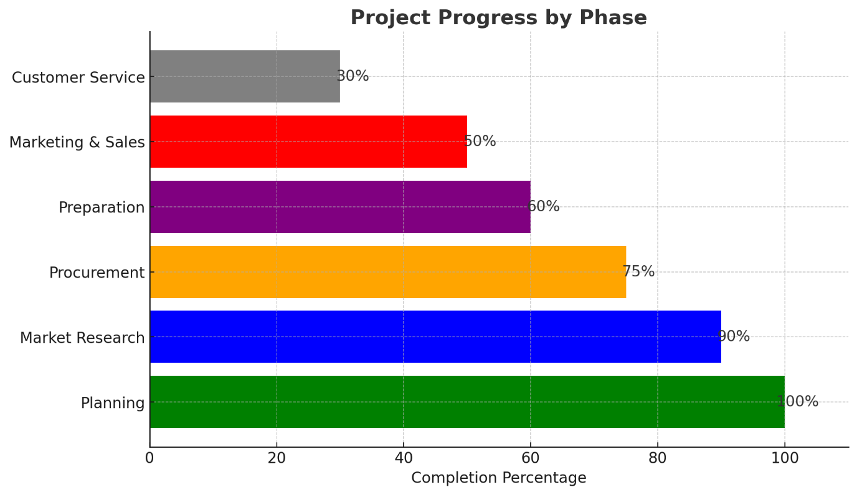

QUALITY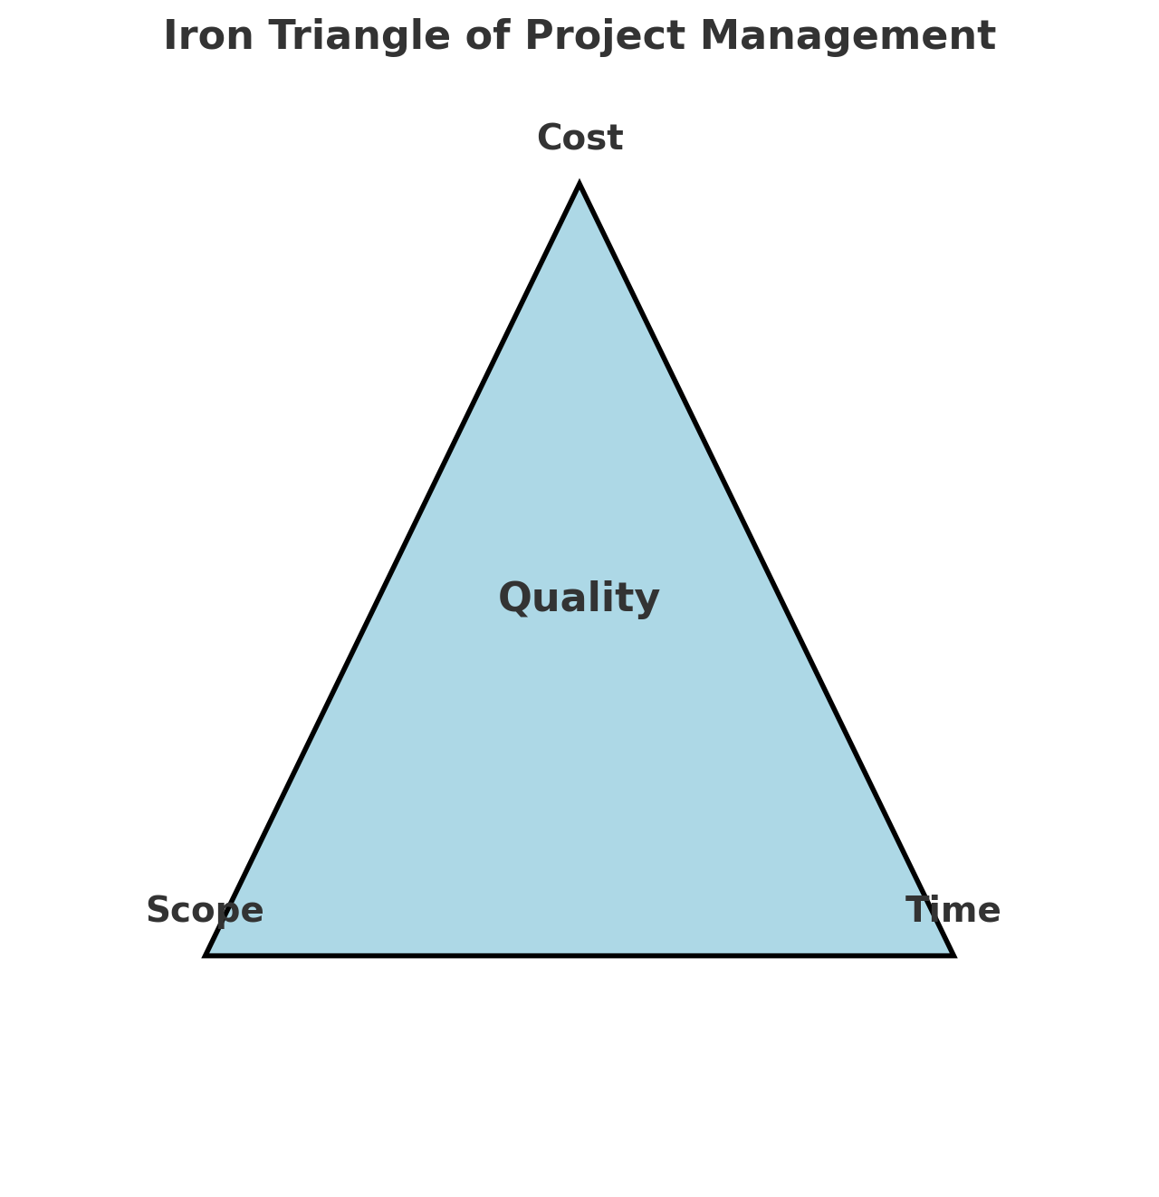

CHANGE MANAGEMENT PROCESS
We effortlessly transition to new, more efficient operations via change management. My responsibilities include preparing my staff for changes, managing their implementation, and guaranteeing their long-term compliance. I can ensure a successful transition and widespread adoption of the new practices throughout the organisation by effectively communicating the rationale for change, providing needed training, and supporting my team.

LOG REQUEST
I must efficiently handle log requests to maintain transparency and accountability in my vehicle sales project management role. Log requests formalise all project changes, decisions, and notable actions. This includes requests to change project scope, timelines, and budgets. By keeping detailed records, I can ensure that every decision is recorded, producing a transparent project timeline. This streamlines project management, informs stakeholders, and guides future decision-making.

AUTHORISATION
I approve the implementation of the project plan as outlined, with the understanding that all key aspects, including budget, timeline, and scope, have been reviewed and agreed upon. I expect regular updates on progress and any deviations from the plan to be communicated promptly. This authorization is granted with the expectation that the project will be managed efficiently and effectively, in alignment with our goals and standards.

CHANGE TO PLAN
Verify that plan revisions are based on reliable information and in line with project goals before adopting them. Before making any changes, I carefully consider their effects on the timeline, finances, and project boundaries. This involves assessing how these changes may affect our overall goals and whether they address any concerns or areas for improvement. After getting approval, I explain the changes to stakeholders and the team so they understand why and how they will be implemented. I will handle adjustments and adapt to unexpected issues to keep the project on track and focused on our goals (Burke, 2013; Kerzner, 2017).

RISK MANAGEMENT
In my position, risk management means anticipating and addressing future issues to keep the project on track. My main goal is to quickly identify hazards, assess their effects, and develop mitigation solutions. I carefully handle all financial, scheduling, and resource risks to limit disruptions and ensure project success. I can handle any issues and keep the project on track by staying vigilant and ready.

CLOSING:

SIGN-OFF/HAND OVER
I am completing and handing over operations to the assigned team as we near the end of this project phase. I checked all deliverables for quality and project goals. To ensure a smooth handover, all outstanding tasks and essential information have been recorded and transferred. I trust the staff to diligently manage the project and ensure its success.

GET PAID
As a project manager, obtaining payment requires checking that all project deliverables have been fulfilled and authorised per the contract. I send detailed reports and bills to the client or stakeholders after major milestones or project completion. Financial paperwork will be accurate, transparent, and aligned with the project's scope. Effective communication with the finance department or customer is essential to accelerate payment and ensure that my salary matches my effort and project value.

CHANGES & ISSUES AGREED
All proposed changes and issues have been thoroughly reviewed and discussed with the relevant stakeholders. We have reached an agreement on how to address these changes and resolve any outstanding issues, ensuring that they align with the project’s objectives and constraints. The agreed-upon adjustments will be implemented accordingly, with clear communication and documentation to keep all parties informed. This approach ensures that the project continues to move forward smoothly, with any disruptions minimized and all decisions fully supported by the team.

LESSONS LEARNT
Reflecting on this project, the lessons learned have been invaluable for both my personal development and the future success of our projects. One key takeaway is the importance of proactive communication; keeping stakeholders informed at every stage helped prevent misunderstandings and kept the project aligned with its objectives. Additionally, the need for flexibility became clear, as adapting to changes and unforeseen challenges was crucial in maintaining momentum. Effective risk management also proved essential in minimizing potential setbacks. These insights will be carried forward, allowing for improved planning, execution, and overall project management in future endeavours.

EVALUATE PROJECT
After evaluating the project, it is clear that despite certain challenges, it was successful and met our goals. The job was done as specified. Despite timetable changes, we stayed within budget thanks to careful financial management and resource allocation.
Communication between team members and stakeholders helped solve problems quickly and ensure project goals were met. A rigorous approach like the V-Model ensured careful planning and validation at each level, resulting in high-quality deliverables.
Other features could be improved. Unexpected hazards that may have been predicted during preparation delayed the project. This highlights the need for more thorough risk assessment and contingency planning in future endeavours. Despite meeting its goals, the project identified areas for process improvement that we will assess.
The program proved the importance of adaptation, proactive risk minimisation, and continual communication. These findings will boost future productivity and effectiveness.

REMOVE ACCESS
Transient team members and external contributors who were granted authorisation during the project will lose access afterward. This involves removing access to project management software, shared hard drives, and other platforms holding confidential project data. Effective access control is essential for project data security, confidentiality, and approved worker access. We must finish this stage to protect our resources and maintain the accuracy of our project documentation.

MY PROJECT
As a project manager, I’ve consistently relied on several key skills to ensure the successful delivery of projects:
- Communication: I’ve effectively communicated with all stakeholders, keeping everyone informed and aligned with the project goals, which has been crucial for smooth project execution.
- Leadership: I’ve led my team with confidence, making decisive decisions and resolving conflicts, which helped in keeping the project on track and maintaining team morale.
- Time Management: By carefully prioritizing tasks and managing deadlines, I’ve ensured that projects stayed on schedule and milestones were consistently met.
- Risk Management: I proactively identified potential risks, assessed their impact, and developed strategies to mitigate them, preventing or minimizing disruptions to the project.
- Budget Management: I closely monitored project finances, controlled costs, and kept the project within budget, contributing to its financial success.
- Problem-Solving: When challenges arose, I applied critical and creative thinking to find effective solutions, ensuring the project remained on course.
- Negotiation: I successfully negotiated with stakeholders, secured the necessary resources, and resolved conflicts, which facilitated smoother project progress.
- Adaptability: I demonstrated flexibility by adapting to changing circumstances and adjusting strategies when necessary, allowing the project to respond effectively to new developments.
- Attention to Detail: I maintained a keen eye for detail, ensuring that every aspect of the project was carefully planned and executed to the highest standards.
- Technical Proficiency: My understanding of the technical aspects of the projects I managed enabled me to make informed decisions and oversee the project’s successful completion.

SKILLS OF A PM
As a project manager, I've learnt and used many skills to complete my projects:
Communication: I am skilled at communicating information to project stakeholders and aligning them with its goals (Kerzner, 2017).
Leadership: I've led various teams, making key decisions and providing direction to overcome problems. Initiatives have advanced due to this (Heagney, 2016).
Effective Time Management: I excel at prioritising work and meeting deadlines, completing assignments on time even under tight deadlines (Lock, 2020).
Risk Management: I actively identify, assess, and minimise risks. This has reduced interruptions and ensured project progress (PMI, 2017).
Budget Management: I strictly monitor project budgets to ensure resource allocation and financial stability (Burke, 2013).
Problem-Solving: I've used analytical thinking and creativity to solve challenges and develop the project (Larson & Grey, 2018).
Negotiation: I have successfully negotiated with stakeholders and team members to obtain resources and settle problems, promoting project progress (Fisher & Ury, 2011).
I adapt to changing conditions and change techniques as needed. The project can now efficiently address unexpected challenges (Turner, 2014).
Excellent Attention to Detail: I have methodically prepared and implemented every project component to the highest degree (Meredith & Mantel, 2012).
Technical Proficiency: I used my technical competence to make informed judgements and complete all project phases (Wysocki, 2011).

EVALUATE SELF AGAINST SKILLS
After reflecting on my project management career, I realise how much my talents have helped my projects succeed. My strong communication skills allow me to inform stakeholders and keep the team on track with project goals. However, there is always potential for improvement, especially in providing succinct information under pressure. I led my team through difficult situations with excellent leadership. However, I need to improve my teamwork skills (Kerzner, 2017).
Time management is my speciality, and I always fulfil deadlines and keep projects on schedule. I can enhance efficiency by precisely estimating delays and adding time buffers when needed. I am proficient in risk management, but I need to improve my early risk assessment to better predict and manage unexpected situations (Heagney, 2016). While I am confident in my skills, I am committed to improving them. I understand that improving these skills will improve my project management.
1. Communication: I consistently communicate well with all key stakeholders and ensure my team is on track with project goals. This trait helps avoid misinterpretations and keep the project on track.
2. Leadership: I lead well. I have successfully led complex teams, making tough decisions and fostering cooperation. I am confident in my ability to motivate and lead my team to success.
3. Time Management: I consistently meet deadlines for most assignments and milestones. There is always room for improvement in estimating delays and adding time for unexpected hurdles.
4. Risk Management: I actively identify and reduce risks to minimise interruptions. However, I recognise that I can improve my first risk assessments to anticipate unexpected issues.
5. Budget Management: I have managed project budgets to maximise resource allocation and financial feasibility. I always excelled here.
6. Problem-Solving: My problem-solving skills have helped me overcome obstacles and keep the project on track. I am confident in my abilities to solve obstacles, but I am always trying to improve my problem-solving.
7. Negotiation: I expertly negotiated with stakeholders to secure the necessary funding for project success. This talent has been vital to managing interactions and ensuring project success.
8. Adaptability: I can adapt to changes and unexpected scenarios to keep the project on track. However, I recognise the need to always improve my ability to adapt quickly and effectively to unexpected changes.
9. Meticulousness: I've always paid attention to every detail to ensure project success. This is my strength, as it's vital to the project's quality.
10. Technical Proficiency: I used my technical knowledge to make educated judgements and handle project challenges. Despite my technical confidence, I consistently improve my knowledge to stay current in the sector.

DEVELOP PDP
I prioritise continuous improvement as a project manager to improve myself and my projects. My Personal Development Plan (PDP) focusses on my strengths, areas for progress, and overall proficiency in complex projects. I am committed to improving my skills and producing exceptional results that meet the team's and organisation's goals by setting clear goals and taking realistic steps (Appendix C).

CONCLUSION
As I conclude this project of buying and selling cars, I’m pleased with the results we’ve achieved. From the initial planning stages to the final sales, the project has been a complex but rewarding journey. We navigated through market analysis, supplier negotiations, and the sales process with careful attention to detail, ensuring that each step aligned with our objectives.
There were challenges along the way, particularly in managing time and anticipating market fluctuations, but these were valuable learning experiences that have strengthened my skills as a project manager. The success of this project reinforces the importance of clear communication, effective risk management, and adaptability in achieving our goals. I’m proud of the team’s hard work and dedication, and I’m confident that the strategies and insights gained here will drive even greater success in future projects.

REFERENCE LIST

Burke, R. (2013). Project Management: Planning and Control Techniques. John Wiley & Sons.
Doran, G. T. (1981). There’s a S.M.A.R.T. way to write management’s goals and objectives. Management Review, 70(11), 35-36.
Fisher, R., & Ury, W. (2011). Getting to Yes: Negotiating Agreement Without Giving In. Penguin Books.
Fleming, Q. W., & Koppelman, J. M. (2016). Earned value project management. Project Management Institute.
Freeman, R. E. (2010). Strategic management: A stakeholder approach. Cambridge University Press.
Gido, J., & Clements, J. (2015). Successful Project Management. Cengage Learning.
Heagney, J. (2016). Fundamentals of project management. AMACOM.
Hillson, D. (2017). Practical project risk management: The ATOM methodology. Berrett-Koehler Publishers.
Kerzner, H. (2017). Project management: A systems approach to planning, scheduling, and controlling. Wiley.
Kerzner, H. (2019). Project management: A systems approach to planning, scheduling, and controlling. Wiley.
Larman, C. (2004). Agile and iterative development: A manager's guide. Addison-Wesley Professional.
Larman, C., & Basili, V. R. (2003). Iterative and incremental developments: A brief history. Computer, 36(6), 47-56.
Larson, E. W., & Gray, C. F. (2018). Project Management: The Managerial Process. McGraw-Hill Education.
Lock, D. (2020). Project management. Gower Publishing, Ltd.
Meredith, J. R., & Mantel, S. J. (2012). Project Management: A Managerial Approach. Wiley..
Meredith, J. R., Shafer, S. M., & Mantel, S. J. (2017). Project management: A managerial approach. Wiley.
Pinto, J. K. (2019). Project Management: Achieving Competitive Advantage. Pearson.
PMI (Project Management Institute). (2017). A guide to the project management body of knowledge (PMBOK guide) (6th ed.). Project Management Institute.
Schwaber, K., & Beedle, M. (2001). Agile software development with Scrum. Prentice Hall.
Sommerville, I. (2016). Software engineering (10th ed.). Pearson.
Turner, R. (2014). Handbook of Project Management. McGraw-Hill Education.
Wysocki, R. K. (2011). Effective Project Management: Traditional, Agile, Extreme. John Wiley & Sons.

APPENDICES

Appendix A
The Waterfall Lifecycle contains numerous phases:
We start by gathering and analysing project requirements. This involves choosing the car categories we want, understanding market trends, setting financial limits, and aligning with our company aim. The project's first phase is crucial since it lays the basis and ensures we understand our goals (Sommerville, 2016).
System Design: After gathering requirements, create a project plan. This requires creating a detailed plan for buying and selling. We plan, allocate resources, and choose tools and methods. This may require establishing systematic processes for vehicle acquisition, inspections, purchasing, and marketing (Bassil, 2012).
The implementation phase involves executing our plan. This includes negotiating with sellers, buying vehicles, prepping them for sale, and implementing our sales strategy. The linear design of Waterfall makes it crucial to discover project scope changes early on. Revisions after installation can be difficult (Royce, 1970).
Validation: We validate before full-scale implementation. This includes ensuring all cars meet our quality requirements and sales operations run smoothly. Testing at this stage helps us identify issues that must be addressed before moving forward, ensuring that we deliver high-quality goods (Balaji & Murugaiyan, 2012).
Testing is followed by deployment/delivery. We sell autos by using marketing and sales methods to reach our target clients. This phase depends on the previous phases' accuracy, as any errors or omissions could hurt our sales (Bassil, 2012).
Maintenance: We don't always stop after the transaction. Post-sale services, customer comments, and vehicle issues will be addressed during maintenance. This stage maintains customer satisfaction and brand reputation, ensuring our long-term success (Sommerville, 2016).
Waterfall Model Benefits and Drawbacks:
Due to its systematic approach to each phase, the Waterfall technique is ideal for our car buying and selling efforts. This allows us to control the process and ensure each step is carefully planned and executed. It's important to recognise this system's flaws, notably inflexibility. Changes can be difficult to accomplish, especially in a fast-changing business where market conditions fluctuate (Royce, 1970; Sommerville, 2016).

We can ensure accurate and rigorous car buying and selling by using Waterfall in our project management technique. This strategy keeps order and lets us evaluate and improve our processes, improving company performance.

Appendix B

Iterative - lifespan phases:
Initial Planning and Design: The iterative lifecycle begins with planning and design. We choose our automotive categories, create early financial strategies, and find promising market opportunities at this point. It lays the groundwork for future versions (Sommerville, 2016).
After planning, the project is executed and evaluated. This step requires buying numerous vehicles or starting a test sales campaign. After this simple deployment, we quickly evaluate the results to ensure they meet our goals. Testing during every iteration of the iterative lifecycle helps us find and fix errors early (Larman & Basili, 2003).
Evaluation and Feedback: Evaluation follows implementation and testing. We evaluate the prior iteration with customer, sales, and market analyst feedback. Feedback is essential for identifying our strengths and weaknesses. This ensures each iteration builds on prior successes and insights (Schwaber & Beedle, 2001).
Improve the plan for future iterations. Our method changes based on evaluation results. This may include changing our car selection, financial allocation, or sales strategy. The project becomes more sophisticated and effective with each iteration. Our industry's market changes quickly, thus flexibility is essential (Larman, 2004).
Finalisation: The process continues until the final goals are met, then ends. This requires combining all iterations into a final vehicle sales campaign or optimal vehicle inventory. The iterative process has assessed and improved our project, increasing the likelihood of success for this phase (Sommerville, 2016).
Pros and Cons of Iterative Lifecycle:
Our car purchasing and selling projects benefit from the iterative lifecycle. Our flexibility lets us quickly adapt to market developments and client preferences, easing strategy and operational adjustments. The continuous feedback loop ensures that we are improving our processes, which may boost results and client happiness.
The iterative technique has limitations. The continuous cycles may cause scope creep, where the project exceeds its initial goals. Each repetition requires planning, implementation, and evaluation, making the iterative lifecycle more resource-intensive than linear systems like Waterfall (Larman & Basili, 2003).
We can better navigate the vehicle buying and selling market by incorporating the iterative lifecycle into our project management. This method improves our ability to adapt rapidly and promotes continuous improvement, which boosts our firm's long-term performance.

Appendix C

Skill | Current Status | Development Goal | Action Plan | Timeline
Communication | Strong communication skills, consistently keeping stakeholders informed. | Improve delivering concise and clear updates, especially under stress. | - Attend a workshop on effective communication under stress.  - Practice summarizing key points in meetings.  - Seek feedback from peers. | 3 months
Leadership | Effective in guiding and motivating teams. | Enhance leadership skills in fostering collaboration. | - Participate in leadership training focused on team dynamics.  - Implement team-building exercises.  - Mentor junior project managers. | 6 months
Time Management | Generally effective, but can improve in anticipating delays. | Build in more buffer time and anticipate potential delays. | - Take a course on advanced time management.  - Review past projects to identify patterns.  - Use project management software for planning. | 3 months
Risk Management | Proactive, but initial assessments can be more thorough. | Enhance the thoroughness of initial risk assessments. | - Study advanced risk management techniques.  - Collaborate with experts.  - Conduct detailed risk analysis during planning. | 4 months
Budget Management | Strong control over budgets, ensuring financial viability. | Maximize resource efficiency. | - Take a financial management course focused on budgeting.  - Analyse budget performance in past projects.  - Implement lessons learned. | 6 months
Problem-Solving | Effective in overcoming challenges and keeping projects on track. | Further enhance problem-solving strategies in high-pressure situations. | - Attend problem-solving workshops.  - Practice scenario-based problem-solving.  - Review past approaches for improvement. | 3 months
Negotiation | Effective in negotiating with stakeholders and securing resources. | Improve negotiation skills in complex situations. | - Participate in advanced negotiation skills training.  - Role-play negotiation scenarios.  - Review outcomes from past projects. | 4 months
Adaptability | Flexible in adapting to changes, but can improve in quickly pivoting strategies. | Improve responsiveness to unexpected changes. | - Learn agile project management techniques.  - Implement more flexible project plans.  - Reflect on adaptability in past projects. | 4 months
Attention to Detail | Strong attention to detail, ensuring high standards are maintained. | Maintain strength while balancing big-picture thinking. | - Balance detail-oriented tasks with overall progress reviews.  - Delegate detailed tasks when needed.  - Seek feedback on balance. | Ongoing
Technical Proficiency | Solid understanding of technical aspects, enabling informed decisions. | Continue to deepen technical knowledge. | - Attend industry conferences and workshops.  - Regularly read industry publications.  - Enroll in advanced courses. | 6 months

