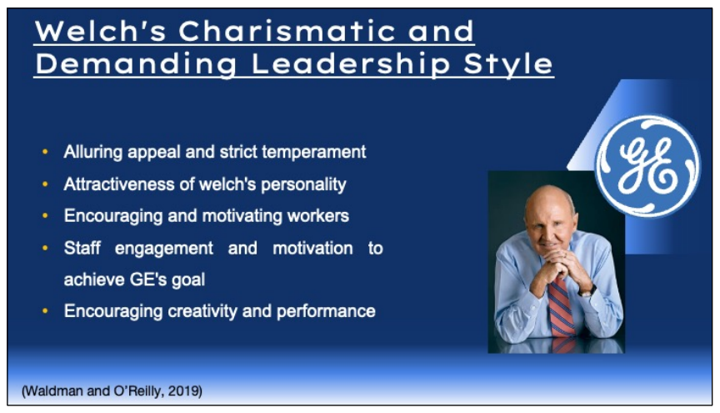
Discover how Jack Welch's leadership style at GE was characterised by his alluring appeal and strict temperament. This presentation explores the attractiveness of Welch's personality, encouraging and motivating workers to perform to the very top of their abilities. Learn how his strict leadership promoted taking chances and a never-ending quest for perfection. Analyse the effect of Welch's charismatic leadership style on staff engagement and motivation to achieve GE's goal. While encouraging creativity and performance, this approach also spurred debates about how to strike a balance between authority and empowerment (Waldman and O’Reilly, 2019). Examine the subtleties of charismatic leadership and its tremendous impact on Welch's management of GE's organisational culture.

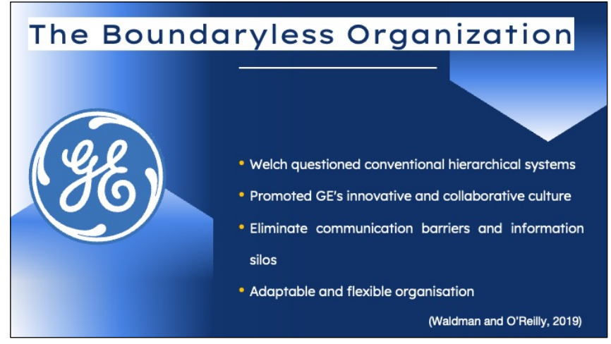
Enter the world of Jack Welch's groundbreaking idea of a "Boundaryless Organisation." This presentation explains how Welch questioned conventional hierarchical systems and promoted GE's innovative and collaborative culture. Discover the methods used to eliminate communication barriers and information silos between corporate departments. Consider the effects of this boundaryless strategy on GE's adaptability and market responsiveness (Waldman and O’Reilly, 2019). Welch's ground-breaking concepts made GE a more adaptable and flexible organisation, enabling individuals to realise their full potential and propel the company forward. Learn about the boundaryless idea's long-lasting influence on contemporary leadership and organisational structure.

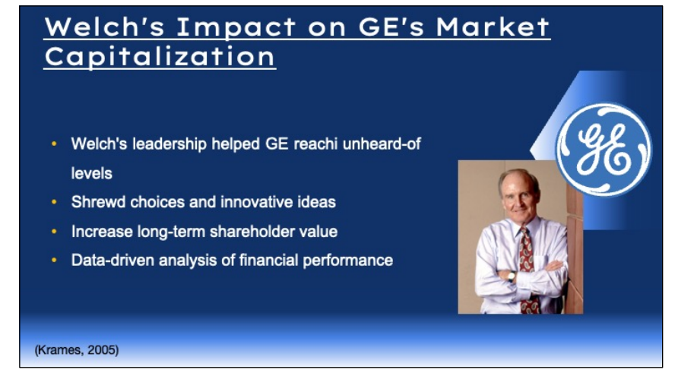
Watch the incredible effect Jack Welch's leadership had on the market value of General Electric. This slide demonstrates the phenomenal expansion GE underwent under Welch's leadership, reaching unheard-of levels. Examine the shrewd choices and innovative ideas that contributed to its ascension to such heights. The link between Welch's leadership skills and GE's market value demonstrate his capacity to increase long-term shareholder value (Krames, 2005). This presentation gives a thorough knowledge of Welch's enormous effect on GE's market position via a data-driven analysis of financial performance, establishing his reputation as one of the most successful business executives in history.

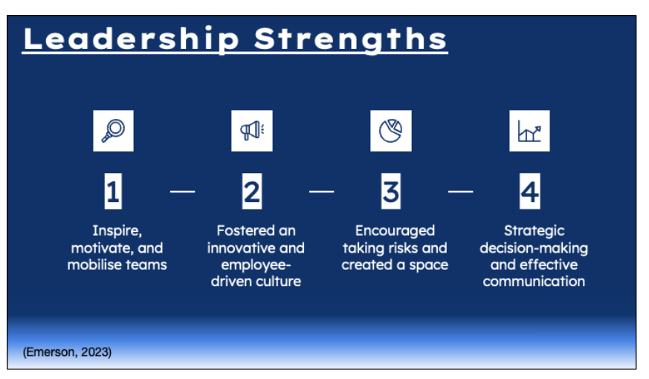
Examine Jack Welch's extraordinary leadership style's core virtues. This slide focuses on the qualities that make him unique as a visionary leader. He can inspire, motivate, and mobilise teams to achieve common objectives. Welch's revolutionary leadership style fostered an innovative and employee-driven culture that fuelled GE's rapid expansion (Emerson, 2023). Find out how he encouraged taking risks and created a space where daring ideas could thrive. This presentation highlights the characteristics that make Welch a legendary leader, leaving an immeasurable legacy in the annals of corporate leadership via an examination of his strategic decision-making and effective communication.

