Page 1 of 15 - Cover Page
R And Filip Problem Solving and Decision Making_C…
R And Filip Problem Solving and Decision Making_Componant 1_PPT Pasted

Turnitin
Document Details
13 Pages
1,303 Words
7,255 Characters
Submission ID trn:oid:::3618:119398329
Submission Date
Nov 1, 2025, 8:12 PM GMT+5

Download Date
Nov 1, 2025, 8:13 PM GMT+5
File Name unknown_filename

File Size
2.0 MB
Page 1 of 15 - Cover Page
Page 2 of 15 - AI Writing Overview
0
% detected as AI
The percentage indicates the combined amount of likely AI-generated text as
well as likely AI-generated text that was also likely AI-paraphrased.
Caution: Review required.
It is essential to understand the limitations of AI detection before making decisions
about a student’s work. We encourage you to learn more about Turnitin’s AI detection
capabilities before using the tool.

Detection Groups
 0 AI-generated only 0%
Likely AI-generated text from a large-language model.
 0 AI-generated text that was AI-paraphrased 0%
Likely AI-generated text that was likely revised using an AI-paraphrase tool or word spinner.

Disclaimer
Our AI writing assessment is designed to help educators identify text that might be prepared by a generative AI tool. Our AI writing assessment may not always be accurate (it may misidentify writing that is likely AI generated as AI generated and AI paraphrased or likely AI generated and AI paraphrased writing as only AI generated) so it should not be used as the sole basis for adverse actions against a student. It takes further scrutiny and human judgment in conjunction with an organization's application of its specific academic policies to determine whether any academic misconduct has occurred.

Frequently Asked Questions

How should I interpret Turnitin's AI writing percentage and false positives?
The percentage shown in the AI writing report is the amount of qualifying text within the submission that Turnitin’s AI writing detection model determines was either likely AI-generated text from a large-language model or likely AI-generated text that was likely revised using an AI paraphrase tool or word spinner.
False positives (incorrectly flagging human-written text as AI-generated) are a possibility in AI models.
AI detection scores under 20%, which we do not surface in new reports, have a higher likelihood of false positives. To reduce the likelihood of misinterpretation, no score or highlights are attributed and are indicated with an asterisk in the report (*%).
The AI writing percentage should not be the sole basis to determine whether misconduct has occurred. The reviewer/instructor should use the percentage as a means to start a formative conversation with their student and/or use it to examine the submitted assignment in accordance with their school's policies.
What does 'qualifying text' mean?
Our model only processes qualifying text in the form of long-form writing. Long-form writing means individual sentences contained in paragraphs that make up a longer piece of written work, such as an essay, a dissertation, or an article, etc. Qualifying text that has been determined to be likely AI-generated will be highlighted in cyan in the submission, and likely AI-generated and then likely AI-paraphrased will be highlighted purple.
Non-qualifying text, such as bullet points, annotated bibliographies, etc., will not be processed and can create disparity between the submission highlights and the percentage shown.
Page 2 of 15 - AI Writing Overview

Programme: Certificate of Higher Education in Business Skills for the Workplace
Module: Problem Solving and Decision Making
Module code: LCLM4004
Assignment Title: Component 1-Individual Presentation on Green Haven Florists
Module leader: Anita Nan
Student name: Robert Andrei Filip
Student ID number: 2439387
Submission deadline: 10 November 10:00 am
Table of Contents
Slide 1 — Title page 3
Slide 2 — Presentation overview 3
Slide 3 — Problem identification (5W2H): WHAT / WHY 3
Slide 4 — Problem identification (5W2H): WHO / WHERE / WHEN 4
Slide 5 — Problem identification (5W2H): HOW / HOW MUCH (scope & impact) 5
Slide 6 — External analysis: PESTEL (overview) 5
Slide 7 — PESTEL: interpretation & implications 7
Slide 8 — Cause-and-Effect (root cause) 7
Slide 9 — Cause analysis: short justification & evidence 8
Slide 10 — Key findings 9
Slide 11 — Conclusion & Recommendation 10
Slide 12 — References 10

2

Slide 1 — Title page


Slide 2 — Presentation overview
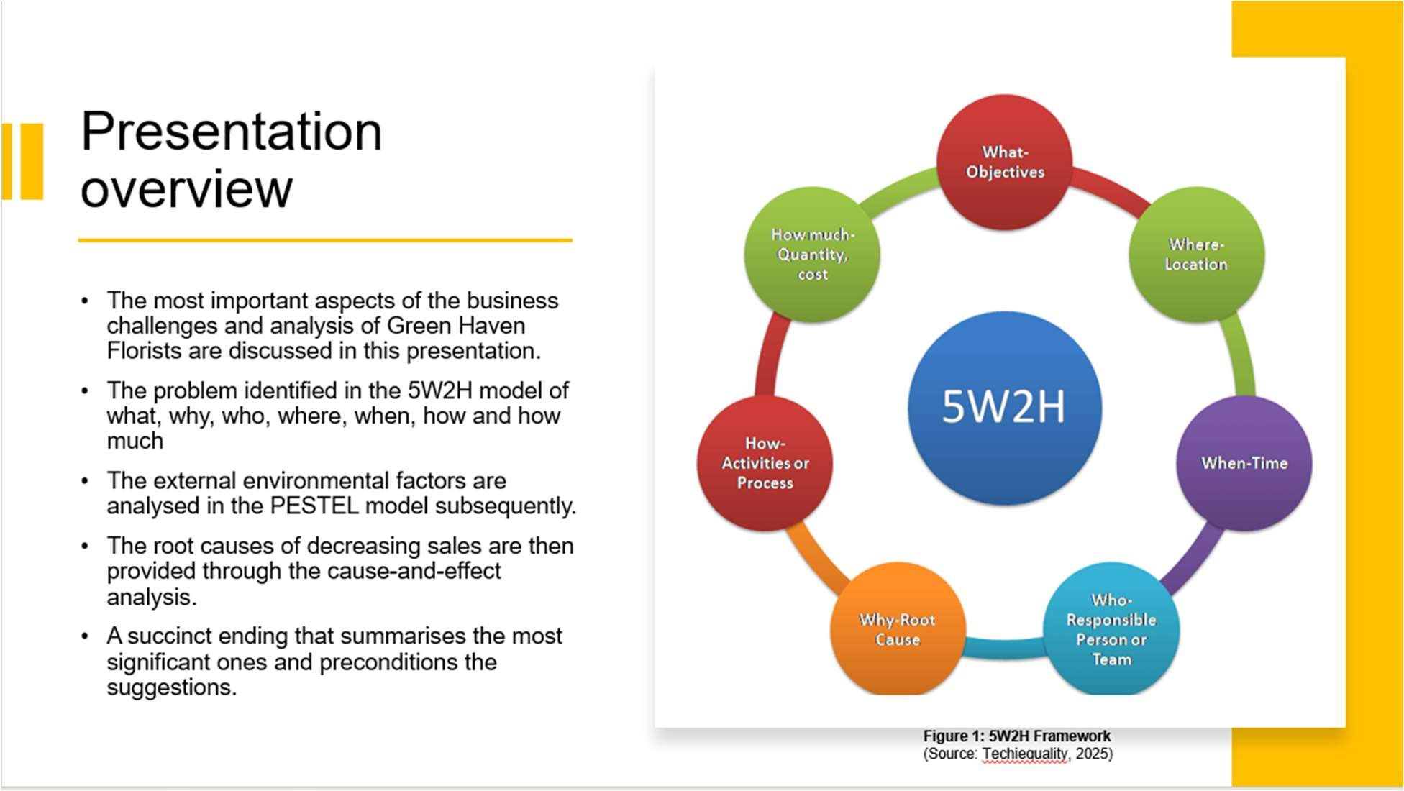
3
In this presentation, the most important aspects of the business challenges and analysis of Green Haven Florists are discussed. It begins by stating the problem identification in the 5W2H model of what, why, who, where, when, how and how much. It analyses the external environmental factors in the PESTEL model subsequently. The root causes of decreasing sales are then provided through the cause-and-effect analysis. Finally, the presentation includes certain concluding findings and a succinct ending that summarises the most significant ones and preconditions the suggestions.

Slide 3 — Problem identification (5W2H): WHAT / WHY
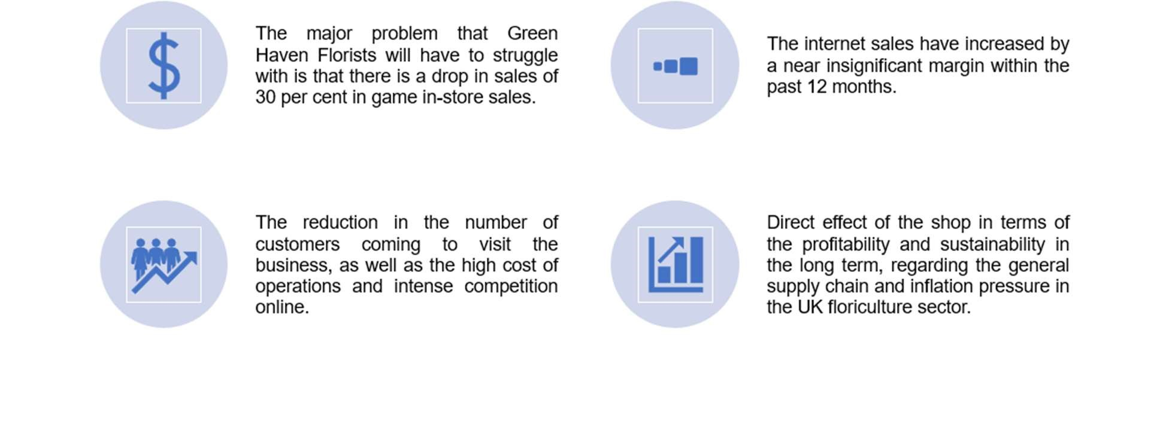
The major problem that Green Haven Florists will have to struggle with is that there is a drop in sales of 30 per cent in game in-store sales, and the internet sales have increased by a near insignificant margin within the past 12 months. It implies that the growth in the digital sphere is not compensating for the losses in stores. Main causes of the decline include the reduction in the number of customers coming to visit the business, as well as the high cost of operations and intense competition online. The significance of these issues is that they directly affect the shop in terms of profitability and sustainability in the 4
long term, regarding the general supply chain and inflation pressure in the UK floriculture sector.

Slide 4 — Problem identification (5W2H): WHO / WHERE / WHEN
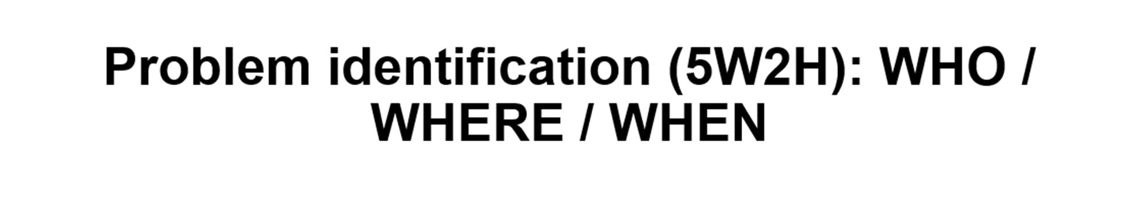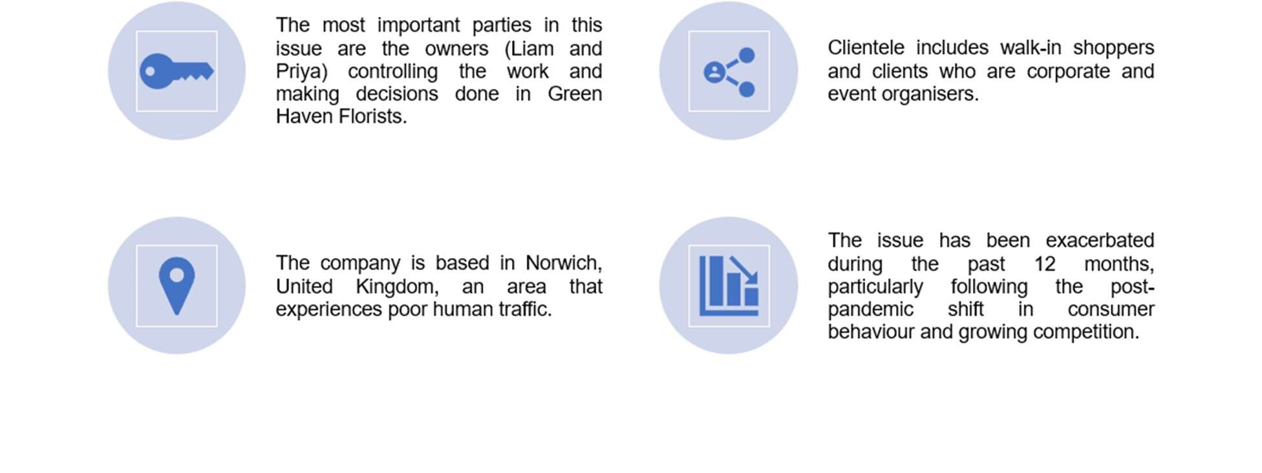
The most important parties in this issue are the owners (Liam and Priya) controlling the work and making decisions done in Green Haven Florists. Their clientele includes walkin shoppers and clients who are corporate and event organisers. The company is based in Norwich, United Kingdom, an area that experiences poor human traffic due to the closure of its physical outlets and the relocation of shoppers to online shopping. The issue has been exacerbated during the past 12 months, particularly following the postpandemic shift in consumer behaviour and growing competition on the internet within the UK flower retail sector in the UK.
5

Slide 5 — Problem identification (5W2H): HOW / HOW MUCH (scope & impact)
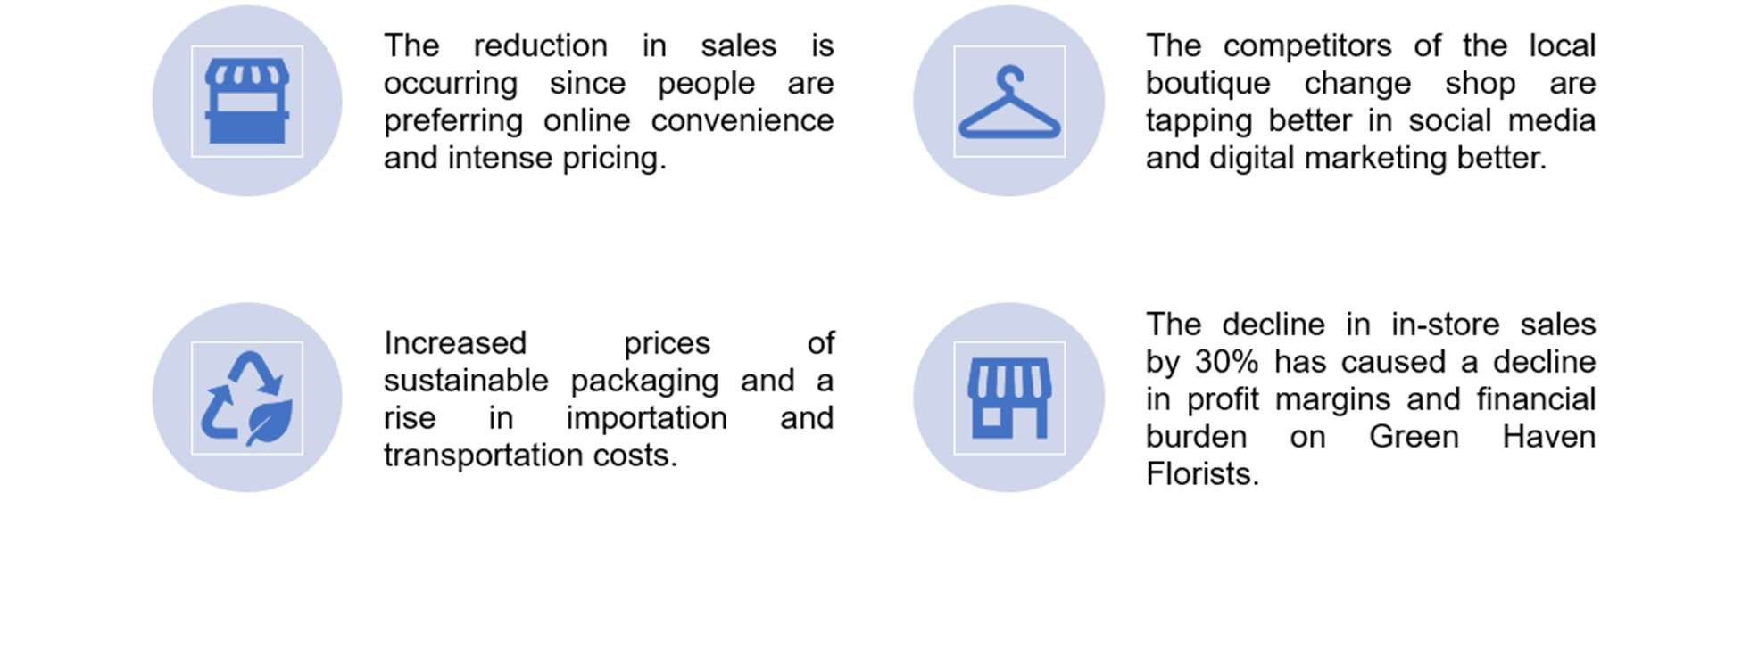
The reduction in sales is occurring since people are preferring online convenience and intense pricing by bigger nationwide florists. The competitors of the local boutique change shop are tapping better in social media and digital marketing better. Increased prices of sustainable packaging and a rise in importation and transportation costs have also added to the cost of operation. The net impact of all the aforementioned factors is the decline in in-store sales by 30% which has caused a decline in profit margins and financial burden on Green Haven Florists. The aggregate effects portray a scenario of how competitive, technological and cost pressures are directly affecting the business performance.
6

Slide 6 — External analysis: PESTEL (overview)
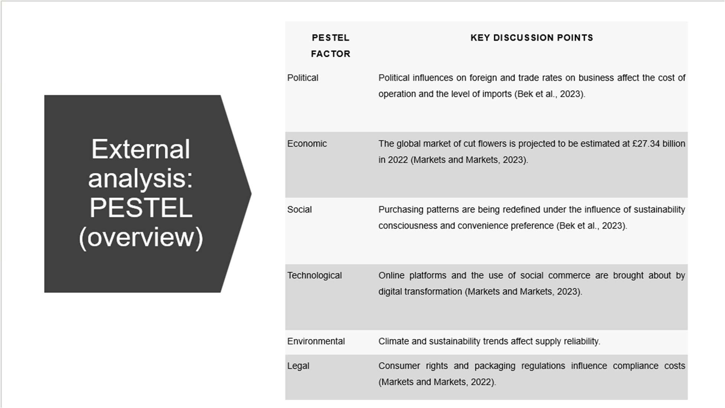
Various external elements affect Green Haven Florists, which are featured in the PESTEL framework. Political influences on foreign and trade rates on business affect the cost of operation and the level of imports. Economically, the global market of cut flowers is projected to be estimated at £27.34 billion in 2022. Purchasing patterns are being redefined under the influence of sustainability consciousness and convenience preference socially. Technologically, Online platforms and the use of social commerce are brought about by digital transformation. Climate and sustainability trends have an environmental influence on the reliability of supply. Legal consumer aspects and packaging laws affect compliance costs.
7

Slide 7 — PESTEL: interpretation & implications
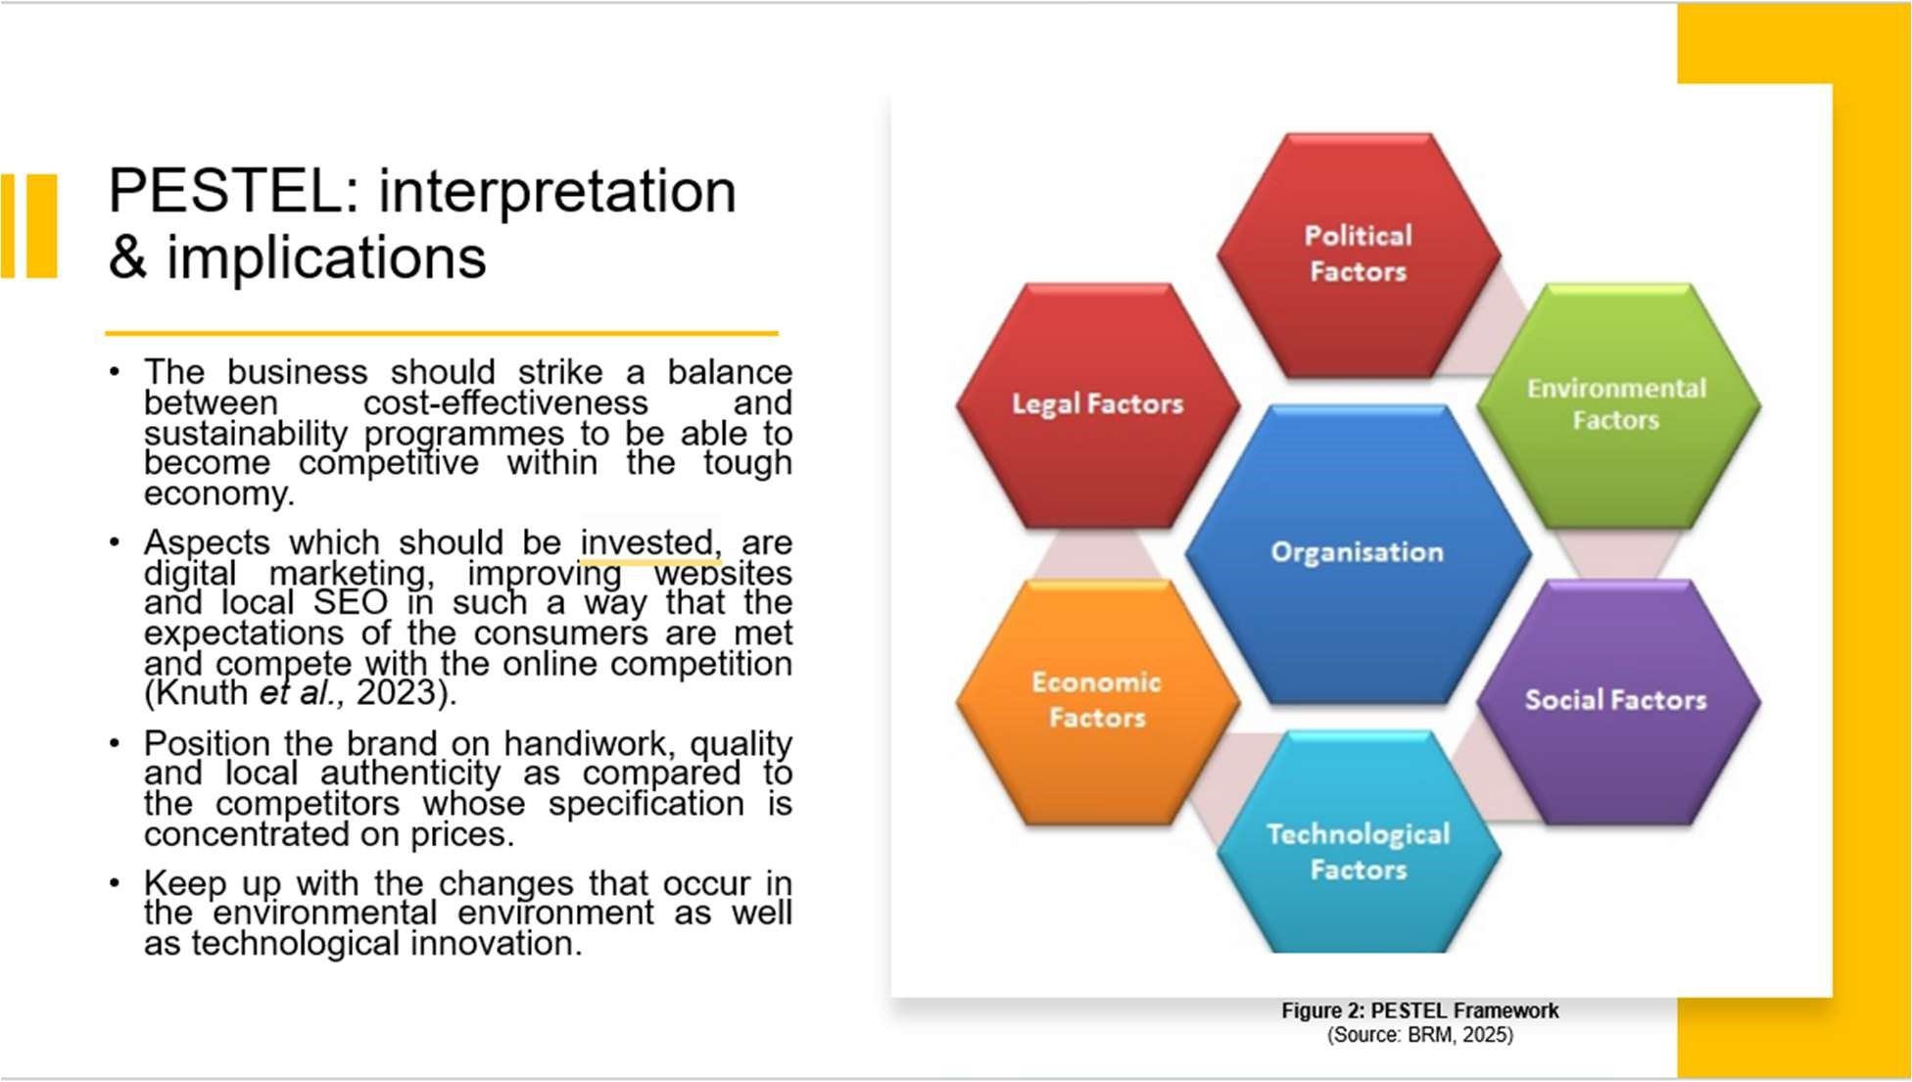
The PESTEL analysis has a number of strategic implications for Green Haven Florists. The business should strike a balance between cost effectiveness and sustainability programmes to be able to become competitive within the tough economy. Some of the aspects which should be invested, are digital marketing, improving websites and local SEO in such a way that the expectations of the consumers are met and compete with the online competition. Also, it is possible to position the brand on handiwork, quality and local authenticity as compared to the competitors whose specification is concentrated on prices. The joint conclusion of the above is the need to adjust to keep up with the changes that occur in the environmental environment as well as technological innovation, as this is significant in ensuring the survival of Green Haven in the long run.
8

Slide 8 — Cause-and-Effect (root cause)
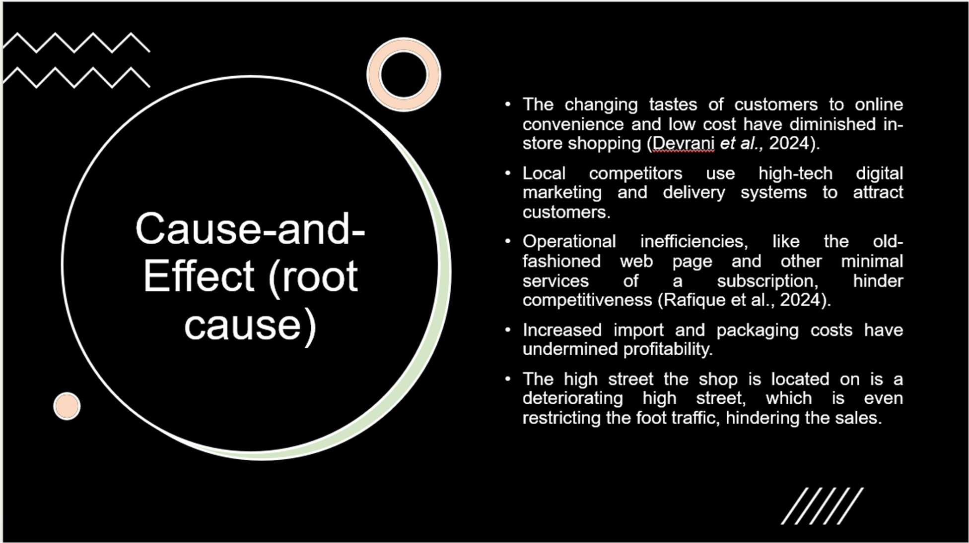
The analysis, using cause and effect, reveals that there are several root causes of the decline in the sales of Green Haven Florists. The changing tastes of customers to online convenience and low cost have diminished in-store shopping. Local competitors, both as national chains and as boutique florists, are employing high-tech digital marketing and delivery systems to attract customers. The lack of competitiveness is caused by operational inefficiencies, like the old-fashioned web page and other minimal services of a subscription. Also, increased costs of imports and packaging have undermined profitability. The high street the shop is located on is a deteriorating high street, which is even restricting the foot traffic, hindering the sales.
9

Slide 9 — Cause analysis: short justification & evidence
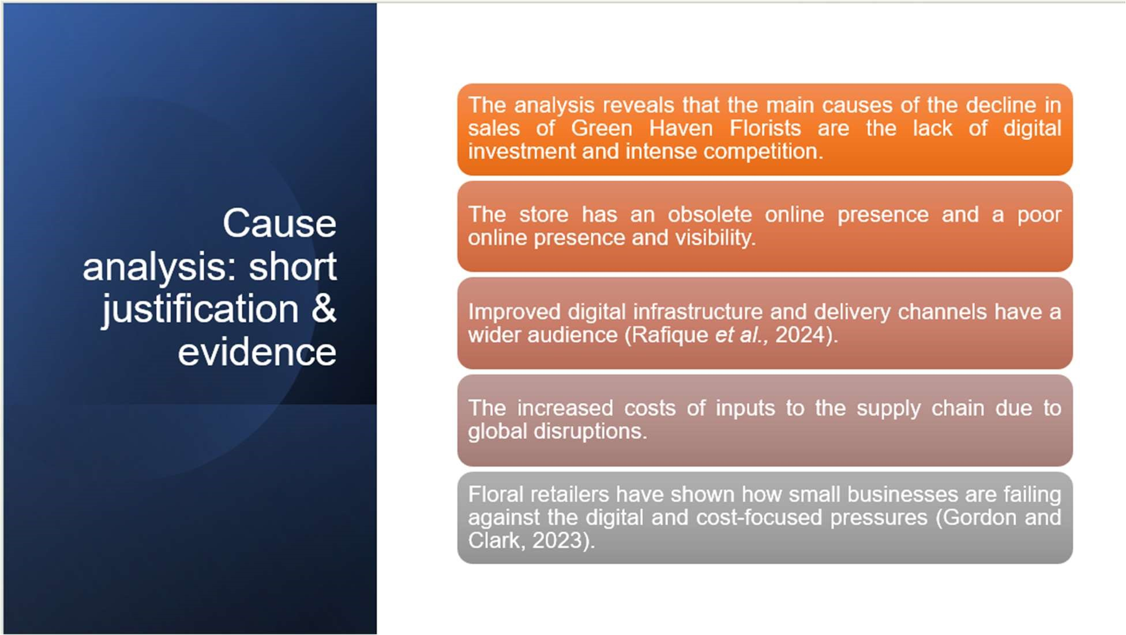
The analysis reveals that the main causes of the decline in sales of Green Haven Florists are the lack of digital investment and intense competition. The store has an obsolete online presence and a poor online presence and visibility. Those companies that have improved digital infrastructure and delivery channels have a wider audience. The second set of causes, secondary causes, is the increased costs of inputs to the supply chain due to global disruptions and additional costs incurred in staying sustainable. The latter results can be attributed to floral retailers that have shown how small businesses are failing against the digital and cost-focused pressures.
10

Slide 10 — Key findings
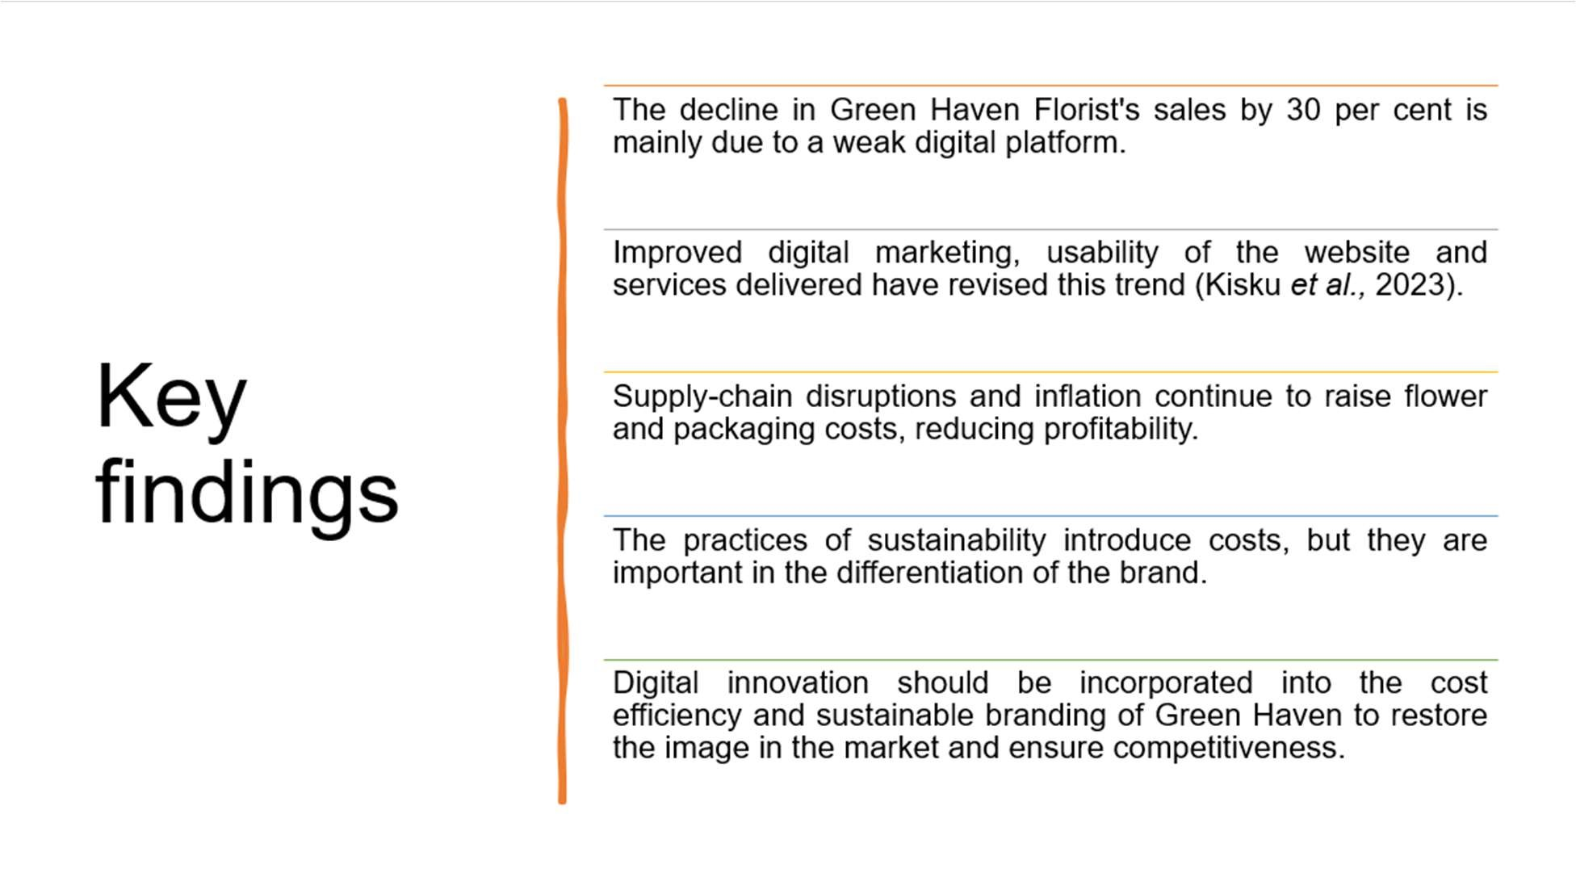
The results indicate that the decline in Green Haven Florist's sales by 30 per cent is mainly due to a weak digital platform and the rising competition in the case of internet-based florists. This could be reversed by improving digital marketing, usability of the website and services delivered. The problem of inflation and supply chain disruption is still increasing, and both the costs of flowers and packaging and profitability are decreasing. Although the practices of sustainability introduce costs, they are important in the differentiation of the brand. To sum up, digital innovation should be incorporated into the cost efficiency and sustainable branding of Green Haven to restore the image in the market and ensure competitiveness in the long-term perspective.
11

Slide 11 — Conclusion & Recommendation
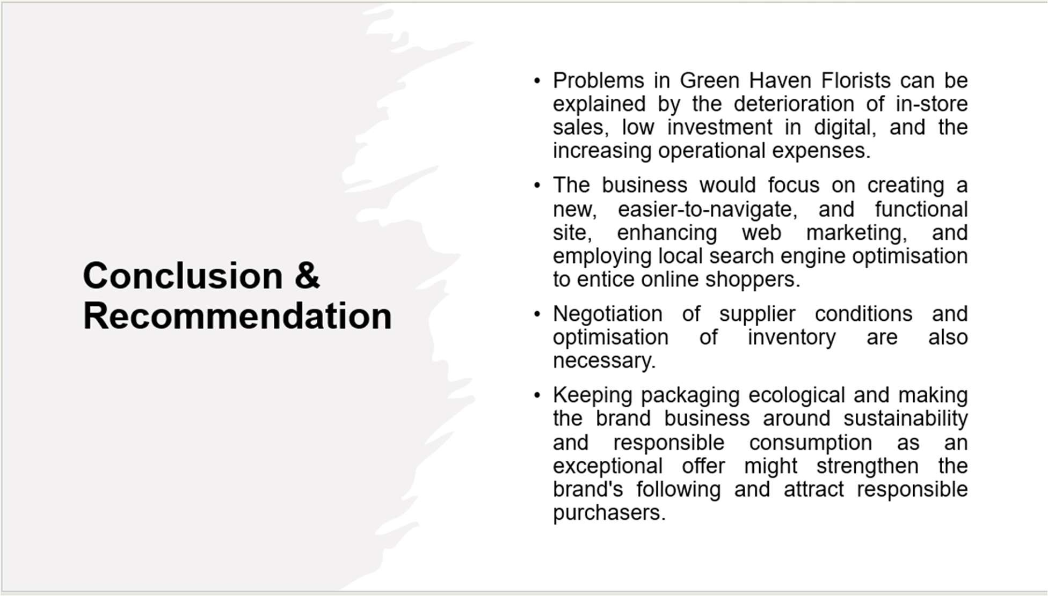
To summarise, problems in Green Haven Florists can be explained by the deterioration of in-store sales, low investment in digital, and the increasing operational expenses. In order to solve these, the business would focus on creating a new, easier-to-navigate, and functional site, enhancing web marketing, and employing local search engine optimisation to entice online shoppers. Other cost-control necessities like negotiation of supplier conditions and optimisation of inventory are also necessary. Lastly, keeping packaging ecological and making the brand business around sustainability and responsible consumption as an exceptional offer might strengthen the brand's following and attract responsible purchasers, guaranteeing their future sustainability and competitiveness.
12

Slide 12 — References
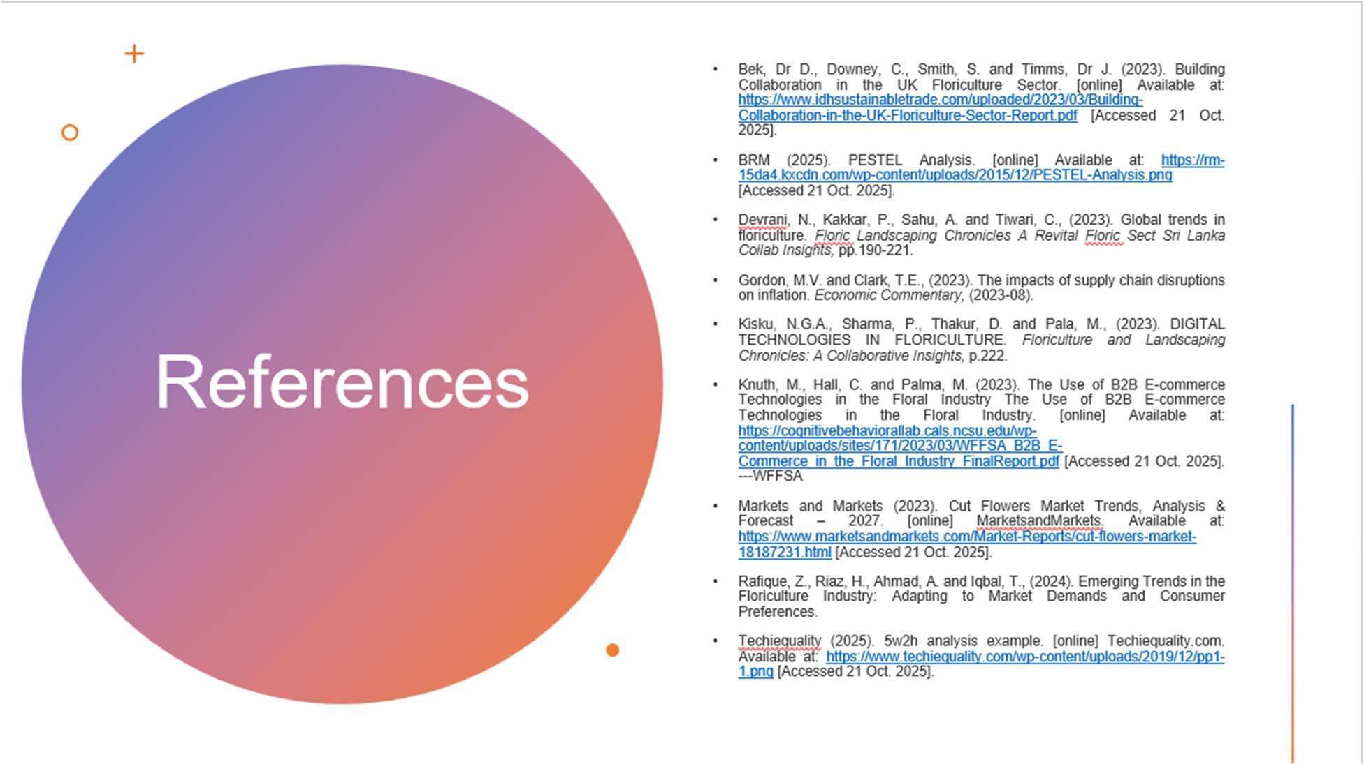

13

