
5/12/2025
Alina Mariana Daraban (2413829)
University of wales trinity of saint david (London)
Assessment 1
BSC APPLIED COMPUTING/LEVEL 5/TERM 1/GROUP 1
Module name: Network Operating Systems and Services
Lecturer: MD. Sadeque Imam Shaikh
Module code: ACCA5023

Home page
Table of Contents
Contents
Home page 1
Introduction 2
Task 1 Report: Research 2
1. Research of Hypervisor 2
1.1 Research on IP Addressing 3
2.1 Research on Routing 4
3.1 Research on Network Services 5
Task 2 Report: Technical Documentation 7
Task 3 Report: Reflection 20
Conclusion 21
References 21

Introduction
Network Operating Systems play a central role in enabling communication, resource sharing and coordinated management across interconnected devices. Unlike general purpose operating system, a NOS is designed to support multi-user environments, maintain reliable network operations and provide essential services such as authentication, file sharing, remote access and security oversight. [1] As modern organisation increasingly depends on distributed systems and cloud-based platforms, understanding how network operating systems function and the services they deliver has become vital for ensuring efficient and secure IT infrastructure. This assessment explores the fundamental concept, features and practical applications of Network Operating Systems and Services, highlighting their importance in supporting today’s digitally connected environments. [2]

Task 1 Report: Research

Research of Hypervisor

Hypervisor also known as Virtual Machine Monitors (VMMs), are the core components enabling virtualization in modern computing environments. By abstracting physical hardware and creating isolated virtual machines (VMs), hypervisor underpin cloud platforms, data centres and virtualised enterprise networks. [1]
While hypervisor is often discussed in relation to CPU and memory virtualization, they also play a crucial role in virtual networking, including IP Addressing, Routing, Switching and delivery of network services. As organisations shift towards software-defined infrastructure and cloud-first strategies, understanding how hypervisors manage and influence network behaviour becomes increasingly important. [1]
This report examines the relationship between hypervisors and three key networking areas: IP Addressing, Routing and Network Services, while analysing their technical mechanisms, benefits, limitations and emerging trends. [2] [3]

Research on IP Addressing
Virtual Network Interfaces

Each VM created by a hypervisor is assigned one or more virtual network interface cards (VNICs). These cards behave like physical network adapters but are entirely software-defined. Since the operating system inside the VM considers the VNIC as a normal NIC, it can receive:
- A static IP Address, configured manually
- A dynamic IP Address from a hypervisor-integrated DHCP service
- An address provided by an external DHCP server through bridged networking

IP Address Allocation Methods

Hypervisor typically offer three main network modes, each affecting IP Addressing differently:
- Bridged Networking
- The hypervisor bridges the VM’s VNIC to the physical network.
- The VM receives an IP address from the same subnet as the host.
- Suitable for scenarios where VM’s must behave as first-class network nodes.
- NAT (Network Address Translation)
- The VM sits behind a virtual NAT device controlled by the hypervisor.
- VM’s receive private IP addresses while the host performs address translation.
- Useful for labs, development or environments requiring outbound traffic without exposing VM’s directly. [3]
- Host-Only Networking
- The VM can only communicate with the host and other VM’s in the same host-only network.
- The hypervisor provides an isolated IP subnet, often through a built-in DHCP service. [2]
IP Address Management (IPAM) in Virtualised Environments

In enterprise systems, hypervisor interact with IPAM or SDN platforms to automate IP management, like:
- VMware vSphere integrates with NSX for automated IP pool allocation.
- KVM-based hypervisor using OpenStack rely on Neutron for software-defined IP management.
- Hyper-V integrates with System Center Virtual Machine Manager (SCVMM) for IP address template enforcement.
Through these methods, hypervisor extend IP addressing from a static, hardware-bound concept to a dynamic component within orchestrated virtual infrastructure.

2.1 Research on Routing
Virtual Switching and Internal Routing

At the heart of networking within a virtualised environment is the virtual switch (vSwitch). Hypervisors such as VMware ESXi, Microsoft Hyper-V and KVM include virtual switches that simulate traditional network switch behaviour.
These switches perform:
- Layer 2 frame forwarding
- MAC address learning
- VLAN tagging and trunking
- Port isolation and filtering
Although these actions occur at Layer 2, they influence higher-layer routing because they determine how packets enter and leave virtual networks.
Hypervisor-Based Routing

Some hypervisor platforms include routing capabilities directly within the virtual network layer. For instance:
- VMware NSX provides distrusted logical routers that run across hypervisors.
- Open vSwitch (OVS), used in KVM-based hypervisors, supports flow-based routing via OpenFlow.
- Hyper-V uses the Hyper-V Extensible Switch to support network virtualization routing (NVGRE).
In these cases, routing no longer depends on physical routers. Instead, the hypervisor distributes routing functionality to each host, enabling:
- Faster east-west traffic between VMs
- Reduced reliance on physical network infrastructure
- Seamless movement of Ms between hosts without IP changes
Overlay Networks and Software-Defined Routing

Modern hypervisor environments often rely on overlay networks using encapsulation protocols such as:
- VXLAN (Virtual Extensible LAN)
- GRE (Generic Routing Encapsulation)
- NVGRE (Network Virtualization using GRE)
These overlays create logical routing domains independent of the physical network. The hypervisor encapsulates packets before forwarding the across the physical network. This allows:
- Large-scale multi-tenant environments
- Network segmentation via logical routing tables
- Mobility of VMs without modifying IP routing at the physical layer
Overlay routing reduces complexity in the physical network while increasing flexibility at the hypervisor level.

3.1 Research on Network Services
DHCP AND DNS Service

Many hypervisors include built-in support for essential network services:
- DHCP serves to allocate IP addresses for internal or isolated virtual networks
- DNS forwarders to resolve names for VMs using NAT or host-only modes
These services ensure VMs can operate even in fully virtualised or isolated environments.
Firewalling and Traffic Filtering

Modern hypervisors provide firewall capabilities at the virtual switch or interface level. These can include:
- ACLs (Access Control Lists)
- Stateful firewalls
- Micro-segmentation policies
- Application-aware filtering (in advance SDN-integrated hypervisors)
Micro-segmentation is especially valuable because it applies granular security rules to individual VMs or groups of VMs, reducing the attack surface of the virtual network.

Load Balancing, Nat, and VPN Services

Advanced hypervisor frameworks such as NSX, OpenStack Neutron or Hyper-V Network Virtualization support additional network services:
- Software load balancers
- NAT gateways
- VPN concentrators
- IPv6 tunnelling
- Traffic shaping and QoS enforcement
These services traditionally required specialised hardware, but hypervisors now deliver them in distributed or virtualised form, improving scalability and resilience. [4]
High Availability and Network Redundancy

Hypervisors also manage high-availability network service, such as:
- Virtual NIC teaming for failover
- Redundant virtual switches
- Live migration traffic isolation
- Storage and cluster heartbeat networking
These network services ensure that VMs remain available even during hardware or network failures. [5]

ADVANTAGES and CHALLENGES
Advantages:
- Flexibility – Hypervisor allow rapid re-addressing, network creation, or re-routing without physical changes.
- Isolation – IP networks and routing domains can be isolated for security or testing.
- Scalability – Overlay networks enable thousands of isolated routing domains.
- Automation – Integration with orchestration tools streamlines network provisioning.
- Cost efficiency – Many network services can be virtualised, reducing hardware dependencies.
Challenges:
- Complexity – Managing virtual and physical networks together increases administrative complexity.
- Performance overhead – Encapsulation and virtual switching can introduce latency.
- Security risks – Misconfigured virtual networks can expose multiple VMs to compromise.
- Troubleshooting difficulty – Packet tracing across virtual and physical planes requires specialised tools. [4] [6]

Hypervisor Diagram (Canva)
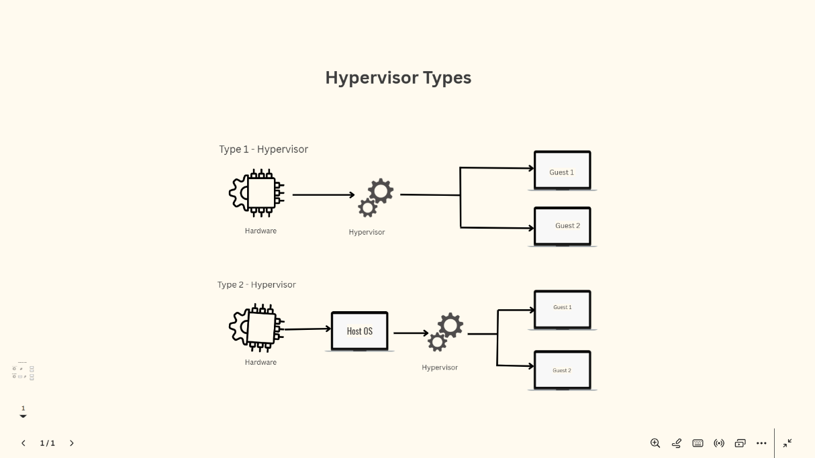

Task 2 Report: Technical Documentation

Oracle VirtualBox is an open-source virtualization platform that allows users to run multiple operating systems on a single physical computer. Widely used in academic and professional environments it provides a practical way to experiment with different system configurations without altering the host machine. For students in the UK, VirtualBox offers a flexible environment for learning about operating systems, networking, cybersecurity and software testing. It’s user-friendly interface, cross-platform compatibility and extensive community support make it a valuable tool for developing compatibility and extensive community support make it a valuable tool for developing technical skills in a safe, controlled workspace.

Choose your Hypervisor
The following screenshots shows the use of Oracle VM VirtualBox, which is a Type-2 hypervisor. A Type-2 hypervisor operates on top of an existing opetating system, meaning it relies on the host machine in this case, Windows to run virtual machines. VirtualBox provides an accessible way to create and manage multiple isolated environments, such as servers or client systems, without altering the main computer. This makes it especially useful in academic setting, where students can practice configuration, networking and system administration tasks in a safe and controlled virtual space. Its user-friendly interface and flexibility make it a practical tool fpr learning about virtualisation technologies. [7]
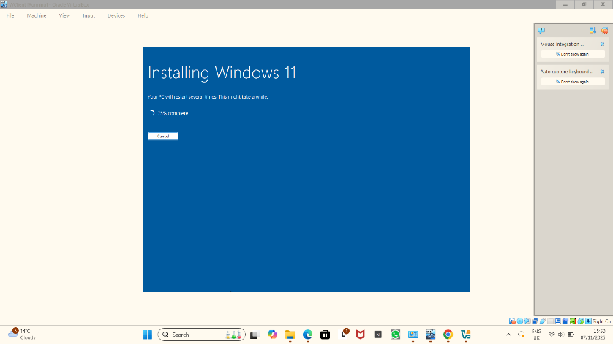
The screenshot shows a virtual machine windows running inside Oracle VirtualBox while Windows 11 is being installed. The installation progress is indicating 75% complete and will restart several times.

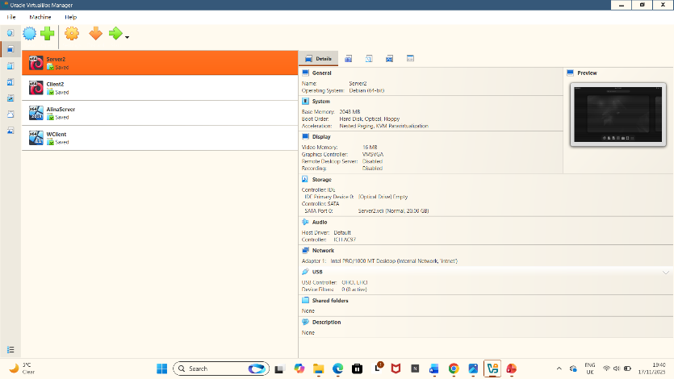
The screenshot shows Oracle VirtualBox Manager with several virtual machines installed. The selected “Server 2” displays its hardware and configuration details on right side, along with a small preview of its current state. The host system’s taskbar is visible at the bottom.
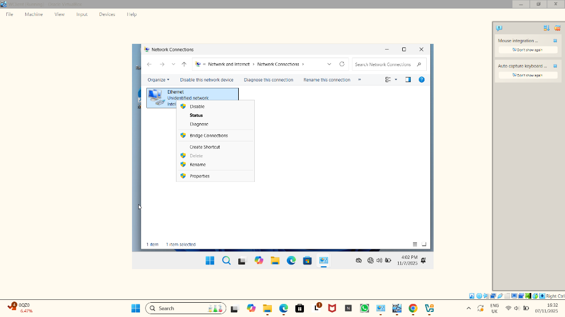

The screenshot shows the Network Connection window inside a virtual machine where the Ethernet adapter has been right-clicked, the menu is open, indicating that I was checking the configuration option for the network connection.
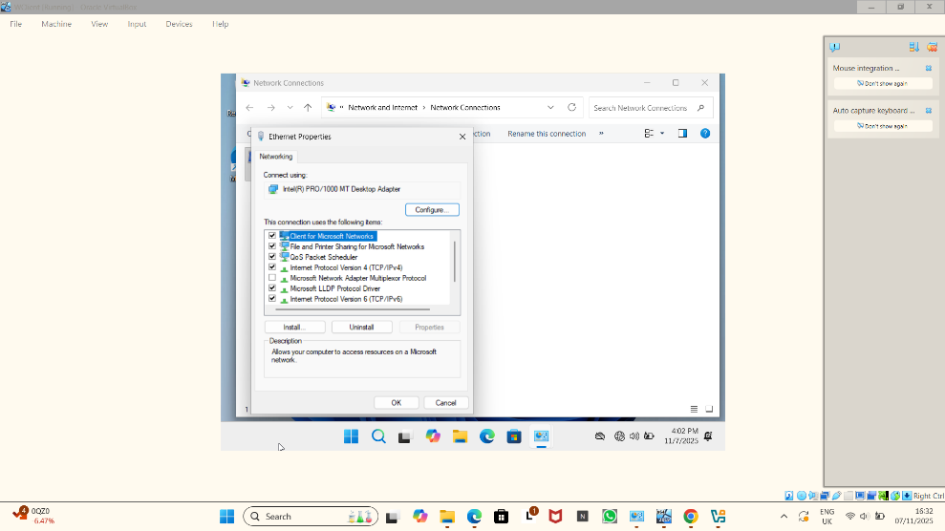
This screenshot shows the Ethernet Properties windows where I opened the settings for the network adapter to view or adjust the networking features it uses. IPv4, IPv8 and Microsoft network services.

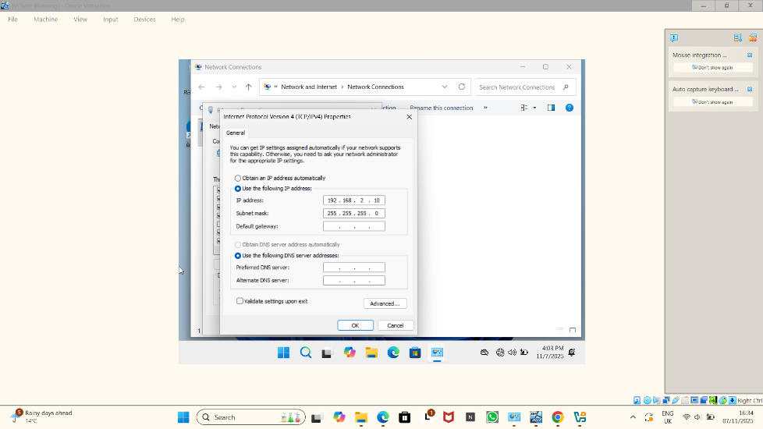
The screenshot shows the IPv4 settings window where I manually entered a specific IP address, subnet mask and DNS options for the network adapter instead of using automatic network settings.

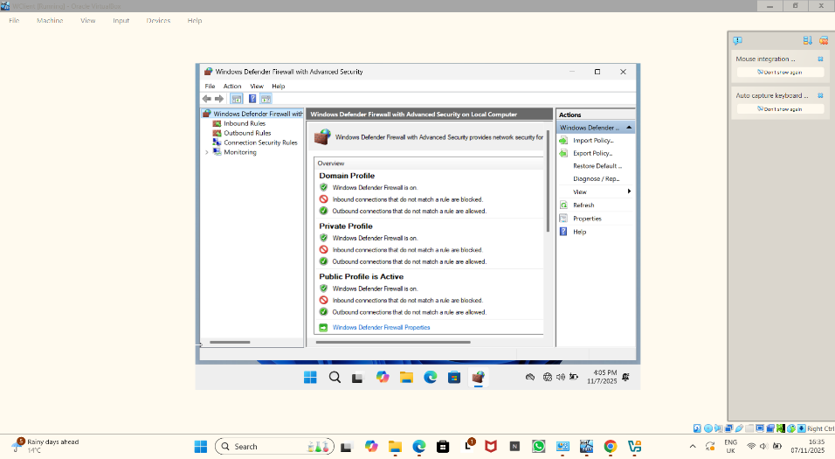
The screenshot above shows the Window Defender Firewall with Advanced Security window where I checked the firewall for domain private and public profiles. It displays which tupes of connections are allowed or blocked on the system.

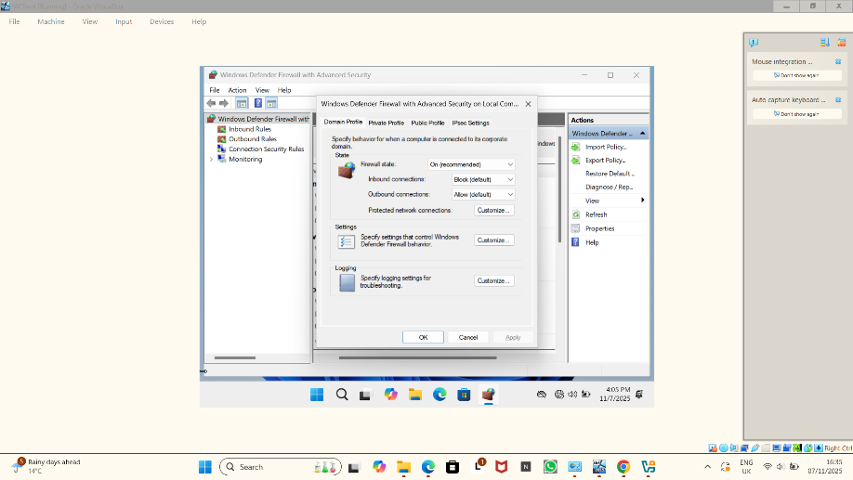
This screenshot shows the Domain Profile settings in Window Firewall with Advanced Security where I review how the firewall behaves when the computer is connected to a trusted corporate network. The firewall is turned on inbound traffic is blocked for protection and outbound traffic is allowed so the computer can access external resources. The window allows to adjust or customise these rules and logging options to meet specific security requirements.

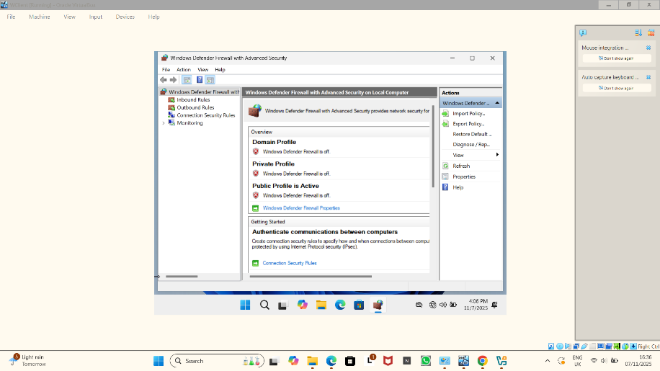

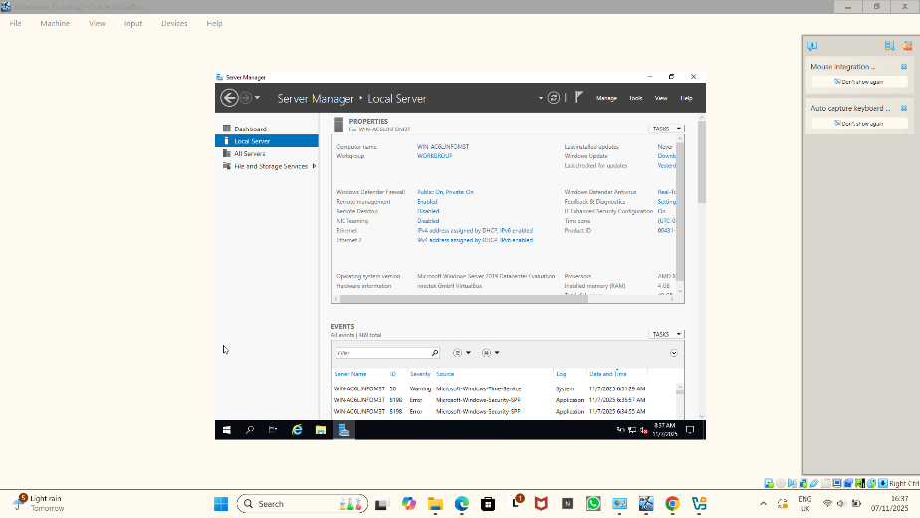
This is the Server Manager window displaying key system information such as firewall status, remote management settings, network configuration and system version that provides an overview of the server’s current state and recent events to help monitoring and administration.

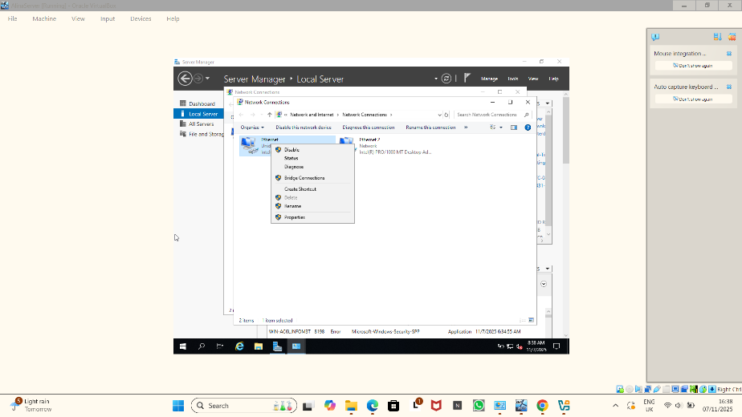

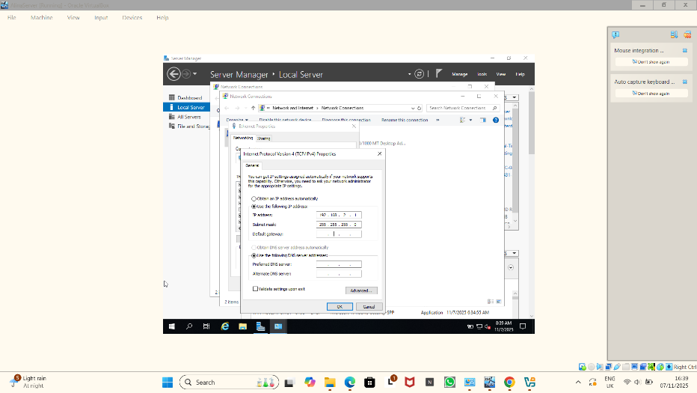
These two above screenshots are repeated steps.

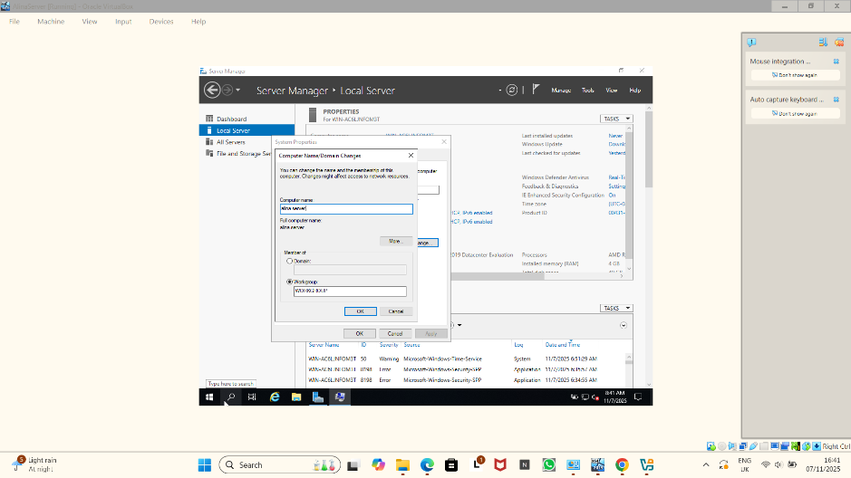

These are repeated steps as the previous screenshots.

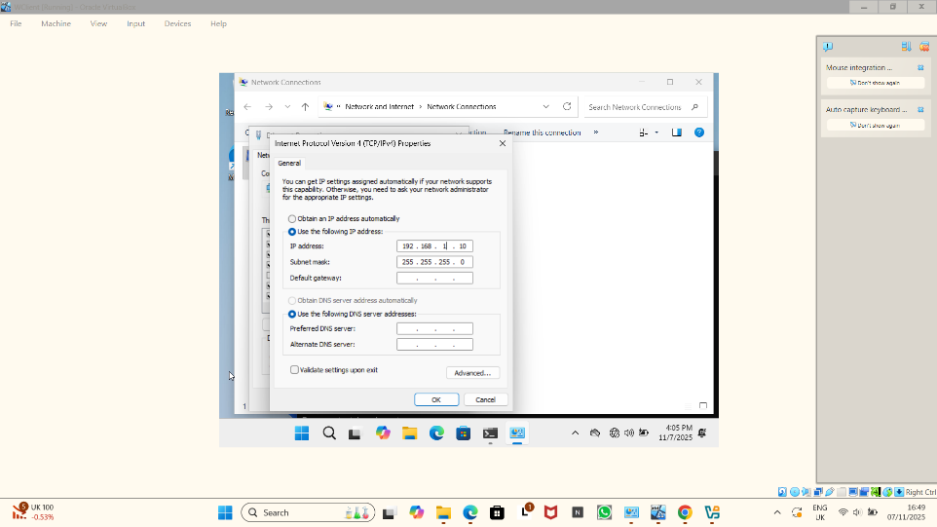
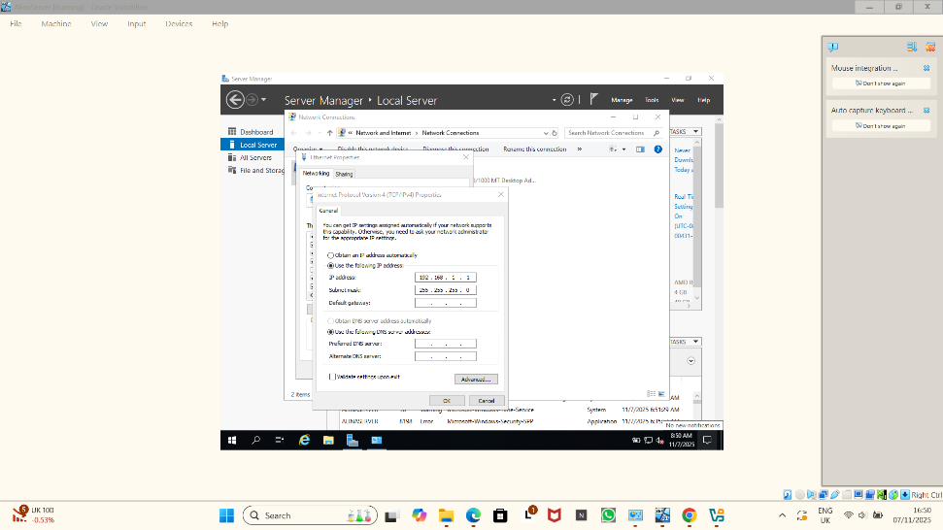
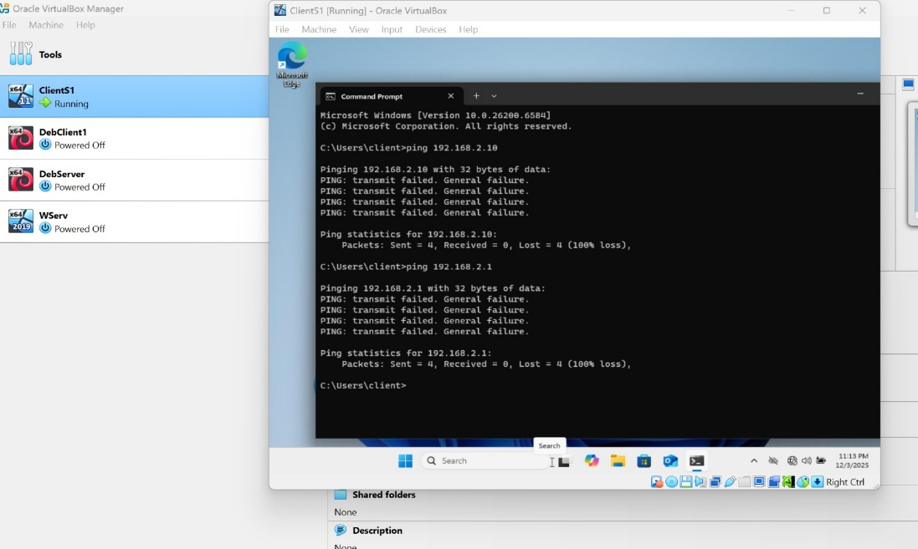
This screenshot shows failure connectivity between Linux and Window networking.

Configuration Step-by-Step
Open VirtualBox, then Select VM, go to Settings and then select Network
Adapter 1 (Internal Network)
- Enable adapter
- Attached to: Internal Network
- Name: intent (can choose any name, but all VM must use the same name)
Adapter 2 (Optional – Internet Access)
- Enable adapter
- Attached to: NAT or Bridged Adapter
Use this only if the machine requires updates or internet access.
I repeated these settings for: Windows Serve, Windows Client, Linux Server and Linux Client. [7]
Next steps need to Set IP Addresses on Each Machine
On Windows Server: Open Control Panel Network and Sharing Centre, then select the network adapter (Internal Network), open Properties IPv4, and then assign a static IP:
- IP: 192.168.10.1
- Subnet: 255.255.255.0
- DNS: Server’s own IP if acting as DNS

On Windows Client: Assign a static IP (or use DHCP if the server provides it):
- IP: 192.168.10.10
- Subnet: 255.255255.0
- Gateway: 192.168.10.1 (Windows Server)
- DNS: 192.168.10.1
On Linux Server: Open the network config file
network:
ethernets:
ens33:
dhcp4: no
addresses: [192.168.10.2/24]
gateway4: 192.168.10.1
nameservers:
addresses: [192.168.10.1]
version: 2
Then run:
bash
sudo netplan apply

On Linux Client: Assign another IP on same network
- IP: 192.168.10.20
- Gateway: 192.168.10.1
- DNS: 192.168.10.1

TEST CONNECTIVITY
On each machine:
Windows: ping 192.168.10.1
ping 192.168.10.2
Linux: bash
ping 192.168.10.1
ping 192.168.10.10
If all machines reply, the internal network is working.

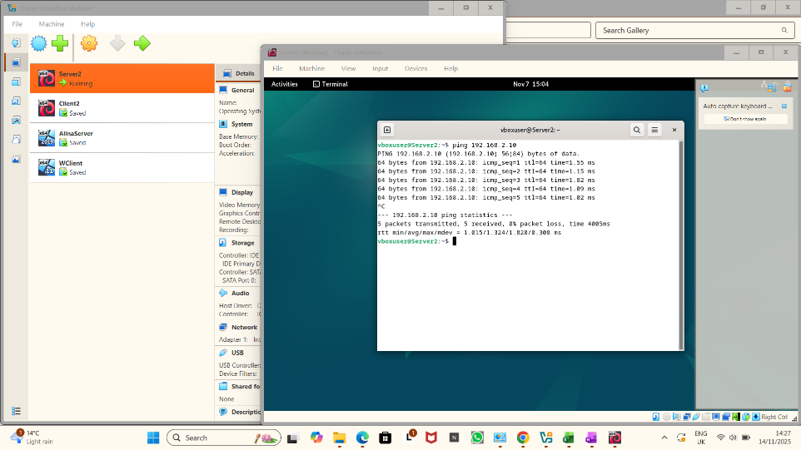

This screenshot shows Linux terminal where is been tested network connectivity by sending ping requests to the IP address 192.168.2.10. The response confirm that the destination is reachable with all packets returned successfully and no loss.
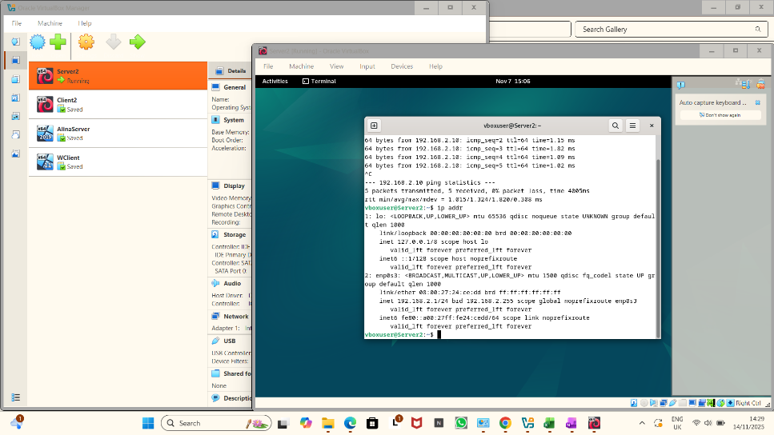

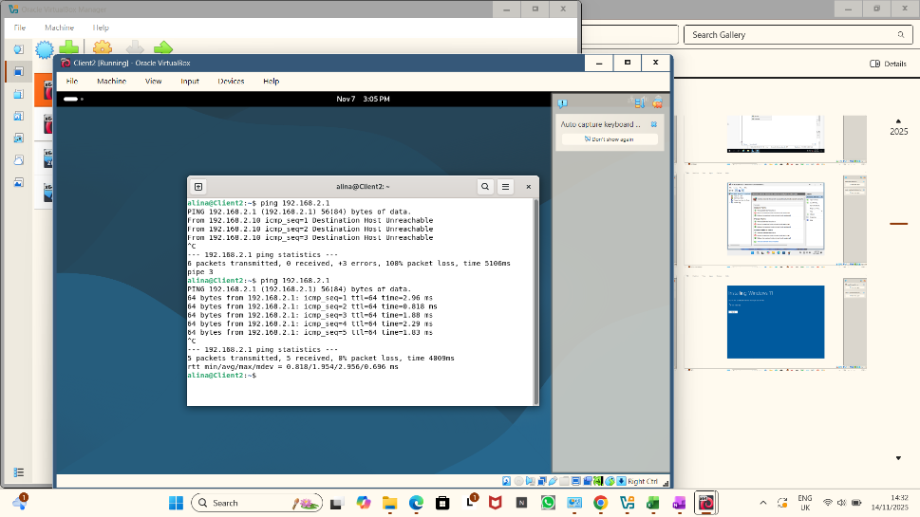

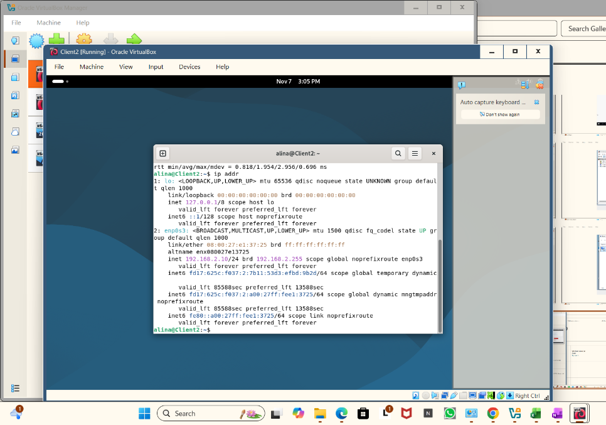

Can be configured Windows Server for DHCP and DNS.

Join Windows Client to Windows Server
On Windows Server Create a domain then on Windows Client:
-open System Properties
- change domain Enter lab.local
- provide domain admin credentials
- restart the machine.

Linux Connectivity to Windows Server
Linux machine can:
-Ping the domain controller
- Access shared folders smb : //
- Resolve DNS if using Server DNS

Task 3 Report: Reflection

Working with VirtualBox to build a network that included Windows and Linux servers and clients has been a valuable learning experience that strengthened both my technical understanding and my confidence in managing virtual environments. At the beginning of the task, I felt unsure about how different operating systems would interact within the same virtual network. However, as I progressed through each step configuring adapters, assigning IP addresses, and testing connectivity I developed a clearer understanding of how virtual networks operate and how closely they mirror real-world network structures. [8]
One of the key lessons I learned was the importance of planning the network design before starting the technical configuration. Deciding to use an Internal Network for communication between machines helped keep the setup organised and secure and it also made troubleshooting much easier. When I configured the Windows Server with a static IP and set up the client to communicate with it, I began to appreciate how essential correct addressing is for any network to function reliably. [9]
Working with Linux added another layer of learning. Unlike Windows, which provides a graphical interface for most network settings, Linux required manual configuration through system files. [10] This helped me understand what happens behind the scenes and highlighted the differences between the two systems. Although it was initially challenging, successfully applying the network setting on Linux gave me a sense of achievement and improved my confidence in command-line work.
Testing connectivity using tools such as “ping” helped me confirm whether the machines were communicating as intended. When issues occurred, such as a client failing to respond, I had to revisit earlier steps and check for errors. This reinforced the importance of methodical troubleshooting and playing attention to details. [10]
Overall, this task improved my understanding of virtualisation, network configuration and cross-platform communication. It also highlighted how valuable hand-on practice is when learning technical concepts. By completing this setup, I now feel more prepared to work with more complex networks and server roles in future modules and professional environments.

Conclusion
In conclusion, setting up and managing a multi-system virtual network in VirtualBox has significantly deepened my understanding of virtualisation and network configuration. By working with both Windows and Linux environments, I gained practical experience in assigning IP addresses, configuring adapters and ensuring communication between different operating systems. The process helped me develop stronger problem-solving skills, especially when identifying and correcting connectivity issues. Overall, this task has enhanced my technical confidence and prepared me for more advanced networking and system administration challenges in future academic work and professional practice.

References
References
References
[1] K. M. Fathima and N. Santhiyakumari, "A survey on evolution of cloud technology and virtualization," 2021 Third International Conference on Intelligent Communication Technologies and Virtual Mobile Networks (ICICV), 2021.
[2] B. Đorđević, et al., "Performance comparison of different hypervisor versions of the type-2 hypervisor VirtualBox," 2023 10th International Conference on Electrical, Electronic and Computing Engineering (IcETRAN), 2023.
[3] S. S. Oyelere and S. Okegbile, "Comparative Analysis of Energy Efficiency in Virtualization Tools and Underlying," Decarbonization or Demise–Sustainable Solutions for Resilient Communities: Selected Papers from the International Conference of Sustainable Ecological Engineering Design for Society (SEEDS) 2023, 2025.
[4] B. Đorđević, et al., "Comparison of type-2 hypervisor performance on the example of VirtualBox VMware Workstation player and MS Hyper-V," PROCEEDINGS IX ICETRAN, pp.6–9, 2022.
[5] D. D. Saputra, et al., "Implementasi Private Cloud Storage dengan Menggunakan Owncloud dan Linux Ubuntu Pada Virtualbox Oracle," Jurnal Komputer Antartika, vol. 2, no. 1, pp.9–15, 2024.
[6] O. V. VirtualBox, "Oracle vm virtualbox," Change, vol. 107, pp.1–287, 2011.
[7] F. N. Almari, et al., "Performance analysis of oracle database in virtual environments," 2012 26th International Conference on Advanced Information Networking and Applications Workshops, 2012.
[8] P. Dash, Getting started with oracle vm virtualbox, Packt Publishing Birmingham, UK, 2013.
[9] S. Ally, "Performance Analysis of KVM and Oracle Virtual Box as Type 2 Open-Source Hypervisors," World Conference on Information Systems for Business Management, 2024.
[10] J. C. Jacob, "No title," Enhancing Virtualization Security in Oracle VirtualBox: Investigating VM Escape Vulnerabilities and Mitigations, 2024.

