Name: Nizar Kasamali Charania
Student Number: 2132189
Module: LCMB7001
Lecturer: Tushara Balendran
Course: MBA
Submission Date: 08th Sep 2022

Table of Contents: (Marks and Spencer)
1. Introduction……………………………………………………………………………………………………………..3
2. PESTLE Analysis………………………………………………………………………………………………………..3
• Political ………….……………………………………………………………………………………………………….4
• Economic…………………………………………………………………………………………………………………4
• Social……………………………………………………………………………………………............................4
• Technological…………………………………………………………………………………………………………..5
• Legal………………………………………………………………………………………………………………………..5
• Environmental………………………………………………………………………………………………………….6
3. PORTER’S Five Forces……………………………………………………………………………………………….6
• Threats of New Entrants…………………………………………………………………………………………..7
• Threat of substitute………………………………………………………………………………………………….7
• Bargaining Power of Supplier…………………………………………………………………………………..7
• Threat of substitute………………………………………………………………………………………………….7
• Rivalry……………………………………………………………………………………………………………………..7
4. SWOT Analysis…….…………………………………………………………………………………………..........8
5. Advantages and Disadvantages of SWOT Analysis…………………………………………………..10
6. Segmentation Targeting and Positioning…………………………………………………………………10
• Segmentation………………………………………………………………………………………………………….10
• Targeting………………………………………………………………………………………………………………..11
• Positioning………………………………………………………………………………………………………………11
7. The Marketing Mix………………………………………………………………………………………………….11
• Product……………………………………………………………………………………………………………………11
• Price…………………………………………………………………………………………….............................12
• Place……………………………………………………………………………………………………………………….12
• Promotion……………………………………………………………………………………………………………….12
8. The Ansoff Matrix.………………………………………………………………………………………………….13
9. Conclusion and Recommendations…………………………………………………………..…………….14
10. References……………………………………………………………………………………………………………..15

- “Introduction”
Michael Marks and Thomas Spencer laid out M&S in Leeds in 1894. It later formed into a notable brand and one of the top division shops in the UK. It kept a generally English brand with an accentuation on quality, an incentive for cash, and reasonableness in spite of monetary high points and low points. M&S is known for selling food and drink, dress, and home merchandise; however it has as of late ventured into monetary administrations including protection and Mastercards. Because of issues with its store network and disappointing item contributions, the firm was in a problematic monetary circumstance toward the start of the 2000s (Mellahi et al., 2002).

- PESTLE Analysis of M&S
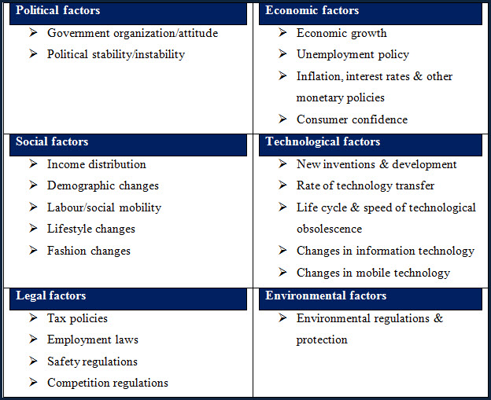
“Figure 1: PESTLE analysis of M&S”
“Source: www.swotandpestle.com”

Political
Free-trade
The expert trade that has been created between a few countries is perhaps of the best thing about contemporary legislative issues. This is very favorable for M&S, which principally works in the UK yet in addition has offices universally. With the solid net revenue, streamlined commerce empowers M&S to import merchandise from different nations at lower costs available to be purchased in their stores (Nandonde, 2019).

Brexit
The UK’s choice to leave the European Union, in some cases known as "Brexit," is a political perspective that could impact Marks and Spencer's business tasks. This is very unfavorable for M&S. Despite the fact that it's questionable where the UK would remain as far as exchange rules and levies after Brexit, large numbers of the potential results are not positive for UK shops (Bergeron, 2009).
Economic
Discount competitors of M&S
Despite the fact that cost has forever been a significant thought in the retail area, a few minimal expense stores have arisen in the UK during the beyond couple of many years. By empowering clients to buy similar merchandise at extensively less expensive rates, these new opponents ranging from markdown supermarkets to limit clothing chains, are grabbing piece of the pie from additional costly organizations (like Marks and Spencer) which is favorable. As a matter of fact, these deal opponents might have been a figure Marks and Spencer's 1999 choice to switch over completely to utilizing abroad providers (Nandonde, 2019).

Social
Non-trendy
In the UK, M&S is definitely not a pristine name. The retail business, which has been laid out since the 1800s, is presently notable to youngsters, the old, and in the middle between. The miserable aftereffect of this well established standing is that clients are beginning to connect M&S with the past (Bergeron, 2009), which is favorable for M&S.

The prepared feast market is served by Marks and Spencer.

The utilization of prepackaged feasts has essentially expanded during the beyond 10 years in the public eye. This might be because of upgrades in food innovation preparing feasts more scrumptious than previously. Any food shop would benefit significantly from this colossal new business (Bergeron, 2009), which is favorable for M&S.

“Technological”
Self-checkout
Self-checkout is one of the significant improvements in contemporary retail, especially in supermarkets. This is favorable for M&S and this inescapable pattern is expected to set aside organizations cash that would somehow be spent on clerks while likewise giving clients a speedier checkout experience (Bergeron, 2009).

Web based buying

Web based buying is one more critical pattern in the retail business and favorable for M&S. As may be normal, M&S as of now has a critical web-based presence, selling essentially their things in general, including clothing, food, and home merchandise. M&S conveys items straightforwardly to clients while selling clothing internet, following the customary model (Bismark, 2018).

“Legal”

The innovation change program that M&S has uncovered would permit the enterprise to turn into a computerized first business and deal an assortment of shopper encounters, it is favorable. It’s will likely give a business, fast, and nimble IT capability that will assist firms with extending. The business is focusing on fostering another innovation working model that will significantly help M&S in using new innovation, including the execution of area deft philosophies (Bismrk, 2018).

“Environmental”

Sustainable produce

Marks and Spencer has frequently vowed to turn into a more supportable business to maintain their standing as a top of the line brand. This applies to many natural components that are available while buying food, garments, and family merchandise (like fossil fuel byproducts from assembling cycles and deforestation for cultivating land), it is favorable (Bismrk, 2018).
Fair trade
The natural impacts of fair exchange, a program intended to give unfamiliar producers more pleasant remuneration, are likewise felt. This is so more modest producers, who benefit most from fair exchange, may work more economically than their more settled rivals. In this way, Marks and Spencer's decision to sell fair exchange products likewise emphatically affects the climate, unfavorable (Bismrk, 2018).

- PORTER’S Five Forces
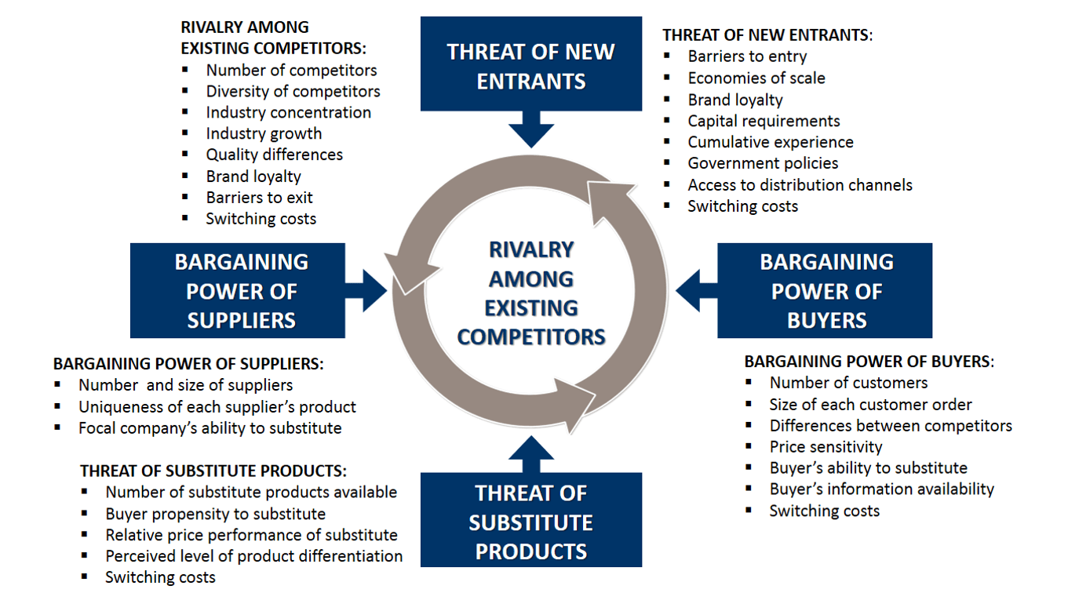

Fig 3

Source: Femfortuniversity.com
Threat of New Entrants (HIGH)

With its corporate base camp in London, Marks and Spencer is a significant maker of clothing, home merchandise, and food items around the world. It very well might be found in excess of 1000 areas around the world. It requires a respectable measure of brand reliability, as is commonplace for notable organizations in this area. Indeed, even yet, it doesn't ensure a lot of deals cash. For every one of these elements, the danger of new adversaries is very troublesome (Warnaby and woodruffle, 1995).

Threat of Substitutes (High)

These two are essential requirement for human sustenance. There are subsequently no genuine options in contrast to them. They can, notwithstanding, be supplanted with products given by different organizations. Also, there are different options in contrast to Marks and Spencer's food contributions, as Waitrose. We could presume that the danger of substitutions is huge considering all the previously mentioned concerns (Bismrk, 2018).

Bargaining Power of Customers (HIGH)

Individuals who purchase the merchandise from M&S are called clients. The retail area is in a general sense extremely cutthroat, and its clients are cost cognizant ordinarily. It is harder to keep clients since there are low exchanging costs for the clients. There is likewise a great deal of client center.

Bargaining power of supplier (LOW)

The associations from which M&S buys its unrefined components are known as providers. It's undeniably true that M&S works universally, has a presence in numerous countries, and has major areas of strength for a value. Rather than utilizing only one source, it buys its feedback materials from a few. They don't give numerous particular materials. We might construe from all of the previously mentioned measures that providers don't have a lot arranging influence (Warnaby and woodruffle, 1995).

Competitive Rivalry (High)
As was recently noted, there is a ton of contest in the retail area. The market has a great deal of contenders, and purchasers are likewise cost cognizant. Clients have an enormous choice of stores to pick from, and exchanging costs for them are practically nonexistent or extremely low. Clients approach a large number of decisions too.
- SWOT analysis
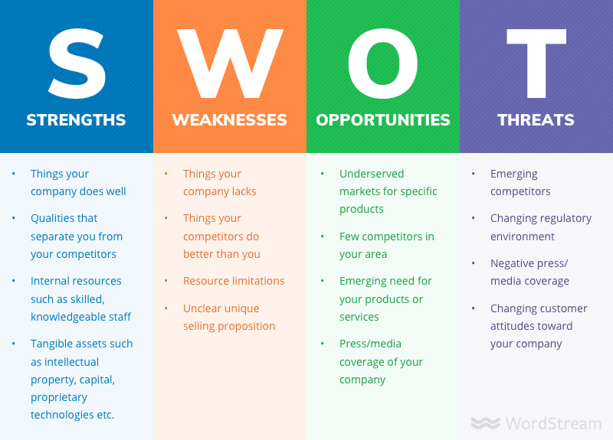
Fig 4: SWOT analysis
Source: word stream.com

“Strengths of M&S”

• Overall brand

Gauges place the quantity of M&S areas at around 1463 across Asia, Europe, and the Middle East, with 1035 of those being in the UK (Bergeron, 2009).
• Market cost

Forbes gauges that M&S had a market worth of $2.3 billion out of 2020.

• Legitimate brand

“An exploration shows that M&S is the second most popular brand in the UK.”

• Experience

“In 137 years, M&S has been a player in the retail area. Before turning into a worldwide brand, it was a penny bazar in Kirkgate Market.”

“Weaknesses of M&S”

Rising costs

A large number of the errands that M&S perform are manually. To finish, a many individuals are required and it requires a long investment.

Discernment

Numerous youngsters accept that M&S is a corporate store that takes care of the old.

“Opportunity”

Division

Market division is the method involved with grouping customers as indicated by their requests and inclinations. Market division ought to be done likewise way as Marks and Spencer.

Internet business
“An internet based store has proactively been laid out by Marks and Spencer. In any case, it misses the mark concerning the type of Amazon, AliExpress, and other top web-based retailers in the globe.

“Threat”

Debates

Whether carrying out the standard hijab in the UK, a self-checkout framework, or an exhibit against Israel.
“Contenders”
A portion of the critical opponents of M&S incorporate Sainsbury, Debenhams, Sports Direct, Asda, Morrisons, John Lewis, Gap, tesco, Next, Amazon, Walmart, and others.

- “The SWOT Analysis' advantages and disadvantages for this.”
“Advantages include:”
It has only four fundamental boxes.
It makes it more straightforward to fathom the association's benefits and detriments.
It advances the development of vital thinking.
Ranking directors might utilize it to focus on their assets and set out open doors (Rapley, 2017).
“Negative viewpoints include”
Some SWOT examination clients decrease the data used to make decisions a lot since using deficient information is straightforward.
The risk of social affair more information could bring about "loss of motion by investigation."
The insights might have been determined utilizing assumptions that a short time later ended up being mistaken (Rapley,2017).

- Segmentation Targeting and Positioning
“Segmentation”
Market division empowers M&S to deal with similar clients in a reliable way while making qualifications between different client gatherings. To pick which markets to offer its items to, M&S utilizes segment division. By age, pay, societal position, and occupation, M&S separates their customers into many sections. M&S explicitly focuses on those more than 30 who have big time salaries and chief positions. Moreover, it depend the division of the market on esteem (Eka, 2018)
.
“Targeting”
"Our key clients keep on being those matured 45 or more, social-affordable gathering ABC1, and the loyal 1-2 shop customers too," the organization's yearly report adds. In actuality, this gathering represents 75% of turnover (M&S Annual Report, 2007). Be that as it may, the business knows about the need to broaden its buyer base and spotlight on all age gatherings. As per Hare et al. (2002), "age might be a useful division, and interest is spreading both to more youthful and more established people," it is significant to target different age gatherings (Eka, 2018).
“Positioning”
Specialists guarantee that M&S needs to further develop its product offering and situating to spike development. The overall situating of M&S is center style and fundamentals with a sexually impartial situating; it is a family store, rather than fast design organizations. Little urban areas will along these lines experience advancement, as per Bisen.
As indicated by Bisen, M&S will likewise have to give appropriate things to speak to the millennial age, which H&M and Zara target. The casualization of style and web coordination, he adds, could likewise introduce hardships for the organization (Eka, 2018).

- The Marketing Mix
“Product”
“Ladies, Lingerie, Beauty, Men, Kids, Home, Furniture, Food, Flowers, Wine, Gifts and Hampers, Offers, and Inspire Me are the classes under which Marks and Spencer's things fall. M&S's Marketing group is utilizing computerized channels to help the Clothing and Home division in arriving at its objectives of moving 33% of deals on the web and expanding buyer portion of occupied mothers and fathers (Marks and Spencer, 2018).”At the point when Marks and Spencer initially began cooperating, they shaped a dream for their business that zeroed in on giving greatness to British clients. M&S is committed to convincing its customers that they are a business worth paying something else for (Fabricbrands, 2020).
"Price"
Since M&S is a top of the line store, a large number of its things have costs in the medium to high class. It ought to be noted, however, that numerous buyers trust the expenses to be sensible, which mirrors the socioeconomics the firm serves (Butler, 2020). The M&S charging the premium prices on the products because of its durable quality.
"Place"
North of 1500 M&S areas might be tracked down in 62 distinct nations (Marks and Spencer, 2020). These foundations utilize in excess of 78,000 laborers who help buyers with their buys. To send off the main web-based food conveyance administration, M&S paid £750 million for a half stake in Ocado's UK retail activity (Espiner, 2016). Our new distribution centre is great news for Milton Keynes and a major step forward for M&S, unlocking the value of our food supply chain and supporting our future growth plans (Marks and Spencer, 2020). There are currently 19 warehouse communities and stockrooms in the organization, remembering enormous habitats for Swindon, Castle Donington, and Bradford according to the report of supply chain digital.
“Promotion”
The last component of Marks and Spencer's advertising blend to consider is advancement (M&S). The business puts a large number of pounds in publicizing and different types of advancement. Nonetheless, it as of late pursued the choice to decrease showcasing spending by £50 million, which was recently spent on regular media like TV and print. The business is presently focusing harder via virtual entertainment (Espiner, 2016).

8. “The Ansoff Matrix”
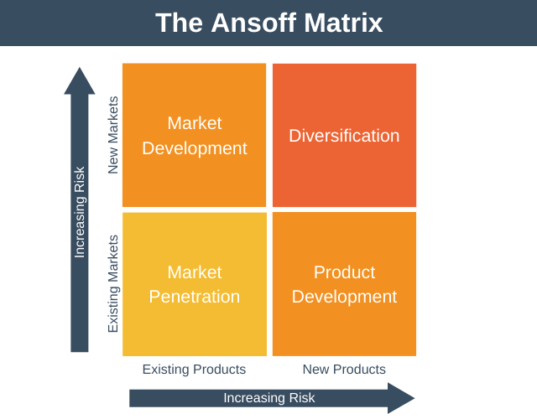
“Figure 2: Ansoff matrix”
“Source: expertprogrammanagement.com”
Market penetration is a methodology for growing a laid out item's piece of the pie. The partnership tries to upgrade the business of its current item in its ongoing business sector by utilizing new promoting methods.
Market development is a development method for tracking down new clients for products currently available. Seeing as new homegrown or overall business sectors for the organization's ongoing item is the key objective.
A development procedure for new items in laid out business sectors is item improvement. To acquire portion of the overall industry, the organization should make new things and acquaint them with its current client base.
A development technique for new things in new business sectors is expansion. To develop their business in different regions, the organization should give new things to new business sectors. This is one of the most critical development systems since it requires the firm to investigate the inclinations of expected clients and fabricate things explicitly for that market (Rapley, 2017). The future strategy of M&S is to become a growth business.

- Conclusion and Recommendations
To conclude, considering every one of the recently referenced issues, we can say that M&S faces a ton of savage contention. At last, the Porter Five Forces Analysis of M&S above exhibits the various variables that affect its cutthroat climate. This information helps with surveying the numerous outer business perspectives that influence each association.
Marks and Spencer is a key part in the retail business with over 100 years of involvement with the UK market and procedure on all mainlands today. Albeit the business has had critical monetary issues recently; that could move along. Brexit, a plethora of bargain rivals, and a name that's becoming more and more connected with an air of antiquity are all problems for Marks & Spencer in the present macro context. On the other hand, given the wide free trade rules, the tendency toward ready meals, the multiple technology advancements, and the drive for eco-friendly products and brands, M&S undoubtedly has certain advantages in the present business environment.

References

- Bergeron, D.M., 2009. Paratexts in Francis Beaumont's The Knight of the Burning Pestle. Studies in Philology, 106(4), pp.456-467.
- Bismark, O., Kofi, O.A., Frank, A.G. and Eric, H., 2018. Utilizing Mckinsey 7s model, SWOT analysis, PESTLE and Balance Scorecard to foster efficient implementation of organizational strategy. Evidence from the community hospital group-Ghana Limited. International Journal of Research in Business, Economics and Management, 2(3), pp.94-113.
- Butler, S. (2020). M&S and Ocado cause anger with different pricing on same items. The Guardian. [online] 18 Oct. Available at: https://www.theguardian.com/business/2020/oct/18/m-and-s-and-ocado-cause-anger-with-different-pricing-on-same-items-price-online-in-store.
- ‌Choudhary, B. and Piparo, T.L., Case Study–Strategy 2020 for M&S.
- Eka, N.A., 2018. Importance of setting an effective target market Netherlands Maritime Institute of Technology.
- Espiner, T. (2016). M&S fashion: Why does it miss the mark? BBC News. [online] 7 Jan. Available at: https://www.bbc.co.uk/news/business-35251415.
- http://fernfortuniversity.com/term-papers/swot/1433/1247-marks---spencer.php
- https://corporate.marksandspencer.com/media/pressreleases/5e0f046f7880b21924350282/m-and-s-accelerates-food-supply-chain-transformation-with-new-distribution-centre.
- https://expertprogrammanagement.com/2022/01/the-ansoff-matrix/
- https://fabrikbrands.com/marks-and-spencer-branding/#:~:text=The%20M%26S%20brand%2C%20and%20the%20focus%20on%20luxury&text=From%20the%20very%20beginning%20when,that's%20worth%20paying%20more%20for.
- https://supplychaindigital.com/sustainability/mands-announces-495000-sq-ft-distribution-hub-part-transformation-initiative
- https://www.swotandpestle.com/marks-and-spencer/
- Mellahi, K., Jackson, P. and Sparks, L., 2002. An exploratory study into failure in successful organizations: The case of Marks & Spencer. British journal of management, 13(1), pp.15-29.
- Nandonde, F.A., 2019. A PESTLE analysis of international retailing in the East African Community. Global Business and Organizational Excellence, 38(4), pp.54-61.
- Rapley, P., 2017. Case Study: Where Next for Next?. Teaching Business & Economics, 21(1), pp.4-8.
- Warnaby, G. and Woodruffe, H., 1995. Cost effective differentiation: an application of strategic concepts to Retailing. International Review of Retail, Distribution and Consumer Research, 5(3), pp.253-269.

