
ASSESSMENT COMPONENT 2: PRESENTATION & REPORT

Student Name: Elena Georgiana Butescu
Student Id: 2132844
Module Code: LCBB50001
Table of Contents
Task 1 - Presentation 3
Slide 1: Introduction 3
Slide 2: Overview of business idea, product and/or service 3
Slide 3: Ownership and legal format 4
Slide 4: Management of the company 5
Slide 5: Evaluation of business idea using SWOT model 5
Slide 6: Cash flow forecast 6
Slide 7: Conclusion 7
Task 2 - Report 9
1.0 Introduction 9
2.0 Brief history of entrepreneur 9
3.0 Achievements 10
4.0 Motives 11
5.0 Entrepreneurial traits 11
6.0 Conclusion 13
References 14
Task 1 14
Task 2 14

Task 1 - Presentation

Title Slide
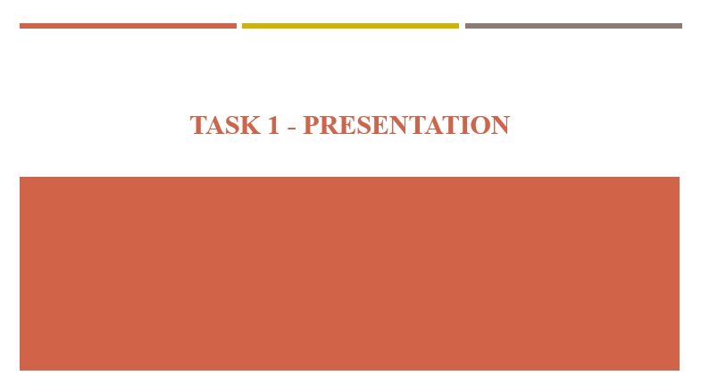

Slide 1: Introduction
- Entrepreneurs rely on a business idea to drive business operations and planning.
- Some business idea works while some fail (Bock, 2018)
- Business plan sets out the pathway for launching a new business
- Every organisation exists for a single purpose which is to create more value
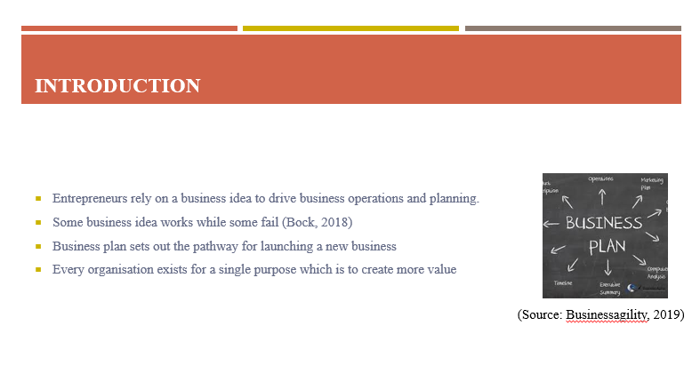
In the world of business, it is important for a potential entrepreneur to rely on a robust business plan. Business plan is important as it reinforces the use of business ideas to strategize goals and achievements for the business to drive new operations. The different stages of the launch for the new business is detailed with the help of a business plan that ultimately acts as a roadmap for the entrepreneur to successfully start a business based on a specific idea. The sole motive of a business is often value creation which is enabled with a help of a business plan where use of resources is highlighted.

Slide 2: Overview of business idea, product and/or service
- Specific business idea used for the business plan is sustainable business products
- Specific product of interest here is the organic skin care product
- The product is designed to target the organic retail market in the UK
- It will be based on the concept of organic cosmetics (Ecogarantie, 2022)
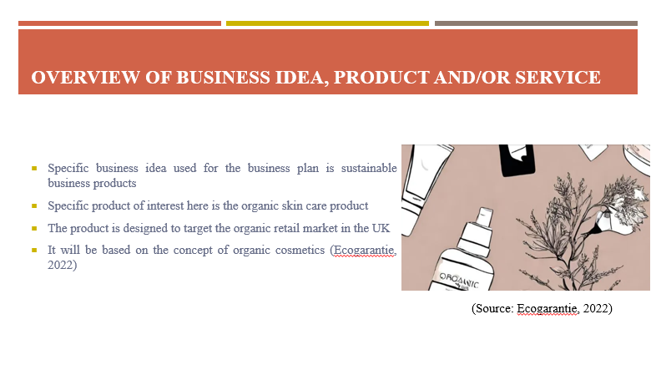
The business idea that will be applied for the business plan is based on the approach of sustainable business. The sustainable business solution targeted here is the development and distribution of organic skin care products for the people. This particular product will belong in the category of organic cosmetics and beauty products where ingredients that will be used are natural and organic in nature. The business product will be set to be launched as a retail marketplace in the UK competing with the other organic retail market products. The use of organic beauty products as the business idea shall help engage responsible business operations to restrict harm to the plants and the animals.

Slide 3: Ownership and legal format
- Business ownership and legal formats can exist in many different forms
- Sole proprietorship legal format will be used for this business idea
- A single owner will be in charge of the operations completely (Conkin, 2023)
- It will enable a simplistic taxable model payable at individual owner level
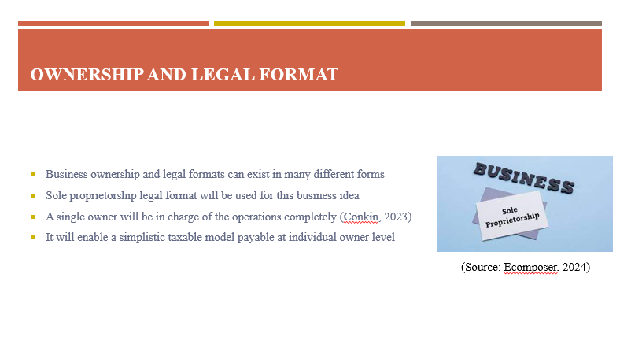
A business organisation can be set up in various forms but it is important that the particular business of selling organic skin care products uses the right model. The business ownership structure or legal format that will be used is sole proprietorship. In the sole proprietorship format, a single person will be responsible for running the entire business firm which will be useful in running a small business on organic skin care product delivery. It is based on a simplistic business model approach where an effective taxable system will be used for adequacy. Income will be taxed at the individual owner level keeping the taxable structure easy to comprehend and strategies.

Slide 4: Management of the company
- Strategic management approach integrating sustainability will be used
- Company will rely on a small team of people to oversee operations
- Quality management will be used to ensure adequate product delivery (Engert et al., 2016)
- Transparency and communication will be focussed within management
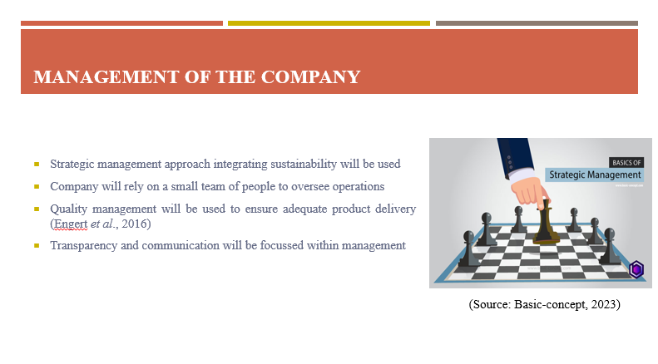
The business will use a strategic management approach as part of corporate sustainability practice to achieve the business objective of selling organic cosmetic products to the people. The company management team will be small scale consisting of manager, manufacturer, delivery men and sales staff to lead the overall operations. Quality management will be used to to adhere to desired quality standards while following the sustainability code of practice. The management of the business shall rely on communication and transparency as part of their strategy to ensure stable work flow of operations allowing the delivery of organic cosmetic products to the customers.

Slide 5: Evaluation of business idea using SWOT model
- Strength: Use of sustainable product design to minimise environmental damage
- Weakness: Lack of staff members to lead larger supply of products
- Opportunity: UK is a good market that can boost sales of organic cosmetic products
- Threat: Existing cosmetic brands will put immense competitive pressure (Liem and Arief, 2023)
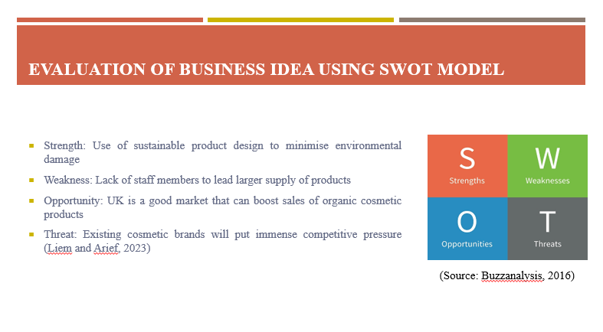
SWOT analysis model details the internal and external factors affecting the business. The company is known to apply the use of a sustainable business model to design their product that offers them strength to enter the UK market. Weakness of the business is detailed in terms of lack of a large group of members to cater to larger size demand from the public. The UK can function as a great market for the delivery of organic skincare products to the customers. It is also stated that the market can give rise to intense competition faced from other cosmetic brands creating issues for the new business to sell their skin care products successfully.
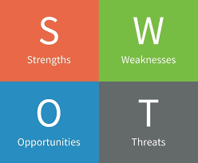
(Source: Buzzanalysis, 2016)

Slide 6: Cash flow forecast
- Cash flow is an essential unit for skin care product financial plan
- Start-up funding of £25000 will be used to start the business operations
- Start-up cost shall cover the bulk of wages, rent, utilities and other costs (Upmetrics, 2021)
- Sales income is assumed for the business that can aid in paying back loans
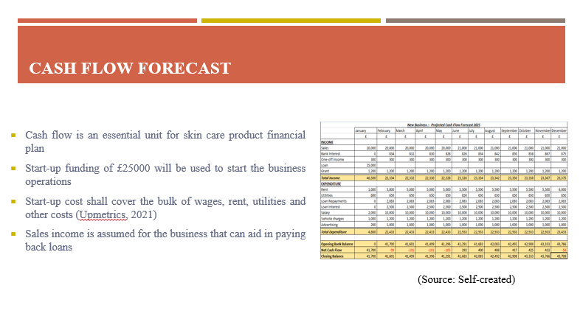
Business startup cost is estimated with the help of financial planning which the business plan uses for setting up the budget. Cash flow has been used for setting out a 12-month cycle of expenses and income for the business with an initial funding of £25000. This funding has been used to calculate the net cash flow for each month considering an expected sales income from the organic cosmetic products. Numerous parameters and their costing have been defined in the cash flow that comprises wages, rent, utilities and other costs.

Slide 7: Conclusion
- Business plan has been formed for the selling of organic skin care products
- Sole proprietorship format has been selected as ideal legal format
- Business shall comprise a small team of members
- Business idea evaluation and cash flow further defines the plan
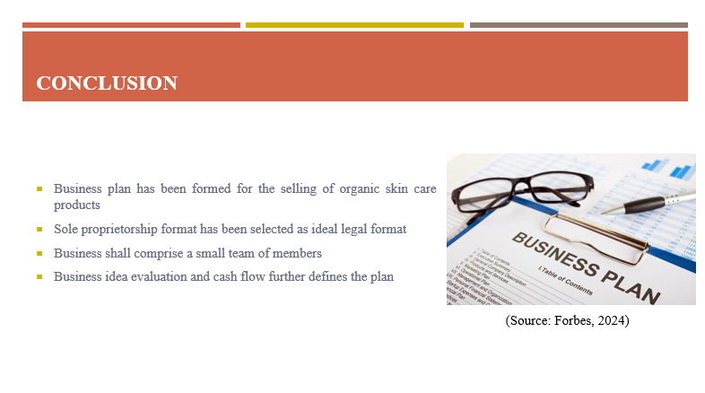
The new business organisation shall aim to sell organic skin care products in the markets of the UK aided by the use of business plan. The business plan details the use of strategic management approach and financial planning to lead operations for the manufacturing and delivery of organic skin care products to the customers. Sole proprietorship has been identified as the appropriate business ownership structure to be used for the business as it offers a simplistic approach to business operations. The SWOT model details the strength, weakness, opportunities and threat of the business.

Task 2 - Report
Executive summary
The report has been developed to discuss the favourite entrepreneur, Richard Branson. The study revolves around the discussion on the history of the entrepreneur, achievements, motives and entrepreneurial traits. Key details have been revealed here that showcases how Richard Branson had certain qualities that made him different from the other entrepreneurs. Numerous achievements have been pointed out that have been guided by key motives of the entrepreneur that centres around passion.

1.0 Introduction
Business entrepreneurs play an important role in the development of society and the generation of economic wealth. In fact, the last 3 decades has observed great contributions from the entrepreneurs to create wealth in the economies. Entrepreneurs are considered heroes of the business world where a number of entrepreneurs have stepped up over time to lead giant business conglomerates to fame. Entrepreneurs often embody special qualities such as creativity, zeal, vision and freedom of spirit that sets them apart from ordinary men (Burns, 2022). One such particular business entrepreneur that will be discussed in this report is Richard Branson who has significantly contributed to the business scene in the UK business landscape.

2.0 Brief history of entrepreneur
The history of personal favourite entrepreneur Richard Branson is evidenced in the autobiography “Losing My Virginity” where it is detailed how the entrepreneur had humble beginnings with the entrepreneur’s father being a barrister and mother being a ballet dancer. Richard Branson was born in the year 1950 where Branson was the oldest among the 3 siblings (Leaders, 2022). The bright entrepreneur was very challenging and even made a bet to aunt that the entrepreneur could learn to swim within 2 weeks at the age of 5. The entrepreneur was not able to learn in the first 2 weeks but didn’t give up learning to ultimately accomplish the task. The next excerpts highlight how Richard Branson faced difficulty in educational institutions as the entrepreneur was dyslexic. Branson reveals how the entrepreneur finds it exciting to constantly challenge the existing self-abilities to reach new heights (Johnsen and Sørensen, 2017). The autobiography details how the early life of Branson changed when the entrepreneur dropped out of school to pursue interests in running a magazine called “Student” that featured many well-known celebrity personas. Soon after Richard Branson found interest in flying hot air balloons and doing sports activities to constantly get into new experiences.
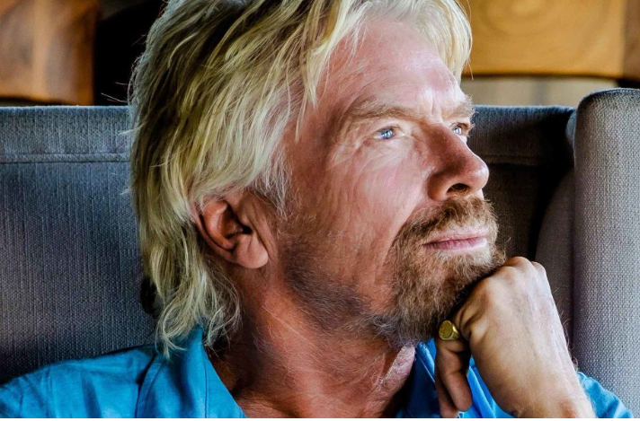
Figure 1: Richard Branson
(Source: Virgin, 2017)

3.0 Achievements
The list of achievements of Richard Branson is quite long as the entrepreneur has been able to achieve quite a lot of success in different business fronts that have been defined below.
- Student magazine: Richard Branson managed to transform a seemingly innocent business idea of student magazine into a global business empire. It was the entrepreneur’s first business project that was started in the year 1960 which is worth over £4 billion today (Galloway et al., 2019).
- Extreme sports: Some of the miscellaneous achievements of Richard Branson includes accolades received in the domain of extreme sports. The entrepreneur is a sports enthusiast who was able to break records by flying across the Pacific in a hot-air balloon (Johnsen and Sørensen, 2017). The entrepreneur also became successful in driving the fastest ferry across the Atlantic to claim the blue ribbon.
- Virgin Group: The most critical success in the life of Richard Branson is the formation of the Virgin Group. This was done solely by transforming the initially planned launched mail order service named Virgin Records business into Virgin Group by including airlines services at a time where there was a dearth of affordable airline services present in the UK for the public (Johnsen and Sørensen, 2017). The prosperous entrepreneur soon churned out multiple businesses from the Virgin Group that included Virgin Express, Virgin Hotels, Virgin Atlantic Holidays, Virgin Galactic and others to name a few.

4.0 Motives
Richard Branson shares an uncommon personality that is different from the others where the former is termed as a business opportunist. The motives of Richard Branson can be defined as reflexivity driven in terms of educational, social and habitual characteristics. The creation of new business empires was continuously influenced by lifelong experiences as well as circumstances instilling new ideas in the mind of the business entrepreneur (Galloway et al., 2019). The motives of Richard Branson can be interrelated with the use of an entrepreneurship model. The model highlights how different factors share an impact on the entrepreneurs depending on the internal and external influences. This dependency is shown below in the figure where the motives are influenced by personal character traits, cultural environment, antecedent influences and situational factor (Burns, 2022). The motive of Richard Branson was also shaped by these influences that included passion as the main personal characteristic trait of Richard Branson that drove the entrepreneur's actions. Similarly, the cultural acceptance and situational instances drove Richard Branson to continuously expand their business model where these forces acted in unison for motivating Richard Branson to create change in the business landscape.
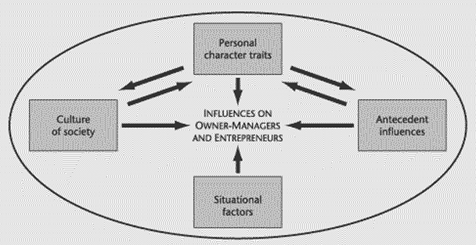
Figure 2: Influence of entrepreneurs
(Source: Burns, 2022)

5.0 Entrepreneurial traits
Some of the entrepreneurship traits of Richard Branson as stated by entrepreneurs themselves that would be utilised for personal development have been described.
Risk taking
One of the most primary trait of Richard Branson is risk taking as the entrepreneur has engaged in a number of risky ventures as part of experimenting with new business ideas that also include the successful ones. Richard Branson has argued that coming up with a great business idea is not enough for an individual, they must pursue that particular idea with integrity to make it possible (Connaster, 2019). A growth mindset is necessary for the entrepreneur to continuously change and try out new things despite possible risks involved with such tasks. Taking calculated risks lies at the heart of entrepreneurship where potential entrepreneurs must take necessary risks for opening the door to change and progress.
Learning from failure
Richard Branson has not only created successful ventures but have also been part of the creation of a number of failed ones. The lesson is said to shape the state of the mind to orient human conduct in a way to engage in entrepreneurial activities continuously despite experiencing failures. It is argued that every successful entrepreneur has learnt from failure including Richard Branson (Virgin, 2017). Entrepreneurs should not cower away from failures as it provides them an opportunity in learning and take the next steps accordingly to bridge success.
Visionary
Richard Branson has been able to observe the success of the Virgin Group before there were any signs. It is highlighted by the leader how entrepreneurs must always strive for seeing the bigger picture for any business idea or concept. The aspect of dreaming big and being visionary is part of the entrepreneurial mindset that drives the creation of new business ideas (Connaster, 2019). Vision is important to strengthen new beginnings and drive the people towards the achievement of success by placing trust on the business idea.
Team building & task delegation
Task delegation is the trait that defines the ability to allocate the right tasks to the people which is part of an entrepreneur’s job. Team building is one of the key recipes of successful entrepreneurship where the entrepreneurs must look for the best people (Forbes, 2017). These two abilities must be developed for an individual aiming for entrepreneurship in the future as having the best people and using them effectively for an enterprise is key to its success as done by Richard Braonson in the Virgin Group.
Effective communication
An essential entrepreneurship trait of Richard Branson is effective communication which the entrepreneur depended on continuously as a tool for motivating the subordinates or the followers to lead them to success. Effective communication plays an important role of facilitating human connections that ultimately aids in the creation of bonds, learning and progressing together (Virgin, 2017). Entrepreneurs should have this key ability for articulately transferring their knowledge and opinion on business ideas for the people to truly follow them and understand the importance of these goals.

6.0 Conclusion
In conclusion, Richard Branson is a great entrepreneur who managed to gain success due to innate abilities and skills in entrepreneurship. The study on the history of Richard Branson shows how ordinary Branson was brought up in the household like the rest of people but yet the extraordinary qualities of Richrad Branson allowed the entrepreneur to shine above the rest. Their achievement and motives says it all on how Richard Branson has left a legacy in the business landscape that one can hardly compete with. The key contribution of Richard Branson in the British business landscape as well as the international scene is commendable highlighting the use of some of the most successful entrepreneurial traits that one should develop for becoming a successful entrepreneur.

References

Task 1
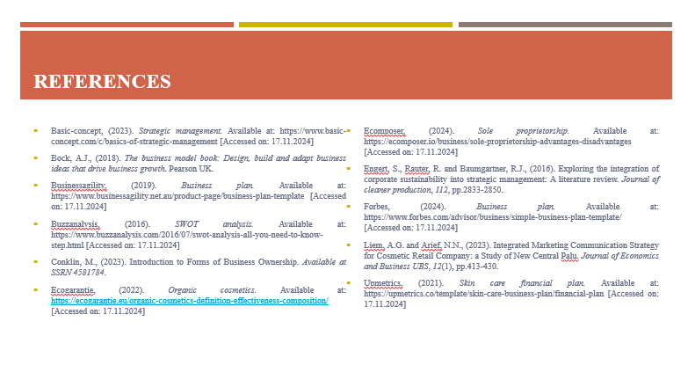
Basic-concept, (2023). Strategic management. Available at: https://www.basic-concept.com/c/basics-of-strategic-management [Accessed on: 17.11.2024]
Bock, A.J., (2018). The business model book: Design, build and adapt business ideas that drive business growth. Pearson UK.
Businessagility, (2019). Business plan. Available at: https://www.businessagility.net.au/product-page/business-plan-template [Accessed on: 17.11.2024]
Buzzanalysis, (2016). SWOT analysis. Available at: https://www.buzzanalysis.com/2016/07/swot-analysis-all-you-need-to-know-step.html [Accessed on: 17.11.2024]
Conklin, M., (2023). Introduction to Forms of Business Ownership. Available at SSRN 4581784.
Ecogarantie, (2022). Organic cosmetics. Available at: https://ecogarantie.eu/organic-cosmetics-definition-effectiveness-composition/ [Accessed on: 17.11.2024]
Ecomposer, (2024). Sole proprietorship. Available at: https://ecomposer.io/business/sole-proprietorship-advantages-disadvantages [Accessed on: 17.11.2024]
Engert, S., Rauter, R. and Baumgartner, R.J., (2016). Exploring the integration of corporate sustainability into strategic management: A literature review. Journal of cleaner production, 112, pp.2833-2850.
Forbes, (2024). Business plan. Available at: https://www.forbes.com/advisor/business/simple-business-plan-template/ [Accessed on: 17.11.2024]
Liem, A.G. and Arief, N.N., (2023). Integrated Marketing Communication Strategy for Cosmetic Retail Company: a Study of New Central Palu. Journal of Economics and Business UBS, 12(1), pp.413-430.
Upmetrics, (2021). Skin care financial plan. Available at: https://upmetrics.co/template/skin-care-business-plan/financial-plan [Accessed on: 17.11.2024]

Task 2
Burns, P., 2022. Entrepreneurship and small business. Bloomsbury Publishing.
Connaster, L.A., (2019). The entrepreneurial mindset.
Forbes, (2017). Views on entrepreneurship. Available at: https://www.forbes.com/sites/danschawbel/2017/10/23/richard-branson-his-views-on-entrepreneurship-well-being-and-work-friendships/ [Accessed on: 17.11.2024]
Galloway, L., Kapasi, I. and Wimalasena, L., (2019). A theory of venturing: A critical realist explanation of why my father is not like Richard Branson. International Small Business Journal, 37(6), pp.626-641.
Johnsen, C.G. and Sørensen, B.M., (2017). Traversing the fantasy of the heroic entrepreneur. International Journal of Entrepreneurial Behavior & Research, 23(2), pp.228-244.
Leaders, (2022). Richard Branson. Available at: https://leaders.com/rankings/person/richard-branson/ [Accessed on: 17.11.2024]
Virgin, (2017). Skills and abilities successful entrepreneurs share. Available at: https://www.virgin.com/branson-family/richard-branson-blog/5-skills-and-abilities-successful-entrepreneurs-share [Accessed on: 17.11.2024]

