Design, conduct and critically evaluate a close-to practice research project (case study) focusing on the model of the transformative teacher in developing practice that has a positive impact on the learner.

Introduction

The focus of this assignment is to explore whether positive reinforcement is vital for maximising students’ engagement and academic achievement. Among the various strategies available, positive reinforcement stands out as a powerful tool for moulding desired behaviours and attitudes among students. The aim of this research is to assess the effectiveness of positive reinforcement techniques in enhancing classroom engagement within a large primary school environment based in Swansea. Participants were from a year 3 class within the school (Estyn, 2018).

Research supports the efficacy of positive reinforcement; for instance, a study by Cameron and Pierce (1994) found that rewards can significantly increase both intrinsic motivation and academic performance when used appropriately. Further, Skinner's (1957) operant conditioning theory reveals that behaviour’s followed by positive reinforcements are more likely to recur, a principle that can be applied effectively in educational settings.

Within my professional practice, I aim to enhance my skills in managing the learning environment, an area I am eager to develop further. To achieve this goal, I have chosen to explore the impact of positive reinforcement on student participation. My interest in this topic begun during my course while observing different schools. I noted diverse behaviour charts and methods of integrating positive reinforcement in classrooms. While there is positive research supporting these observations, negative findings are less frequent, suggesting a potential bias in available literature. Essentially, exploring positive reinforcement in the classroom will not only better my understanding of effective teaching and learning but also provide me with tangible evidence of my professional development journey, aligning closely with the goals and objectives outlined in my Professional Learning Passport.

This research will utilise a mixed-methods approach, integrating quantitative measures like observation charts with qualitative data gathered from questionnaires administered to students. Through the investigation of how positive reinforcement influences student participation, attentiveness, and the general classroom ambiance, this study aims to offer valuable insights into effective pedagogical strategies.

Literature Review

Positive reinforcement is a fundamental concept in behaviourism, highlighting the utilisation of rewards to strengthen preferred behaviours. Within education, positive reinforcement has gained notable attention due to its capacity to amplify student involvement, drive, and academic achievement. This literature review provides an overview of key finding and trends in research related to positive reinforcement in educational settings.

Many are unaware, teachers consistently employ reinforcement strategies throughout their classroom interactions. Their aim is to encourage desired behaviours and understanding of class rules and routines, employing positive rewards or negative consequences to amplify desired actions and diminish undesirable ones (Teaching Channel, 2021).

Skinner is one of the first theorists that investigated positive reinforcement. He stated that positive reinforcement entails introducing a stimulus after a behaviour, thereby heightening the probability of that behaviour recurring. Skinner's theory of operant conditioning underscores the significance of consequences in moulding behaviour. He argued that behaviours rewarded with positive reinforcement are reinforced and are more inclined to be repeated (Cherry, 2023).

BimiBoo (2022) states that skinner had a firm belief that positive reinforcement had the potential to enhance a child’s self-esteem, leading them to make improved behavioural choices independently. Skinner also focused on how giving rewards or incentives can help encourage good behaviour. This is used at home, work and at schools to boost learning and motivation. Semal (2020) argues that skinners theory excessively focuses on behaviour. He states that the theory “neglects internal mental process such as thoughts and feeling”. This perspective may limit understanding of complex human behaviour. Davis and colleagues (2003) support what Semal said in 2020, that how well reinforcement methods work can change based on factors such as student age, cultural context, and task complexity. Deci et al (1999) argue that depending too much on rewards can result in external motivation and weaken internal motivation.

Like a lot of the literature, I have already discussed Hawes (2018) states that rewarding a student for excellent performance could boost the likelihood of them maintaining their engaged behaviour. Ismail (2023) suggests that through positive reinforcement, educators can underscore students' abilities, interests, and unique traits. Consequently, this affords teachers an opportunity to interact with students, communicate proficiently, and ultimately encourage them to express their authentic selves.

Dad et al (2010) investigated on the efficacy of positive reinforcement in enhancing student performance. Their study aimed to evaluate the frequency and efficacy of positive and negative reinforcement methods utilised by educators. The results revealed that both reward and punishment reinforcement techniques can effectively enhance student academic achievement and foster desired classroom behaviours.

Khattak and Ahmad (2018) undertook a separate investigation to explore the impact of positive reinforcement on students' academic attainment. The research targeted students sharing similar socioeconomic status and no cultural differences. The results of the study indicated that positive reinforcement significantly influences students' academic success. Consequently, educators can harness positive reinforcement as a tool to enhance classroom methodologies and elevate students' academic progress.

Koepplin (2023) examined the adverse effects of positive reinforcement on children. They argue that phrases like "good job" are commonly used to praise children after task completion. While seemingly appropriate, this approach can inadvertently foster a dependence on adult approval, potentially undermining the child's sense of autonomy. In alignment with Koepplin's perspective, Leaf et al (2021) implies that employing reinforcement is commonly advocated within applied behaviour analysis. However, Leaf underscores the necessity of recognising and reflecting upon the potential unintended repercussions linked with reinforcement. Furthermore, they delve into the adverse effects that positive reinforcement may induce, including instances where it could result in diminished energy levels or fatigue in individuals, subsequently reducing their motivation to engage in other behaviours that might be more rewarding or advantageous for them.

During my PGCE studies, I got really interested in how different ways of praising students affect how much they take part in class. I found out that using positive approaches in teaching can be super helpful. I read studies showing that praising students can make them more involved in learning. But I also noticed something missing in the research. There wasn't much about how praising students impacts how active they are in class. This got me wondering about the connection between praising and student engagement.

Moreover, my experiences during the course exposed me to a diversity of reinforcement strategies implemented across different schools. Considering that many of these strategies continue throughout a student's education, I began to contemplate whether students in key stage 2 might become disengaged to these methods over time. This prompted me to question whether children at this stage might show signs of boredom with the strategies commonly employed.

Explanation of Case Study

Case study research is a qualitative approach used to deeply analyse a particular case or multiple cases within a specific system, like an organisation, community, or individual. Its goal is to grasp complex phenomena within their real-life settings and provide detailed insights into the complexities of the case being studied. Case studies often entail gathering and examining diverse data sources, such as interviews, observations, documents, and artifacts (Yin, 2018).

McCombes (2023) describes a case study as “detailed study of a specific subject” this could include a person, place, group, phenomenon, or an organisation. A case study works well as a research plan when you're aiming to get detailed, specific knowledge about a particular real-life topic. It lets you dive deep into the important aspects, meanings, and consequences of that case.

There is ongoing discussion about the potential advantages and disadvantages of employing case studies as a research method. Lohman and Boyd (2023) state the strengths of a case study. Case studies can grasp the intricacy and distinctiveness of the subject being examined, without simplifying or making broad assumptions. Case studies delve into various aspects and viewpoints of a scenario, including its historical, cultural, social, and psychological elements. They can demonstrate the interplay between theory and application in particular settings, as well as how diverse stakeholders perceive and react to the subject. Furthermore, case studies can uncover fresh insights and validate or enhance existing theories. According to Pubrica (2019) a case studies pose several limitations. Firstly, they often lack scientific rigor, making it difficult to apply their findings to a wider group. Secondly, there's a risk of researcher bias as personal opinions may influence the study. Thirdly, replicating case studies can be challenging. Moreover, they require significant financial resources and time investment. Lastly, the depth of analysis can be limited by the available data and time constraints. Willis (2014) states that case studies have become a synonym of freedom for research where anything goes. Another issue Willis discusses is that how well a study measures what it intends to, is the reliability and consistency of single case studies. This often connects to criticisms of qualitative research methods overall.

Within my research project having a representative sample is crucial for ensuring that the findings accurately reflect the larger population from which the sample is drawn. This way, the results that I obtain can be trusted to represent everyone. When each person in the big group has an equal chance of being picked for the study, it helps make sure the findings aren’t one-sided. So, choosing participants carefully to include a mix of different kinds of people is key to getting reliable results (Young, 2023).

My research project's sample will be representative because I'm inviting the entire class to participate. This ensures that children from various backgrounds and ethnicities are included. Additionally, I've reached out to all parents to get their permission for their child to take part in the study. This approach helps ensure that the findings reflect the diversity within the class and can be generalized to similar groups of children.

Research Methods

Research methods involve gathering and examining data. When considering my research methods, I had to decide whether they would be qualitative or quantitative. For my project, I've chosen to use qualitative observations and questionnaires.

Smit et al (2018) states that observation is a fundamental method in qualitative research, dating back to ancient times. It involves gathering data through careful observation, particularly by using our senses, such as sight and hearing, in a structured and purposeful manner. Jhangiani et al (2020) says that Observational research encompasses various non-experimental studies where behaviour is methodically observed and documented. Its aim is to show one or more variables. In general, it aims to catch specific features of a person, group, or place.

Qualitative observation involves collecting data by observing subjects in their natural environment, followed by analysis. It focuses on subjects' attitudes, beliefs, behaviours, psychological characteristics, and other factors. This method entails closely observing, documenting, and noting the actions, attitudes, and characteristics of objects, phenomena, or living beings. Researchers use this technique to understand subjects' behaviour and personality (Johns, 2017).

The qualitative observation method offers numerous advantages, as discussed by Voicedocs (2023). One key advantage is its high level of accuracy, facilitated by the researcher's presence to observe the entire situation first-hand. This makes it more accurate compared to many other methods. Additionally, observations occur in the natural environment of the child, eliminating the need for additional setup or organization, which can make this method relatively inexpensive.

However, there are limitations to consider. Qualitative observation can be time-consuming, as it may take a while to obtain the desired results. Researchers have no control over the situation and cannot ask direct questions, which may require multiple observations to gather sufficient data. Moreover, obtaining consent from parents is essential, and researchers must provide a summary of what they intend to observe to ensure subjects' comfort, as noted by Choudhury (2022).

Questionnaires represent another approach I'll employ to gather data for this project. According to Bhandari (2022), questionnaires are defined as "a series of questions or prompts designed to gather information from respondents." They serve as an effective tool for individuals to explore attitudes, experiences, and opinions, while also facilitating the collection of both quantitative and qualitative data.

Questionnaires offer numerous benefits. They excel at gathering information from a wide range of individuals, enabling researchers to collect data from a sizable and diverse sample. This broad representation of the target population enhances the generalizability and external validity of the study findings. Additionally, questionnaires can be distributed to a large group of respondents via email, which aids in saving both time and resources (Lindemann, 2023).

Questionnaires are helpful for keeping things private and secret. Anonymity means people can answer honestly without worrying about what others might think. When answers are anonymous, people are more likely to share their true thoughts and feelings, even about personal stuff. Confidentiality is about keeping people's personal information safe. It promises that data won't be shared with anyone who shouldn't see it. Keeping things confidential builds trust between people answering questions and the researchers, which makes them more likely to join in and help (Lindemann, 2023).

There are some disadvantages to questionnaires that need to be mention. Although questionnaires are cost effective and have many benefits, one of the main limitations is receiving incorrect feedback. Participants will often lie when answering questionnaires as they believe it will benefit the researcher (McLeod, 2023). Beiske (2002) states that questionnaires don’t offer the researcher the opportunity to follow up on any ideas or answers. Researchers may also want to clarify some of the answers given unfortunately questionnaires do not always allow this.

While questionnaires offer cost-effective advantages and numerous benefits, it's beneficial to acknowledge their drawbacks. One significant limitation is the potential for inaccurate feedback. Participants may lie when responding, assuming it benefits the researcher (McLeod, 2023). Additionally, Beiske (2002) states that questionnaires don’t offer the researcher the opportunity to follow up on any ideas or answers. Researchers may also want to clarify some of the answers given unfortunately questionnaires do not always allow this.

Saunders et al (2002) emphasises that one of the main limitations to questionnaires is the restricted depth of information. Questionnaires normally relay on structured and predefined responses which can limit the participants on how much information they give whilst answering. Despite being easy to create and hand out, this does not guarantee a high response rate. Low response rates occur when a notable portion of invitees choose not to participate or fail to complete the survey, potentially introducing bias and undermining the study's overall quality (Lindemann,2023).

Researchers must diligently follow the ethical guidelines outlined by BERA, stressing to participants students in particular that their involvement is voluntary, ensuring confidentiality of all data, and reassuring them of the option to withdraw without repercussion at any stage (BERA, 2018). In this study, parental consent was obtained prior to the participation of the participants, as detailed in Appendix 3. Moreover, it was reiterated to students that they retained the right to revoke this consent at any point without facing any consequences.

In summary I felt that closed questionnaires (See appendix 1) and observations (See appendix 2) would be the most suitable research to adopt within this case study. As previously mentioned, the participants were from a year 3 class within a primary school. As, such prioritising the age, capabilities and overall well- being of the participants was paramount to ensure research conducted was ethically informed (BERA,2018). Within the questionnaires, a Likert Scale was used. Student responded to questions such as “do you like the new reward system that is being used in class?”. They were then asked to circle the emoji that they felt answered that question. Emojis were chosen for their visual appeal and familiarity. Given the participants' potential difficulty with more complex questionnaires, this straightforward format was deemed most appropriate ((Lindemann, 2023; BERA, 2018). Observations were also chosen within this case study as a way of collecting data by observing subjects in their natural environment, followed by analysis. It focuses on subjects' attitudes, beliefs, behaviours, psychological characteristics, and other factors (Johns, 2017). This was a great way for me to be able to observe how the children reacted and answers to the new reward system and if it effected their participation. The Leuven scale was used whilst observing it give me an understanding of how children behave and interact within the classroom environment. It was also suited to the age of the children. The Leuven scale also helped with the validity and reliability of my observations (Delhaye et al, 2012).

Data Presentation and Analysis Methods

Due to this case study using a scaled questionnaire, adopting a Likert Scale, all data collected was ordinal. Ordinal data consists of categories within a variable that possess an inherent rank order (Bhandari,2022). Within my questionnaires there were 3 types of possible responses the pupils could circle ‘agree’, ‘neural’ or ‘disagree’. Rudderstack (2012) states that it can sometimes be unclear how much space there is between each level of ranking. For example, think about customer satisfaction ratings like "Excellent," "Good," "Fair," and "Poor." The gap between "Good" and "Excellent" might not be the same as between "Fair" and "Poor." Due to this case stud gathering information pupil perceptions each category contained a range of these perceptions.

Descriptive statistics were used in order to analyse the ordinal data, summarising and describing the data set to identify possible patters (Marshall and Jonker, 2010). Researchers often using descriptive statistics as they are good for providing basic information about variables in data. They can also be understood by non-technical individuals such as educators (Simplilearn, 2023).

There are limitations to descriptive statistics they only provide a summery based on the participants that have been measured. This data cannot be used to draw conclusions about other participants or objects (Leard Statistics, 2020). A way that these potential problems could be resolved is to combine descriptive statistics and inferential statistics (Ledidi, 2019). Although descriptive statistics help to summarise they aren’t able to give in depth information about the data and can’t explain the causes or effects of the patters or trends that are observed (Hiller, 2023).

Ethical Considerations

The focus of this research was to uphold ethical standards. Before conducting research, an ethics form (See Appendix 4) was submitted and approved by the Ethics committee at the University of Wales trinity Saint David (UWTSD). Additionally, a consent letter (See Appendix 3) was sent to all parents of the participants in the selected class. This letter outlined the purpose of the research and the participation requirements for their child. Assent was also gained from pupils directly prior to their involvement, through a whole class discussion. This discussion outlines the aims of the research and what they would need to do.

It was made clear to the participants that they had the option to opt out or withdraw from the study at any point simply by telling me or leaving their table. To comply with ethical standards, all data pertaining to the school and participants was anonymised. For instance, participants who completed the questionnaires were identified using letters (e.g., "Student A" or "Student B"), and any identifying information like location or gender was removed. Questionnaire data were stored securely in a locked cupboard in the classroom accessible only to myself and the class teacher. For further details on ethical considerations, please refer to the ethics form (See Appendix 4).

Results

Out of the 29 pupils that were invited to take part in my study, 10 of the pupils participated within the research and their responses highlighted some interesting results. Descriptive analyses were used to calculate the frequency distribution, mode and median. The median number in the data was 'neutral', showing the central set of data. The mode was also calculated most students ‘agreed’ that the reward system in their classroom affected their motivation, listening, relationships, and engagement.

Several finding will now be discussed further. In questions relating to motivation and engagement many of the students ‘agreed’ that the reward cards had an influence. This was also apparent in research carried out by Rumfola (2017) who found that “student who were reinforced in a positive manor were 68% more likely to follow what was being encouraged of them”. These discoveries suggest that positive reinforcement also contribute to motivation and self-esteem levels within the classroom sample. This also links with literature previously mentioned. Charles (2022) states that skinner had a firm belief that positive reinforcement had the potential to enhance a child’s self-esteem, leading them to make improved behavioural choices independently. Additionally, research may be needed to gain knowledge on what areas of learning are affected.

The first question in the questionnaire asked the children if they liked the new reward system that was being in used in class. All 10 of the participants answered ‘yes’ this question.

Results from the questionnaire also found that most students feel ‘happy’ when a teacher praises them for great work in front of the class, and this this influences their involvement. As motioned above Hawes (2018) states that rewarding a student for excellent performance could boost the likelihood of them maintaining their engaged behaviour. Interestingly, a lot of literature that has looked at praising children verbally discusses the negative effects that it has on them. Dewer et al (2010) states that children who receive a lot of verbal praise are more likely to experience negative psychological outcomes. This statement is backed up by previously mentioned literature where Koepplin (2023) argues that phrases like "good job" are commonly used to praise children after task completion, but this can affect the child in a negative way where they foster a dependence on adult approval, potentially undermining the child's sense of autonomy.

It is also crucial to note that some students responded with ‘neutral’ or ‘disagree’ to various statements concerning the impact that positive reinforcement has on their participation. Although, (Morin, 2024) states that “positive reinforcement can be one of the most effective behaviour techniques” it is important that we consider they aren’t successful for every child. The children within this school have been using reward systems since starting to mean they may have lost all interest in reward and positive reinforcement given by their teacher. Heick (2010) says that we need to keep in mind that many children are rewarded all the time and that overusing rewards can reduce its effectiveness.

The case study evidence indicates that employing positive reinforcement within the classroom has both advantages and disadvantages. Many of the children seem to appreciate and like to be rewarded, but how the praise is given might raise questions. It’s also important to note that this student only uses descriptive analysis, which might not fully connect with other data points, as noted by Walz (2020). Additionally, since it relies on just one research method, its challenging to be sure of the findings truly reflect how positive reinforcement impact student participation. This case study has allowed for deeper understanding on how positive reinforcement effects stoutens participation within the professional placement. it has also shown me how positive reinforcement can help to manage the classroom and challenging behaviours. Getting to know the children and assenting their needs are a fundamental part of the Welsh curriculum, by getting to know the learner we will have a better understanding of what their needs are and how to meet them successfully (Welsh Curriculum, 2024)

Conclusion

A case study was selected to investigate the impact of using reward cards on children's participation in classroom settings, aiming to gain a thorough understanding of this phenomenon. Questionnaires and observations were chosen as the main research methods for their effectiveness, simplicity, and potential for detailed exploration. However, it's important to recognize the limitations of this study, particularly the small sample size, with only 10 out of 29 students participating. This limited sample size may affect the validity of the findings, especially regarding the effects of rewarding children on their participation. Additionally, while questionnaires were suitable for the children, conducting interviews alongside them could have provided deeper insights and opportunities to discuss aspects requiring further exploration. We also need to be very careful in generalising any results from this case study outside of the sample classroom. This case study could serve as a valuable starting point for future investigations into the effects of positive reinforcement on student participation by other researchers.

In conclusion, this study in a primary school setting has highlighted the effectiveness of positive reinforcement methods in boosting student motivation and involvement. Examining various approaches like verbal praise, rewards, and recognizing effort, it's clear that positive reinforcement not only improves the learning atmosphere but also encourages students to participate. These results emphasize the importance of integrating customized positive reinforcement techniques into teaching, enabling educators to promote overall student development and academic achievement. Moving ahead, it's crucial to keep refining and applying these strategies to guarantee that all students receive the necessary support for both academic and emotional growth.

Recommendations

Within future practise, to ensure that engagement within the classroom is successful, I plan to expand the range of questions so that each student has the opportunity to have their voices heard within the classroom. In the future, I plan to revisit this case study with an expanded sample size and a broader array of research methodologies and analyses. This approach aims to provide a more comprehensive and detailed insight into how positive reinforcement impacts students participation. Many interventions can be in place to help with student participation for example, a behaviour tracking system, teacher modelling and consistently and feedback. Most schools seem to have these interventions in place, but it can sometimes be challenging to ensure that they are used daily. Within my carer I aim to ensure that these interventions are in place and used regularly this would help ensure that every child reaches their full potential and benefits from learning from the curriculum. Ensuing that a verity of interventions are used would also benefit each child individually.

Reference list
Beiske , B. (2002) Research methods. uses and limitations of questionnaires, interviews, and case studies, GRIN. Available at: https://www.grin.com/document/15458?lang=en (Accessed: 30 April 2024).
Bhandari, P. (2022a) Questionnaire design: Methods, question types & examples, Scribbr. Available at: https://www.scribbr.co.uk/research-methods/questionnaire-design/#:~:text=A%20questionnaire%20is%20a%20list,the%20social%20and%20health%20sciences (Accessed: 30 April 2024).
Bhandari, P. (2022b) What is ordinal data?: Examples & definition, Scribbr. Available at: https://www.scribbr.co.uk/stats/ordinal-data-meaning/ (Accessed: 30 April 2024).
Cameron and Pierce (1994) Misu admin, Ministry of Education, Guyana. Available at: https://www.education.gov.gy/web/index.php/parenting-tips/item/1793-differences-between-the-terms-reward-and-reinforcement (Accessed: 05 April 2024).
Bimi Boo(2022) The benefits of positive reinforcement, Bimi Boo. Available at: https://bimiboo.net/the-benefits-of-positive-reinforcement/ (Accessed: 05 April 2024).
Cherry, K. (2023) B. F. Skinner: The Life of Psychology’s radical behaviorist, Verywell Mind. Available at: https://www.verywellmind.com/b-f-skinner-biography-1904-1990-2795543#:~:text=What%20is%20the%20Skinner%20theory,occur%20again%20in%20the%20future. (Accessed: 03 April 2024).
Choudhry, A. (2022) Advantages and limitations ‘observation’ method for data collection, Your Article Library. Available at: https://www.yourarticlelibrary.com/social-research/data-collection/advantages-and-limitations-observation-method-for-data-collection/64507 (Accessed: 27 April 2024).
Davis , P. (2003) Welcome to Digital Education Resource Archive (DERA), Digital Education Resource Archive (DERA). Available at: https://dera.ioe.ac.uk/ (Accessed: 05 April 2024).
Delhaye, R., Klimstra, T. and Goossens, L. (2012) (PDF) the leuven adolescent perceived parenting scale (LAPPS): Reliability and validity with French-speaking adolescents in Belgium. Available at: https://www.researchgate.net/publication/222088850_The_Leuven_Adolescent_Perceived_Parenting_Scale_LAPPS_Reliability_and_Validity_with_French-Speaking_Adolescents_in_Belgium (Accessed: 01 May 2024).
Dewar, G. (2024) The effects of praise: Evidence-based tips for better outcomes, PARENTING SCIENCE. Available at: https://parentingscience.com/effects-of-praise/ (Accessed: 01 May 2024).
EstynHMI (2018) Ysgol Gynradd Gymraeg lôn las, Estyn. Available at: https://www.estyn.gov.wales/provider/6702036 (Accessed: 10 April 2024).
Ethical guidelines for educational research, Fourth edition (2018) (2018) BERA. Available at: https://www.bera.ac.uk/publication/ethical-guidelines-for-educational-research-2018-online (Accessed: 01 May 2024).
Jhangiani, R.S. et al. (2019) Observational research, Research Methods in Psychology. Available at: https://kpu.pressbooks.pub/psychmethods4e/chapter/observational-research/ (Accessed: 27 April 2024).
Johns (2017) Advantages and disadvantages of observation method - javatpoint, www.javatpoint.com. Available at: https://www.javatpoint.com/advantages-and-disadvantages-of-observation-method (Accessed: 27 April 2024).
Hawes 2018, T. (2018) Praise and positive reinforcement makes school meaningful for everyone, Main Street Blog. Available at: https://blog.nationallife.com/praise-positive-reinforcement-makes-school-meaningful-everyone/ (Accessed: 11 April 2024).
Heick (2010) What to do when positive reinforcement isn’t working, Expert Columns: What to do When Positive Reinforcement Isn’t Working. Available at: https://www.mayinstitute.org/news/acl/asd-and-dd-child-focused/what-to-do-when-positive-reinforcement-isnt-working/#:~:text=If%20the%20reward%20is%20available,effectiveness%20if%20it%20is%20overused. (Accessed: 01 May 2024).
Hiller (2023) Explore data analytics: The careerfoundry blog, CareerFoundry. Available at: https://careerfoundry.com/en/blog/data-analytics/ (Accessed: 01 May 2024).
Ismail , A. (2023) Using positive reinforcement to increase student ... Available at: https://red.mnstate.edu/cgi/viewcontent.cgi?article=1885&context=thesis (Accessed: 05 April 2024).
J, C. and W. D. , P. (1994) Apa PsycNet, American Psychological Association. Available at: https://psycnet.apa.org/record/1995-15243-001 (Accessed: 03 April 2024).
Khattak and Ahmad (2018) (PDF) effects of positive reinforcement on students academic erformance. Available at: https://www.researchgate.net/publication/339068532_Effects_of_Positive_reinforcement_on_students_academic_erformance (Accessed: 11 April 2024).
Kopplin, M. (2023) Benefits/downfalls of positive reinforcement, Rainbows United. Available at: https://rainbowsunited.org/benefits-downfalls-of-positive-reinforcement/#:~:text=However%2C%20there%20is%20a%20downside,they%20then%20need%20adult%20approval. (Accessed: 10 April 2024).
Leaf , Cihon and Russell (2021) Large format digital graphic printing and production: XG Group, XG Group - Large format digital printing experts. Available at: http://xtremegraphics.co.uk/ (Accessed: 30 April 2024).
Leuven Scale: A teacher’s guide (2021) Leuven Scale . Available at: https://www.structural-learning.com/post/leuven-scale-a-teachers-guide#:~:text=The%20main%20advantage%20of%20the,effective%20early%20years%20teaching%20resources. (Accessed: 01 May 2024).
Lohman , L. and Boyd , N. (2023) Advantages & Disadvantages of Case Study Method of data collection, Study Lecture Notes. Available at: https://studylecturenotes.com/advantages-disadvantages-of-case-study-method-of-data-collection/ (Accessed: 05 April 2024).
Lindemann, N. (2024) 12 advantages and disadvantages of questionnaires, Pointerpro. Available at: https://pointerpro.com/blog/questionnaire-pros-and-cons/#:~:text=Questionnaires%20provide%20structured%20and%20standardized,to%20process%20the%20data%20quickly. (Accessed: 30 April 2024).
Marshall and Jonker (2010) An introduction to descriptive statistics: A review and practical guide ... Available at: https://www.researchgate.net/publication/229134518_An_introduction_to_descriptive_statistics_A_review_and_practical_guide (Accessed: 03 May 2024).
McCombes, S. (30AD) Case study: Definition, Examples & Methods, Scribbr. Available at: https://www.scribbr.co.uk/research-methods/case-studies/ (Accessed: 17 April 2024).
Mcleod, S. (2023) What is a questionnaire and how is it used in research?, Simply Psychology. Available at: https://www.simplypsychology.org/questionnaires.html (Accessed: 30 April 2024).
Morin, A. (2024) How positive reinforcement encourages good behavior in Kids, Parents. Available at: https://www.parents.com/positive-reinforcement-examples-8619283 (Accessed: 01 May 2024).
Observation method of data collection (2023) Voicedocs. Available at: https://voicedocs.com/en/blog/observation-method-of-data-collection (Accessed: 27 April 2024).
Public (2019) What are the limitations of case studies?, Academy. Available at: https://pubrica.com/academy/concepts-definitions/what-are-the-limitations-of-case-studies/ (Accessed: 05 April 2024).
Rudderstack (2012) What is ordinal data?, RudderStack. Available at: https://www.rudderstack.com/learn/Data/what-is-ordinal-data/ (Accessed: 03 May 2024).
Rumfola , L. (2017) Positive reinforcement positively helps students in the ... Available at: https://core.ac.uk/download/pdf/233575937.pdf (Accessed: 03 April 2024).
Saunder (2002) (PDF) ‘Research methods for business students’ chapter 4: Understanding research philosophy and approaches to theory development. Available at: https://www.researchgate.net/publication/330760964_Research_Methods_for_Business_Students_Chapter_4_Understanding_research_philosophy_and_approaches_to_theory_development (Accessed: 30 April 2024).
Semal (2020) What are the disadvantages of Skinner’s theory?, Quora. Available at: https://www.quora.com/What-are-the-disadvantages-of-Skinners-theory (Accessed: 03 April 2024).
Smit (2018) Observations in qualitative inquiry: When what you see is ... Available at: https://journals.sagepub.com/doi/10.1177/1609406918816766 (Accessed: 27 April 2024).
Supporting learner progression assessment guidance (2024) Welsh Curriculum . Available at: https://hwb.gov.wales/curriculum-for-wales/assessment-arrangements/supporting-learner-progression-assessment-guidance (Accessed: 01 May 2024).
Simplilearn (2023) Exploring descriptive statistics: Everything you need to know!: Simplilearn, Simplilearn.com. Available at: https://www.simplilearn.com/what-is-descriptive-statistics-article (Accessed: 01 May 2024).
Teaching Channel (2021) Skinner’s reinforcement theory in the classroom, Teaching Channel. Available at: https://www.teachingchannel.com/k12-hub/blog/reinforcement-theory-classroom/ (Accessed: 03 April 2024).
Walz, R. (2020) Understanding the limitations of descriptive analytics, Administrate. Available at: https://www.getadministrate.com/blog/understanding-the-limitations-of-descriptive-analytics/#:~:text=Descriptive%20data%20often%20lacks%20a,conclusions%20and%20difficult%20decision%20making. (Accessed: 01 May 2024).
Willis, B. (2014) The advantages and limitations of single case study analysis, E. Available at: https://www.e-ir.info/2014/07/05/the-advantages-and-limitations-of-single-case-study-analysis/ (Accessed: 17 April 2024).
Yin (2018 ) in Case study research and applications: design and methods. Sixth edition.
Young, J. (2023) Representative sample: Definition, importance, and examples, Investopedia. Available at: https://www.investopedia.com/terms/r/representative-sample.asp (Accessed: 17 April 2024).

Appendix 1 – Questionnaires

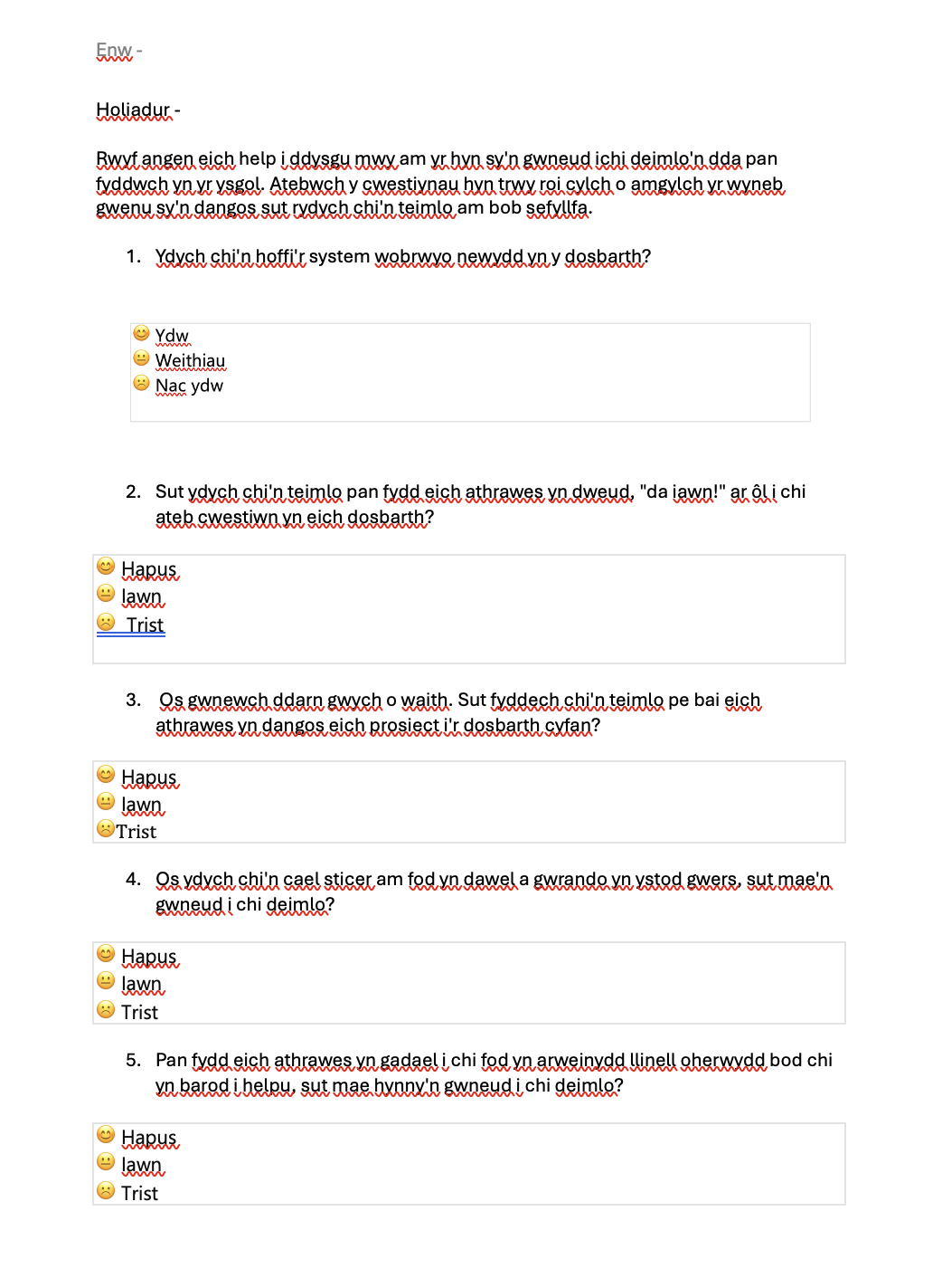

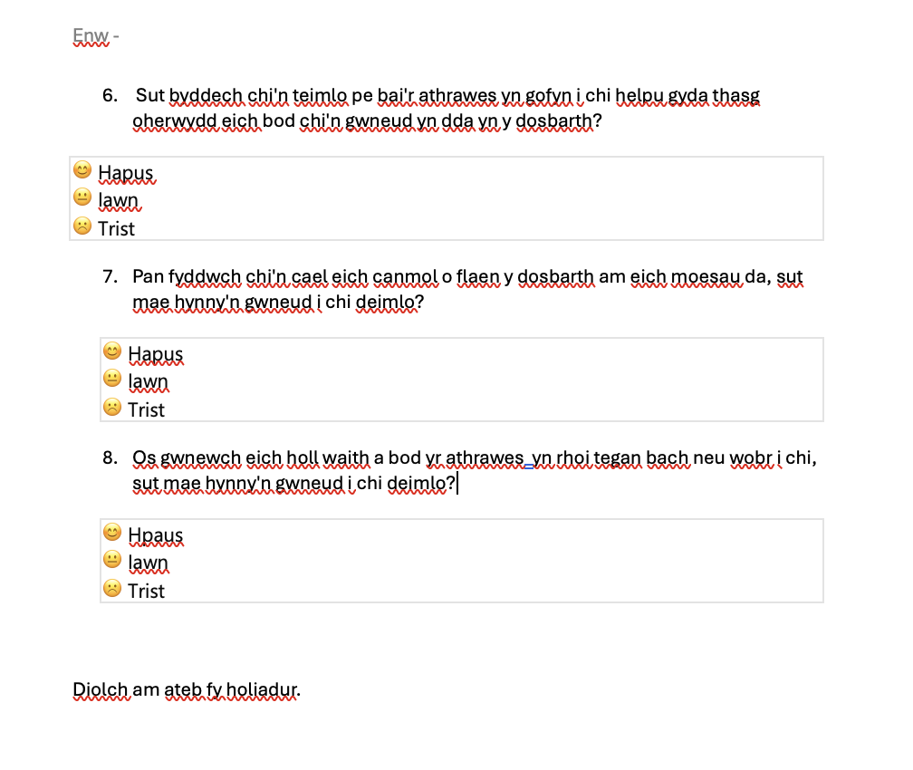

Appendix 2 – 0bservation

Used the Leuven scale to determine how praising children effects their participation.

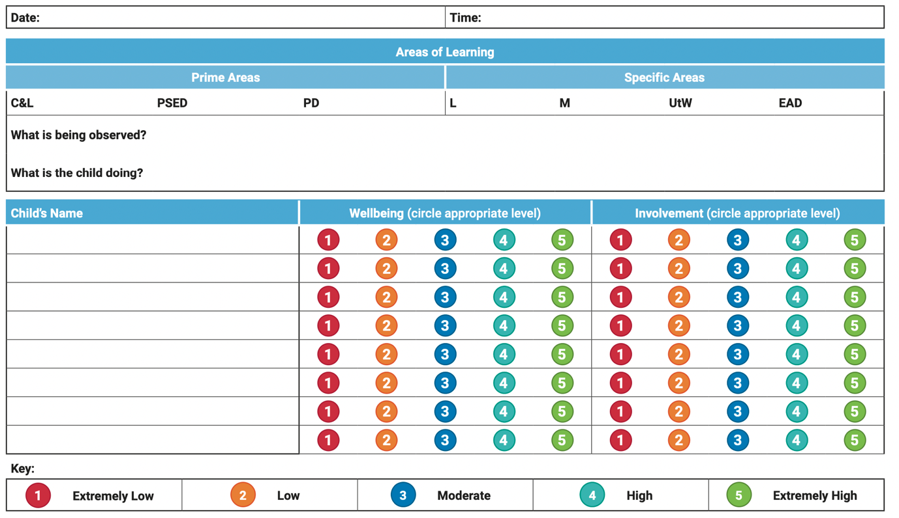
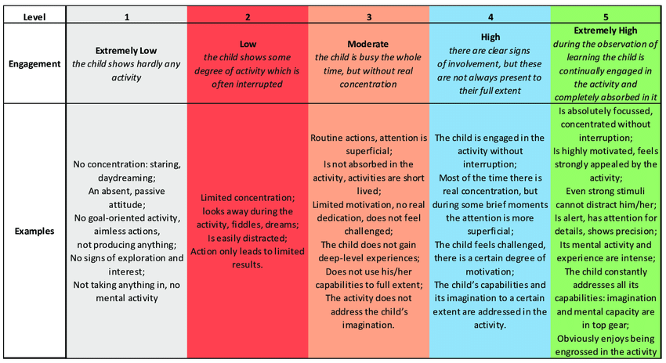
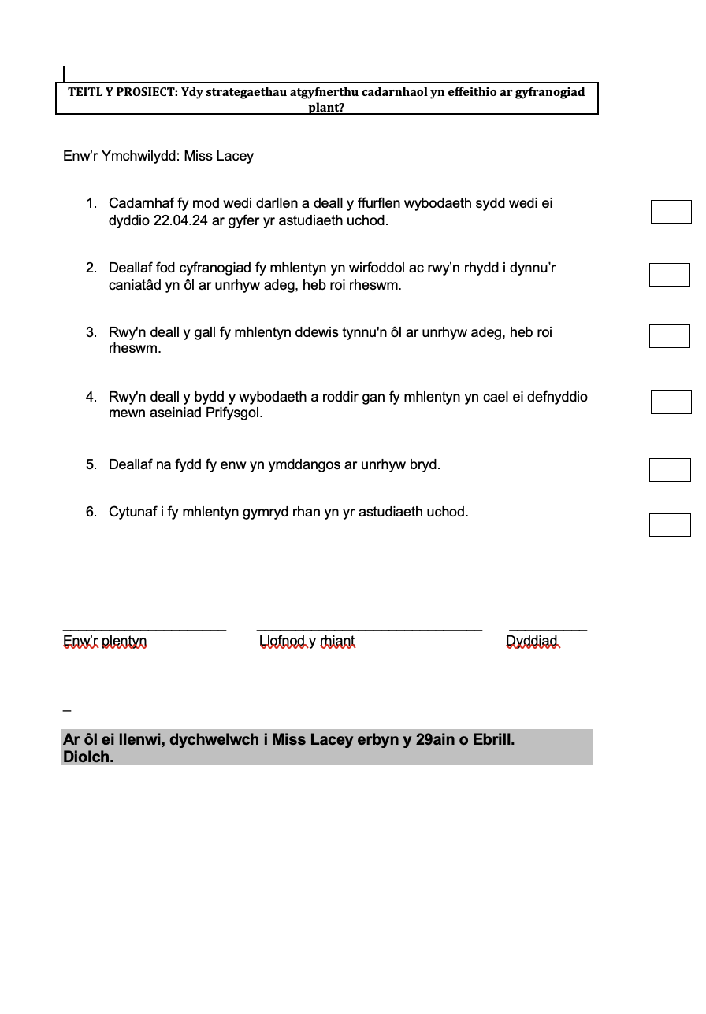
Appendix 3 – Letter of consent.

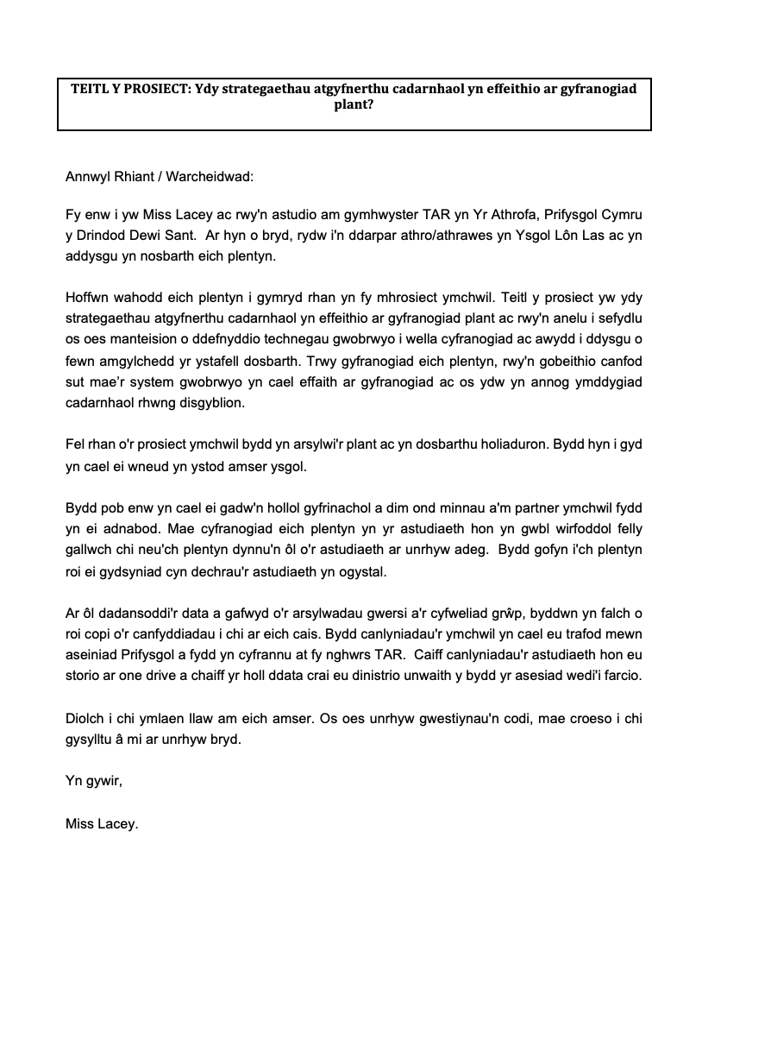


Appendix 4 – Ethics Form



