

Module Name: Managing Enterprise

Module Code: BMSW4011

Assessment 1: Business Plan and Reflection

Student Name: Lauren Dalling

Student Number: 2506840

Lecturer: Chris Wilkin

Deadline: Friday 19th June2 23:59PM

AI Acknowledgement

I confirm that I have not presented any AI generated materials as my own work.
I confirm that I have copies of my drafts, notes, and other resources I used, which I may be asked to provide in evidence.

Part 1: Business Plan (1,000 words)

- Product / Service Proposition and Company Name
LD Beauté is a salon based beauty business located in Swansea, South Wales. The business specialises in Nail, Brow and Lash treatments, including Builder Gel Nails, Brow Wax and Tint, Henna Brows, Brow Lamination, Lash Lifting and Tinting and Eyelash Extensions. The business aims to provide professional beauty treatments at affordable prices within a welcoming and professional salon environment.
The business proposition is based on providing high quality treatments, excellent customer service and competitive pricing. Customers can access multiple beauty services in one location, creating convenience and encouraging repeat bookings.

- The Story Behind My Idea
LD Beauté was created from my passion for the beauty industry and helping clients feel more confident. After completing professional training in nails, brows and lashes, I identified an opportunity to offer multiple beauty services under on brand. Entrepreneurship involves identifying opportunities and creating value for customers (Hisrich et al., 2019).
I wanted to create business that combines affordability, professionalism and customer satisfaction. The beauty industry continues to grow, and I believe there is string demand for high quality beauty treatments delivered in a welcoming and friendly environment.

- Business Ownership Structure
LD Beauté will operate as a sole trader business. A sole trader retains all profits and maintains complete control over decision-making (Barrow et al., 2021). Advantages include flexibility, simple administration and low start up costs. Disadvantages include unlimited liability and personal responsibility for business debts.
The structure is appropriate because the business is owner-operated and relatively small. It also allows decisions to be made quickly without consulting business partners.
- Mission Statement, Aim, SMART Objectives and USP
Mission Statement
To provide professional and affordable beauty treatments while delivering excellent customer service.
Business Aim
To establish LD Beauté as a trusted beauty brand within Swansea and achieve profitability within the first year.
SMART Objectives
- Build a client base of at least 150 active customers within 12 months.
- Increase Instagram followers from 312 to 1,000 within one year.
- Achieve 40-50 appointments per week.
- Maintain customer satisfaction levels above 95%.
Unique Selling Point
LD Beauté offers Nail, Brow and Lash treatments under one brand, providing convenience, personalised service and competitive pricing.

- Location and Rationale
The business operates from a rented salon space in Swansea costing £200 per month. Swansea was selected because it has a large potential customer base and provides convenient access for local clients. Operating within a salon environment increases professionalism and customer confidence. A Google Maps image of the business location can be found in Appendix G.

- Human Resources
Initially, the business will be owner operated. Responsibilities include treatments, customer service, stock management, marketing, appointment scheduling and administration. As the business grows, additional staff may be recruited to support increasing demand. An organisation chart is provided in Appendix H.

- Marketing Activities
Marking is essential for attracting and retaining customers (Kotler et al., 2023). LD Beauté has developed a professional logo, price list and Instagram business page (see Appendices A-C).
Instagram is the primary marketing platform and is used to showcase treatment results, customer reviews and promotions. Additional marketing activities include referral discounts, loyalty rewards and word of mouth promotion.
Primary research showed that 81.8% of respondents had booked beauty treatments due to social media influence. Furthermore, 96.4% expressed interest in loyalty rewards, supporting the decision to implement a customer loyalty scheme.

- Market Research
Primary market research was conducted using an online questionnaire through Google Forms and was completed by 55 respondents (Appendix D). Market research helps businesses understand customer needs and reduce uncertainty when making decisions (Finch, 2022).
The results showed that 72.7& of respondents were aged between 18 and 34 years old. Additionally, 43.6% booked beauty treatments every 2-4 weeks, demonstrating strong repeat business potential.
Nails were identifies as the most popular beauty treatment, followed by brows and lashes. Reviews and reputation were considered the most important factors when choosing a beauty technician.
The research findings directly influenced several business decisions. Nails were identified as the most popular treatment, supporting the decisions to make nail services a core offering. The strong interest in loyalty rewards influenced the introduction of social media marketing, justifying the decision to prioritise Instagram marketing.
Secondary research shows that social media increasingly influences consumer purchasing decisions and brand awareness (Kotler et al., 2023). Effective planning and market research can reduce business risk and improve business performance (Finch, 2022).

- Financial Resources
The business requires approximately £3,204 in start-up funding. Costs include £600 for brow and lash training, £700 for nail training, £600 for stock, £800 for equipment and £204 for annual insurance. Funding will be provided through personal savings and revenue generated from existing beauty treatments.
Research conducted using Moneyfacts Compare identified a range of small business loans available in the UK, demonstrating that external finance would be accessible if required (See Appendix I). However, due to the relatively low start-up costs and existing business income, external funding is not currently necessary.
Monthly operating expenses are estimated at approximately £497. A detailed 12-month cash flow forecast is provided in Appendix E.
The financial forecast suggests that the business is financially viable because projected revenue exceeds operating expenses throughout the year. The relatively low start-up costs and overheads reduce financial risk, while increasing customer numbers should support future profitability (Williams, 2022).

- Competitor Analysis
Competitor analysis was conducted using local beauty businesses including Nails By Tia Fitzgerald and Browlashed By Leonie (Appendix F). Competitor Analysis helps businesses identify opportunities for differentiation and competitive advantage (Hooley et al., 2020).
Both competitors have strong branding and active social media accounts. However, LD Beauté offers a wider combination of nail, brow and lash treatments under one brand. This creates opportunities for cross-selling services and increasing customer spending per visit.
- SWOT Analysis and Critical Appraisal
Strengths include professional qualifications, multiple treatments options, strong branding and positive market research findings.
Weaknesses include limited reputation as a new business and reliance on one individual.
Opportunities include growing demand for beauty services, social media marketing and customer loyalty programmes.
Threats include local competition, economic uncertainty and rising operating costs.
Overall, LD Beauté appears to be viable and realistic business opportunity. This SWOT analysis identified more strengths and opportunities than weaknesses and threats. Primary research demonstrated strong customer demand, while the financial forecast suggests that the business has potential to generate sustainable profits. Therefore, the evidence suggests that LD Beauté has strong potential for long-term growth and sustainability (Barringer and Ireland, 2020).

Part 2: Individual Reflection (500 Words)

Throughout this module, I developed a range of entrepreneurial skills while creating the business plan for LD Beauté. Before completing this assessment, I had experience providing beauty treatments but limited knowledge of business planning and business management. The process helped me understand the importance of research, planning and financial management when starting and growing a business.
One of the most valuable skills I developed was market research. Designing and distributing a questionnaire allowed me to gather information about customer preferences, spending habits and booking behaviours. Analysing the results helped me understand the importance of making decisions based on evidence rather than assumptions. This improved my analytical skills and helped me identify a clear target market for LD Beauté. The survey also highlighted the importance of customer reviews, loyalty schemes and social media marketing, which influenced several business decisions within my plan.
I also developed my marketing knowledge. Creating a logo, price list and Instagram business page helped me understand how branding influences customer perceptions and purchasing decisions. The survey findings highlighted the importance of social media within the beauty industry and reinforced the need for consistent online marketing. As a result, I became more confident in using social media as a business tool and understanding how businesses attract and retain customers.
Another important skill developed during this module was financial planning. Producing start-up cost estimates and a cash flow forecast increased my understanding of budgeting and financial feasibility. I learned the importance of forecasting income and expenditure and assessing whether a business idea is realistic and sustainable. This gave me a better understanding of the financial responsibilities involved in running a business and the importance of monitoring performance.
I also developed my problem-solving skills throughout the project. I had to make decisions regarding pricing, marketing, budgeting and business strategy. This helped me understand that entrepreneurs often need to make decisions using limited information and adapt when challenges arise. As a result, I became more confident in evaluating different options and selecting the most appropriate solutions for the business.
The assessment also improved my organisational, communication and time-management skills. Managing research, analysing data and completing the report within the deadline required careful planning and prioritisation. These skills will be valuable when operating and developing my business in the future.
I would personally invest in LD Beauté because the business has relatively low start-up costs and the market research demonstrated strong customer demand. The survey showed that many respondents regularly book beauty treatments and are influenced by social media marketing, which supports the proposed business model. In addition, the financial forecast suggests the business has the potential to become profitable within its first year.
However, I recognise that there are risks associated with investing in any business. Competition within the beauty industry is high and customer spending may be affected by economic conditions. Operating as a sole trader also means that success of the business is heavily dependent on one individual. Despite these risks, I believe the strengths outweigh the challenges because the business offers multiple services, has a clear target market and benefits from strong marketing opportunities.
If I were to complete this project again, I would carry out research with a larger number of people and use more secondary sources to strengthen my findings. I would also spend more time testing different financial scenarios to see how changes in customer demand could affect the business. This would improve the accuracy of my planning and forecasts.
Overall, this module has increased my understanding of entrepreneurship and what is involved in starting and managing a business. It has helped me develop skills in research, marketing, financial planning, communication and organisation that will support both my current beauty business and future business opportunities. Completing this project has increased my confidence and provided valuable insight into the challenges and responsibilities involved in running a successful business.

Contents Page

Contents
AI Acknowledgement 2
Part 1: Business Plan (1,000 words) 3
Part 2: Individual Reflection (500 Words) 8
Contents Page 10
Reference List 11
Appendices 13

Reference List

Barringer, B.R. and Ireland, R.D. (2022) Entrepreneurship: Successfully Launching New Ventures. 6th Edn.
Barrow, C., Barrow, P. and Brown, R. (2021) The Business Plan Workbook. 10th Edn.
Browlashed by Leonie (2025) Available at: https://www.instagram.com/browlashed__byleonie?igsh=c2tya3BkZXdoczd6
(Accessed 16th June 2026)
Finch, B. (2022) How to Write a Business Plan. 7th Edn.
Google Maps (2026) Swansea Business Location. Available at: https://share.google/hHXU0TC6p76NJyMig (Accessed: 17th June 2026)
Hisrich, R.D., Peters, M.P. and Shepherd, D.A. (2019) Entrepreneurship. 11th Edn.
Hooley, G., Nicoulaud, B. and Rudd, J. (2020) Marketing Strategy and Competitive Positioning. 7th Edn.
Instagram (2026) LD Beauté Business Page. Available at: https://www.instagram.com/ldbeaute?igsh=emZ1eHluOHNyZWpj&utm_source=qr
(Accessed: 17th June 2026)
Kotler, P., Armstrong, G. and Opresnik, M.O. (2023) Marketing: An Introduction. 15th Edn.
LD Beauté (2026) Market Research Questionnaire. Available at : https://forms.gle/74rKoLPbwEDYQS6g9
Moneyfacts Compare (2026) Business Loan Comparison Information. Available at: https://moneyfactscompare.co.uk/loans/loan-calculator/
(Accessed: 17th June 2026)
Nails By Tia Fitzgerald (2026) Instagram Business Page. Available at: https://www.instagram.com/nailsbytiafitzgeraldx?igsh=OXRtZHV6Zm1zZXlj
(Accessed: 17th June 2026)
Williams, S. (2022) The Financial Times Guide to Business Start Up 2022/2023.
Young, P. (2021) Business Plan.

Appendices

Appendix A – LD Beauté Logo
A1. LD Beauté Business Logo


Appendix B – LD Beauté Price List
B1. LD Beauté Service Price List
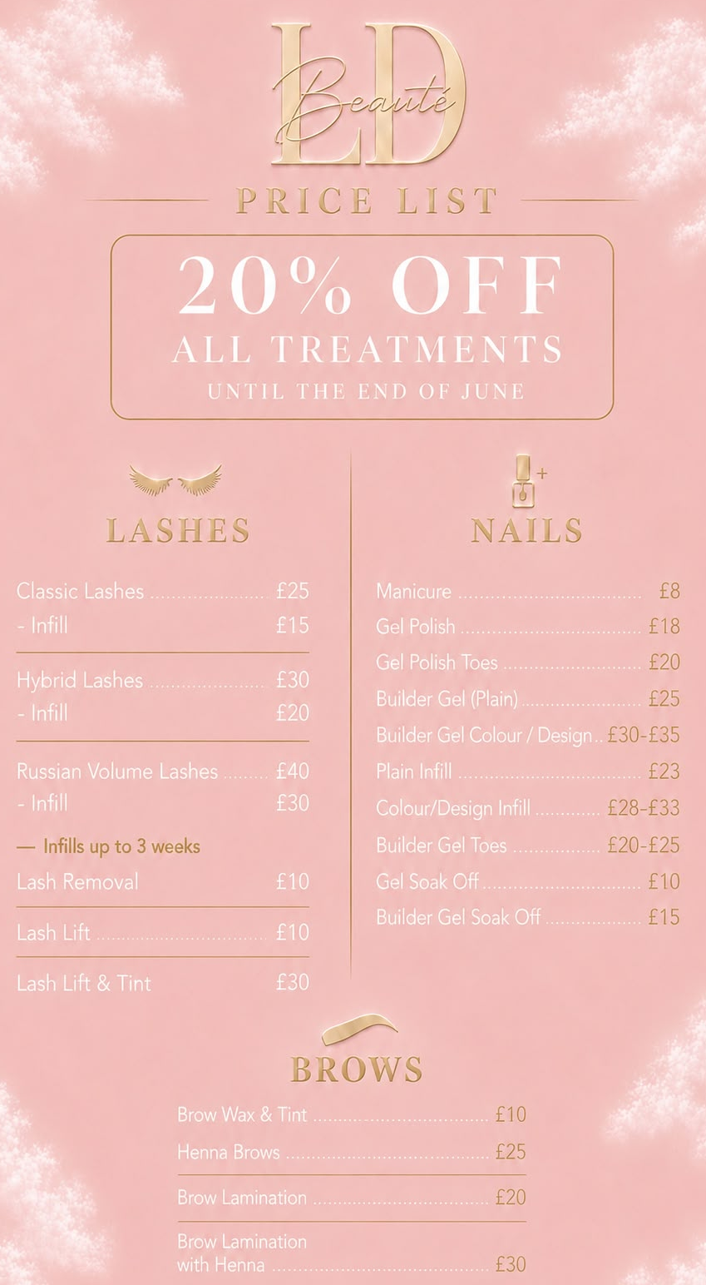

Appendix C – Instagram Business Page
C1. LD Beauté Instagram Business Page
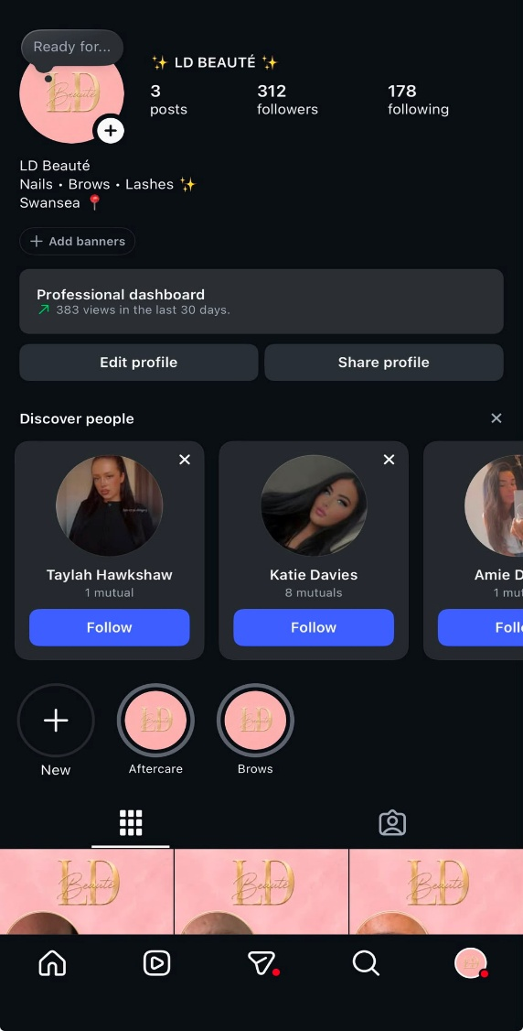

Appendix D – Market Research Results
D1. Age of Respondents
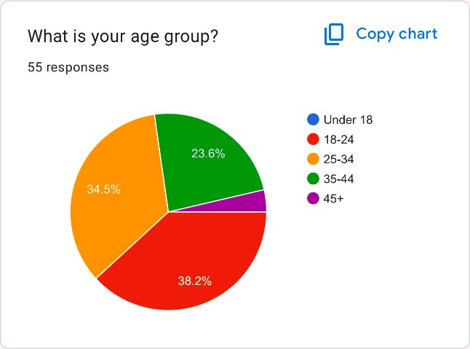

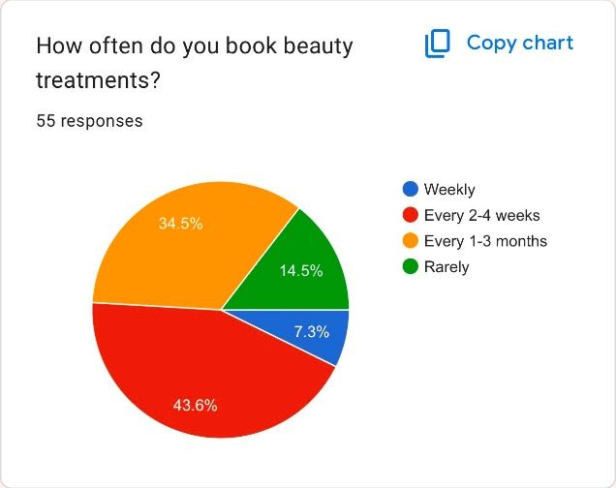
D2. Frequency of Beauty Treatment Bookings

D3. Most Frequently Booked Beauty Treatments
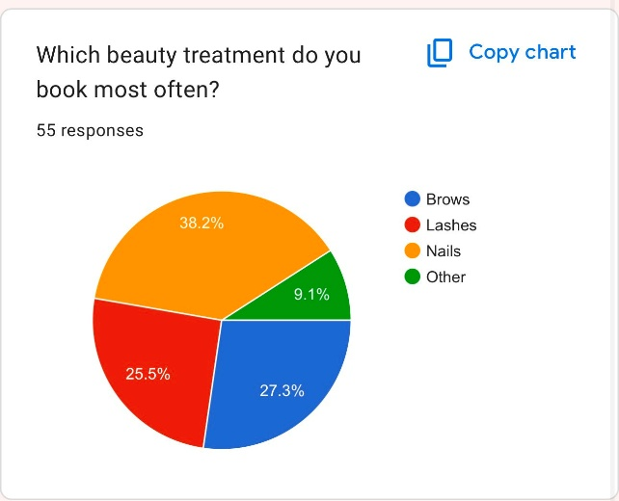

D4. Most Important Factor When Choosing a Beauty Technician
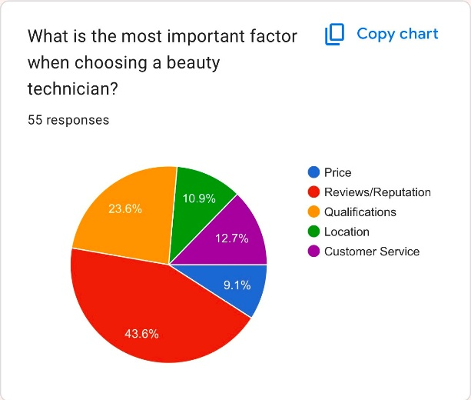

D5. Interest in Mobile Beauty Servies
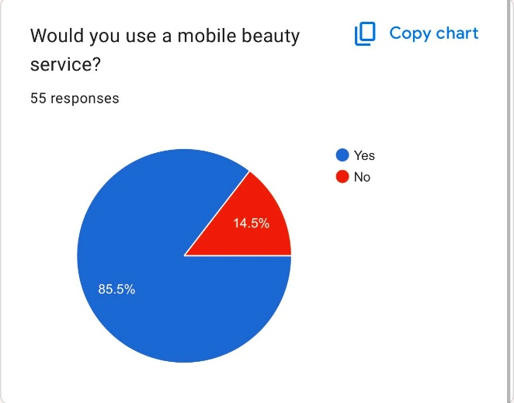

D6. How Customers Find Beauty Businesses
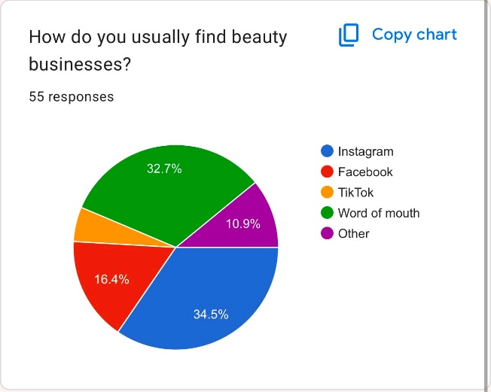

D7. Typical Customer Spending
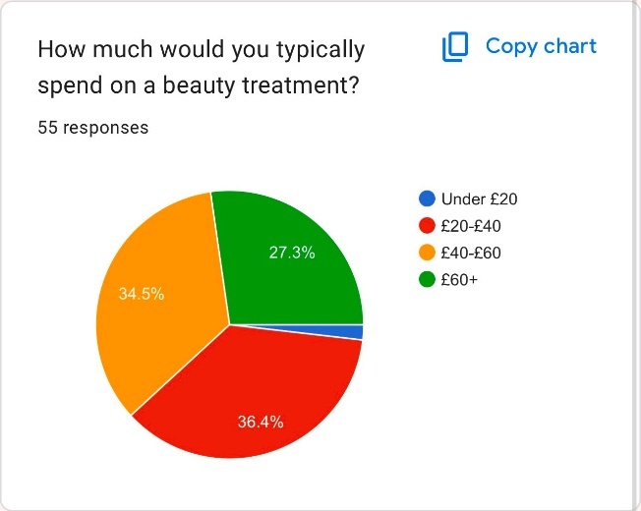

D8. Influence of Social Media
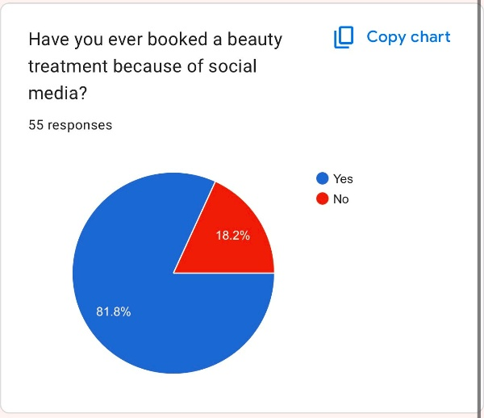

D9. Interest in Loyalty Rewards and Referral Discounts

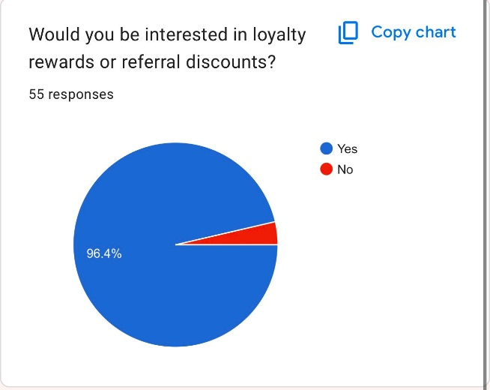

D10. Likelihood o Recommending a Beauty Business
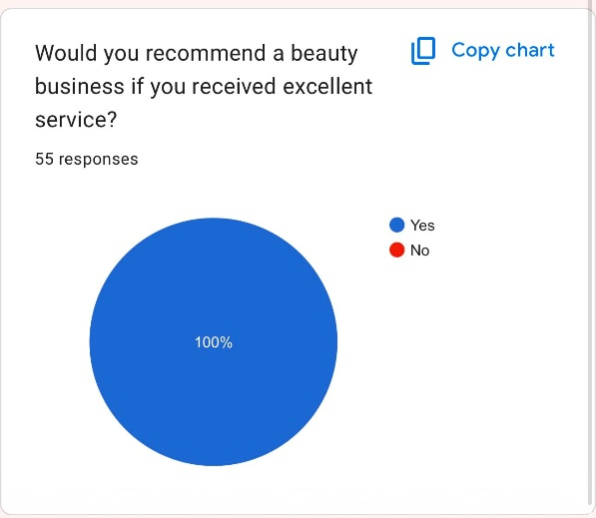
Key Findings
- 38.2% of respondents were aged 18-24.
- 43.6% book beauty treatments every 2-4 weeks.
- Nails were the most popular treatment (38.2%)
- Reviews and reputation were the most important factor when choosing a technician (43.6%).
- 85.5% would use a mobile beauty service.
- Instagram and word of mouth were the most common ways customers find beauty businesses.
- 81.8% had booked because of social media.
- 96.4% were interested in loyalty rewards.
- 100% would recommend a business after excellent servie.
Link For Survey –
https://forms.gle/LALDFbMxXAzt7f5s9

Appendix E – 12 Month Cash Flow Forecast
E1. 12 Month Cash Flow Spredsheet
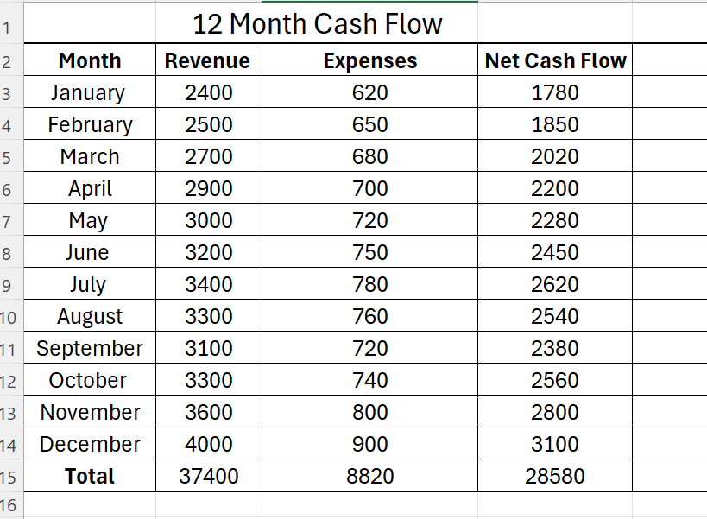

Appendix F – Competitor Analysis
Business | Strengths | Weaknesses
Nails By Tia Fitzgerald | Home based, active on social media, specialises in BIAB and gel nails, establishes customer base. | Limited treatment range, mainly nail focusses.
Browlashed by Leonie | Wide range of treatments, professional branding, established pricing structure. | Higher prices for some treatments.
LD Beauté | Salon Based, competitive pricing, brows, lashes and nails offered. | New business with lower brand awareness.

F1. Nails by Tia Fitzgerald Social Media Advertisement
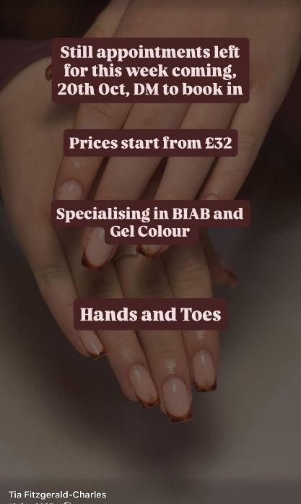

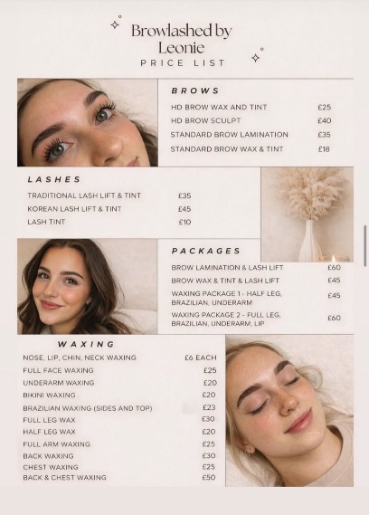
F2. Browlashed by Leonie Price List

Appendix G – Business Location
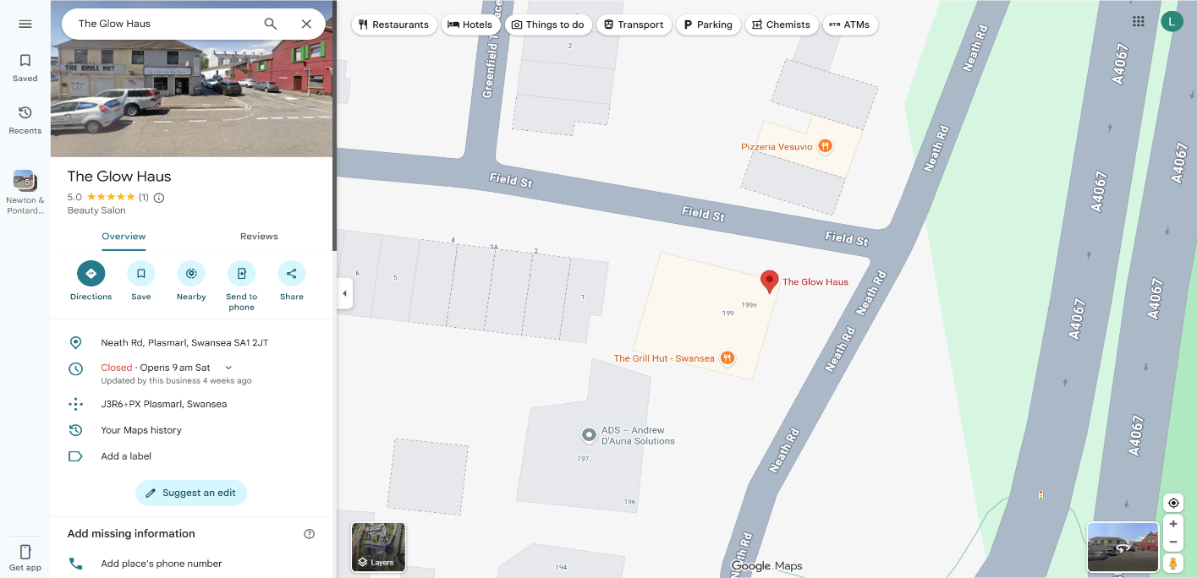
The Glow Haus
199 Neath Road, Swansea, SA1 2JT

Appendix H – Organisation Chart

Appendix I – Funding Options

Funding Option | Description | Advantages | Disadvantages
Personal Savings | Using personal funds to start and operate the business. | No repayment required and full control retained. | Limited amount of funding available.
Bank Loan | Borrowing money from a bank to support business growth. | Access to larger amounts of finance. | Monthly repayments and interest charges.
Government Start-Up Loan | A government backed loan for new businesses. | Competitive interest rates and business support available. | Repayments Required.
Family and Friends | Borrowing money from family and friends. | Flexible repayment arrangements. | Potential strain on personal relationships.
Business Grants | Non-repayable funding offered by organisations or local authorities. | No repayment required. | Highly competitive and specific eligibility criteria.

Preferred Funding Option:
LD Beauté intents to use personal savings initially, as this allows the business to start with minimal financial risk and without incurring debts. As the business grows, additional funding options such as a start-up loan may be considered to support expansion and the purchase of new equipment.

I1. Available Business Funding Options (Moneyfacts Compare)
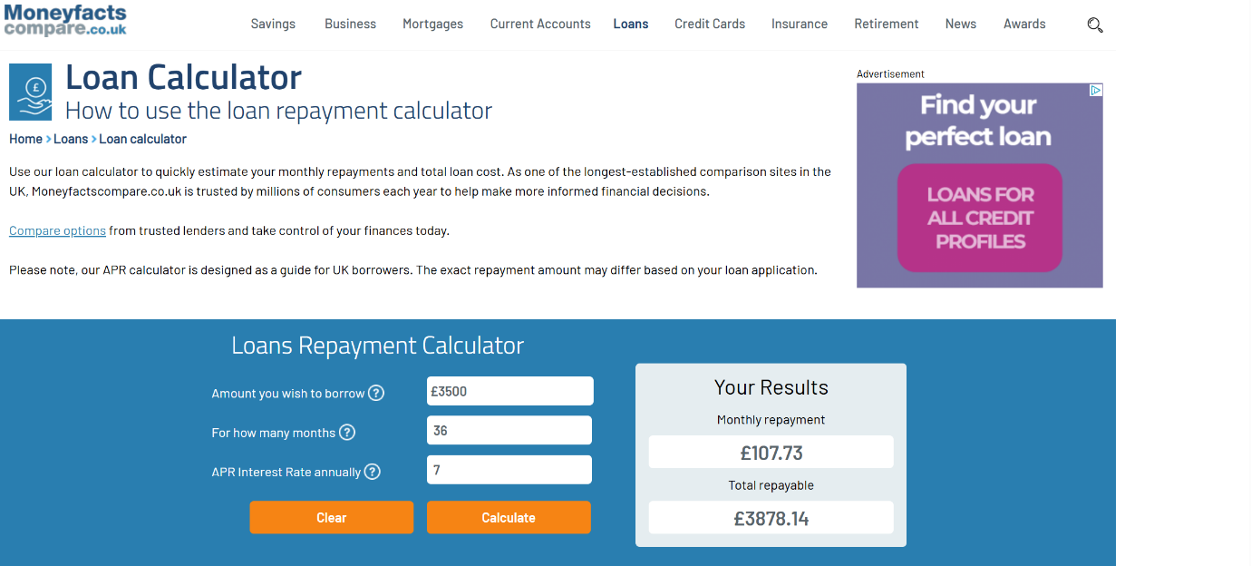
The Moneyfacts Compare website was used to compare loan options available to support business growth. Based on a loan amount of £3,500 over 36 months, monthly repayments would be approximately £112-£117 depending on the lender and interest rate offer. This funding could be used to support equipment purchases, srock and marketing activities if required in the future. However, LD Beauté intends to use personal savings to minimise financial risk.

