WORKPLACE CULTURE and its impact on
ORGANISATIONAL EFFICIENCY

STUDENT: Ionut-Eugen Barbulescu
LECTURER: MD Kalam
STUDENT ID: 1921331

INTRODUCTION

The purpose of the Paper is to evaluate the impact of organisational beliefs, attitudes and value systems in workplace behaviour also explain how do broader external environmental factors along with Covid-19 and ethical dilemmas affect organisational culture and its performance.
The organisation that I choose is selling one of the things we are all dependants of : cars. Even if we are taking a good or less good one , we are paying It or rent, we are everywhere depending of It.
General Motors Co. is an American automaker that designs, produces and sells automobiles, trucks and parts all over the world. The following automobile segments are part of the company’s operations: GM North America, GM Europe, GM International Operations and GM South America are the four divisions of General Motors.
The Chevrolet, GMC, Buick and Cadillac brands are sold under the GM North America sector, which includes sales, product and distribution facilities in Central America and the Caribbean.
With sales, production and distribution operations spanning Western and Central Europe, the GM Europe sector sells vehicles under the names Vauxhall, Opel, Chevrolet.
GM International Operations sells automobiles under Cadillac, the Buick, Daewoo, Chevrolet, GMC, Isuzu, FAW, Holden, Opel, Jiefang and Wuling brands throughout Asia-Pacific, Eastern Europe, Middle East, the Commonwealth of Independent States, Africa. Through its subsidiary, GM Financial Co., Inc., It also offers automobile financing (GM Financial). Credit Facilities and securization trusts, which issue asset- backed securities to investors , are used to fund its loan origination activity.
The analytical tool I choose to discuss in my assessment is MCKINSEY’S 7’S Framework and LEWIN’S THREE STEP model.
MCKINSEY’S 7’S Framework includes strategy, structures , such as organisation charts and
reporting lines and systems. They are three “hard” factors, formal processes and IT systems. These are rather starightforward to spot and management has direct control over them.
The four “soft” characteristics, instead, are more difficult to define, less concrete and influenced by the company’s culture. If the organization has success, they have the same importance as the hard elements.

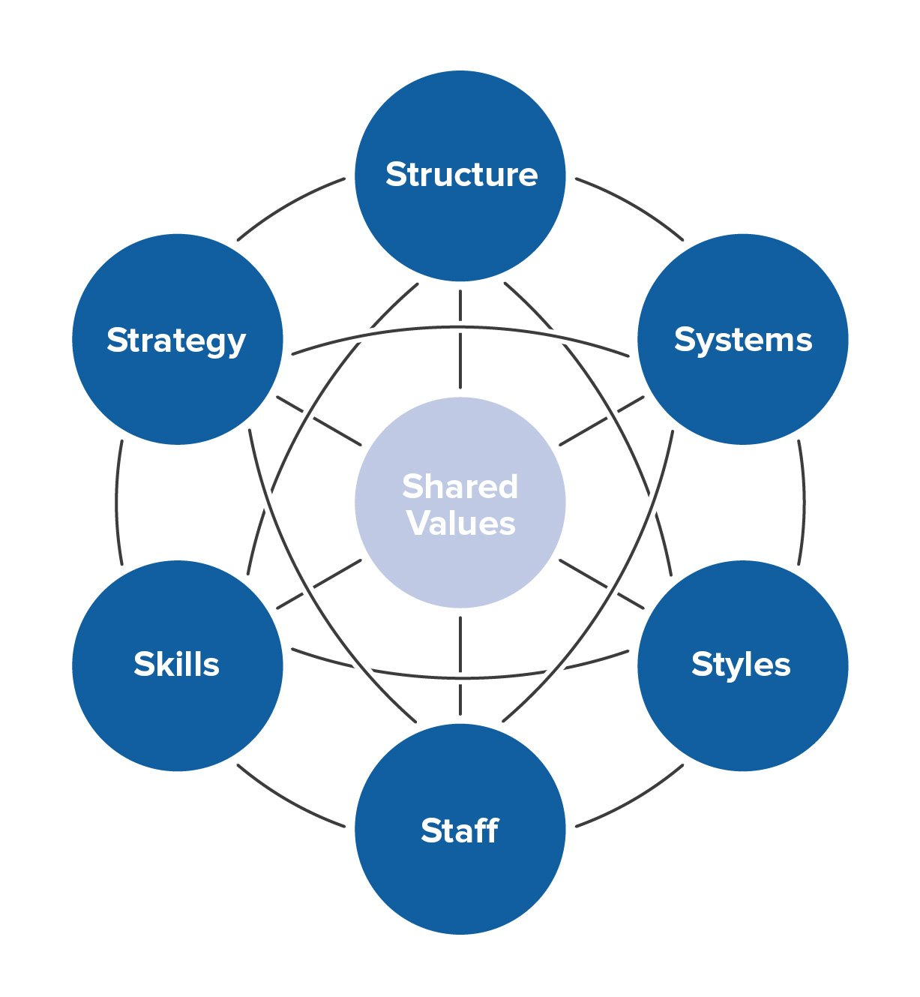
LEWIN’s THREE STEP model is regarded as one of the first chance thinkers. His “Three Step Change Model” provided the groundwork for modern-day change theory.
Understanding this fundamental model is important since It has created the groundwork for many subsequent models and starting here will give us the best chance of learning more complex models. However, its actual application in modern business is debatable, owing to the compelxity of organisations.





