supportive paper
Cybercrime
Increased Child Sexual Exploitation as a result of technology.
Mia Pitman- 1706437
08/01/2021
Supportive paper- cybercrime
Increased child sexual exploitation as a result of modern technology
Cybercrime is growing and evolving at a rapid pace across the world becoming more technically efficient and aggressive becoming an issue of pressing concern to society. "Cyberspace" being the realm of computerized interactions has offered a new range of opportunities to criminals across the globe bringing the emergence of a new type of criminal- cybercriminals. (Yar & Steinmetz, 2017). Cybercrime is not new yet there are significant amounts of confusion among computer experts, users, and academics and many would find it hard to define the term precisely despite its common now common usage (Ford & Gordon, 2006). The crown prosecution service state "cybercrime" is an umbrella term for various types of crimes which either take place online or where technology is a means or target for the attack" (CPS, 2019). A similar definition is offered (Kshetri, 2010): it is a criminal activity in which computers or computer networks are the principal means of committing an offense". The emergence of the internet poses challenges to the existing criminological perspectives and it is often unclear to what extent the theories are compatible with cybercrime/criminals (Kshetri, 2010). Cybercrime has become an increasingly widely debated topic that is dramatically affecting society, politics, and economics. Traditional crimes are technically evolving having increased accessibility significantly the ability to form connections around the world, businesses, individuals, governments, security systems are also facing complete new kinds of criminal activity every day (National Crime Agency, 2019). The absence of a consistent definition proves to be a major problem for the criminal justice system and the agencies aiming to tackle it (Yar & Steinmetz, 2017). The government and the criminal justice system are developing and adapting to keep up with the forever changing cyberspace and criminals within. This assignment outlines cybercrime and how it has evolved, the types of crime and criminals focusing on child sexual exploitation online.
Computers were first introduced in the 1950s, during this time computer complexity and cost limited their availability however the dramatic technological evolution began creating mainframe and mini frame computers, and costs decreasing. however examination of the history of cybercrime ought, to begin with, the internet- without the internet cybercrime would not exist- its not computers alone but the internet that provides the crucial electronically generated environment that cybercrime takes place (Kshetri, 2010). The internets origins can be traced back to the 1959s where an enemy bomber early warning interception system was developed, by the 60s defense advanced research projects further explored internet networking systems resulting in the ARPNET being the first experimental network in the US- whereby two computers were connected 400 miles apart and successfully sending a message. The ARPANET aimed to create secure and resilient communication and coordination for the military, the original ARPANET was then split into two the ARPANET and the MILNET (Schjolberg, 2020). Kshteri 2019 states that the creation of Arpanet began the development not only of the appropriate but that of protocols, codes, and rules allowing computers to understand each other (Kshetri, 2010). By the 1970s mail applications, the UKs JANET (the joint academic network was established and networks around the globe were beginning to communicate with each other forming the internet. By the 90s ARPANET was released to civilians along with the developments of web browsers allowing civilians to use the internet on their personal computers (Schjolberg, 2020). Businesses began to see the commercial potential of the internet since its commercialization the growth of the internet became incredibly rapid, Furnell 2002 states that between 1994 and 1999 the number of countries connected to the internet increased from 83 to 226- reaching 580 million internet users across the globe by 2002 which is 10% of the world's population (Furnell, 2002). Along with this increase in internet users came the increase in cyberspace cybersex, cybershopping, cyber surfing, and of course cybercrime (Yar & Steinmetz, 2017). Following the developments in technology cybersecurity became a challenge, this rapid growth of cyberspace created new opportunities to exploit online carry put cyberattacks posing a threat to the state, international peace, and security (Schjolberg, 2020). Research portrays clearly that the relationship between crime and technology is not new and the potential to create harm does not stretch far from technological development- cybercrime has grown and continues to grow significantly with the united kingdom along with the governments of the world making every effort to keep up.
There is an ongoing argument among current criminologists, many argue that cybercrime is the same type of crime as traditional non-virtual crimes and is just using new tools that are helpful to criminals whereas others insist that it represents a completely new form of crime that is very different (Schjolberg, 2020). Cybercrime around the globe is has become extremely sophisticated, it does not distinguish between government targets, larger corporations, and individual users (Jeffray & Feakin, 2015). The modern-day cybercrime threat can be generally be split up into two broad categories. Cyber-dependent crimes are offenses that can only be committed using a computer, computer networks, or another form of information communications technology (GOV, 2013). Cyber-dependent acts often involve the spread of viruses, malware, hacking and other activities that are primarily directed against computers or network resources. Cyber dependent crimes are often the most common cyber threat- social media has allowed civilians of all ages to often be a victim of hacking- the attacks may often be financially devastating to people and businesses however crime statistics are unreliable with cybercrime being extremely under-reported due to the level of sentencing at court for these attacks is not equal to the seriousness of the attack with the national crime agency stating it is an area ripe for consideration (NCA, 2017). The 2017 WannaCry ransomware attack spread rapidly due to its self-replicating worm- 300,000 devices were infected, 150 countries were spanned affecting services worldwide one being the NHS- it was a demonstration of real-world harm that cyber-attacks can have. Toon 2017 from the national crime agency states
"Recent years will be remembered as the years of ransomware attacks and massive data breaches, supply chain threats and fake news stories- with attackers now able to achieve their aims by using basic techniques, making cybercrime more difficult"
The second cybercrime subdivision is cyber-enabled crimes. Cyber-enabled crimes are traditional crimes that can be increased in their scale or reach by the use of computers, computer networks, or other forms of information communications technology (ONS, 2013). Cyber-enabled crimes to include economic-related cybercrime, illegal online marketplaces (dark web), cyberbullying, child sexual offenses, extreme pornography, and so on (CPS, 2019). Cyber-enabled crimes are increasing with the continuing developments in technology, the office of national statistics annual crime survey for England and wales demonstrate this increase.

Figure 1 December 2016 (ONS, 2016)

Figure 2 December 2017 (ONS, 2017)
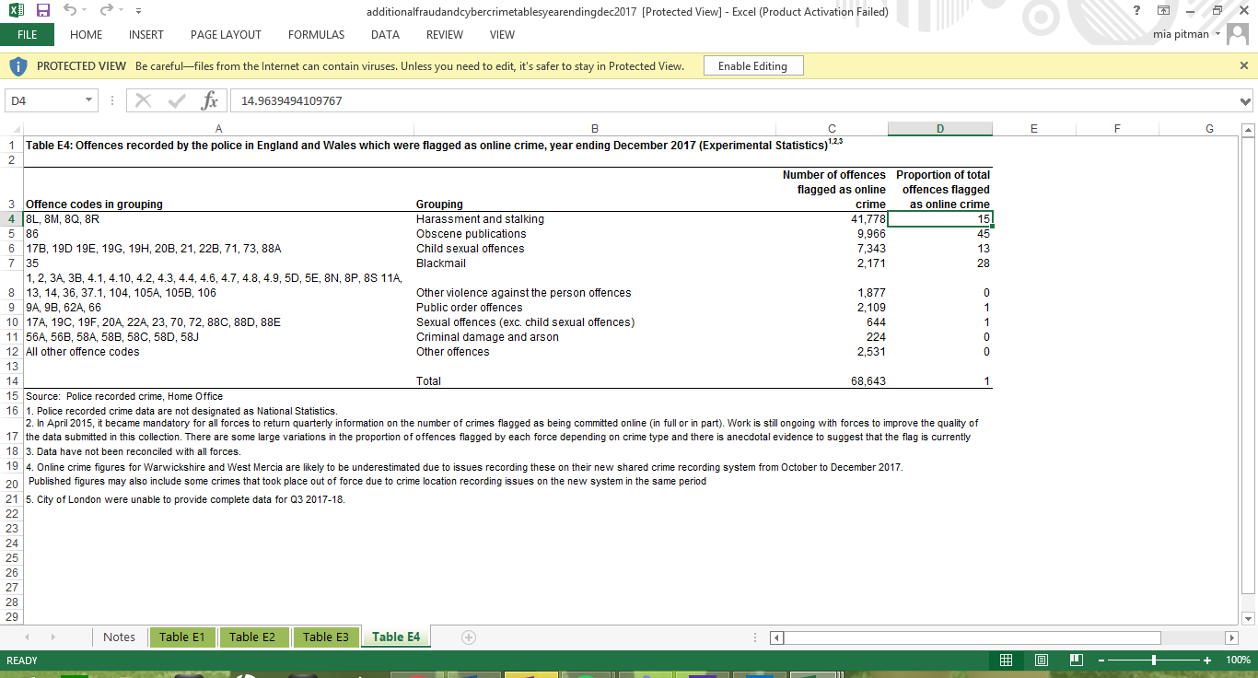
Figure 3 December 2018 (ONS, 2018)
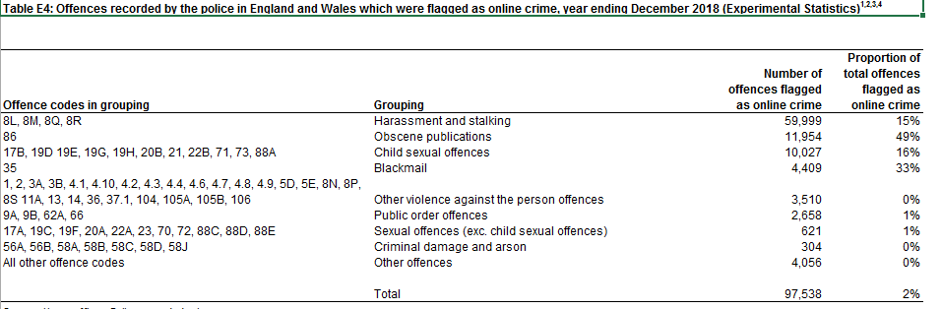

These figures demonstrate the increase in cyber offending, the most significant increase in harassment and stalking alongside child sexual offenses- it is clear that the internet is providing improved accessibility to criminals having a dramatic effect on these crime rates. Despite this the current COvid 19 outbreak and the far-reaching lockdown measures are having a direct and indirect effect on cybercrime, street crime has decreased and the move towards working and shopping online has resulted in drastic, unprecedented changes in crime opportunities (Buil-Gil, 2020). Such a drastic increase in certain cybercrime rates would suggest that governments/criminal justice systems do not have the correct resources to combat these crimes- indicating that these crimes are becoming more extreme and more of a threat to individuals across the globe, children in particular.
The advancement in technology has altered criminal behaviour and resulted in a range of new offenses coming into existence. Traditional offenses such as fraud, child exploitation have developed through technological advancement resulting in offenses becoming more extreme, dangerous, and easier to perpetrate (MP Javid, 2019). All in all the internet and this form of technology has greatly extended our understanding of what constitutes a sexual offense, it is allowing sex offenders to commit an offense against children without being in a child's presence – J.Holt 2010 states
"Paedophiles have not been slow to make use of the internet to gain the trust and confidence of children in chat rooms, social media websites… for their purposes" (Holt, 2010)
Yar and Steinmetz 2017 suggest that the problem of child sexual abuse online has become grossly neglected- the nature of the problem has only recently been acknowledged. (Yar & Steinmetz, 2017). Crime control has improved significantly over time, measures have been taken in recent years to combat child abuse and attempted child abuse cases on the internet- john Reid home secretary of the time announced in 2007 the Government's intention to curb internet grooming however his attempts and many attempts similar have receiver much criticism- this provides a clear example of how difficult it is for the criminal justice system to stop determined criminals online (The Guardian, 2007).
The last two decades of cybercrime has had a significant impact on the world in many ways. Technology is extending criminal activity beyond what was previously, along with stretching and challenging the capabilities of police officers and criminal agencies beyond what was traditionally achievable by manpower alone- child sexual exploitation online is an evident example of technology extending an offense that was previously limited physically, now being enhanced by technology (Yar & Steinmetz, 2017).

Bibliography
Buil-Gil, D., 2020. Cybercrime and shifts in oppertunities during COVID-19 a preliminary analysiis in the UK. European societies in the time of a coronavirus crisis.
CPS, 2019. Crown prosecution services- prosecution guidance. [Online]
Available at: https://www.cps.gov.uk/legal-guidance/cybercrime-prosecution-guidance
[Accessed 7 January 2021].
CPS, 2019. Cybercrime-prosecution guidance. [Online]
Available at: https://www.cps.gov.uk/legal-guidance/cybercrime-prosecution-guidance
[Accessed 05 January 2021].
Ford, R. & Gordon, S., 2006. On the definition and calassification of cybercrime. Journal in Computer Virology, pp. 13-20.
Furnell, S., 2002. Cybercrime: Vandalizing the information society. Information Research- an international electronic journal.
GOV, 2013. GOV- Review of the evidence- cyber dependent crimes. [Online]
Available at: https://assets.publishing.service.gov.uk/government/uploads/system/uploads/attachment_data/file/246751/horr75-chap1.pdf
[Accessed 6th January 2021].
Holt, T. J., 2010. considering the pedophile subculture online. sexual abuse.
Jeffray, C. & Feakin, T., 2015. Special Report undergorund web. International Cyber policy centre, p. 17.
Kshetri, N., 2010. The Global Cybercrime Industry. s.l.:Springer.
MP Javid, S., 2019. Home office funds innovative policing technology to prevent crime. [Online]
Available at: https://www.gov.uk/government/news/home-office-funds-innovative-policing-technology-to-prevent-crime
[Accessed 7 January 2021].
National Crime Agency, 2019. NCA- cyber crime. [Online]
Available at: https://nationalcrimeagency.gov.uk/what-we-do/crime-threats/cyber-crime
[Accessed 5 January 2021].
NCA, 2017. The cyber threat to uk business, s.l.: NCA.
ONS, 2013. Cyber crime: A review of the evidence, chapter 2-cyber enabled crimes, s.l.: Office of national statistics.
ONS, 2016. Crime in England and Wales, year ending December 2016, s.l.: Office of National Statistics.
ONS, 2017. Crime Rates in England and wales, year ending December 2017, s.l.: Office of National Statistics.
ONS, 2018. Crime Rates in England and Wales, year ending December 2018, s.l.: Office of National Statistics.
Schjolberg, S., 2020. The History of Cybercrime. 3rd ed. s.l.:Cybercrime research institute.
The Guardian, 2007. Crackdown on pedophiles internet aliases. The Guardian, 6 February.
Yar, M. & Steinmetz, F. K., 2017. Cybercrime and Society. 3 ed. London: SAGE.

