L5 Research Practices writing task: 2500 words

Student Name: Leila Roworth

P Number: 1702604

Programme of Study: Surface Pattern Design

Module: ADAD5001

Words: 2695

Keywords:
- Circular economy
- Wabi sabi
- Fibre
Question:
- What is the future of cloth?
- How can design and technology combine to be more innovative and create a sustainable future for cloth?

Designing in the 21st century has to become more sustainable, designers need to
come up with innovative solutions to the textile waste epidemic which is harmful to
our eco systems. Everything is designed, I am interested in designing out waste and
how the circular economy model solves waste issues. Sustainable design minimizes
pollution, reduces the mass consumption of raw materials and natural resources and
reduces energy used to make textiles. Within this text I will discuss my three key
words circular economy, Wabi Sabi and Fibre and underpin the problems and
solutions designers are creating to resolve the textile waste issues. Further
discussing why, it is important for designers to become more responsible for future
generations.

A Circular economy within textiles and design is beginning to gain momentum with

new generations being more aware of how raw materials effect sustainability and

how the textile industry is damaging to our environment. A circular economy model

“builds economic, natural and social capital” (Ellen Mcarthur Foundation 2016). The

main aims behind the model are to design out waste and pollution, keep product

and materials in use and regenerate natural systems. It is becoming more evident

that new designers must come up with solutions to design out waste in order to

reduce the textile waste epidemic that we are globally suffering from. According to

WRAP a company which is a catalyst for sustainability and works in-between

businesses and government recorded that “£140 million worth of clothing goes into

landfill each year.” (WRAP 2018). As designers, it is important to address the figures

and come up with innovative solutions to the problem. Increasingly working towards

a circular economy where waste does not exist and reduce the amount of waste that

is incinerated or sent to landfill.

Being a designer in the 21st century there are more pressures with sustainability and

consequently a feeling of social responsibility. If more textile based companies

followed a more circular way of thinking the model according to the Ellen Mcarthur

Foundation “could provide concrete solutions for the future.” (Mcarthur 2016 p12).

The model tackles the waste problem by reusing, recycling and reimagining

products. Within the circular economy model brands and designers are expected to

understand stewardship with their product and even carry responsibility once the

item is purchased. After previously endeavouring on a live brief with Orangebox a

company that creates upholstery for office furniture they explained that after use the

products can be sent back to them. Where they will use elements of the furniture to

recreate new furniture for the future, this is an example of company stewardship.

Although, they are aiming for a sustainable future and looking to become more

circular one tonne of waste per week is incinerated often these raw materials are

made from wool, flax and cotton.

Nudie Jeans a denim-based brand that offers free repairs for life and received the

sustainable fashion award in 2018. Although they are not following the circular

economy model their brand strives for sustainability by “Offering free repair service

reselling second-hand products recycling worn out products.” (Nudie Jeans 2018).

This is an example of brand stewardship although a customer would typically pay

more for a pair of jeans from this brand, they are selling the idea of an unconditional

good quality pair that will be shaped by your lifestyle. Images on their social media

platforms (refer to figure 1) share the way people are living to their full potential in the

jeans. Styled images of cool models taking adventures in these jeans add to the

positive attitude and lifestyle they are trying to sell. This is enticing because it makes

the customer feel good for buying a pair of everlasting jeans that they believe to be

sustainable. Additionally, this makes the brand seem more giving by offering an

above and beyond service. This has been carefully designed and means that no

jeans should technically end up in a landfill but, until more brands adhere to taking

sustainability seriously and create stewardship plans there will always be waste.

Figure 1 Nudie Jeans @nudiejeans
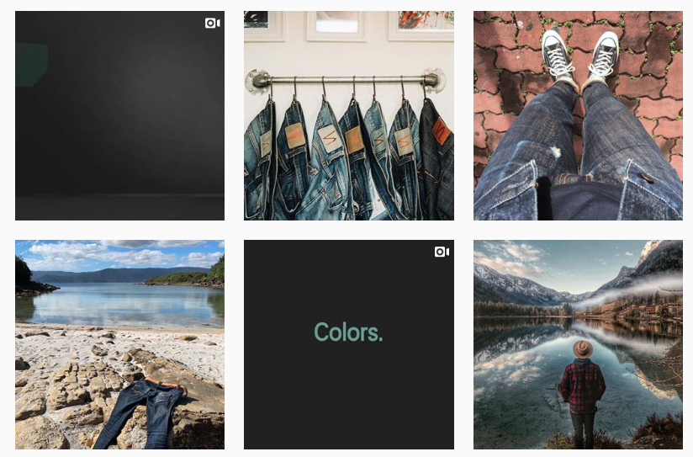

Trends are now occurring within some fashion houses to be creating more

sustainable products that aim to design out waste and avoid mass consumption of

raw materials. Recently, Jack Wolfskin an outdoor adventure selling brand have

created a 100% recycled jacket that has been designed to be durable, waterproof

and sustainable (refer to figure 2). By larger brands making these changes in the

way clothes are designed it will encourage more fashion houses to follow as

pressures in sustainability increase. Once customers have accepted that a 100%

recycled jacket can offer exactly the same as what a jacket made from 100% raw

materials can offer we will see change in how we buy clothes. It is also important to

consider that once over recycled items were perceived as second hand and not as

worthy as a brand new item. However, with the correct marketing and social media

influence views on recycled clothing are changing as the public begin to feel a sense

of social responsibility. Which is also enforced by the news and articles about waste.

Unfortunately, the cost of these clothes seems considerably higher than a jacket sold

at a none sustainable fast fashion retailer but this is the price that must be paid to

end fast fashion and work towards a more circular future. Recycling products still

requires energy as materials have to be broke down and reimagined to create

something new. A circular economy benefits everyone it changes mind sets and is

not damaging to the environment it allows more ecological balance and preserves

natural resources for future generations.

Figure 2 Jack Wolfskin
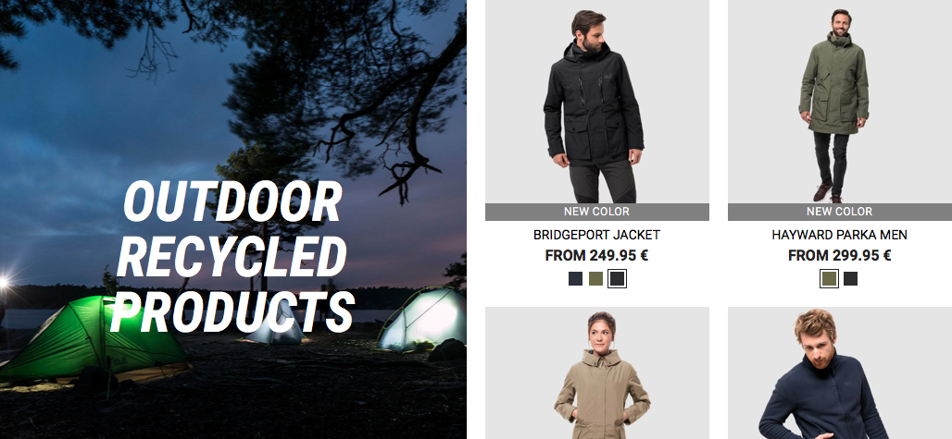

Wabi Sabi “the Japanese philosophy of finding beauty in imperfection” (Greenwood

2018) Wabi Sabi is a design philosophy that embodies finding beauty in raw

materials it allows a greater sense of purpose within art and decoration which in the

ever evolving world of fast fashion and mass production, I feel this way of thinking

would improve sustainability. Also, creating opportunities and alternative to mass

produced environments. The design criteria for Wabi Sabi includes “no shiny uniform

materials, materials that clearly show the passage of time, materials whose

decoration is expressive and attractive” (Juniper 2003 pg 106). Further adding value

to recycling and allowing objects and clothing to allow the aesthetic of not being new

and embracing the imperfections that time has on materials. Additionally, acceptance

of non-uniformity creating a bolder identity for individuals who chose to follow the

design criteria and put this philosophy into place within their wardrobe.

The Wabi Sabi style and philosophy is still relevant in today’s society as according to

Juniper “the beauty of wabi sabi will always strike a chord in the spirits of man

affirming our insignificance in a world of constant flux” (Juniper 2003 pg 99). This

Japanese culture of acceptance and value of materials and the act of repairing and

restoring represents wabi sabi. By being non uniform and irregular it creates a new

design aesthetic which contrasts to the fast fashion world. Creating a free expression

of beauty allowing people to be more individual and turning away from mass

produced clothing and becoming more unique. Which further links to the notion of a

circular economy and encourages artisans and designers to design out waste by

repairing and recycling materials in order to create simple yet beautiful design that is

more suitable to the 21st century.

Repair cafes are a modern way of looking at wabi sabi and circular economy they

aim to teach skills in a free environment in communities where experts help the

public repair their own goods rather than disposing of them. Also there are

opportunities to sell goods creating new value from what could have been waste.

Stitched Up is a repair café based in Manchester (refer to Figure 3) it repairs items

such as clothes and electricals but they also offer craft based courses that include

metal their aim is to not only teach people and create a skill sharing opportunity.
They are passionate about reducing waste and making a difference to the

environment. They feel responsible because “Textile production creates more

greenhouse gas (GHG) emissions annually than all international flights and maritime

shipping combined.” (Stitched up 2019) Their manifesto further explains their beliefs

as brand.

“We love our planet and believe we should treat it with respect.

We support garment workers worldwide in their quest for fair wages.

We inspire a more creative, sustainable and individual approach to clothing.

We prove that sustainable clothing is for everyone, without compromising on style.

We are passionate about recycling, upcycling, reuse and reducing waste.

We are a community that has fun sharing new skills and ideas, and we want you to

join in!” (Stitched up 2019) Repair cafes bring people together, give them new skills

and allow a social opportunity whilst reducing waste.

Figure 3 Stitched up
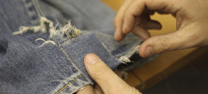

Within wabi sabi it is believed that “the rough, asymmetric and modes objects of wabi

sabi are considered by some to be the essence of beauty” (Juniper 2003 pg 80)

these objects speak to the soul of the viewer more because, like us they are not

perfect and polished they allow imperfections and find beauty in them. The ancient

tradition of kintsukuroi, which means “golden repair” is the art of repairing and

mending ceramics with gold. A precious material which adds value to the ornament

but additionally repairs the ceramic vessel in a beautiful way adding a design detail.

“While kintsugi has endured and fascinated for centuries, its longevity may be due to

its tender embrace of accidents and mistakes.” (Cassey Lesser 2018). Often we

discard clothes due to the wear and tear of time however, this design philosophy

would encourage mending and repairing with a new material creating a new

aesthetic possibly adding new yarn to a worn jumper. It is suggested by (WRAP

2018) that “30% of clothing that ends up in landfill could be repaired and recycled”.

Moreover, if we were to repair and mend more disposable clothing it would give

more purpose to the items and minimize consumption. Changing the way, we buy

clothes choosing quality over quantity meaning less clothes would need to be

repaired. I believe it would create a respect for clothes which I feel has been lost

through time due to mass production, disposability and convenience.

Fibre “A thread or filament from which a vegetable tissue, mineral substance, or

textile is formed.” (OED pg 156 2012) Undoubtedly, fibres form so much of the world

around us. I am interested particularly in the future of textile fibres and the changes

that are being made into creating more sustainable cloth for future generations.

Currently textile production is in crisis from the way it is farmed to finish, the majority

of textiles we see day to day on the high street are unsustainable and mass

produced. However, it is important to understand that fashion and clothes are

different entirely and both meet different needs, such as the need for identity. I

believe repair cafes could help to solve this problem as individuals once taught skills

can add and repair their own garments adding unique elements and embellishments

further supporting individuality.

Due to advances in science, technology and production a lot of changes are being

made in the way cloth is formed and what materials are used in order to create cloth.

Kate Fletcher discusses these in her book about sustainable fashion “carbon neutral

fibres such as bamboo and lyocell absorb the same amount of carbon dioxide from

the atmosphere during natural growth” (Fletcher 2008 pg 7) This notion of carbon

neutral fibres makes a shift away from oil based synthetic compositions that are non-

biodegradable such as nylon and polyester which represent a high percentage of

fibre content in our clothes. The benefits to using carbon neutral fibres means that

they are more sustainable and reduce carbon.

According to Better Cotton Initiative (BCI) “In traditional cotton production it can take

about 10,000 litres of water to produce one kilogramme of cotton fabric” (BCI 2018)

For the weight of cotton that is produced, the amount of water it is very

unsustainable. Considering the limit of clean drinking water in some developing

countries where these fibres are often processed. Additionally, the chemicals used to

create these products are extremely harmful and often effect public waterways.

Alternatives such as organic low chemical cotton could shape the future “flax, hemp

and lyocell could bring benefits by reducing pesticides to water use” (Fletcher 2008

pg 4). Using these fibres over traditional cotton would severely reduce the amount of

water being used, fertiliser and pesticides. Designers need to become more

innovative and create ways to design out waste problems but also be more

collaborative with science and technology. In order to reduce the harmful effects, the

textile industry is currently having on the environment allowing for a more circular

economy.

Hemp is a plant that grows very rapidly in warm and cool climates it naturally

smothers weeds and improves the structure of soil “between 20-30% of the plant is

fibre” (Flethcher 2008 pg 25) which is quite a large yield meaning that it is superior to

other natural fibres and has increased productivity. If hemp was to overtake cotton

and be more commonly used it would have less impact on the environment and

reduce energy consumption.

Recycled fibres are also interesting compounds as they are fibres created from

existing cloth and garments. The fibres are extracted using carding machines which

breaks the fabric down into small and long fibres however, some of the fibres are too

short and can only create a low quality yarn that may not create as durable cloth.

(Fletcher pg 35 2008) says that “innovation to extract longer fibres and develop

quality products could work to change this”. This would mean that breaking cloth

down and recycling and reusing its fibres to create new garments could change the

high street and all of the clothes we consume could be made from recycled material.

The most available recycled synthetic fibre is polyester made from plastic bottles

which was innovatively designed. (Fletcher pg 36) “it has applications that range

from home furnishings to automotive upholstery”. The uses for this fibre are broad

and can easily replace other raw materials like leather which is often found in

automotive vehicles are help reduce the amount of leather that is farmed.

Innovations to create new fabric from recycled materials and resources are

transforming and shaping the textile industry. But it is a slow process and more must

be done to slow down the system of mass produced unsustainable textiles.

“morphotex” is a leading example of a colourful textile made without using any dye or

pigment. As no dye is used to produce the fabric it is less harmful and fewer

resources are needed to produce it. This could potentially help to decrease dye

usage. According to (Quinn pg 112 2010) The fabric is named after a South

American “morpho butterfly an insect which wings contain no pigment just scales

that reflect light” The Japanese fibre company Teijin used Nano technology in order

to create and mimic varying thickness of butterfly scales. This technology has

allowed Teijin to create “the world’s first laminated chromogenic fibres as a result”

(Quinn pg113 2010). The textile is then woven with nylon and polyester which

appears blue however due to different light the garment is effected and can also

appear red, purple and green depending on the light source.

After composing this text and the research to underpin ideas about circular economy,

waste, fibres and design philosophy behind wabi sabi. I am interested in further

exploring the future of cloth and how we can look to a more sustainable future when

science technology and design combine. I aim to continue to explore these themes

in my major project by dyeing fabric more sustainably. Furthermore, using

sustainable cloths and fabrics to support my designs to become a more sustainable

designer in the 21st century. It will be interesting to research further into these points

and use my practical application in order to support my dissertation.

Reference list

Better Cotton Innitiative BCI (2018) traditional cotton
Available at: https://bettercotton.org/about-bci/how-much-water-is-used-in-cotton-production/
Accessed: 7th April 2019)

Cassey Lesser (2018) The Centuries-Old Japanese Tradition of Mending Broken Ceramics with Gold

Available at: https://www.artsy.net/article/artsy-editorial-centuries-old-japanese-tradition-mending-broken-ceramics-gold (Accessed 7th April 2019)

Ellen Mcarthur foundation (2016) Circular economy.
Available at: https://www.ellenmacarthurfoundation.org/circular-economy/concept (Accessed:16th march 2019)

Fletcher, K (2008) Sustainable fashion and textile design journeys. Sterling Earthscan

Jeans, N (2018) Jeans
Available at: https://www.instagram.com/nudiejeans/?hl=en
(Accessed: 15th march 2019)

Juniper, A (2003) Wabi Sabi the Japanese art of impermanence. Japan Turtle Publishing

Mcarthur, E (2016) A new dynamic:2 effective systems in circular economy. 1st ed. Isle of wight. UK Ellen Mcarthur Foundation publishing.

Nudie Jeans (2019) About us
Available at: https://www.nudiejeans.com
(Accessed: 15th march 2019)

Oxford English Dictionary (2012) Franklin Watts 2012

Quinn, B (2010) Textile Futures Fashion, Design, and Technology. Berg Publishing New York

Stitched up (2019) Here’s a great project for all those holey t-shirts that are beyond repair Available at : http://stitchedup.coop/blog/
(Accessed 22nd April 2019)

Wrap (2018) What we do.

Available at: http://www.wrap.org.uk/about-us/what-we-do
(Accessed:16th march 2019)

Wolfskin, J (2018) 100% recycled outdoors
Available at: https://www.jack-wolfskin.com/recycled-products/ (Accessed 17th march 2019)

Figures

- Nudie Jeans (2019) About us
Available at: https://www.nudiejeans.com
(Accessed: 15th march 2019)

- Wolfskin, J (2018) 100% recycled outdoors
Available at: https://www.jack-wolfskin.com/recycled-products/ (Accessed 17th march 2019)

- Stitched up (2019) Here’s a great project for all those holey t-shirts that are beyond repair Available at : http://stitchedup.coop/blog/
(Accessed 22nd April 2019)

