Does Switching Between Languages Have any Value or Purpose?

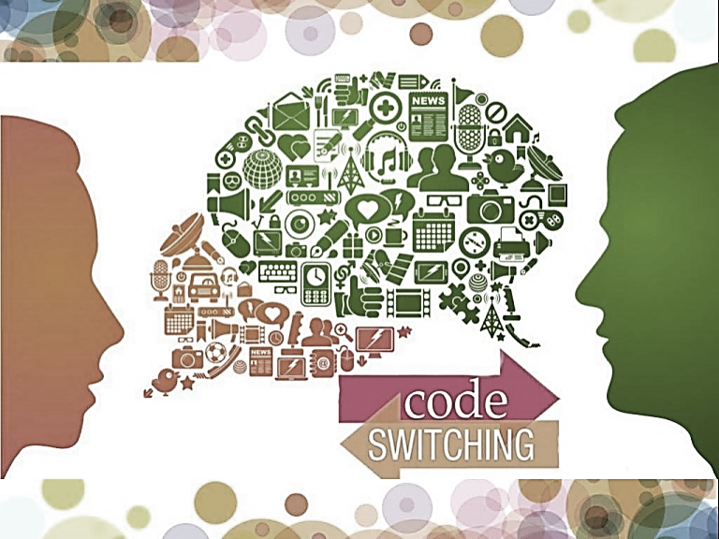
Code-switching is a term referred to bilinguals and their moving from one language to another, inside or across sentences (Baker, 2014). In addition, Hughes et al. (2006) suggested that to switch a code between two or more languages, speakers have to possess a high level of cognition in the two or more cultures and a deep understanding of current structures and purpose of second language systems. So, when two speakers know both languages, they can switch between the two in their relationship and speaking (Graddol, 1997). Code-switching in Iran is used as a daily routine because most of people especially educated people and teenagers can speak English. In addition, code-switching changed to a method to explain specific and scientific issue in an academic background. However, other people also use code-switching just for showing off. Furthermore, in the popular universities and English courses, Iranian students use code-switching more than usual. There are some examples of code-switching in Iran gathered in the following sentences:
-Ok هستی
- Are you ok?
. برات توضیح دادم . Do you understand?
- I have explained it to you. Do you understand?

Trans-languaging and Code-switching
Are there any differences between switch the code and translanguaging?
There are other strategies we can remember after applying code-switching, they are ‘trans-languaging’ and ‘codemixig’. Some authors think that code-switching and trans-languaging can be used interchangeably. The following description about trans-languaging by Williams (1994, as cited in Baker, 2014) can clarify some ambiguous matters about trans-languaging. He claimed that where the input (reading or listening) is in one language and output (speaking or writing) in the other language, trans-languaging is occurred. Garcia & Vogel (2017) expanded the idea of trans-languaging. They emphasized on trans-linguaging as a sociolinguistic and psycholinguistic theory to improve our understandings of the language of bilinguals; it privileges bilingual performances and is not confined to monolingual ones. Furthermore, as a pedagogical practice, it makes deep comprehension and engagement of complex content and texts for bilingual learners.

Types of Code-switching
Baker (2014) claimed Code-switching (CS) may use in large parts of speech like inter-sentential and intra-sentential that is explained in functional aspects of CS. Intra-sentential is used to switch codes within the sentence while inter-sentential refers to switching between two sentences (Fig 2). There is other type of code-switching called tag-switching also known as extra-sentential CS (Muysken, 1995, as cited in Rezvani et al., 2011) means using a tag or a short fixed phrase in one language into a conversation which is uttered in the other language, entirely.
No problem
Never I buy it for you

Intra-sentential
اگر می خوای بری برو
.
Inter- sentential
این رنگ برات خیلی تیره است.

Tag- Switching
بعد از یک سری استراکچر که با To می آیند، gerund داریم، مثل Look Forward to
We have gerund after some structures with to like Look Forward to.

Fig 2. Inter and intra-sentential code switching in sentences.

According to Baker (2014) there are some other debates in this respect. One of the important issues includes language mixing. Mixing two languages in early ages among the children has been occurred that is probably due to limited bilingual proficiency and after acquiring more knowledge and linguistic resources, they do not need to borrow between languages (Genesee, 1989; Meisel, 1994 as cited in Bosma & Bolm, 2019). Given the points, some researchers believed that mixing languages in early ages and code-switching in bilingual adults are the same (Cantone, 2007; Meisel, 1994; Paradis, Nicoladis, & Genesee, 2000 as cited in Bosma & Bolm, 2019). Baker claimed that recently many researchers do not feel a distinction between code-switching and mixing two languages. When we look at the Iranian community in other countries, borrowing the words from L1 (Farsi) is completely perceived while it is not common in Iran and this process is applied conversely. It means some people use the words of target language to represent their intention clearly (intra-sentential).
Reasons Speakers Use Code-switching
Is code-switching used deliberate or accidental?
Baker (2014) believed that there are some reasons speakers use CS; some of them are represented to explain why people switch codes between the languages in the social context.
- Emphasize or focus on a specific point or word in a sentence. This is a valuable way to outline what you would like to emphasize in your utterance.
- Sometimes there are not any words or phrases to show specific meaning. The learner cannot find an equivalent in other languages. For example, “Ta’arof” is a Persian word which does not have any meaning in English. This word is used to respect other people unusual. When a customer buys a dress in a store, a salesman may use “Ta’arof” to not get any money from the customer and mentions it several times; this is a kind of kindness and deference in Iranian culture that may be meaningless for other cultures.
- Express adequately an opinion and though. Imagine you are in a Mathematic class, you need to use some phrase or description in English to enhance and improve your knowledge about it then you switch to codes in minority or majority language.
- For clarifying a meaning or word. In Iran, teachers have to explain a concept in both languages (Persian and English) to be assured all students understand the matter in depth. CS usually happens in English class to clarify the grammar instructions.
- Achieving identity and friendship among peers or listeners who speak minority language. Some people need to be accepted by their friends and other people of society so they have to use code-switching.
- Related to a conversation done before, a person may speak about the conversation in a language used. For example, conversation is reported in English authentically between two people who speak Arabic.
- CS may be used to interject into a conversation i.e. using a different language to break into a conversation.
- CS is used to change the mood in a long discussion or conversation and ease tension and inject humor.
- Change of relationship and a change of attitude can be shown as social distance. For instance, some people in a business conversation may speak native language at the end of the meeting. We can encounter with Persian summary of presentation in the classroom which had been presented in English or Arabic to be assured all people understood that story and points behind it. Or some vocabularies are explained and translated in Persian after the presentation.
When is Code-switching Used?
Are there any situations where code-switching should be used or avoided?
So, due to these points, we can suggest that CS is not a random process but it is a strategy with a specific purpose. All bilingual people finally find that where and when is suitable to switch the code; Baker believed that CS used by children when they faced to people understand both languages while children distinguish whether switch the code is acceptable among the people or not. So, situations of using CS have been recognized; but is CS interference language as a third language of bilingual people? Baker claimed that it is not interference language but it is a strategy by which bilinguals affect on some situations wisely.
As Gumperz & Blom (1972, as cited in Bailey, 2014) represented, there are two different types of code choices, i) situational switching and ii) metaphorical switching.
Situational switching refers to certain settings like home, school and work that are associated with kinds of activities (speaking in public, formal discussion, special ceremonials and verbal games) as well as encountering different categories of speakers (friends, family, strangers, government officials). These categories are applicable for Iranian people in using language and switching codes in different situations. In specific situation, particular codes are used by Iranian people in an academic discussion or presentation depend on relationship, formality ratio, type of activities and events.
In addition, the nature and process of CS can be affected by familiarity, projected status, ethos of context, and linguistic skills of the listeners. Baker opened a new window in CS he believed that CS is a linguistic process and indicates crucial social and power relationships.
Metaphorical CS as Blom & Gumperz suggested is switching the code without any changes in the physical situation. For example, creating an informal situation from a formal situation in a business or official meeting or communicate in secret, i.e. using code switching without changing the setting is metaphorical code switching. Later, Gumperz change the name of metaphorical code-switching to ‘conversational switching’ in 1982. In conversational switch, language is not a system of reference but we can use language as a mode of action at various levels to create social worlds (Garfinkel, 1967 as cited in Bailey, 2014).

Does CS Maintain Useful?
Some useful advises about applying CS
According to all explanations and rational mentioned above, CS has a purpose, introducing a third language (Baker, 2014) (see Figure 1) in a suitable situation. Given the issues, every bilingual or monolingual person over the world had an experience in case of CS to communicate effectively. Because of our using of CS, next generation acquainted with mixing or switching unintentionally. But some questions are raised in our mind and it is: ‘do we come across with another side of CS usage?’, ‘are there any worries about using CS in bilingual children?’, ‘How can we keep CS purpose in the future?’
سلام خوبی؟
عالی !دقیقا. شاید. انگار. می دونم. به هیچ وجه. مشکلی نیست. ممکنه
Hello, are you OK?
Ever, Never. Fantastic. I know. Maybe

Fig 1. Third language (Finglish= Farsi+English) in result of code-switching

Is code-switching harmful? Do we come across with another side of CS usage?
As a bilingual speaker, I have been accused of being amateur in learning second language whenever I used CS, while it is not related to linguistic capacity, it can enlighten the speaker’s intention. Baker describe this meaning clearly that some words or phrases have no equivalent in the culture or language of other language and people have to use CS to transfer their meaning. In addition, some parents concern about CS in learning process may make students mixed-up and may be it will distract them in the classroom environment or even social contexts. But in an educational environment, CS can influence on the learning process positively using translation from first language to the target language and describe some complex instructions in learning language (grammar or specific structures). Although CS has a positive impact on learning process, it can be a bad habit and obstacle by doing it more than usual.

Are there any worries about using CS in bilingual children?
Some parents do not like CS and it can make them unhappy with someone who uses it (their husband/wife/ children) because of flexion of their prestige in society. It must be considered that CS is not a negative point, when your children or your husband speak English at home and use native language in a special situation. When they feel less confident to speak English in society, because of getting rid of the feeling, they use CS automatically. Parents must pay attention to automatic and natural aspect of CS in conversation. If you have a bilingual family, you definitely find that CS can be useful in some situation to express your meaning more easily than other languages and this occur because of your familiarity and competency in one of the languages you can speak fluently. All in all, community like friends, family, pupil groups and even members in a meeting play a crucial role in use of L1. According to Giles and Johnson (1987 as cited in Nwagbo, 2016) as people grow up, some social categories also are raised in their mind by which they group themselves and other people due to it and usually employ a language as a distinctive sign ethnically. This is a group they feel belong to and their identity is shaped in. If we look at constructing individual’s identities as a social ‘practice’, language can be used as a mean speakers creating their identities instead of reflecting their identity only (Eckert, 2012, p.88 as cited in Ben Nafa, 2018). Given the issues mentioned situations, identity and lack of language proficiency are important leverages in using code-switching and must be considered by parents and bilingual speakers.

Code-switching is not a problem among speakers
As we pointed out, according to the Baker’s point of view, CS has a goal and this is creating third language. If we tend to explain third language, we will encounter to communication among people that is a purpose. The words people use to switch are whatever in their mind and use them instead of other words in L2 to speak confidently and clearly, sometimes a Chinese or Persian word can transfer your intention more than English words in the context. CS involves cognitive control, there is no difference why people switch the codes, control start from one language schema to other one even if CS is used for filling the gap (Green & Wei, 2014 as cited in Bosma & Blom, 2019). Using cognitive control mechanism in CS indicates ability of learners to solve the gaps by passing control between two or more languages (Bosma & Blom, 2019). This is a competence for balanced switching into two languages and for detecting gaps and deficits simultaneously. Speaking psycholinguistics, CS cannot be applied in your conversation or generally in your communication without cognitive control. Wu and Thierry (2013, as cited in Bosma & Blom, 2019) indicated that English-Welsh bilinguals performed better on cognitive control when they represented both English and Welsh words. There are huge phrases and sentences in a bilingual mind in both languages but they must be articulated in a correct serial order. Cognitive control helps bilinguals to use both languages during CS without any interferences.
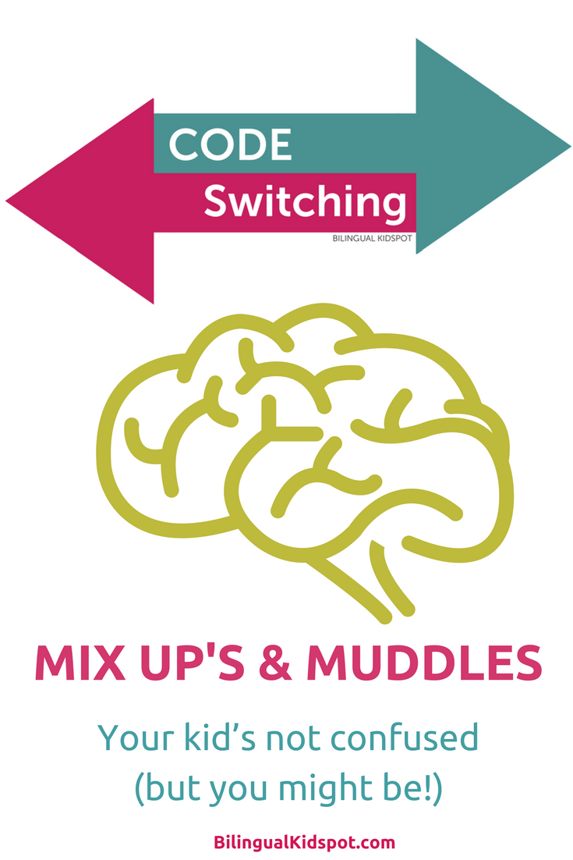

Aa an advice for parents before passing the judgment about ‘bilingual children’ who use CS, we review ‘bilinguals’. Bilingual, according to Ben Nafa (2018) is a term used to describe a person with a balanced competence of two languages. This is a positive point that your children have proficiency in two languages. It can be used to encourage them to understand target language in depth that it depends on level of comprehension. To develop your children’s understanding you can explain words by cognates to improve your children confidence as well as their proficiency. Keep in your mind when your children use CS, they immerse in linguistics knowledge of both languages and switch the code among huge codes which they memorized. Do not forget, they are able to store and process the information rapidly as well as using creativity in their utterance. It is a complicated process that improve their competence in linguistic knowledge. Children use CS because they can manage the both languages; this is a perfect potential in language acquisition; just communicate with your children regardless what effects it has, they can learn useful valued experiences in family environment, then.

Resources
Abu-Krooz, H.H., Al-Azzawi, Q.O., Saadoon, M.M. (2019). Code-switching and Code Mixing: A Sociolinguistic Study of Senegalese International Students in Iraqi Colleges. http://researhgate.net. University of Kufa.
Baker, C. (2014). A Parents’ and Teachers’ Guide to Bilingualism. Fourth Edition, pp. 61-63.
Bailey, B. (2000). Social/Interactional Functions of Code Switching among Dominican Americans. International Pragmatics Association.
Bailey, B. (2014). Social/Interactional Functions of Code Switching Among Dominican American. International Pragmatics Association.
Ben Nafa, H.O.A. (2018). Code-Switching and Social Identity Construction Among Arabic-English: A Stance Perspective. Manchester Metropolitan University.
Blom, J.P., Gumperz, J. (1972). Code-switching in Norway. In J. Gumperz and D. Hymes (eds.), Directions in Sociolinguistics. New York: Holt, Rinehart and Winston, pp. 407-34.
Bosma, E; Bolm, E. (2019). A Code-Switching Asymmetry in Bilingual Children: Code-Switching from Dutch to Frisian Requires More Cognitive Control than Code-Switching from Frisian to Dutch. International Journal of Bilingualism (SAGE)
Cantone, K. F. (2007). Code-switching in bilingual children. Dordrecht, The Netherlands: Springer.
Eckert, P. (2012). Three waves of variation study: The emergence of meaning in the study of sociolinguistic variation. Annual Review of Anthropology.
Garcia, O., Vogel, S. (2017). Translanguaging. Oxford Research Encyclopedia of Education.
Garfinkel, H. (1967). Studies in Ethnomethodology. Englewood Cliffs.
Genesee, F. (1989). Early bilingual development: One language or two? Journal of Child Language.
Giles, H. and Johnson, P. (1987). Ethnolinguistic Identity Theory: a Social- Psychological Approach to Language Maintenance. International Journal of the Sociology of Language.
Graddol, D. (1997). The Future of English. The Britisg Council (UK). Ltd.
Green, D. W., & Wei, L. (2014). A control process model of code-switching. Language, Cognition and Neuroscience.
Hughes, C.E., Shaunessy, E.S., Brice, A.R., Ratliff, M.A., McHatton, P.A. (2006). Code-Switching among Bilingual and Limited English Proficient Students: possible Indicators of Giftedness. Journal for Education of the Gifted. Florida.
Meisel, J. M. (1994). Code-switching in young bilingual children. Studies in Second Language Acquisition.
Meisel, J. M. (Ed.). (1990). Two first languages: Early grammatical development in bilingual children. Germany. Walter de Gruyter.
Mesthrie ,R. (2001). Concise Encyclopedia of Sociolinguistics. Oxford: Elsevier Science Ltd.
Muysken, P. (1995). Code-switching and grammatical theory. In L. Milroy, & P. Muysken (Eds.), One Speaker, Two Languages: Crossdisciplinary Perspectives on Code-switching (pp. 177-197). New York: Cambridge University press.
Nwagbo, O, G. (2016). Identity and Code Switching among Liberian Refugees in Oru Camp, Nigeria. Journal of African Studies. University of Lagos.
Paradis, J., Nicoadis, E., & Genesee, F. (2000). Early Emergence of Structural Constraints on Code-Mixing: Evidence from French- English Bilingual Children. Bilingualism: Language and Cognition.
Rezvani, E., Eslami Rasekh, A. (2011). Code-switching in Iranian Elementary EFL Classrooms: An Exploratory Investigation. English Language Teaching. http://ccenet.org.
Williams, C. (1994). Afraniad o ddulliau dysgu ac addysgu yng nghyd-destun addysg uwchradd ddwyiethog [anevaluation of teaching and learning methods in the context of bilingualsecondary education]. (Unpublished PhD thesis). University of Wales, Bangor, UK.
Wu, Y. J., & Thierry, G. (2013). Fast modulation of executive function by language context in bilinguals. Journal of Neuroscience.

