Title Page

Qualification: CIPD Diploma in Applied Human Resources

Module Name: Developing Professional Practice in HR

Portfolio

Word Count: 5795

Student Name: Mrs Angela May Procter
Student Number: 2015609
CIPD Membership Number: 54466106

By signing below, I confirm that the work/evidence presented is my own, unaided work. I understand the regulations pertaining to candidate malpractice and the action that may be taken as a result.

Signed: A M Procter
Date: 03/01/2021

Portfolio
CIPD Diploma in applied Human Resources – Level 5
Angela Procter

Table of Contents
Evidence Matrix 0
Activity 1 – CIPD Diploma in applied Human Resources – Level 5 1
Programme Overview 1
Funding and the Welsh Government 1
CIPD and the HR Profession 1
Key Sources of Information for the Diploma 2
Further support 3
Reference List 4
Activity 2 - CIPD HR Profession Map 6
The Core Professional Areas 6
The HRPM Behaviours 7
Reference List 9
Activity 3 – Work-based Activity 10
Evidence Gathering 10
Influencing the Organisation 11
The 5 Whys 12
The Project 13
Reference List 15
Activity 4 - Team Dynamics and Organisational Politics 16
Team Dynamics 16
Organisational Politics 17
Reference List 19
Activity 5 – Self Assessment and Development Plan 20
Rationale for Selection 20
The Assessment 21
The Objectives 22
Development plan 23
Self Assessment 26
Belbin team type questionnaire 34
How to complete the questionnaire 34
Results 42

Evidence Matrix
Candidate name: Mrs Angela May Procter |  |  |  |  | CIPD Membership/registration No.: 54466106
Qualification title: CIPD Diploma in Applied HR – Level 5 |  |  |  |  | Unique Learner No. (ULN): 2015609
Unit code | Unit title |  | Assessment criteria no. | Evidence description | Evidence reference number |  | Assessor  initials | I/V initials if sampled
A1 | Activity 1 – Programme Overview |  |  | Completed Induction Questionnaire
A5 | Activity 5 – Self-Assessment and Development Plan |  |  | Completed Development Plan
A5 | Activity 5 – Self-Assessment and Development Plan |  |  | Completed Self-Assessment
Candidate declaration:
- I confirm that the work/evidence presented for assessment is my own unaided work.
- I have read the assessment regulations and understand that if I am found to have ‘copied’ from published work without acknowledgement, or from other candidate’s work, this may be regarded as plagiarism which is an offence against the assessment regulations and leads to failure in the relevant unit and formal disciplinary action.
- I agree to this work being subjected to scrutiny by textual analysis software if required.
- I understand that my work may be used for future academic/quality assurance purposes in accordance with the provisions of the Data Protection Act 1998.
- I understand that the work/evidence submitted for assessment may not be returned to me and that I have retained a copy for my records.
- I understand that until such time as the assessment grade has been ratified through internal and external quality assurance processes it is not final.
Signature: |  |  |  |  |  | Date:

Notes on candidate evidence matrices

Candidates should be encouraged to develop a matrix indicating how their evidence relates to each unit/module and learning outcomes/assessment criteria. This helps advisors and assessors to support candidates to draw links between units and encourage cross-referencing and the possible multi-use of evidence.

Evidence matrices can be developed using the unit/module and learning outcomes/assessment criteria, giving candidates an opportunity to link their evidence to each outcome.

Another approach is to have a more generic form where candidates list evidence and tick relevant boxes to show coverage.

Whatever approach is employed candidates should be encouraged to complete these forms themselves and not expect assessors to do this for them.

Activity 1 – CIPD Diploma in applied Human Resources – Level 5

Programme Overview

The HR Development Programme is delivered through the CIPD Diploma which is a Level 5 two year university course, financially supported by the Welsh Government and administered by Coleg Sir Gãr, however it is the University of Wales Trinity Saint David (UWTSD) that actually delivers the programme through a course that comprises 16 modules, 5 of which are core modules, 6 are knowledge based with the remaining 5 modules demonstrating competency.

The course delivers the programme through monthly workshops which, in normal times, would run for a whole day but currently are being restricted to half day workshops due the pandemic. Guided learning (work-based & workshops) account for 450 hours with another 450 hours as self-study, bringing the total study required to 900 hours.

To assist in delivering the programme, resources are accessed through the University of Wales Trinity Saint David website by making use of ‘Quick Links’ which help to negotiate the different elements of the site. Moodle is the main teaching forum and each module is laid out within the platform to help support the learner with the relevant resources. Each module contains the Learning Plan, Reading List and Assessment Criteria which outlines the method for assessment: Portfolio, Presentation or Report, the results of which are a Pass, Refer or Fail.

Within each module on Moodle resources can be found to assist with the learning and to help the student in preparing for the chosen method of assessment which can include podcasts, articles, templates, links to further resources etc.

Funding and the Welsh Government

The Diploma in HR is funded by the Welsh Government and a contract is created between it and the employer which commits the employee to completing the course or makes the employer responsible for the funding should the course not be completed. In addition, there is also a requirement to pass an examination for three areas of competence: Application of number; Communication (English); Digital Literacy.
To ascertain the level of work required, the student must undergo a series of assessments to demonstrate progress which commences with an initial assessment to determine the current level of competence. Further activities are then set to assist in progressing towards an examination. Progress is reviewed in terms of both these and work towards the Diploma by the Assessor for Coleg Sir Gãr who reviews this on a three monthly bases.

There is also a requirement for non-Welsh Speakers to undertake a series of exercises around the Welsh Language in order that the Welsh Government can fulfil its requirement for the Government of Wales Act 2006 in ensuring there are one million Welsh speakers by 2050 ie Cymraeg 2050.

CIPD and the HR Profession

CIPD is the governing body behind the HR Development Programme and provides the qualification at the end of the course. All modules must have been passed to receive the CIPD Diploma, so too does membership to CIPD. Membership as a student also allows full access to the resources on the CIPD website. An important part of this is the HR Profession Map which sets out the requirements of all HR professionals to ensure trust and integrity remains at the core of the profession. This therefore centres around ethical behaviours to ensure professionalism is maintained.

The CIPD has a Code of Ethics which explicitly outlines the standard of behaviour expected and to what all HR professionals are bound to,. The university too has a Student Code of Conduct which stipulated as to what is expected of all students studying within UWTSD and the likely results of not adhering to these, with the ultimately penalty being removed from the course.

The CIPD HR profession map is the tool used to self-assess and thereby create a development plan in which to develop within the HR profession. This is an on-going plan to be used and regularly updated throughout the individual’s HR career to ensure continuous professional development which is one of the requirements of a HR professional.

One of the modules studied is Employment Law which provides the legal framework in which HR professionals are bound. Other modules look at providing value to the business through the HR function by ensuring staff are well motivated, supported, contribute to individual, team and organisational objectives, support change and are fully utilised in the most efficient way which ultimately delivers the purpose of the HR function described by CIPD as “sustainable organisation performance – to be made real by using insights to create HR strategies and deliver solutions that stick, taking people with them and staying agile and innovative” (CIPD,2013).

All work that is submitted for marking is returned with feedback from the lecturer on how well the student has understood the subject, noting any improvements that could be made in order to improve further submissions.

Key Sources of Information for the Diploma

In addition to Moodle, there are other sources of information to assist in the learning requirements of the Diploma with CIPD being the main source. These are as follows:
- Social media
  - Facebook
  - Linked-in
  - Twitter
  - Youtube

- UWTSD
  - Library
    - Online services
      - Journals
      - Peer reviews
      - Reports
      - Studies
    - Physical library
      - Books
      - Professional magazines
- Publications
  - Newspapers
  - Online articles
  - CIPD members magazine
  - Programme Handbook

- CIPD
  - Articles
  - Self-assessment
  - Guides
  - Fact sheets

Further support

In addition to the resources available for study, other support is available to help the student during their time at university. These include:
- Programme Director – for support in relation to any aspect of the course
- Lecturers – for support on any aspect in relation to the taught modules
- Student services – to support the student with aspects of student life
- Staff/Student Committee – to provide feedback in relation to improvements for the course
- Student Union – to provide students with information on what’s going on and the latest student information
- Hwb Support – to resolve any IT issues

An induction questionnaire has been completed in support of this programme and can be found at the end of this section.

Reference List

Welsh Government, Cymraeg 2050: A Million Welshspeakers Annual Report 2017/18 - WG37249 (gov.wales) accessed 29/12/2020

CIPD HR Profession Map (2013) can be found at https://www.cipd.co.uk/learn/profession-map/2012-profession-map (accessed 12/11/2020)

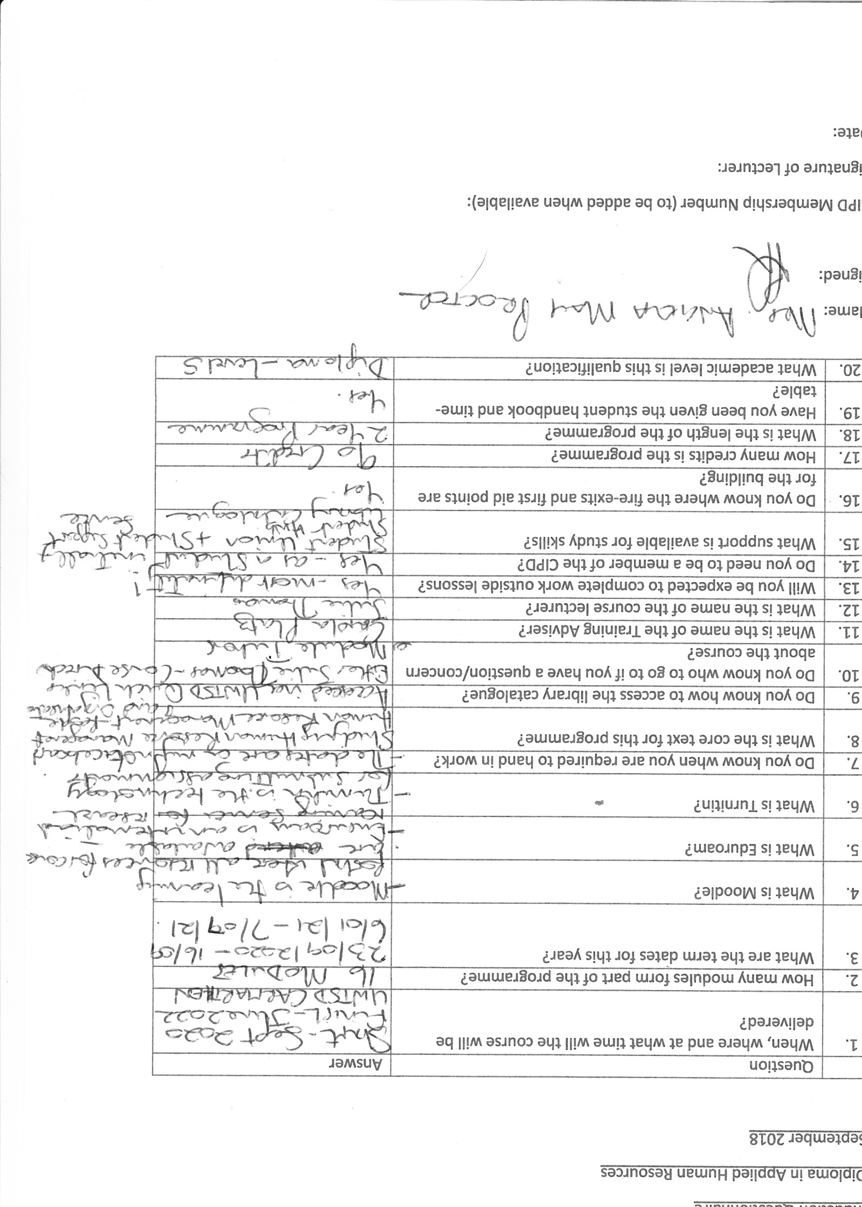

Activity 2 - CIPD HR Profession Map

The CIPD has a vision to be ‘the people profession for now and for the future’ (CIPD) and have therefore created a tool in order to achieve that vision by setting standards for HR professionals. This tool is the HR Profession Map (HRPM) originally created in 2009 by CIPD and updated in 2013 which is the basis for study, however, it has since been remodelled and it is this new CIPD HR Profession Map that is now used by professionals in the workplace to guide their work, develop their skills and plan their careers.

The HR Profession Map (2013)
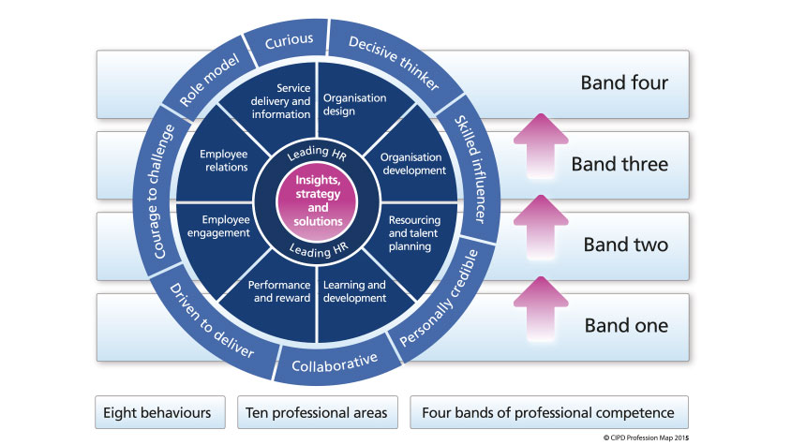
Source: CIPD (2013)

As can be seen from the map above, it comprises ten professional areas, two of which are core areas that underpin the whole HR profession – ‘Insights, strategy and solutions and Leading HR’. These areas stipulate what HR professionals need to know and what to do. The eight behaviours stipulate how this should be done which ultimately gives credibility to the HR profession.
Also included in the map are four bands of professional competence which determines what activities and behaviours need to be displayed when working at the various levels within the profession, with the lowest level being one and the highest, four. Each part of the map will apply equally to all of those within the profession to a greater or lesser extent, however, the level of responsibility and influence will vary accordingly with those working within Band four having the greatest level of responsibility as they will be working at a strategic level.

The map is used for individuals to plan their own continuous professional development (CPD) which is based on reflection, to prepare for performance reviews, interviews, CIPD membership and new career opportunities. However, it is also a useful tool for businesses and organisations as it is able to help identify the skills needed for change and team capability, to develop career pathways, competency frameworks and role profiles which focus on the behaviours needed to deliver success in the workplace.

The Core Professional Areas

As mentioned above, the two ‘Core’ professional areas: ‘Insights, strategy and solutions’ and ‘Leading HR’ provide a firm foundation on which to base the remaining eight professional areas. In fact, when evaluating these areas, it is clear that there is a direct link between the ‘Core’ areas and the supporting professional areas as each professional area fits perfectly within one of the ‘Core’ areas to help deliver the objectives as can be seen below:

- Insights, strategy and solutions
  - Objective: To develop an understanding of the organisation and its context and use these insights to tailor strategy and solutions to meet organisational needs now and in the future
    - Organisational design
    - Organisational development
    - Resource and talent planning
    - Learning and development
- Leading HR
  - Objective: To act as a role model, maximising the contribution that HR, or a specialist function, makes throughout the organisation both through their own efforts and through supporting, developing and measuring others across the organisation
    - Performance and reward
    - Employee engagement
    - Employee relations
    - Service delivery and information

The HRPM Behaviours

For years, many organisations have included competencies only when managing the performance and development of their staff which has often resulted in the wrong behaviours being adopted. It has been recognised that behaviours are just as important, if not more important, than the competencies themselves as it is ‘how’ an activity is performed that delivers professionalism and not just the ‘what’ is done. Certainly the College of Policing ( has adopted a framework similar to that of the CIPD profession map (2013) to manage the performance of its officers and staff across all police forces within England and Wales which can be seen below:

The College of Policing’s Competency and Values Framework (CVF)
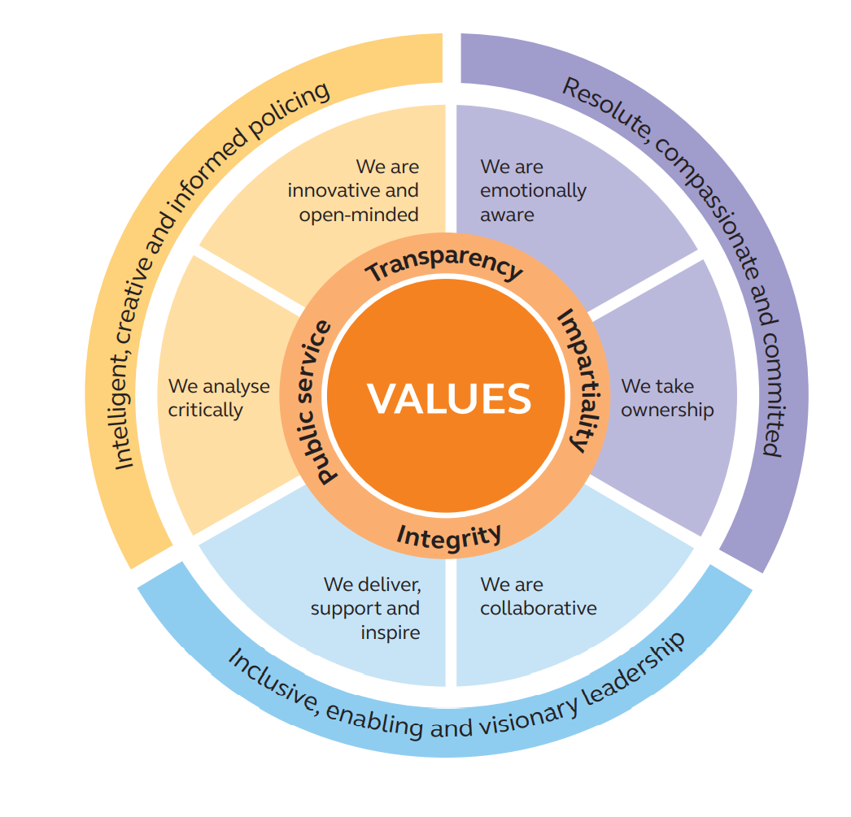

Other public sector bodies including the NHS and government departments have similar models.
Traditionally, HR professionals have focused on compliance, however, as reported by Rachel Sharp (2019), David D’Souza, CIPD Membership Director has pointed out, the CIPD has made it clear that ‘in every interaction and decision, we’re expecting people to reflect on what’s the right thing to do’. Certainly ethics and integrity are key behaviours that are needed to demonstrate professionalism and this has been included within both the framework and the qualifications for CIPD accreditation. The new CIPD HRPM now not only includes this within its behaviours under ‘ethical practice’ but it is also included within one of the three main values as ‘Principles-led’.

Any breaches to the code of conduct by an HR Professional will be investigated by CIDP which may then be referred to a Code of Professional Conduct Hearing should this be proven.

The way in which individuals and companies behave has come to the forefront in recent years with scandals such as the VW emissions scandal and the Carillion’s collapse , although perfectly legal, the damaging behaviours caused significant harm to individuals, other companies and the environment.

HR professionals have a responsibility to try to influence and challenge the behaviours of individuals and cultures within companies with performance and development systems being the perfect tool to influence this, thereby allowing the CIPD HRPM to be adapted for this purpose. Difficult decisions would need to be made where there is a mismatch in values between the HR professional and the organisation in which they work if they were unable to influence the changes required. As Claire Fox, Chief People Officer for Unicef has said ‘The human race needs to change the way it lives, and the way it does business is an important part of that’ Sharp (2019). In answer to Rachel Sharp’s question ‘how can HR develop it’s capability in regards to ethics?’ Richard DeGeorge, co-director of the International Center for Ethics, responded ‘simply treating people with respect and considering everybody who might be affected by one’s own actions’ which is sound advice when considering behaviours.

Certainly the behaviours within the HRPM revolve around adding value to the organisation, stakeholders and peers, working effectively and inclusively to deliver the best results for the organisation and its people, acting with integrity, impartiality and independence.

Reference List

CIPD HR Profession Map (2013) can be found at https://www.cipd.co.uk/learn/profession-map/2012-profession-map (accessed 12/11/2020)

CIPD ‘CIPD Vision can be found at https://www.cipd.co.uk/news-views/guture-profession (accessed 12/11/2020)

College of Policing CVF Framework can be found at http://beta.college.police.uk/career-learning/career-development/competency-and-values-framework-cvf (accessed 30/12/2020)
Sharp, R. (2019) Ethics & HR, HR Magazine April 2019

Sharp, R. (2019) Ethics and HR, HR Magazine, April 2019

Activity 3 – Work-based Activity

Having recently commenced my role with the organisation as an HR Officer I was keen to provide full support to the Division, however, it was clear that things were not working very well and the Senior Management Team were not getting the information they needed to make informed decisions around resourcing.

Evidence Gathering

I decided to conduct a brainstorming session to try to identify what the issues were so I knew what was needed to improve. It was not possible to complete this in a group so an individual approach was taken after initially speaking with various staff and officers across the Division. According to the Mindtools website, ‘this is the best approach as individual’s are more likely to be uninhibited than if they were in a group’. It certainly suited the situation given the working practices that had to be adopted due to the pandemic.

The results of the brainstorming session were captured within the Mind Map below.

The main issues (in yellow) were then identified as follows:
- Difficult to keep track
- No sight of teams
- Updating systems
- Management requirement
- Frequency of moves
Essentially, these were all tracked back to the HR function and the inability to provide up-to-date information on current resources.
To drill down a little deeper, I decided to complete an Ishikawa (Fishbone) Diagram (Ishikawa, 1976), as referred to by Suarez-Barraza et al (2019), which looks at the cause and effect of a problem, with the problem in this instance being the ‘lack of resourcing information’.

From the Ishikawa Diagram above, I was able to identify that a significant number of improvements could be made to address the root cause, with the majority being attributed to process. As outlined by Suarez-Barraza et al (2019), Deming (2000, p315) uses the 94/06 rule where 94% can be attributed to process with the remaining 6% to people. Although there are a number of people issues identified within the diagram, much of this is associated with the fact that there is an element of ‘we’ve always done it this way’ as opposed to taking certain opportunities to review this ie reviewing process when there are changes in technology.

Influencing the Organisation

It was clear that some of the changes required were out of my control and would need to be considered at a higher level. I therefore created a document detailing the issue, impact and recommendations for change and the associated benefits, presenting this to the Acting Head of HR after having a lengthy conversation about the approach I had taken and my findings. I was conscious of the fact I was new into the organisation and considered how best to approach this given that the outcome I needed was for them to accept the document as a useful tool for improvement as opposed to resisting it from ‘an outsider’ who was clearly at a lower grade than they were, although as noted by Senior and Swales (2010, P181), French & Raven (1959) determined, positional power is only one of five sources of power and I was conscious of the fact that I was unable to use this one. However, I was able to use three of the other sources of ‘expert, referent and reward power’. It was also important to me that I was asked for the document rather than me sending it to them as this would indicate some ‘buy-in’ to the change and couldn’t be misconstrued as coercive which is the last of the five powers and certainly not a behaviour I would like associated with myself.

I sold the idea on the basis that a new Head of HR was soon to be appointed and if we were able, as a department, to illustrate to them that we were aware of the issues and what needed to be done to address these then this would look good for the department, especially for the Acting Head of HR. It would also be a pivotal point for the department as it was likely that the new Head of HR would have the ears of the Chief Officers Team and therefore their support to implement the change.
An example of the document sent can be seen below:

Issue | Process | Impact on the Division | Recommendations | Benefits
It takes too long to transfer officers (min 4 weeks) | Link to process inserted into this box | Line Manager is unable to see officer on any system until they are moved which prevents them from managing their work/welfare | Streamline the process by reviewing holistically to ensure all dependencies are captured and that all non-value added activities are removed | Improved timeliness of transfers so Line Managers are able to manage their teams more effectively  Increased capacity for staff to work on value-added activity  Improved quality of data on systems as fewer roles are involved in the process

Having received the document, the Acting Head of HR referred to this within a team meeting which raised the interest of other senior managers within the team who also requested a copy. When the new Head of HR started a number of managers referred to my document and this was again requested. Much of the contents were corroborated by senior officers and staff and has since been used to influence the direction of the organisation in terms of the HR functionality. I certainly used some of the attributes of friendliness, vision, empowerment, and building alliances with knowledge and expertise within the powers outlined above and as described by Yemm (2008) for effective influencing.
Recognising that most of the recommendations for improvement would more than likely be long-term, I needed a solution which would help me in my role of supporting the Division and decided to use the 5 Whys, another tool used to explore root cause as described by Mindtools.

The 5 Whys

I am unable to fully support the Division with resource management – WHY?
- Because I cannot see the bigger picture – WHY?
  - Because the information is spread across multiple systems – WHY?
    - Because it was designed to facilitate the processes in place at the time – WHY?
      - Because it was considered to be the easiest solution – Why?
        - Because HR Officers were not involved in the changes at the time – WHY?
          - Because there was a lack of understanding of the importance of the HR role - WHY?
- Because they were not valued – WHY?
- Because they weren’t expected to inform decisions – WHY?
                - Because they had insufficient knowledge – WHY?
  - Because they couldn’t see the bigger picture!!

The Project

The solution therefore was to create a Dashboard so I could see the bigger picture.
To support me in this, I decided to create a project plan as this formed part of my probation, identified by myself, and I needed to ensure that it was completed for my 3 month review as timeliness was of the utmost importance. I used a Gantt chart to capture the plan which can be seen below:

Status of project at 1st milestone

Status of project at 2nd milestone
Status at Probationary Review

Essentially, the Dashboard was an organisational chart which captured the teams and personal details surrounding each member, including the roles and skills, pay reference numbers, seat references, retirement dates etc with the use of colour-coding to identify those who were in work, abstracted, transferred to temporary positions and awaiting promotion. Although I am unable to publish this data in its true form because of its contents, I am able to include a screen print for illustration purposes:

The Dashboard has certainly fulfilled its purpose and has enabled me to not only provide the information required to the Senior Management Team but has also ensured that I am able to work in a much more efficient and accurate way by having all of the information in one place which allows me to use the copy and paste facility thus reducing the likelihood of error, whilst ensuring data is transferred in an efficient manner.

It is also designed so that it may be evolved in the future to contain any additional information required and reported on.

Ensuring that the Dashboard remains accurate provides the opportunity to liaise with all Sergeants and Inspectors within Ceredigion Division on a regular basis which is helping to build strong working relationships and provides the useful data required to report back to Headquarters. It also provides a strong basis on which to challenge figures that are coming out of Headquarters in terms of resourcing when errors occur.

Reference List

Brainstorming can be found at https://www.mindtools.com/brainstm.html (accessed 16/10/2020)

Deming, W. (2000) Out of the Crisis, Cambridge, 2nd Edn

Senior, B. Swailes, S (2010) Organizational Change, Harlow 4th Edn

Suarez-Barraza, Manuel F, Rodriguez-Gonzalez, Francisco, G.(2019) International Journal of Quality and Service Sciences: Bingly, Vol 11, Issue 2, p302 – 316

The 5 Whys Article can be found at https://www.mindtools.com/pages/article/newTMC_5W.htm (accessed 31/10/2020)

Activity 4 - Team Dynamics and Organisational Politics

There are so many factors to consider when undertaking the position of a Manager or Leader but two of the most important are not necessarily the most obvious. These are team dynamics and organisational politics.

Team Dynamics

The definition for a team as provided by Greenburgh and Baron (1997) and presented by Reissnar and Watson (2014,p212) is “a group whose members have complementary skills and are committed to a common purpose or set of performance goals who hold themselves mutually accountable”. In order to be successful a team depends on both individual and team performance with collective responsibility for the results. Clegg et al (2005) goes further and determines that each team member enters into an unspoken psychological contract with the other team members during the early stages of the team formation.
Team cohesiveness and stability were linked in early research on team dynamics to higher productivity and communication was found to be more satisfying and frequent within a stable team, especially when team members shared similar values as this ensured a greater level of participation by each team member.
Belbin (1981,1996) looked into the team roles at work which were partly impacted by the personalities of individuals and their behaviours and partly by team dynamics. It was determined that by classifying people into team types, it was possible for team leaders to create effective teams using a various mix of these types and to identify where gaps were in terms of the skills needed within existing teams. For example in a task-related team, you would want to have at least one ‘Completer/Finisher’ to ensure the task was kept on track and reached a timely end. At the same time you would want a ‘Shaper’ to tease out the possible options and the final objectives in which to work towards.
For the individual, the identification of the preferred working style and roles best suited to their individual style allows them to seek out opportunities that best meets their personal preferences so they are able to make best use of their skill set.
Given the amount of change and frequency of that change, it is recognised that it is more important than ever to ensure team members have differing skill sets so others can tap into these to achieve good results, especially when the objectives suddenly change and new skill sets are required.
Being able to form and reform to adapt to these changes in organisational need are critical, however, so too is an understanding of the impact these changes will have on team performance. One of the most popular models to demonstrate the stages a team will go through is that of Tuckman (1965) who created a four stage model, later adding a fifth stage in the 1970’s.
This model has been adapted for the purposes of this report to include the management approach which balances how a team can be supported during this period of change through change in management style.

Understanding team dynamics and recognising the stages a team will go through is an important role for any Leader, who as shown above, can provide the much needed support to help in the creation of an effective team.

Organisational Politics

Another area that needs to be understood and recognised by the Leader is organisational politics and how this can impact on the achievement of organisational objectives.
In order to understand politics, it is first useful to define what is meant by the term ‘organisational politics’. A clearly understood definition would be a variety of activities associated with the use of influential tactics to improve personal or organisational interests. Studies have shown that individuals with political skills are often better in gaining more personal power as well as managing the demands placed upon them thus consequently reducing stress. They also have a greater impact on the outcomes for the organisation.
This can be demonstrated by using the example of influence within the previous activity (Activity Three) where it was recognised that the position and the sensitivities surrounding the timing of that position required a level of politics in order to influence those within senior positions to enact the changes identified for the benefit of the organisation, in particular, around those within the HR function.

Jarrett (2017) considers that to enable Leaders to be more comfortable with the political landscape it is important to map the political terrain and has devised a map based on four metaphors, depending on whether these powers are implicit or explicit: Implicit – ‘The Weeds’ and ‘The Woods’ or Explicit – ‘The Rock’ and the ‘High Ground’.

Based on map by Jarrett (2017)

There is a difference of opinion on whether managers should be involved in organisational politics with Horn (2009) stating that although managers need to be aware of it and manage it, they should avoid being part of it, whereas Rodgers (2007) sees that engaging with political dynamics is essential to ensure all change is successful. This could be because executives tend to view organisational politics as negative, however, the map above clearly shows that each political power has both positives and negatives. Jarrett (2017) provides many examples of where successful change has happened using both implicit and explicit powers. One good example is based on that of the ‘Higher Ground’ where a public agency was failing to collect millions in tax revenues because the processes in place to stop fraud were too slow. Senior Leaders decided to set up a special task-force to resolve the problem. This resulted in the problem being halved in the first year and the agency receiving 95% of the tax revenue in the second. Subsequently, the official processes were changed to match those followed by the task-force, thereby creating benefit for the organisation in a controlled manner.

Reference List

Belbin, R.M.(1981) Management Teams: why they succeed or fail. London Heinemann

Belbin, R.M.(1996) Team Roles at Work. London Butterworth Heinemann

Clegg, S. Komberger, M. and Pitsis, T. (2005) Managing and Organizations: An Introduction to Theory and Practice, London

Horn, R (2009) Business Skills Handbook, CIPD, London

Jarrett, M. (2017), The 4 Types of Organizational Politics, Havard Business Review

Reissner, S. and Watson, G.(2014) Developing Skills for Business Leadership, CIPD, 2nd Edn, London

Tuckman, B.W.(1965) Developmental sequence in small groups. Psychological Bulletin. Vol 63, No 6 p384 – 99

Activity 5 – Self Assessment and Development Plan

As part of my development, I undertook a self-assessment using the HR profession map (2013) which I accessed through ‘My CPD’ on the CIPD website. Although I did eventually assess myself against all of the professional areas and behaviours my main focus was on the professional areas of ‘Leading HR’ (one of the two core areas) and ‘Service delivery and information’, along with the behaviours of ‘Decisive Thinker, ‘Courage to challenge’ and ‘Personally credible’ as can be seen in the profession map below:

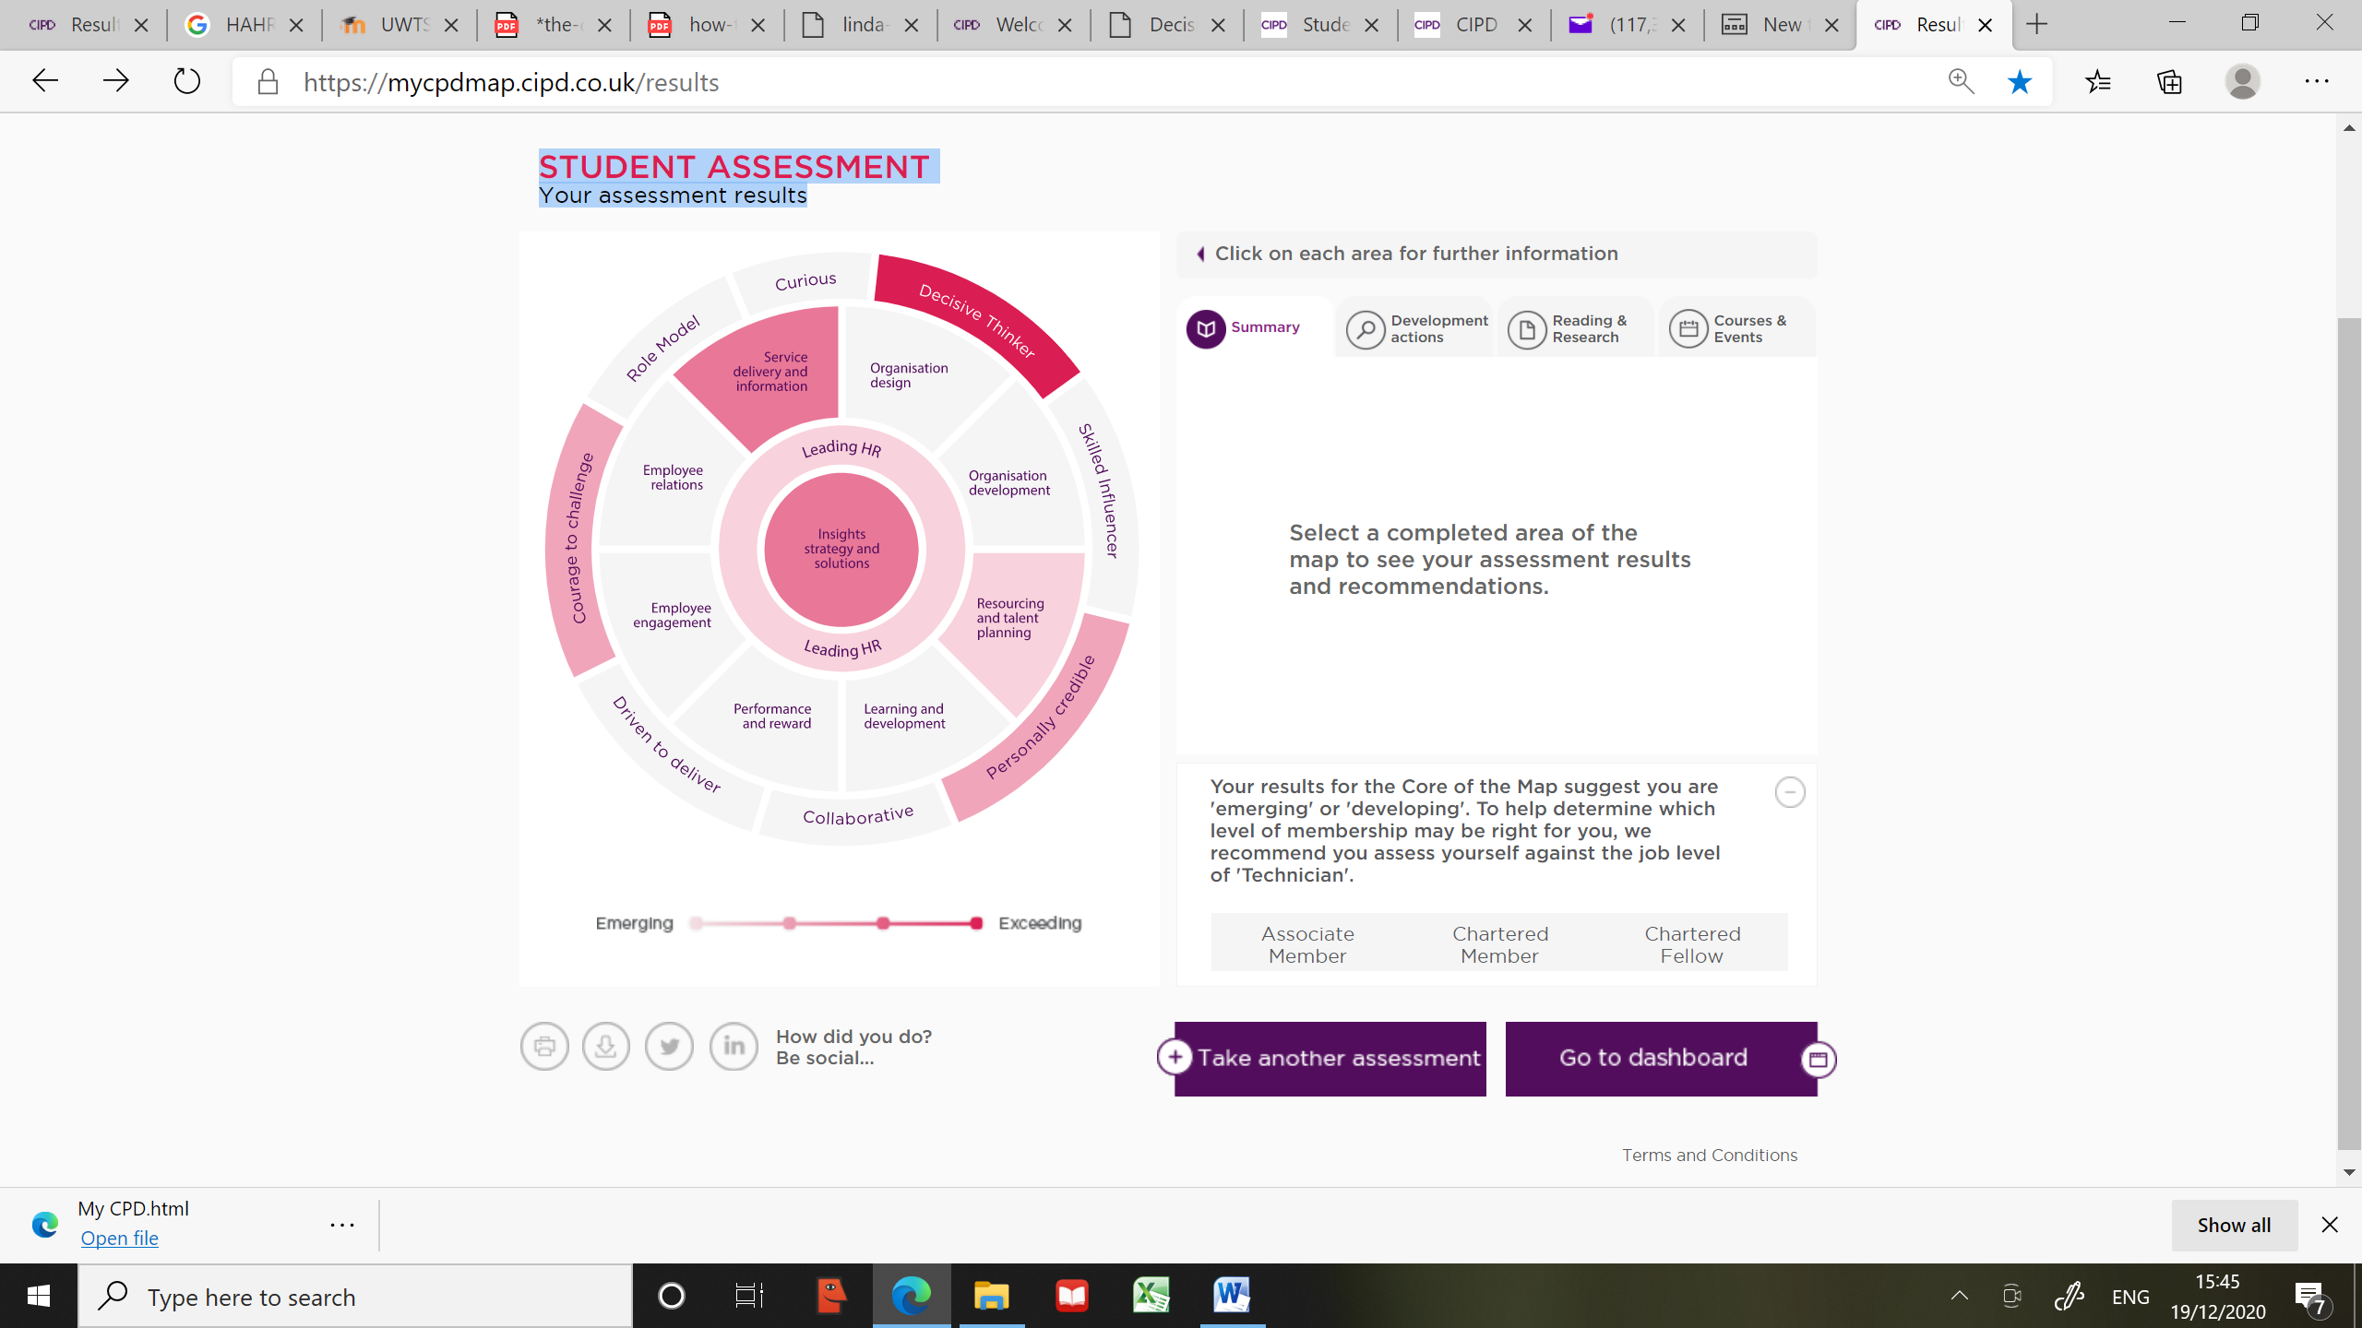

Rationale for Selection

When deciding which professional areas to focus on I first looked at the two ‘Core’ areas which underpin the others. The first ‘Insights strategy and solutions’ did not appear to offer as much in the way of development for me given my previous experience outside of the HR function and appeared to be better met within the ‘Service delivery and information’ area of the map. However, ‘Leading HR’ was a key area in which I recognised that I needed to develop as my role, being the only HR Advisor for the Ceredigion Police Division, required me to be able to provide advice and information to the Senior Leadership Team on which critical decisions were made.
I did originally assess myself against ‘Resourcing and Talent Planning’ as this was an area that I was particularly interested in but considered that my role within the organisation would not provide sufficient opportunity to develop, having reviewed the suggested developmental actions, as resourcing is generally delivered by a specialist department based at Headquarters with little influence from the Divisions.

Having selected the most appropriate professional areas for development, I then considered all of the behaviours and recognised there were three in which gaps prevented me from working in the way I would like. These were:

- Decisive thinker
  - The gap within this behaviour wasn’t around being able to make a decision but more around accessing the information quickly so a more timely response can be made. My level of knowledge around the way in which information is collated and the systems/reports available is limited due to the length of time in post
- Courage to challenge
  - The gap within this behaviour was around the ability to respond positively and challenge where needed to do so in a professional manner. I recognise that I often do not have the information to hand to respond immediately and therefore this undermines my confidence and does not allow me to be as assertive as I would otherwise be
- Personally credible
  - The gap within this behaviour is specifically around the HR function and the fact that I have never worked within this field of expertise although I have had experience of elements of it. My area of expertise is around change management and identifying how to improve a business area in order to deliver a good standard of service and to provide value to an organisation.

The Assessment

The level in which I assessed myself was at a Band 2 which, for the majority, saw me at the emerging/developing stage. This would be correct in relation to HR which is what I based my answers on but not necessarily when considering different aspects of my career and the skills I have obtained working at a much higher level, albeit not within the HR function. In order to obtain maximum benefit from the Development Plan I deemed it important to assess myself based on my experience within HR and not within the wider context.

Another factor which has skewed the results is the fact there is not currently a strategy or delivery plan for the department, however, having worked at a strategic level in a much larger police force (and achieving an MBA) I do have experience of developing strategies and departmental plans but, again, these were not specific to HR. I have therefore abstracted the development opportunities that I feel would best fit my situation and maximise the benefit to the organisation for which I work.

Much of my development needs are around improving my knowledge on the subject of HR, the policies and procedures, and of employment law. Without this, I am unable to fulfil my role to the best of my ability which will ultimately impact my confidence in providing advice and presenting challenge where needed. In addition, I only joined the organisation in July of this year so am familiarising myself with the way in which the organisation operates and identifying where it can improve, having a background in service improvement which is the reason I selected ‘Service delivery and information’ as the second professional area and one which I could add the most value as I could use the skills to help improve the HR function, particularly as I have been selected to be one of the Change SPOCs (Single Point of Contact) and will be responsible for identifying and delivering change. Having joined in the midst of a pandemic has not helped as I have not received the training that I would normally have received which has impeded my development also.

Given my extensive experience of ‘Service Delivery and Information’ and the role I am to play within developing the HR function, I was keen to include an action that would allow me to work at Level 3 in order to fully utilise my skills and experience in this area as the assessment states ‘In order to be able to work at the next level up ……..you’ll continually look for ways to improve HR service delivery and will take a lead role in proposing and implementing changes to structures and processes’. To do this I would ‘need to understand the HR service delivery needs of your internal customers and make sure those needs are met’ (CIPD).

The full results for my assessment can be seen at the end of this section

The Objectives

Having considered my overall assessment and the developmental actions arising from the assessment I have determined that my objectives should be the following:

- To be able to confidently advise employees and managers on HR and people-related issues
- To build the trust of employees and managers by providing consistently reliable advice and support
- To help create the delivery targets and operating model of the organisation’s HR service so that it delivers to a good standard
- To reach early conclusions by using all evidence available
- To be able to access the data and tools quickly to enable informed decisions at faster pace
- To remain calm when standing by decisions
My Development Plan is designed to achieve these and this can also be seen at the end of this section.

The Belbin Team Type Assessment is also included so I am able to help understand my preferred role within a team for future development, especially as this has been referred to within Activity 4.

Development plan

NAME: | Mrs Angela May Procter | MEMBERSHIP NUMBER: | 54466106
COVERING THE PERIOD FROM: | October 2020 | TO: | October 2021

Factors to consider: Pandemic – increased demand on workforce/remote working/high level of abstractions/no physical contact
New in post – new to organisation/new to HR/former occupation: Service Improvement professional

Objectives | Developmental Actions | What resources or support will I need? | What will my success criteria be? | Target dates for review and completion
To be able to confidently advise employees and managers on HR and people-related issues  To build the trust of employees and managers by providing consistently reliable advice and support | - Become an expert in my field by putting time aside to develop my knowledge and expertise in the organisation's policies and procedures, as well as relevant law and practice. Spend time with the business to ensure my advice is relevant and appropriate to the organisation's culture.  - Gain feedback on my expertise within the workplace from customers, managers or my peers. Pick one developmental area to focus on. Work to build up my expertise by reading, researching and building relationships with individuals who have experience in this area.  - Work to become the 'go to' person for your area/s of expertise, by ensuring that you are always in a position to provide accurate and up to date advice and guidance | Guidance from experienced HR Officers, Specialists and Managers  Policies and Procedures  Employment Law and Understanding of Police Regulations | An increase in the number of times I am able to answer a query straight away | Review every 3 months  Completion 13 October 2021
To help create the delivery targets and operating model of the organisation’s HR service so that it delivers to a good standard | - Build up my understanding of different HR operating models (for example, centralised, de-centralised, Business Partnering) and how they can contribute to the organisation's people and business performance.  - Consider the pros and cons of the HR operating model your organisation uses, and the impact it has on the business. | Modules within the CIPD Diploma  Support from other Continuous Improvement SPOCs within the  department  Involvement in developing the People Strategy and Departmental Plans to help shape improvements within the department | The creation of Service Level Agreements  Reduction in length of processes and roles involved | Review: 13th April 2021  Completion : 13th October 2021
To reach early conclusions by using all evidence available  To be able to access the data and tools quickly to enable informed decisions at faster pace | - Improve knowledge of organisation’s analytical tools, systems and reports  - Observe senior managers when making decisions an d the factors considered when doing so | Time with analysts & IT specialists  Assigned a Mentor | Time spent on analysing data  Proactive approach to HR as opposed to reactive  Decisions made within a meeting as opposed to outside | Review every 3 months  Completion: 13th October 2021
To remain calm when standing by decisions | - Consider what types of responses to my views frustrate me, and how I react in those situations. Discuss with my colleagues or manager how I can overcome that frustration so that I come across to others as calm and rational when others are opposing my position.  - Ask for feedback on my approach to challenging others. What are my strengths and areas for development? How can I improve my approach?  - In anticipation of a new idea or proposal, understand who the key decision makers / stakeholders are and engage them into discussions early on | Improved knowledge of HR  CIPD Diploma to provide confidence in that knowledge  Assigned a mentor  Close working relationships  360⁰ Review | Professional persona  Assertive and confident  Being able to support decision with facts | Review every 3 months  Completion: 13th October 2021

Self Assessment - Angela Procter

Leading HR

Leading HR is about maximising the contribution that HR makes in your organisation by supporting, developing and leading others across the business, and by acting as a role model. At your level you typically need to approach HR with a commercial mindset, advising and supporting business managers on people-related issues. When it comes to the people strategy you’ll develop budgets, objectives, milestones and metrics to support the successful delivery of integrated people plans. You’ll know how to engage and motivate others, and you’ll build the capability of the HR team to keep them at the leading edge. You’ll also build your own expertise by regularly seeking out and acting on feedback.

How prepared am I?

What you’ve told us indicates that your knowledge and skills in this core area are emerging. This usually applies to someone who is at the early stages of building their experience of leading HR projects and teams at this level.
Below, we show you the areas where you’re particularly strong, areas where you’re competent and areas where you have skill and knowledge gaps. If you're keen to increase your knowledge and improve your skills in Leading HR, you should consider the courses, reading materials and practical development actions that we've recommended for you. These recommendations reflect your individual strengths and development areas based on what you've told us in your assessment. As your score suggests you have some room to develop in this area at your current level, we think these recommendations will be of particular benefit to you in building the skills and experience you’ll need to excel in HR.

What’s it like Leading HR at a more senior level?

In order to be able to work at the next level up within the HR profession, you typically need to demonstrate strong people management and leadership capability, bringing a commercial mindset to both HR and the business. You’ll translate the people strategy into operating and financial plans, ensuring that people services are delivered at best value. As an HR leader, you’ll continually seek out and act on feedback, building the professional, technical and commercial capability of the HR team.

What are my strengths and gaps for my current level?

Where I am competent

- Assessing the capability of the HR team to deliver professional HR practice, in line with the organisation’s needs

My Gaps

- Developing objectives, milestones and metrics (eg, service level agreements, Key Performance Indicators) for HR plans
- Supporting the development and monitoring of HR budgets
- Ensuring that HR delivery plans are fully integrated into the HR strategy
- Approaches to engaging and motivating individuals from different backgrounds
- Ways to assess the capability of a team against the organisation’s requirements
- Demonstrating a commercial mindset in own approach to HR
- Confidently advising employees and managers on HR and people-related issues
- Proactively seeking and acting on feedback to develop as an HR professional
- Building high performing teams using good people practices
- Approaches to managing and evaluating team performance
- Interpreting budgets and other financial and non-financial data to draw conclusions

Development Action

- Champion the use of metrics and measures in the organisation. Demonstrate a commercial mindset by ensuring that measures and KPIs are integrated into all people plans and projects, and that all projects are appropriate costed in terms of budget and resources, clearly showing a return on investment.
- Become an expert in your field by putting time aside to develop your knowledge and expertise in your organisation's policies and procedures, as well as relevant law and practice. Spend time with the business to ensure your advice is relevant and appropriate to your organisation's culture.
- Ask a range of other people (such as your manager, a couple of your peers, a couple of your customers) for feedback on the work you deliver and the way you deliver it. Ask for some specific examples of areas you could improve, and strengths to build on. Ask your manager and trusted peers to offer some feedback on the extent of your HR expertise in the area you work in, and build their feedback into your development plan.
- Take opportunities to coach members of the HR function outside of your direct team. Seek out relevant managers from within your organisation who could mentor and coach HR team members to provide a broader perspective.
- Apply the organisation's talent processes to your own team to develop clear talent management and succession plan for all critical roles.
- For each people plan / project you're working on, develop objectives and measures which can be evaluated at the end - consider both financial metrics to demonstrate return on investment, as well as people and business metrics. Set out a project plan with key dates, milestones where you need to check in and get sign off with key stakeholders, and resources.
- Towards the end of each financial year, ask to be involved with the development of next year's HR budget. Share your insights into the people priorities that your team needs to focus on for the next 12 months, and have ready some costed plans to support those budgets. Take responsibility for one or more budgetary areas for the for the HR team.
- Review the overall people strategy for the organisation, and consider how the HR operating plans are aligned to this. Do all plans and projects support the overall people strategy, and are they all offering a return on investment? If not, consider whether those plans need to be reworked.
- Ask your team for feedback on your management style. (You could consider anonymous 360 feedback here.) Spend time with each team member to understand their preferred way of working and learning, so you can be ready to adapt the way you work with them appropriately.
- Undertake a learning needs analysis for your team - against the requirements of their roles, and also what they will need to deliver for the business in the next 12 months. Consider different ways of introducing new skills to the team which will make them more effective in the way they support the business on people issues.
- Research different ways of managing and evaluating the performance of your team by speaking to peers inside and outside of your organisation. Which approach to measuring team performance will most effectively demonstrate the impact your team has on the business?
- Spend time with the finance team to understand how to read and use budget sheets, P&L sheets and other financial information which is regularly shared in the organisation (don't limit yourself to HR financial data - consider data around the organisation's performance as well).

Reading and Research

Gennard and Judge
BOOK: Managing employment relations
SEE MORE

CIPD
PODCAST: CIPD Podcast 86 - Look ahead to 2014
SEE MORE

CIPD
FACTSHEET: HR outsourcing
SEE MORE

CIPD
RESEARCH: Megatrends: the trends shaping work and working lives
SEE MORE

Service Delivery and Information
When you work in Service Delivery and Information you’re working to ensure the highest levels of customer-focused HR service delivery across the entire employee lifecycle. You keep this as effective and cost-efficient as possible through process and project management. You’re also providing meaningful analytics that can be used to inform business improvements. At your level you typically need to be able to use technology to access a range of HR resources to help you deal with complex HR cases. You’ll provide service performance level information to colleagues and senior managers and support the selection of HR suppliers (as well as monitoring the service they deliver.

How prepared am I?

What you’ve told us indicates that your knowledge and skills in this area are meeting expectations. This would be typical of someone who has strong experience in HR and Service Delivery and Information at this level.
Below, we show you the areas where you’re particularly strong, areas where you’re competent and areas where you have skill and knowledge gaps. If you're keen to increase your knowledge and improve your skills in Service Delivery and Information, you should consider the courses, reading materials and practical development actions that we've recommended for you. These recommendations reflect your individual strengths and development areas based on what you've told us in your assessment. Your score suggests you may be ready to assess yourself against the next level up, or in a different area of HR. To do this, return to the home screen to take a different assessment.

What’s it like working within Service Delivery and Information at a more senior level?

In order to be able to work at the next level up within Service Delivery and Information, you typically need to understand the HR service delivery needs of your internal customers and make sure those needs are met. You’ll lead the selection and management of HR suppliers, making sure that a quality service is provided at a reasonable cost. You’ll continually look for ways to improve HR service delivery and will take a lead role in proposing and implementing changes to structures and processes.

What are my strengths and gaps for my current level?

My strengths

- Role-modelling the delivery of a customer-focused service, coaching team members to do the same
- Evaluating the impact of the HR service on customers
- Process improvement tools, such as Six Sigma, Kaizen and Lean

Where I am competent

- Delivering an HR service in line with agreed service level agreements and metrics
- Monitoring the service provided by the team, colleagues and suppliers, giving feedback where necessary
- Using analysis tools and customer feedback to identify ways to improve the HR service
- The different stages of the employee lifecycle

My Gaps

- The delivery targets and operating model of the organisation’s HR service

Development Actions

- Build up knowledge and expertise in the organisation’s procurement policy and the process to commission, contract and manage service providers (such as options appraisal, needs identification, provider selection) as well as external good practice in this area.
- Request informal feedback on the customer service you and your team provide, asking for specific examples of what you do well and what could be improved. Act on the feedback.
- Set up and carry out regular customer satisfaction surveys to measure the impact of your service on the business. Review the feedback with your manager and team, and consider what changes can be made to make the service more customer-centric and effective.
- Identify systems and processes in your role that you can become an ‘expert user’ of. Use your expertise to feed back suggestions for improvement and also to coach team members.
- Build up your understanding of different HR operating models (for example, centralised, de-centralised, Business Partnering) and how they can contribute to the organisation's people and business performance. Consider the pros and cons of the HR operating model your organisation uses, and the impact it has on the business.

Reading and Research

CIPD
SURVEY REPORT: HR Outlook: Winter 2012-13: a variety of leader perspectives
SEE MORE

CIPD
SURVEY REPORT: HR Outlook: Winter 2012-13: views of our profession
SEE MORE

Decisive Thinker
When you’re displaying decisive thinking, you’re demonstrating the ability to analyse and understand data and information quickly. You’re using information, insights and knowledge in a structured way to identify options, make recommendations and make robust, defendable decisions.

How prepared am I?

What you’ve told us indicates that your behaviour in this area is exceeding expectations. This usually applies to someone who is role-modelling this behaviour expected at this level.
Below, we show you the areas where you’re particularly strong, areas where you’re competent, and areas where there are gaps in the way you demonstrate decisive thinking. If you’re keen to develop your decisive thinking, you should consider the courses, reading materials and practical development actions that we've recommended for you. These recommendations reflect your individual strengths and development areas based on what you've told us in your assessment.

What are my strengths and gaps for my current level?

My strengths
- Gathering , analysing and critiquing information from different sources before making a decision
- Comparing and contrasting situations and information, identifying patterns and trends to inform decisions
- Applying own judgement and objective criteria when developing HR solution or approaches
- Identifying suitable analytical tools or data gathering approaches, depending on the specific context

Reading and Research

Bazerman and MOORE
BOOK: Judgment in managerial decision making
SEE MORE

Hinton
BOOK: Introducing information management: the business approach

Courage to Challenge
When you’re displaying courage to challenge, you’re demonstrating the confidence to speak up skilfully and challenge others, even when confronted with resistance or unfamiliar circumstances.

How prepared am I?
What you’ve told us indicates that your behaviour in this area is developing. This usually applies to someone who is demonstrating some of the behaviours expected at this level, but is yet to demonstrate and develop their competence more broadly in this area.
Below, we show you the areas where you’re particularly strong, areas where you’re competent, and areas where there are gaps in the way you demonstrate courage to challenge. If you’re keen to develop your courage to challenge, you should consider the courses, reading materials and practical development actions that we've recommended for you. These recommendations reflect your individual strengths and development areas based on what you've told us in your assessment. As your score suggests you have some room to develop at your current level, we think they’ll be of particular benefit to you in building the skills and experience you’ll need to excel in your role.

What are my strengths and gaps for my current level?

My strengths
- Working closely with stakeholders, consulting with them for their views and involving them in developing solutions

Where I am competent
- Observing, listening, questioning and challenging others to ensure discussions are informed and timely decisions are made

My Gaps
- Remaining calm and standing by decisions in the face of opposition or resistance
- Reaching conclusions and taking views on issues early on in discussions

Development Actions

- Consider what types of responses to your views frustrate you, and how you react in those situations. Discuss with your colleagues or manager how you can overcome that frustration so that you come across to others as calm and rational when others are opposing your position.
- Ask for feedback on your approach to challenging others. What are your strengths and areas for development? How can you improve your approach?
- In anticipation of a new idea or proposal, understand who your key decision makers / stakeholders are engage them into discussions early on. Create a forum for workshops / discussions in order to gain their views, potential resistance early on.

Reading and Research

BOOK: Assertiveness
SEE MORE

Personally Credible

When you’re displaying personal credibility, you’re building and delivering professionalism by combining commercial and HR expertise to bring value to the organisation, your stakeholders and peers.

How prepared am I?
What you’ve told us indicates that your behaviour in this area is developing. This usually applies to someone who is demonstrating some of the behaviours expected at this level, but is yet to demonstrate and develop their competence more broadly in this area.
Below, we show you the areas where you’re particularly strong, areas where you’re competent, and areas where there are gaps in the way you demonstrate personal credibility. If you’re keen to develop your personal credibility, you should consider the courses, reading materials and practical development actions that we've recommended for you. These recommendations reflect your individual strengths and development areas based on what you've told us in your assessment. As your score suggests you have some room to develop at your current level, we think they’ll be of particular benefit to you in building the skills and experience you’ll need to excel in your role.

What are my strengths and gaps for my current level?

Where I am competent

- Seeking out feedback from others, and modifying own behaviour or performance in response

My Gaps

- Drawing on theoretical and practical HR expertise to address individual and organisation issues and opportunities
- Identifying and pursuing opportunities for new experiences or to stretch existing skills
- Building the trust of employees and managers by providing consistently reliable advice and support

Development Actions

- Gain feedback on your expertise within the workplace from customers, your manager or your peers. Pick one developmental area to focus on. Work to build up your expertise by reading, researching and building relationships with individuals who have experience in this area.
- Pick one area within your role that you feel you have less understanding, knowledge or confidence with. Work to build up your knowledge, exposure and expertise within this area though reading, research and connecting with individuals who have an expertise in this area.
- Pick one area within your role that you are less comfortable or familiar with. Proactively research this area through reading, research and talking to others.
- Work to become the 'go to' person for your area/s of expertise, by ensuring that you are always in a position to provide accurate and up to date advice and guidance.

Reading and Research

Blanchard, Fowler and Hawkins
BOOK: Self leadership and the one minute manager: increasing effectiveness through situational self leadership
SEE MORE

Covey
BOOK: The seven habits of highly effective people : restoring the character ethic
SEE MORE

Whetten and Cameron
BOOK: Developing management skills
SEE MORE

Belbin team type questionnaire

The Belbin questionnaire seeks to identify your preferred role in a team. It is based on the work of Dr Meredith Belbin, whose research into team performance concluded that the most effective teams have a good mix of different personality types.

How to complete the questionnaire

On the following pages are a series of statements divided into seven sections.
For each section, distribute a total of ten points among the statements which you think best describe your own behaviour. See the example below:

When involved in a project with other people:

A | I have an aptitude for influencing people without pressurising them
B | I am generally effective in preventing careless mistakes and omissions from spoiling the success of an operation | 1
C | I like to press for action to make sure that the meeting does not waste time or lose sight of the main objective | 3
D | I can be counted on to contribute something original | 2
E | I try to maintain my sense of professionalism
F | I am quick to see possibilities in new ideas and developments
G | I believe my capacity for judgement can help to bring about the right decisions | 1
H | I can be relied upon to bring an organised approach to the demands of the job
I | I am always ready to back a good suggestion in the common interest | 3
Your points may be distributed among several sentences as in the example above. In extreme cases they may be spread among all sentences or ten points may be given to a single sentence.
At the end, there are further instructions on how to tally your score.
Section 1
What I believe I can contribute to a team

A | I think I can quickly see and take advantage of new opportunities
B | I can work well with a very wide range of people
C | My specialist knowledge and experience is usually my major asset | 4
D | My ability rests on being able to draw people out whenever I detect they have something of value to contribute to group objectives | 2
E | I can be relied upon to finish any task I undertake
F | I am prepared to be blunt and outspoken in the cause of making things happen | 1
G | I can usually tell whether a plan or idea will fit a particular situation | 1
H | I can offer a reasoned and unbiased case for alternative sources of action | 1
I | Producing ideas is one of my natural assets | 1

Section 2
If I have a possible shortcoming in teamwork, it could be that:

A | I am not at ease unless meetings are well structured and controlled and generally well conducted | 1
B | I am inclined to be too generous towards others who have a valid viewpoint that has not been given a proper airing | 1
C | I have a tendency to talk a lot once the group gets on to a new topic
D | My objective outlook makes it difficult for me to join in readily and enthusiastically with colleagues
E | I am sometimes seen as forceful and authoritarian when dealing with important issues | 4
F | I find it difficult to lead from the front, perhaps because I am over-responsive to group atmosphere
G | I am apt to get caught up in ideas that occur to me and so lose track of what is happening
H | I am reluctant to contribute unless that subject deals with an area I know well | 1
I | I am reluctant to express my opinions or proposal or plans that are incomplete or are insufficiently detailed | 3

Section 3
When involved in a project with other people:

A | I have an aptitude for influencing people without pressurising them | 2
B | I am generally effective in preventing careless mistakes and omissions from spoiling the success of an operation
C | I like to press for action to make sure that the meeting does not waste time or lose sight of the main objective | 1
D | I can be counted on to contribute something original | 1
E | I try to maintain my sense of professionalism | 1
F | I am quick to see possibilities in new ideas and developments | 1
G | I believe my capacity for judgement can help to bring about the right decisions
H | I can be relied upon to bring an organised approach to the demands of the job
I | I am always ready to back a good suggestion in the common interest | 4

Section 4
My characteristic approach to the group is that:

A | I contribute when I know what I’m talking about | 4
B | I am not reluctant to challenge the view of others or hold a minority view myself | 1
C | I can usually find a line of argument to refute unsound propositions | 1
D | I think I have a talent for making things work once a plan has to be put into operation | 1
E | I prefer to avoid the obvious and to open up lines that have not been explored | 1
F | I bring a touch of perfectionism to any job I undertake
G | I am likely to be the one to make contacts outside the group or the firm
H | While I am interested in all views I have no hesitation in making up my mind once a decision has to be made | 1
I | I maintain a quiet interest in getting to know colleagues better | 1

Section 5
I gain satisfaction in a job because:

A | I enjoy analysing situations and weighing up all the possible choices | 1
B | I feel that I am using my special qualifications and training to advantage | 2
C | I like to feel I am fostering good working relationships | 1
D | I can have a strong influence on decisions | 1
E | I have a chance of meeting new people with different ideas | 1
F | I can get people to agree on priorities and objectives | 1
G | I feel in my element where I give a task my full attention | 1
H | I can find an opportunity to stretch my imagination | 1
I | I am interested in finding practical solutions to problems | 1

Section 6
If I am suddenly given a difficult task with limited time and unfamiliar people:

A | I would feel like devising a solution of my own and then trying to sell it to the group
B | I would be ready to work with the person who showed the most positive approach | 3
C | I would find some way of reducing the size of the task by establishing what different individuals might best contribute
D | My natural sense of urgency would help to ensure that we did not fall behind schedule
E | I like to read up as much as I conveniently can on the subject | 5
F | In spite of conflicting pressure I would press ahead with whatever needed to be done
G | I would take the lead if I felt the group was making no progress | 1
H | I would open up discussions with a view to stimulating new thoughts and getting something moving | 1
I | I believe I would keep cool and maintain my capacity to think straight

Section 7
With reference to the problems to which I am subject to in working in groups:

A | I am apt to show my impatience with those who are obstructing progress | 2
B | Some people criticise me for being too analytical | 3
C | My desire to check that we get the important details right are not always welcome | 3
D | I am inclined to feel I am wasting my time and would do better on my own
E | I find it difficult to get started unless the goals are clear | 2
F | I am sometimes poor at putting across complex points that occur to me
G | I am conscious of demanding from others the things I cannot do myself
H | I hesitate to express my personal views in front of difficult or powerful people
I | I tend to show boredom unless I am actively engaged with stimulating people

Now read on, for details of how to tally your score.

Results
- Your primary team role (the one with the most points)
Specialist

- Your secondary team role
Shaper

Roles | Section 1 | Section 2 | Section 3 | Section 4 | Section 5 | Section 6 | Section 7 | Totals
Completer  Finisher | E | I1 | B | F | G1 | D | C3 | 5
Implementer | G1 | A1 | H | D1 | I1 | F | E3 | 7
Monitor  Evaluator | H1 | D | G | C1 | A1 | I | B3 | 6
Specialist | C4 | H1 | E1 | A4 | B2 | E5 | D | 17
Co-ordinator | D2 | B1 | A2 | H1 | F1 | C | G | 7
Team worker | B | F | I1 | I1 | C1 | B3 | H | 6
Resource  Investigator | A | C | F1 | G | E1 | H1 | I | 3
Shaper | F1 | E4 | C1 | B1 | D1 | G1 | A2 | 11
Plant | I1 | G | D1 | E1 | H1 | A | F | 4

