1. Assessment is considered an important part of physical education. What are the key purposes/aims of assessment in physical education? (10 marks).
Assessment is defined by Green (2008), as “collection of information in order to establish whether, and to what extent something has been attained or achieved”.
However, in physical education (PE), assessment can play a key part in terms of both current performance and potential for improvement and assessment can formally be split into two parts, assessment OF learning and assessment FOR learning.
This plays a key part within physical education as you are able to ‘record attainment at a current time’ (Lockwood & Bowler, 2013) through judging grades of achievement and competence for pupils and record this as an assessment of learning. Whereas, assessment for learning allows pupils to gain feedback not of their current position but of potential and improvement that can be gained - questioning and establishing potential to improve learning and understanding (Spackman, 2002).

Lockwood & Newton (2004 ) highlight key aspects to assessment within the physical education sector, in that it can be used to:
- indicate “strengths and weaknesses of pupils”, which in turn can focus on improvements or developments for pupils in the future, potentially setting objectives, targets and stretching pupils to achieve their potential;
- determine the “progress being made by pupils”, to ensure knowledge and understanding increases throughout the course or term and allow teachers to monitor their learning;
- enable teachers, if progress is being made, to “identify certain needs of pupils” to help increase learning to maximise potential for the pupils;
- transfer accountability to pupils, for example by using the Siedentop (1994) sports education model as a form of assessment, use modified assessment tasks during the course of the season that will allow the pupils to be made accountable for their learning at that time.

In addition, Lockwood & Bowler (2004) indicate that assessment can provide clarity to teachers whether or not “unit and lesson outcomes are being met” – a reflective exercise that can draw on the success or not of the pupils in learning and improving.
Consideration of these elements may suggest where teaching is not working effectively and therefore where improvements are needed – and indeed where things are working particularly well and similar approaches may be useful for other aspects of teaching for specific groups of pupils. Reflecting on whether outcomes are met can inform teachers in their “planning and identify where emphasis should be placed within the teaching” setting.

Metzler (2011) states assessment is key as teachers are able to “judge or evaluate the quality of that learning, usually for grading”. This can allow teachers to make decisions on improving their approach or instructions and learning when standards are not sufficient to deliver a good improvement in performance. Also, assessment are key to enable grading and prediction of grades for pupils within a physical education. This will allow teachers to produce formal reports to be sent to parents and for the knowledge of the pupil itself.

Finally, assessment is critical for third parties to understand properly both individual potential and level of achievement within their current establishment – parents, other teachers, potential employers, other potential institutions (e.g. colleges or clubs) – helping decide future development plans and make decisions. Assessment highlights current levels of competence and performance, and may indicate areas in which they can improve, and in which third parties may build on and set target for improvement.

Lockwood & Bowler (2013) suggest that if used effectively then assessment can have a “significant effect on pupils motivation” and this can be very positive. Clearly, however, if assessment is used badly (e.g. critical without offering suggestions, discriminatory, bullying or condescending) then it can have very negative impacts, decrease motivation and discourage. For example, if broadcasted to the whole class, positive feedback from assessment can significantly encourage and motivate pupils who want to be recognised as “the best” – but may demotivate others if their effort is not recognised or if such endorsement is seen as preferential.
2. Teachers utilise a range of assessment procedures within physical education. Identify and explain different forms of assessment used in physical education, and discuss the advantages and disadvantages of each (15 marks).
There are two types of assessment, known as traditional and alternative forms of assessment. However, under these terms you have a formative and summative assessment. Summative assessment occurs at the end of a learning period. For example, it is almost always scored/ compared with others and includes achievement, knowledge and recall. This can also be related to Assessment of Learning (AoL). On the other hand, Formative assessment is based around an on- going process which provides information for the learner on how to improve, set targets for future learning and enhance development. This process isn’t scored but can include comparing to previous efforts. Also known as, Assessment for Learning (AfL).
Traditional assessment has been around within physical education for many years and comprises an umbrella term for multiple assessments such as, fitness test, written tests, standardised skills test etc.
Fitness tests has been around in school for many years, although these tests have been changed or adapted over the years: for example, coopers run, multistage fitness test and so on and involve a number of advantages and disadvantages. To begin, fitness testing provides many advantages to pupils who participate within them for example, Whitehead et al (1990) states fitness testing promotes healthy, active lifestyles, motivates people to enhance or maintain their physical fitness, promotes positive attitudes, while Pate (1994) indicates it enhances cognitive and affective learning, while facilitating goal setting and self-monitoring and self-testing skills.
However, other positives come from fitness testing that are highlighted by Freedson et al (2000), which include tracking of fitness over time, indication of children at risk or in need of improvement. If the fitness test used is valid and reliable and used appropriately, Freedson et al (2000) states, fitness testing can provide many benefits:
- to educate pupils with regard to the different components of fitness;
- to aid learning and support children in maintaining a fit and healthy lifestyle;
- can be educational as part of understanding the various ways in which the body moves;
- to inform pupils about their own relative fitness levels and enable pupils to make informed decisions;
- gives children knowledge of their strengths and limitations of their own bodies;
- to help older pupils learn how to improve their personal fitness.
However, if a fitness test does not have a valid or reliable form and just used because it’s the norm then fitness testing comes with its disadvantages. Keating (2003) claims that fitness testing is questionable as it may not even improve fitness or involvement within physical activity. Corbin et al (1995) suggest caution, since if testing is not done properly, it may turn youngsters off. Keating (2003) does go on to highlight the lack of privacy with testing and test results may put off children in wanting to participate in fitness testing. In addition, many pupils may feel embarrassed if they aren’t as physically fit as others and finish with a poor score in comparison. In addition, fitness testing does not measure a range of skills within physical education, it can only focus on stamina/running. Lastly, if a pupil who is discouraged from running from line to line, maybe hinder his physical education experience as the pupil may not bring his kit to an fitness testing lesson.
Alternative Assessments can represent newer ways of assessing pupils within an educational context. There are numerous ways of delivering such assessments, for example, rubrics, personal journals and group projects.
For example, rubrics allow teachers to clarify criteria in detail and use these to assess pupils in a consistent way that follow and document the findings reasonably objectively. Potentially, this approach can motivate students to reach the higher levels of standard specified in the rubric in that this can be specified and (if defined correctly) clearly defined. A rubric may give pupils more control of their own learning process, but its motivational effect depends also on its achievability for the individual, even providing for an acceptable level of effort and improvement.
However, rubrics also involve disadvantages also. Firstly, rubrics can restrict students in their initiative and innovation in that they may feel they need to complete the performance strictly according to the rubric instead of exploring their own learning through trial and error. The criteria within rubrics maybe too complex and students may feel overwhelmed and may hinder success – or indeed vague, incorporate jargon and be little understood. Rubrics may be time consuming to develop and complete and the documentation involved may become more of a for-filling exercise than concentrating on providing understanding or learning for the pupils.
There are 3 types of assessment that measure achievement within physical education. These 3 types are highlighted by Lockwood & Bowler (2013):
- Norm-referenced- judged in relation to the performance of others.
- Criterion referenced- judged in relation to set criteria.
- Ipsative- measuring against an individuals previous work
These types of assessment come with many advantages and disadvantages. Advantages of norm referencing is that it’s the easiest to use when comparing student progress with performance. However, the disadvantages to outweigh the advantages as this form only compares from other schools, and pupils may become discouraged if they aren’t performing as well as others form different schools.
Criterion referencing can be viewed as a suitable form, as items can be designed specific to program objectives. However, creating a test that is both valid and reliable requires extensive time and effort.
However, ipsative assessment measure, has its advantages as a pupil is able to compare against himself and able to view progression from previous scores.

3. The use of fitness testing in physical education is a highly debated topic. Discuss the potential benefits and disadvantages of incorporating fitness testing in physical education (20 marks).
Fitness tests has been around in school for many years, although these tests have been changed or adapted over the years: for example, coopers run, multistage fitness test and so on and involve a number of advantages and disadvantages. To begin, fitness testing provides many advantages to pupils who participate within them for example, Whitehead et al (1990) states fitness testing promotes healthy, active lifestyles, motivates people to enhance or maintain their physical fitness, promotes positive attitudes, while Pate (1994) indicates it enhances cognitive and affective learning, while facilitating goal setting and self-monitoring and self-testing skills.
However, other positives come from fitness testing that are highlighted by Freedson et al (2000), which include tracking of fitness over time, indication of children at risk or in need of improvement. If the fitness test used is valid and reliable and used appropriately, Freedson et al (2000) states, fitness testing can provide many benefits:
- to educate pupils with regard to the different components of fitness;
- to aid learning and support children in maintaining a fit and healthy lifestyle;
- can be educational as part of understanding the various ways in which the body moves;
- to inform pupils about their own relative fitness levels and enable pupils to make informed decisions;
- gives children knowledge of their strengths and limitations of their own bodies;
- to help older pupils learn how to improve their personal fitness.
However, if a fitness test does not have a valid or reliable form and just used because it’s the norm then fitness testing comes with its disadvantages. Keating (2003) claims that fitness testing is questionable as it may not even improve fitness or involvement within physical activity. Corbin et al (1995) suggest caution, since if testing is not done properly, it may turn youngsters off. Keating (2003) does go on to highlight the lack of privacy with testing and test results may put off children in wanting to participate in fitness testing. In addition, many pupils may feel embarrassed if they aren’t as physically fit as others and finish with a poor score in comparison. In addition, fitness testing does not measure a range of skills within physical education, it can only focus on stamina/running. Lastly, if a pupil who is discouraged from running from line to line, maybe hinder his physical education experience as the pupil may not bring his kit to an fitness testing lesson.

4. The creation of effective assessments requires consideration of several factors. Outline the factors teachers should consider in order to devise effective, high quality assessment procedures within physical education (10 marks).
Question 4. The creation of effective assessments requires consideration of several factors. Outline the factors teachers should consider in order to devise effective, high quality assessment procedures within physical education (10 marks).
Validity
Good assessment has to ensure validity of its data and its conclusions. Thomas, Nelson & Silverman (2015) define validity as “the degree to which a test or instrument measures what it purports to measure”. Furthermore, any assessment needs to be subjected to “reasonableness checks” and comparison with intuitively expected results to ensure that the process is working correctly and there are no fundamental misunderstandings or exceptions from the norm.
Reliability
Any assessment also has to demonstrate reliability, as reliability “pertains to the consistency, or repeatability, of a measure” (Thomas, Nelson & Silverman, 2015). This is a fundamental feature of objective knowledge and demonstrates that there is relatively little subjective interpretation and others would come to similar conclusions.
Clarity
(Lockwood & Bowler, 2013) state that good assessments must be “clear what performance is being measured against”. It is essential that the type of measurements used is clear - for example, is it based on an expectation of “normal” and judged against the performance of others, criterion referenced and so judged against set criteria or, finally, “ipsative” which is measuring against an individual’s previous performance levels.
Good assessment within a physical education context according to afPE (2014) should be engaging support and motivate pupils to become a competent, confident, creative and reflective mover. This should enable pupils to work together and succeed in a physically demanding and competitive environment.
The objectives of specific assessments need to be clearly understood and then mechanisms and approaches can be delivered appropriately, so a number of factors need to be considered:
- is the assessment purely for an individual to understand his/her personal progress, to set personal goals and set personal development plans and targets; or
- is the assessment for third party use and the objective one of comparison, grading and overall conclusion: this is about present state and, perhaps, potential; or
- is the assessment also about adequacy of teaching / mentoring / coaching and improvement of approaches / techniques for the benefit of the individual supported or of cohorts of pupils.
In addition, quality assessment should be always situated around the students learning even if purposes vary. Penney et al (2009) state, “quality assessment practices in PE should focus on intended student learning, authentic from a learner perspective, and be inclusive in construction”. By creating an inclusive assessment, is vital to allow all pupils to achieve success and progress their performance within a physical education setting.
To be fully effective then full consideration needs to be given to the context of the assessments to be undertaken and the content that will be examined in conjunction with the purpose. For example, assessments may be appropriate for Elite athletes and ESN pupils, but the approach will be very different, the content and comparisons will be potentially at different ends of a long spectrum. Full context needs to be considered in terms of comparative assessments: these may vary with a large number of factors:
- culture or ethnicity;
- religion;
- age and gender;
- facilities available;
- breadth of assessment (specific physical skills right up to “Physical Literacy”);
- availability of comparative data and purpose to which it may be used.
Finally, decisions need to be made in respect of “how” the assessment is undertaken to deliver the most accurate results and most useful decisions. Is the most appropriate approach longitudinal observation and interactive discussion or specific performance assessment to a very prescriptive script at a specific point in time, is it a single assessor or more than one, is the assessor known to the “victim” and vice versa – or not? Or any mixture of the above. How widely (and therefore how formally) will the assessment results be shared, as quality must be also considered in terms of “fit-for-purpose”.
Teachers must have sufficient content knowledge to devise effective assessments. Shulman (1987) states, that content knowledge, is the knowledge, understanding, skill and disposition are to be learned by school children. For educators to understanding content knowledge they must build a clear understanding and the content fitting to the subject. A teacher must have sufficient observational skills to measure success within an assessment.

5. Curriculum, pedagogy and assessment are considered inter-related aspects that support the delivery of high quality physical education (Penney et al., 2009). With a specific focus on assessment, discuss this statement (20 marks).

Curriculum, pedagogy and assessment represent the three core elements of any sort of development activities – definition of objectives, the means by which these are delivered and finally monitoring of progress during delivery and eventually of the results at the end point. If there is indeed an end-point to individual development of Physical Literacy.
High quality physical education suggests that the purpose is well defined through curriculum and this is a policy issue in that this is down to Government and Society. In the Welsh context, Curriculum has been recently revised and updated as a result of the Donaldson Review.
To provide high quality physical education, each assessment must focus on the aims of the curriculum provided. Copple & Bredekamp (2009) state appropriate child assessment linked to well-planned and implemented curriculum is a critical component of any high-quality education.
Assessment then has a critical part to play in validating and ensuring delivery of curriculum. For example, Barnett et al (2008) state attention is being paid to the benefits of assessment that is embedded within a specific curriculum. However, authentic curriculum/embedded assessment such as teaching strategies which occur in typical classroom activities may improve chances of assessments being met that have been highlighted via the curriculum. The curriculum and assessment are used to attack the domains of pupils. Assessment are able to test physical, social, cognitive and affective which can link the curriculum to creation of holistic pupils. To complete the curriculums aims, quality of assessment is key which is taught during physical education lessons.
Pedagogical models are key then in both developing pupils in the most appropriate way and then assessing them. This has needed a move away from traditional assessment models and methods and more towards utilising student-centred assessments. “Student-centred assessment” for individuals is a good way of understanding what they themselves can do, are capable of and what their own individual way forward can be so they can target their own efforts to best effect.
The same sort of approach can be taken in regards to assessment for external purposes in the same “student-centric” way – in that the students own competence and performance can be compared to external standards and agreement reached as to what is actually feasible and what stretch targets can be attempted to compare against wider standards. This can be helpful in setting personal targets and highlighting areas of improvement and the best way of maximising results in specific areas.
Such assessments – especially those relating to individual performance - do not all have to be undertaken by teachers and peer assessment may be a great practical strategy for some pupils, if the peers understand both the competencies and the process / psychology sufficiently. Oslin, Mitchell & Griffins (1998) suggest a specific model for this: the Game Performance Assessment Instrument (GPAI). This allows pupils to observe a performer participating in a practical activity (e.g. football, but can be used for other activities) and asses their decision, skill execution and support play.
Teachers can also introduce “peer teaching” (Metzler, 2011), which entails a performance checklist for pupils to use to enhance learning of their peers. This allows pupils to follow a checklist step by step to improve learning and performance of a

6. Physical Literacy has been described as “the motivation, confidence, physical competence, knowledge and understanding to value and take responsibility for engagement in physical activities for life” (IPLA, 2017). It is suggested that physical literacy be considered the main outcome of high quality physical education (UNESCO, 2015).
a. Using practical examples, outline how physical literacy could be assessed within physical education (10 marks).
“Physical literacy can be described as the motivation, confidence, physical competence, knowledge and understanding to value and take responsibility for engagement in physical activities for life” (Whitehead, 2013). This involves a wide range of competencies - the development of fundamental movement and sport skills, allowing individuals to move confidently and competently in a wide range of activity and sport situations but also developing cognition and understanding of what's going on in particular situations and reacting appropriately.
This is the approach adopted by IPLA and is close to the aims and objectives set out in the new Welsh Curriculum in terms of developing “healthy, confident individuals” (Welsh Government ,2017). PE has a key role in delivering some aspects of this aspiration but has to work alongside the other learning areas to deliver this wide set of competencies and knowledge needed. However, like any aspirations and developmental targets, progress towards achieving physical literacy needs to be assessed and monitored – to ensure development and target future learning and support needed. Given the breadth of the definition, this gives rise to a number of challenges and need for structure in assessment. There are a range of practical approaches to assessment of competence and performance to monitor progress and development. However, choosing ways of assessment depends on what the assessment objective is. If it is purely to monitor progress for an individual as a planning tool for next stages, then an in depth and collaborative approach may be taken and result in a really personalised set of future development and targets tailored for the individual. However, if this is for the purpose of more objective assessment and grading – setting an individual grades for comparison with others or agreed set standards of “norm” then a more rigorous and structured process of assessment will be needed and documentation used.
For example, for motor development an agreed approach could be taken such as that of Clark and Metcalfe (2000)

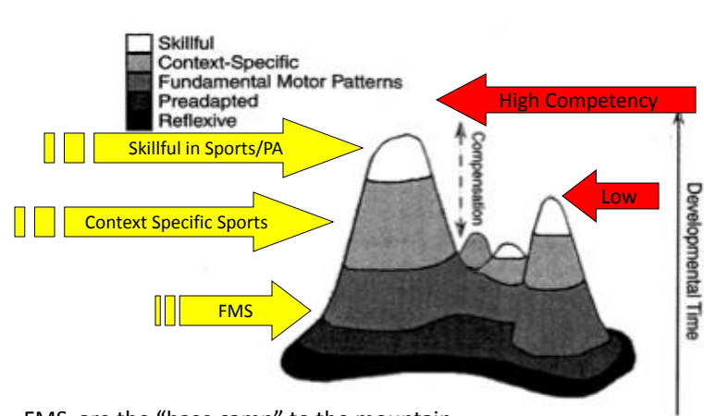

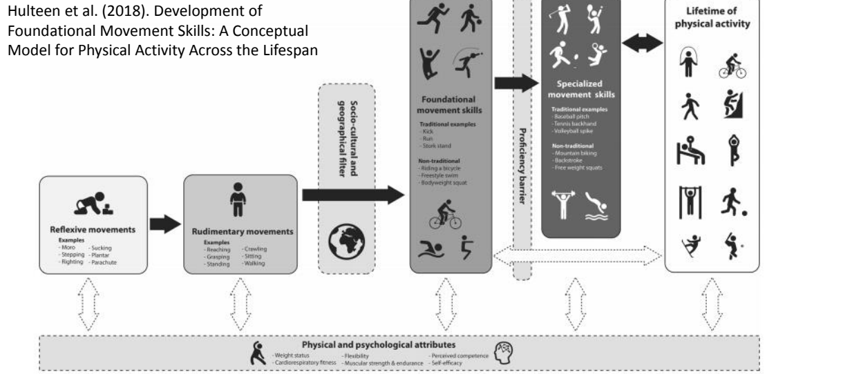
From this you can see the lower the peak the lower competent and lack of Fundamental movement skills to become skilful in other activities or even to be able to transfer the skills to other sports. Lack of fundamental skills will result in lower activity further along in their lifetime. But, from this a child is constantly learning motor skills up until a certain age. Hulteen et al (2018) developed a a model that highlights movement skills from a young age up until activity for life.

One can take such a model to develop an agreed set of expectations and develop expected ‘normal’ expectations of competence for gender and age, then use these to compare individual performance. Individuals can then be ‘graded’ on movement skills that will enhance lifetime of physical activity. The Welsh government then suggests a structure of measurement that encompasses a number of dimensions including: physical movement, analytic skills, participation / motivation, cognitive decision making, social skills and leadership. These can then be developed into a rubric.

The core PE contributions to developing Physical Literacy can then be measured through:
- Observation of performance in physical activity;
- Comparison against expected achievement levels published or developed by research;
- Achievement in Sport: specific games, representation levels, contribution and detailed skill levels;
- Leadership through interaction with others in a team – or as team captain;
- Paper based assessment of understanding of concepts through examinations or tests;
- Ability to understand how learning happens through practice and reflection so that Literacy becomes a lifelong practice and improvement continues.
Rubric development and completion can be helped through developing detailed descriptions of expectations – but in easy to understand words that describe the different levels of grades or expectations.
Physical literacy test are split into 4 areas, physical fitness, fundamental movement skills, physical activity behaviour and knowledge questionnaires which were devised by the Canadian assessment of physical literacy. To test physical fitness they uses test such as hand grip, arm flexibility, strength, and test such as push ups, sit and reach, run/pacer tests.
Fundamental movement skills, which is split into two, dynamic and static such as obstacle courses, jumping, kicking and static is throwing, catching and striking.
Physical activity Behaviour tests are used for example, pedometers worn for seven consecutive days as well as their daily log sheet.
Lastly, knowledge questionnaires, on understanding of health and physical fitness motor skills and physical activity.

b. Discuss potential challenges to assessing physical literacy within physical education (15 marks).
There can be a variety of challenges to assessing physical literacy within physical education. There are clearly many challenges to undertaking such assessments within Physical Education. There are the challenges of developing the key appraisal factors of validity, accuracy and objectivity – ensuring repeatability and independence from subjective factors.
These are clearly difficult for two key reasons. Firstly, these are clearly not areas of “right” and “wrong”. The issues in sport, movement and softer social skills are not so easily measurable. They involve concepts of artistry and innovation. There may be some understanding that is more mechanically measurable but many areas are subjective and down to individual characteristics or preferences.
The concepts themselves are also very broad, including that of individual responsibility and ability to take on one’s own development and embed this into a practice of life-long learning.
In addition, many of the concepts are subject to continually changing views and ideas – what is a good diet, how much exercise does one need, what does a physically active lifestyle actually represent in cities/towns/villages.
Further, there will be differences in expectations that are impacted by culture, religion, political considerations, sheer physical capabilities or disabilities - and other elements - that make single sets of measurements impossible. Rubrics will need to be developed that take all the above into consideration. This may be time consuming, involve a deep knowledge of the subject and local success factors – but still meet the basic factors demanded of rubrics and assessment objectives. This will need handling carefully to ensure the assessment results can be motivating for the individuals as well as providing reasonably objective comparative assessments.
For example, there is no universal measurement for assessing physical literacy as you cannot compare researchers’ findings together as they all have different views and approaches. This could include different types of questionnaires. Assessing physical literacy cn include a range of activities and can give teachers opportunity to assess and observe children carrying orange of movements. Hannah Walker (2015) asserts that observations can give detail on the participants involvement in tasks. However, the method does not give a full image of the child, their involvement and their improvements. Nor does it indicate WHY they are performing the way they are (progressions or regressions). Therefore, this would lack usefulness for the educator to create an in- depth understanding on the participants Physical Literacy levels.

