Introduction
Efficient software design is essential for building scalable and maintainable applications. This report explores the application of object-oriented programming (OOP) principles and design patterns in developing the Car Park Management System. The system incorporates key OOP concepts—abstraction, encapsulation, inheritance, and polymorphism—alongside best practices such as inheritance, abstract classes, virtual methods, generics, and structured storage mechanisms to enhance code reusability and extensibility [1-9].
By adhering to modular and object-oriented design principles, this project demonstrates how structured development practices contribute to creating robust and adaptable software solutions. The following sections will discuss the design choices, best practices, and performance considerations in implementing the Car Park Management System, providing a practical demonstration of OOP best practices in a real-world application.

Design choices, best practices and performance considerations
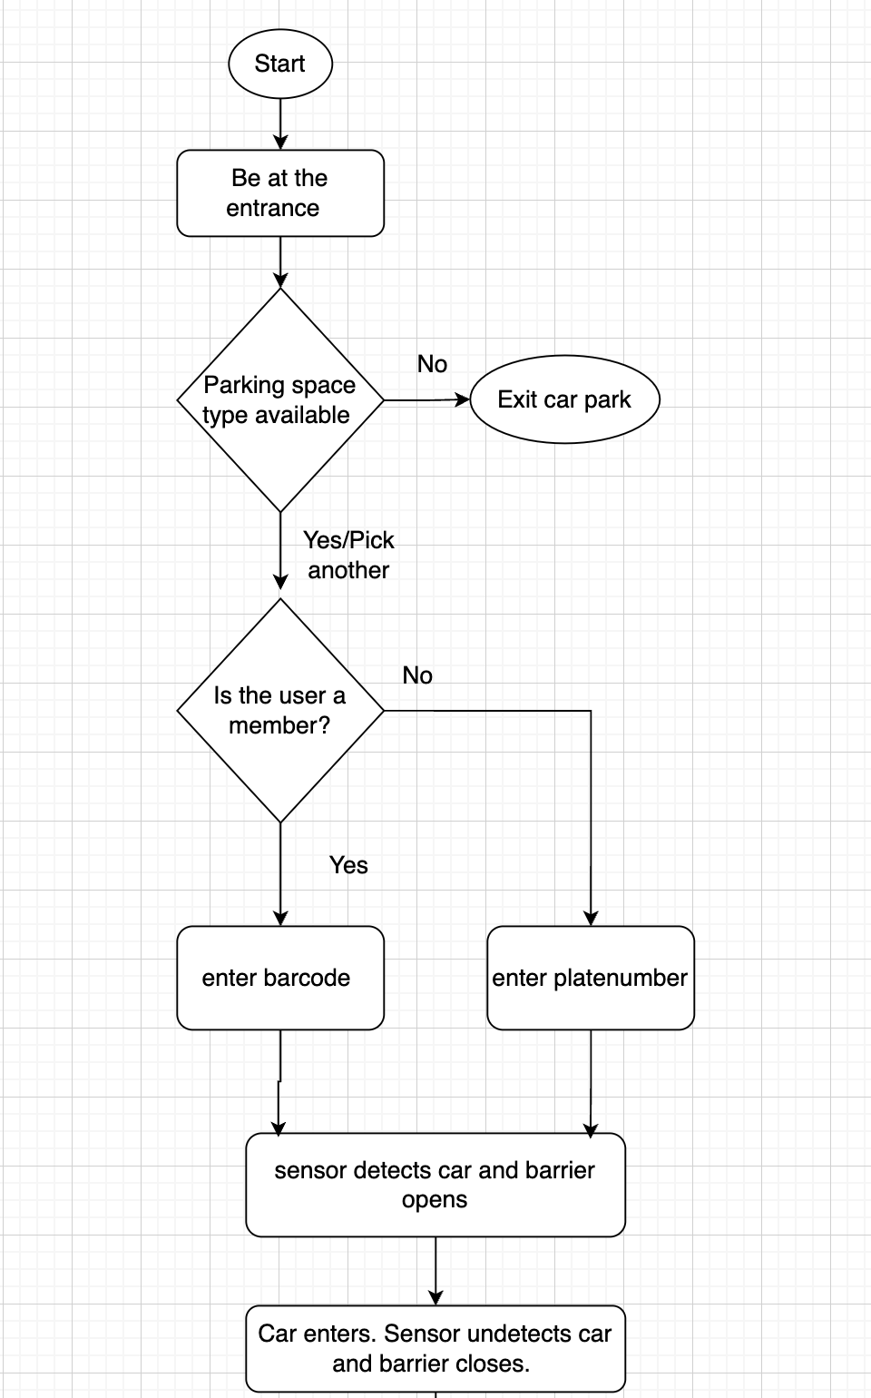

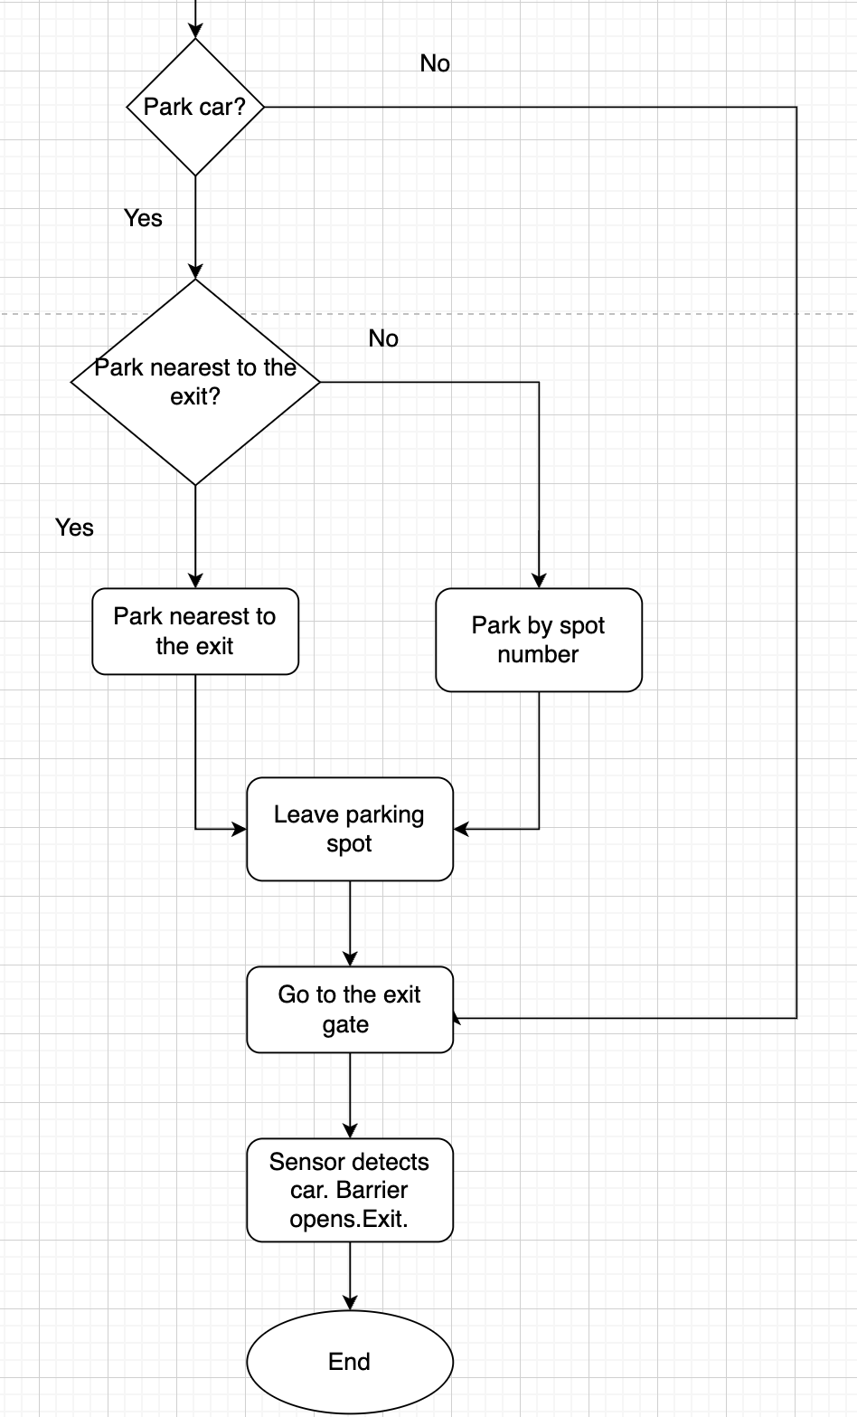
Figure 1: User journey through the Car Park Management System

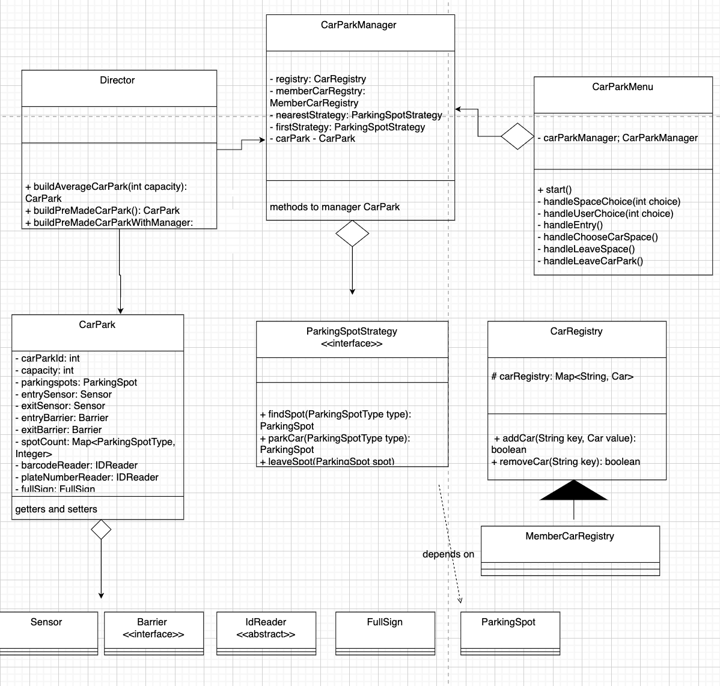
Figure 2: Key Class diagrams involved in the design of the Car Park Management System
The classes in figure 2 have been designed with the user journey in mind (see Figure 1).

Core Domain Model Design
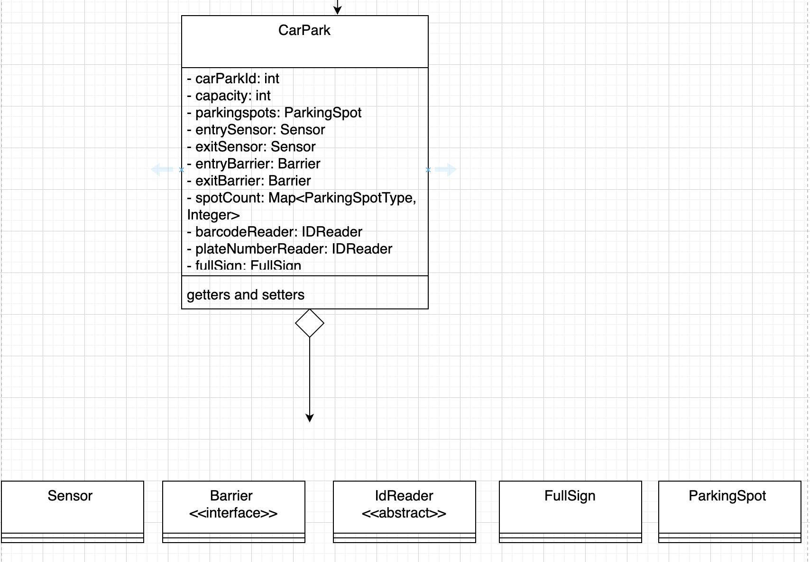
Figure 3: The CarPark class and its aggregates.
The CarPark class is the core entity of the system, serving as its foundation. It aggregates instances of other classes, including Sensor, Barrier, IdReader, FullSign, and ParkingSlot. These relationships define the structure of the domain model, ensuring that the system components interact cohesively. Most of its methods are getters and setters, primarily used for accessing and modifying attributes, reinforcing encapsulation [4].
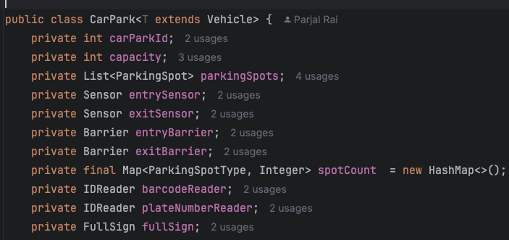
Figure 4: Use of Generics in the CarPark Class
A well-structured domain model prioritises code reusability, a fundamental principle in object-oriented programming (OOP), as it saves time and resources while promoting maintainability. When a change is required, it only needs to be made once, simplifying updates and reducing system complexity. One of the primary ways to achieve this is through inheritance, which can be implemented using interfaces or abstract classes [2][4]. These serve as blueprints, ensuring that subclasses adhere to a predefined structure and functionality. This approach supports software extensibility while maintaining control over system behaviour, reinforcing the Open/Closed Principle, which states that software entities should be open for extension but closed for modification [8].
A clear example of inheritance and type safety in the system is the CarPark class, which utilises generics (T extends Vehicle) (Figure 4) . This design allows CarPark to accommodate any Vehicle or its subtypes, ensuring scalability and flexibility. By using generics instead of raw types, explicit casting is eliminated, while subtype-specific constraints prevent unintended type mixing. This approach enhances maintainability, promotes reusability, and ensures adaptability for future enhancements [7].
Beyond CarPark, the aggregate classes further demonstrate these principles by maintaining a modular and scalable structure while delegating responsibilities efficiently. For example, the Sensor class detects incoming or outgoing cars in the car park (Figure 5). Once a car is detected, the IdReader class, implemented through its subclasses (BarcodeReader or PlateNumberReader), determines whether the user is a member or non-member by reading either a barcode or a registration plate, respectively (Figure 6).
After identification, the Barrier interface defines the behaviour of entry and exit barriers, which are implemented through EntryBarrier and ExitBarrier (Figure 7). These barriers control access to the car park based on the vehicle’s identification, ensuring smooth traffic flow within the system. By structuring the system using interfaces and abstract classes, the design promotes code reusability, maintainability, and extensibility, allowing future enhancements without modifying existing functionality.
The Car class introduces compile-time polymorphism through constructor overloading [3]. This allows instances of Car to be created using either a plate number (as a string) for non-members or a barcode (as a long) for members. This mechanism works in conjunction with IdReader, which reads either the car’s barcode or plate number depending on the user’s membership status.
Once the car enters the CarPark, it is assigned to a ParkingSlot based on the user’s selection. This structured approach ensures a seamless and efficient parking process, reinforcing the modularity, scalability, and effectiveness of the Domain Model Design.
.

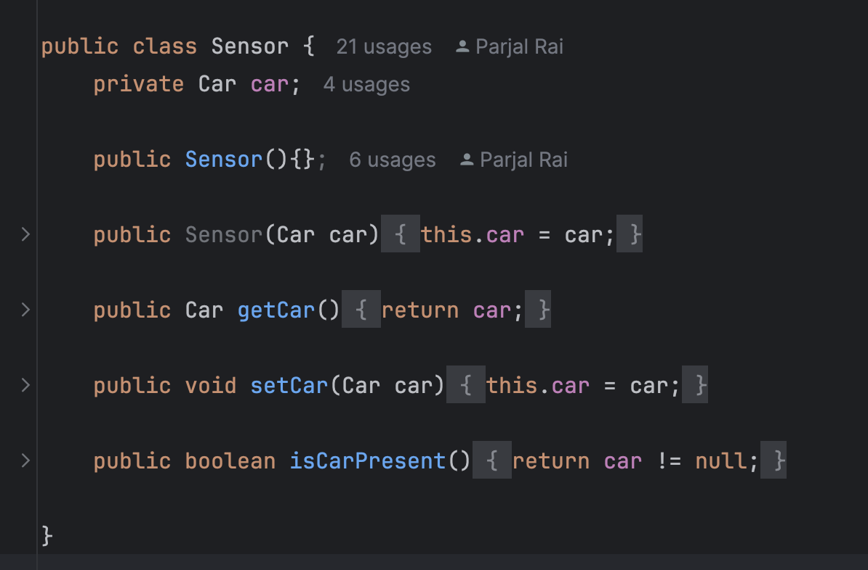
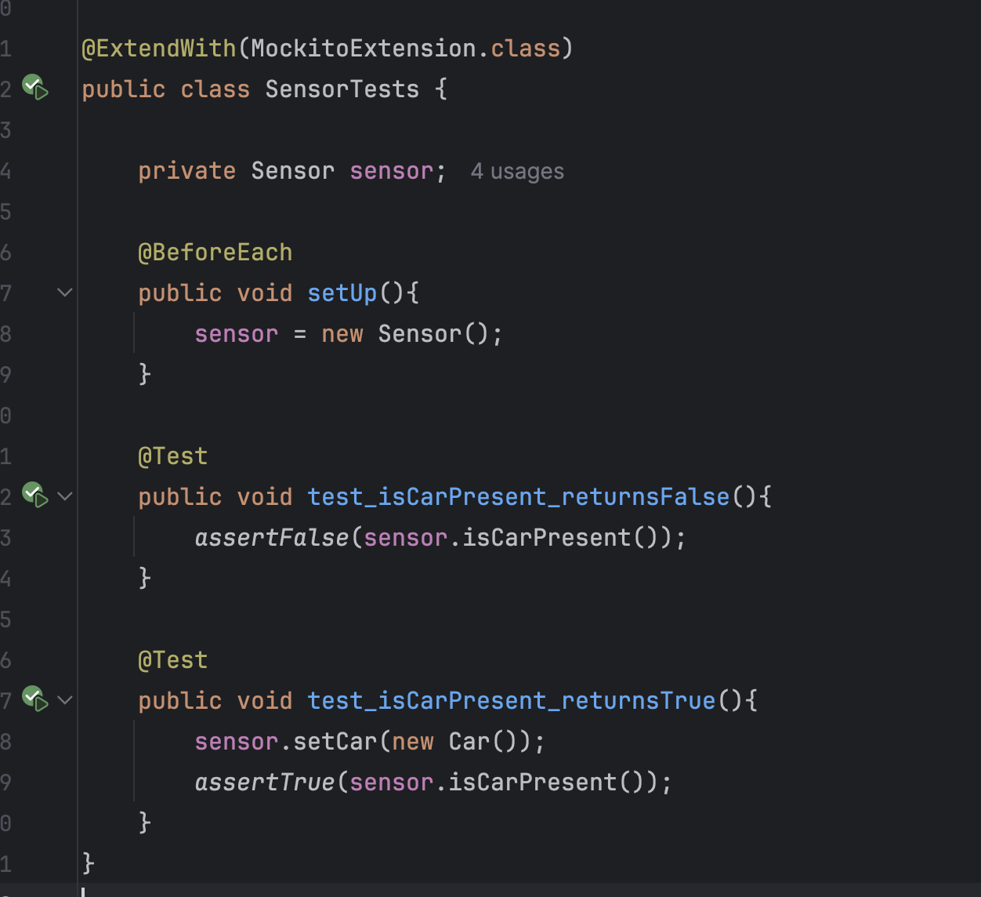
Figure 5: Sensor Class and Junit tests

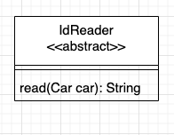
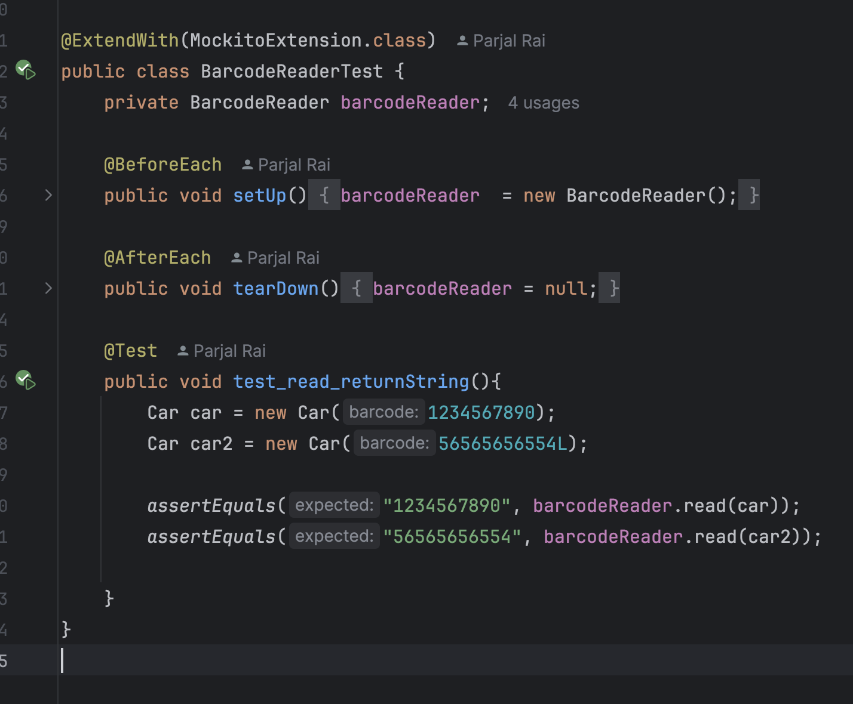
Figure 6: IDReader Class – An abstract class and unit testing of its subclass.

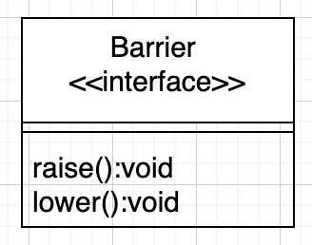
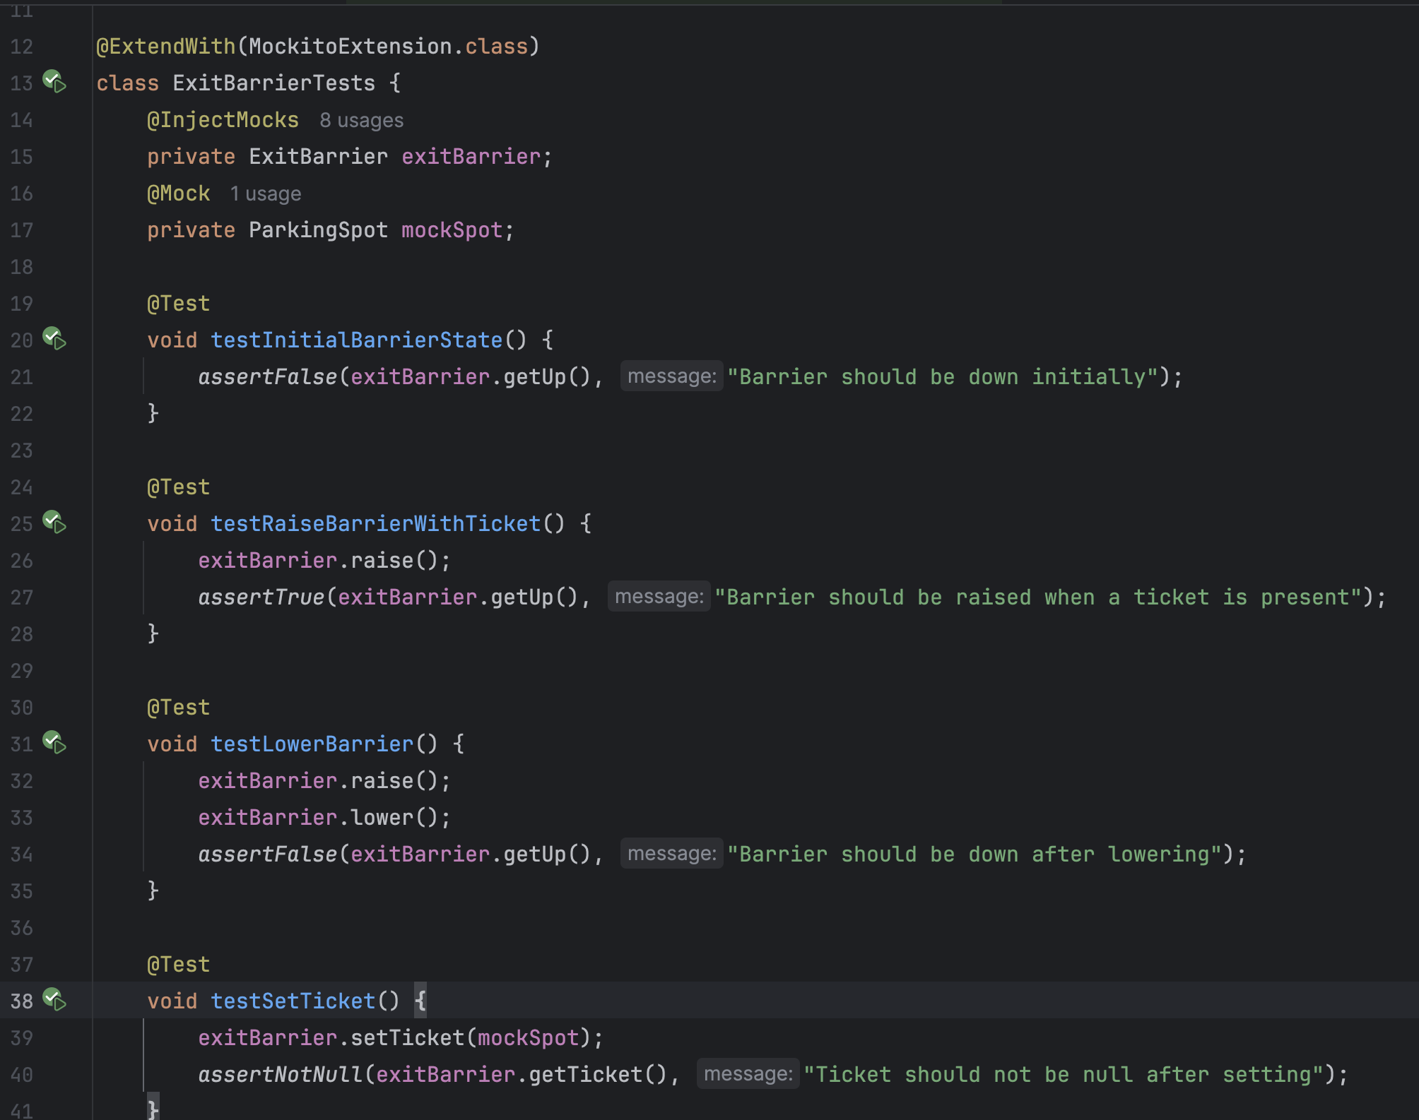
Figure 7: Barrier interface and unit testing of its implementation.
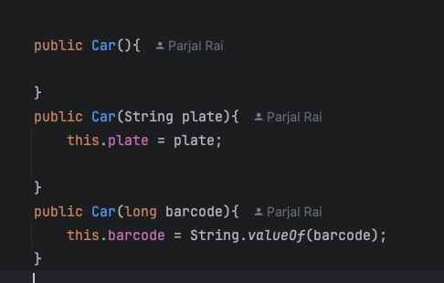
Figure 8: Car Class

Service Layer Design
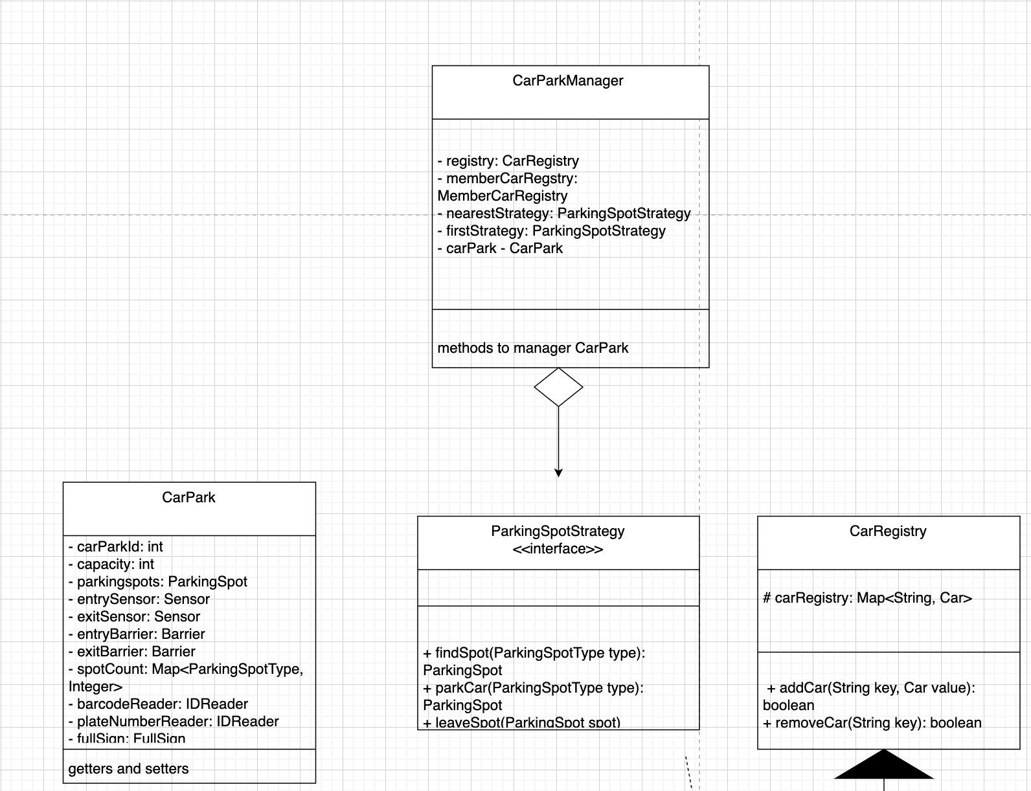
Figure 9: CarParkManager as a Service Layer Class and Its Aggregates
The service layer class is essential for managing business logic and coordinating interactions between different components. It oversees all logic within the CarPark component, as well as other supporting classes such as ParkingSpotStrategy and CarRegistry, which enhance the functionality of the Car Park Management System (Figure 10).
ParkingSpotStrategy employs the Strategy Design Pattern, allowing users to select parking spots using different strategies. Meanwhile, CarRegistry plays a crucial role in maintaining vehicle records by adding cars upon arrival and removing them when they leave the car park (Figure 9).

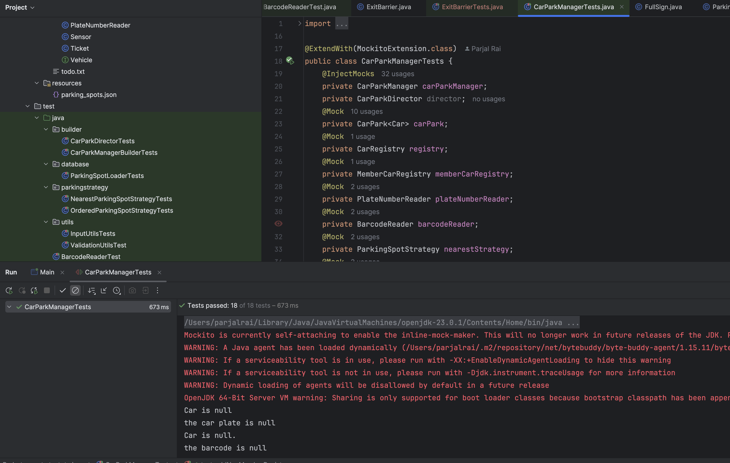
Figure 10 – Unit testing of CarParkManager.

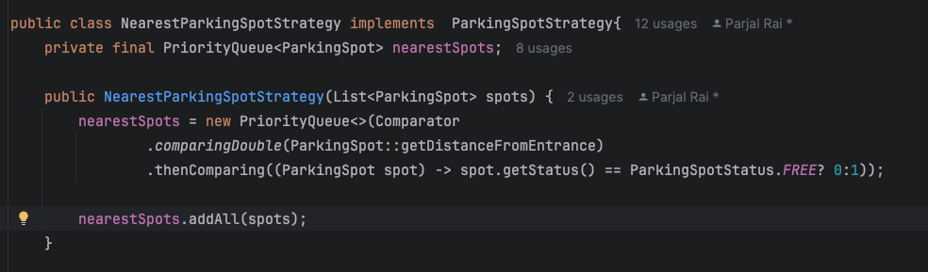
Figure 11 – PriorityQueue used in NearestParkingSpotStratey Class

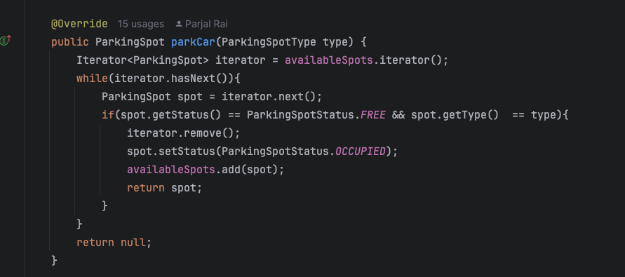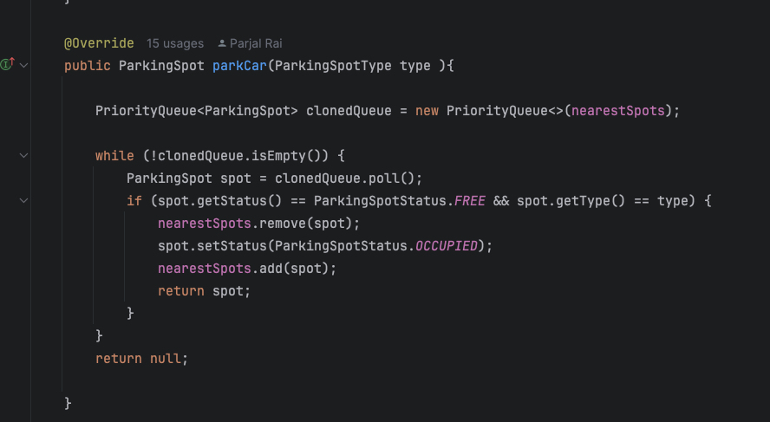
Figure 12: Virtual method implemented in different ParkingSpotStrategy Class
The Service Layer in the CarPark Management System serves as the intermediary between the underlying system components and the user interface, orchestrating interactions between business logic, data models, and various services. It coordinates operations like car entry and exit, parking allocation, and vehicle tracking. The CarPark class acts as the central entity of this layer, integrating essential components such as ParkingSpotStrategy, CarRegistry, and others that enhance the system’s functionality (Figure 10).
The ParkingSpotStrategy interface is central to the service layer’s design. It defines a contract for various parking strategies, which can be implemented dynamically based on the user’s requirements. This enables flexibility in how parking spots are allocated within the car park. For example, the OrderedParkingSpotStrategy uses a TreeSet collection to maintain parking spots in a predefined order, which is crucial for high-traffic car parks where order and availability need to be strictly managed. In contrast, the NearestSpotStrategy employs a PriorityQueue (min-heap) to ensure that cars are allocated the nearest spots to the entrance or exit (Figure 11). Both strategies improve system performance by efficiently managing the allocation of parking spots [9].
In terms of runtime polymorphism, the parkCar() method within the ParkingStrategy subclasses is a virtual method. This allows each subclass to define its own implementation of the parking logic [3]. For instance, while OrderedParkingSpotStrategy prioritises parking based on a predefined order, NearestSpotStrategy focuses on proximity to the entrance (Figure 12). The ability to select the appropriate strategy at runtime is essential to providing a flexible and adaptive service layer, which is central to the system’s efficiency and scalability.
The CarRegistry plays a pivotal role within the service layer by managing vehicle records. This class is responsible for adding vehicles to the system upon entry and removing them upon exit, ensuring accurate tracking of car park occupancy. Through runtime polymorphism, the service layer is able to interact with different parking strategies and vehicle data dynamically, supporting flexibility in managing car park operations.
The system relies on in-memory data structures such as TreeSet, PriorityQueue, and Map to facilitate efficient operations within the service layer. These structures allow quick access to parking spots and car data, supporting real-time management of car park entries and exits. The TreeSet and PriorityQueue are particularly effective for managing parking spot availability and prioritisation, with operations like insertion, deletion, and retrieval all optimised for high-performance environments (O(logN) time complexity) [2]. Meanwhile, Map allows for constant-time lookups, which is essential for quick identification of cars based on their barcode or registration number [2].
The integration of these data structures within the service layer enables the car park to efficiently handle high-traffic scenarios where many cars enter and exit the system simultaneously. By choosing the right data structures, the service layer can ensure the scalability and performance of the system, particularly when managing large numbers of vehicles and complex parking strategies.
By structuring the system with these data structures and service layer components, the car park management system ensures modularity, scalability, and efficiency. The service layer facilitates easy extension, allowing new strategies or features to be integrated without changing the core functionality, ensuring that the system can adapt to evolving requirements over time [4].

3. Instantiation Logic Design

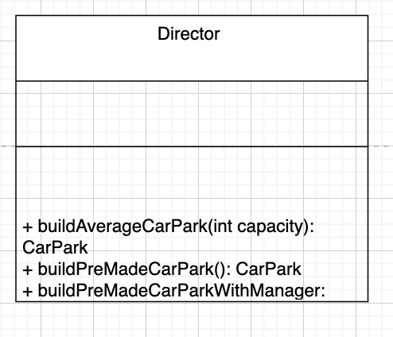
Figure 13: Director class implementing Builder Pattern.
The instantiation logic layer in the Director class employs the Builder pattern to instantiate both the CarPark and CarParkManager [9]. This logic works seamlessly with the DatabaseLoader class, which uses a JSON file to store parking spot data, allowing the CarPark to be populated dynamically.
This approach ensures the car park is loaded with pre-defined data, simulating a realistic environment without the complexity of managing a full database. As this is a prototype, using this storage solution proves practical by eliminating the need for object-relational mapping (ORM) or database persistence [2], allowing the focus to remain on the core design and functionality of the system.

Presentation Logic Design
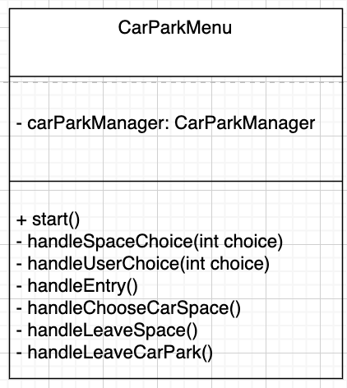
Figure 14: CarParkMenuClass handling logic of the presentation layer
CarParkMenu interacts with the service layer class, CarParkManager, to manage the logic of the presentation layer. Each CarParkMenu method corresponds to a decision outlined in the flowchart in Figure 1. By adhering to the Single Responsibility Principle, CarParkMenu effectively encapsulates the functions related to the presentation layer [2].

Static memory allocation vs dynamic memory allocation in java data structures

Memory allocation in Java occurs in two main areas of the Java Virtual Machine (JVM): the stack and the heap, each facilitating static and dynamic memory allocation, respectively.
In static memory allocation, memory is allocated at compile-time and is stored in the stack memory. Allocation and deallocation happen automatically, following the Last-In-First-Out (LIFO) mechanism used by the stack. The size of memory allocated is fixed and predetermined, which can make memory allocation faster due to low overhead. However, this can lead to memory wastage if the allocated space is not fully utilized. An example of a data structure that uses static memory allocation is an array.
In terms of data structure storage, the reference to the array (or any object) is stored in the stack, but the actual object (or array data) is stored in the heap, which is also where dynamic memory allocation occurs.
In dynamic memory allocation, memory is allocated in the heap at runtime, as needed. This allows the size of data structures to grow or shrink dynamically, enabling more efficient memory usage. However, this dynamic resizing is managed by the garbage collector, which automatically handles memory deallocation when objects are no longer referenced. This process can introduce significant memory overhead. Data structures such as ArrayList, HashMap, and TreeSet use dynamic memory allocation to adjust their size during runtime [1,4,6].

Running the project

- To build the project download the app, and go to the application folder using terminal. Then use the following command:
mvn clean install
- Then to run the application after it has been successfully built, use the following command:

java -jar target/CarPark-1.0-SNAPSHOT.jar

Conclusion
The Car Park Management System demonstrates how object-oriented programming (OOP) principles and design patterns can be effectively applied to create a scalable, maintainable, and efficient software solution. By utilizing core OOP principles such as inheritance, polymorphism, and abstraction, the system ensures code reusability and modularity, allowing for seamless future enhancements.
The system follows a layered architectural design that clearly separates concerns: the Domain Model layer (CarPark and associated entities), the Service Layer (CarParkManager, handling business logic), and the Presentation Layer (CarParkMenu, managing user interaction). This separation promotes maintainability and flexibility, making the system easy to modify or expand.
Additionally, the integration of strategy patterns for parking space allocation and the use of efficient data structures such as TreeSet, PriorityQueue, and HashMap optimize performance, especially in high-traffic scenarios. Careful attention to memory management, including dynamic vs. static allocation, further enhances overall system efficiency and responsiveness.
By adhering to best practices in software design, this project highlights the importance of flexibility, extensibility, and performance optimization in real-world applications. The structured class design, with clear relationships and responsibilities, ensures that the system remains adaptable for future expansions, such as database integration or the addition of new parking strategies.
Ultimately, this project serves as a real-world demonstration of how OOP, design patterns, and layered architecture can be leveraged to build a robust, adaptable, and high-performance parking management solution.

References
[1]
Maaike van Putten and S. Kennedy, Java Memory Management. Packt Publishing Ltd, 2022.

[2]
E. B. Koffman and P. A. T. Wolfgang, Data structures : abstraction and design using Java. Hoboken, Nj: John Wiley & Sons, Inc, 2021.

[3]
J. T. Streib and T. Soma, “Objects: Inheritance and Polymorphism,” Undergraduate topics in computer science, pp. 293–319, Jan. 2023, doi: https://doi.org/10.1007/978-3-031-22842-1_9.

[4]
N. Singh, S. S. Chouhan, and K. Verma, “Object Oriented Programming: Concepts, Limitations and Application Trends,” 2021 5th International Conference on Information Systems and Computer Networks (ISCON), Oct. 2021, doi: https://doi.org/10.1109/iscon52037.2021.9702463.

[5]
H. Ali, M. Hamza, and T. Rashid, “Exploring Polymorphism: Flexibility and Code Reusability in Object- Oriented Programming,” 2023. Available: https://passer.garmian.edu.krd/article_189667_b5fb20044fc0571614a42f29beeeed39.pdf

[6]
“A Research on Object Oriented Programming and Its Concepts,” International Journal of Advanced Trends in Computer Science and Engineering, vol. 10, no. 2, pp. 746–749, Apr. 2021, doi: https://doi.org/10.30534/ijatcse/2021/401022021.

[7]
KONSTANTIN BOJCHEVSKI and Luka Fürst, “Generics in Java and parallels with templates in C++,” Uni-lj.si, Mar. 2025, doi: https://repozitorij.uni-lj.si/Dokument.php?lang=eng&id=166400&dn=.

[8]
Naveen Chikkanayakanahalli Ramachandrappa, “SOLID Design Principles in Software Engineering,” International Journal of Computer Trends and Technology, vol. 72, no. 9, pp. 18–23, Sep. 2024, doi: https://doi.org/10.14445/22312803/ijctt-v72i9p104.

[9]
E. Gamma, R. Helm, R. Johnson, and J. Vlissides, Design patterns : elements of reusable object-oriented software. Boston: Addison-Wesley, 1994.

Appendix
Figures of working app


