The Grand Theatre Swansea

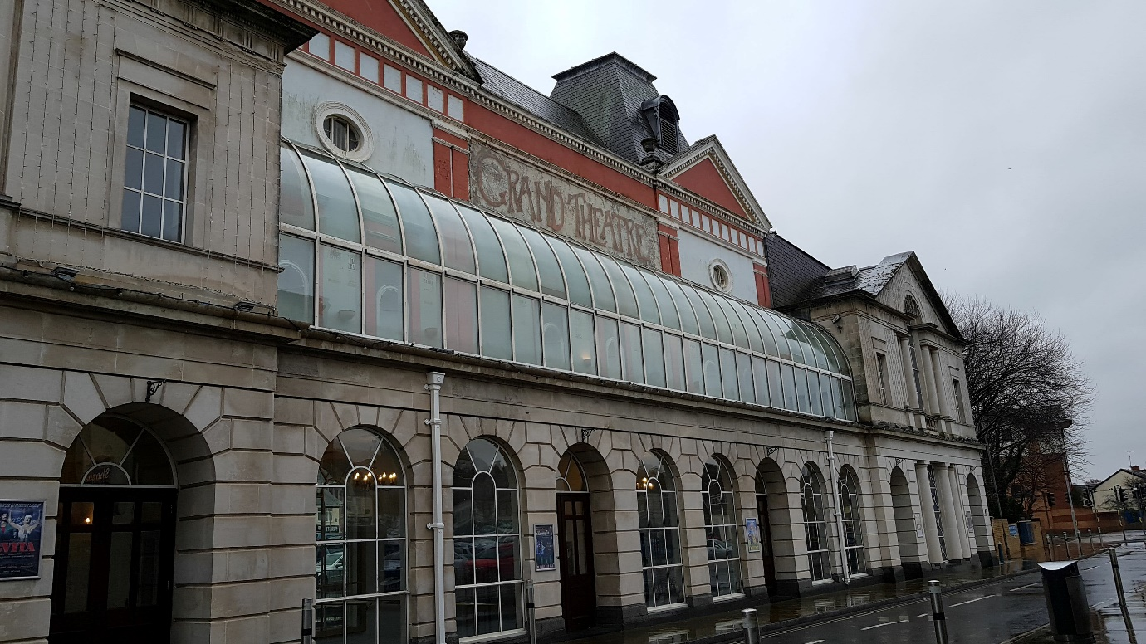

Project Initiation Document (PID)

Project Consultant: Courteney Augustine
P144589
Module: Consultancy Project
(M6X02113)
Level: 6
Submission Date: 16th March 2018
Lecturer: Michael Davies

Contents
1.0 Project Justification 3
1.1 Background 3
1.2 Project Aim 3
1.3 Project Objectives 3
1.4 Initial Ideas 4
1.5 Rationale 4
1.6 Scope and Exclusions 4
1.7 Possible Constraints and Assumptions 5
2.0 Business Case and Project Approach 6
2.1 Potential Benefits 6
2.2 Potential Project Costs 6
2.3 Potential Project Issues (Risk Management) 6
2.4 Project management team structure 8
3.0 Proposed Research methodology 9
4.0 Quality management strategy 10
5.0 Work breakdown structure 11
5.1 Gantt Chart 11
6.0 Communication management structure 13
7.0 Project Plan 14
8.0 Project Controls 15
9.0 Review Project Plan 16
10.0 Appendix 17
10.1 Garden Area 17
11.0 References 18

Project Justification

1.1 Background
Swansea Grand Theatre opened on the 26th July 1897 by Opera Diva Madame Adeline Patti. The theatre has provided the public with a broad range of cultural, artistic and general entertainment event since 1897.
In 1933 to the early seventies the grand entered a turbulent period with many successes and many failures including it being turned into a cinema for a fourteen-year period. However, the then local authority (Swansea Corporation/City Council) came to the rescue and took out a long lease in May 1969 before buying the building outright in 1979. The City and County of Swansea continues to own, manage and fund the building today.
A multi-million-pound refurbishment programme from 1983 - 1987 turned the 1000 seat theatre into one of the most technically advanced and aesthetically pleasing venues in the UK. In 1999 the Grand Theatre became the proud `Owners’ of a new arts wings, which has increased the space open to visitors by a third. It has also created a new studio performance area, three exhibition areas and a rooftop restaurant and terrace. (Swansea.gov.uk. (2014).

1.2 Project Aim
To provide opinions and recommendations on how to liven up the garden area of the Grand Theatre with events.
(Appendix 10.0 – Garden area)

1.3 Project Objectives
To achieve the Project aim there have been several objectives set in place.
- To develop ideas on how to the enhance the garden area of the Grand Theatre, to make it more appealing to the eye
- To increase the revenue of Footlights Cafe Bar which is situated inside the theatre.
- To provide ideas & recommendations on how to/what small events the theatre could host at the weekends during the summer period (June – August) 2018/2019
- To attract new customers to the theatre/ continue to attract regular customer to the events.

1.4 Initial Ideas
The initial idea for this project is to create a feasibility Study on whether hosting weekend events during the summer period between June to August of 2018/2019, will attract new customers to the theatre and continue to attract repeat customers.
The Project will provide recommendations and opinions on how to develop the garden area of the Grand Theatre to make it more appealing to the eye and to provide opinions on what type of events should be held at the Theatre and how the theatre will be able to increase their income at the Footlights Café Bar during the events. The overall project will have a budget of £3000.

1.5 Rationale
Attracting new customers and keeping the interest of repeat customers, is an aim of every business. The Grand Theatre host a range of different events/ shows throughout the year which attracts a variety of customers to suit each event/ show that is hosted.
However, The Grand Theatre also has the potential to host outdoor events which will bring in revenue to the theatre through the Flootlights café bar and bring the community of all ages together for something magnificent over the summer period.

1.6 Scope and Exclusions
This project intends to provide recommendations and opinions on how to redevelop the garden area of the Grand Theatre and what types of events can be held there during the summer period. This is to help bring revenue into the Flootlights café bar, as the event will be free to attend.
This project will be created by a Student of University of Wales Trinity Saint David Swansea, purely for a University Project. However, if the Grand Theatre would like to take this project document further themselves and put it to the test then they may do so in the future.

1.7 Possible Constraints and Assumptions
Whilst completing this feasibility Study there will be some constraints and assumptions that may affect the research. As a student is completing this study time is going to be a constrain as there will be deadlines that have to be met. Also, a constraint would be keeping the events and redevelopment in the £3000 budget.
However, an assumption that the consultant may make is being able to get information about pervious events that have taken place from the Grand Theatre Manager Paul Hopkins on short notice. On the other hand, assuming Staff members of the Grand will be willing to answer questions to whether hosting events will be beneficial to the theatre, this is because staff members may or may not answer the questions truthfully, as they may be afraid of saying something they should not. In this situation the staff will be notified that everything that is said and written will be strictly private and confidential.

Business Case and Project Approach

2.1 Potential Benefits
As it was previously mentioned attracting customers is a big part of every organisations. The Grand Theatre is always thriving to attract customers to the venue through their shows, exhibitions and their events.
- Re- develop the garden area of Grand Theatre
- Create Summer Events
- Bring revenue into the Flootlights Café Bar
The benefits of this feasibility study are that it will give recommendations and opinions on how to re-develop the garden area of the grand theatre to make it more attractable to the customer’s eye. The study will also provide recommendations on the type of events that will bring customers in through the summer period and how to bring people into the venue as it will be free to attend these events.
Finally, it will bring in revenue for the theatre through the Flootlights Café bar and it will bring the communities together for something magnificent over the summer period.

Potential Project Costs
This project will only require a certain amount of money for the cost of development of the grand theatre and for the cost of some entertainment for events. The consultant is offering her services free of charge, to help benefit the company. Although, it is not certain how much the re-development of the garden area will be and how much the entertainment will cost, the manager of the Grand Theatre Paul Hopkins has given the consultant a maximum of £3000 budget for the whole project. The events are also required to be free of charge for customer to attend so there will not be any money spent on Ticketing for the event.

Potential Project Issues (Risk Management)
When planning a project of any size, there are always going to be potential issues that occur. The consultant will identify potential issues that may occur whilst planning the feasibility study on the Grand Theatre, she will then provide solutions on how she can overcome them and provide a high standard report.
- Document Errors
- Primary Research
- Time management
- Communication with the Manager
- Managing the Budget
When the consultant writes the final document for the Grand Theatre, there may be some unintentional errors throughout, which may cause problems for the manager and his team. To resolve this issue, the consultant will get others to proof read the document a couple of times before it is given to the manager.
The feasibility study will require a range of primary research from the staff, customers and local businesses who are willing to answer questionnaires and provide opinions on the proposed events, some individuals may not always be available to complete these questions. To resolve this issue, the client will communicate with the individuals to make sure they are available.
As the consultant is a University student being able to manage her time effectively is key to making sure this feasibility study is done to the highest standard. However, there may occasions where questionnaires have not been completed, the consultant will need to take this into consideration when planning the time scale to allow extra time for incomplete questionnaires.
Paul Hopkins manager of the Grand Theatre has a busy schedule which means that he will not always be available speak right away when the consultant needs to. To resolve this issue keeping a record available dates and time, this will help minimise the lack of communication between consultant and manger.
Finally, when planning events, it is possible to go over budget when wanting to create an amazing experience. To minimise the likely hood of this happening during this report, the consultant will keep a record of all money that could potentially be spent. This is to ensure that it is kept well within the £3000 budget.

Project management team structure
“Project teams differ from other teams in that they perform a one-off, non-routine task, they are temporary rather than permanent, they are usually heterogeneous and cross-functional, and they are highly educated specialists rather than generalist’’ (Young & Samson, 2008)
There must be a team structure in place to identify who are/ may be involved in the plan.
Consultant
Paul Hopkins - Manager
Grand Theatre Staff
Grand Theatre Regular Customers
Local dance/ drama clubs

Will be Involved
Might be Involved
KEY:

Above you can see the people that will be involved in the project and the places that might be involved.
However, the client of this project is the manager Paul Hopkins. Paul does not need to be involved in every aspect of this project, but the consultant will need to have access to data from pervious events that have taken place outside, if any. Also, Paul will need to keep up to date with the consultant to oversee some parts of the project, this is to ensure that the project is going how he planned it to.

3.0 Proposed Research methodology
“Research is the systematic process of collecting and analysing information (data) in order to increase our understanding of the phenomenon about which we are concerned or interested.’’ Cited from (Sachdeva, 2009)
This project will conduct both qualitive research and quantitative research, these are also known as primary and secondary research.
The qualitive research that is project will undertake are:
- Questionnaires
- Surveys
- Interviews
This project will be more focused on using qualitive research as the consultant want to get an in-depth analysis on whether events in the garden area would be feasible for the Grand Theatre. Questionnaires and surveys will be carried out to ask people their opinions on the project. There will be hard copies printed out for the customers who go to the café and for the staff who work in all aspects of the theatre. There will also be online surveys which will be put on social media to get opinions from people who live in Swansea and attend events.
There is also a possibility that interviews will be taking place with companies that would be interested in taking part in the event if it was to happen. The type of people the consultant may want to ask are local dance and drama clubs, local musicians and comedic acts. This is to give the feel that its bring the community together to create something magnificent.
The quantitative research that this project will use are:
- Journals
- Articles
- websites
- Grand theatre data
The consultant will use journals, articles and website to help support the project on the types of events which could work in the garden area. Also, they will be used to find out any other similar event that have taken place, in other companies.
Finally, the consultant will gather data from the Grand Theatre on the pervious type of event they have held there, and how many people attended them, from this the consultant can see what need to be done differently in order to bring more people into the event.

Quality management strategy
Throughout this project there will be standards and certain exceptions that the consultant will need to stick by when doing the research. When doing primary research, the consultant must to be aware of what information the interviewee wants to be put into the report. Also, when the questionnaire is given out in the Grand Theatre some staff members may not want to say what part of the theatre they work, as they do not want it to be put into the research findings.

5.0 Work breakdown structure

5.1 Gantt Chart
The consultant has created a Gantt charting showing what she plans to do/ undertake until the 2nd May 2018, beside each project there are notes explaining what the consultant wants to happen.

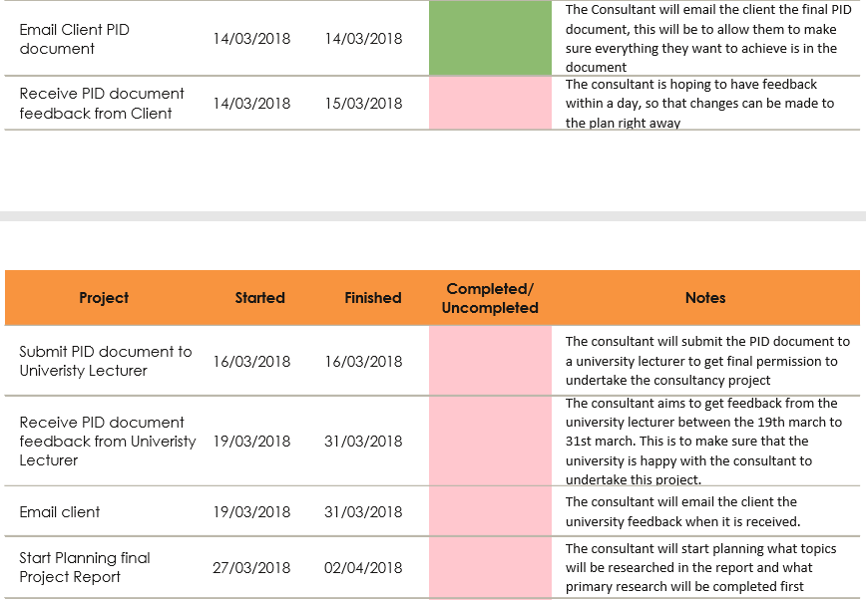
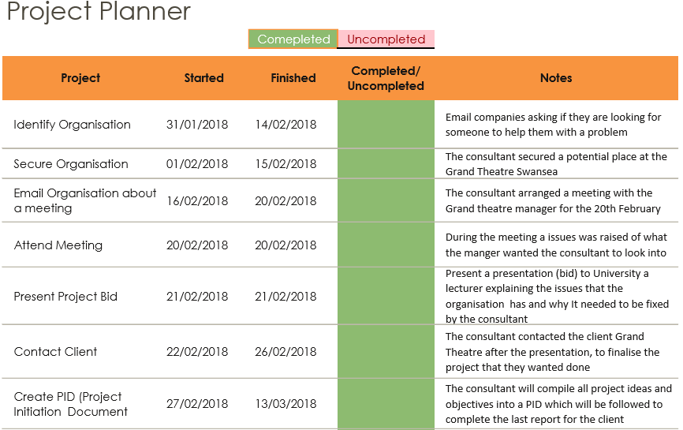

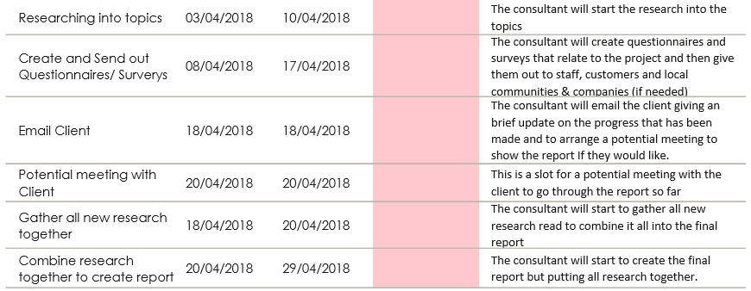
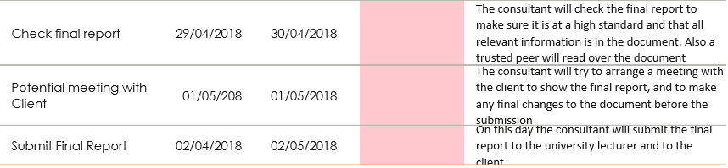

6.0 Communication management structure
During this project communication is going to be key, without communication with the manger this project will be extremely hard to carry out for the consultant.
To ensure communication is kept between the consultant and the Grand Theatre Manager, there will be two main communication channels set in place:
- Emails
- Meetings.
Emails will be the main form of communication between the consultant and manager, this is to communicate any issues that may have occurred to share information that may be needed and to ensure that the consultant is still covering everything the manger wants.
However, meetings will be held if there is a serious problem that has occurred but before the end of the project the consultant will arrange meeting to finalise the report with the manager.
The meetings and emails between the client and the consultant will be documented through minutes. Alongside, these a brief description of what’s was said and done throughout the meetings will be recorded.

7.0 Project Plan
This project will begin on the 31st January 2018 until the 2nd of May 2018 when the final consultancy document is completed and given to the client (Grand Theatre).
First part of the plan will be carrying out research on the Grand Theatre and the events that are held within. Also, to gather any relevant information that will help carry out the project.
Second part of this plan will be to gather all primary research such as questionnaire, survey and interviews if necessary. This is to provide opinions on whether events in the garden area will work. After this, the consultant will do some secondary research to support the consultants research.
Third part of this plan will be an analysis on the overall project, discussing the pros and cons of the aims and objectives set of out within this project.
Finally, the consulted will also provide recommends of what events which would work within the garden area. Also, the consulted will provide recommendations of developments for the garden area.

8.0 Project Controls
Throughout each stage of the project the consultant will review the project process. This is to ensure that the project sticks to its aims and objectives. Also, to ensure there are no failed research projects in-between.
During the schedule of this project the consultant has allowed an extra 3-5 days flexibility, encase any meetings are rescheduled or for any questionnaires/ survey which are not complete, or the consultant has not received the right quantity.
However, if the schedule does go over the time scale. Then the project will be immediately reviewed to see what actions are to be taken to carry on the project

9.0 Review Project Plan
Once the project plan has been completed it will be reviewed by the reviewers which are the university lecture and the client (Grand Theatre). Also, the consultant will receive feedback from a trusteed peer who will review the project and give feedback before it is sent to the client.
This is to ensure the plan is accurate and at a high standard before the final report is completed.

10.0 Appendix

10.1 Garden Area
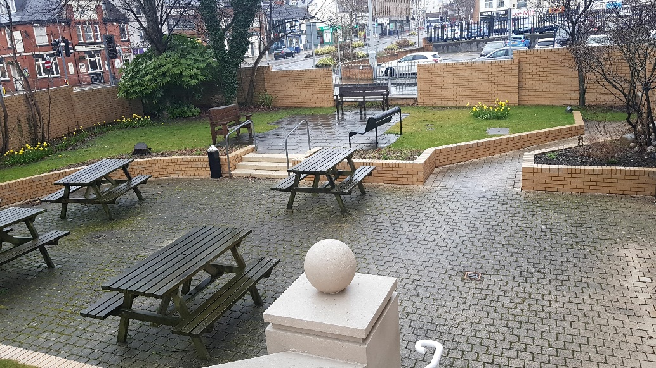

11.0 References
Scott-Young & Samson, 2008. Project success and project team management: Evidence from capital projects in the process industries. Journal of Operations Management, 26(6), pp.749–766.
Sachdeva, J.K., 2009. Business research methodology, Mumbai [India]: Himalaya Pub. House.
Swansea.gov.uk. (2014). Swansea - History of Swansea Grand Theatre. [online] Available at: https://www.swansea.gov.uk/HistoryOfSwanseaGrandTheatre [Accessed 7 Mar. 2018].

