Coursework Title
Module Name: Computer Architecture & OS
Module Code: ACCA4022
Student Name: Filip Paul-Gabriel
Student ID: 2519767
Lecturer Name: Dr Md Shantanu Islam

Submission date:

Contents
Introduction 4
Key functions of general Operating Systems 4
Task Management: 4
Application/Program Management: 4
File/Directory Management: 5
Device Management: 5
Security Management: 6
Use of Windows OS CLI commands 7
Example 1: 7
Example 2: 7
Example 3: 8
Example 4: 8
Example 5: 8
Example 6: 9
Example 7: 9
Example 8: 10
Example 9: 10
Example 10: 11
Use of Linux OS CLI commands 11
Example 1: 11
Example 2: 12
Example 3: 12
Example 4: 13
Example 5: 13
Example 6: 14
Example 7: 14
Example 8: 15
Example 9: 15
Example 10: 16
Use of Windows OS scripts 16
Example 1: 16
Example 2: 17
Use of Linux OS scripts 18
Example 1: 18
Example 2: 19
Conclusion 20
References 20
Appendices 21

Introduction
Write a brief description of this coursework. Describe what this report contain. (100 words)
This coursework provides a practical study of basic system administration in both Windows and Linux operating systems. The report contains a detailed breakdown of core concepts, featuring step-by-step explanations of real command-line operations and system utilities shown in terminal screenshots.
Inside this document, you will find explanations of essential CLI commands used for file navigation, directory management, network diagnostics, and process tracking. Furthermore, the report explores basic script automation using Windows Batch files and Linux BASH scripts for mathematical tasks and conditional logic. Overall, it summarizes how to manage system hardware, security features, installed applications, and terminal operations efficiently.

Key functions of general Operating Systems
Write an introduction about windows operating system when it came, importance, functions. Use 1-2 references (50 words)
First introduced by Microsoft in 1985, Windows is a vital operating system that revolutionized personal computing. It acts as a bridge between users and hardware, offering essential functions like file management, memory allocation, hardware control, and security features to ensure smooth everyday software operations

Task Management:
Write about task management in windows. Use 1 reference minimum (100 words)
Task management illustrate hardware usages [1].
The figure 01 shows the Task Manager open. It displays all the applications and processes currently running on the computer. You can see as well the programs like Google Chrome and Microsoft Word are utilizing the processor and RAM. Task Manager is wery useful when a program stops responding or slows down the computer. The user can select the application and click “End Task” to close it. It also allows for monitoring processor, memory, and disk performance.
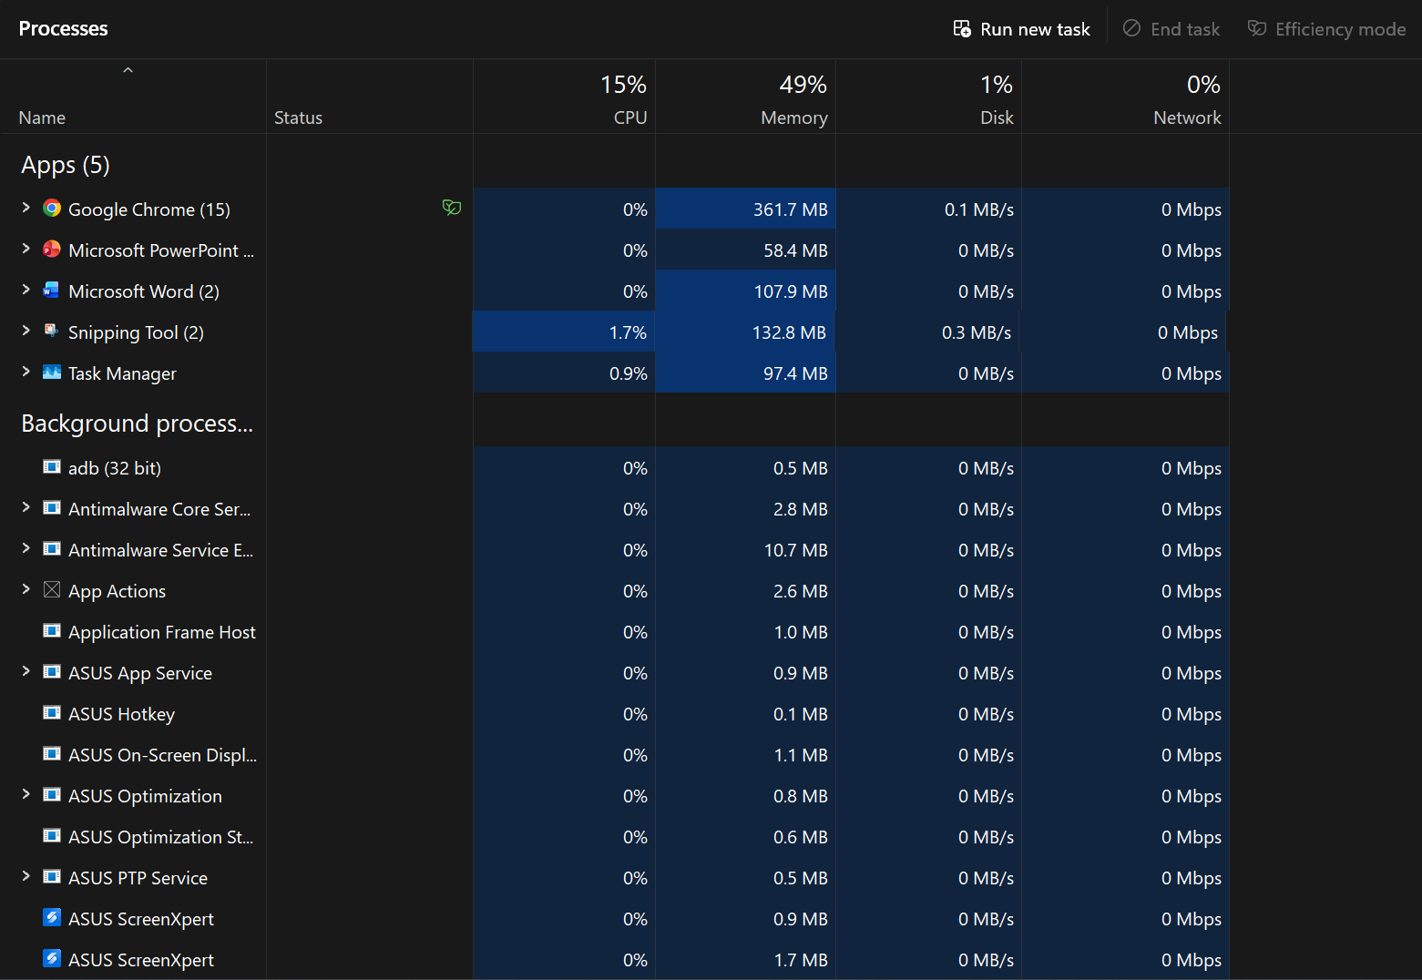
Figure 1: Description

Application/Program Management:
Write about Application/Program management in windows. Use 1 reference minimum (100 words)
This image shows the "Installed Apps" menu in Windows. It lists all applications installed on the computer, such as Grand Theft Auto V Legacy, Spotify, iCloud, Epic Online Services, WhatsApp, Rockstar Games Launcher, etc. (2)Windows also displays the storage space used by each application, helping the user identify which programs take up the most room. From this window, users as well can uninstall unnecessary applications and more easily manage installed programs.
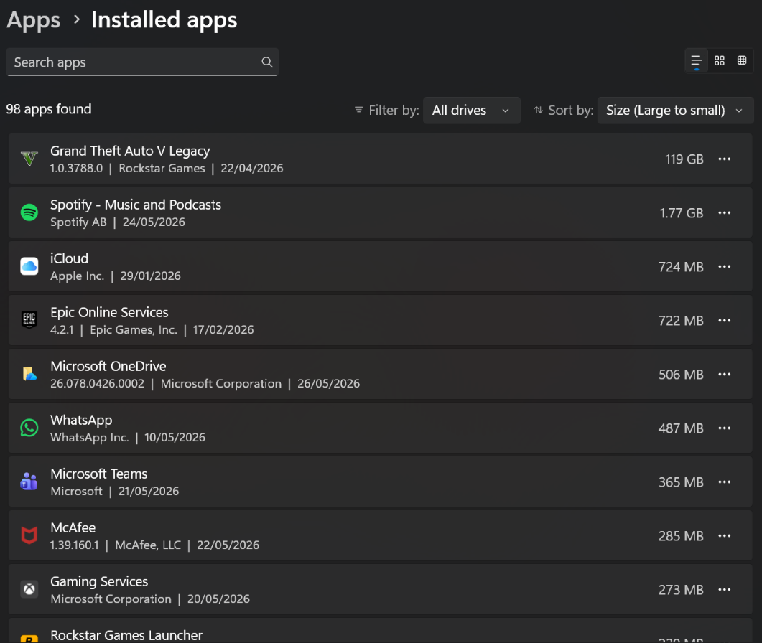
Figure 2: Description

File/Directory Management:
Write about in File/Directory Management windows. Use 1 reference minimum (100 words)
In this screenshot we see the File Explorer application, which is used to organize files and folders. [3]The computer's main locations are displayed on the left, while folders such as Program Files, Users, Windows, and other directories on the C: drive appear on the right. Using File Explorer, the user can create new folders, copy, move, or delete files, and quickly locate saved documents.
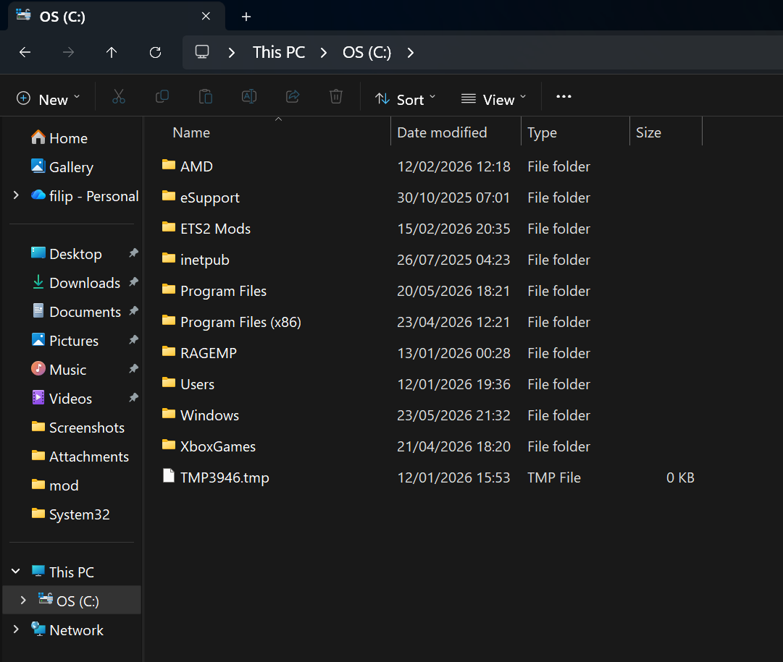
Figure 3: Description

Device Management:
Write about device management in windows. Use 1 reference minimum (100 words)
In this image shows Device Manager open the application used to manage the computer's hardware components. It displays all connected devices, such as the video card, network card, keyboard, mouse, and other components. [4] Users can verify that these devices are functioning correctly and update or reinstall drivers if issues arise. Drivers enable communication between Windows and the hardware; if a driver is missing or faulty, the corresponding device may not work properly.

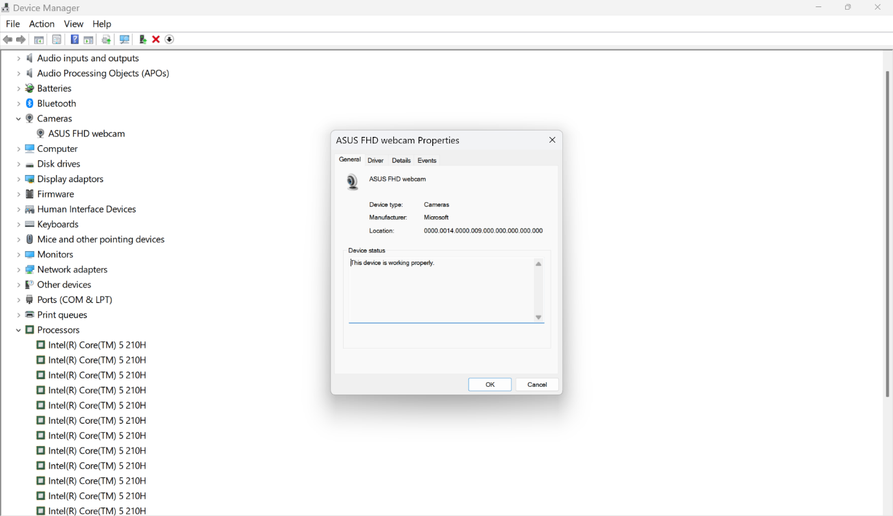
Figure 4: Description

Security Management:
Write about Security Management in windows. Use 1 reference minimum (100 words)
[5]This image shows the Windows Security app open. Who protects the computer against viruses, malicious programs, and other threats. From this app, the user can check if the antivirus is active, run a system scan, and view the firewall status. Options for account protection and app control are also available here. It is recommended to enable all these features to protect personal data and prevent the computer from becoming infected with malware.

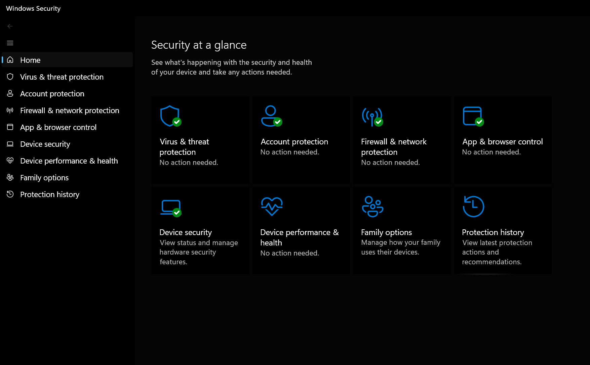
Figure 5: Description

Use of Windows OS CLI commands
Write about windows CLI functions and applications. Use 1-2 references. (40 words)
Command Prompt (CMD) is a Windows application that allows commands to be executed via the keyboard. Using these commands, you can navigate folders, create or delete directories, list existing files, and check information about the computer or the internet connection. Although most users rely on the graphical interface, Command Prompt is highly useful for system administration and for quickly performing various operations.[6]

Example 1:
Explain the command and output. (30 words)
The “dir” command is used in this example. It displays all files and folders in the current directory. Folders such as Documents, Downloads, Videos, and OneDrive can be seen in the image. The available free disk space is also displayed at the end. This command is useful when the user wants to view the contents of a folder.
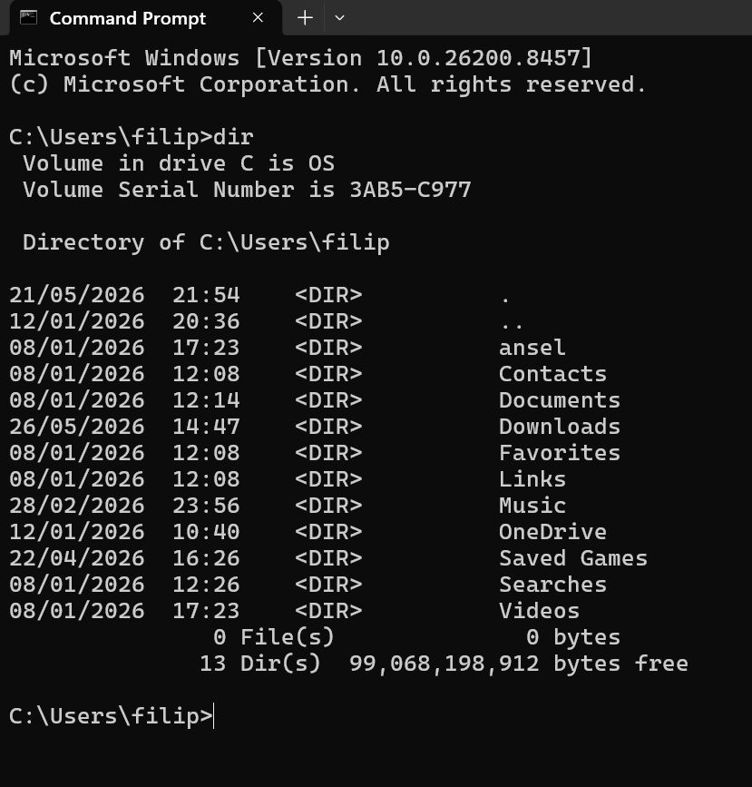
Figure 6: Description

Example 2:
Explain the command and output. (30 words)
This example uses the “cd” (Change Directory) command. With it, the user enters the Downloads folder, then uses “cd “ to return to the previous folder and navigates between directories again. This command is one of the most frequently used in Command Prompt because it allows for quick movement between folders.
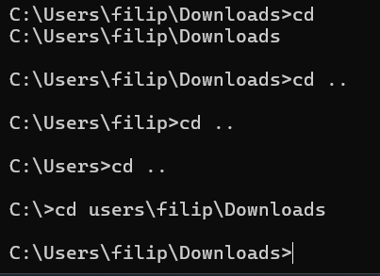
Figure 7: Description

Example 3:
Explain the command and output. (30 words)
This image shows the use of the “mkdir new” command. The command creates a new folder named "new". After executing the “dir” command, the new folder appears in the list of existing directories. This command is used to quickly create folders.

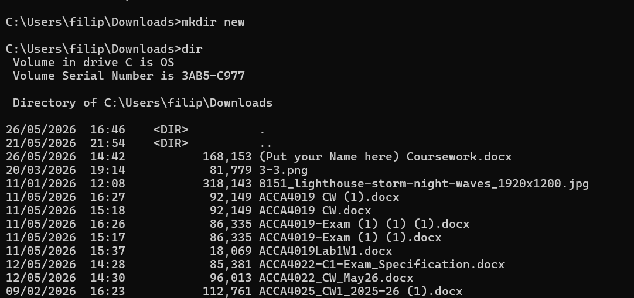
Figure 8: Description

Example 4:
Explain the command and output. (30 words)
In this example, a folder named `folder1` is created using the “mkdir” command and then deleted using the “rmdir” command. Finally, the “dir” command confirms that the folder no longer exists. These commands are used for directory management.

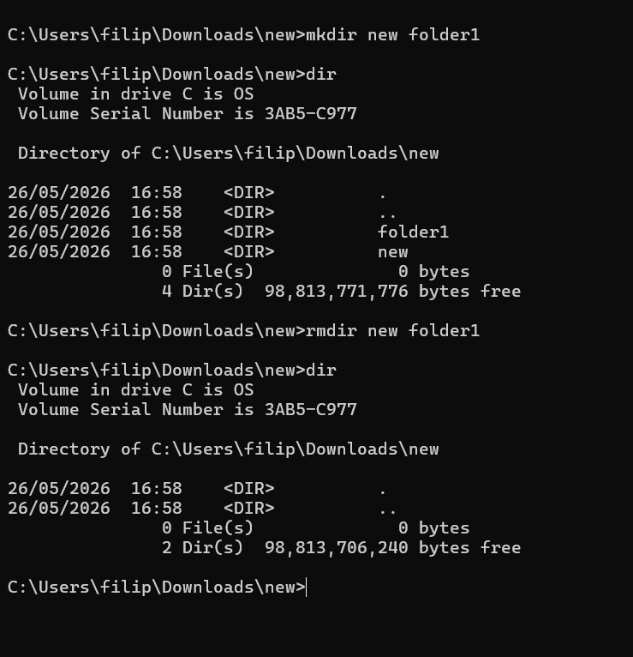
Figure 9: Description

Example 5:
Explain the command and output. (30 words)
In this example, the user navigates between several folders using the “cd” command. Finally, the following command is executed:
echo this is a sample > new.txt
This creates a text file named “new.txt” and writes the message "this is a sample" into it. The command is useful for quickly creating text files.

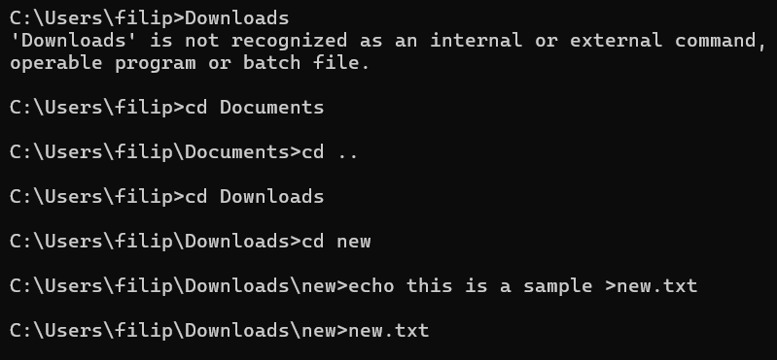
Figure 10: Description

Example 6:
Explain the command and output. (30 words)
The “ipconfig” command is used in this example. It displays information about the computer's network connection. The image shows the IPv4 address, subnet mask, and default gateway for the Wi-Fi connection. This information is very useful when there are internet issues or when the network configuration needs to be checked.

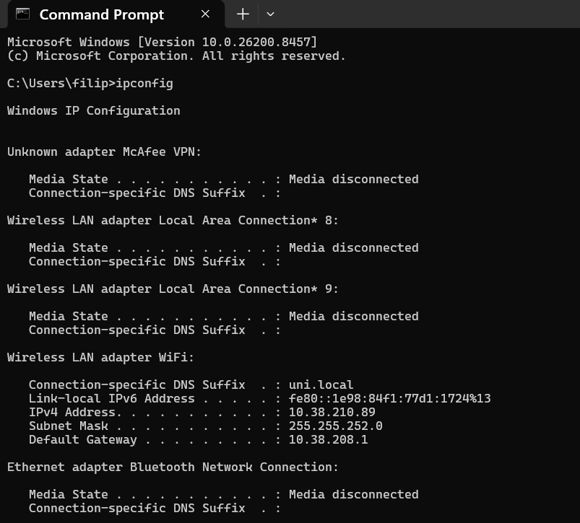
Figure 11: Description

Example 7:
Explain the command and output. (30 words) The netstat command displays all active TCP network connections. The output shows protocol types, local IP addresses with ports, connected foreign addresses, and current connection states like ESTABLISHED.
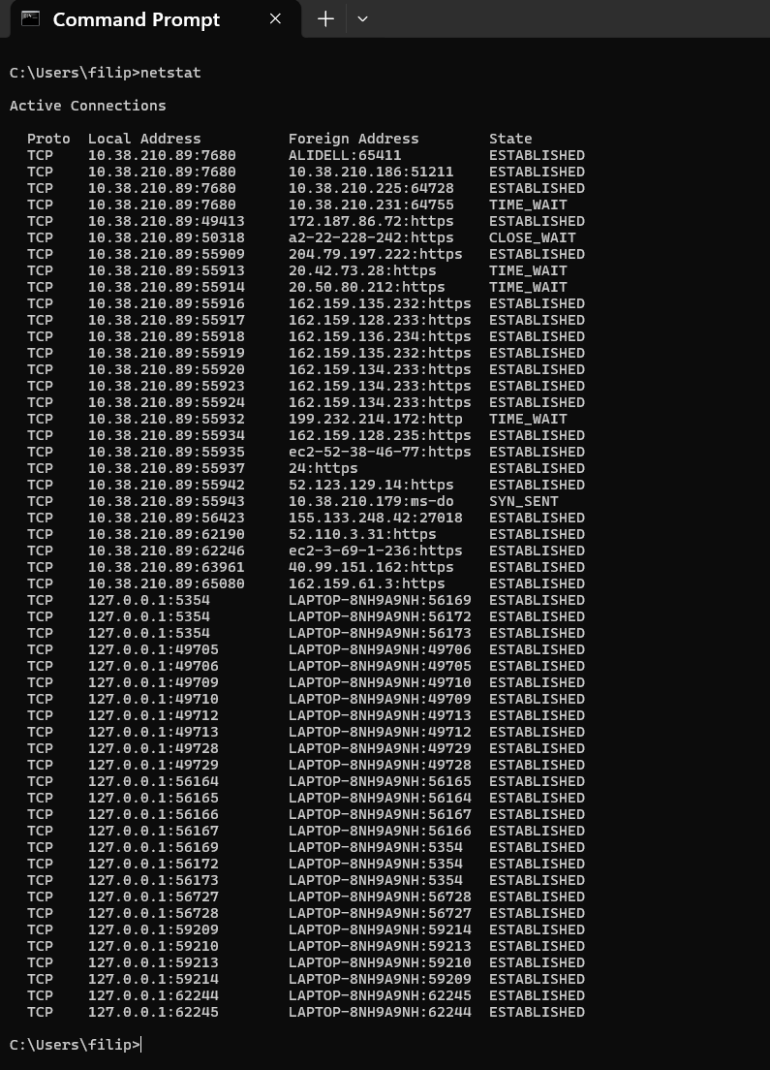
Figure 12: Description

Example 8:
Explain the command and output. (30 words)
Command and Output: The ping [www.google.com] checks the internet connection to Google (successful, average 100ms). Then, netstart is typed incorrectly, showing an error because it is not a valid command.
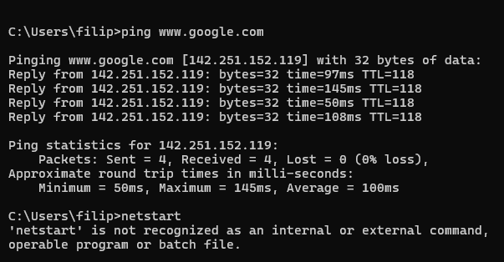
Figure 13: Description

Example 9:
Explain the command and output. (30 words)
Command and Output: The systeminfo command shows detailed information about the Windows operating system, computer name, processor, BIOS version, available RAM memory, and installed security updates (hotfixes) on the computer.
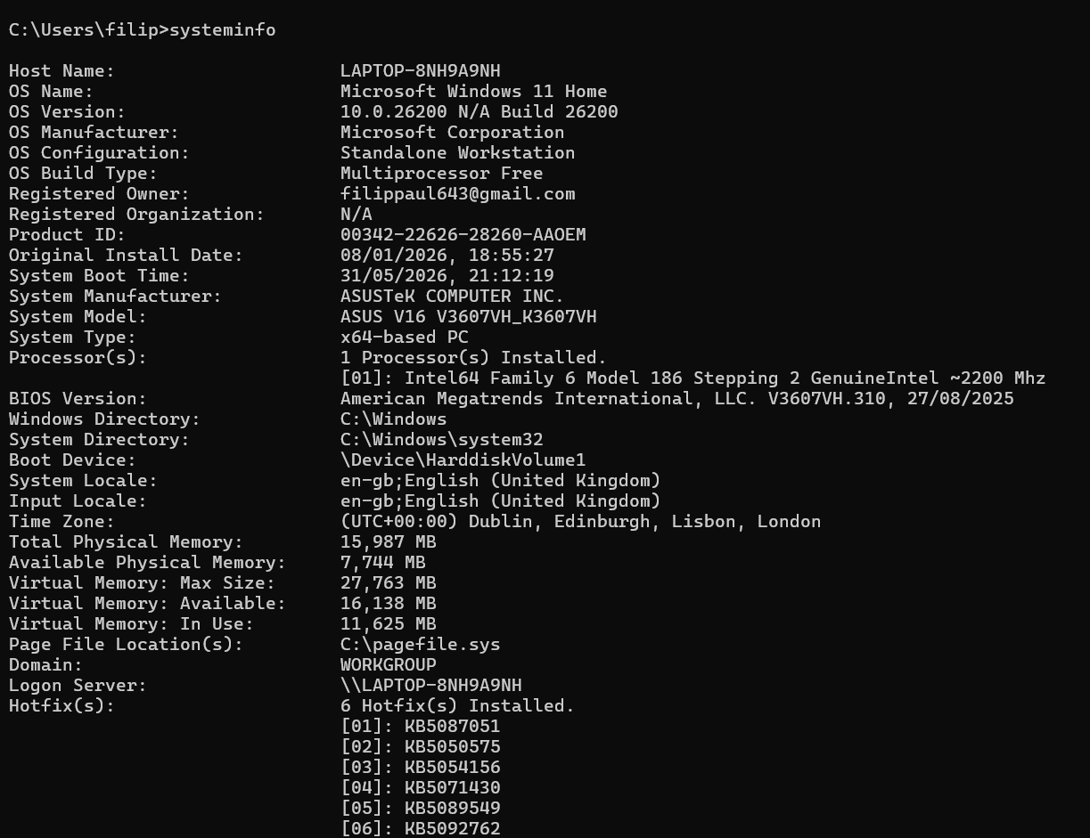
Figure 14: Description

Example 10:
Explain the command and output. (30 words)
Command and Output: The tasklist command shows all programs and processes currently running on the Windows system, including details like process name, ID (PID), session name, and RAM memory used.
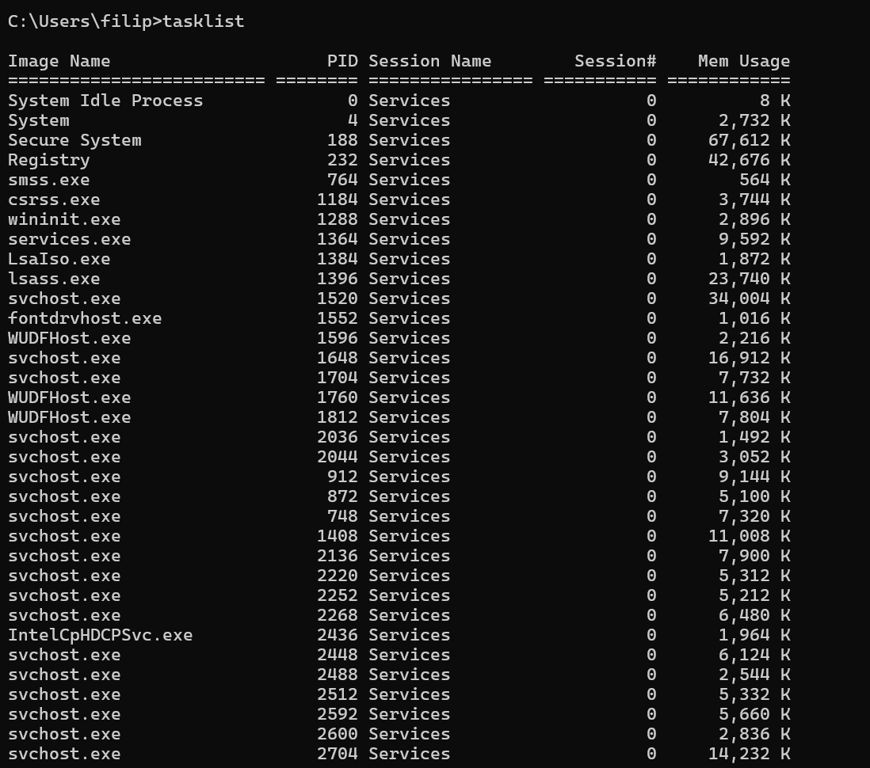
Figure 15: Description

Use of Linux OS CLI commands
Write about Linux CLI functions and applications. Use 1-2 references. (40 words)
The Linux Command Line Interface (CLI) allows users to manage files, processes, and networks easily using text commands. It is very important for managing servers and automating tasks (Shotts, 2019; Nemeth et al., 2017).

Example 1:
Explain the command and output. (30 words)
Command and Output: The su command attempts to log in as root, failing due to an incorrect password. Then, su sysadmin switches to the sysadmin account successfully after entering the correct password.
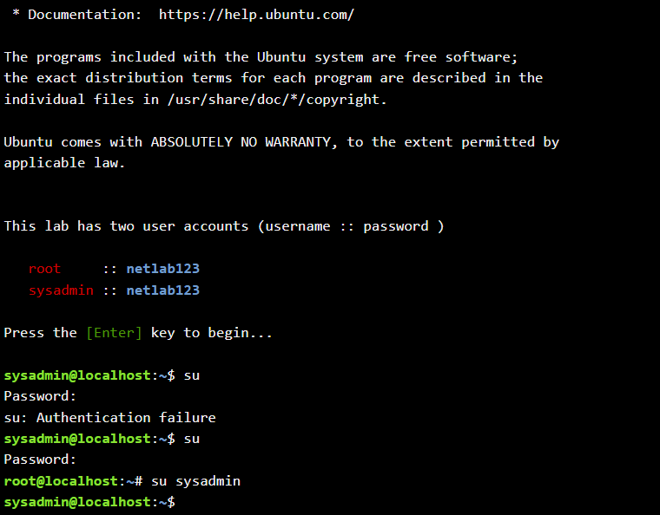
Figure 16: Description

Example 2:
Explain the command and output. (30 words)
Command and Output: ls lists visible contents. ls -a shows hidden files (starting with .). ls -l shows long format details like permissions, file size, owner, and date modified.
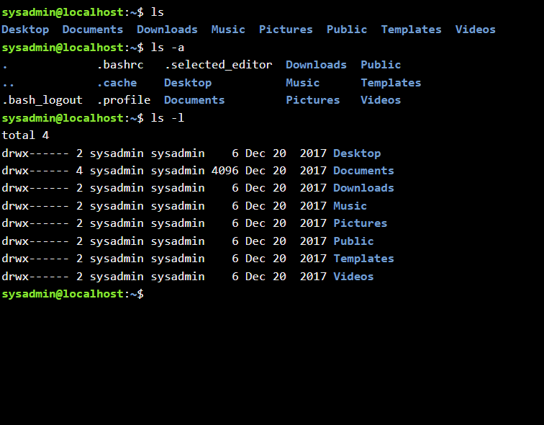
Figure 17: Description

Example 3:
Explain the command and output. (30 words)
Command and Output: The command cd Desktop/ changes the working directory from the user's home directory into the Desktop folder. The command line prompt updates to display ~/Desktop$.
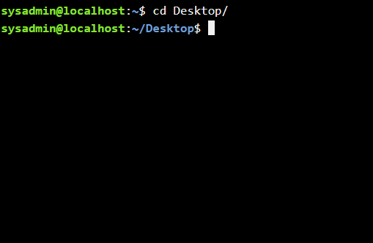
Figure 18: Description

Example 4:
Explain the command and output. (30 words)
Command and Output: cd Desktop/ navigates into the Desktop folder. The command pwd prints the complete absolute path of the current working directory, showing /home/sysadmin/Desktop.
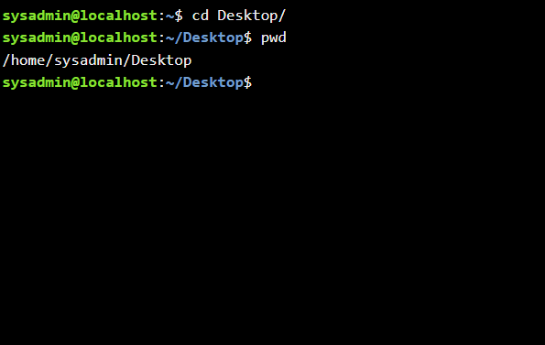
Figure 19: Description

Example 5:
Explain the command and output. (30 words)
Command and Output: The mkdir new command creates a new directory named new. Running ls lists the contents of the current folder, confirming that the directory new was created.

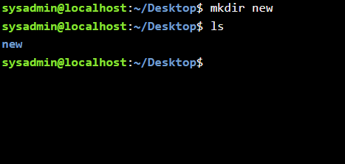
Figure 20: Description

Example 6:
Explain the command and output. (30 words)
Command and Output: The rmdir new command removes the empty directory named new. Running ls afterwards shows that only the folder new1 remains inside the current location.
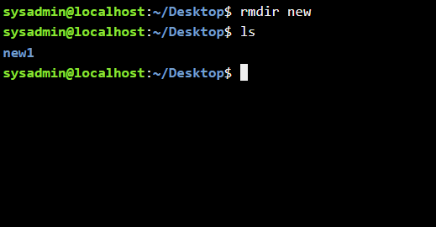
Figure 21: Description

Example 7:
Explain the command and output. (30 words)
Command and Output: rmdir new removes the new folder. touch new.txt creates an empty file named new.txt. Running ls verifies that new.txt and new1 are present.
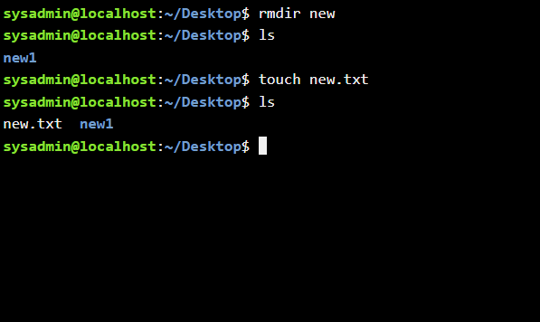
Figure 22: Description

Example 8:
Explain the command and output. (30 words)
Command and Output: echo hello > new.txt writes "hello" into new.txt. Running cat new.txt reads the file and outputs its contents ("hello") directly to the terminal screen.
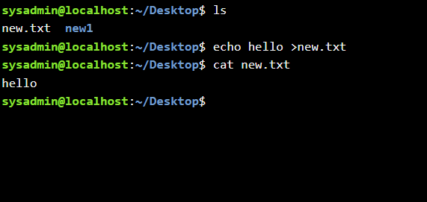
Figure 23: Description

Example 9:
Explain the command and output. (30 words)
Command and Output: The ifconfig command displays active network interfaces. It shows the IP address (192.168.1.2) for eth0, netmask, loopback interface (lo), and network traffic statistics for packets sent/received.
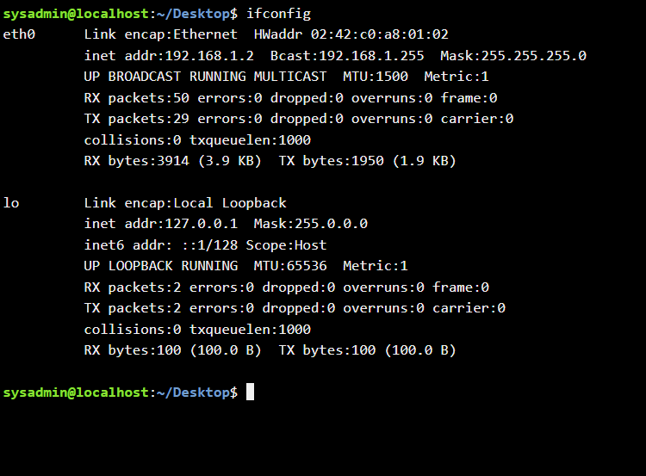
Figure 24: Description

Example 10:
Explain the command and output. (30 words)
Command and Output: The whoami command prints the current logged-in username (sysadmin). The date command prints the system's current date, time, time zone (UTC), and year (2026).
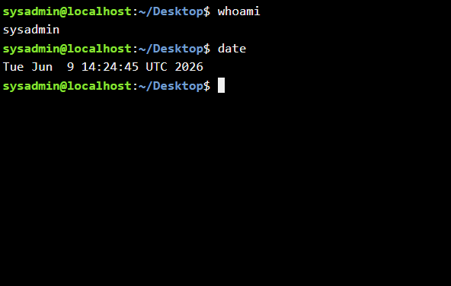
Figure 25: Description

Use of Windows OS scripts
Write about Batch scripting and its applications. Use 1-2 references. (50 words)
Batch scripting in Windows involves using .bat files filled with commands executed sequentially by cmd.exe. It is widely used by administrators to automate routine tasks, configure environment settings, perform system maintenance, and manage file operations efficiently without requiring manual user input for every step (Yosifovich et al., 2017).

Example 1:
Explain the script and output. (150 words)
-The Script (Figure 26): @echo off prevents individual commands from displaying on the terminal, making the script output clean. The set /p commands prompt the user to input two numbers (number1 and number2). The set /a total= number1 + number2 line performs an arithmetic addition of both values and assigns the answer to the variable total. echo displays the resulting sum, while pause holds the command window open until a key is pressed.
- The Output (Figure 27): The terminal window displays prompts asking the user to enter numbers. The user types 7 for the first number and 8 for the second number. The script calculates the values and outputs "The sum is 15", followed by the system text "Press any key to continue...".

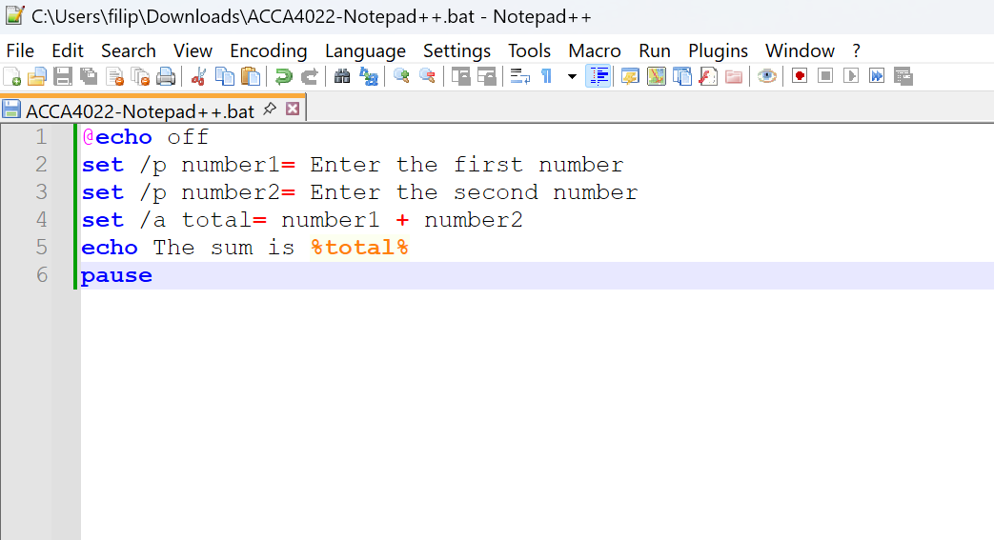
Figure 26: Description
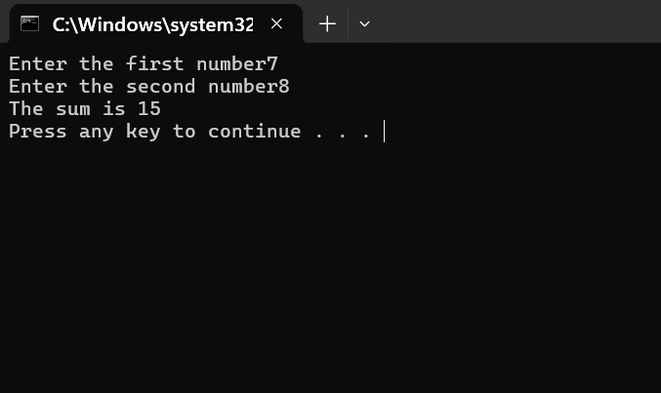
Figure 27: Descriptio

Example 2:
Explain the script and output. (150 words)
-The Script (Figure 28): This script checks voting eligibility based on age. @echo off hides command text. set /p age= asks the user to enter their age. The conditional statement if %age% geq 18 checks if the entered number is greater than or equal to 18 (geq). If true, it outputs "You are eligible to vote.". If false (else), it prints "You are not eligible to vote yet.". pause keeps the terminal window open.
-The Output (Figure 29): Two separate execution examples are demonstrated:
- Entering age 18 evaluates as true, printing "You are eligible to vote.".
- Entering age 6 evaluates as false, printing "You are not eligible to vote yet.".

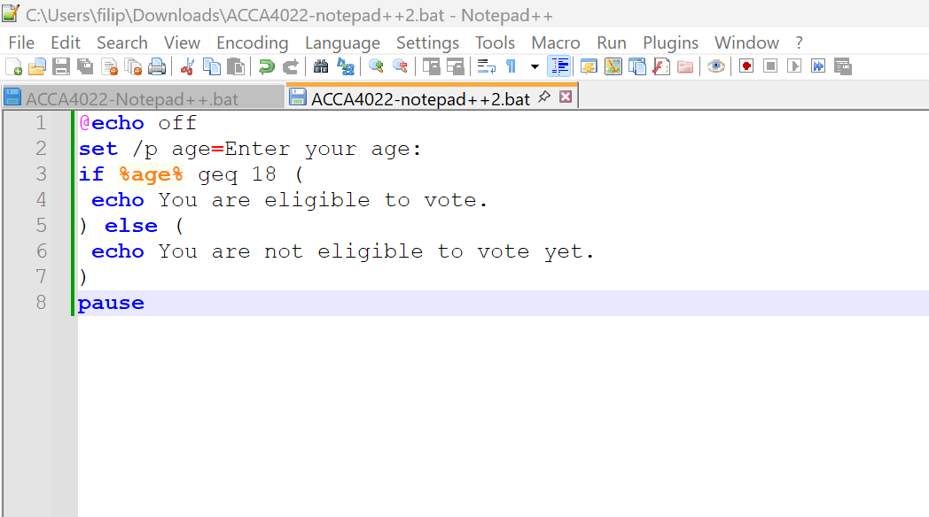
Figure 28: Description
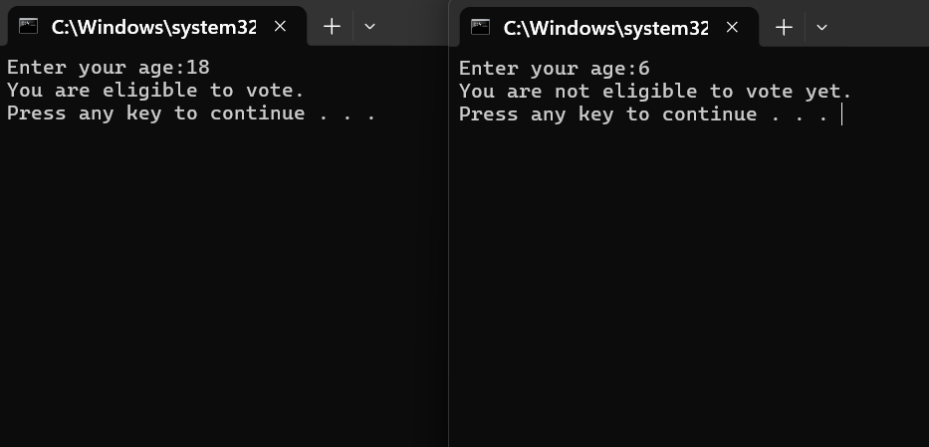
Figure 29: Description

Use of Linux OS scripts
Write about BASH scripting and its applications. Use 1-2 references. (50 words)
BASH scripting uses plain text files containing shell commands executed by the Bash shell interpreter. It is essential for Linux administration, allowing users to automate system tasks, process data files, handle system administration routines, and create complex programs using variables, loops, and conditional structures (Shotts, 2019).

Example 1:
Explain the script and output. (150 words)
-The Script (Figure 30): The script calculates the sum of two user-provided numbers. echo prints a prompt on the screen, and read num1 stores the user's input into num1. The process repeats for num2. The arithmetic syntax total=$((num1+num2)) calculates the total sum, and echo "The sum is $total" displays the final calculation.
-Execution & Output (Figure 31): The user creates exemple1.sh in nano and grants execution permissions using chmod +x exemple1.sh. Running ./exemple1.sh prompts the user for two inputs (45 and 78). The script computes the sum and outputs "The sum is 123".

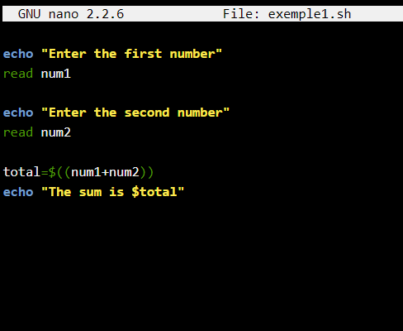
Figure 30: Description
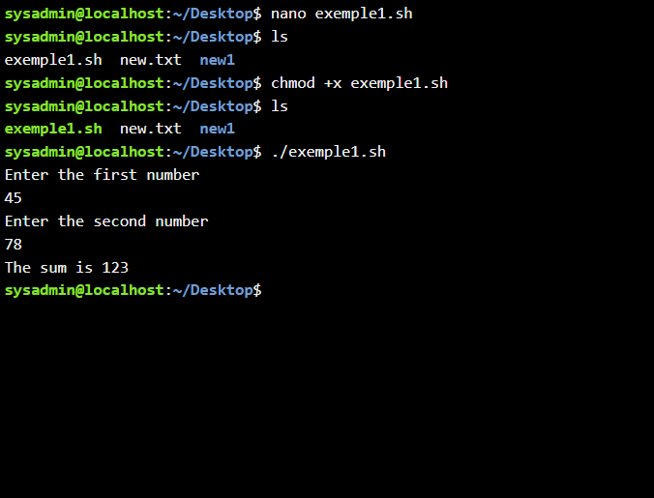
Figure 31: Description

Example 2:
Explain the script and output. (150 words)
-The Script (Figure 32): The script prints a sequence of numbers using a for loop. echo asks the user for a number, and read count stores the value. The loop for ((i=1; i<=count; i++)) sets counter variable i to 1 and increments it (i++) on each iteration until it reaches count. echo "$i" prints the current counter value.
-Execution & Output (Figure 33): After making the script executable using chmod +x loop.sh, running ./loop.sh asks "How many times you want to run?". The user enters 8, and the loop outputs numbers 1 through 8 sequentially on individual lines.

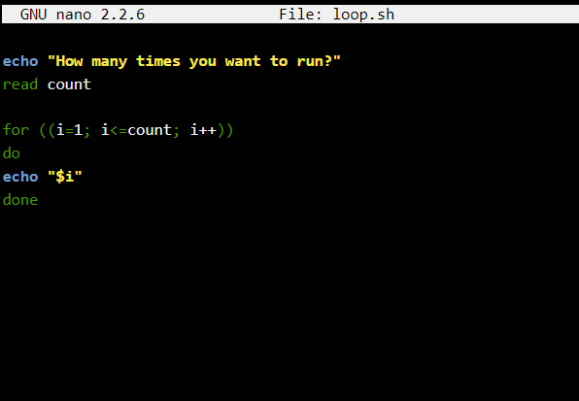
Figure 32: Description
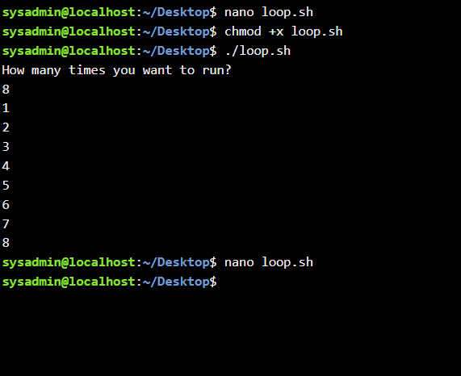
Figure 33: Description

Conclusion
Summarize the report and your understanding of these tasks. (50 words)
This course provided a practical overview of Windows and Linux environments. Through screenshots, I learned to manage installed apps, files, hardware, and security tools. Additionally, I mastered essential CLI commands and basic script automation in both operating systems to perform mathematical calculations, process control, and network diagnostics efficiently.

References
[1] P. Yosifovich, A. Ionescu, M. E. Russinovich, and D. A. Solomon, Windows Internals: System Architecture, Processes, Threads, Memory Management, and More, Part 1, 7th ed. Redmond, WA, USA: Microsoft Press, 2017.
[2] E. Bott, Windows 11 Inside Out. Redmond, WA, USA: Microsoft Press, 2022.
[3] E. Bott and C. Stinson, Windows 10 Inside Out, 2nd ed. Redmond, WA, USA: Microsoft Press, 2020.
[4] E. Bott and C. Stinson, Windows 10 Inside Out, 2nd ed. Redmond, WA, USA: Microsoft Press, 2020.
[5] A. Mueller, Windows 11 All-in-One. Hoboken, NJ, USA: John Wiley & Sons, 2022.
[6] C. Cowart and B. Knittel, Sams Teach Yourself Windows 10 in 24 Hours, 2nd ed. Indianapolis, IN, USA: Sams Publishing, 2018.

Appendices
Online Course name: INTRODUCTION TO CYBERSECURITY
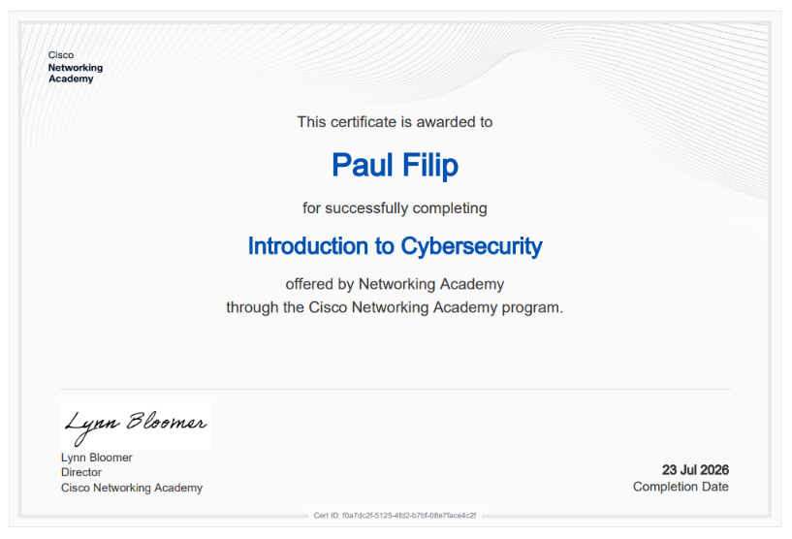
Figure 34: Certificate of completion

