Phase 1 – Preliminary Site Report – Swansea Bay Sports Park

Construction Technology

Joseph Lewis

2414282

Contents

Purpose
- Site Context
- Climate and Weather
- Geology
- Environment
- Codes of Practice
- Conclusion
- References

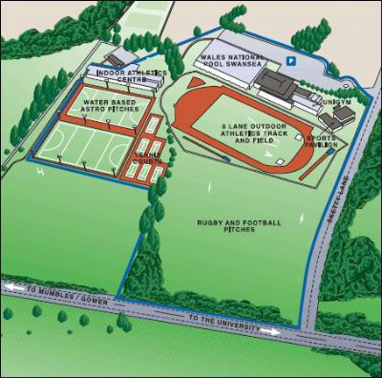

Figure 1 – Overview of the site with proposed building to be built on Rugby and Football Pitches area. (Google Images)

Purpose

I have been approached by a client with the intention of building a new hotel in the Swansea Bay area near the Swansea Bay Sports Park on Sketty Lane. I have been asked to do this as the client is inexperienced in Construction Technology and to better inform on using the land for the proposed hotel.

The client has specified the hotel to be medium to high rise and has tasked me with carrying out a preliminary site investigation and report describing and justifying my choices for:
- The Structural frame and exterior envelope of the building
- Material choice and form of construction
- The possible use of prefabricated elements of the hotel

As part of my report, I will be taking into consideration numerous factors such as:
- Ground conditions
- The Local Environment
- Local Weather
- Environmental and Community Impacts
- Sustainability

When researching the above points, I will be giving consideration to key health and safety factors of the building including structural strength and fire safety.

Site Context
The proposed development is located on the playing fields that form part of the Swansea Bay Sports Park which is very close to Singleton Hospital, Swansea University Campus and the Swansea Bay seafront. The site is relatively flat and has never previously been built upon so provides a prime piece of greenfield land to house the project.

A medium to high rise building located here would need to act as a landmark for the local area and help to support the tourism of the area. However, the size of the project should not overshadow the local area and must retain the tourism appeal that the Swansea Bay currently holds.

Local Climate and Weather
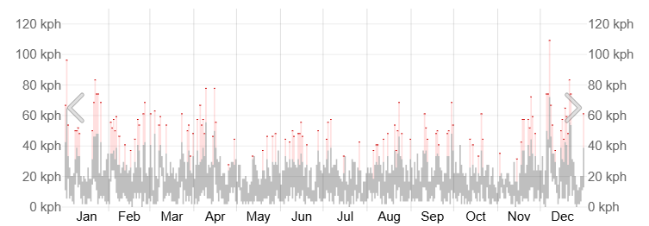
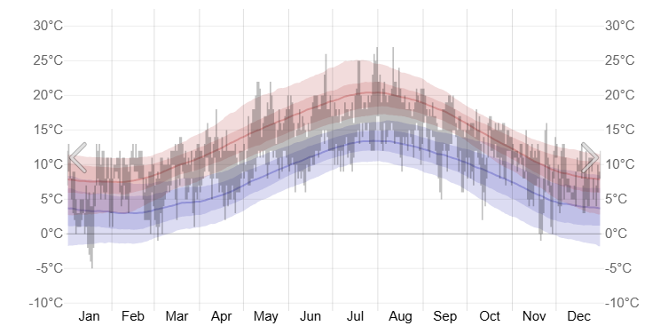
As the site is in an exposed coastal location, the building would need to be able to withstand more severe environmental conditions that what an inland site would. As shown in the weather reports below from 2024, Swansea can suffer heavily from wind and stormy weather. Winds of over 100 Kph have been recorded in winter months. Temperatures in the area rarely go above 30°C or below -5°C depending on the season and therefore wouldn’t provide many issues for the hotel.
Figure 2 – Wind and Temperature reports for Swansea in 2024 (Weatherspark)
For a medium to high rise building, serious wind considerations will need to be taken into account and therefore design will be critical to ensure both structural stability and comfort within the building. The building envelope will need to be robust enough to provide adequate shelter to the interior of the building.

Flood Risks
During extreme weather events, the risk of flooding in the Swansea Bay area is extremely high particularly so because of the proximity to the coast. According to the Swansea City Council Flood Risk Management Plan and flood risk survey maps, the proposed site, particularly the playing fields, is at a low risk. But areas adjacent to the site such as the Oystermouth Road and Singleton Park can be higher risk due to the River Clyne overflowing. As a recommendation, site specific flood surveys should be carried out to further understand the risk.
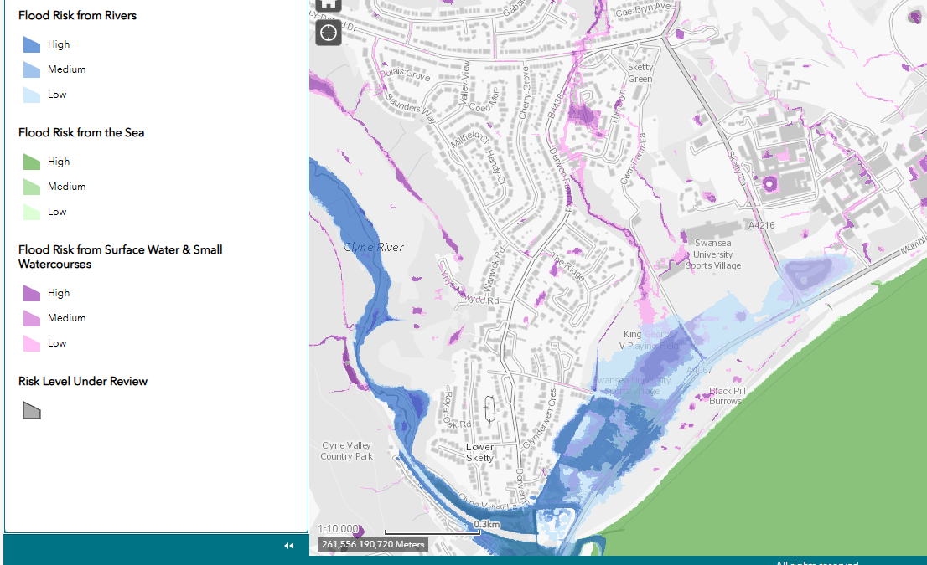
Figure 3 – Flood risk map showing the proposed site and adjacent areas. (Natural Resources Wales)

Ground Conditions

As stated previously, the site is a greenfield site meaning no previous buildings have been housed here. But there can still be issues with the materials within the ground on the site due to both the proximity of the site to the coast and other historical factors of the land. When researching ground conditions at the site, I collected some borehole surveys from the British Geological Survey (BGS).

The investigative boreholes were carried out close to the site in 1999, when the Wales National Pool was built, at a depth of 6 meters and reports show that the grounds below had a lot of sand and loose material present. This can indicate that the ground conditions on the site could be poor and could require deep piled foundations for a multi-story building. At the deeper levels of the borehole, the ground seems to get more dense but sand is still present so I would recommend carrying out investigative boreholes to a deeper level to fully understand what lies below.

It is also shown in the report that no groundwater was present during the boreholes, which would cause less problems in the foundations of the building and the construction of the building.

Also, as no definitive surveys have been carried out on the proposed site, I would recommend having a full geotechnical survey and borehole report carried out to fully understand the ground conditions.
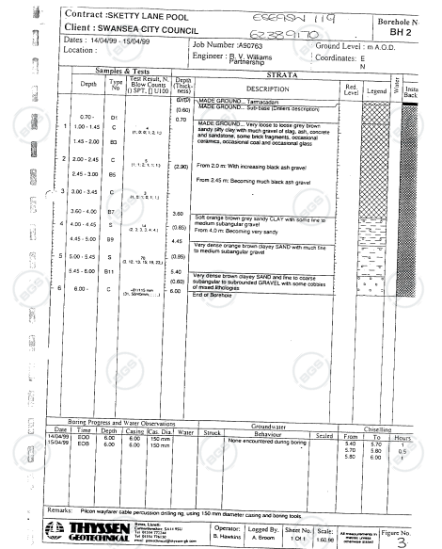
Figure 4 - Borehole report carried out in 1999 at the site of the National Pool Wales located close to the proposed site. (British Geological Survey)

Foundation
As the building is located in an exposed area, near the coast and could at the element of extreme weather conditions, serious considerations need to take place regarding the structural frame and stability of the building.
At foundation level and given the ground conditions previously spoken about, I would recommend the use of bored reinforced concrete piles that would provide a stronger base for a multi-story building. The depth of the piles would need to be determined via the geotechnical survey spoken about previously. The use of this foundation is recommended as it is able to transfer structural loads to deeper and more stable and competent strata. This is also more suitable for a multi-story building with large loads being placed on the ground below.
Once the pile foundations are in place, a reinforced concrete slab can be constructed above the piles to provide a better base for the ground floor and to reduce the amount of ground movement.

Structural Frame
Due to the building being specified to be a medium to high rise multi-story hotel and located close to the coast, the structural frame will be exposed to many extreme weather conditions and potential erosion of building materials over the lifespan of the building. Therefore, robust and suitable materials are recommended to be used around the building to maintain the structure, aesthetics, durability and fire safety of the building. This selection is a highly critical part of a project and must be able to respond appropriately to the environment.

Durability
From a durability perspective, a high recommendation for structural frame would be to utilise a reinforced concrete frame with a central reinforced concrete core as the primary structure. Reinforced concrete is able to perform well in wetter and windier environments and therefore provides a better structure than a steel frame in these conditions due to the probability of steel rusting and needing constant maintenance. Also, as there is a concrete core to this building, it can be utilised for lift shafts or stairwells for the hotel and acts as a primary lateral stability system helping to reduce the effect of high wind forces on the building.

Fire Safety
Fire safety is also a major factor in the construction of a hotel to ensure guests and workers stay safe and this can greatly affect the process of selecting a suitable structural frame. For example, a hotel would be required to perform well under fires because of the high number of people who could potentially be staying in the hotel and because of the complexity of the build. Reinforced concrete is again deemed as a more suitable material to be able to improve the fire safety of a building and is more robust. A stated previously, steel is a robust product but would require intumescent coatings regularly and maintenance to prevent the effects of a fire.

Acoustics and Vibration
The acoustics and vibration levels within a hotel are required to be very low due to the amount of people staying there and that they look to relax and rest when in a room. Due to this factor, a material that reduces this such as concrete is an important element to the buildings design and construction. Due to the high mass of concrete, it helps to reduce the impact of airborne sound and reduce it room to room. Also, the buildings upper floors would benefit greatly in terms of sound reduction if all floors were concrete floor slabs. This would further prevent the effects of sound into hotel rooms.

External material selection
The proposed building will need to be both aesthetically pleasing and will need to fit in with other buildings in the local area to improve the appeal to the local area and to keep current local residents pleased with the project. Because of this, aesthetics will need to be designed carefully and will play a major role in the construction of the project.

Cladding
As it is recommended that the building has a concrete structural frame, the building could benefit greatly from the use of cladding panels to make it more aesthetically pleasing. Due to the location and previously mentioned weather conditions, it would be recommended to use a durable type of cladding such as fibre cement or a marine grade aluminium to prevent regular maintenance and to withstand the strong winds, potential salty air and moisture from the coast.
Also, a major consideration in the selection of cladding panels will be their fire safety due to the building regulations in place from the disaster at Grenfell Tower in London. These regulations now state that all cladding panels on high rise buildings should be non-combustible. Also, cladding systems must now undergo rigorous fire performance testing to prevent a fire raging through a building.
Recently, construction work has taken place close to the proposed site at Singleton Hospital to replace and renew cladding panels on the building due to them being old and structurally degrading. The construction work included the replacement of all cladding panels on the main block of the hospital in a three phase process. A survey of the building found out that the panels had degraded and corroded because of the salty air from the coast and rainfall. Although Singleton Hospital is a brick construction building, similar processes can be used on the construction of the hotel and materials can be expected to last the same amount of time before needing maintenance or replacement.

Windows
Windows inside a hotel pose a major design process. Because of this, many factors are taken into consideration such as durability, acoustics and heating performance.
Aluminium windows are a popular choice of windows especially for buildings close to the coast because of the ability for them to be marine graded. A marine graded aluminium window is constructed from corrosion resistant aluminium alloys that are protected with a marine grade powder coating designed to maintain structural integrity and appearance in a costal environment. These properties give the windows a long lifespan and require low maintenance compared to timber or plastic frame windows.

Glazing
Glazing is a key component of a building’s envelope and, in the case of the proposed hotel, will be key in the building’s thermal performance, comfort and energy efficiency.
Given the medium to high rise design proposed for the hotel, the glazing will need to withstand significant wind pressure especially due to the coastal location. It is always recommended that, for external panes of glass, safety glass is recommended to be fitted to limit the risk of glass failure and breakage. As a recommendation, double or even triple glazing should be installed to further reduce noise within the building and to improve the thermal performance. Hotels should be able to maintain a comfortable environment in terms of temperature for its guests and should provide adequate safety especially at higher heights.
Also, if the building is to have a large glass façade, like many hotels usually do, further structural, thermal and lighting requirements will need to be met accordingly.

Prefabrication
Prefabrication of certain building elements has become more popular over recent times due to the reduced construction times and ease of construction of projects. Hotels are able to accommodate many prefabricated elements whether internal or external. For example, many hotels have utilised the use of prefabricated bathroom pods. This involves fully fitting a bathroom off site and craning into position once all services have been fitted on site. This can be useful for the amount of rooms that would require fitting out within a hotel and could drastically reduce the amount of site work and reduce construction times.
All prefabricated elements of a construction are quality controlled off site and go through rigorous testing before coming to site. They can also help if a site is restricted by access, space and can help a project become hybrid by combining traditional construction and prefabrication.

Conclusion
In conclusion to the above findings, I believe that a reinforced concrete structure would be a more suitable design compared to a steel frame structure. This is due to the weather conditions that expose the site both from the coast and exposed location. Local buildings within the area are also constructed using similar construction methods such as Singleton Hospital and this can help the building to fit in better within the environment and can make it more aesthetically pleasing for the area.
In addition to this, I believe this construction method would further enhance the appeal of the area to tourists and wouldn’t ruin the natural landscape that Swansea Bay is fortunate to have.
Both traditional and prefabrication methods can be used within the construction phase of the project to potentially decrease the timeline of construction and to make life on site easier for workers. Also, the design element of the project will be critical to ensure safety, comfort and compliance with Building Regulations.

References
Natural Resources Wales, (2026) Flood Risk and Coastal Erosion Maps (Online)
Available at: https://flood-risk-maps.naturalresources.wales/?locale=en (Accessed on 5th January 2026)
file:///C:/Users/JosephLewis/Downloads/Flood_Risk_Management_Plan_2015.pdf
Weatherspark, (2025) Historical Weather during 2024 in Swansea (Online)
Available at: https://weatherspark.com/h/y/37763/2024/Historical-Weather-during-2024-in-Swansea-United-Kingdom#google_vignette (Accessed on 6th January 2026)
Wales Online, (2024) Swansea Singleton Hospital New Look (Online)
Available at: https://www.walesonline.co.uk/news/health/swansea-singleton-hospitalnew-look-28733253 (Accessed on 9th January 2o26)
MPS Windows, (2024) Which Windows are best in a coastal location (Online)
Available at: https://www.mpswindows.co.uk/2024/09/27/which-windows-are-best-in-a-coastal-location/
(Accessed on 7th January 2026)
JLL, (2025) Why prefab methods stack up for hotels (Online)
Available at: https://www.jll.com/en-uk/insights/why-prefab-methods-stack-up-for-hotels
(Accessed on 6th January 2026)

HYB Construction, (2025) Understanding Reinforced Concrete Frames: Design, Benefits & Application Available at: https://www.hybconstructionltd.co.uk/blogs/understanding-rc-frames-in-construction
(Accessed 10th January 2026)

