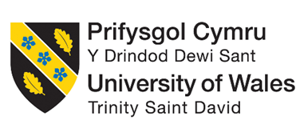
Programme: BA International Hotel Management
Module: Managing Hotel Administration
Module code: BMIH6004
LEVEL 6
Assignment Title: Student Learning Log
(Reflection on Administrative Role at Delta Hotels Newcastle Gateshead)

Lecturer name:Kathryn Roberts
Student Name: Andreea Catalina Mecic
ID:2215573

Table of Contents
Introduction 1
Section 1: Reflection on Experience and Personal Development 1
Section 2: Critical Analysis of Work-Based Skills and Technical Knowledge 3
Section 3: Reflection on Organisational Issues 4
Section 4: Future Action Plan 4
Conclusion 5
References 6
Appendix 1

Introduction
During my placement at Delta Hotels Newcastle Gateshead, I was involved in the administrative functions of the hotel which are crucial to the effective functioning of departments ranging from reception to the human resources and finance departments (Bardi, 2010). The administration organizes and plans work, and controls communication flows and resources to provide effective work and satisfy the customers. As a result of the placement learning, specific learning objectives were developed to enhance the knowledge and proficiency in administrative tasks as well as technical and interpersonal skills (Wood, 2013). Primarily, I planned to observe the supervisory responsibilities of managers within the administrative division, advance in technical know-how about communication, and enhance issue-solving skills in the process of organization of resources and guests.

Section 1: Reflection on Experience and Personal Development
During my placement, I followed a supervisory position, which allowed gaining valuable experiences in delegation of assignments, team organization, and problem solving. By actively engaging myself in the implementation of the health facility, I was in a position to identify how administrative duties and commitments can be observed without compromising the quality of the services offered and how certain challenges can be handled (Channell, 2023).
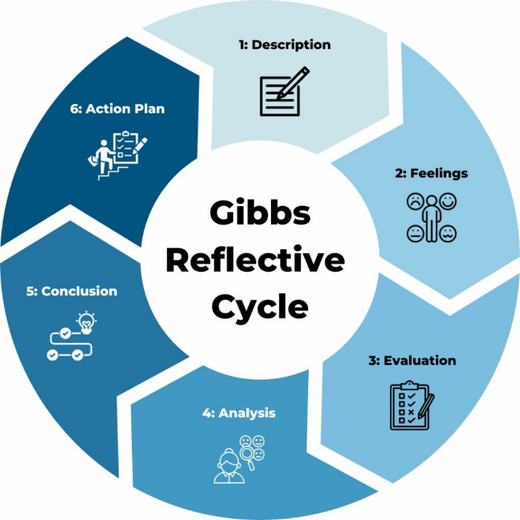
Figure 1 Gibbs’ Reflection Model; Source: (Channell, 2023)
Description
I also saw the supervisor supervising the management of the interaction of tasks in different departments, staff rostering and resource organization. I was also actively involved in overseeing the completion of tasks, helping with data input of performance reports, and addressing small customer complaints regarding the bill (Channell, 2023).
Feelings
The tasks I was carrying out gave me a feeling of stress and nervousness about my capacity to perform complex administrative tasks and interact with the team members. It was a bit nerve-wracking but gradually, I noticed an improvement across the three aspects that were being observed as well as self-confidence, especially after a challenging time-sensitive assignment and after my supervisor complimented me on my work.
Evaluation
I could note that it was a very interesting experience because it offered practical experience in solving some real-time problems. One of them was an improvement of communication skills through interaction with other team members. Nevertheless, some challenges were observed when working on the project during periods of high activity, which caused inaccuracies in some records of resources (Aldabbagh et al., 2022).
Analysis
The experience was useful in illustrating major aspects like the need to; I now understand that departmental updates reduce delays and errors (ASET, 2017). I learnt from the theory that proactive cooperation helps complete tasks and increases guest satisfaction, proving the effectiveness of communication and organisation.
Conclusion
This means that being calm while working and asking for clarification from the supervisors was an effective way of avoiding common mistakes. The exercise reiterated a very crucial and relevant attribute, flexibility, which I shall further enhance. Also, I found out that communication was critical throughout the teams to ensure that tasks were well completed.
Action Plan
In my future work, I will try to make it a practice to come together with the team during the moments when crucial tasks are being completed with the idea of avoiding misunderstandings and sorting things out (Haag, 2013). I will also make a checklist to monitor the progress of the tasks and the resource usage to avoid making mistakes as well as increase efficiency.

Section 2: Critical Analysis of Work-Based Skills and Technical Knowledge
When I was in my placement, I considered several other pertinent work-related competencies that were crucial to my learning during my placement, work organization and planning, teamwork, and interpersonal communication within the administrative setting (Haag, 2013). Therefore, the prudent use of time enabled me to schedule my administrative duties properly and complete these tasks within the set timeframe. I also engaged in teamwork during the allocation of resources and in departmental planning meetings where it is arranged who should undertake which task. In the same way, the aspect of communication was embraced in the monitoring and avoiding of misunderstandings between departments and enhancing service delivery (Wood, 2013).
Such task management and operational software like hotel management systems for bookings and performance tracking helped this learning process. I often used applications to track activities and report pending tasks to the supervisor (Haag, 2013). By doing so, I realised some performance areas needed immediate attention. Technical proficiency was used to correct a guest billing error using service recovery.
I linked these practical activities with the concepts from Kolb’s experiential learning cycle, which underlines the use of the acquired knowledge in practice. The problem-solving and decision-making that is required in the administrative setting helped me to develop critical thinking and cooperative skills (ASET, 2017). For instance, while in a departmental meeting, I proposed that duties be reallocated among available employees to address a tight deadline and prevent any compromise of services; thereby promptly attending to the guests’ demands. This showed that decision-making could be most effective when made practically with the help of cooperation.

Section 3: Reflection on Organisational Issues
While on my placement, I noted a major communication gap between the front office and the administration concerning the latest development on guest booking changes. That was because the information transfer was slow, and this led to some guests being assigned to the wrong rooms, therefore, were not happy with the rooms allocated to them and the reception team had to ensure that all those problems were corrected within the shortest time possible (Casado, 2012).
It directly slowed department delivery of guest requests. Work organisation was affected because correcting miscommunication messages took more time than performing administrative tasks. Guests complained about late check-ins and wrong billing, which were fixed.
In the given case, I used Shannon and Weaver's communication model because it emphasises message encoding and decoding to avoid distortion (Goby and Hiba, 2023). The inability to provide accurate booking updates showed that noise—interruptive communication—can hinder an organization's operations. This theory led me to discover a process gap—the hotel's communication channels' inconsistent updates.
I proposed feasible measures that follow the SEP's departmental operational policies. I suggested starting the day with briefings to inform new team members of important information that may change (Heyes, 2017). I also suggested adding an alert system to the hotel's software to notify departments of booking changes. These measures would improve communication, reduce errors, and improve guest service.

Section 4: Future Action Plan
This placement has played a significant role in shaping my future career goal as it equipped me with valuable knowledge of what goes on behind the scenes of the hospitality industry about management and how to handle different issues that arise in an organization (QAA, 2018). Thus, I now see myself in a leadership position in which I will be able to enhance the organisational performance as well as guests’ satisfaction through the application of technical and people skills.
To further build up the key skills, the following shall be achieved: Leadership: This skill can be attained through learning and exposure to practical experience (Wood, 2013). This way I will strive to ensure that I participate in more cross-functional projects so that I can be able to develop good decision-making under different scenarios. That is why I plan to attend leadership development courses to enhance my skills in managing teams. I also aim to practice reflection often and use tools such as Gibbs’ cycle of reflection among others to assess my work output and work towards improvement on the role I play in future administrations.

Conclusion
From this placement, I was able to learn more about how to manage tasks, communicate across the departments and solve problems within the administrative set-up of a hotel. These skills include; The ability to work in a team, good technical skills and the ability to perform well under pressure. Shadowing was beneficial for developing my knowledge of hotel administration because it made me see how the administration of a hotel is established through the smooth coordination of resources and decision-making processes to meet the needs of the guests. These aspects have enhanced my capacity for applying theoretical concepts as well as practical skills in future professional practice in the hospitality industry.

References
Aldabbagh, A., Neyazi, D., Alsahafi, M., Sarhan, A. and Palaniswamy, T. (2022). Improving the Quality of The Housekeeping Management Process for Stay at Bridge Suites Hotel. Journal of Advances in Humanities Research, 1(1), pp.26–41. doi:https://doi.org/10.56868/jadhur.v1i1.9.
ASET (2017). A good practice guide for placement and other work-based learning opportunities in higher education. Moorfoot: Aset.
Bardi, J.A. (2010). Hotel Front Office Management, 5th Edition. Wiley Global Education.
Casado, M.A. (2012). Housekeeping management. Hoboken, N.J.: John Wiley & Sons.
Channell, M. (2023). Gibbs Reflective Cycle – How to Learn from Experience and Become a Better Leader. [online] TSW Training. Available at: https://www.tsw.co.uk/blog/leadership-and-management/gibbs-reflective-cycle/.
filbert, fernan & (2024). Problem Solving in Hospitality Industry. [online] Medium. Available at: https://medium.com/@fernanfilbert/problem-solving-in-hospitality-industry-12fa805d64d4.
Goby, J. and Hiba, A. (2023). The Shannon and Weaver Model of Communication at Work. [online] Human Focus. Available at: https://humanfocus.co.uk/blog/the-shannon-and-weaver-model-of-communication-at-work/.
Haag, E. (2013). Internship guide : work placements step by step. The Hague: Eleven International Publishing, Cop.
Heyes, A. (2017). Hotel front office management. Routledge eBooks, 2(22), pp.57–69. doi:https://doi.org/10.4324/9781315169965-5.
QAA (2018). UK Quality Code for Higher Education Advice and Guidance Work-based Learning. [online] Available at: https://www.qaa.ac.uk/docs/qaa/quality-code/advice-and-guidance-work-based-learning.pdf?sfvrsn=f625c181_2.
Tewari, J.R. (2009). Hotel front office : operations and management. New Delhi ; New York: Oxford University Press.
Wood, R.C. (2013). Key concepts in hospitality management. London Etc.: Sage.

Appendix
Acknowledgement of the Use of AI

RESEARCH | For this assessment, you can use Generative AI to support you in research, including searching for bibliography, and using tools to summarise, compare and  interrogate materials. | Yes ☐  No ☐✔
STRUCTURE | For this assessment, you can use Generative AI to support you in structuring your submission, including creating a draft argument structure, identifying parts  and headings, etc. | Yes ☐  No ☐✔
PROOFREADING | For this assessment, you can use Generative AI to check your own text/creation for grammatical and syntactical mistakes, including rephrasing of your  own work within specific standards. | Yes ☐  No ☐✔
WRITING | For this assessment, you can use Generative AI to create text for submission. | Yes ☐  No ☐✔
CREATIVE | For this assessment, you can use Generative AI to create creative materials, such as images. | Yes ☐  No ☐✔
PROGRAMING | For this assessment, you can use Generative AI to create and check code. | Yes ☐  No ☐✔
NONE | For this assessment, you are not allowed to use any type of Generative AI support. This includes research support, structure support, writing/proofreading  support and creative support. | Yes ☐✔  No ☐

Basic Acknowledgement format of AI tool use
I acknowledge the use of Grammarly (https://www.grammarly.com/) on 25 February 2025 to check my work using the prompt(s):
- Please check the following text for readability, grammar and syntax.
I confirm that I have not presented any AI generated text as my own work. I confirm I have copies of my drafts, notes, and other resources I used before, and after the use of AI tools which I may be asked to provide in evidence.

