


LOCATION: SWANSEA | LLEOLIAD: abertawe
LEVEL 6 | LEFEL 6
EXAMINATION PERIOD | CYFNOD ARHOLIADAU
jANUARY 2019 | IONAWR 2019

MODULE CODE: M6X01084
ADVANCED ROUTING

Name :

Student ID :

Date & Time :

This is an individual practical lab-test, held under examination conditions. You will be assigned three Routers, you should configure these Routers based on the following specifications.

The routers that you will configure are: R1, R2, and R3.
The switches that you will configure are: S1, S2, and S3.

This paper is marked out of 100.

You will have 2 hours to complete this task.

Topology
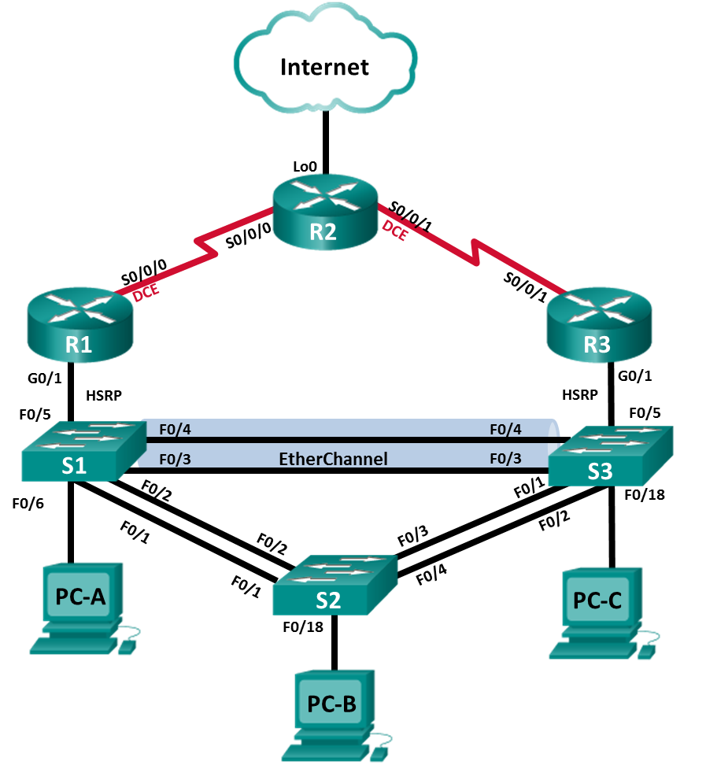
Addressing Table
Device | Interface | IP Address | Subnet Mask | Default Gateway
R1 | G0/1 | 172.27.0.1 | 255.255.255.0 | N/A
R1 | S0/0/0 | 172.27.123.1 | 255.255.255.252 | N/A
R2 | S0/0/0 | 172.27.123.2 | 255.255.255.252 | N/A
R2 | S0/0/1 | 172.27.123.5 | 255.255.255.252 | N/A
R2 | Lo0 | 209.165.200.225 | 255.255.255.248 | N/A
R3 | G0/1 | 172.27.0.3 | 255.255.255.0 | N/A
R3 | S0/0/1 | 172.27.123.6 | 255.255.255.252 | N/A
S1 | VLAN 1 | 172.27.0.11 | 255.255.255.0 | 172.27.0.2
S2 | VLAN 1 | 172.27.0.12 | 255.255.255.0 | 172.27.0.2
S3 | VLAN 1 | 172.27.0.13 | 255.255.255.0 | 172.27.0.2
PC-A | NIC | 172.27.0.21 | 255.255.255.0 | 172.27.0.2
PC-B | NIC | 172.27.0.22 | 255.255.255.0 | 172.27.0.2
PC-C | NIC | 172.27.0.23 | 255.255.255.0 | 172.27.0.2
Assessment Objectives
Part 1: Initialize Devices
Part 2: Configure Device Basic Settings
Part 3: Configure LAN Redundancy and Link Aggregation
Part 4: Configure EIGRP for IPv4 Dynamic Routing Protocol
Part 5: Verify Network Connectivity and HSRP Configuration
Scenario
In this Skills Assessment (SA), you will create a small network. You must connect the network devices, and configure those devices to support IPv4 connectivity, LAN redundancy, and link aggregation. You will then configure EIGRP for IPv4 on the network and verify connectivity and HSRP.
- Initialize Devices
  - Initialize and reload the routers and switches.
Erase the startup configurations and reload the devices.
Task | IOS Command | Points
Erase the startup-config file on all routers. |  | (1 points)
Reload all routers. |  | (1 points)
Erase the startup-config file on all switches and remove the old VLAN database. |  | (1 points)
Reload all switches. |  | (1 points)
Verify that the vlan.dat file is not found in flash on all switches. |  | (1 points)
- Configure Device Basic Settings
  - Configure R1.
Configuration tasks for R1 include the following:
Configuration Item or Task | Specification | Points
Disable DNS lookup |  | (1/2 point)
Router name | R1 | (1/2 point)
Interface G0/1 | Set the description  Set the Layer 3 IPv4 address. Refer to the Addressing Table for IPv4 address information.  Activate interface | (1 point)
Interface S0/0/0 | Set the description  Set the Layer 3 IPv4 address. Refer to the Addressing Table for IPv4 address information.  Set a clocking rate of 128000.  Activate interface | (2 points)

  - Configure R2.
Configuration tasks for R2 include the following:
Configuration Item or Task | Specification | Points
Disable DNS lookup |  | (1/2 point)
Router name | R2 | (1/2 point)
Interface S0/0/0 | Set the description  Set the Layer 3 IPv4 address. Refer to the Addressing Table for IPv4 address information.  Activate interface | (1 point)
Interface S0/0/1 | Set the description  Set the Layer 3 IPv4 address. Refer to the Addressing Table for IPv4 address information.  Set a clocking rate of 128000.  Activate interface | (2 point)
Interface Loopback 0 (Simulated Internet connection) | Set the description.  Set the Layer 3 IPv4 address to 209.165.200.225/29. | (1 point)
Default route | Configure a default route out Lo0. | (1/2 point)

  - Configure R3.
Configuration tasks for R3 include the following:
Configuration Item or Task | Specification | Points
Disable DNS lookup |  | (1/2 point)
Router name | R3 | (1/2 point)
Interface G0/1 | Set the description  Set the Layer 3 IPv4 address. Refer to the Addressing Table for IPv4 address information.  Activate interface | (1 point)
Interface S0/0/1 | Set the description  Set the Layer 3 IPv4 address. Refer to the Addressing Table for IPv4 address information.  Activate interface | (1 points)

  - Configure S1.
Configuration tasks for S1 include the following:
Configuration Item or Task | Specification | Points
Disable DNS lookup |  | (1/2 point)
Switch name | S1 | (1/2 point)
Assign an IPv4 address to the default SVI. | Refer to the Addressing Table for IPv4 address information. | (1 point)
Assign the default-gateway. | Refer to the Addressing Table. | (1 point)
Force trunking on Interfaces connected to S2 and S3. | Use VLAN 1 as the native VLAN. | (1 points)
Disable the Dynamic Trunking Protocol (DTP) on all other ports. | Make sure ports are configured as access switchports. | (1 point)

  - Configure S2.
Configuration tasks for S2 include the following:
Configuration Item or Task | Specification | Points
Disable DNS lookup |  | (1/2 point)
Switch name | S2 | (1/2 point)
Assign an IPv4 address to the default SVI. | Refer to the Addressing Table for IPv4 address information. | (1 point)
Assign the default-gateway. | Refer to the Addressing Table. | (1 point)
Force trunking on Interfaces connected to S1 and S3. | Use VLAN 1 as the native VLAN. | (1 points)
Disable the Dynamic Trunking Protocol (DTP) on all other ports. | Make sure ports are configured as access switchports. | (1 point)

  - Configure S3
Configuration tasks for S3 include the following:
Configuration Item or Task | Specification | Points
Disable DNS lookup |  | (1/2 point)
Switch name | S3 | (1/2 point)
Assign an IPv4 address to the default SVI. | Refer to the Addressing Table for IPv4 address information. | (1 point)
Assign the default-gateway. | Refer to the Addressing Table. | (1 point)
Force trunking on Interfaces connected to S1 and S2. | Use VLAN 1 as the native VLAN. | (1 points)
Disable the Dynamic Trunking Protocol (DTP) on all other ports. | Make sure ports are configured as access switchports. | (1 point)

  - Configure IPv4 addresses on PCs.
Configuration Item or Task | Specification | Points
Configure static IPv4 address information on PC-A. | Refer to Addressing Table for IPv4 address information. | (1/2 point)
Configure static IPv4 address information on PC-B. | Refer to Addressing Table for IPv4 address information. | (1/2 point)
Configure static IPv4 address information on PC-C. | Refer to Addressing Table for IPv4 address information. | (1/2 point)

- Configure LAN Redundancy and Link Aggregation
  - Configure Spanning Tree on S1.
Configuration tasks for S1 include the following:
Configuration Item or Task | Specification | Points
Configure Rapid PVST+. |  | (1 points)
Configure as primary root bridge for VLAN 1. |  | (1 points)
Configure PortFast and BPDU Guard on the interface connected to PC-A. |  | (1 points)

  - Configure Spanning Tree on S2.
Configuration tasks for S2 include the following:
Configuration Item or Task | Specification | Points
Configure Rapid PVST+. |  | (1 points)
Configure PortFast and BPDU Guard on the interface connected to PC-B. |  | (1 points)

  - Configure Spanning Tree on S3.
Configuration tasks for S3 include the following:
Configuration Item or Task | Specification | Points
Configure Rapid PVST+. |  | (1 points)
Configure as secondary root bridge for VLAN 1. |  | (1 points)
Configure PortFast and BPDU Guard on the interface connected to PC-C. |  | (1 points)

  - Configure HSRP on R1.
Configuration tasks for R1 include the following:
Configuration Item or Task | Specification | Points
Configure the HSRP virtual IP address on interface G0/1. | Group: 1  Virtual IP address: 172.27.0.2 | (1 points)
Make this the primary HSRP router. |  | (1 points)
Configure this router to become the primary HSRP router on a reboot. |  | (1 points)

  - Configure HSRP on R3.
Configuration tasks for R3 include the following:
Configuration Item or Task | Specification | Points
Configure the HSRP virtual IP address on interface G0/1. | Group: 1  Virtual IP address: 172.27.0.2 | (1 points)

  - Configure an LACP EtherChannel between S1 and S3.
Configuration tasks include the following:
Configuration Item or Task | Specification | Points
On S1, configure an LACP EtherChannel on interfaces connected to S3. | Use group 1 and enable LACP unconditionally. | (1 points)
On S3, configure an LACP EtherChannel on interfaces connected to S1. | Use group 1 and enable LACP only if a LACP device is detected. | (1 points)

- Configure EIGRP for IPv4 Dynamic Routing Protocol
  - Configure EIGRP on R1.
Configuration tasks for R1 include the following:
Configuration Item or Task | Specification |  | Points
Autonomous System (AS) number | 1 |  | (1 point)
Router ID | 1.1.1.1 |  | (1 points)
Advertise directly connected networks. | Use classless network addresses. |  | (5 points)
Set all LAN interfaces as passive. |  |  | (1 points)
Manually disable automatic summarization. |  |  | (1 point)
Set the bandwidth on S0/0/0 | 128 Kb/s |  | (1 point)
Change the hello-interval on S0/0/0. | 30 seconds | (1 point)
Change the hold-time on S0/0/0. | 90 seconds | (1 point)
Change bandwidth percentage available to EIGRP | 70% | (1 points)

  - Configure EIGRP on R2.
Configuration tasks for R2 include the following:
Configuration Item or Task | Specification | Points
Autonomous System number | 1 | (1 point)
Router ID | 2.2.2.2 | (1 points)
Advertise directly connected Networks. | Use classless network addresses. | (4 points)
Manually disable automatic summarization. |  | (1 point)
Propagate the default route to all other EIGRP routers. |  | (1 points)
Set the bandwidth on both serial interfaces. | 128 Kb/s | (1 point)
Change the hello-interval on serial interfaces. | 30 seconds | (1 point)
Change the hold-time on serial interfaces. | 90 seconds | (1 point)
Change bandwidth percentage available to EIGRP. | 70% | (1 points)

  - Configure EIGRP on R3.
Configuration tasks for R3 include the following:
Configuration Item or Task | Specification | Points
Autonomous System number | 1 | (1 point)
Router ID | 3.3.3.3 | (1 points)
Advertise directly connected Networks. | Use classless network addresses. | (5 points)
Set all LAN interfaces as passive. |  | (1 points)
Manually disable automatic summarization. |  | (1 point)
Set the serial interface bandwidth. | 128 Kb/s | (1 point)
Change the hello-interval on S0/0/1. | 30 seconds | (1 point)
Change the hold-time on S0/0/1. | 90 seconds | (1 point)
Change bandwidth percentage available to EIGRP. | 70% | (1 points)

  - Verify network connectivity.
Verify that EIGRP is functioning as expected. Enter the appropriate CLI command to discover the following information:
Question | Response | Points
What command will display all connected EIGRP routers? |  | (1 point)
What command displays EIGRP hello-interval, hold-time, and bandwidth percentage for all EIGRP interfaces on a router? |  | (1 point)
What command displays the EIGRP Autonomous System number, router ID, routing networks, and passive interfaces configured on a router? |  | (1 point)
What command displays only EIGRP routes? |  | (1 point)
- Verify Network Connectivity and HSRP Configuration
Use the listed command to verify that network is working as expected.
  - Verify end-to-end connectivity.
Take corrective action if results are other than expected.
From | Command | To | Expected Results | Points
PC-A | ping | PC-C | Ping should be successful. | (1 point)
PC-B | ping | PC-A | Ping should be successful. | (1 point)
PC-B | ping | PC-C | Ping should be successful. | (1 point)
PC-B | ping | Default Gateway | Ping should be successful. | (1 point)
PC-B | ping | 209.165.200.225 | Ping should be successful. | (1 point)
PC-B | tracert | 209.165.200.225 | Trace should route through R1. | (1 point)
Note: It may be necessary to disable the PC firewall for pings to be successful
  - Verify HSRP is working as expected.
Issue the shutdown command on R1 G0/1, and then re-issue the following commands to verify that HSRP is working as expected:
From | Command | To | Expected Results | Points
PC-B | ping | 172.27.0.1 | Ping should not be successful. | (1 point)
PC-B | ping | Default Gateway | Ping should be successful. | (1 point)
PC-B | ping | 209.165.200.225 | Ping should be successful. | (1 point)
PC-B | tracert | 209.165.200.225 | Trace should route through R3. | (1 point)
Note: Wait a few seconds before testing after shutting down the interface on R1.
- Cleanup
NOTE: DO NOT PROCEED WITH CLEANUP UNTIL THE EXAMINER HAS INSTRUCTED YOU TO DO SO. ENSURE YOU UPLOAD ONE FILE PER DEVICE to moodle WITH THE FOLLOWING OUTPUT COPIED, WITH THE NAMING CONENTION AS: YOURNAME_PNumber_DEVICE.txt

For Routers:
#sh run
#sh ip int br
#sh ip route
#sh ip eigrp neigh

For Switches:
#sh run
#sh eth sum
#sh ip int br
#sh spanning-tree sum

