IMM Assignment 1 presentation
Student Name: Farid Lezaar
Student Number: 2117388
Tutor Name: Philippa Fitzgerald
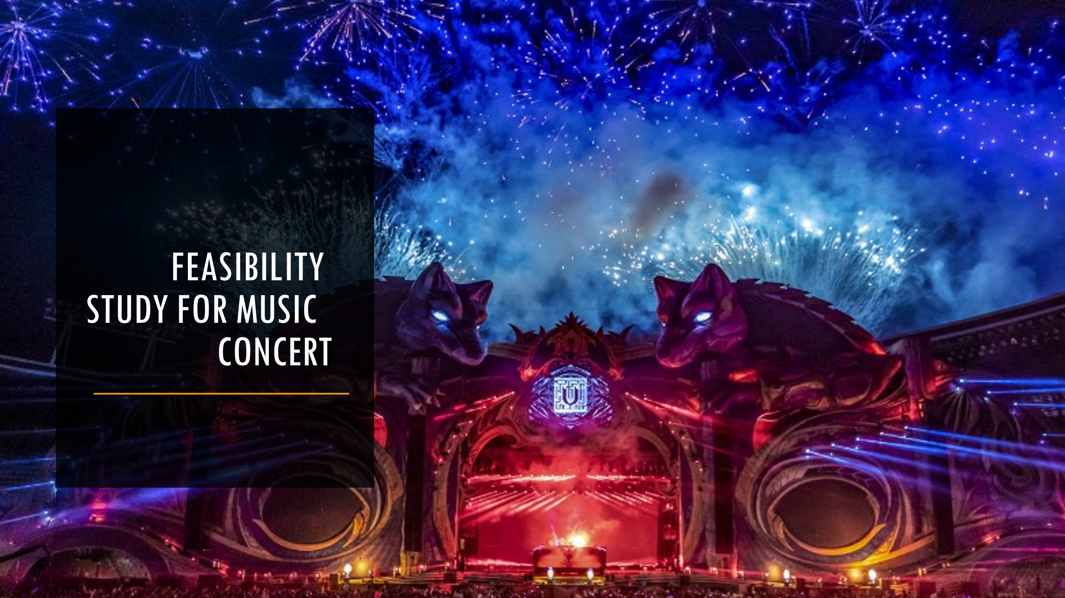

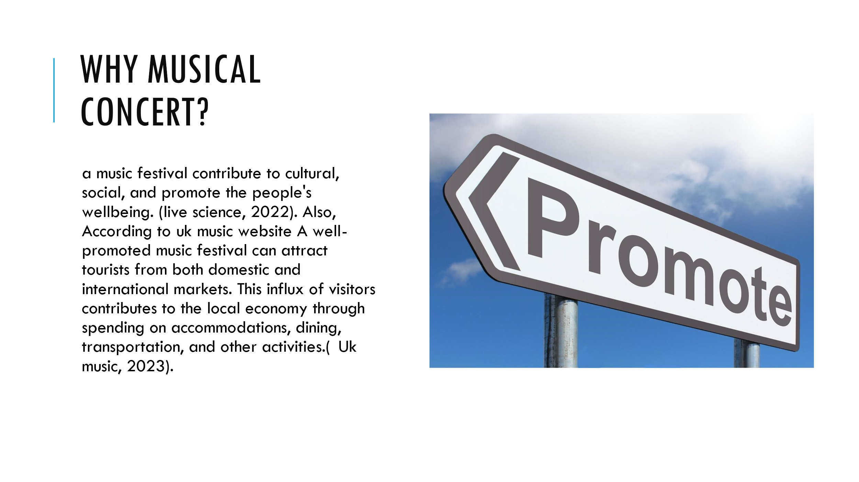

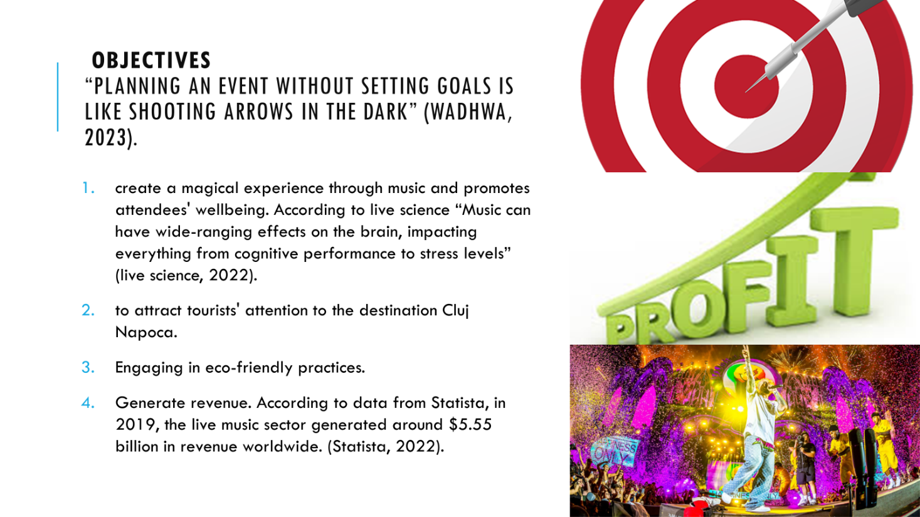
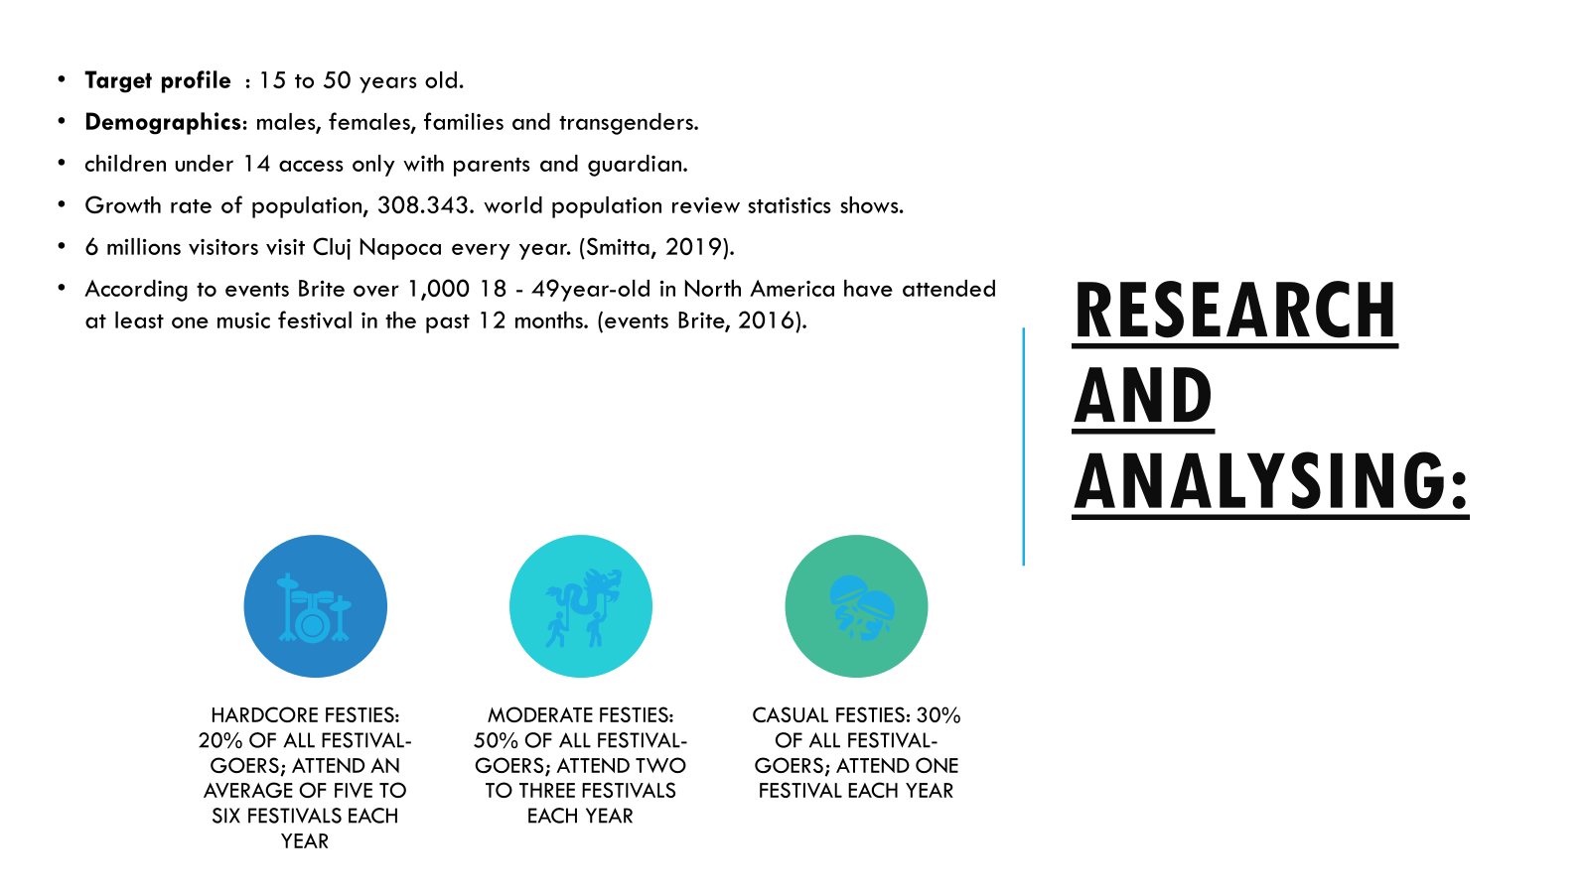

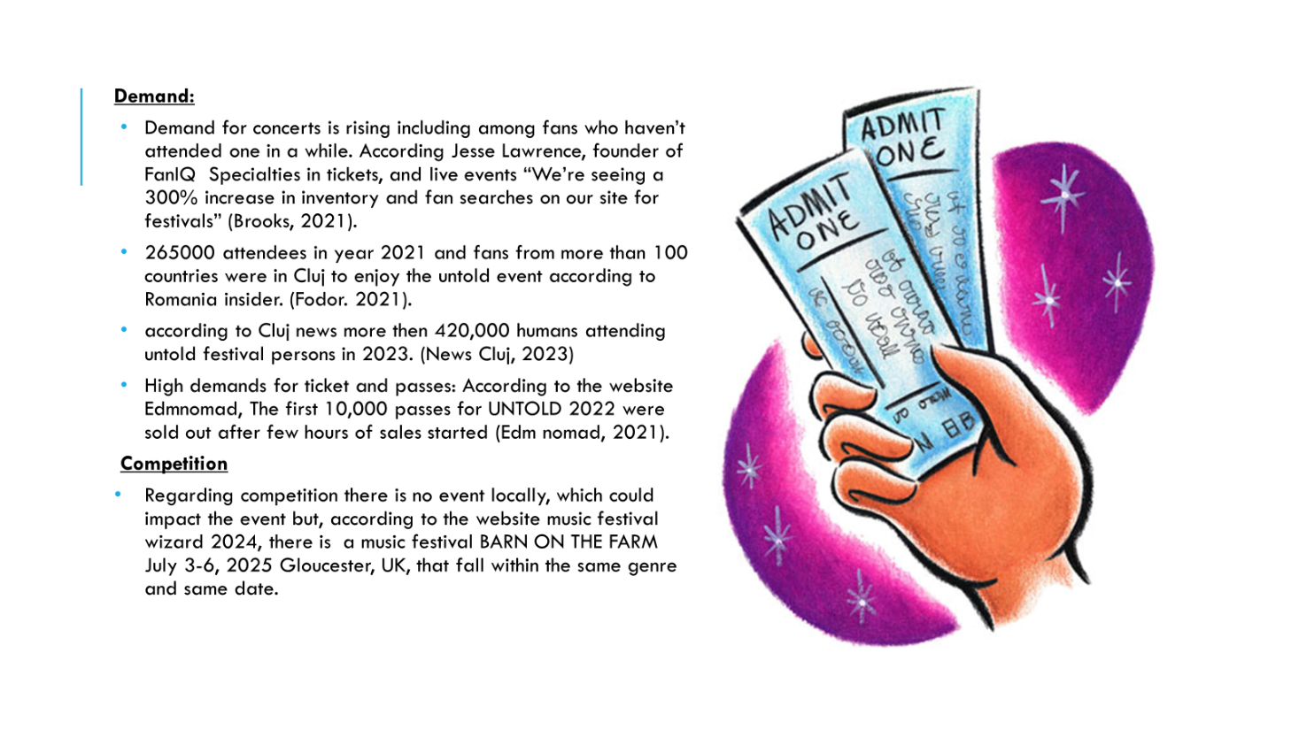
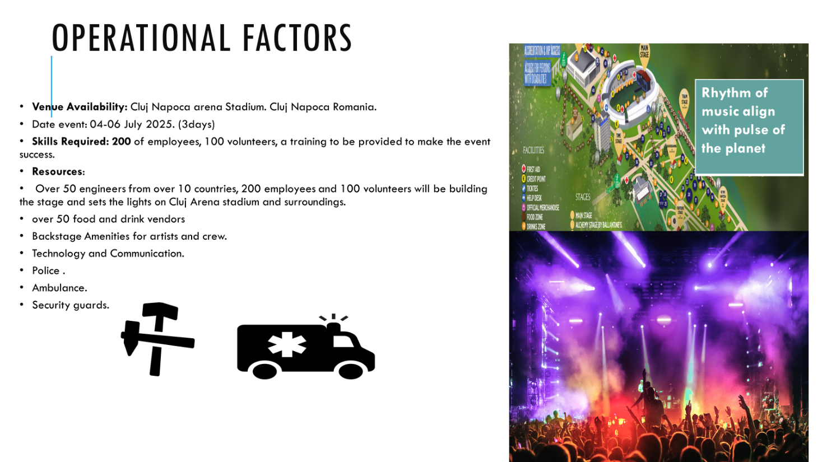

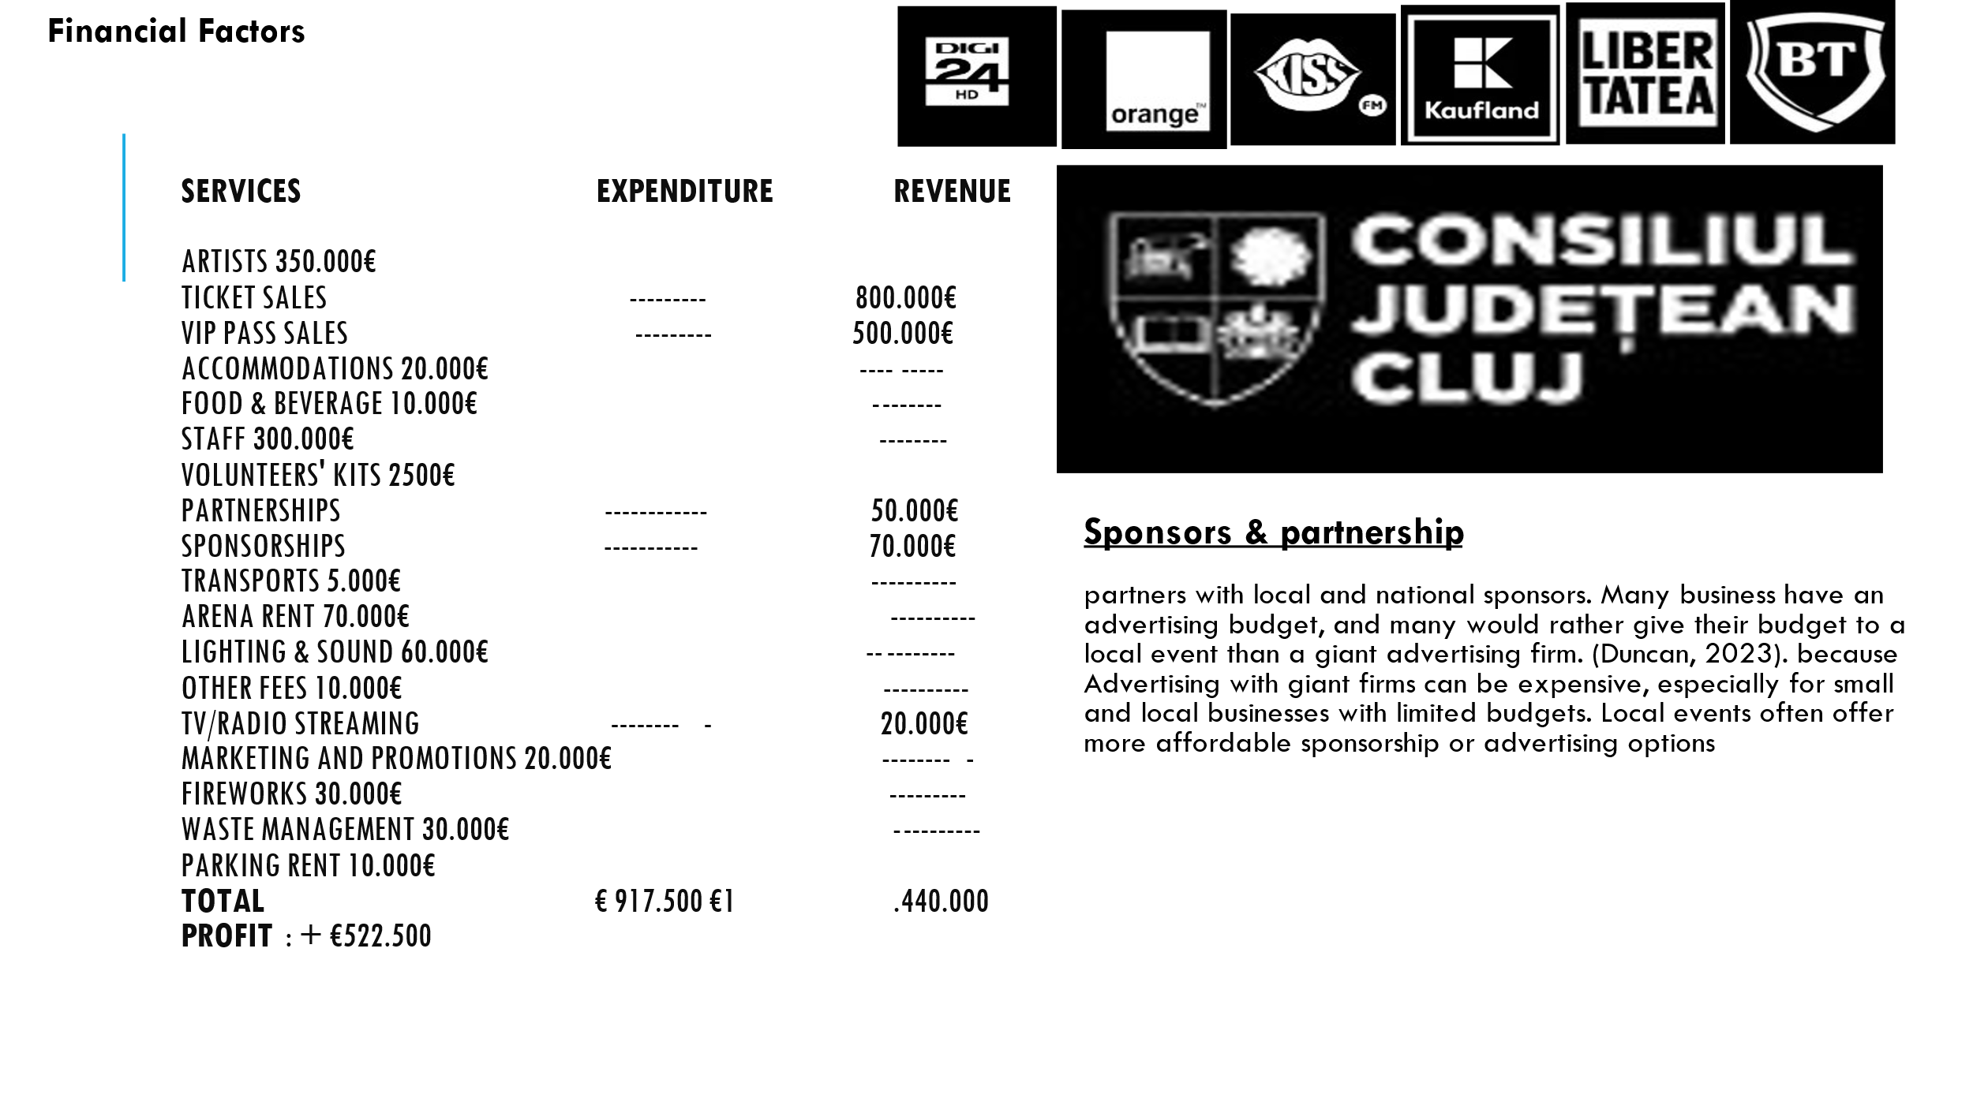

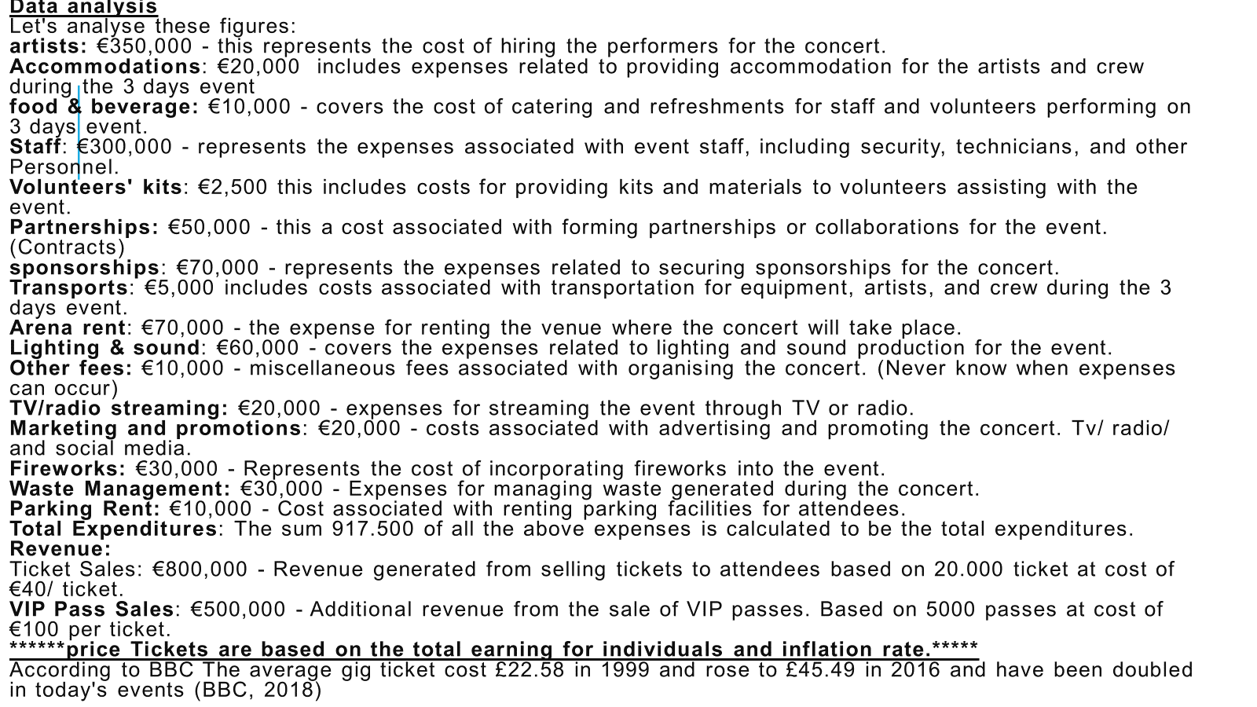

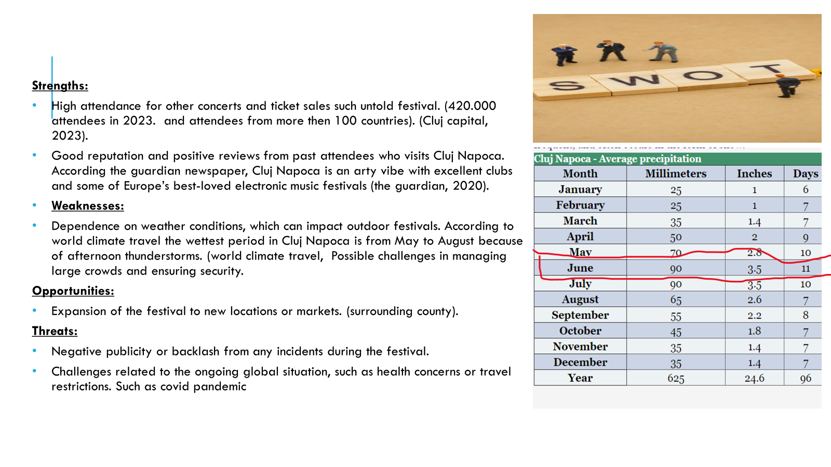
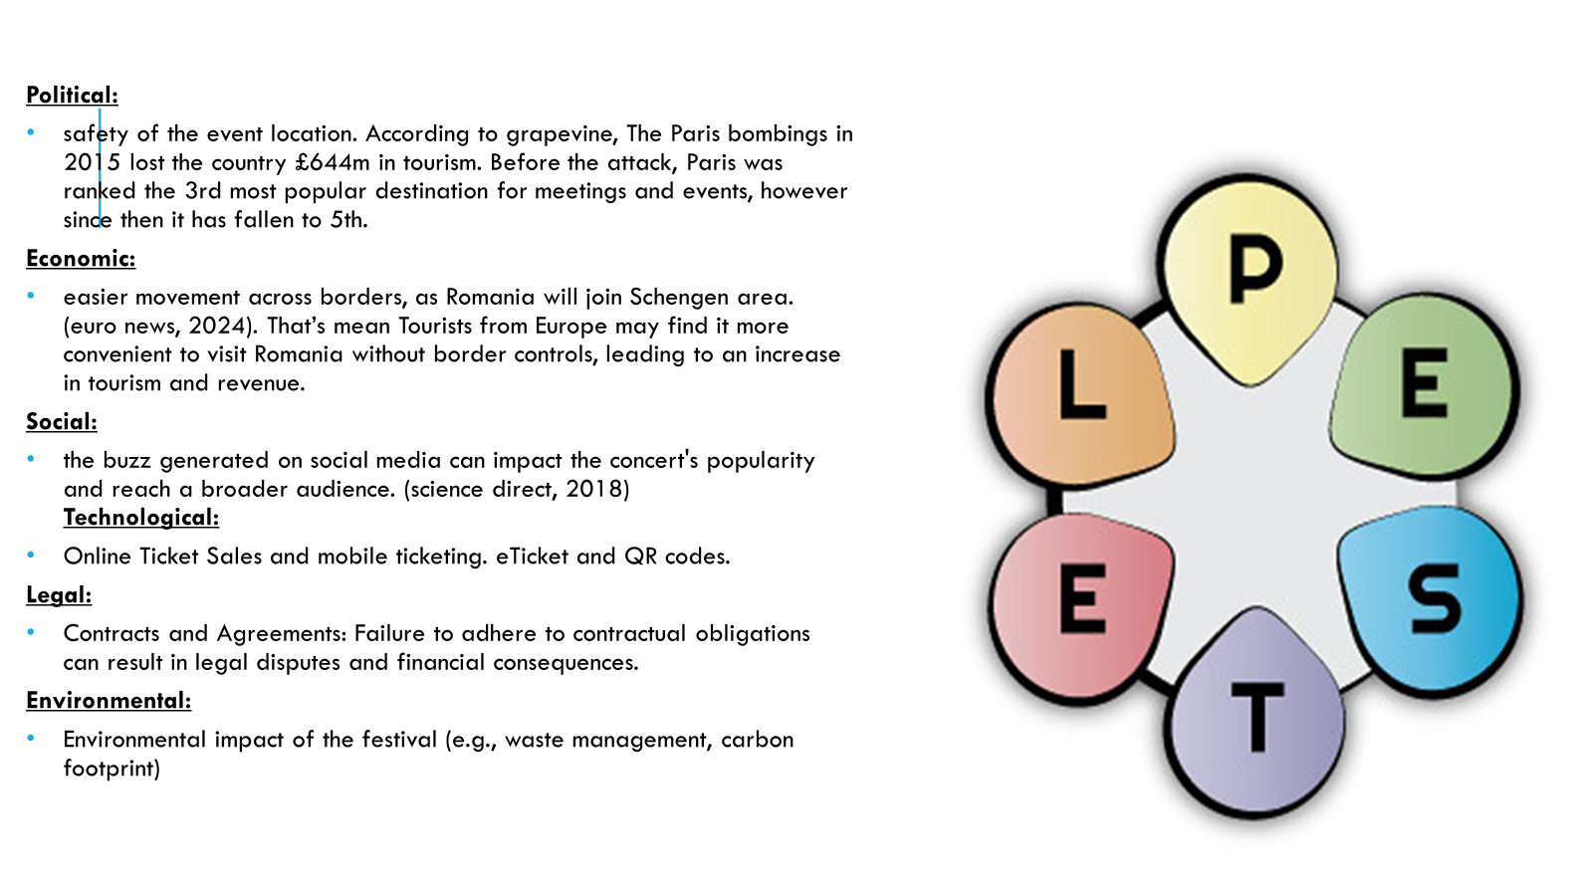
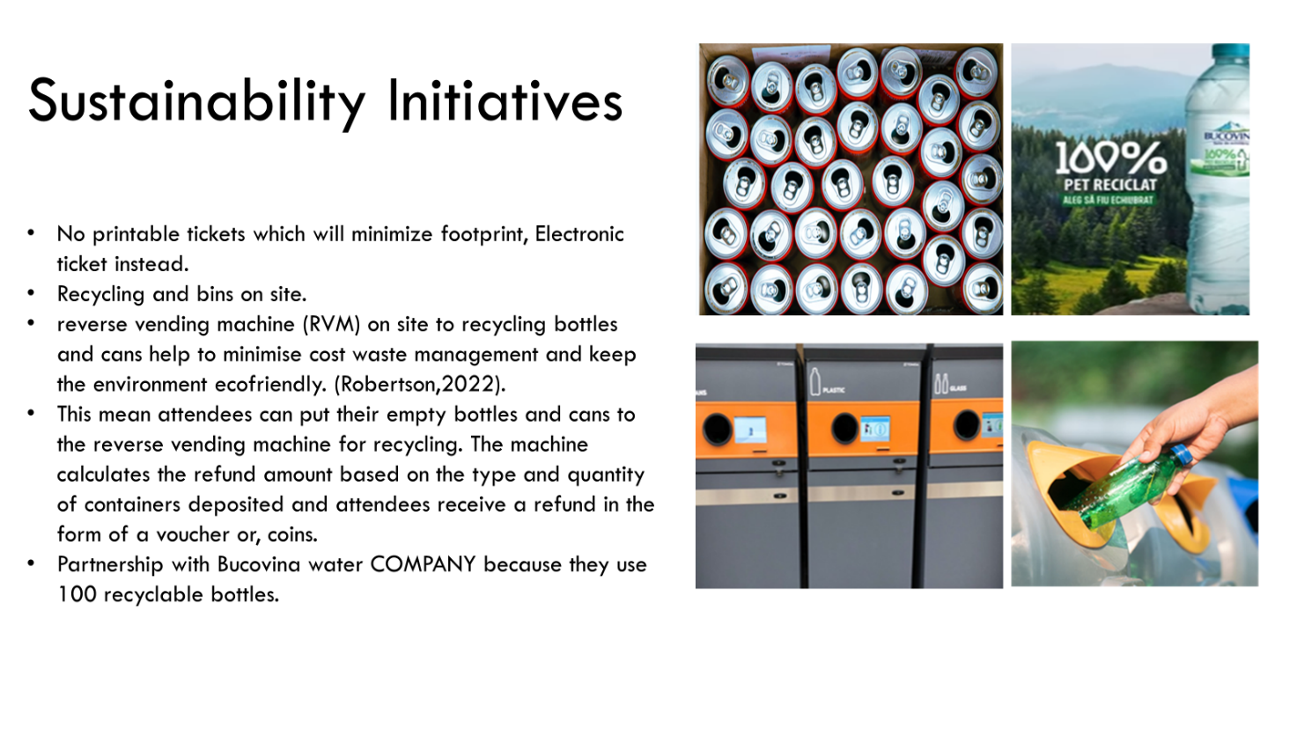


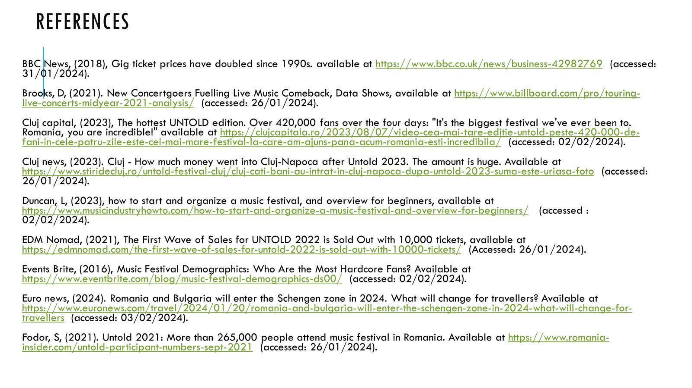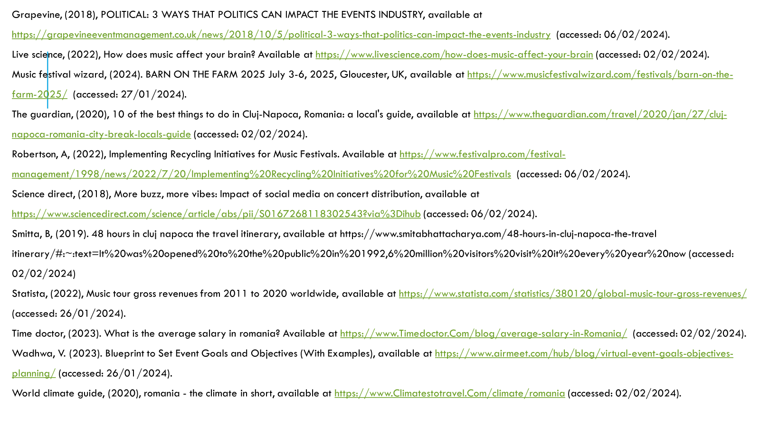

References:
BBC News, (2018), Gig ticket prices have doubled since 1990s. available at https://www.bbc.co.uk/news/business-42982769 (accessed: 31/01/2024).
Brooks, D, (2021). New Concertgoers Fuelling Live Music Comeback, Data Shows, available at https://www.billboard.com/pro/touring-live-concerts-midyear-2021-analysis/ (accessed: 26/01/2024).
Cluj capital, (2023), The hottest UNTOLD edition. Over 420,000 fans over the four days: "It's the biggest festival we've ever been to. Romania, you are incredible!" available at https://clujcapitala.ro/2023/08/07/video-cea-mai-tare-editie-untold-peste-420-000-de-fani-in-cele-patru-zile-este-cel-mai-mare-festival-la-care-am-ajuns-pana-acum-romania-esti-incredibila/ (accessed: 02/02/2024).
Cluj news, (2023). Cluj - How much money went into Cluj-Napoca after Untold 2023. The amount is huge. Available at https://www.stiridecluj.ro/untold-festival-cluj/cluj-cati-bani-au-intrat-in-cluj-napoca-dupa-untold-2023-suma-este-uriasa-foto (accessed: 26/01/2024).
Duncan, L, (2023), how to start and organize a music festival, and overview for beginners, available at https://www.musicindustryhowto.com/how-to-start-and-organize-a-music-festival-and-overview-for-beginners/ (accessed : 02/02/2024).
EDM Nomad, (2021), The First Wave of Sales for UNTOLD 2022 is Sold Out with 10,000 tickets, available at https://edmnomad.com/the-first-wave-of-sales-for-untold-2022-is-sold-out-with-10000-tickets/ (Accessed: 26/01/2024).
Events Brite, (2016), Music Festival Demographics: Who Are the Most Hardcore Fans? Available at https://www.eventbrite.com/blog/music-festival-demographics-ds00/ (accessed: 02/02/2024).
Euro news, (2024). Romania and Bulgaria will enter the Schengen zone in 2024. What will change for travellers? Available at https://www.euronews.com/travel/2024/01/20/romania-and-bulgaria-will-enter-the-schengen-zone-in-2024-what-will-change-for-travellers (accessed: 03/02/2024).
Fodor, S, (2021). Untold 2021: More than 265,000 people attend music festival in Romania. Available at https://www.romania-insider.com/untold-participant-numbers-sept-2021 (accessed: 26/01/2024).
Grapevine, (2018), POLITICAL: 3 WAYS THAT POLITICS CAN IMPACT THE EVENTS INDUSTRY, available at https://grapevineeventmanagement.co.uk/news/2018/10/5/political-3-ways-that-politics-can-impact-the-events-industry (accessed: 06/02/2024).
Live science, (2022), How does music affect your brain? Available at https://www.livescience.com/how-does-music-affect-your-brain (accessed: 02/02/2024).
Music festival wizard, (2024). BARN ON THE FARM 2025 July 3-6, 2025, Gloucester, UK, available at https://www.musicfestivalwizard.com/festivals/barn-on-the-farm-2025/ (accessed: 27/01/2024).
The guardian, (2020), 10 of the best things to do in Cluj-Napoca, Romania: a local's guide, available at https://www.theguardian.com/travel/2020/jan/27/cluj-napoca-romania-city-break-locals-guide (accessed: 02/02/2024).
Robertson, A, (2022), Implementing Recycling Initiatives for Music Festivals. Available at https://www.festivalpro.com/festival-management/1998/news/2022/7/20/Implementing%20Recycling%20Initiatives%20for%20Music%20Festivals (accessed: 06/02/2024).
Science direct, (2018), More buzz, more vibes: Impact of social media on concert distribution, available at https://www.sciencedirect.com/science/article/abs/pii/S0167268118302543?via%3Dihub (accessed: 06/02/2024).
Smitta, B, (2019). 48 hours in cluj napoca the travel itinerary, available at https://www.smitabhattacharya.com/48-hours-in-cluj-napoca-the-travel itinerary/#:~:text=It%20was%20opened%20to%20the%20public%20in%201992,6%20million%20visitors%20visit%20it%20every%20year%20now (accessed: 02/02/2024).
Statista, (2022), Music tour gross revenues from 2011 to 2020 worldwide, available at https://www.statista.com/statistics/380120/global-music-tour-gross-revenues/ (accessed: 26/01/2024).
Time doctor, (2023). What is the average salary in romania? Available at https://www.Timedoctor.Com/blog/average-salary-in-Romania/ (accessed: 02/02/2024).
Wadhwa, V. (2023). Blueprint to Set Event Goals and Objectives (With Examples), available at https://www.airmeet.com/hub/blog/virtual-event-goals-objectives-planning/ (accessed: 26/01/2024).
World climate guide, (2020), romania - the climate in short, available at https://www.Climatestotravel.Com/climate/romania (accessed: 02/02/2024).
The presentation link
https://uowtsd-my.sharepoint.com/:v:/g/personal/2117388_student_uwtsd_ac_uk/EVCtM_rb_J1OuGe770c_ONcBwD9-EjFFtZ84ncs4jkrCzw?referrer=Teams.TEAMS-ELECTRON&referrerScenario=MeetingChicletGetLink.view.view

