

"All bark, no bite": How do the south Wales and Gwent public and police officers perceive police dog units?

Jack Lake
2320026
Degree – Policing and criminology
JUNE 2026

Word count – 7,349

Acknowledgement

I would like to thank my partner Isabelle Stone, whom without her support I would never have been able to complete this dissertation. Furthermore, I would like to thank my mother and farther for their support.

I would also like to thank my assessors from the university and their support throughout the three-year degree program.

Finally, I would like to thank my participants that allowed for this research to take place.

Declaration
This work has not previously been accepted in substance for any degree and is not being concurrently submitted in candidature for any degree.
Signed: J.L
Date: 20.06.2026
Statement 1:
This dissertation is being submitted in partial fulfilment of the requirements for the degree of BSc Policing and Criminology.
Signed: J.L
Date: 20.06.2026
Statement 2:
This dissertation is the result of my own independent work/investigation, except where otherwise stated.
Other sources are acknowledged by footnotes giving explicit references. A bibliography is appended.
Signed: J.L
Date: 20.06.2026
Statement 3:
I hereby give consent for my dissertation, if accepted, to be available for photocopying and for interlibrary loan, and for the title and summary to be made available to outside organisations.
Signed: J.L
Date: 20.06.2026
Statement 4:
I hereby give consent for my dissertation, if accepted, to be available on the university’s IT system to those who have consent to use the system.
Signed: J.L
Date: 20.06.2026

Abstract
This dissertation examines how police dog units are perceived by the public and response officer who work and reside in the Gwent and South-Wales police force area. This research was conducted in response to finical pressure on UK police forces and ongoing debates surrounding effectiveness, cost-efficacy and ethical use of police dogs.

A quantitative research approach was utilized, with data collected through three separate surveys distributed to members of the public, response officers and police dog handlers. In total 70 responses were gathered. These include 22 responses from the public, 44 responses from response officers and 4 from serving dog handlers. The collected data was analysed utilizing graphs and quantitative data collection.

The findings outline that police dog units in the south-Wales and Gwent police area are overwhelming perceived as effective. Participants identified suspect tracking, missing person searches, officer safety, and management of violent incidents as the area in which police dogs provide the greatest operational benefit. Furthermore, the study shows that respondents believed that that police dog units should continue to receive funding despite wider budget constraints.

The study concluded that police dog units are not perceived as “all bark and no bite”, rather, they are regarded as an effective, specialist policing capability whose operational benefits justify the financial investment required.

Table of Contents
Chapter 1: Opening Paragraph ………………………………………………….8
Chapter 2: Literature Review …………………………………………………….9
2.1 Introduction and Research Focus ...........................................................9
2.2 Terminology .............................................................................................9
2.3 Operational Roles and Effectiveness of Police Dogs ..............................9
2.4 Financial Costs of Police Dog Units ......................................................11
2.5 Ethical Considerations and Animal Welfare Concerns ..........................11
2.6 Case Study: Police Dog Use and Accountability (IOPC) .......................13
2.7 Literature Review Conclusion ................................................................14
Chapter 3: Research Methodology…………………………………………….15
3.1 Surveys as primary research analysis ...................................................15
3.2 Interviews as primary research analysis ...............................................16
3.3 Ethnography as primary research analysis............................................16
3.4 Quantitative Data Analysis…………………….........................................17
3.5 Conclusion………………........................................................................17
Chapter 4: Analysis of Results…………………………………………………18
4.1 Survey demographic..............................................................................18
4.2 Response Officer Survey Results..........................................................19
4.3 Public Survey Results……………..........................................................21
4.4 Dog Handler Survey Results..................................................................23
Chapter 5: Findings and Discussion………………………………………….26
5.1 Public Survey Findings ..........................................................................26
5.2 Dog Handler Survey Findings ...............................................................26
5.3 Response Officer Survey Findings ........................................................27
5.4 Ethical Use of Dog Units Findings .........................................................27
5.5 Summary of Findings ............................................................................28
5.6 Research Limitations .............................................................................28
5.7 Recommendations to Gwent and South Wales Police ..........................28
5.8 Recommendations for Further Research ..............................................28
Chapter 6: Closing paragraph………………………………………………….29
Chapter 7: Bibliography ...............................................................................31

Appendices
Appendix A – Ethical approval.........................................................................34
Appendix B – Research Proposal ..................................................................48
Appendix C – Dog handler survey ..................................................................52
Appendix D – Dog handler survey results……………………………………….56
Appendix E – Public survey ............................................................................62
Appendix F – Public survey responses...........................................................68
Appendix G – Response officer survey………………………………………….76
Appendix H – Response officer survey responses……………………………..80

Chapter one - Introduction

Police dog units have long been an integral component of policing within the UK, providing specialised capabilities such as a higher level of tracking persons and objects. These skills support frontline officers in a wide range of operational contexts. Since their formal introduction into British policing in 1907, police dogs have developed into a highly valued resource, utilised for tasks including suspect apprehension, tracking, detection of drugs and explosives, and searching for missing or vulnerable individuals. Their enhanced sensory abilities, particularly their highly developed sense of smell, alongside their speed, agility, and capacity to deter offenders, position them as a unique asset within law enforcement that cannot be easily replicated by human officers alone. As a result, police dog teams are often viewed as a crucial tactical advantage in both routine and high-risk policing environments.
However, despite their longstanding role and operational utility, increasing financial pressures on police forces across Britain have raised important questions resistibility and cost-effectiveness of such specialised units. In recent years, police services have faced significant budget constraints, with estimates suggesting that forces require substantial additional funding in order to maintain effective levels of service provision. These financial challenges have necessitated greater scrutiny of all policing resources, particularly those that involve ongoing costs such as training, equipment, and maintenance. Police dog units, which require considerable investment throughout a dog’s lifecycle, from initial purchase and specialised training to long-term care and handler support, have therefore become a subject of debate in discussions surrounding resource allocation and efficiency within policing.

Chapter 2 - Literature review

Chapter 2.1 - Introduction and research focus

Police dogs and their handlers have long been a vital component of police departments across Britain. After the Metropolitan Police learned of their success in Belgium, they were deployed for the first time in Britain in 1907 (Thin Blue Paw, 2025). My research examines whether police dog teams are perceived as cost-effective by both the public and police officers. Currently, police forces are facing financial constraints, as the government has not provided sufficient funding to enable the police to access all necessary equipment for effective law enforcement (Davis, M., 2025). Estimates suggest that police forces in Britain require at least an additional one billion pounds to operate with adequate funding. Therefore, my research focuses on assessing the cost-effectiveness of police dog units and analysing whether these teams should receive further funding or be phased out.

Chapter 2.2 - Terminology

Firstly, it is important to understand the different terminology related to police dogs. The College of Policing provides clear definitions for these terms. A police dog is defined as a dog that belongs to the police force, has undergone specific training, and is cared for either by the chief constable or on their behalf. A police dog handler is a police officer assigned a police dog prior to its initial training. A dog team consists of the police dog and its handler, while a dog unit refers to the specific division within the police force responsible for the care and training of police dogs (College of police, 2024).

Chapter 2.3 - Operational Roles and Effectiveness of Police Dogs

Police dogs serve multiple important functions within law enforcement, one of which is their highly developed sense of smell. Research indicates that a dog’s sense of smell is closely linked to its vision. The BBC published an article in 2025 that features insights from dog handlers regarding the effectiveness of police dogs in their roles (Morris, J., 2025). It details the various responsibilities police dogs undertake, from detection and apprehension to demonstrating loyalty. The detection section explains that police dogs are used not only for tracking drugs and apprehending suspects but also for detecting mobile phones involved in major crimes, explosives, and counterfeit money. This highlights the critical role police dogs play in evidence recovery, which is essential for bringing offenders to justice. The article further discusses how dogs assist in pursuing suspects who flee from officers, often causing offenders to surrender out of fear of the dog’s presence and perceived aggression. It also emphasizes that, due to their strong loyalty, police dogs may sometimes be considered more dependable than human officers, as they are willing to risk their lives for their handlers and the public. At the conclusion, PC Felicity Thomas states, "There is absolutely a place for dogs in police forces around the country.”
This article presents a largely positive portrayal of police dogs, emphasising their efficiency, versatility, and reliability in operational policing. The evidence provided suggests that police dogs offer capabilities that exceed those of human officers in specific areas, particularly in detection tasks and suspect apprehension, which strengthens the argument that they are a valuable resource.
This concept of this article provided by the author is that police dogs hold an important role within law enforcement, as their skills and abilities may surpass those of a regular police officer. Police dogs are more efficient in searches due to their enhanced sense of smell. They are also more effective in apprehending suspects, as they are quicker and can intimidate offenders more effectively. Furthermore, the article states that police dogs demonstrate strong loyalty both to the public and to their colleagues.
This article is relevant to the research as it highlights the efficiency and capabilities of police dogs in their roles. The source is credible, as the BBC is a well-respected organization known for thorough investigations and reputable reporting. However, the article has limitations. Since the information is primarily based on interviews with dog handlers, it presents a somewhat one-sided perspective, focusing mainly on positive aspects without addressing potential drawbacks. Additionally, relying solely on the opinions of dog handlers may introduce bias, as they are likely to view their work favourably (Walton, D., 1999).
Shoesmith (2025) provides an insight into the operational role of Humberside police’s dog section through direct observation and interviews with police dog handlers. The article points out some roles that are undertaken by police dogs, including suspect searches, tracking and dangerous situations. The article then goes on to state the how the dogs are trained along with how the dog is taken care of. The article also provides the positive aspects of the police dogs such as their sense of smell. The source is relevant to the research as it provides contemporary evidence of how police dog units operate within the UK police force and supports arguments that police dogs should remain within the UK police force. However, there are some negative aspects to the source, the article primary speak about the positive aspect of police dogs failing to provide a negative aspect of police dogs. The source it should is reliable as it has been provided by the BBC, due to the article being one-sided and provides limitation to its use. This article is a great example of how the public may perceive dog units as the article is mainstream and will reach a wide variety of the public. This BBC article has an overwhelming positive outlook on the police dog unit, should the public only see this article it will provide for an overwhelming positive outcome on the research data.
Alpin (2025) discusses the positives and negatives of using dogs in the police work. The article outlines several benefits of police dogs including exceptional sense of smell, ability to locate missing people and effectiveness in detecting drugs. Additionally, the article outlines how police dogs not only provide operational benefits but also provides emotional support to operational police officers. The article states how police dogs provide and improvement in morale. The article later goes on to state how technology in the future may make police dogs redundant, or the reduction in police dogs will take place. This source is relevant to the research as it presents arguments on both sides of the argument; this allows for a more balanced argument. The article discusses the ethical arguments of the police using dogs, this argument in the article expresses positive views on the ethical welfare of police dogs in operational policing. However, there are limitations to this source. DoggoDigest is not an academic journal or government publication or a tested source the credibility of this source is untested. Although the source provided balanced arguments these arguments are observations rather than points supported by evidence. Overall, the article is useful for identifying arguments regarding the advantages and disadvantages of police dog units, it’s findings should be treated as with caution.

Chapter 2.4 - Financial Costs of Police Dog Units

Gritton (2025) provides a comprehensive analysis of the overall costs associated with police dogs, from their initial purchase as puppies, through training, to ongoing maintenance. This research is relevant to my own work as it helps to understand the financial investment required for police dog teams, allowing for comparisons with their operational effectiveness. The article details the expenses involved in all aspects of police dog management and concludes that, on average, a police dog costs approximately £11,000 before specialized training. Depending on the role for which the dog is trained, costs may vary. Training a handler typically costs around £5,000. Before a dog is trained for specific duties, the initial investment averages £16,000, with an additional annual maintenance cost of approximately £5,500 (Gritton, C., 2025). This information aims solely to outline the costs associated with police dogs without offering opinions or biases. It is relevant to my research because understanding these costs is essential for evaluating their cost-effectiveness. The article presents factual data but does not assess whether police dog units are cost-efficient, which is an area I plan to investigate further.‌
Ministry of defence police (2019) released a letter under the freedom of information act 2000. In this letter is outlines how many police dogs the ministry of defence police had per year between 2012 and 2017, the letter also goes on to state the budget that was allocated to the police dog units and the mounted unit in the ministry of defence police, between the years of 2012 and 2018. Both stats show a reduction in the number of police dogs and the budget that is allocated to the unit. This source of information is useful to my research as it allows insight into a police forces budget on their dog unit and the number of dogs that the force had operational per year. The downside of this citation is that it is for the ministry of defence police and not Gwent or south Wales police. Furthermore, in the citation the budget that is stated is split between the dog unit and the mounted unit, and without the correct percentage split between the two it is impossible to determine the budget that is fully allocated the dog unit. On the other hand, the citation is a reliable source as it comes directly from a reliable source as it being a letter from the ministry of defence police, meaning that the information that is provided is first hand and accurate. However, the citation was published in 2019 and only shows the statistics up to 2018, therefore the information is 6 years old and is not accurate to the modern-day policing statistics.

Chapter 2.5 - Ethical Considerations and Animal Welfare Concerns

When assessing whether police dogs are a worthwhile investment, it is important to consider not only the costs associated with their maintenance and training but also the legal and ethical considerations related to having animals in law enforcement. Additionally, concerns raised by charities and other organizations should be taken into account. PETA has called for the phased removal of police dogs following reports of injuries and fatalities occurring during their service (Giddings, A. 2024). The article notes that while police dogs are active in high-risk situations, some sustain injuries or even die due to neglect. For example, police dogs deployed to riots and other dangerous incidents have been hit with objects such as bricks, leading to injury. Furthermore, the article describes an incident involving a police dog named Ivy, who suffered heat stroke and was found unconscious in the back of a police vehicle after being left unattended for two hours. An investigation revealed that the vehicle's air conditioning was faulty. Such incidents raise questions about the welfare of police dogs and serve as potential arguments against their continued use, emphasizing that these animals do not have a choice in their service. The article also highlights public opinion, suggesting that many members of the community believe police dogs should not be used in law enforcement roles.
The key concept of the above article by the BBC is that animal charities such as PETA advocate for the gradual discontinuation of police dog use in contemporary policing, citing concerns over animals being injured or killed in the line of duty, whether due to injuries or police officer errors. PETA suggests that modern alternatives should be adopted to replace police dogs, thereby promoting more humane treatment of animals (Nogueira, L.B., et al., 2021.) The article is relevant to my research as it presents the perspective that, in the view of some members of the public, police dogs should eventually be phased out. This article offers a critical viewpoint on police dogs, which is important for my research.
The author has structured the arguments in this article by including quotes from PETA and relevant police reports to support their claims.
However, the article primarily reflects the opinion that police forces should cease using dogs, and this perspective stems from an organization committed to preventing animals from working or being harmed. As a result, the viewpoint may be biased. Additionally, the article does not fully represent the opinions of the wider public or police officers, leaving space for my own research to explore and gather diverse perspectives from both the public and law enforcement personnel.
When forming an opinion, it is important to consider multiple perspectives. The article by Kihlandern (2019), published in an independent journal, provides a balanced discussion of the use of police dogs in active duty, presenting arguments both for and against.
The article begins by addressing some of the ethical concerns associated with police dogs, particularly regarding their acquisition. It notes that police forces often rely on selective breeding to produce suitable working dogs, which can lead to inbreeding and associated genetic issues that may affect the animals' well-being over their lifetimes. Additionally, the article highlights tragic incidents, such as the death of 46 police dogs in the United States between 2011 and 2015 due to being left in overheated police vehicles.
Regarding post-retirement circumstances, the article reports that most police dogs are adopted by their handlers; however, in rare cases, dogs may be euthanized due to concerns about potential misuse of their specialized skills in a home setting.
On the positive side, the article emphasizes the remarkable sensory abilities of police dogs, noting that they possess approximately 225 million scent receptors compared to humans’ 5 million, making their sense of smell around 45 times more effective. It also states that dogs are trained primarily through positive reinforcement, promoting a humane approach that encourages their natural abilities rather than subjecting them to negative treatment. The agility and speed of police dogs are highlighted as key factors that enhance their efficiency in apprehending suspects. Furthermore, their superior olfactory capabilities make them invaluable in locating missing persons and evidence. Overall, the article illustrates how police dogs can outperform humans in specific aspects of policing, underscoring their importance and utility in the police force.
The core focus of this journal is to present both the advantages and disadvantages of police forces owning and utilizing police dogs. These perspectives are articulated by examining the ethical considerations associated with the use of police dogs, which appear to be viewed negatively. This is then followed by an overview of the positive aspects, primarily highlighting the efficiency of deploying police dogs. This journal is relevant to my research as it will enhance my understanding of the ethical implications involved, helping to determine whether police dogs are deemed worthwhile from both an ethical and financial perspective. The source originates from an independent publication, ensuring a neutral stance from the author. This enhances the credibility of the journal, as its arguments are supported by facts and quotations. Additionally, the journal does not provide a definitive conclusion, which allows for further investigation. In my research, I will synthesize this information and draw my own conclusions based on the evidence, thereby contributing valuable insights to existing literature.

Chapter 2.6 - Case Study: Police Dog Use and Accountability (IOPC)

When conducting research, it is important to understand how individuals form their opinions. A significant portion of contemporary societal opinions are influenced by social media and online articles. (Policeconduct.gov.uk, 2024b) is an article published by the Independent Office of Police Conduct (IOPC). IOPC (2024) states an investigation conducted by the IOPC regarding a police dog handler who used their dog, resulting in injuries to a subject. According to the report, the police dog was deployed after two officers approached a male individual regarding his motorcycle. Subsequently, the officers were assaulted, prompting them to activate their emergency buttons. The dog handler arrived first on the scene and deployed the police dog to assist the officers. The dog bit the subject, causing injuries. The article presents multiple perspectives: the public may perceive this as an abuse of power, viewing that the police could have used less force and potentially minimized injuries. Alternatively, some may interpret the use of the dog as a necessary response in a frantic situation, ensuring officer safety and enabling them to complete their duties (Hart, L.A., et al., 2000). Furthermore, the article indicates that police dog handlers’ actions are subject to scrutiny and thorough evaluation to ensure they are lawful and appropriate. This process helps foster a positive perception of dog handlers and police dogs, promoting a balanced and informed public opinion.
The key focus of this article is to highlight that police practices, including the use of police dogs and handlers, are subject to scrutiny and investigation when necessary. This approach enables the public to develop their own informed opinions regarding police dogs and handlers after reading the article. The content is relevant as it illustrates how police dogs are deployed in high-pressure situations and the potential consequences officers must consider when making split-second decisions. For the finding of the research the public will be asked how they form their opinions, and articles like this support the public's understanding and help them form more informed perspectives. The article presents only facts without taking a particular stance, allowing readers to draw their own conclusions. It is authored by the Independent Office for Police Conduct, a highly respected organization known for ensuring police accountability and preventing abuse of power. This article provides valuable context for shaping public opinion, which will be useful for my research.
Chapter 2.7 - Conclusion

To conclude the literature review, research has identified relevant citations to the research. The majority of these articles tend to present a one-sided perspective, either supporting a negative or positive viewpoint, and many do not offer a balanced consideration of both sides of the argument. A few of the articles exhibit bias related to the authors' backgrounds. Additionally, there is a noticeable gap in research regarding public opinion and police officers' perspectives on police dogs, as most studies have gathered insights from only one or two officers and a single member of the public. The research will be conducted on a larger scale, allowing for more comprehensive data and a more accurate assessment of whether police dogs are perceived as a worthwhile investment.

Chapter 3 - Research methodology

This research aims to examine the question, "All bark, no bite": How do the south Wales and Gwent public and police officers perceive police dog units? This research addresses an identified gap in the existing literature regarding the effectiveness and perception of police dog units. To explore this topic, I will focus on answering specific objective questions, such as:

- The perceived effectiveness of police dog units in reducing crime in the eyes of the public and response officers.
- The types of crime that police dog units are perceived to be most effective at reducing
- Are police dogs worth the continued funding in the eyes of the public and response officers

Chapter 3.1 - Surveys as primary research analysis

To conduct this primary research, the distribution of questionnaires to police officers, the general public, and dog handlers. This approach has been selected this approach because surveys provide firsthand data directly from the source, thereby reducing reliance on outdated secondary information. This enhances the accuracy of the research data (Schonlau, M., et al., 2002), furthermore it allows for a larger amount of data to be collected and utilised due to the surveys not taking much time partake in. The data collected from the surveys will allow for easy data analysis. Surveys will be distributed using Google Forms via email and Microsoft Teams, which will facilitate broad distribution to reach my target audience effectively. Surveys will be sent to members of the public via email to social groups.

This method was chosen because the results are easily quantifiable. Surveys allow for close-ended questions, enabling clear and concise responses that can be efficiently represented through graphs and charts. Additionally, this approach is both time-efficient and cost-effective, as surveys can be created and distributed at minimal expense (Nayak, M.S.D.P. and Narayan, K.A., 2019). A single survey can reach a large number of respondents, reduce workload while increase data collection.

The target is to collect 20 responses from the public, 20 from active police officers, and four from serving dog handlers.

The survey will consist of both multiple-choice and open-ended questions in order to collect a range of data. Multiple-choice questions were selected as they provide an efficient and structured method of data collection, allowing participants to respond quickly and easily. Furthermore, these questions generate quantitative data, which can be readily analysed and presented through graphs and other visual representations. A number of questions will utilise a five-point Likert scale, ranging from 1 (strongly disagree) to 5 (strongly agree), enabling participants to indicate the extent to which they agree with specific statements. For example, participants may be asked to respond to the statement, “Police dog units should continue to receive funding.” This format allows respondents to express their opinions in a clear and measurable manner, facilitating comparisons between different participant groups.
However, whilst multiple-choice questions are effective for collecting quantitative data, they are limited in their ability to capture detailed opinions and explanations. To address this limitation, the survey will also include open-ended questions. These questions provide participants with the opportunity to elaborate on their views and experiences, generating richer qualitative data. For example, participants may be asked, “In your opinion, what is the main benefit of having police dogs?” Such questions allow respondents to provide more detailed and nuanced answers, resulting in a deeper understanding of their perceptions and contributing greater context to the quantitative findings.

Chapter 3.2 - Interviews as primary research analysis

For this research, interviews were considered as a method due to their advantages, such as providing in-depth and detailed data. Interviews enable participants to express their opinions more fully and allow for greater flexibility in questioning and responses, as opposed to the fixed format of surveys. This facilitates more nuanced dialogue and comprehensive insights. However, there are certain limitations associated with interviews, including the considerable time required for scheduling, conducting, and transcribing the sessions. This is an important factor to consider in the context of this research (Alshenqeeti, H., 2014). Additionally, the sample size for interviews is inherently limited; given the time constraints, a maximum of four individuals could be feasibly interviewed.

Chapter 3.3 - Ethnography as primary research analysis

A supplementary research method was considered for data collection. Ethnography was also evaluated as an approach for this level of research. Gathering first-hand data on the subject would facilitate more accurate data collection. Ethnography involves collecting data through close observation of the subject in real-life settings. This approach would require a two-day observation period, allowing a researcher to observe a police dog team during their duties to gather data. However, a primary limitation of this method is its time-intensive nature (Hammersley, M., 2006). Ethnography raised further issues, such as data gathered would be of a smaller sample size in comparison to surveys and interviews, due to the time consumption of gathering ethnography data, furthermore the observer effect may come into play, the dog handler may change their behaviour in order to paint them into a good light. This would provide false data.

Chapter 3.4 - Quantitative data analyses

The research will collect quantitative data (Anscombe, F.J., 1973). The findings will be illustrated through graphical representations, enabling a clear and accessible visualization of all results (Ball, M.S. and Smith, G.W., 1992). Graphs facilitate quick comparisons and provide a comprehensive overview of range of responses, making data analysis more efficient. Additionally, visual representations help readers comprehend the data more easily. From a professional perspective, the use of graphs and visual data displays enhances the credibility. However, it is important to recognize that graphs and quantitative data have limitations; for example, they may oversimplify complex information. When dealing with intricate data, visual representations might not fully capture all nuances of the responses (Keim, D.A., et al., 2006). Another consideration is the potential for misinterpretation; proper labelling and accurate display are essential to ensure that the data is understood correctly.

There are limitations to quantitative data, such as a lack of depth and context. While numerical data can effectively convey valuable information, this approach does not capture feelings, motivations, or personal experiences. The quality of data collection depends on the design of the questions used to collect it; flaws in question formulation can lead to miscommunication and misrepresentation of the data (Claudio, D., et al., 2026). This issue may arise from assumptions about shared understanding of the questions, as researchers cannot directly communicate with participants, thereby requiring a certain level of assumption that all parties interpret the questions consistently (Price, J.H. and Murnan, J., 2004). Given the researcher's position, access to serving police officers, dog handlers, and the public allows for the collection of relevant data.

`Chapter 3.5 - Conclusion

To summarize this research methodology, three different types of research have been considered, survey, interview, and ethnography (Walker, D.H., 1997.) The advantages and limitations of each method have been evaluated, with surveys identified as the most suitable approach for gathering the primary data required for this study. The surveys will target a sample size of 40 individuals, with half of the questionnaires distributed to the general public and the remaining half to police officers and two dog handlers. The data collected will be primarily quantitative and will be presented through graphs, which are an effective way to visualize the findings. However, this approach may limit the depth and contextual understanding of the responses. Overall, the collected data will facilitate addressing the research objectives and main questions, contributing to the successful completion of the study.

Chapter 4 - Analysis of results

This research seeks to address the question: "All bark, no bite": How do the south Wales and Gwent public and police officers perceive police dog units? To answer this research question, surveys were distributed to collect the relevant data. One survey was designed for members of the public residing within the Gwent and South Wales policing areas. A second survey was tailored for response officers currently undertaking active operational duties. The final survey was specifically developed for police dog handlers.

Chapter 4.1 - Survey demographic

This chapter presents an analysis of the data collected from these surveys. In total, the three surveys received 70 responses. Of these, 44 responses were obtained from response police officers, 22 from members of the public, and 4 from police dog handlers.

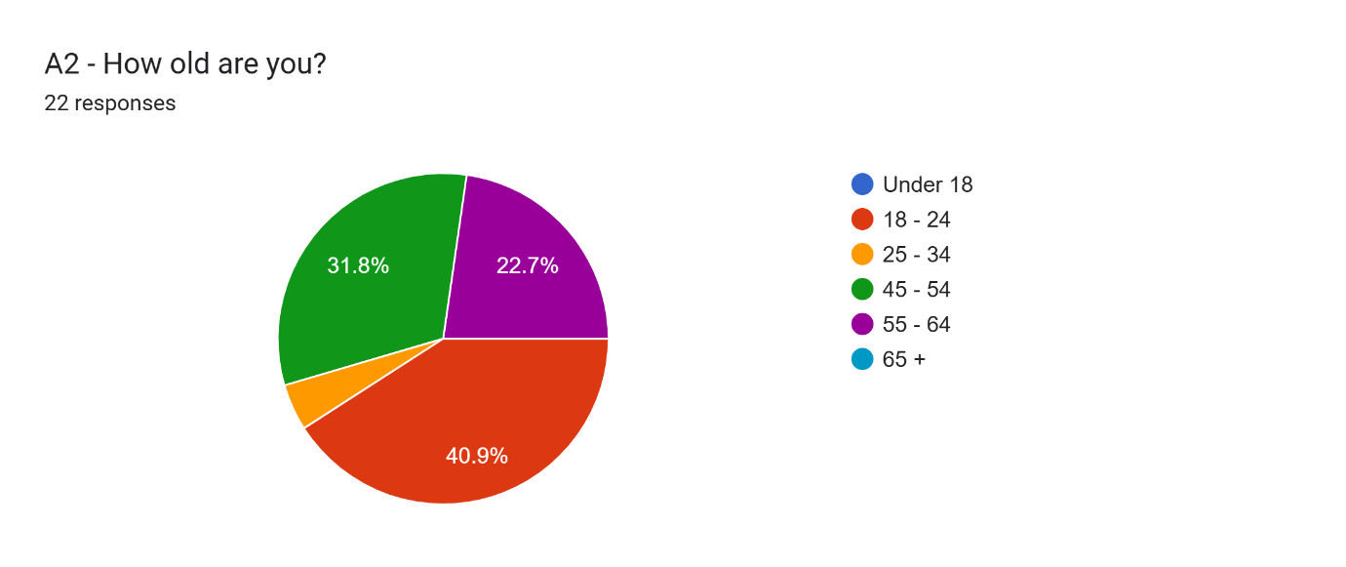
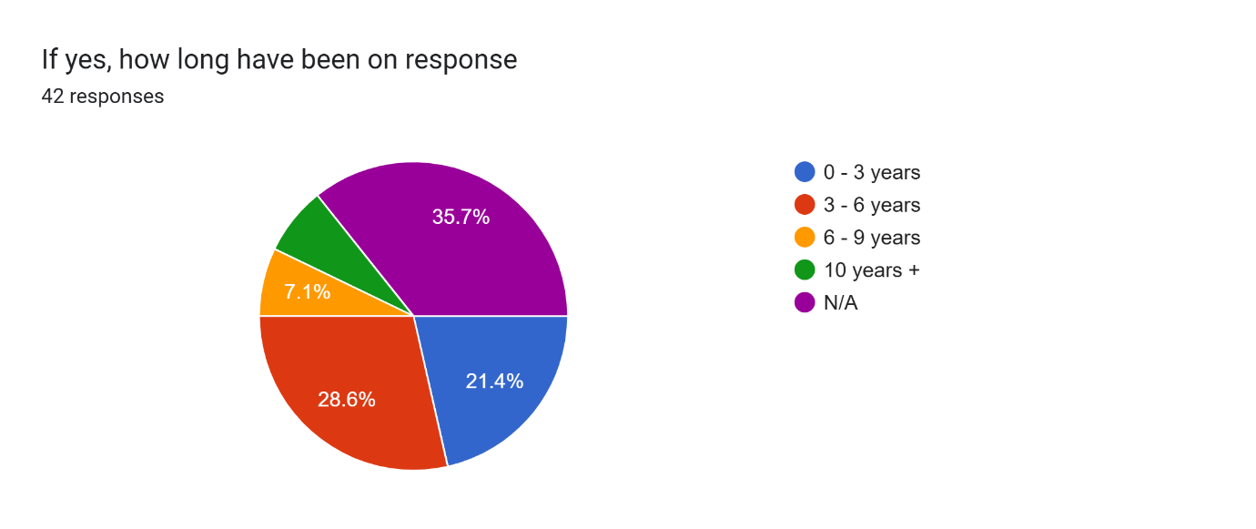
The age range of public respondents spanned from 18 to 64 years, providing representation across multiple generations and allowing for the collection of varied public perspectives.

The length of service reported by response officers ranged from 0–3 years to over 10 years on response duties. This distribution ensured input from both newly trained and more experienced officers, enabling a balanced reflection of operational perspectives. Collectively, these demographic and service-length ranges contributed to a broad and representative dataset, supporting a fair and meaningful analysis of the results.

Chapter 4.2 - Response officers’ response

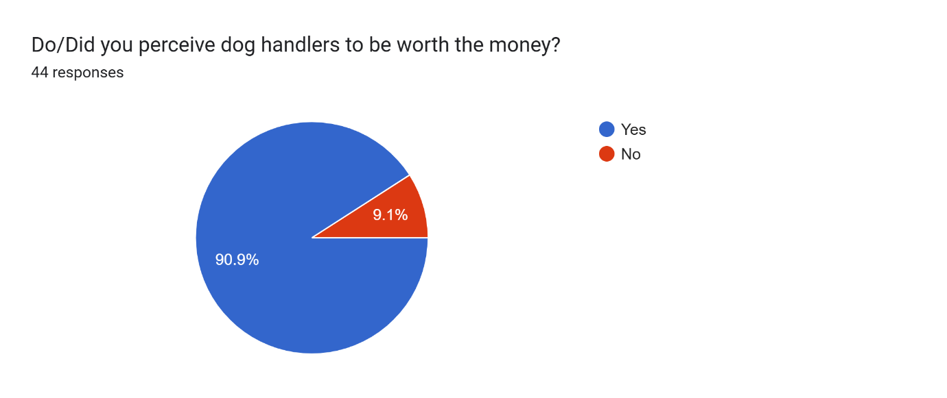

Analysis of the responses from frontline response officers indicates a predominantly positive perception of police dog handlers and dog units. The majority of participants described their views of dog units as favourable, with 90.9% of response officers stating that they believe police dog units are both effective and provide value for money.
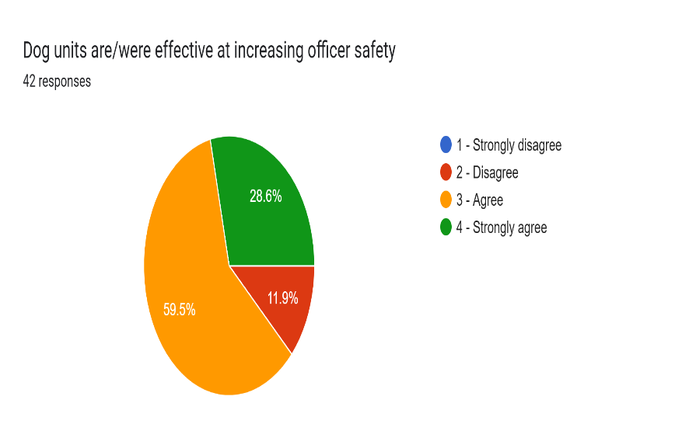
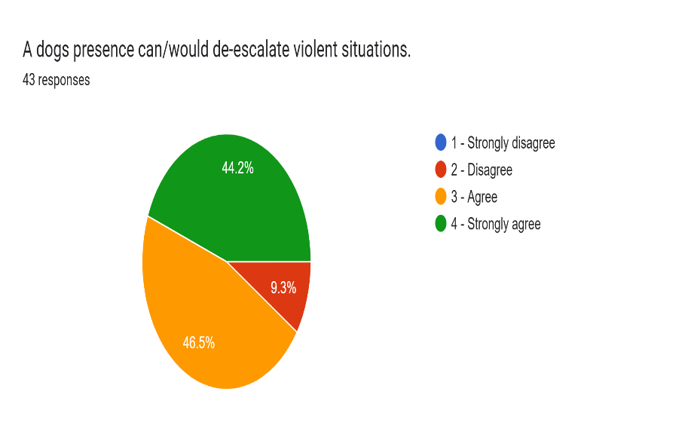
When examining perceptions of operational effectiveness, respondents most strongly associated dog units with enhancing officer safety and de-escalating violent situations. A total of 44.2% of officers strongly agreed that dog units are effective in de-escalating violent incidents, while 28.6% agreed that dog units play a significant role in increasing officer safety.

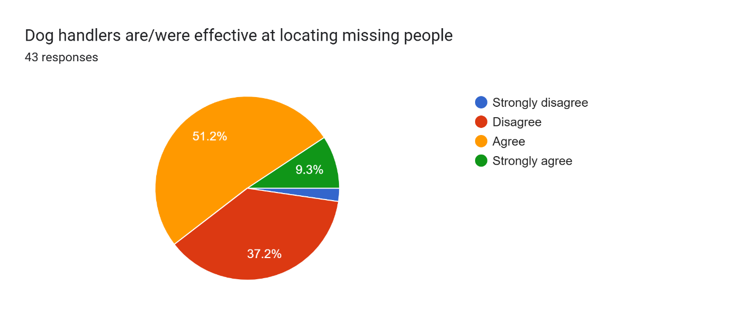

In contrast, respondents identified locating missing persons as the least effective aspect of police dog unit deployment. Specifically, 37.2% of officers disagreed that dog units are effective in locating missing people, and a further 2.3% strongly disagreed. These findings suggest that while response officers highly value dog units in high-risk and confrontational contexts, there is less confidence in their effectiveness for missing person searches.
The responses from response officer holds great value to the research as they hold firsthand information on how dog units are utilised in frontline policing, and have first handle knowledge of the utilisation and the benefits of police dog units.

Chapter 4.3 - Public responses

Analysis of the public survey responses also indicates an overall positive perception of police dog units. Participants responded to perception-based questions using a five-point Likert scale ranging from 1 (Strongly disagree) to 5 (Strongly agree). The findings suggest strong public confidence in the operational effectiveness of police dog units.
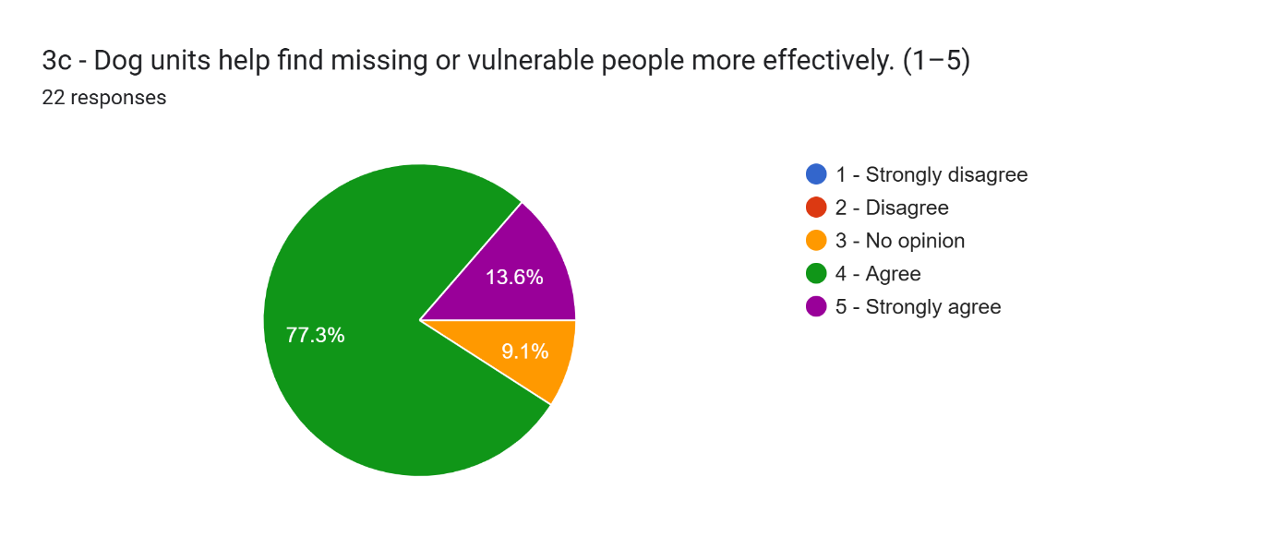

A total of 72.7% of respondents agreed that police dog units are more effective than regular response officers in locating suspects, while 77.3% stated that they believe dog units are more effective at locating missing persons than response officers.

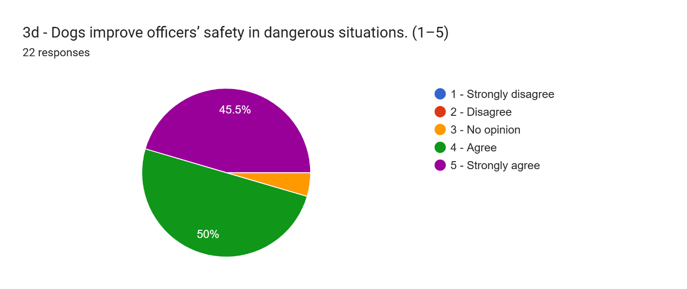

Perceptions of officer safety were also notably positive, with 45.5% of respondents strongly agreeing and a further 50% agreeing that dog units improve officer safety.

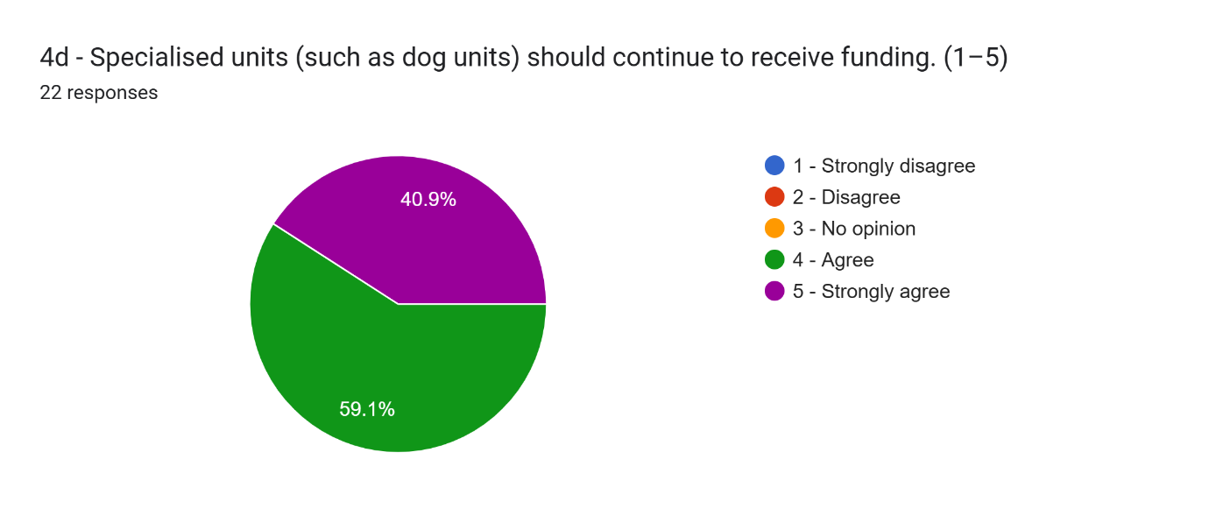

Support for continued funding was high, with 40.9% of respondents strongly agreeing and 59.1% agreeing that police dog units should continue to receive financial support.
Despite these positive perceptions, responses relating to personal experience revealed limited public exposure to police dog units. A total of 63.6% of respondents stated that they never see dog units operating in their local area, while 36.4% reported that they were not aware of the work undertaken by police dog units. Furthermore, 59.1% of respondents indicated that they had never seen a police dog unit in person. However, among the 40.9% who reported having seen a dog unit, 61.6% described the experience as positive.

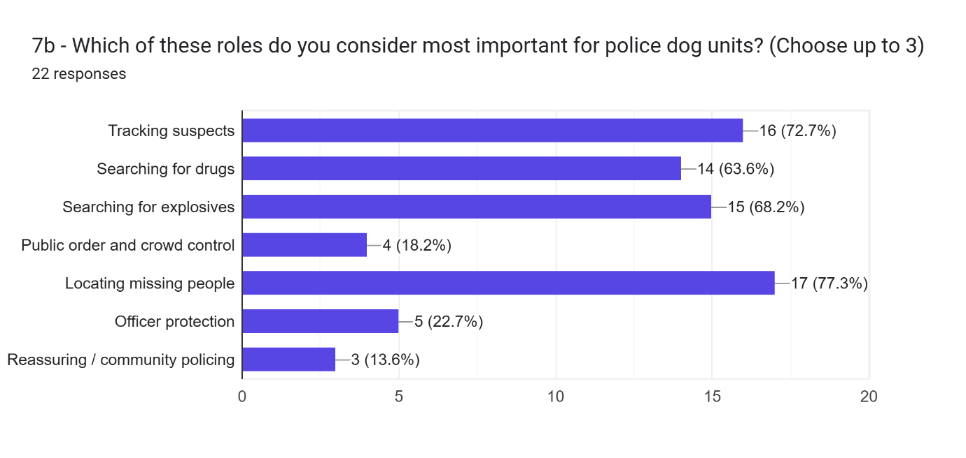

When asked to identify the most effective roles undertaken by police dog units, the public most frequently selected locating missing persons (77.3%), followed by tracking suspects (72.7%) and searching for explosive devices (63.6%). In contrast, reassurance and community policing were perceived to be the least effective roles, with only 13.6% of respondents selecting this option. Public order and crowd control were also viewed as less effective, with 18.2% of respondents identifying this as a primary role of police dog units.
Overall, 95.5% of public respondents stated that police dog units are perceived to be worth the financial cost.
In comparison to response officers’ knowledge the public do not hold and much firsthand information as is outlined by the following question.

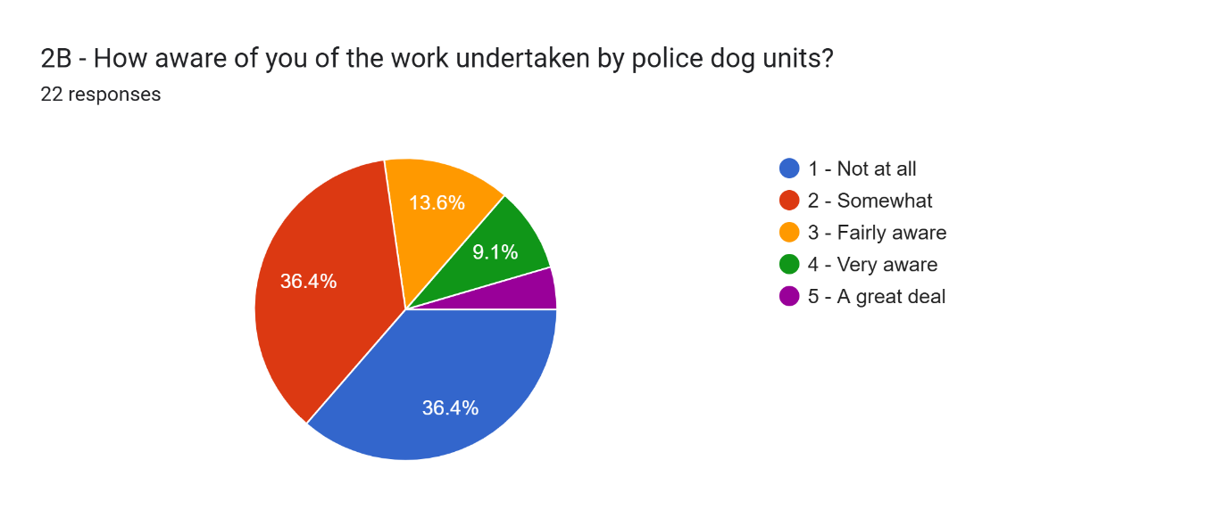
Meaning that the public’s response to the surveys are not as reliable as the response officers’ responses.

Chapter 4.4 - Dog handler responses

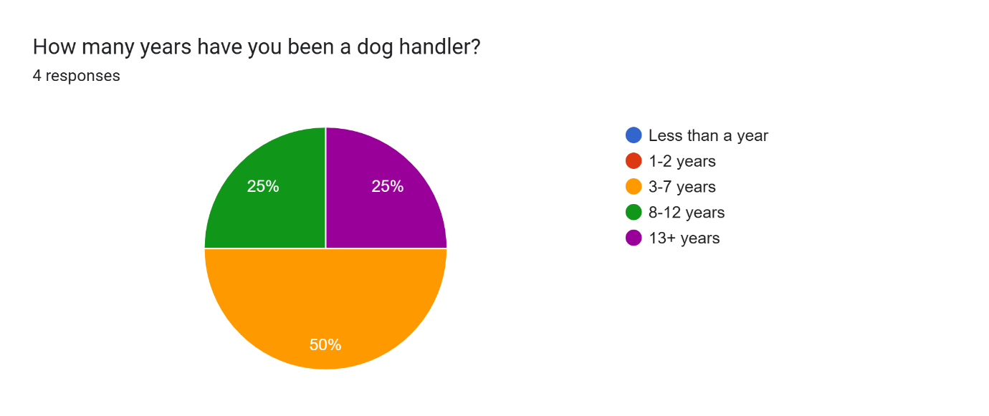
The survey distributed to police dog handlers was designed to gain a clearer understanding of the operational role of dog units within the police service. The responding handlers reported lengths of service ranging from 3 years to over 13 years, providing a mix of both relatively new and highly experienced handlers.
This variation allowed for the collection of balanced and informed perspectives, contributing to the reliability of the findings. Participants were asked to indicate how frequently they performed specific duties using a five-point scale ranging from 1 (Never) to 5 (Very Frequently).

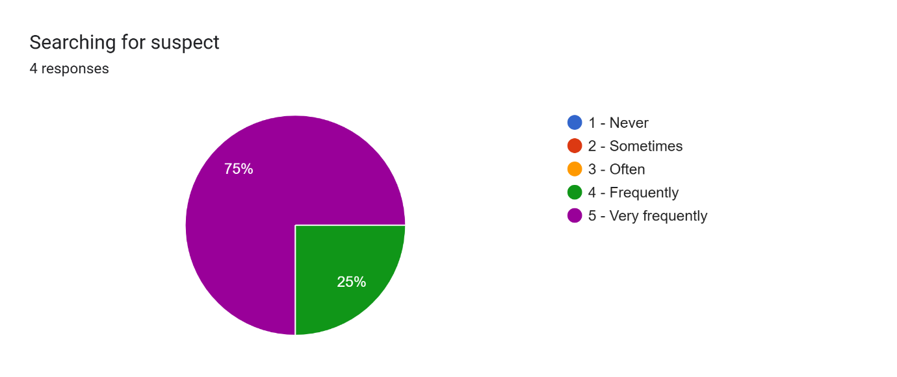

The results indicated that searching for suspects is a central function of the role, with 75% of handlers stating that they undertake this task very frequently and the remaining 25% reporting that they do so frequently.
Tracking missing persons was also reported as a routine responsibility, with 50% of handlers indicating that they frequently perform this task and a further 25% stating that they do so often.

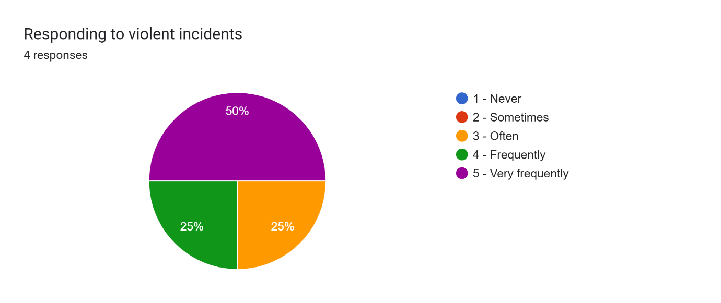

Responding to violent incidents was likewise identified as a key aspect of deployment, with 50% of handlers reporting that they very frequently attend such incidents and 25% indicating that they often do so.
These responses agree with the responses gathered from both the public and response officers, that dogs handlers are most effective in violent incidents and searching for suspects.
When asked about outcomes, all handlers reported positive results from deployments involving their police dog, with 50% stating that their dog often contributes to a positive outcome and the remaining 50% stating that this occurs very often.

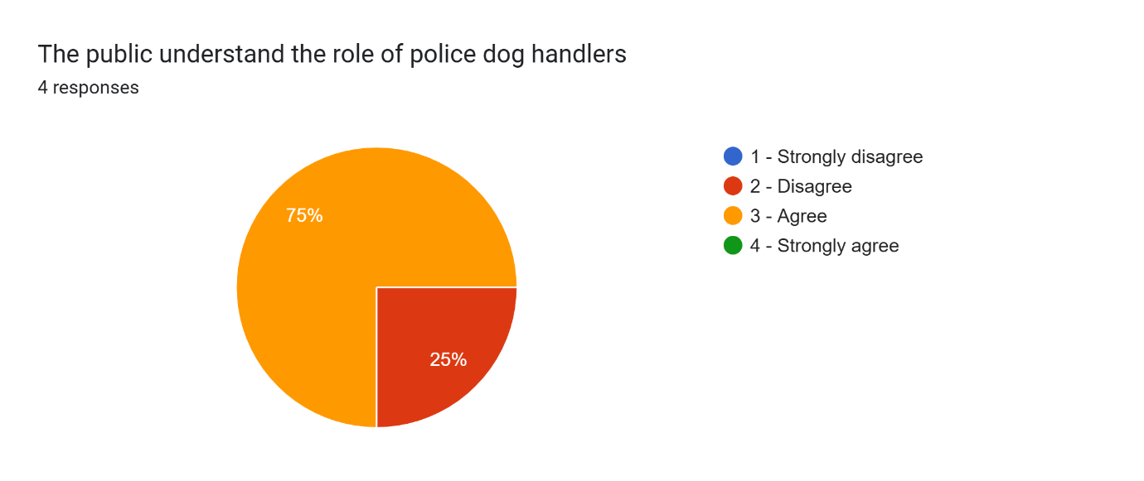

In relation to public understanding and perceptions of value, 75% of dog handlers agreed that the public understands the role of police dog units, while 25% disagreed. Notably, all respondents (100%) agreed that the public perceives police dog handlers to be worth the financial cost, indicating strong confidence in the perceived value of the role.

Chapter 5 - Findings and conclusions

Chapter 5.1 - Public survey findings

The public survey findings outline that most respondents reported limited direct contact to police dog units, often stating that they rarely or hardly ever see police dog units operating in their area that they live. Despite this low contact with respondents, the perceptions of police dog units were overwhelmingly positive. The vast majority of participants concluded that police dogs are effective in locating suspects, finding missing or vulnerable people, and enhancing officer safety. This idea supports Morris’ (2025) argument that police dogs possess capabilities that exceed the capabilities of response officers, especially due to their enhanced sense of smell, speed and capability to intimidate suspects. The public’s overall confidence in police dogs outweighs the negative perceptions despite a lack of exposure to police dog units. This suggests that the participants opinion on police dog units maybe shaped by institutional reputation, cultural understanding, and the way the media portrays dog units rather than the direct exposure alone. Importantly, the majority of respondents concluded that police dog units are worth the cost spent on them and should be protected from government budget cuts. This contradicts claims that were made by animal rights groups and organisations such as PETA. Giddings (2024) in in contrast to my groups and challenges my findings by stating that the publics opinion of police dog units is increasingly negative and oppose the use of dogs in police forces.

Chapter 5.2 - Dog handlers survey findings

Participants from the survey sent to the dog handlers reported a high level of deployments, typically responding to between 20 and 50 incidents per month, confirming that dog units are operationally active despite their limited public visibility. Dog handers who responded to the survey stated that their dogs frequently directly contribute to successful outcomes, including suspects apprehension, evidence recovery and missing person searches. These findings strongly co-inside with the BBC article by Morris (2025), which outlines how police dogs play a vital role in modern day policing through detection, pursuit and deterrence. Handlers also reported that police dogs reduce the amount of force required during police incidents when they are deployed. This supports ethical arguments that police dogs can facilitate a proportionate response in high-risk situations, enabling officers to use a reasonable level of force appropriate to the circumstances. When handers were asked the question about the cost effectiveness, an overwhelming amount of handers perceived their role as adding equal or greater value to incidents in comparison to non-dog units. This supports the argument raised by Gritton’s (2025) cost analysis, suggesting that while initial and ongoing cost are notable, the frequent and impact of dog hander deployments justify the financial investment. However, the response from dog handlers can be perceived as bias, as they preform the role and do not hold a neutral opinion on the subject as they rely on this extra funding to carry out their roles.

Chapter 5.3 - Response officer survey findings

Participants from the response officers survey provided valuable data into the operational integration of police dog units. The majority of response officer reported working with dog handlers occasionally or frequently and agreed that dog units add a positively to front line policing. Respondents of the response officer survey stated they view dog handlers as effective in locating suspects and missing people and improving officer safety. However, perceptions were more varied concerning response time and the availability of police dog units. Some response officers reported a slow response time from dog units attending incidents when requested. This reflects limitations on resources rather than a dissatisfaction with dog unit performance as reflected in the data collected. These responses highlight pressure caused by a shortage of dog units within financially challenged police forces as described by Davis (2025). Participants overwhelmingly agreed that dog handlers are worth the money that is spent on them. Upon reflecting onto the responses from response officer, these answers range from officer believing that handlers receive no extra funding to £3,200 extra pay per month to cover the extra costs of the dogs. Data clearly shows that there was confusion regarding the handler pay and allowances, with officers providing varied responses on the pay of police dog handlers. Data suggests that there is a lack of internal understanding rather than criticism and supports organisational justice arguments highlighted by Kihlander (2019), where fairness in police forces depends on the force being transparent rather than remuneration.

Chapter 5.4 - Ethical use of dog units’ findings

Findings show that ethical issues are acknowledged but balanced against the operational necessity of police dog units. Public participants showed a high trust in police dog handlers’ professionalism, whereas response officer and handlers themselves outlined training, welfare standards and accountability. The IOPC report (2024) spoke about in the literature review shows how the use of police dog is subject to scrutiny and investigation, which participants appeared to understand as a safeguard against misuse. The finding from the survey results suggest that the existence of formal outsourced accountability groups play a large role in maintaining public confidence in the police forces, especially when police dog handlers use force. Ethical issues raised within the literature review, especially those raised by PETA (Giddings, 2024) and Kihlander (2019), were considered and data was collected from the public survey to gather the opinion of the public on dogs. The public were given opportunity to raise any issues they had with the use of dogs within the police, later in the survey in the open-ended question where the survey asked, “any other comments about police dogs units in your area?” The public raised no ethic issue with police dogs units in this section, furthermore the public survey showed that 13 people who had, experience with police dogs stated that it was a positive experience.

Chapter 5.5 - Summary of findings

Throughout the three surveys, the main opinion from participants was that police dog units represent good value for money. Public participants, handlers and repose officers largely stated and acknowledged that police dog units should be ruled out of budget cuts. Rather, police dog units were seen as a specialist capability that should be protected, even during times of budget cuts. When this data is viewed alongside Gritton’s (2025) breakdown of finances, police dog units are presented as cost effective in comparison to their operational impact. Given their furthered ability to located suspects and missing people more effectively, reduce officer risk and support evidence recovery it is apparent that their continued funding is justified. To answer the question "All bark, no bite": How do the south Wales and Gwent public and police officers perceive police dog units? The 95.5% of the public stated that police dig units are worth the cost and 90.9% of response officers believed that dog units provided good value for money. The public believe that dog units are most effective in locating mussing people with 77.3% answering this way. Both response officers and dog handlers associated police dogs to violent incidents. Overall, the public and response officers have a good overview of police dog units.

Chapter 5.6 - Research limitations

One limitation of this research is that the level of public knowledge regarding police dogs was unknown prior to data collection. As a result, participants may have possessed varying degrees of understanding and awareness of the role, capabilities, and deployment of police dogs. These differences in prior knowledge could have influenced how participants interpreted survey questions and formed their responses, potentially affecting the reliability and comparability of the data. The findings may reflect participants' existing knowledge levels as well as their opinions, making it difficult to determine the extent to which responses were influenced by informed understanding of the topic.
Another limitation the research encountered was understanding how the public gathered there answers as the format of collecting data was surveys, should further data be collected on this research topic conducting interviews may be a more effective way of understanding how the public form there answers and be able to get more in-depth answers on the subject.

Chapter 5.7 - Recommendations to Gwent and South-Wales police force

The findings gathered from the data suggests that public knowledge of police dogs may vary considerably. Due to this Gwent and South Wales police should increase public engagement through community events, social media and demonstrations to better the understanding the public have on police dog units. This will allow for a better understanding of the role, responsibility, capabilities and safeguards surrounding the police dog units. Greater transparency may help maintain public trust and confidence in dog units. Furthermore, the data shows an overwhelming positive opinion of police dog units from the public and response officer surveys. Gwent and South Wales police should continue the investment in police dog units as the findings suggest that police dog suits are perceived as a valuable operational resource that contributes to the effectiveness of policing and public safety.

Chapter 5.8 - Recommendations for further research

Due to limitations in resource constrictions should further research be conducted on this topic one recommendation would be to increase the amount of police forces that research is conducted on. This could be increased to all police forces in Wales doubling the research parameters or research could be conducted on all police forces in Britain. Further studies also could examine the relationship between public knowledge and attitude towards police dog units. The prior knowledge that participants had of police dog units was unknown before conducting the surveys and collecting the data, further research could assess participants knowledge levels this would allow for more accurate data and legitimacy from participants.

Chapter 6 - Closing paragraph

In conclusion, this research set out to examine whether police dog units are perceived to be worth the financial investment by exploring the views of members of the public, response officers, and police dog handlers. The findings demonstrate a consistently positive perception of police dog units across all participant groups, with respondents recognising their effectiveness in locating suspects, searching for missing persons, improving officer safety, and supporting positive policing outcomes. While concerns regarding animal welfare and financial costs were identified within the literature, the data collected suggests that these concerns are generally outweighed by the perceived operational benefits provided by police dog units. Furthermore, the findings indicate that police dog units continue to be viewed as a specialist policing resource that offers significant value for money and should be protected from future budget reductions. Although limitations relating to participant knowledge and sample size must be acknowledged, this research has contributed to addressing a gap within the existing literature by providing insight into both public and police perceptions of police dog units. Overall, the evidence gathered supports the conclusion that police dog teams remain a valued, effective, and cost-efficient component of modern policing within Gwent and South Wales Police.

Chapter 7 - Bibliography

Alshenqeeti, H. (2014). Interviewing as a data collection method: A critical review. English Linguistics Research, 3(1), pp.39-45.

Anscombe, F.J. (1973). Graphs in statistical analysis. The American Statistician, 27(1), pp.17-21.

Ball, M.S. and Smith, G.W. (1992). Analyzing visual data. Vol. 24. London: Sage.

Brady, K., Cracknell, N., Zulch, H. and Mills, D.S., 2018. Factors associated with long-term success in working police dogs. Applied Animal Behaviour Science, 207, pp.67-72.

Busch, B.T., 2023. Police Dogs in Forensic Investigation (Master's thesis, Universidade do Porto (Portugal)).

Claudio, D., Comey, D.L., Aghbashian, E. and Moyce, S. (2026). Misrepresentation in Data Collection as a Form of Institutional Discrimination. American Journal of Public Health, 116(1), pp.6-11.

Davis, M. (2025). Warnings that police £1.2bn funding shortfall will continue to grow. The Independent. Available at: https://www.independent.co.uk/news/uk/home-news/chancellor-government-england-wales-police-b2768108.html [Accessed 10 Dec. 2025].

Doggodigest. Available at: https://doggodigest.com/should-we-stop-using-dogs-for-police-work-pros-and-cons-4-267995/.

Freedom of Information Act 2000: Ministry of Defence Police: Police Dog and Horse Numbers. (2019). Available at: https://assets.publishing.service.gov.uk/media/5d5fb62540f0b607bc3462fe/Number_of_police_dogs_and_horses_between_2009_and_2019.pdf.

Giddings, A. (2024). Peta calls for police dogs to be phased out. [online] BBC News. Available at: https://www.bbc.co.uk/news/articles/ceqnyrr2gxno.

Gritton, C. (2025). How Much Does a Trained Police Dog Really Cost? A Deep Dive - Best Pet Facts. [online] Best Pet Facts. Available at: https://bestpetfacts.com/how-much-is-a-trained-police-dog/ [Accessed 10 Dec. 2025].

Hammersley, M. (2006). Ethnography: problems and prospects. Ethnography and Education, 1(1), pp.3-14.

Hellmann, M. (2026). Eight people have died in dealings with ICE so far in 2026. These are their stories. [online] The Guardian. Available at: https://www.theguardian.com/us-news/2026/jan/28/deaths-ice-2026-.

Hoyt, M. (2024). Police Dogs: A Useful Tool or Expensive Legal Nightmare Police Dogs: A Useful Tool or Expensive Legal Nightmare. Themis: Research Journal of Justice Studies and Forensic Themis: Research Journal of Justice Studies and Forensic Science Science, [online] 12(1), p.11. Available at: https://scholarworks.sjsu.edu/cgi/viewcontent.cgi?article=1130&context=themis.

Keim, D.A., Mansmann, F., Schneidewind, J. and Ziegler, H. (2006). Challenges in visual data analysis. In: Tenth International Conference on Information Visualisation (IV'06). IEEE, pp.9-16.

Kihlander, K. (2019). Police Dogs: A Necessity or a Disservice. [online] Sentient Media. Available at: https://sentientmedia.org/police-dogs-a-necessity-or-a-disservice/.

Morris, J. (2025). ‘I can’t imagine policing without dogs’. BBC News. [online] 26 Aug. Available at: https://www.bbc.co.uk/news/articles/cjr1zx205gjo.

Nayak, M.S.D.P. and Narayan, K.A. (2019). Strengths and weaknesses of online surveys. Technology, 6(7), pp.0837-2405053138.

Nogueira, L.B., Palme, R. and Mendonça-Furtado, O. (2021). Give them a toy or increase time out of kennel at lawn areas: what is the influence of these interventions on police dogs’ welfare? Animals, 11(8), p.2264.

Policeconduct.gov.uk. (2024). Officer deployed police dog leading to serious injuries – Cleveland Police, March 2024 | Independent Office for Police Conduct (IOPC). [online] Available at: https://www.policeconduct.gov.uk/our-work/learning/officer-deployed-police-dog-leading-serious-injuries-cleveland-police-march-2024.

Policeconduct.gov.uk. (2024b). Officer deployed police dog leading to serious injuries – Cleveland Police, March 2024 | Independent Office for Police Conduct (IOPC). [online] Available at: https://www.policeconduct.gov.uk/our-work/learning/officer-deployed-police-dog-leading-serious-injuries-cleveland-police-march-2024.

Price, J.H. and Murnan, J. (2004). Research limitations and the necessity of reporting them. American Journal of Health Education, 35(2), pp.66-67.

Reiner, R., 2010. The politics of the police. OUP Oxford.

Schonlau, M., Ronald Jr, D. and Elliott, M.N. (2002). Conducting research surveys via e-mail and the web. Santa Monica: Rand Corporation.

Shoesmith, K. (2025). Inside Humberside Police’s dog section. BBC News. [online] 16 Jul. Available at: https://www.bbc.co.uk/news/articles/c70xrl5jreqo.

Thin Blue Paw. (2025). Thin Blue Paw. Available at: https://www.thinbluepaw.org.uk/role-and-history-of-police-dogs.

Walton, D. (1999). One-sided arguments: A dialectical analysis of bias. Albany, NY: SUNY Press.

www.college.police.uk. (2024a). Police dogs | College of Policing. Available at: https://www.college.police.uk/guidance/public-order-public-safety/police-dogs.

Appendix A - Ethical approval

APPLICATION FOR ETHICAL APPROVAL

RESEARCH STUDENTS
This form is to be completed by the student within SIX months for full-time students and TWELVE months for part time students, after the commencement of the research degree or following progression to Part Two of your course.

Once complete, submit this form via the MyTSD Doctoral College Portal at (https://mytsd.uwtsd.ac.uk).

This document is also available in Welsh.

RESEARCH STAFF ONLY
All communications relating to this application during its processing must be in writing and emailed to pgresearch@uwtsd.ac.uk , with the title ‘Ethical Approval’ followed by your name.

STUDENTS ON UNDERGRADUATE OR TAUGHT MASTERS PROGRAMMES should submit this form (and receive the outcome) via systems explained to you by the supervisor/module leader.

In order for research to result in benefit and minimise risk of harm, it must be conducted ethically. A researcher may not be covered by the University’s insurance if ethical approval has not been obtained prior to commencement.

The University follows the OECD Frascati manual definition of research activity: “creative work undertaken on a systematic basis in order to increase the stock of knowledge, including knowledge of man, culture and society, and the use of this stock of knowledge to devise new applications”. As such this covers activities undertaken by members of staff, postgraduate research students, and both taught postgraduate and undergraduate students working on dissertations/projects.

The individual undertaking the research activity is known as the “principal researcher”.

Ethical approval is not required for routine audits, performance reviews, quality assurance studies, testing within normal educational requirements, and literary or artistic criticism.

Please read the notes for guidance before completing ALL sections of the form.

This form must be completed and approved prior to undertaking any research activity. Please see Checklist for details of process for different categories of application.

SECTION A: About You (Principal Researcher)
1 | Full Name: |  | Jack Lake
2 | Tick all boxes that apply: |  | Member of staff: | ☐ | Honorary research fellow: | ☐
 | Undergraduate Student | ☒ | Taught Postgraduate Student | ☐ | Postgraduate Research Student | ☐

3 | Institute/Academic Discipline/Centre: | IMH
4 | Campus: | Swansea
5 | E-mail address: | 2320026@student.uwtsd.ac.uk
6 | Contact Telephone Number: | Not needed
 | For students:
7 | Student Number: | 2320026
8 | Programme of Study: | BSc (Hons) Professional Practice
9 | Director of Studies/Supervisor: | Jane Davies

SECTION B: Approval for Research Activity
1 | Has the research activity received approval in principle?  (please check the Guidance Notes as to the appropriate approval process for different levels of research by different categories of individual) |  | YES | ☒ | NO | ☐
 |  |  |  |  | Date
2 | If Yes, please indicate source of approval (and date where known): Approval in principle must be obtained from the relevant source prior to seeking ethical approval | Research Degrees Committee |  | ☒
2 |  | Institute Research Committee |  | ☐
2 |  | Other (write in) |  | ☒ | JANE DAVIES 17.11.2025

SECTION C: Internal and External Ethical Guidance Materials
 | Please list the core ethical guidance documents that have been referred to during the completion of this form (including any discipline-specific codes of research ethics, location-specific codes of research ethics, and also any specific ethical guidance relating to the proposed methodology). Please tick to confirm that your research proposal adheres to these codes and guidelines. You may add rows to this table if needed.
1 | UWTSD Research Ethics & Integrity Code of Practice | ☒
2 | UWTSD Research Data Management Policy | ☒
3 | [List any other relevant documents here] | ☐

SECTION D: External Collaborative Research Activity
If there are external collaborators then you should gain consent from the contact persons to share their personal data with the university. If there are no external collaborators then leave this section blank and continue to section E.
1 | Institution
2 | Contact person name
3 | Contact person e-mail address
4 | Is your research externally funded? |  | YES | ☐ | NO |  | ☐
5 | Are you in receipt of a KESS scholarship? |  | YES | ☐ | NO |  | ☐
6 | Are you specifically employed to undertake this research in either a paid or voluntary capacity? | Voluntary | YES | ☐ | NO | ☐
7 |  | Employed | YES | ☐ | NO | ☐
8 | Is the research being undertaken within an existing UWTSD Athrofa Professional Learning Partnership (APLP)? | If YES then the permission question below does not need to be answered. | YES | ☐ | NO |  | ☐
9 | Has permission to undertake the research has been provided by the partner organisation? | (If YES attach copy)  If NO the application cannot continue | YES | ☐ | NO |  | ☐

Where research activity is carried out in collaboration with an external organisation
10 | Does this organisation have its own ethics approval system? | YES | ☐ | NO | ☐
 | If Yes, please attach a copy of any final approval (or interim approval) from the organisation (this may be a copy of an email if appropriate).

SECTION E: Details of Research Activity
1 | Indicative title: | All bark no bite, are police dog teams perceived to be worth the money?
2 | Proposed start date: | 17.11.2025 | Proposed end date: | 29.06.2026
Introduction to the Research (maximum 300 words per section)
Ensure that you write for a Non-Specialist Audience when outlining your response to the points below:
- Purpose of Research Activity
- Proposed Research Question
- Aims of Research Activity
- Objectives of Research Activity
Demonstrate, briefly, how Existing Research has informed the proposed activity and explain
- What the research activity will add to the body of knowledge
- How it addresses an area of importance.
3 | Purpose of Research Activity  My vision for the dissertation is to evaluate the effectiveness of dog units on urban area, and to influence police forces on their current strategies on dog units use. I would like to allow for a deeper understanding of dog units in urban areas and the effectiveness they have on crime deterrence and detection. Furthermore, I would like to support the development of ethical use for dog deployment policies, to allow for public safety when deployed in urban areas.  (this box should expand as you type)
4 | Research Question  - How do urban crime rates differ when dog units are utilized?  - What is the community perception of dog units in urban areas surrounding safety?  (this box should expand as you type)
5 | Aims of Research Activity  I will have four aims in my dissertation these will be as follows,  - To evaluate the effectiveness of police dog units in reducing crime rates in urban environments  - To examine what types of crimes dog units are most effective in when deployed  - To explore the opinions of police officers and the public on dog units in urban areas  - To compare the crime statistics of dog unit deployment and not deployed on volume crime  (this box should expand as you type)
6 | Objectives of Research Activity  In order to achieve my aims I will complete the following objectives.  I will send a question form to police officer in order to gather their opinion on the topics, alongside sending the same form to members of the public in order to get their opinion on the matters. Another way I will achieve my aims is by using past research to support my arguments for and against. I will use statistics that have been published to allow for a clear picture of data to be seen over the years to allow for a fair evaluation.  (this box should expand as you type)
Proposed methods (maximum 600 words)
Provide a brief summary of all the methods that may be used in the research activity, making it clear what specific techniques may be used. If methods other than those listed in this section are deemed appropriate later, additional ethical approval for those methods will be needed. You do not need to justify the methods here, but should instead describe how you intend to collect the data necessary for you to complete your project.
7 | I will gather my data through Quantitative data, I will gather data through the number that are produced for volume crime when a dog unit is not deployed against when it is deployed in urban areas, to see the effectiveness of the unit. I will be doing this as it will allow me to see the full effect dog units are having on urban areas. This is feasible as there are many sources that outline the statistics that I require. This will be effective as it will allow for a greater picture of dog units to be seen. There is barely any risk to gathering this data. The data that I collect through my questions form will also be gathered through the same process, the form will be complete anonymously to allow for no risk to data.  (this box should expand as you type)
Location of research activity
Identify all locations where research activity will take place.
8 | I will base the location of policing opinion to Gwent police and the opinion of public opinion to the United Kingdom. Citations my come from other countries as may statistics.  (this box should expand as you type)
Research activity outside of the UK
If research activity will take place overseas, you are responsible for ensuring that local ethical considerations are complied with and that the relevant permissions are sought. Specify any local guidelines (e.g. from local professional associations/learned societies/universities) that exist and whether these involve any ethical stipulations beyond those usual in the UK (provide details of any licenses or permissions required). Also specify whether there are any specific ethical issues raised by the local context in which the research activity is taking place, for example, particular cultural and/or legal sensitivities or vulnerabilities of participants. If you live in the country where you will do the research then please state this.
9 | No  (this box should expand as you type)

10 | Use of documentation not in the public domain: Are any documents NOT publicly available? | NO | ☒
10 |  | YES | ☐
11 | If Yes, please provide details here of how you will gain access to specific documentation that is not in the public domain and that this is in accordance with the current data protection law of the country in question and that of England and Wales.  (this box should expand as you type)

 | Does your research relate to one or more of the seven aims of the Well-being of Future Generations (Wales) Act 2015? | YES | NO
12 | A prosperous Wales | ☐ | ☒
13 | A resilient Wales | ☐ | ☒
14 | A healthier Wales | ☐ | ☒
15 | A more equal Wales | ☐ | ☒
16 | A Wales of cohesive communities | ☐ | ☒
17 | A Wales of vibrant culture and thriving Welsh language | ☐ | ☒
18 | A globally responsible Wales | ☐ | ☒
19 | If YES to any of the above, please give details:
 | (this box should expand as you type)

SECTION F: Scope of Research Activity
 | Will the research activity include: | YES | NO
1 | Use of a questionnaire or similar research instrument? | ☒ | ☐
2 | Use of interviews? | ☐ | ☒
3 | Use of focus groups? | ☐ | ☒
4 | Use of participant diaries? | ☐ | ☒
5 | Use of video or audio recording? | ☐ | ☒
6 | Use of computer-generated log files? | ☐ | ☒
7 | Participant observation with their knowledge? | ☐ | ☒
8 | Participant observation without their knowledge? | ☐ | ☒
9 | Access to personal or confidential information without the participants’ specific consent? | ☐ | ☒
10 | Administration of any questions, test stimuli, presentation that may be experienced as physically, mentally or emotionally harmful / offensive? | ☐ | ☒
11 | Performance of any acts which may cause embarrassment or affect self-esteem? | ☐ | ☒
12 | Investigation of participants involved in illegal activities? | ☐ | ☒
13 | Use of procedures that involve deception? | ☐ | ☒
14 | Administration of any substance, agent or placebo? | ☐ | ☒
15 | Working with live vertebrate animals? | ☐ | ☒
16 | Procedures that may have a negative impact on the environment? | ☐ | ☒
17 | Other primary data collection methods. Please indicate the type of data collection method(s) below. | ☐ | ☒
 | Details of any other primary data collection method:  (this box should expand as you type) | ☐ | ☒
If NO to every question, then the research activity is (ethically) low risk and may be exempt from some of the following sections (please refer to Guidance Notes).

If YES to any question, then no research activity should be undertaken until full ethical approval has been obtained.

SECTION G: Intended Participants
If there are no participants then do not complete this section, but go directly to section H.

 | Who are the intended participants: | YES | NO
1 | Students or staff at the University? | ☒ | ☐
2 | Adults (over the age of 18 and competent to give consent)? | ☒ | ☐
3 | Vulnerable adults? | ☐ | ☒
4 | Children and Young People under the age of 18? (Consent from Parent, Carer or Guardian will be required) | ☐ | ☒
5 | Prisoners? | ☐ | ☒
6 | Young offenders? | ☐ | ☒
7 | Those who could be considered to have a particularly dependent relationship with the investigator or a gatekeeper? | ☐ | ☒
8 | People engaged in illegal activities? | ☐ | ☒
9 | Others. Please indicate the participants below, and specifically any group who may be unable to give consent. | ☒ | ☐
 | Details of any other participant groups:  The officers and police staff currently working in my force.  (this box should expand as you type) | ☒ | ☐

Participant numbers and source
Provide an estimate of the expected number of participants. How will you identify participants and how will they be recruited?
10 | How many participants are expected? | 30  (this box should expand as you type)
11 | Who will the participants be? | The police officers and police staff.  (this box should expand as you type)
12 | How will you identify the participants? | I will conduct a questionnaire to share on the police beat and also print to distribute to my colleagues.  (this box should expand as you type)

 | Information for participants: | YES | NO | N/A
13 | Will you describe the main research procedures to participants in advance, so that they are informed about what to expect? | ☒ | ☐ | ☐
14 | Will you tell participants that their participation is voluntary? | ☒ | ☐ | ☐
15 | Will you obtain written consent for participation? | ☒ | ☐ | ☐
16 | Will you explain to participants that refusal to participate in the research will not affect their treatment or education (if relevant)? | ☒ | ☐ | ☐
17 | If the research is observational, will you ask participants for their consent to being observed? | ☒ | ☐ | ☐
18 | Will you tell participants that they may withdraw from the research at any time and for any reason? | ☒ | ☐ | ☐
19 | With questionnaires, will you give participants the option of omitting questions they do not want to answer? | ☒ | ☐ | ☐
20 | Will you tell participants that their data will be treated with full confidentiality and that, if published, it will not be identifiable as theirs? | ☒ | ☐ | ☐
21 | Will you debrief participants at the end of their participation, in a way appropriate to the type of research undertaken? | ☒ | ☐ | ☐
22 | If NO to any of above questions, please give an explanation
 | (this box should expand as you type)

 | Information for participants: | YES | NO | N/A
24 | Will participants be paid? | ☐ | ☒ | ☐
25 | Is specialist electrical or other equipment to be used with participants? | ☐ | ☒ | ☐
26 | Are there any financial or other interests to the investigator or University arising from this study? | ☐ | ☒ | ☐
27 | Will the research activity involve deliberately misleading participants in any way, or the partial or full concealment of the specific study aims? | ☐ | ☒ | ☐
28 | If YES to any question, please provide full details
 | (this box should expand as you type)

SECTION H: Anticipated Risks

Outline any anticipated risks that may adversely affect any of the participants, the researchers and/or the University, and the steps that will be taken to address them.

If you have completed a full risk assessment (for example as required by a laboratory, or external research collaborator) you may append that to this form.
1 | Full risk assessment completed and appended? |  | Yes | ☐
1 |  |  | No | ☒
2 | Risks to participants  For example: sector-specific health & safety, emotional distress, financial disclosure, physical harm, transfer of personal data, sensitive organisational information
 | Risk to participants:  (this box should expand as you type) | How you will mitigate the risk to participants:  (this box should expand as you type)
3 | If research activity may include sensitive, embarrassing or upsetting topics (e.g. sexual activity, drug use) or issues likely to disclose information requiring further action (e.g. criminal activity), give details of the procedures to deal with these issues, including any support/advice (e.g. helpline numbers) to be offered to participants. Note that where applicable, consent procedures should make it clear that if something potentially or actually illegal is discovered in the course of a project, it may need to be disclosed to the proper authorities
 | (this box should expand as you type)
4 | Risks to the investigator  For example: personal health & safety, physical harm, emotional distress, risk of accusation of harm/impropriety, conflict of interest
 | Risk to the investigator:  (this box should expand as you type) | How you will mitigate the risk to the investigator:  (this box should expand as you type)
5 | University/institutional risks  For example: adverse publicity, financial loss, data protection
 | Risk to the University:  (this box should expand as you type) | How you will mitigate the risk to the University:  (this box should expand as you type)
6 | Environmental risks  For example: accidental spillage of pollutants, damage to local ecosystems
 | Risk to the environment:  (this box should expand as you type) | How you will mitigate the risk to environment:  (this box should expand as you type)

 | Disclosure and Barring Service
 | If the research activity involves children or vulnerable adults, a Disclosure and Barring Service (DBS) certificate must be obtained before any contact with such participants. | YES | NO | N/A
7 | Does your research require you to hold a current DBS Certificate? | ☐ | ☒ | ☐
8 | If YES, please give the certificate number. If the certificate number is not available please write “Pending”; in this case any ethical approval will be subject to providing the appropriate certificate number.

SECTION I: Feedback, Consent and Confidentiality

1 | Feedback  What de-briefing and feedback will be provided to participants, how will this be done and when?
Feedback can be provided to participants, once all questionnaires have been complete

(this box should expand as you type)
2 | Informed consent  Describe the arrangements to inform potential participants, before providing consent, of what is involved in participating. Describe the arrangements for participants to provide full consent before data collection begins. If gaining consent in this way is inappropriate, explain how consent will be obtained and recorded in accordance with prevailing data protection legislation.
 | (this box should expand as you type)
3 | Confidentiality / Anonymity  Set out how anonymity of participants and confidentiality will be ensured in any outputs. If anonymity is not being offered, explain why this is the case.
 | (this box should expand as you type)

SECTION J: Data Protection and Storage

 | Does the research activity involve personal data (as defined by the General Data Protection Regulation 2016 “GDPR” and the Data Protection Act 2018 “DPA”)? | YES | NO
1 | “Personal data” means any information relating to an identified or identifiable natural person (‘data subject’). An identifiable natural person is one who can be identified, directly or indirectly, in particular by reference to an identifier such as a name, an identification number, location data, an online identifier or to one or more factors specific to the physical, physiological, genetic, mental, economic, cultural or social identity of that natural person. Any video or audio recordings of participants is considered to be personal data. | ☐ | ×
 | If YES, provide a description of the data and explain why this data needs to be collected:
2 | (this box should expand as you type)
 | Does it involve special category data (as defined by the GDPR)? | YES | NO
3 | “Special category data” means sensitive personal data consisting of information as to the data subjects’ –  (a) racial or ethnic origin,  (b) political opinions,  (c ) religious beliefs or other beliefs of a similar nature,  (d) membership of a trade union (within the meaning of the Trade Union and Labour Relations (Consolidation) Act 1992),  (e) physical or mental health or condition,  (f) sexual life,  (g) genetics,  (h) biometric data (as used for ID purposes), | ☐ | ×
 | If YES, provide a description of the special category data and explain why this data needs to be collected:
4 | (this box should expand as you type)

 | Will data from the research activity (collected data, drafts of the thesis, or materials for publication) be stored in any of the following ways? | YES | NO
5 | Manual files (i.e. in paper form)? | ☒ | ☐
6 | University computers? | ☐ | ☒
7 | Private company computers? | ☒ | ☐
8 | Home or other personal computers? | ☐ | ☒
9 | Laptop computers/ CDs/ Portable disk-drives/ memory sticks? | ☒ | ☐
10 | “Cloud” storage or websites? | ☒ | ☐
11 | Other – specify: | ☐ | ☒
12 | For all stored data, explain the measures in place to ensure the security of the data collected, data confidentiality, including details of backup procedures, password protection, encryption, anonymisation and pseudonymisation:
 | (this box should expand as you type)

 | Data Protection
 | Will the research activity involve any of the following activities: | YES | NO
13 | Electronic transfer of data in any form? | ☒ | ☐
14 | Sharing of data with others at the University outside of the immediate research team? | ☐ | ☒
15 | Sharing of data with other organisations? | ☐ | ☒
16 | Export of data outside the UK or importing of data from outside the UK? | ☐ | ☒
17 | Use of personal addresses, postcodes, faxes, emails or telephone numbers? | ☐ | ☒
18 | Publication of data that might allow identification of individuals? | ☐ | ☒
19 | Use of data management system? | ☐ | ☒
20 | Data archiving? | ☐ | ☒
21 | If YES to any question, please provide full details, explaining how this will be conducted in accordance with the GDPR and Data Protection Act (2018) (and any international equivalents, where appropriate):
 | (this box should expand as you type)
22 | List all who will have access to the data generated by the research activity:
 | (this box should expand as you type)
23 | List who will have control of, and act as custodian(s) for, data generated by the research activity:
 | (this box should expand as you type)
24 | Give details of data storage arrangements, including security measures in place to protect the data, where data will be stored, how long for, and in what form. Will data be archived – if so how and if not why not.
 | (this box should expand as you type)
25 | Please indicate if your data will be stored in the UWTSD Research Data Repository (see https://researchdata.uwtsd.ac.uk/ ). If so please explain. (Most relevant to academic staff)
 | (this box should expand as you type)
26 | Confirm that you have read the UWTSD guidance on data management (see https://www.uwtsd.ac.uk/library/research-data-management/) | YES | ☒
27 | Confirm that you are aware that you need to keep all data until after your research has completed or the end of your funding | YES | ☒

Appendix B – Proposal form



UNDERGRADUATE DISSERTATION
RESEARCH PROPOSAL FORM

Please complete the following research proposal and submit it to Turnitin.

Which project option are you taking? Please tick:

8,000-word project

NAME: Jack Lake | STUDENT ID No.: 2320026
DRAFT RESEARCH TITLE QUESTION: "All bark, no bite": How do the south Wales and Gwent public and police officers perceive police dog units?

INTRODUCTION:

Researching the topic of dog units in urban crime is worth researching as a dissertation topic as in the field of policing research tends to fall under the categories of stop and search, criminal rehabilitation and youth offending (Reiner, R., 2010). The subject of dog units in an under-researched area, which will allow research in this area to stand out. Additionally, the topic will allow theory to come into practice, as research into relevant concepts such as the broken window theory can be explored. The subject is particularly relevant for an undergraduate dissertation because it is timely in public discourse, especially following the BBC undercover Panorama investigation at Charing Cross. The discussion surrounding police use of force is currently prominent, and exploring the role of dog units offers insight into an underexplored aspect of policing practice.

The deployment of police dog units was established in the United Kingdom during the 1950s, providing approximately 75 years of findings for critique within this dissertation. The use of these units has evolved from their initial application during civil unrest in the 1950s to their current roles in locating missing persons and executing warrants.
SUMMARY OF RESEARCH OBJECTIVES:

I aim to research the perceived effectiveness of police dog units in reducing crime according to the public and response officers. To achieve this objective, I will aim to gather first hand evidence through surveys that will be sent to both the public, response officer and police dog handlers.

To achieve my objective of examining which types of crimes police dog units are perceived most effective in addressing, I will conduct a survey with officers from Gwent Police and south Wales police. This will allow me to gather firsthand insights into their perceptions of how police dogs are currently utilized, how their deployment could be improved, and the types of crime where police dogs are most effective.

To achieve my final objective, of assessing whether police dogs are perceived to be cost-effective and worthy of continued funding. This will also be achieved via a survey sent to the public and the response officers.

LITERATURE REVIEW:

Hoyt, M. (2024) examines the advantages and disadvantages of whether police dogs are a cost-effective investment for law enforcement agencies, considering expenses related to training, deployment, and officer allowances. The article also discusses the legal considerations associated with police dog use, weighing whether these factors justify the costs incurred. This publication provides compelling arguments that support the ongoing evaluation of this topic, contributing to the broader research conducted in this area.

Busch, B.T. (2023) focuses their research on police dogs within the field of forensic investigation. This study emphasizes the emerging applications of police dogs, offering valuable insights into their evolving role. This perspective provides an interesting standpoint on the use of police dogs and will facilitate my evaluation of their function in contemporary law enforcement.

Brady, K. et al. (2018). This publication examines the long-term success of working police dogs. It provides a foundation for further research, built upon previous studies. However, there is a gap in the existing research regarding the short-term performance of police dogs. Addressing this gap will allow me to conduct my own investigation.

Upon reviewing the literature related to the topic of this dissertation, it is evident that numerous articles and books are available to support further research in this area. However, there appears to be a limited amount of research specifically examining the cost-effectiveness of police dogs. This dissertation aims to conduct its own research by building upon the sources mentioned above to contribute to this gap in the literature.

SUMMARY OF RESEARCH –SURVEY METHOD:

The research methods for this dissertation will involve conducting surveys distributed to members of the general public in addition to police officers. This approach will help gather diverse opinions on the subject in a manner that is fair and reliable, with minimal influence from other participants. This method is well-suited for the study, as it allows for efficient collection of data.

Other research methods were considered for this study, such as interviews with members of the public and police officers. However, this raised concerns regarding the project's time frame, as approximately 3 interviews would be necessary. Consequently, it was deemed more practical to not proceed with conducting these interviews.

SUMMARY OF SAMPLING FRAMEWORK:

The target sample for this research will consist of 17 individuals. The study will include at least 2 dog handlers and 15 police officers. These participants will be invited to complete a questionnaire provided by the researcher, with the same set of questions administered to all to ensure a fair and consistent evaluation of the subject. This sampling method is considered appropriate for obtaining objective and honest insights.

Among the participants, at least two of these will be a dog handler. The inclusion of a dog handler is important, as this officer possesses specialized expertise in the field of dog handling, providing valuable professional insight on the topic. This perspective will enhance the research by offering an informed, insider view on dog handling in urban environments.
ETHICAL ISSUES:

The research should not have any ethical issues.

All officers including dog handlers will remain anonymous
TIME SCALE:

I will conduct a literacy review for my proposal; this will be complete by the 26.01.2026

I will the start conducting my research methodology by the 01.02.2026 and have the research gathered by the 28.02.2026.

I will have the results analysed by the 28.03.2026

I will have the full dissertation submitted and complete by the 29.06.2026.
REFERENCE LIST:

Hoyt, M. (2024). Police Dogs: A Useful Tool or Expensive Legal Nightmare Police Dogs: A Useful Tool or Expensive Legal Nightmare. Themis: Research Journal of Justice Studies and Forensic Themis: Research Journal of Justice Studies and Forensic Science Science, [online] 12(1), p.11. Available at: https://scholarworks.sjsu.edu/cgi/viewcontent.cgi?article=1130&context=themis.

Busch, B.T., 2023. Police Dogs in Forensic Investigation (Master's thesis, Universidade do Porto (Portugal)).

Brady, K., Cracknell, N., Zulch, H. and Mills, D.S., 2018. Factors associated with long-term success in working police dogs. Applied Animal Behaviour Science, 207, pp.67-72.

Reiner, R., 2010. The politics of the police. OUP Oxford.

Appendix C – Dog handler survey

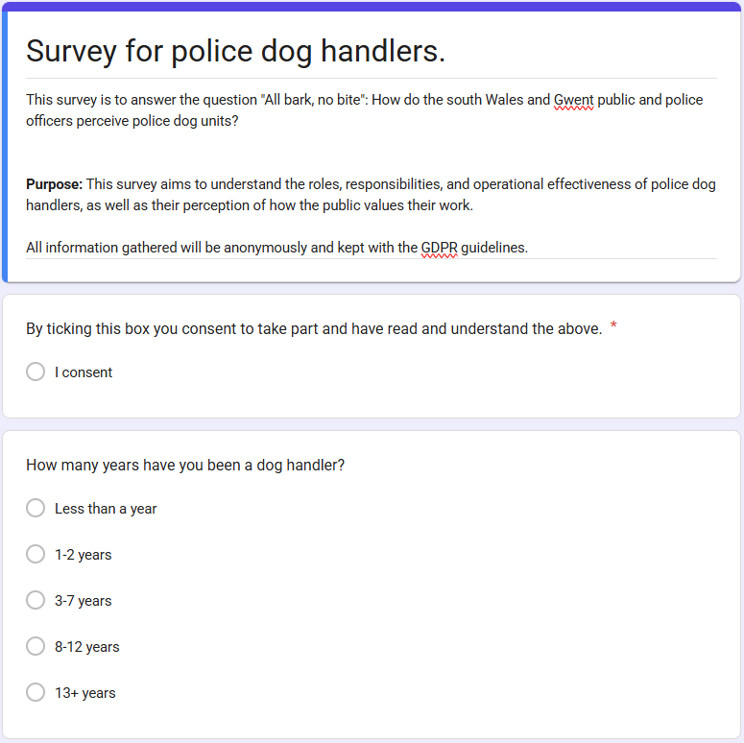
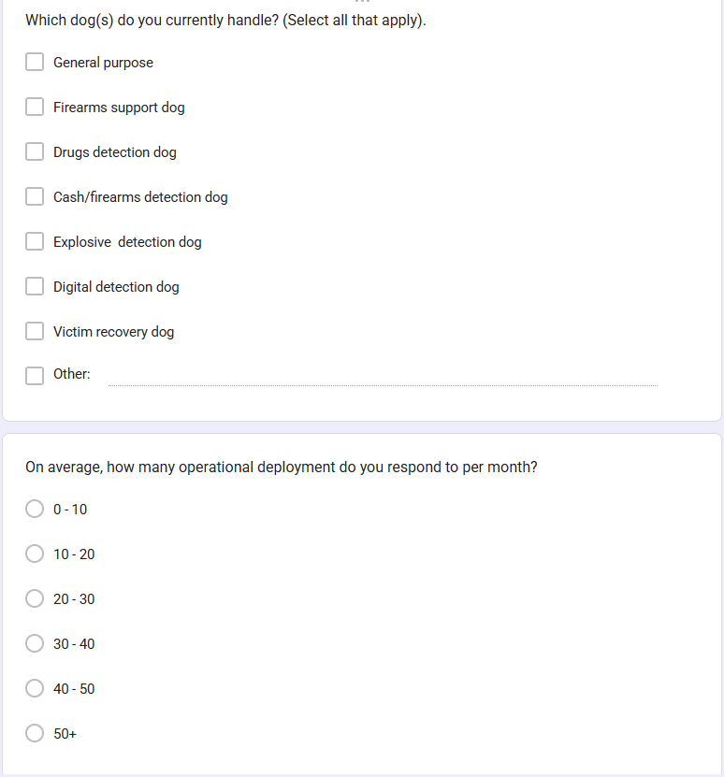
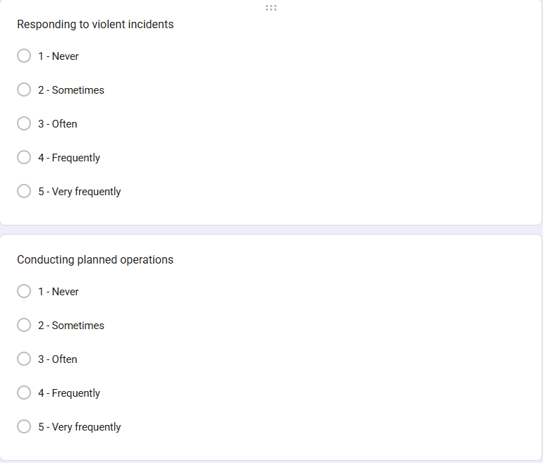
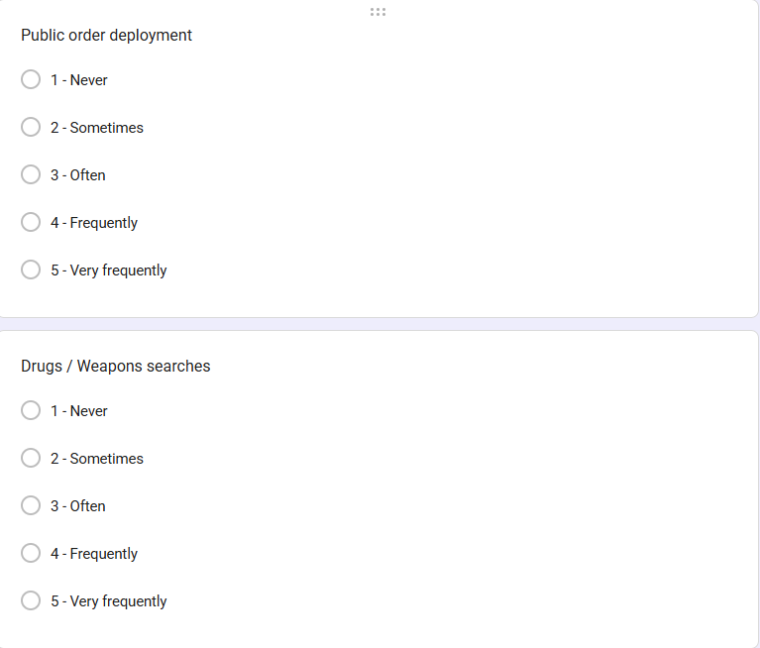
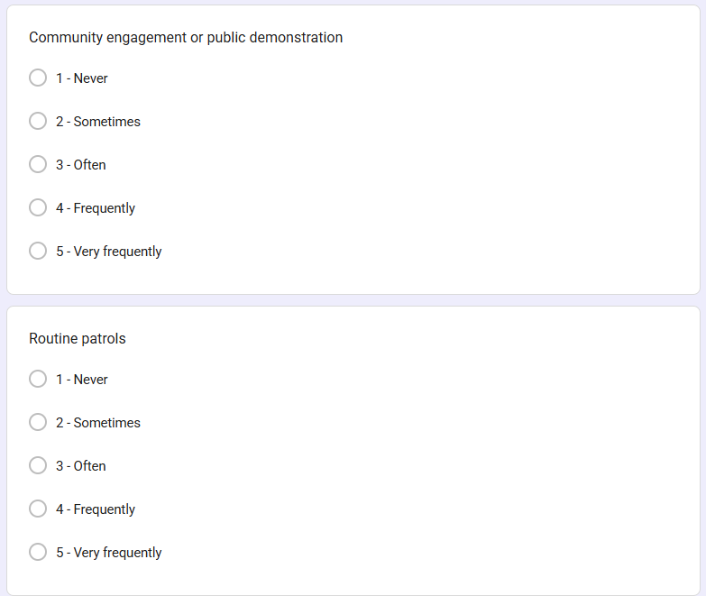
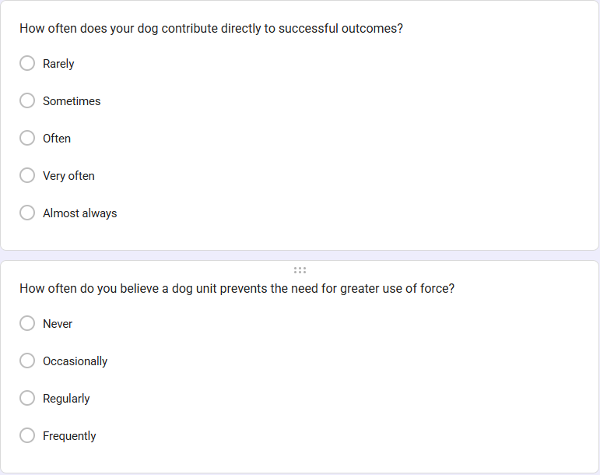
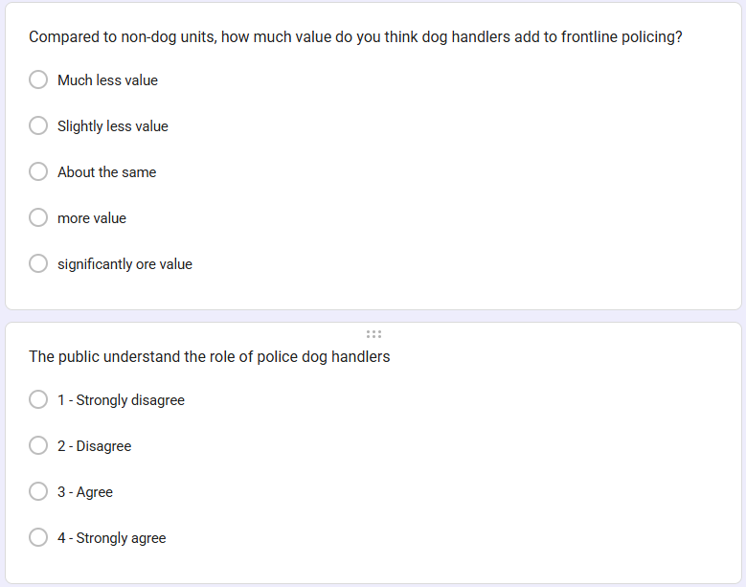
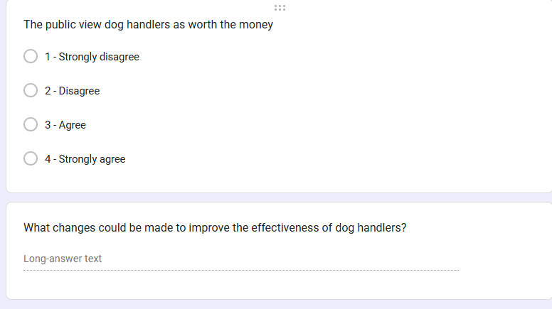

Appendix D - Dog handler survey results

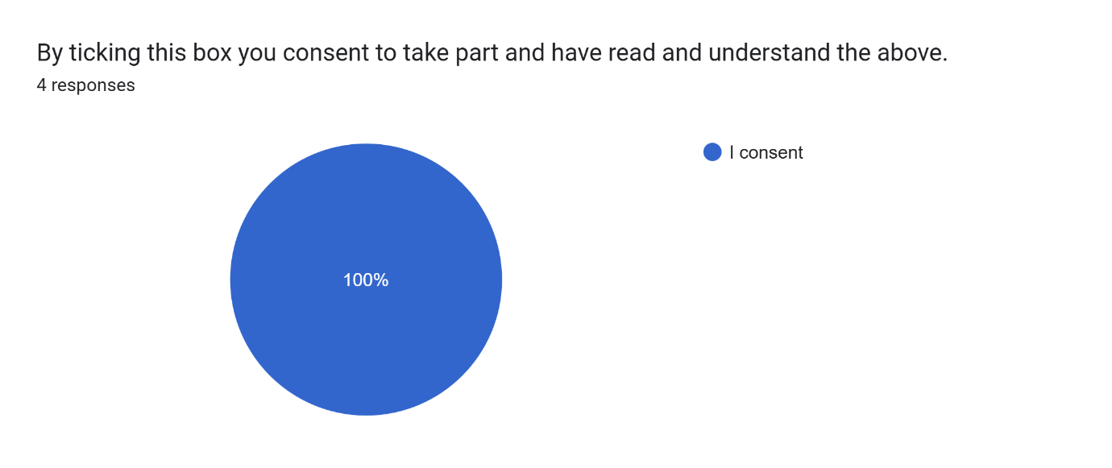
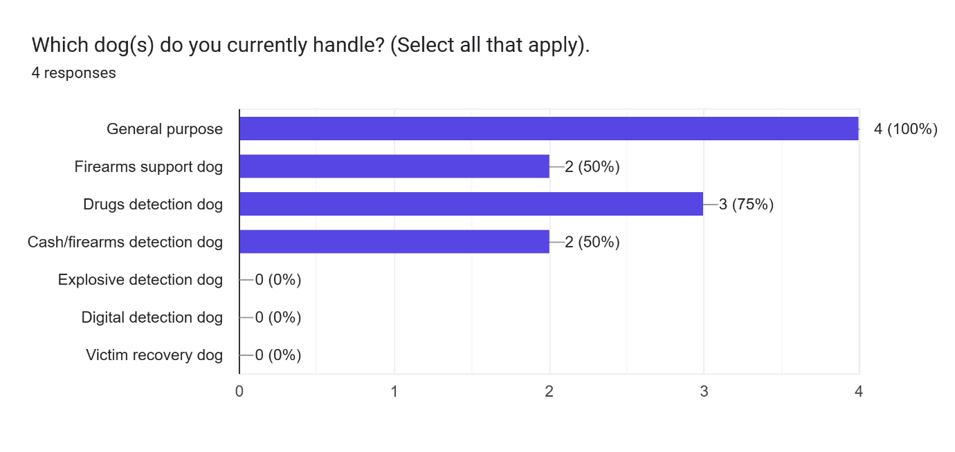

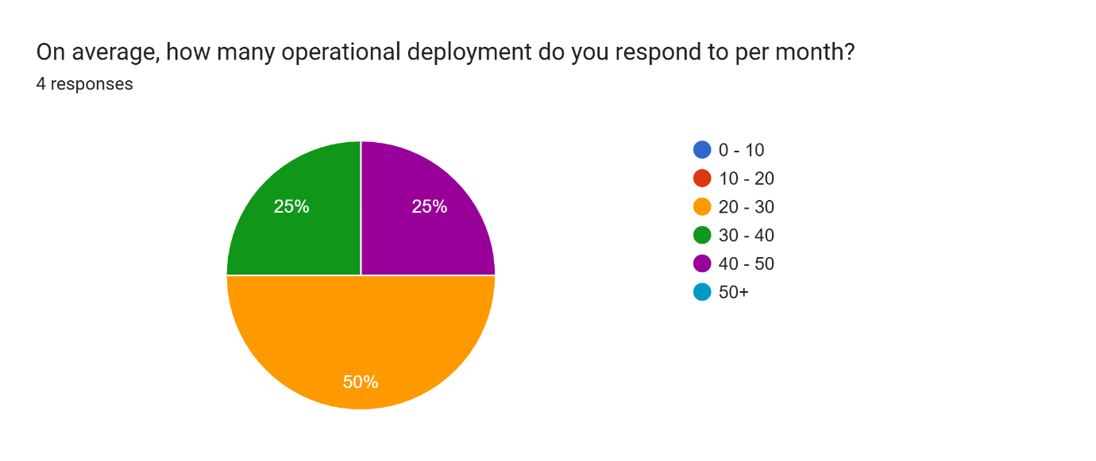
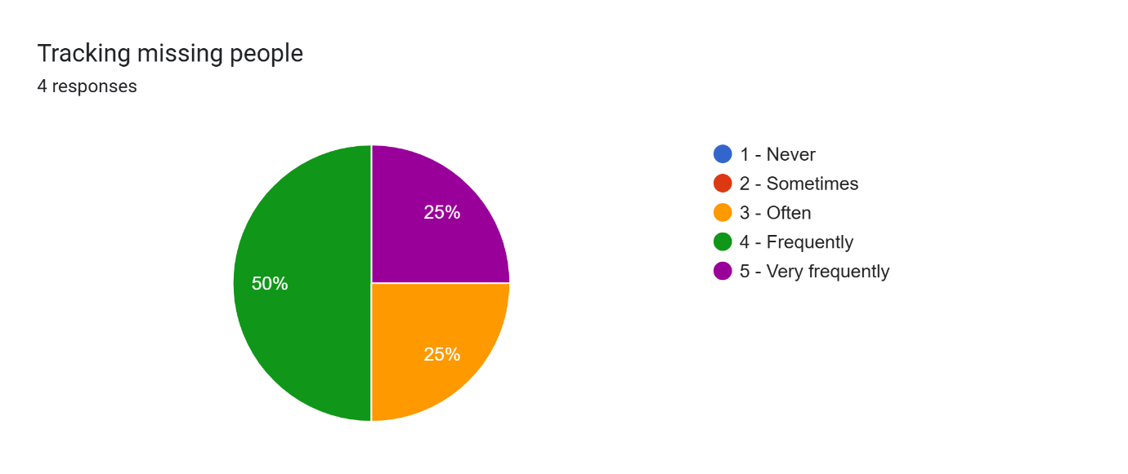
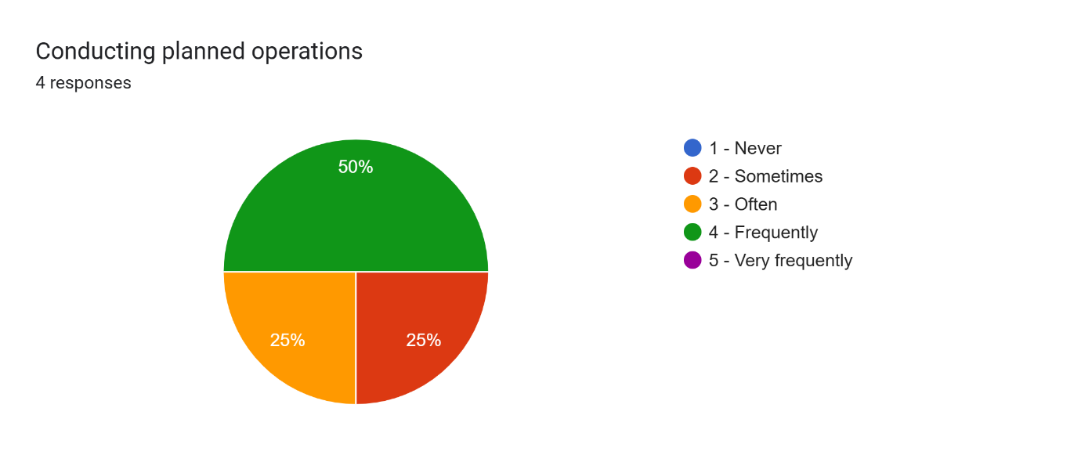
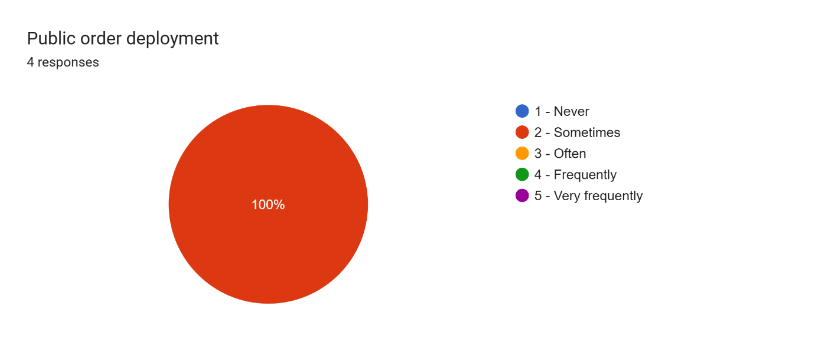
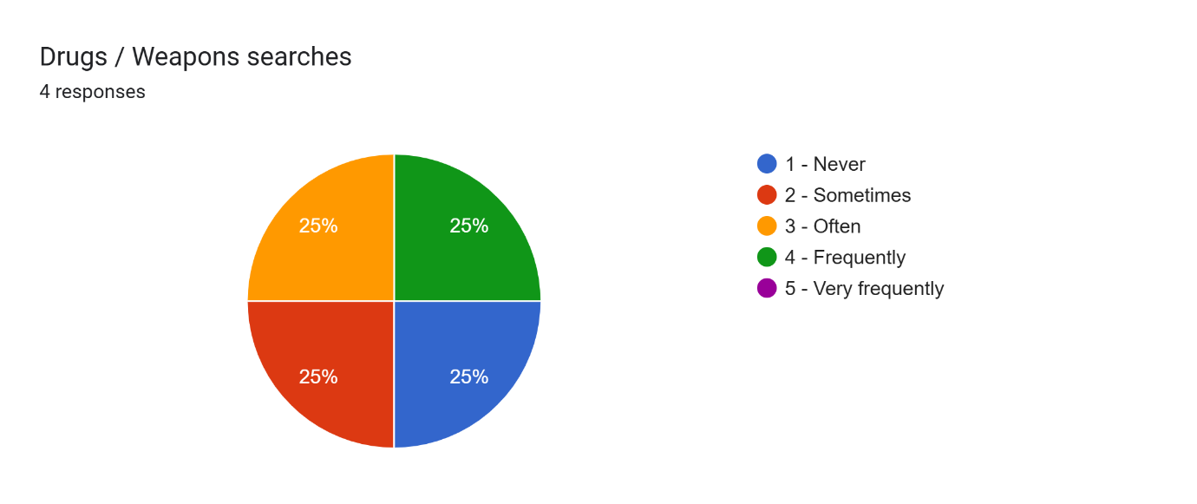
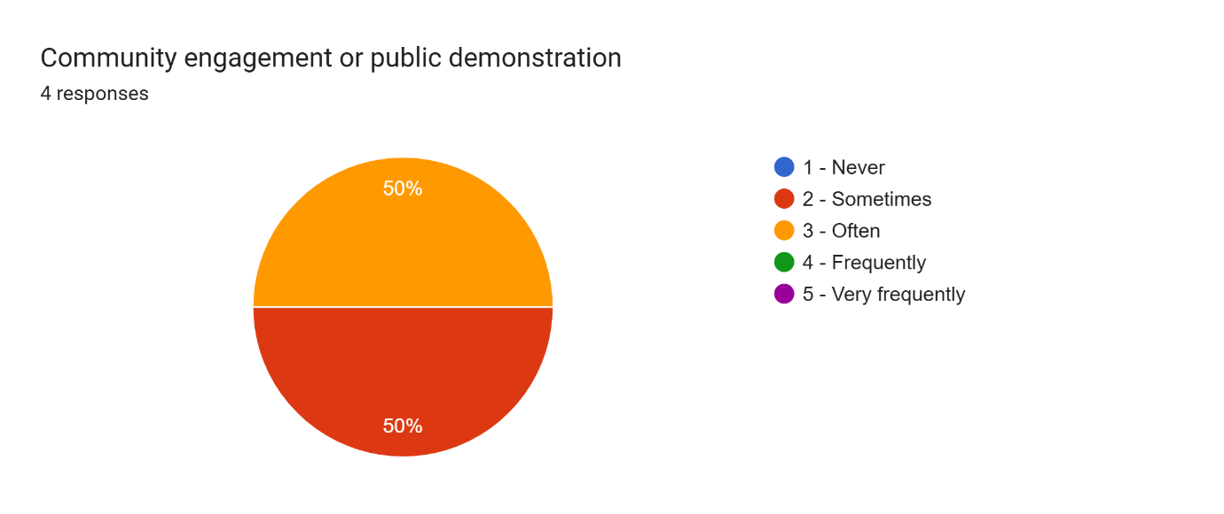
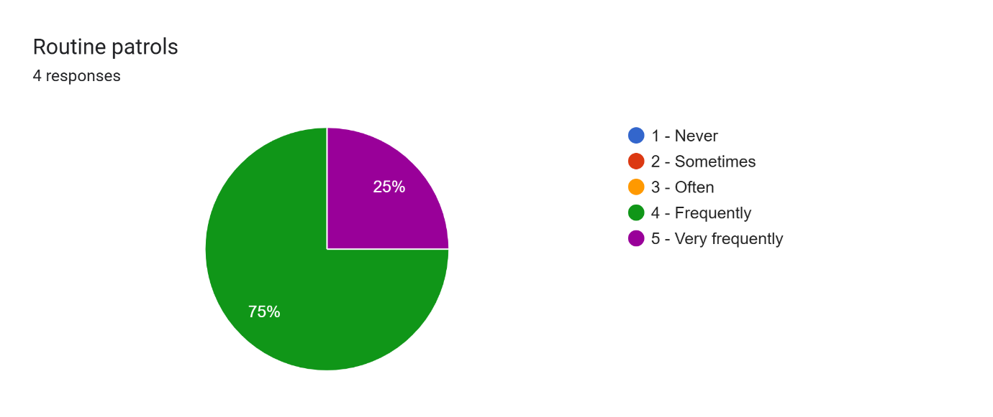
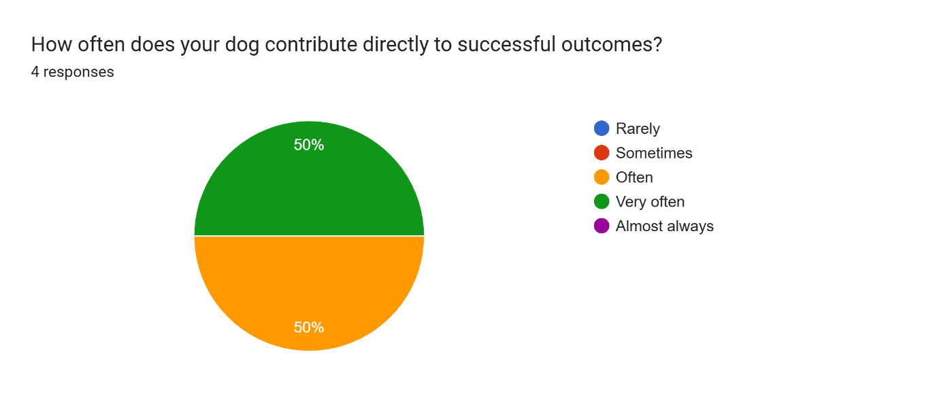
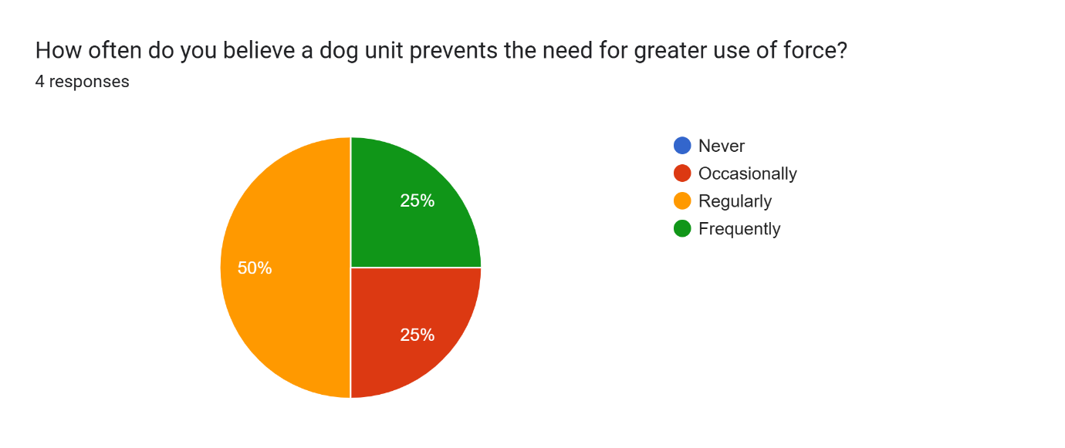
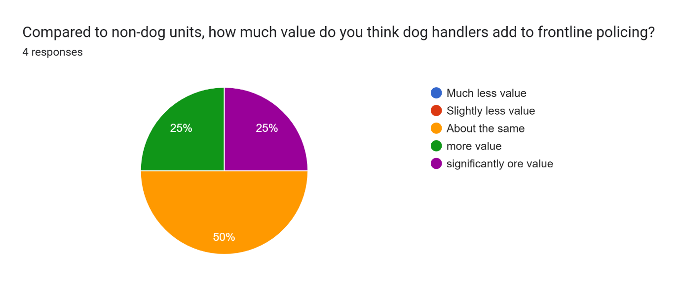
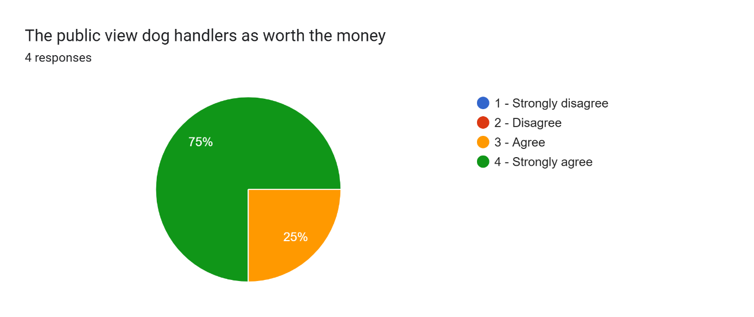


Appendix E – Public survey

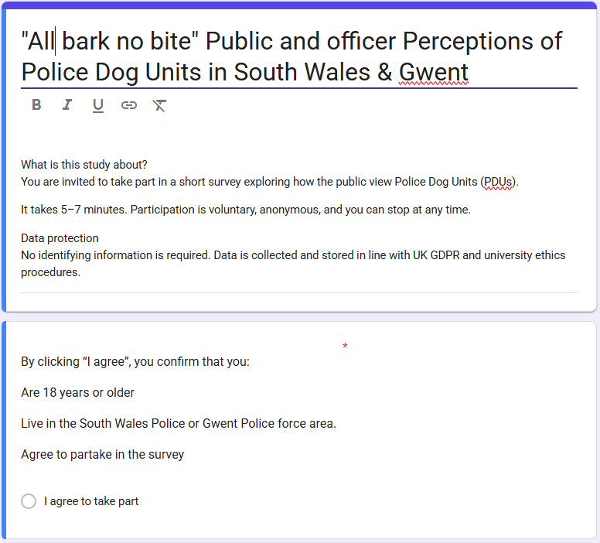

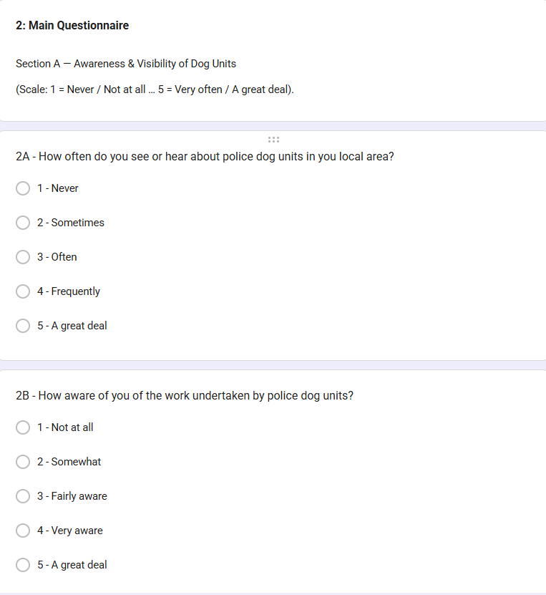
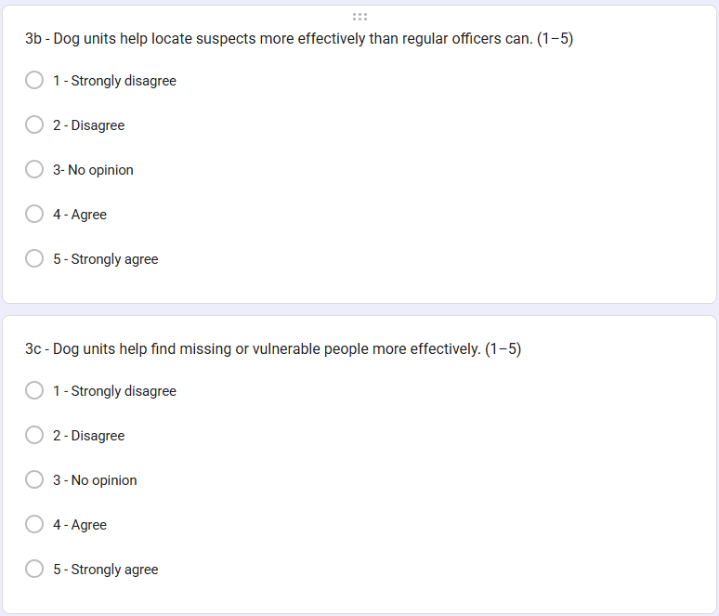
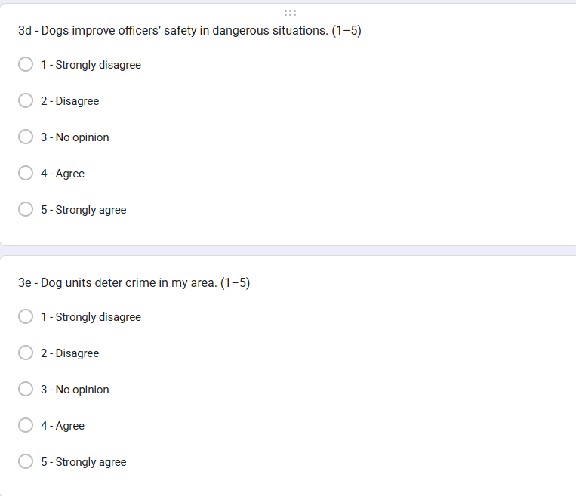
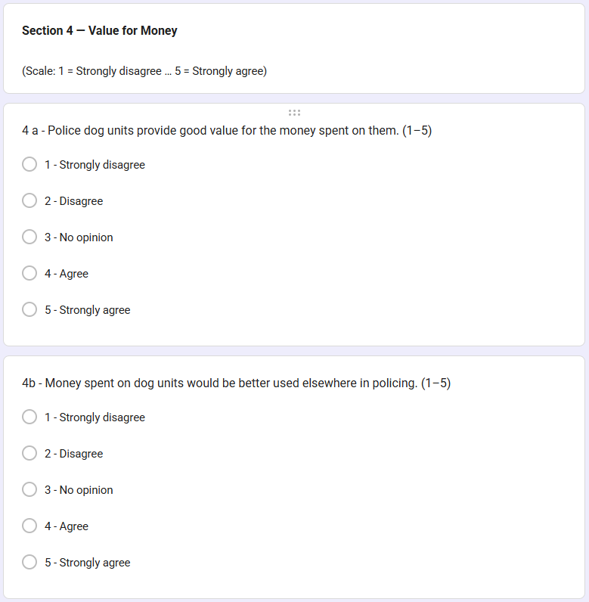
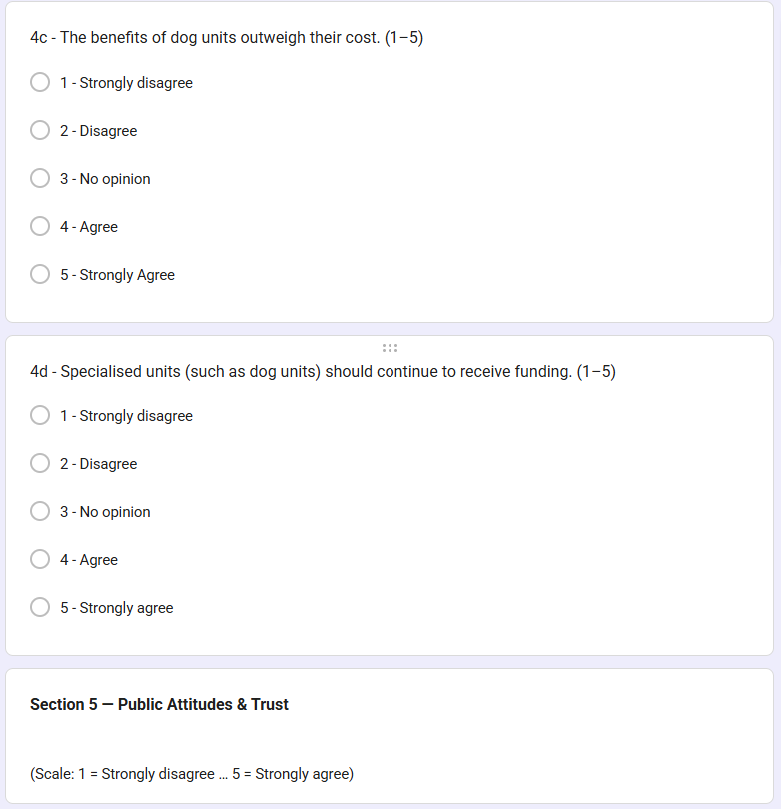
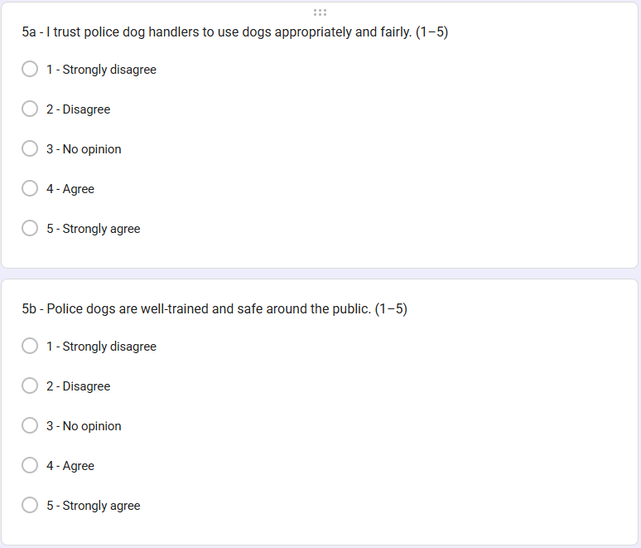
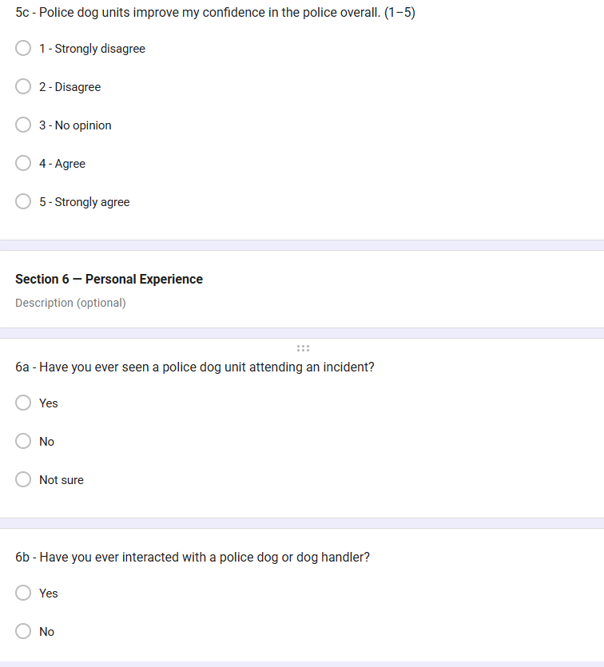
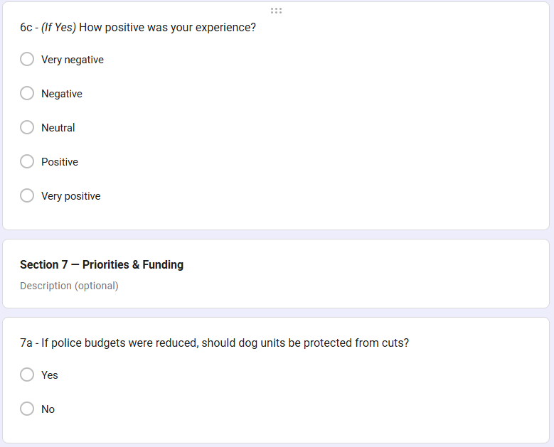
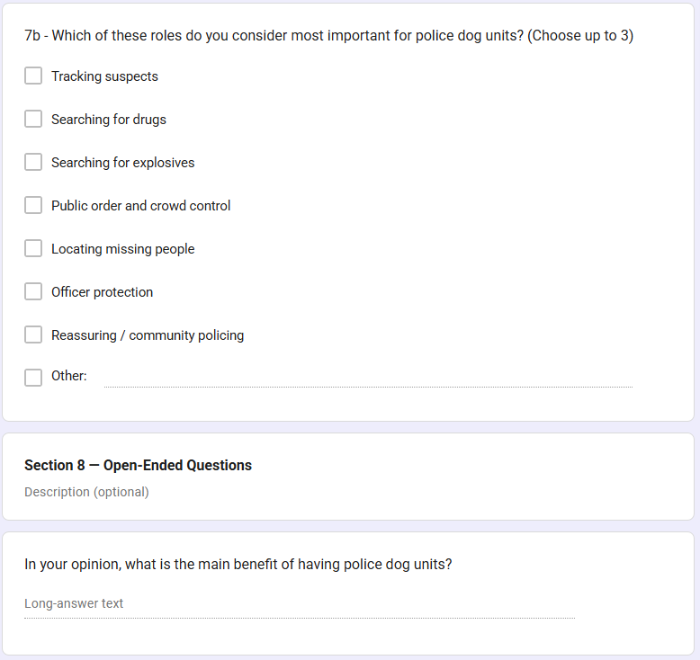
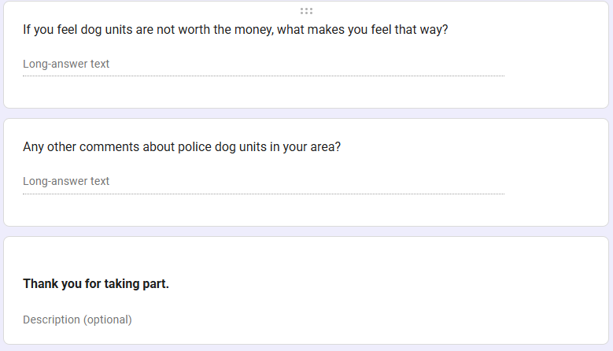
Appendix F – Public survey responses

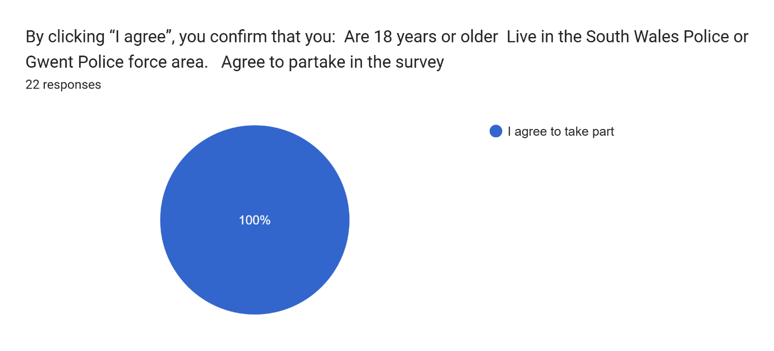
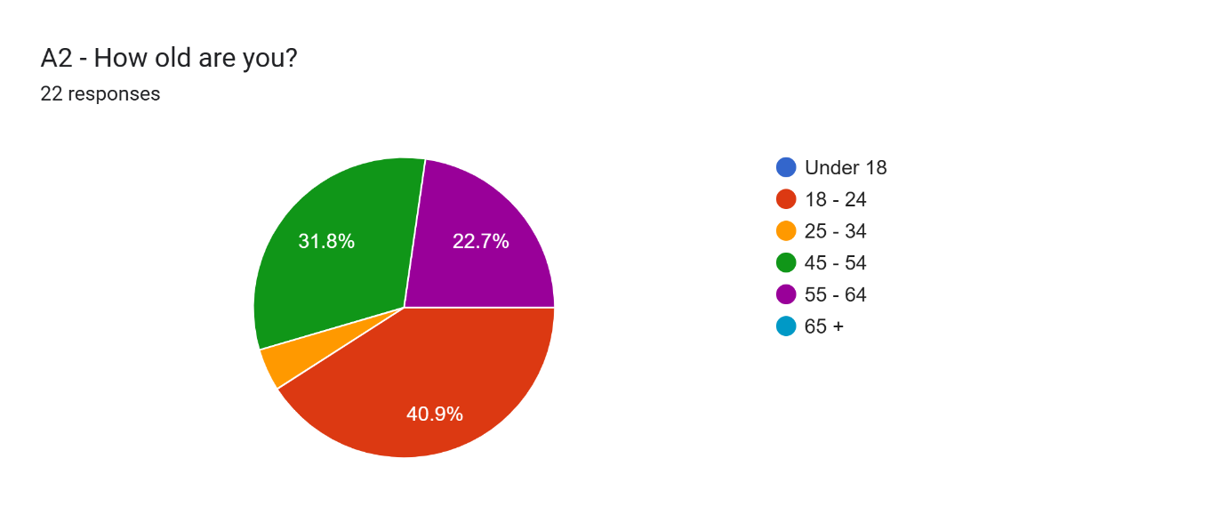
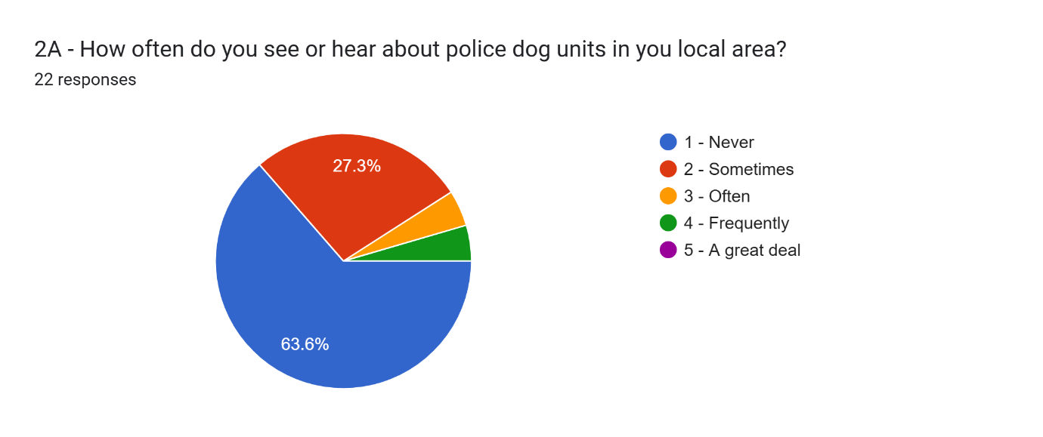

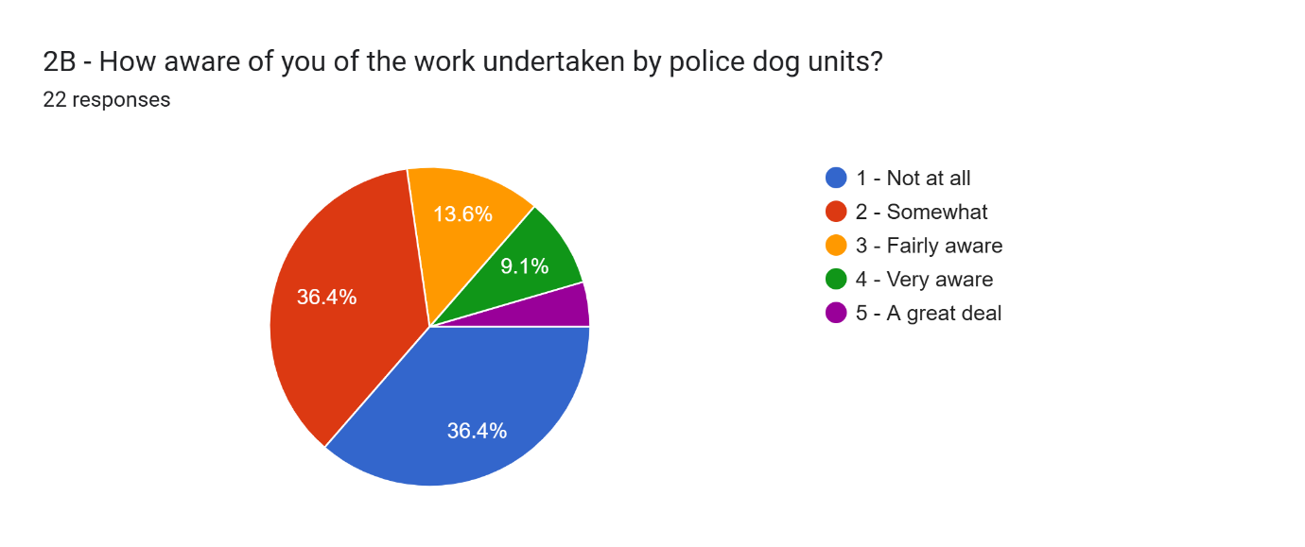
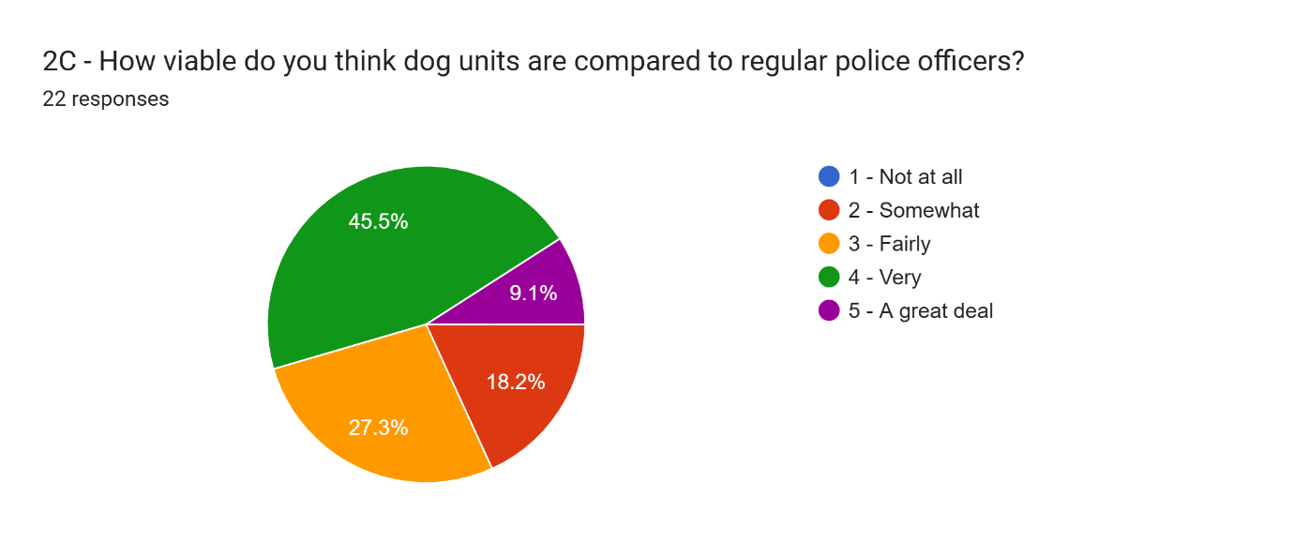
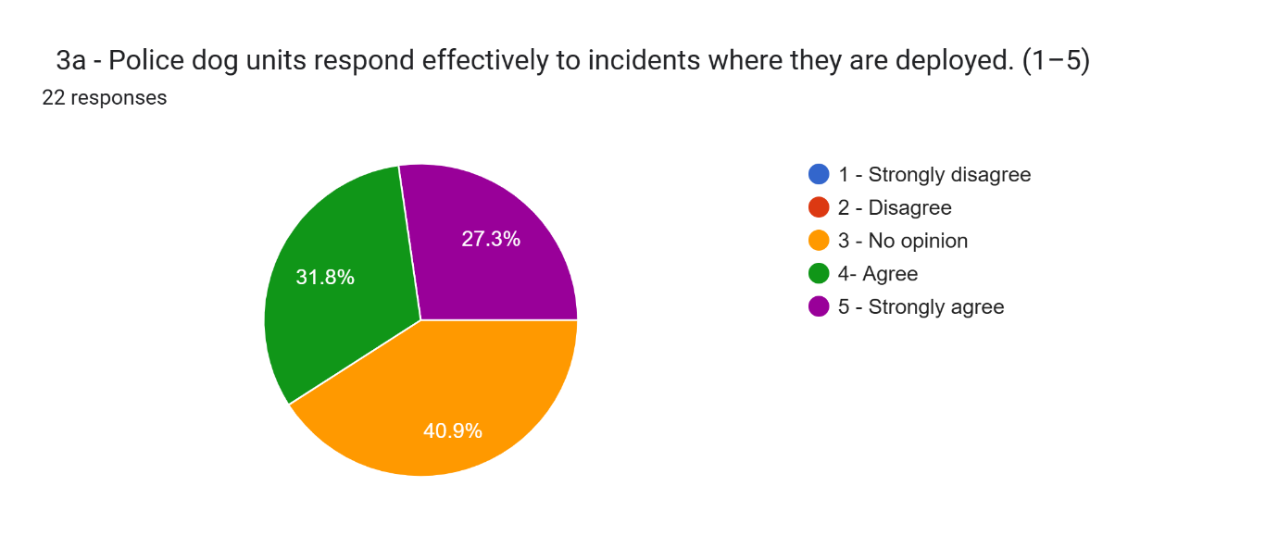
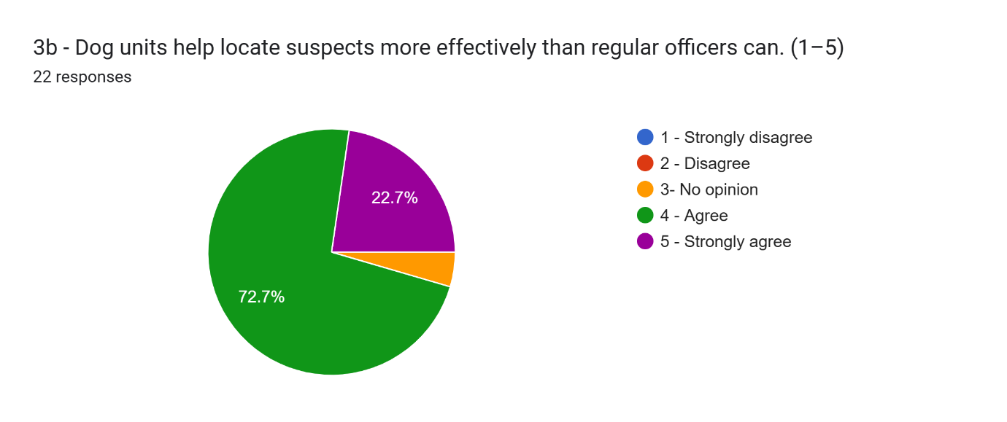
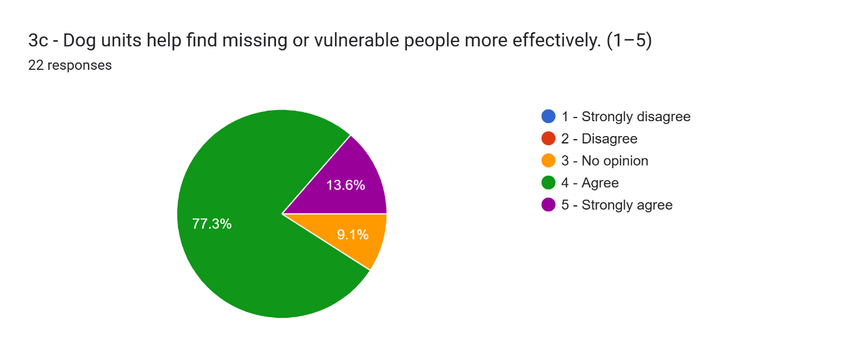
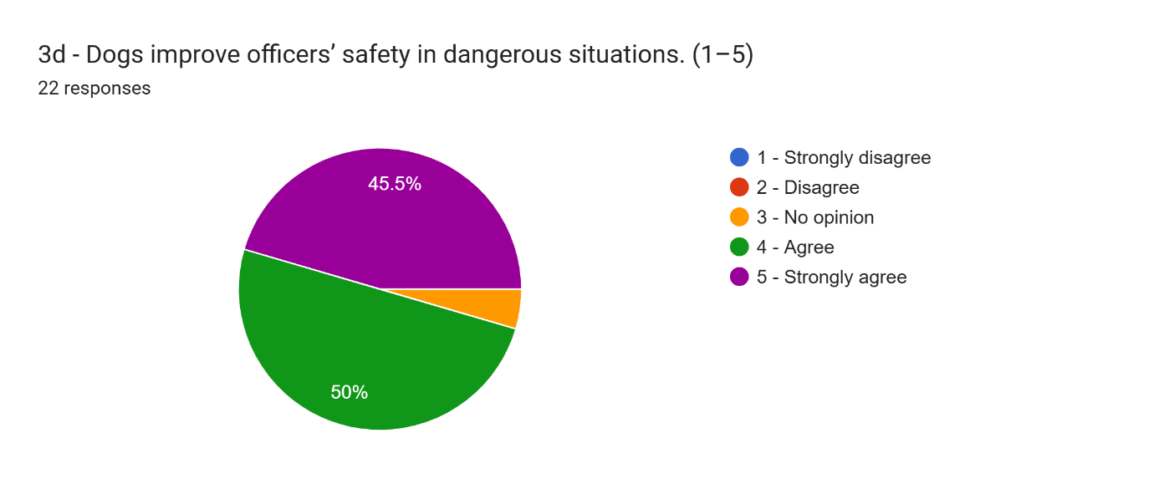
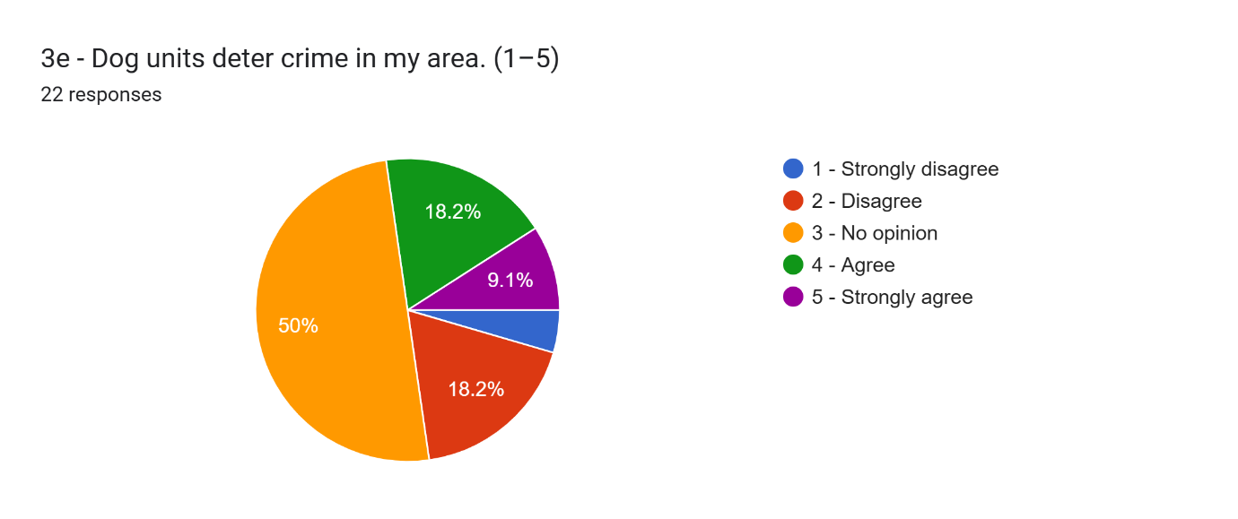
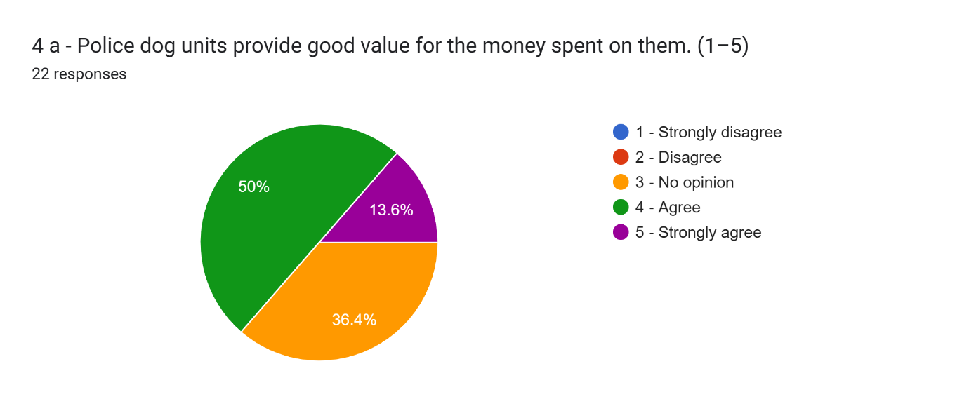
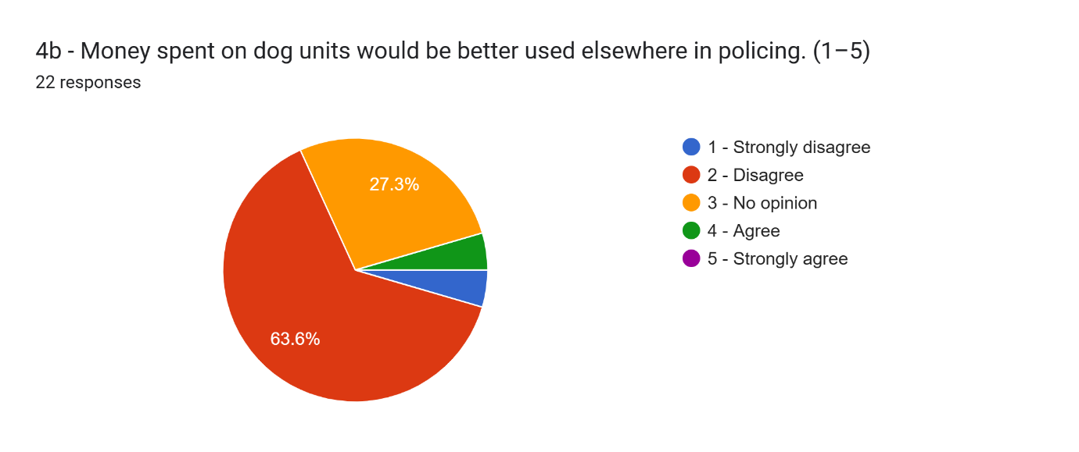
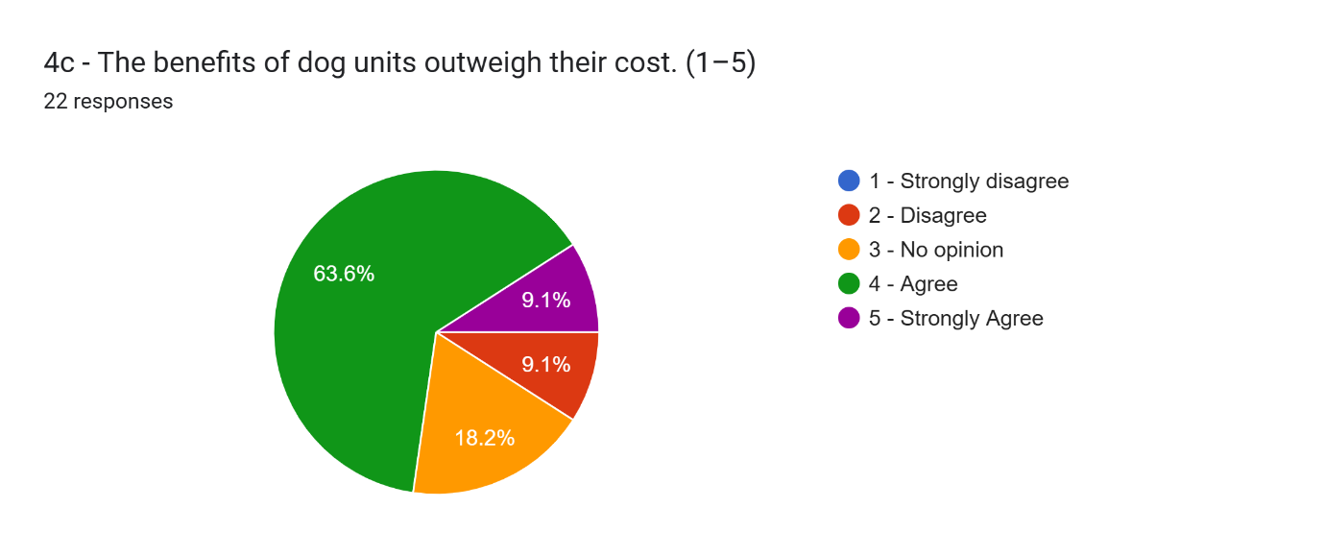
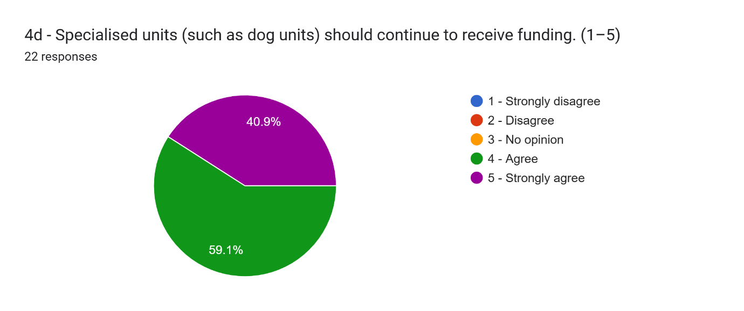
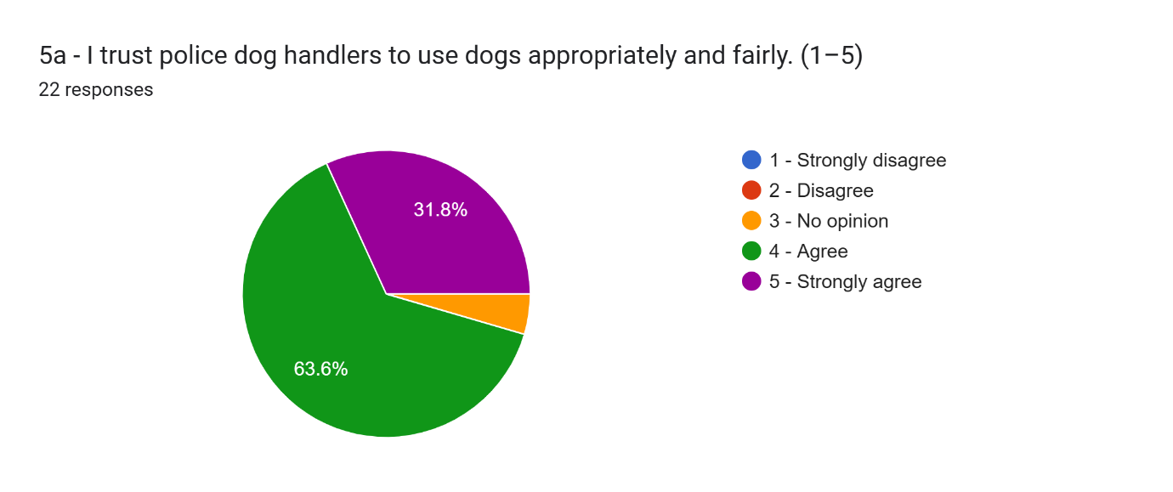
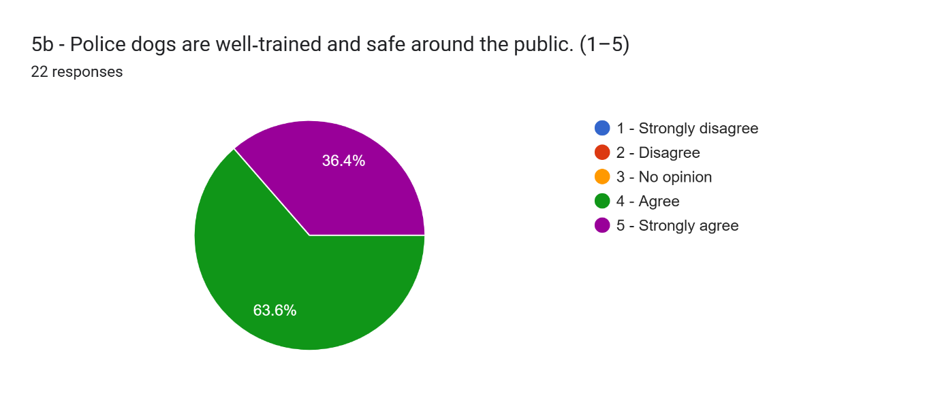
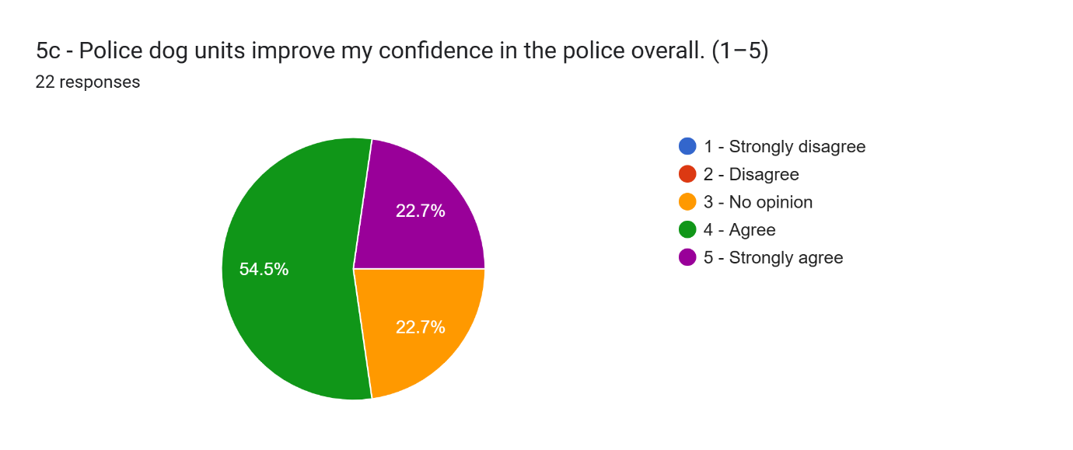
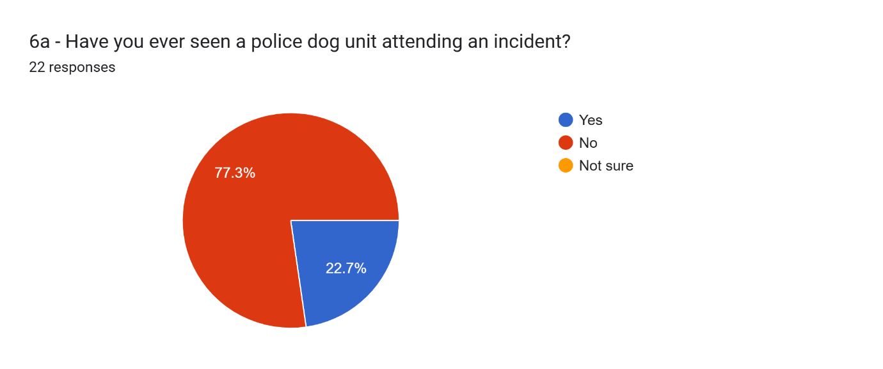
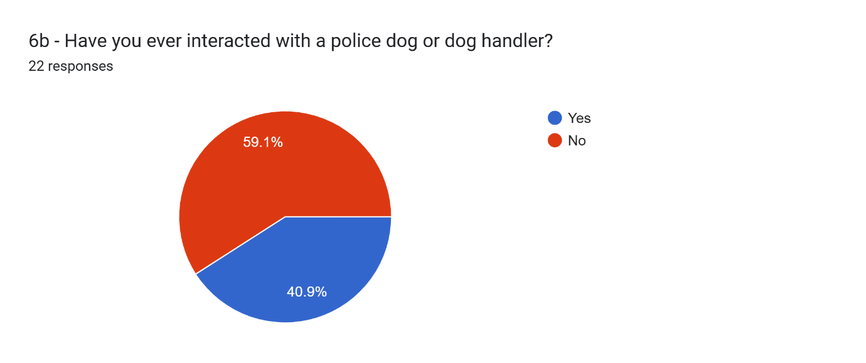
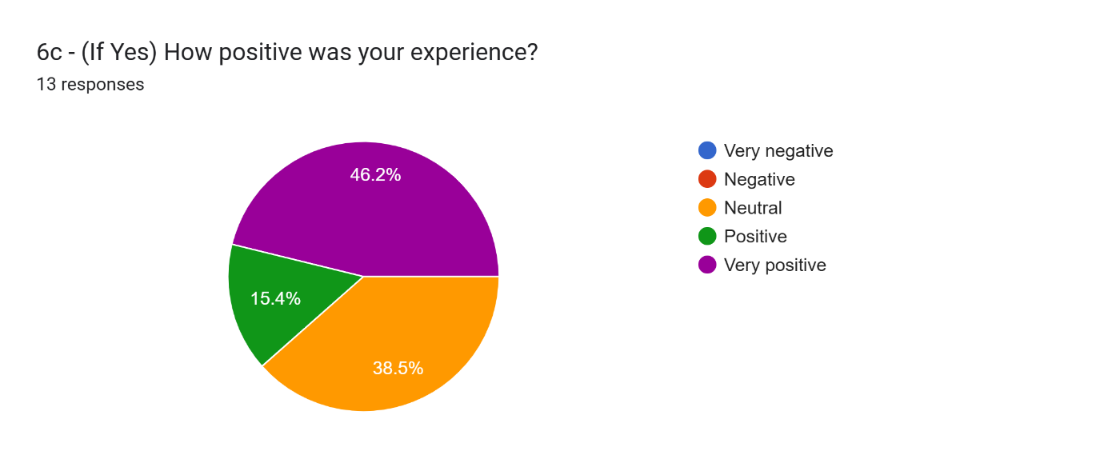
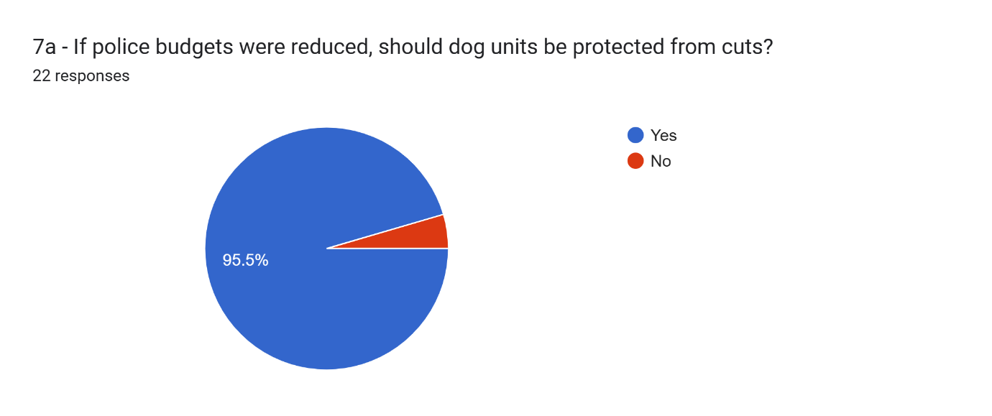

Appendix G – Response officer survey

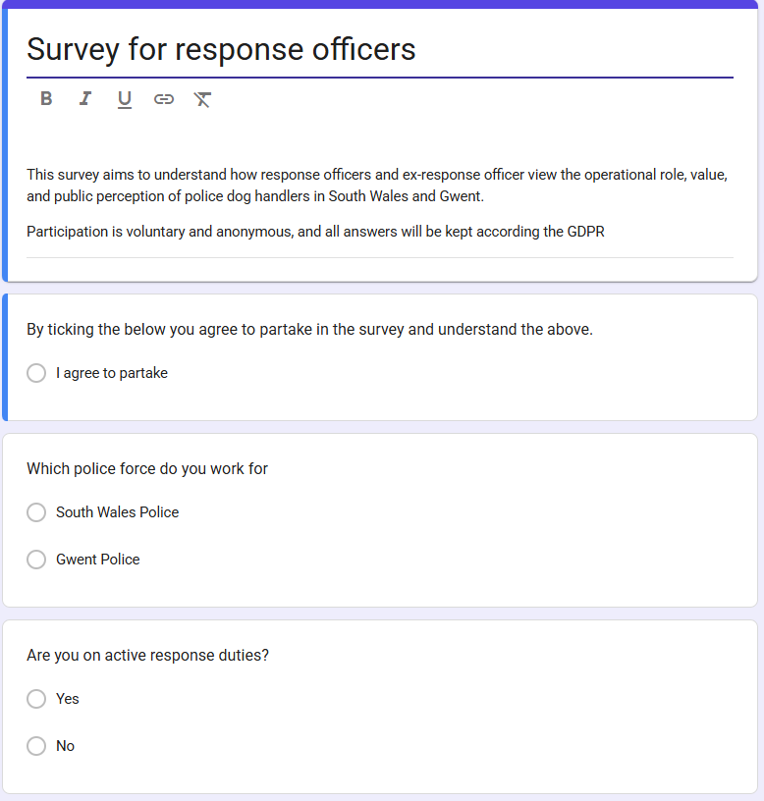
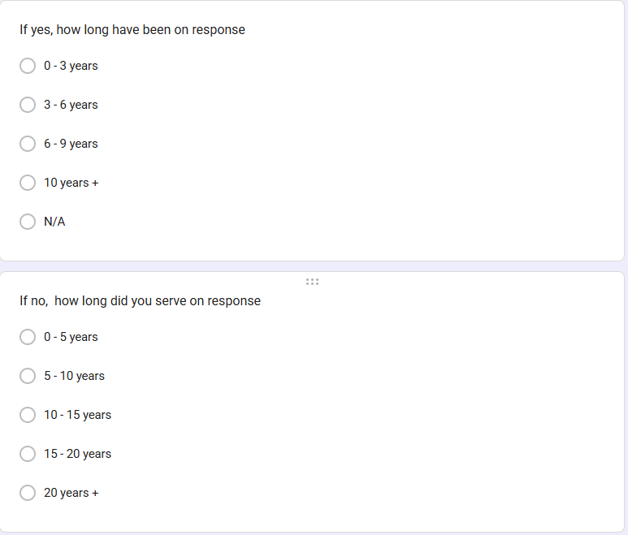
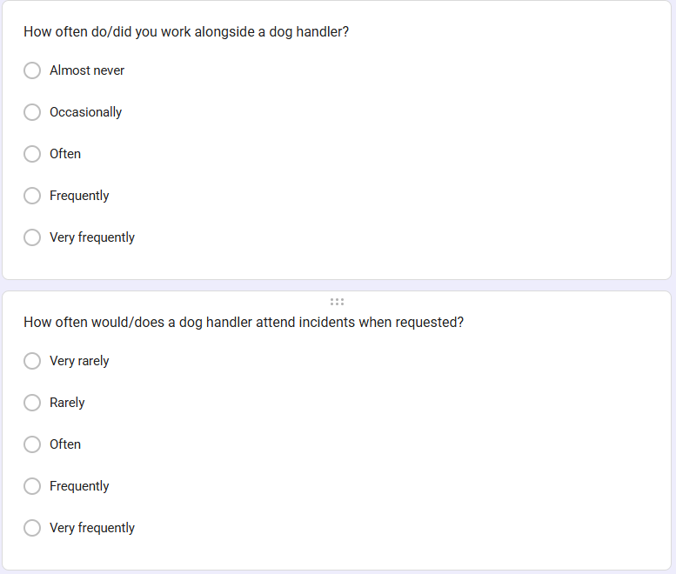
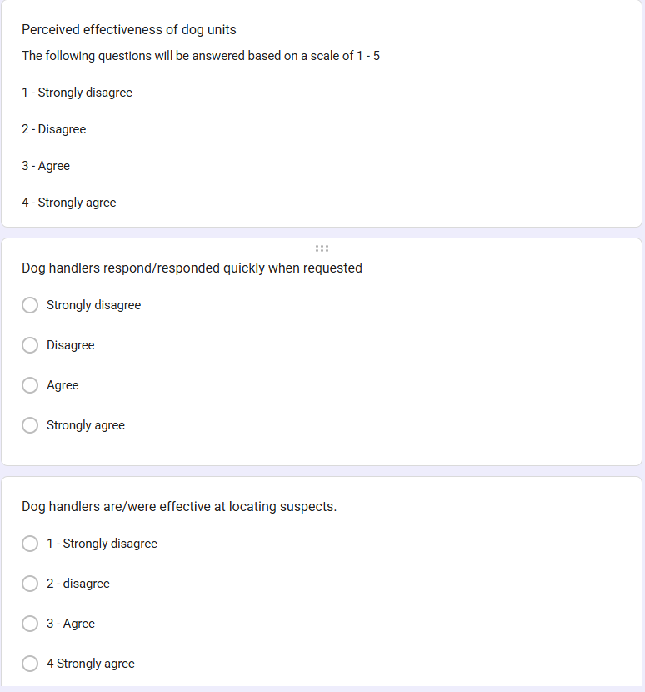
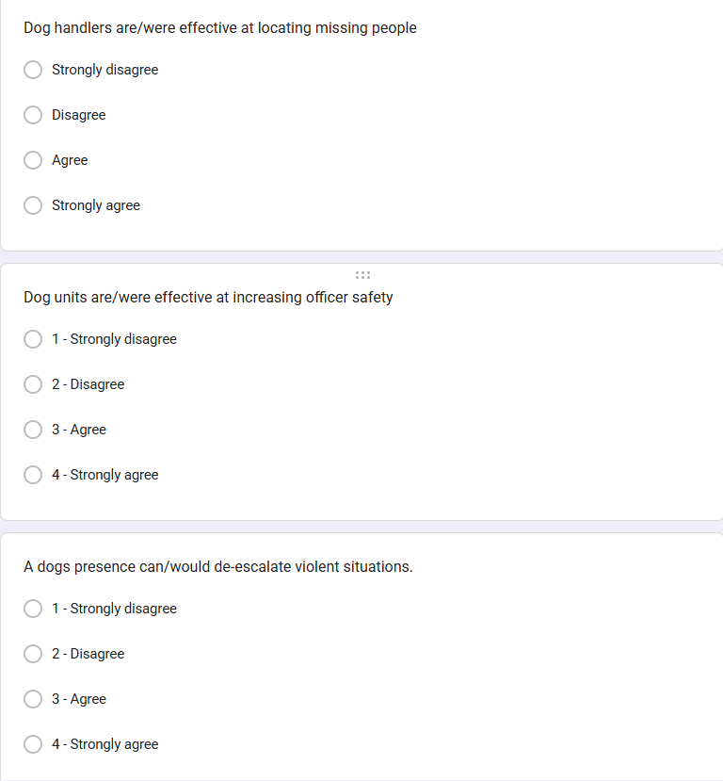
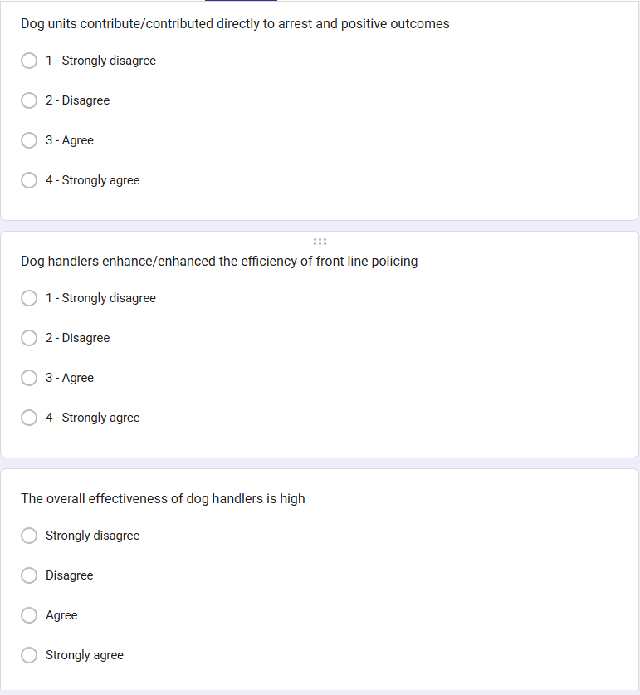

Appendix H – Response officer survey responses



