Student Name: Sobia Khan
Student ID: 2327970
Module Title: Changemakers: Building Your Personal Brand for Sustainable Employment
Assessment: Component 2 – Written Assignment (Report) Developing Employability Skills and a Professional Career Plan for the Role of Healthcare Assistant (Band 3) in the National Health Service (NHS), United Kingdom
Module Code: BMHP-5015
Submission Date: 19 July 2026

Table of Contents
Introduction 3
Job Role Chosen 3
Job Responsibilities and Employability Skills Required 4
Evaluation of My Skills Against the Job Role 4
Five-Year Action Plan and Timeline 5
Building My Personal Brand 7
Promoting My Professional Identity 7
Building a Professional Network for Successful Employment 8
Conclusion 9
References 10

Introduction
Healthcare Assistants (HCAs) are very important in helping nurses and other healthcare workers in the UK's healthcare system. This study examines my current skills and experience, identifies the abilities required for a Healthcare Assistant (Band 3) role, and provides a plan for the next five years to help me achieve this career goal.

Job Role Chosen
The selected job is a Band 3 Healthcare Assistant at Northern Care Alliance NHS Foundation Trust (Figure 1). The job involves helping patients manage their care, monitoring their health, maintaining records, and assisting doctors and nurses. It also offers opportunities for training, learning new skills, and career advancement, which makes it a great job in the NHS.
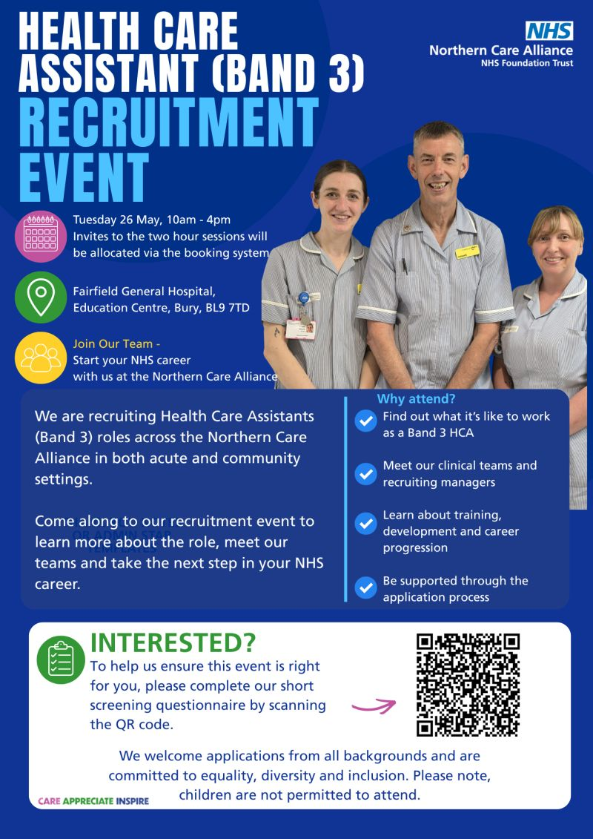
Source: https://tinyurl.com/3j3pdpdh

Job Responsibilities and Employability Skills Required
At the Northern Care Alliance NHS Foundation Trust, a Healthcare Assistant (Band 3) cares for patients with kindness and focuses on their individual needs in hospitals and community settings. Healthcare Assistants help patients with everyday activities like keeping clean, moving around, eating, and offering emotional support, all while respecting their choices and dignity (Kindell et al., 2025). They work with registered nurses and other health workers. They also manage electronic patient records, accurately document observations, monitor patients' conditions, and promptly report any problems to their superiors (The Health Foundation, 2026). Healthcare assistants help prevent infections, follow safety rules, and create a safe and supportive caring environment (Murphy et al. 2012).
To perform this job better, I need several important skills. Healthcare assistants need strong communication skills to interact effectively with patients, their families, and other members of the healthcare team (Sheehan et al., 2021). Patients often need care, support, and kindness during tough situations, so being compassionate and understanding is very important (Gill et al., 2015). Healthcare assistants need to work well with doctors, nurses, therapists, and other professionals to provide quality care, so teamwork is essential (Babiker et al., 2014).
To focus on patients’ needs and to get work done quickly in busy healthcare environments, this job also requires effective time management and organisational skills to build patients’ trust in the care system (Babiker et al., 2014). This means keeping patients’ information private, being reliable, and following NHS rules (Gill et al., 2015).
Also, being flexible helps healthcare assistants handle tough work and changing patient needs (Kindell et al., 2025). Being proficient with technology is important for using online patient record systems and completing online courses, as healthcare is increasingly dependent on technology (Sheehan et al., 2021).
Finally, companies expect job applicants to be committed to learning and improving their skills by attending necessary training during their time working there (World Health Organization 2024). When healthcare assistants have useful skills in working with people, technology, and their jobs, they can provide safe, effective, and caring support to ensure quality healthcare.

Evaluation of My Skills Against the Job Role
I evaluated my skills against the requirements for the Healthcare Assistant (Band 3) job. This helped me find out what I do well and what I need to work on. Even though my education is in business and supply chain management rather than healthcare, my work as a teacher and logistics worker has equipped me with skills that align with what the NHS is looking for. I have excellent communication skills because, as a teacher, I delivered presentations, supported students, facilitated discussions, and clearly explained complex topics.
As a result of this experience, my written and verbal skills improved. This is important for communicating with patients, their families, and other medical staff (Sheehan et al., 2021). Working with my co-workers, managers, and students to meet our goals has also helped me build strong teamwork skills. My previous job in logistics and warehouse management helped me work better with different teams and handle pressure effectively.
I am very good at staying organised and managing my time. I had to plan carefully and prioritise my tasks to handle my teaching duties, prepare course materials, maintain academic records, and supervise students. Similarly, my logistics skills involved maintaining clear records, checking stock levels, and ensuring compliance with the organisation's rules. My ability to focus on details and do tasks accurately has improved from these experiences. These skills are useful for maintaining patient records and supporting clinical teams (Schneller et al., 2023).
I know some things that could be improved. I have not yet received any healthcare-related certificates, such as the Care Certificate, training for keeping people safe, infection control, or Basic Life Support (BLS). I also do not have any practical experience caring for patients. I also need to gain practical experience working in NHS hospitals, watching patients' conditions, and assisting them with their personal care. Learning these skills is important for meeting the needs of a healthcare assistant job.
I want to fill these gaps by taking approved NHS training, volunteering in hospitals or care homes, and getting practical experience in healthcare. My experience shows that I am professional, adaptable, and eager to learn. This makes me confident that I can easily move into the healthcare field. I believe I can be a helpful and friendly healthcare assistant who improves patient care and works well with the healthcare team. I will do this by using my existing skills, learning more about healthcare, and continuing to grow in my job.

Five-Year Action Plan and Timeline
To become a Healthcare Assistant (Band 3), I need to be committed to learning more, improving my existing skills, and gaining practical experience. Even though I have leadership, teamwork, communication and management skills, I still need to learn more about healthcare to meet NHS standards (National Health Service 2023). To improve my job prospects and secure this position, I have developed a five-year plan outlining my next steps.
I will complete the Care Certificate, Level 2 training in keeping adults and children safe, Infection Prevention and Control, and Basic Life Support (BLS) training with approved NHS providers in my first year (Skills for Health 2025). In addition, I am studying a BSc in Health and Social Care at UWTSD, where the course outline deepens my knowledge of the health and social care sector.
I plan to keep volunteering during my studies at UWTSD. In my bachelor's program, through various modules, I will learn about dementia care, communication, equality, diversity, person-centred care, and improving digital skills. I will also learn how to use Electronic Patient Record (EPR) systems. I will improve my technical and social skills through these activities.
In my third year, I want to look for jobs with the NHS as a Healthcare Assistant (Band 3) once my degree is completed. I will update my resume, improve my LinkedIn page, and create a professional portfolio that includes my references, qualifications, training records, and volunteer feedback before I apply. To build my confidence for NHS job interviews, I will practice my interview skills.
After getting a job, I will continue learning and participate in all necessary training programs for the NHS during my fourth year. To improve my skills and help healthcare teams, I will seek advice from my mentors, experienced nurses and supervisors.
By the fifth year, I want to improve at my job by earning new qualifications, such as training to become a nursing associate or learning more about healthcare (NHS England 2024). This progress will improve my job prospects and enable me to support the NHS's long-term goals while providing better patient care.
Table 1: Five-Year Career Timeline
Year | Planned Activities
Year 1 | Starting volunteering after completing the Care Certificate, safeguarding, infection prevention, and BLS training, along with my studies at UWTSD.
Year 2 | Develop digital skills, attend CPD workshops and continue voluntary work.
Year 3 | After graduation, apply for NHS Healthcare Assistant (Band 3) vacancies and prepare your CV, LinkedIn profile, and professional portfolio.
Year 4 | Gain NHS employment, complete mandatory training and continue Continuous Professional Development (CPD).
Year 5 | Pursue Nursing Associate or advanced healthcare qualifications and progress within the NHS.

Building My Personal Brand
Building a good personal brand is very important for getting a job in the medical field. A person's personal brand reflects their values, skills, behaviour at work, and commitment to providing great service (Park 2020). My personal brand for the Healthcare Assistant (Band 3) role will focus on professionalism, care, reliability, and a willingness to learn. These values align with the NHS's focus on putting patients first, treating them with respect, and upholding their dignity (Department of Health and Social Care 2023).
I will complete important healthcare training, like the Care Certificate, safety training, infection control, and Basic Life Support, to help develop this brand. To show how much I care about helping patients, I will get real experience by volunteering at nursing homes or hospitals. I will also maintain a professional LinkedIn page to showcase my qualifications, volunteer work, transferable skills for different roles, and any training I'm pursuing to improve myself.
In modern healthcare, managing digital professional identity is recognised as important for career progression and networking (Karim and Talhouk 2021). I will improve my profile by updating my resume to align with NHS needs and by showcasing my achievements, qualifications, and professional references (Department of Health and Social Care, 2023). I will also maintain a strong online presence by connecting with professional groups and sharing healthcare information. I can build a credible personal brand that sets me apart from other applicants and improves my chances of being hired by the NHS by consistently demonstrating competence, empathy, integrity, and a willingness to grow (Park, 2020).

Promoting My Professional Identity
The term "professional identity" refers to how someone expresses their beliefs, values, actions, and the skills required for a specific job or field (Cruess et al., 2015). I want to show that I can be an efficient healthcare assistant by being kind, caring, and prioritising people first, in line with the NHS values. It requires dedication to high standards, taking responsibility, and continuous learning to build this identity (Department of Health and Social Care, 2023).
I will complete training designed for the healthcare field and participate in ongoing learning to strengthen my professional skills. I will begin practising reflection by examining my experiences and identifying areas for improvement. This develops clinical judgment and self-awareness (Gibbs, 2013). Professionalism means keeping patient information private, respecting their dignity, and following rules to prevent infections and keep everyone safe. To improve and feel more confident in clinical situations, I plan to ask my mentors, bosses, and co-workers for helpful feedback (Babiker et al., 2014).
I will ensure that my behaviour, appearance, and communication style, both in person and online, follow NHS guidelines. My work records, including my resume, LinkedIn profile, and portfolio, will always show that I am skilled, reliable, and committed to caring for patients. I will create a professional identity that helps me grow in my career and become a trustworthy member of the healthcare team by acting ethically, continuing to learn, and following NHS values (Cruess et al. 2015).

Building a Professional Network for Successful Employment
Building a strong network of professional contacts is an important way to find a job and advance in the healthcare field. By networking, people can find job opportunities, get career advice, and learn from experienced professionals (Park, 2020). Building relationships with healthcare workers would help better understand NHS rules and hiring processes for the healthcare assistant role (Department of Health and Social Care, 2023). I want to create a LinkedIn profile and connect with recruiters, nurses, healthcare assistants, and NHS organisations to grow my professional network. I will attend workshops, seminars, job fairs, and NHS hiring events to meet experts and learn about new healthcare practices. Besides gaining practical experience, volunteering at hospitals, community health centres, or assisted living places will help me connect with experienced workers.
To access educational resources, job opportunities, and career advice, I will join professional groups and online forums, such as NHS Careers and Skills for Care. Consulting with tutors, experienced nurses, and healthcare workers will help improve skills, build confidence, and receive helpful feedback (Babiker et al., 2014). Building professional relationships through regular communication and continuous learning will help me get a job as a healthcare assistant in the NHS and support my long-term career growth.

Conclusion
My written report analysed the skills needed for the Healthcare Assistant (Band 3) job at the Northern Care Alliance NHS Foundation Trust. I compared my current skills with the required job descriptions. The study shows that providing safe and personalised care requires good communication, teamwork, kindness, professionalism, adaptability, technical skill, and a commitment to learning and improvement. My previous experience as a teacher and a logistics worker has helped me develop important skills that can be applied in many areas. These skills include problem-solving, leading others, staying organised, and communicating effectively. I understand that it's important to gain practical experience, obtain professional qualifications, and learn specific information about healthcare, such as the Care Certificate and the training required for the NHS.
The five-year action plan provides a helpful way to achieve these goals by using formal education, volunteering, continuing education, and practical experience. Also, I will have better job prospects and demonstrate my commitment to NHS values by building a strong personal brand, projecting a professional image, and connecting with others in my field.

References
- Babiker, A., et al. (2014) ‘Health care professional development: Working as a team to improve patient care’, Sudanese journal of paediatrics, 14(2), 9–16.
- Cruess, R. L., et al. (2015) ‘A schematic representation of the professional identity formation and socialisation of medical students and residents: a guide for medical educators’, Academic medicine: journal of the Association of American Medical Colleges, 90(6), 718–725. https://doi.org/10.1097/ACM.0000000000000700
- Department of Health and Social Care (2023) The NHS Constitution for England. Available at: https://www.gov.uk/government/publications/the-nhs-constitution-for-england (Accessed: 16 July 2026).
- Gibbs, G. (1988) Learning by Doing: A Guide to Teaching and Learning Methods. Oxford: Further Education Unit.
- Gill, V. et al. (2015) Healthcare Assistants and compassionate care: Perceptions of 12-hour shifts. Available at: https://www.england.nhs.uk/6cs/wp-content/uploads/sites/25/2015/09/natcen-hcas-12hr-shifts.pdf (Accessed: 16 July 2026).
- Karim, J. L., and Talhouk, A. (2021) ‘Correction: Person-Generated Health Data in Women's Health: Protocol for a Scoping Review’, JMIR research protocols, 10(10), e34211. https://doi.org/10.2196/34211
- Kindell, J. A., et al. (2025) ‘Exploring the everyday care practices of healthcare support workers when working with people with dementia admitted to National Health Service hospital wards in the United Kingdom: a qualitative systematic review of the literature’, Aging & mental health, 29(5), 915–927. https://doi.org/10.1080/13607863.2024.2447319
- Murphy, D. M., et al. (2012) ‘Competency in infection prevention: a conceptual approach to guide current and future practice’, American journal of infection control, 40(4), 296–303. https://doi.org/10.1016/j.ajic.2012.03.002
- NHS England (2024) NHS Long Term Workforce Plan. London: NHS England. Available at: https://www.england.nhs.uk/publication/nhs-long-term-workforce-plan/ (Accessed: 16 July 2026).
- Park L. J. (2020) ‘Using the SBAR handover tool’, British journal of nursing (Mark Allen Publishing), 29(14), 812–813. https://doi.org/10.12968/bjon.2020.29.14.812
- Sheehan, J., et al. (2021) ‘Methods and Effectiveness of Communication Between Hospital Allied Health and Primary Care Practitioners: A Systematic Narrative Review’, Journal of multidisciplinary healthcare, 14, 493–511. https://doi.org/10.2147/JMDH.S295549
- Schneller, E., et al. (2023). Strategic management of the healthcare supply chain. (2nd edn). NY: John Wiley & Sons.
- Skills for Health (2025) Care Certificate Standards for national care training. Available at: https://www.skillsforcare.org.uk/Developing-your-workforce/Care-Certificate/Care-Certificate-standards.aspx (Accessed: 14 July 2026).
- The Health Foundation (2026) Electronic patient record systems in England: what do NHS staff think? Available at: https://www.health.org.uk/reports-and-analysis/analysis/electronic-patient-record-systems-in-england-what-do-nhs-staff-think (Accessed: 14 July 2026).
- World Health Organization (2024) Infection prevention and control in-service training guide and curricula description. Available at: https://iris.who.int/server/api/core/bitstreams/c377f741-7640-488b-89e9-508171275767/content (Accessed: 12 July 2026).

