Ashley John Rees (2009258)
ACCA4024 Networks and Cyber Security Essentials
School of Applied Computing
Wales Institute of Science and Art Date
8th January 2021

CONTENTS
- Introduction
- Vulnerabilities
  - Network vulnerabilities
  - Operating system vulnerabilities
  - Human
- Processes
  - Hidden backdoor programs.
  - Unencrypted data
  - Security bugs
  - Account privileges
- Threats
  - Malware
  - Ransomware
  - Phishing/ spear phishing/ whaling
  - Data breaches/ leaks
  - Hackers
  - DDOS attacks
  - Man in the middle attacks
  - Mobile apps/ devices
  - Industrial spies
  - Attack on internet of things
- Attacks
  - Sessions hijacking
  - Password attacks – brute force, dictionary
  - Malware attack
  - Ping of death
  - IP spoofing
- Implementation
- vulnerabilities
- threats
- Attacks
- Digital signatures and data encryption
- Data encryption
- Attack
- Network Layout
- Annexure 1
  - Policy for Che-Si
- Conclusion
- Reference

- Introduction

As cybersecurity has become one of the main threats globally for all businesses and organisations, It is important to ensure that networks are setup properly and have basic computer and network security implemented. Without security, important and sensitive data could be lost or hacked, causing the company a lot of money or its reputation.
In this assignment I plan to identify and research the threats, vulnerabilities and attacks that may be carried out on Che-Si’s Network. Ways in which to prevent these occurring and create a policy to adhere to in order to minimise the risks of attacks happening. I will also be creating a simulation to show how an attack can be carried out.
After careful thought and consideration, I have identified and researched the following areas that are most vulnerable to threats and attacks that pose the biggest risk to Che-Si’s business, personal and client data.
- Vulnerabilities
  - Network vulnerabilities
issues with the network’s hardware/ software. This can also include poorly configured firewalls and insecure access points.
  - Operating system vulnerabilities
Operating system that has a flaw which could allow access via hidden back doors, these are often patched quickly but if installing these updates are down to individual users then, they may not be updated for some time allowing access to hackers.
  - Human
Humans are the weakest link in the fight against cyber security, we can easily expose data, wrongly configure devices, click links, have weak passwords etc.
[1] One of the most common ways cyber criminals get access to your data is through your employees. They will send fraudulent emails impersonating someone in your organisation and will either ask for personal details or for access to certain files. Links often seem legitimate to an untrained eye and it is easy to fall into the trap. This is why employee awareness is vital.
One of the most efficient ways to protect against cyber-attacks and all types of data breaches is to train your employees on cyber-attack prevention and inform them of current cyber attacks.
They need to:
- Check links before clicking them.
- Check email addresses from the received email.
- Use common sense before sending sensitive information. If a request seems odd, it probably is. It’s better to
check via a phone call with the person in question before actioning the “request”
- Processes
Can be created by specific controls or lack on controls, an example would be a weak password.
  - Hidden backdoor programs.
In 3rd party software, there may be an intentional or unintentional back door allowing hackers to gain access to the system or sensitive information.

  - Unencrypted data
While this does not cause an attack, but it does make it easier for attacks to occur. This puts transmitted data in clear text which makes it usable.
  - Security bugs
When programs are made to interact and pull data from one another. There may be programming issues and conflicts which can cause software vulnerability issues. These can be very common.
  - Account privileges
Allowing full control to every user, essentially allowing everyone ‘superuser accesses. Have different levels of access to teams, very few people need access to everything. Leaving admin accounts as default usernames and passwords.
- Threats
  - Malware – viruses, keyloggers, worms, trojans, ransomware, logic bombs, bot/ botnets, adware and spyware, rootkits
[6] Collective name for several malicious software, including all the above. The software is developed by cyber attackers/ hackers to cause catastrophic damage to data and systems or to gain unauthorised access to networks.
  - Ransomware
Is a malware that encrypts the victim’s files, and the attackers demands a payment to gain back access upon receipt of the payment.
  - Phishing/ spear phishing/ whaling
Type of social engineering attack, to steal data. Phishing the attacker poses as a genuine entity to lure you to give personal login credentials. Spear phishing is more sophisticated where the attacker personalises and gains more knowledge of the target. Whaling is ever more targeted and usually aimed at hight level senior executives.
  - Data breaches/ leaks
A data breach is a security violation where sensitive, protected, or confidential data is copied, viewed, stolen, or used by an unauthorised individual or group.
  - Hackers
Unauthorised used who breaks into a computer system to steal, change, or destroy information. Often installing dangerous malware without your knowledge or consent.
  - DDOS attacks
A DDos attack is an attack on a server, service, website, or network flood it with internet traffic. If the traffic overwhelms the target, its server, service, website, or network is rendered inoperable.
  - Man in the middle attacks
This is an attack where important data is intercepted by an attacker using a technique to inject themselves into the communication between the server and computer.
  - Mobile apps/ devices
[5] As mobile devices go with people wherever they go, they are susceptible to multiple attacks, these include but not limited to network spoofing, unsecured wifi, data leaks, spyware improper session handling, lack of a passcode, fingerprint, or face recognition. As well as being mobile, they can be easily stolen lost or damaged.
  - Industrial spies
Competitors employing hackers to gain or leak sensitive information.
  - Attack on internet of things
Internet of thing devices are vulnerable to compromise and could be used to gain entry into a network as they do not have any firewalls or antivirus, these devices are usually smart devices, such as smart TV’s or smart home devices that are connected to the internet by wi-fi.
- Attacks
  - Sessions hijacking
A form of man in the middle attack, a hacker can steal the session token and use it to access the account that person was accessing, such as banking apps. There are a few ways this can be done, either installing a malware onto the device which monitors the session or cross-site scription where the attacker uploads a programming script into the webpage that the person visits frequently visits, which forces the computer to send the session cookie information to the server. Another method is to use flaws in the application to guess or reveal the cookie data.
  - Password attacks – brute force, dictionary
Brute force - Attackers use a computer program to login to an account with all possible password combinations. Brute force attacks do not start at random, instead they start with the easiest-to-guess passwords and increase with complexity if the password is not cracked.
Dictionary attack – attacker use a problem which cycles though common words. Unlike a brute force attack which goes letter by letter, a dictionary attack only tries possibilities most likely to succeed. Dictionary attacks rely on knowing the persons phycology, so it will pick short passwords which is based off common words. So, it starts with the short words and adds numbers at the end and replace letters with number etc, until the password is cracked.

  - Ping of death
This is a type of denial-of-service attack in which an attacker tries to crash, destabilize, or freeze the targeted computer, or company by sending malformed or oversized packets using a ping command.
  - IP spoofing
The hacker uses a tool to modify the sounds address in the packet header to make the receiving computers think the packet is from a trusted source, this causes the PC to accept it. This is hard to detect as there are no external signs of entry. This is another type of denial-of-service attack, which can overwhelm computer networks with traffic.
- Implementation

Please see annexure 1

- vulnerabilities
To prevent vulnerabilities, As Che-Si’s network is open for staff members, clients, and vendors, from anywhere in the world. This leaves the network wide open for attacks, network equipment such as access points will need to be configured correctly, with strong passwords with few people as possible having access to this information. As well as this network software will also need to configure correctly also, such as software firewalls and any software that may need to gain information from the internet.
Employees will need to undertake training to increase their knowledge of basic cyber security to keep them informed, they will need to be vigilant with possible attacks with create passwords to a specific complexity.
Processes will need to be created for everyone to adhere to, this will ensure a systematic approach in reporting and prevent possible vulnerabilities and what the employees will need to do if anyone suspects it.
Depending on the employee’s job title and access needs, will determine what access they will need. For example, receptionists would need basic access rights, to send and receive email and access a shared drive. The Human Resources manager would need access to everyone’s personal records, so would therefore need more account rights. The security chief would need the highest level of access.
- Threats
To prevent against potential threats, malware and virus protection software where will need to install on all devices and kept up to date, this will minimise the risk against basic malware.
To protect employees against social engineering attacks such as phishing, spear phishing and whaling I believe training would be the most beneficial. To teach people to be careful on click on emails and special promotions they receive. Firewalls can be configured to block specific emails being received but it will not be able to block everything.
As Che-Si current policy states that everyone can use their own devices mobile devices, this exposes not only work data but corporate information also. I would suggest that employees can only do very basic tasks using mobile devices, such as checking and replying to emails as well as the option of having a corporate instant messenger installed, such as Microsoft Teams. As the employees can access the network from outside of the office, this makes people vulnerable to hackers, especially when using unsecured wireless networks where hackers are able to intercept internet traffic to gain access to personal or classified information.
[2] one of the fastest growing technologies today is the cloud. This is because of its incomparable flexibility, accessibility, and capacity. However, cybersecurity experts have been warning that the cloud is not secure, and the increasing number of attacks orchestrated on the cloud has added weight to these claims. There us one great vulnerability in the cloud: everything is shared. People and organisations have to share storage space, CPU cores, and network interfaces. Therefore, it only requires hackers to go past the boundaries that cloud vendors have established to prevent people from accessing each other’s data. Since the vendor owns the hardware, he/ she has ways to bypass these boundaries. This is what hackers are always counting on in order to make their way into the backend of the cloud where all the data resides. There is a limit to the extent to which individual organisations can ensure the security of the data that they store in the cloud. The security environment of the cloud is largely determined by the vendor. While individual organizations might be able to offer unbreakable security to its local severs, they cannot extend the same to the cloud. There are risks that arise when cybersecurity becomes the responsibility of another party. The vendor man not be so through with the security adored to the client’s data. The cloud also involves the use of shared platforms with other people, yet a cloud user is only given limited access controls. Security is majorly left to the vendor.
- Attacks
While attacks cannot be stopped, by doing all the above this can minimise the risk of attacks happening. As states above, one of the most common ways to gain access to data is through employees.

- Digital signatures and data encryption

[3] A digital signature is a mathematical technique which validates the authenticity and integrity of a message, software, or digital documents. It allows us to verify the author name, date, and time of signatures, and authenticate the message contents. The digital signature offers far more inherent security and intended to solve the problem of tampering and impersonation (Intentionally copy another person's characteristics) in digital communications.
The computer-based business information authentication interrelates both technology and the law. It also calls for cooperation between the people of different professional backgrounds and areas of expertise. The digital signatures are different from other electronic signatures not only in terms of process and result, but also it makes digital signatures more serviceable for legal purposes. Some electronic signatures that legally recognizable as signatures may not be secure as digital signatures and may lead to uncertainty and disputes.
There are 4 types of digital signatures. Certified, approval, visible digital and invisible digital signatures.
- Data encryption
[4] Data Encryption is used to deter malicious or negligent parties from accessing sensitive data. An important line of defence in a cybersecurity architecture, encryption makes using intercepted data as difficult as possible. It can be applied to all kinds of data protection needs ranging from classified government intel to personal credit card transactions. Data encryption software, also known as an encryption algorithm or cipher, is used to develop an encryption scheme which theoretically can only be broken with large amounts of computing power.
Encryption is often applied in two different forms, a symmetric key or an asymmetric key. A symmetric key, or secret key, uses one key to both encode and decode the information. This is best used for one to one sharing and smaller data sets. Asymmetric, or public key cryptography, uses two linked keys – one private and one public. The encryption key is public and can be used by anyone to encrypt. The opposite key is kept private and used to decrypt.

- If data is encrypted, even if Chi-Si’s network is hacked and data was taken it would require a lot of computing power to make the information readable and therefore identifiable. There are not many people who would have access to the kind of computing power needed.
12. Attack
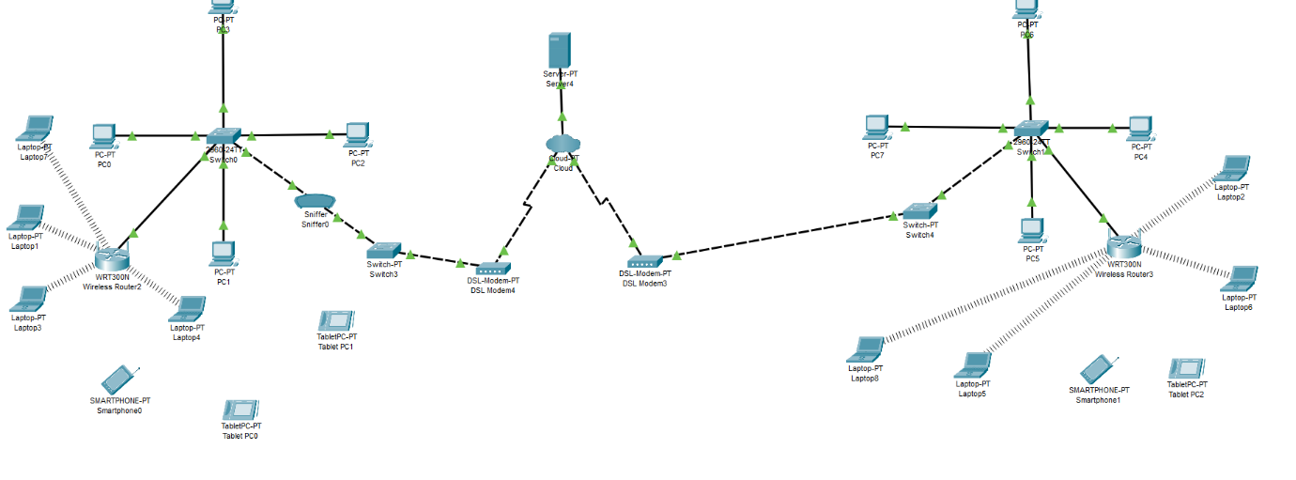
The below attack shows how a sniffer can be user to intercept and capture sensitive information, including passwords and confidential files.
- Network Layout
The below network will be the ideal layout and structure for the needs of Che-Si

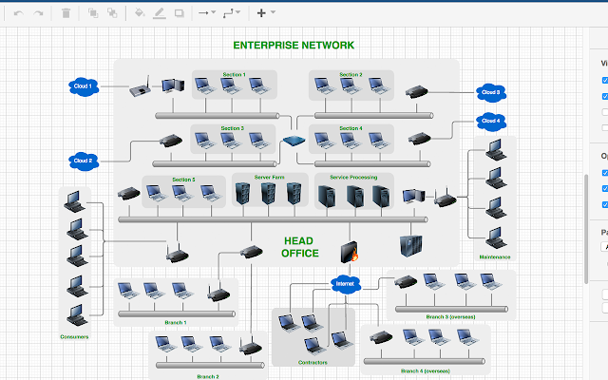
[4]
- Annexure 1
  - Policy for Che-Si
Che-Si Cyber security policy
Introduction
The risk of data loss, scams and potential security breaches can have a massive impact on a company’s system, reputation, and technical infrastructure. As a result, che-Si has created this policy to help outline the security procedures put in place to ensure data remains secure and protected.
Purpose
The purpose of this policy is to (a) protect Che-Si’s data and infrastructure, (b) outline the protocols and guidelines that govern the cyber security measures, (c) define the rules for company and personal use, and (d) list the company’s disciplinary process for violation of the policy rules.
Scope
This policy applies to all Che-Si’s remote workers, permanent, and part time employees, contractors, volunteers, interns, supplies and/ or any individuals with access to the company’s electronic systems, information, software, and/ or hardware.
Confidential data
Che-Si define the following as ‘confidential information’ as:
- Unreleased and classified financial data.
- Customer, supplier, and shareholder data
- Customer leads and sales-related data.
- Patents, business processes, and/ or net technologies
- Employees passwords, assignment, and personal information
- Company contacts and legal records
Personal Device security
When employees of Che-Si use their digital devices to access company emails or account, they introduce and security risk to the company’s data. We ask all our employees to keep both their personal devices (including but not limited to phone, tablet, laptop). Use VPN whenever accessing information on laptop devices when not connected to internal network (from home, coffee shop etc).
Email security
Emails are often used to send malicious software or gain personal information. To avoid virus infection or data theft, please can all employees:
- Verify the legitimacy of each email, including the email address and the sender name
- Avoid opening suspicious emails, attachments and clicking on links
- Look for give-ways in email addresses such as grammar mistakes, capital letters
Manage passwords properly
Password leaks are dangerous since they can jeopardise the entire infrastructure. Please adhere to the following password structure, this will be enforced by IT. Please use a minimum of 8 characters, including at least one capital letter and a number. Please refrain from using east to guess passwords, such as the month and year. Please do not write down your password.
Transferring data
Please refrain from transferring classified data to employees and outside parties.
Disciplinary action
Violation of this policy can lead to disciplinary action, depending on the magnitude of the violation and number of times it has occurred. This will be looked at on a per violation basis.

- Conclusion
I have taken information from a lot of sources such as books, websites and journals and have outlined the vulnerabilities, threats, and possible attacks that can affect Chi-Si’s network. I have created a policy in which details the relevant procedures to help mitigate these. I have also created a basic attack showing how data can be captured and how to prevent it.

- Reference

[1] Leaf “10 Ways to prevent Cyber Attacks” [Online]. Available https://leaf-it.com/10-ways-prevent-cyber-attacks/. [Accessed Jan. 05, 2021]
[2] Y. Diogenes, Cybersecurity – Attack and Defnese Strategies P97 https://www.google.co.uk/books/edition/Cybersecurity_Attack_and_Defense_Strateg/pyZKDwAAQBAJ?hl=en&gbpv=1&dq=cyber+security+books&printsec=frontcover 2018

[3] ‘Digital Signature’ [Online]. Available https://www.javatpoint.com/cyber-security-digital-signature [Accessed Jan. 05, 2021]

[4] https://workspace.google.com/marketplace/app/diagramsnet/671128082532 [Accessed Jan. 05, 2021]
[5] https://www.kaspersky.co.uk/resource-center/threats/top-seven-mobile-security-threats-smart-phones-tablets-and-mobile-internet-devices-what-the-future-has-in-store [Accessed Jan. 05, 2021]
[6] https://uk.norton.com/internetsecurity-malware-malware-101-how-do-i-get-malware-complex-attacks.html [Accessed Jan. 05, 2021]

