

BA (Hons) Leadership and Management Skills in the Workplace
Module Assignment Submission
Student Name: | Armin Tiberiu Polyak
Student Number: | 1904920
Module No: | BMSK5012
Module Title: | Understanding & Engaging in the Customer Experience

Statement of Confirmation of Authenticity
By the act of making this submission, the student declares that this is the work of the student named above. The work has not, in whole or in part, been knowingly presented elsewhere for assessment, or where assessment has been built on a previous assessment, this has been identified. Where materials have been used from other sources it has been properly acknowledged. If this statement is untrue, the student acknowledges that an assessment offence has been committed.
Attention is drawn to the plagiarism and unfair practice policies of both the University and of ILM.

Table of Contents
2. Tesco's customer lifecycle from acquisition 4
‌3. Customer Relationship Management of Tesco 6
Acquisition and Beyond: 6
Direct and Indirect Customer Value Metrics: 6
Customer Centrality: 7
Segmentation Strategies: 8
Application of CRM Theory: 8
‌ 8
4. Factors that impact Tesco's ability to maximize customer value 9
Supply Chain Efficiency: 9
‌Technology Integration: 9
‌‌Customer Service: 10
Competitive Pricing: 11
Brand Reputation and Trust: 11
Market Trends and External Environment: 11
‌Innovation and Product Development: 12
5. Quality processes of Tesco company and their effectiveness in meeting customer requirements 12
6. The benefits and challenges of developing and maintaining good customer relationships 15
Benefits: 15
Challenges: 16
7. Challenges faced with maximising customer value 17
8. Conclusion 18
References list 19

1. Introduction
Tesco, a major UK retailer, maintains leadership in the grocery market with a strategic focus on increasing customer value and engagement. Through strong digital marketing initiatives and a customer-centric approach, Tesco has successfully diversified its customer base and strengthened brand loyalty. At the core of their strategy is the innovative use of technology, such as the Tesco Clubcard, which provides valuable data insights for increased customer loyalty as well as personalized marketing strategies. Tesco's commitment to quality service and operational efficiency has helped it overcome challenges such as economic volatility and competitive pressures from discount retailers. Understanding and engaging with the customer experience is critical as Tesco moves forward, using data analytics to anticipate and meet customer expectations while ensuring a seamless shopping journey across online and in-store platforms. By focusing on these aspects, Tesco is committed to maintaining its market leadership and providing exceptional value to its customers.

2. Tesco's customer lifecycle from acquisition
Tesco, a prominent UK retailer, initiates its customer lifecycle strategy with a robust focus on technology and digital marketing to expand its market presence in the UK. Historical methods such as TV advertising, print media, and direct mail are supported by digital strategies such as social media campaigns, email newsletters, and online advertising (West, 2023). These efforts aim to improve brand visibility and diversify their customer base. Tesco's effective move is evidenced by its second most popular retail website worldwide, delivering an excellent 28% conversion rate with over 25 million monthly visits, the highest of any UK retail website. An additional £4.9 billion in 2023 shows the importance of specific advertising technology for British television.
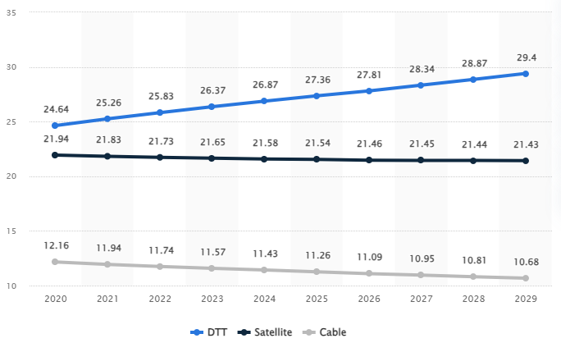
Figure 1: Traditional TV advertising reach in the UK 2020-2029
(Source: Statista, 2024)
According to the graph, Tesco's TV advertising reach is expected to fluctuate across various segments until 2029. Notably, the DTT (Digital Terrestrial Television) segment shows a significant projected increase, with Tesco potentially gaining 4.76 million viewers between 2020 and 2029.
Tesco's success is evidenced by the Tesco Clubcard, which is deeply dominant with 80% of total transactions. This loyalty program appeals to customers through mass attraction and promotion and converts them through personalized offers. By February 2024, the Tesco Clubcard app claimed 16.3 million users worldwide, including 12.7 million in the United States, and 2.6 million in Central Europe (Insights, 2022). The program's 22 million active UK households attest to its effectiveness, revealing how effective it has become in improving brand loyalty and expanding profits. Bellini points out that the Clubcard allows for precise measurement in delivery, which has improved Tesco's market leadership and innovation. This approach has stabilized Tesco's leading position in the food retail sector by improving customer differentiation and satisfaction.
After the transformation, customers are prioritized through Tesco's customer protection through state-of-the-art service and shopping interior offerings. This stage ensures loyalty and repeat customers continue. With around 6,900 stores and 440,000 employees worldwide, Tesco handles around 80 million purchases per week, offering both online and in-store services. Characteristically, the customer satisfaction score has improved to 43.4 as of October 30, 2023, while the quality score is approximately adequate at 28.7 as of January 14, 2022, and is set at 18.1 as of August 11, 2023. Tesco's targeted communication and exclusive reward system secures customer engagement, customer satisfaction and their commitment to market leadership.
Tesco has now redesigned its approach to customer surveys and is now directly engaging with the customer experience (Rigby, 2023). They request Udbuddhadas to write to him to share their views. With customer satisfaction at the fore, Tesco proactively aligns itself through surveys, social media and feedback on customer service aspirations. This proactive move is in line with Tesco's creative alignment, which helps it adapt to changing customer preferences. In 2024, Tesco announced annual revenue of $85.391 billion, marking a 6.95% increase from 2023, which saw a decline. The company recently expanded its customer service structure and revised business hours, while increasing its customer-facing staff by 3,000 since February 2016. Tesco evaluates customer loyalty, which turns satisfied customers into loyalists who recommend the brand through word-of-mouth and online reviews (Xaif, 2023). This strategy enhances Tesco's corporate image and attracts new customers, completing the customer life cycle. In addition, Tesco uses special promotional offers online and in stores such as 'buy one get one' offers and discounts. In addition, the Clubcard loyalty program establishes customer trust which is a priority in Tesco's marketing strategy.

‌3. Customer Relationship Management of Tesco
The sophistication of Tesco's CRM strategy spans from acquisition to long-term engagement, emphasizing direct and indirect customer value metrics, customer centrality, segmentation strategies, and the application of CRM theory.

Acquisition and Beyond:
Tesco's CRM strategy is mainly focused on customer acquisition, which is often more visible through the Tesco Clubcard. It acts as a powerful data collection tool and generalizes fulfilment, where it attracts new customers and repeats purchases while providing differentiated incentives based on the intrinsic future of shopping (Tesco, 2024). As of February 2024, the Tesco Clubcard app is claimed to have 16.3 million users, including 12.7 million in the United States, 2.6 million in Central Europe, and one million in Ireland. In the United States alone, 22 million families actively participate. Tesco uses Clubcard data and local demographics to customize product preparation for each convenience store, driving local tastes and shopping behavior. Participants earn 1 point for every £1 spent, which can be redeemed for discounts, vouchers, or trips. This data provides information for initiatives aimed at stimulating healthy shopping and food choices by motivating value beyond, enriching customer engagement and satisfaction.

Direct and Indirect Customer Value Metrics:
Tesco uses focused and unfocused customer value metrics to evaluate effective CRM performance. These metrics provide periodic information for revenue planning based on buying trends, transaction volume, and basket analysis scenarios (Aeroplan, 2024). As decentralized metrics, customer satisfaction scores, net promoter scores (NPS), and customer lifetime value (CLV) are measured, which measure long-term trust and loyalty levels. Tesco has an NPS of 14 with 45% Promoters, 24% Passives, and 31% Detractors, reflecting the customer's likelihood of giving advice. In comparison, Tesco's 62% satisfaction rating in 2017 reflects their commitment to improving the store experience. This knowledge apply to Tesco to develop customer satisfaction, drive sustainable growth, and protect profitability.
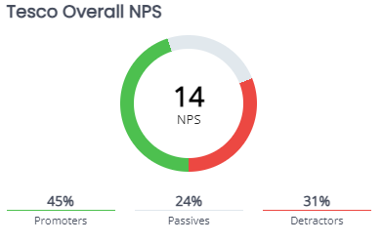
Figure 1: Tesco NPS Trend
(Source: Dziura, 2024)
According to this figure, Net Promoter Score (NPS) is utilized as a management tool for assessing the satisfaction levels of a firm's customer relationships. NPS is widely embraced as a crucial metric frequently associated with the revenue potential of a company’s product or service (Dziura, 2024). At Tesco, customers who respond with a score of 9 to 10 in the Net Promoter Score (NPS) survey are classified as Promoters and are recognized for their positive behaviors, such as actively recommending Tesco to others. Customers who give a score of 7 or 8 are categorized as Passives at Tesco and are generally seen to have a neutral effect on others, unlike Promoters who actively endorse the brand. Detractors at Tesco are those who rate the company from 0 to 6 on the NPS scale and represent dissatisfied customers who might be discouraged from using Tesco's products or services.

Customer Centrality:
Tesco's CRM strategy is customer-centric, focusing on understanding and fulfilling customer needs beyond the transaction. Using data analytics and feedback methods, Tesco strives to elevate the overall customer experience by consistently improving offerings, store layouts, and service models. This move builds trust and responsiveness in a changing retail environment (Davey, 2022). In addition, Tesco identifies conditions defined as customer behavior cleanliness, product availability, waiting time, staff support, and price which ensure that they are key to defining the customer journey. Using the In moment platform, Tesco is able to ensure in-store shopping presentation. To serve various customer segments through marketing, banking, mobile services, wholesale, and dunnhumby, Tesco combines customer knowledge to optimize operations and establish lasting customer relationships.

Segmentation Strategies:
Tesco follows a technical segmentation strategy to strategically target different customers based on demographics, shopping behavior, and purchasing patterns. By classifying customers into specific segments, Tesco customizes marketing communications, product layouts, and promotional offers to meet individual responses and preferences, which improves relevance and engagement (Alonso, 2022). By using information from customer loyalty programs and local demographics, Tesco customizes product preparation in convenience stores according to local tastes and shopping behavior. Also, Tesco uses experiential positioning for its health and beauty products, where multi-segment positioning often targets different customer segments with different products, to maximize market penetration and customer satisfaction.

Application of CRM Theory:
Tesco's CRM strategy emphasizes integrated decisions that emphasize data-driven decision making, lifecycle management, and relationship building. Using advanced analytics and CRM technologies such as RightNow (later acquired by Oracle), Tesco optimizes customer relationships at all touchpoints (P, M.A. 2024). These methods ensure effective customer acquisition and long-term relationship improvement in personal relationships and targeted marketing efforts. Performed calculations are useful in retail enterprises, such as Tesco and Reliance, who use CRM software (SAP for Reliance). Tesco's strong digital marketing strategy supports its various products and brands, including increasing administrative power, enriching brand awareness, generating leads, increasing sales, improving customer service, and reconceptualizing target audiences.

‌

4. Factors that impact Tesco's ability to maximize customer value

Supply Chain Efficiency:
Tesco's efficient supply chain management enables it to offer competitive prices and a wide product range by reducing costs and responding quickly to customer expectations, which helps Tesco attract and retain customers worldwide (Business-Essay, 2024). Founded in 1919, Tesco has expanded internationally, currently having more than 4,811 locations. Operations are optimized through innovations such as RFID technology and data-driven supply chains, which ensure seamless coordination across the supply chain, from point-of-sale data integration to efficient cross-docking and demand-driven replenishment strategies.

‌Technology Integration:
Innovations in technology, such as data analytics and artificial intelligence, give Tesco the ability to understand customer preferences and behavior, which facilitates personalized marketing and optimized inventory management. Tesco collects valuable customer data through its Clubcard loyalty program, which enables customized discounts and product recommendations. In addition, Tesco's introduction of online shopping services and self-service checkout points increased convenience, reduced labor costs (Global data, 2023). This technological advance reinforces Tesco's strategy of leveraging innovation and collaboration with partners. With annual ICT spending estimated at around $1.9 billion by 2023, Tesco prioritizes investment in software, hardware and ICT services, which drive operational efficiency and customer satisfaction through digital transformation.
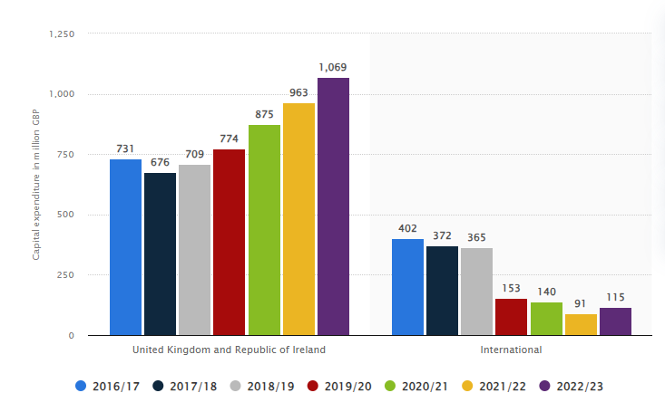
Figure 2: Capital expenditure of Tesco Group worldwide from 2016/17 to 2022/23
(Source: Statista, 2023)
As per the graph, Tesco's huge capital expenditure of £1.07 billion in the UK and Ireland for the 2022/23 financial year, as well as its Hertfordshire headquarters, highlights strategic investment aimed at increasing customer value (Statista, 2023). The funding is likely to strengthen Tesco's supply chain capabilities, technological innovation and customer service initiatives. Such investments are critical to ensuring competitive pricing, operational excellence and a seamless shopping experience, which ultimately maximizes customer satisfaction and loyalty.

‌‌Customer Service:
Tesco's commitment to high-quality customer service is evident through investment in staff training and effective protocols, which enhance customer perception and interaction. Recent initiatives include adding a new customer service desk and increasing the number of customer-facing staff. This proactive approach is in line with Tesco's strategy, which is to understand customer preferences, adapt product selection and marketing, and use data from the Clubcard program to encourage healthy shopping habits, thus increasing customer satisfaction and retention.

Competitive Pricing:
Tesco's pricing strategy has a direct impact on customer choice and profitability. By using dynamic pricing models and promotional strategies, Tesco attracts price-sensitive customers and at the same time ensures profitability (Carroll, 2024). Initiatives such as Aldi Price Match, Clubcard Price for exclusive deals and Low Everyday Prices highlight the brand's value offer, strengthening the supermarket's competitive edge. Recently, Tesco reported a 7.2% year-on-year increase in sales to £61.48 billion, attributing this success to an effective pricing strategy in an environment of rising prices, and linked to positive volume growth in the latter half of the financial year.

Brand Reputation and Trust:
Tesco's commitment to quality, reliability and ethical practices builds customer loyalty by establishing trust through transparent communication and responsible business conduct. Supermarkets leverage their customer loyalty programs, which boast over 13 million members, to gather valuable insights into market trends, purchasing behavior, preferences and interests. This data-driven approach enables Tesco to refine its offerings and customize its strategies to meet customer expectations, thereby increasing its ability to attract and retain a loyal customer base.

Market Trends and External Environment:
Tesco, which holds a 27% market share in the UK grocery sector as of April 2023, faces significant impacts from changing consumer preferences, changing economic conditions and a changing regulatory environment. To compete with Sainsbury's, Asda, Aldi Lidl and other minority competitors, Tesco should preserve its competence. External conditions such as import/export speeds, the influence of financial authorities, trade barriers, and the Brexit situation make it necessary for Tesco to quickly draw on more experience with the management and preparation of its supply chain. It is important to ensure Tesco's preparedness by quickly learning from these challenges, in order to benefit from changing market conditions and protect its customer value proposition.

‌Innovation and Product Development:
Tesco's ability to introduce new products and services in line with evolving customer needs and preferences strengthens its market position. Continuous innovation is vital to maintaining long-term customer value.

5. Quality processes of Tesco company and their effectiveness in meeting customer requirements
Tesco, a well-established leader in the retail industry, implements rigorous quality processes based on Total Quality Management (TQM) principles, the key elements of which are continuous improvement, customer centricity and active employee participation, which on the one hand ensures exceptional customer experience and on the other through human resource management. Creates a values-driven organizational culture in which significant contributions are made to overall business results by employees and associates; As a result, Tesco maintains a competitive edge through the continuous introduction of new products and services based on customer preferences, and at the heart of their quality management strategy, areas of improvement using the Deming cycle known as PDCA (Plan, Do, Check, Act) (MindTools, 2022). Systematically identifies, develops robust implementation plans and tests solutions through small-scale pilot projects, which guides Tesco through a structured problem-solving and continuous improvement process and ensures that any changes are thoroughly evaluated against predetermined success criteria before implementation; This iterative approach not only increases operational efficiency, but also supports Tesco's commitment to providing high-quality products and services through the supply chain, thereby emphasizing Tesco's emphasis on supplier quality management and ensuring that products sold in their stores meet strict standards. By doing so, thereby reducing customer complaints and maintaining overall product integrity, and by incorporating PDCA/PDSA methods into their management framework, processes and products are continuously refined by Tesco, setting new standards in the retail sector.

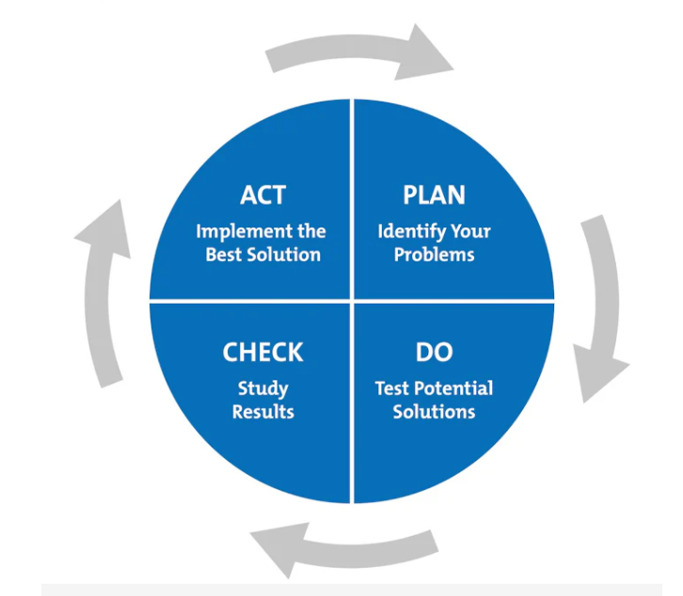
Figure 2: The plan-do-check-Act Cyle
(Source: Mind Tools, 2022)
In this figure, Tesco applies the PDCA/PDSA framework to improve quality processes, ensuring that they effectively meet customer requirements. By dividing activities into iterative stages, Tesco identifies areas of improvement and systematically implements Total Quality Management initiatives (MindTools, 2022). This approach maximizes product availability and service delivery throughout their supply chain and retail operations. Although PDCA/PDSA promotes incremental improvement, its structured nature may not always be appropriate for urgent problems or fundamental innovation needs. Yet, by integrating customer feedback and the ISO 9001 standard, Tesco ensures that its quality management meets customer expectations, increasing satisfaction and loyalty. This systematic approach not only drives operational efficiency but also reinforces Tesco's commitment to consistently delivering superior retail experiences The iterative process allows Tesco to plan improvements, implement them, monitor results and quickly make necessary adjustments. By continuously refining its operations through PDCA, Tesco ensures that its processes are fine-tuned to meet and exceed customer expectations.
Tesco, a leading commercial sector leader in openness, including Khudabak, has incorporated Lean principles into its supply chain and marketing operations to increase efficiency and, in essence, reduce redundancies. The main objectives of these strategies are to reduce costs and improve product transparency and reliability so that products are available to consumers at affordable and substitutable prices. In addition to lean principles, Tesco participates in the ISO 9001 Quality Assurance Initiative. These precision systems, externally verified, strive to exceed customer expectations as part of thorough transparency and accountability in establishing cleanliness. Among Tesco's additional practical services, Tesco has a pre-structured maintenance plan aimed at presenting Tesco's operational standards. Engineers refine system calibrations, evaluate operating conditions, and ensure component performance by deciding ratios for timing changes. Renton clarifies the importance of Cooper forecasting the need for pro-excess maintenance, particularly the presentable systems to protect the core.
Tesco's importance and service compliance on Salter's love and safety reforms, especially initiation situations, must be communicated to give and typed through the right-of-place process human rights, quality and safety standards. Therefore, Cooper has been awarded ISO 9001 certification, ISO 14001 and AHSAS 18001 certification, demonstrating their support of health and environmental performance principles commensurate with risk (Rosnizam, 2024). Tesco uses customer feedback micromechanics and data analysis to improve its customer satisfaction and support by communicating its customers' location music to their service delivery. Compliance, incorporation of Tesco's Lean principles, adherence to ISO standards, and communication with service providers such as Cooper demonstrates an improvement in management, customer satisfaction and preservation of dialogues and improvement of the matter through the application of information, current assumptions and customer expectations as well as product change requirements and In the case of the partner, the lovely intercession is prepared according to his availability and benefits.

6. The benefits and challenges of developing and maintaining good customer relationships

Benefits:
Building and maintaining strong customer relationships is crucial for Tesco, which provides various benefits for customer satisfaction and business success. First, these relationships generate improved customer loyalty, which Tesco achieves through initiatives such as its Clubcard scheme. This program matches the customer personally, and delivers promotions tailored to individual preferences, increasing loyalty and reducing customer churn. Tesco uses customer data science to ensure offers are relevant, resulting in an amazing 20% ​​coupon revaluation. Also, satisfied customers are partners in love through promotion, which attracts new customers with cost-effectiveness. This natural growth is met for Tesco's operations, which all contribute to sales and profits. Loyal customers tend to spend more over time and are less wary of price changes than new customers. Tesco's strategic focus on protecting customers has contributed to the company's economic success. Tesco's success is down to building customer satisfaction and loyalty, with UK sales up 5.9% to 21.8 billion units and profits up 5% to 1.2 billion (Juanamasta, 2019). The company's like-for-like sales grew by 0.3%, with enterprises outperforming the market level with a strong showing in the food and non-food segments.
Tesco's recent financial performance has highlighted its strong customer-centric strategies, which have been considered a major factor behind its success. The supermarket chain reported like-for-like sales growth of 0.3%, which exceeded industry benchmarks, and the achievement was credited to its emphasis on customer loyalty through initiatives such as Tesco's Clubcard scheme. According to Tesco's half-yearly statement, their strategy is based on competitive prices, attractive promotions and increasing customer loyalty using Clubcard benefits. They claim that Tesco maintains the highest levels of customer loyalty among the UK's major supermarkets, with a significant number of customers doing more than half of their shopping at Tesco alone (Alshurideh, 2016). Alongside strong food sales, Tesco saw a significant increase in non-food sales in the UK of 2.5%, reaching £4.4 billion. Tesco Bank also experienced positive growth, gaining 200,000 new customer accounts during the period, while revenue and profit increased by 12.9% and 12.2% respectively to £474 million and £129 million. Across all their regions, Tesco's group sales rose 8.3% to £32.9 billion, while pre-tax group profit rose 12.5% ​​to £1.6 billion. Tesco chief executive Terry Leahy expressed confidence in Tesco's prospects, crediting their resilience and growth to ongoing investment to improve the shopping experience amid a slow and steady economic recovery in the UK.

Challenges:
For Tesco, changing and maintaining good customer relations is critical to success, but it is also recognized for its careful management and strategic planning of several key organizations. First, there is a greater experience disparity to be determined between Tesco's operations and the direct contract of personalized experience for the customer base experience and in different rights. This requires tracking overall operations and customer preferences, and neighborhood contracts require proper CRM systems and organizational due diligence (Pearson, 2016). Therefore, Tesco is operating in a changing open business environment, which is an unbounded market between consumer expectations and competitive competition. Customers now expect immense omnichannel experiences and fast problem resolution, which Tesco needs so much to keep up with and change its need to make customer relationships competitive.
The onset of the Covid-19 pandemic further tested Tesco's ability to maintain customer relationships. Despite having a well-established infrastructure for online shopping and delivery, Tesco has had to adapt quickly to meet increased demand while ensuring safety and support for customers and employees. This period has demonstrated Tesco's commitment to the needs of its customers, delivering essential goods, ensuring safety and supporting communities as a priority. In addition, Tesco faced economic factors such as the cost-of-living crisis in the UK, which increased fuel prices and inflation, thereby impacting consumer spending. This economic environment has led to changes in consumer behavior, with more customers turning to discount retailers such as Lidl and Aldi, impacting Tesco's profits and online sales. Furthermore, Tesco faces operational challenges in implementing sustainability initiatives such as carbon labelling and promoting low-carbon options, while managing cost concerns and profitability in a competitive grocery market. These initiatives are critical to Tesco's ESG (Environmental, Social and Governance) commitment and maintaining their market reputation. Customer complaints and feedback are managed effectively by Tesco, which requires quick resolution to maintain customer trust and loyalty (Soltani, 2016). Failure to properly address this issue may result in negative publicity, which may damage Tesco's brand reputation in a competitive market. Finally, external factors such as the economic downturn and regulatory changes further complicate Tesco's efforts to maintain strong customer relationships. Economic changes affect consumer spending and demand, affecting Tesco's business performance and marketing strategies, particularly in their highly dependent UK market.

7. Challenges faced with maximising customer value
Major UK grocery retailer Tesco plc, which has a market share of more than 27%, has progressed to maximize customer value in numbers. This is a major issue that varies in consistency between cost-efficiency integration, which needs to be matched with customer expectations (Rusanen, 2023). This problem is often such that investments in high-quality products and services, which if not managed properly, can squeeze profit margins. This is crucial to maintain consistency across different customer preferences and demographics. Tesco's offerings in each segment need to experience value with fullness, and strategy in product proposition and customer complexity strategy is required.
In the retail sector, Tesco and other retail companies face a long-term crisis for quality of life. In order to prevent customer abandonment on the shores of discount competitors, Tesco must continue to innovate masterfully during the pandemic and demonstrate that they follow a technologically integrated strategy. However, with the connection to the dominant market, to enter human life, Tesco needs to be able to navigate smoothly in a regular manner and be integrated in the manner they need (Wang, 2023). To maintain its market leadership, Tesco needs to review its response proposition and increase its value as it consolidates and forces the organization to consolidate. It uses low-cost strategies, personalized customer experiences, and data analytics to proactively predict and fulfil evolving customer needs. These values ​​are added to the conditions for a respected and interested message in a binary market expansion, which forces it to strengthen its institution as a customer-focused brand. Although Tesco maintains a dominant position among UK supermarkets, its success with its operational capabilities and the ability to project in recent retail accounts will determine its success in managing and navigating these crises.

8. Conclusion
In conclusion, Tesco's customer lifecycle management and customer relationship management strategies reflect its commitment to improving customer value and satisfaction. Using a suite of advanced technologies including data analytics and CRM systems, Tesco acquires, retains and attracts customers through personalized experiences and targeted marketing initiatives. The Tesco Clubcard, for example, doesn't just reward loyalty, it also provides additional customer value that drives continuous improvement in its retail operations. Related meritocratic headwinds, such as changing ownership expectations and economic numbers, sub select Tesco's ex-state acquisitions and management restatements, presenting its sustainability as flawed. Going forward, Tesco's contributions to technology and the Tesco concept will be the crux of sustaining lifestyle essentials and will be necessary to continue to prioritize its market leadership over many organizations that serve its users.

References list
Aeroplan, M.S.-C.M. - G. (2024). Tesco profit warning - how much was Clubcard responsible? [online] Available at: http://www.marksage.net/2012/01/tesco-profit-warning-how-much-was.html.
Alonso, T. (2022). Strategy Study: How Tesco Became the Biggest Retailer in the UK. [online] www.cascade.app. Available at: https://www.cascade.app/studies/tesco-strategy-study.
Alshurideh, M.T., 2016. Is customer retention beneficial for customers: A conceptual background. Journal of Research in Marketing (ISSN: 2292-9355), 5(3), pp.382-389.
Business-Essay.com. (2024). Tesco: Supply Chain Management Strategies | Business Paper Example. [online] Available at: https://business-essay.com/tesco-supply-chain-management-strategies/.
Carroll, N. (2024). Tesco CEO claims retailer ‘more competitive than ever’ on value. [online] Marketing Week. Available at: https://www.marketingweek.com/tesco-ceo-more-competitive-value/.
Davey, J. (2022). Tesco says Britons buying less and trading down to navigate inflation. Reuters. [online] 17 Jun. Available at: https://www.reuters.com/business/retail-consumer/uks-tesco-sees-early-signs-changing-customer-behaviour-inflation-hits-2022-06-17/.
Dziura, S. and Masternak, W. (2024). Building an effective loyalty program strategy for Tesco Clubcard with Szymon Dziura. [online] www.openloyalty.io. Available at: https://www.openloyalty.io/insider/building-an-effective-loyalty-program-strategy-for-tesco-clubcard-with-szymon-dziura.
Global data (2023). Tesco - Digital Transformation Strategies. [online] Market Research Reports & Consulting | GlobalData UK Ltd. Available at: https://www.globaldata.com/store/report/tesco-plc-enterprise-tech-analysis/.
Insights, H. of (2022). UK Grocery Retailer Deep Dive: Tesco. [online] estorebrands.com. Available at: https://estorebrands.com/blog/uk-grocery-retailer-deep-dive-tesco#:~:text=Tesco%20is%20the%20second%20most [Accessed 7 Jul. 2024].
Juanamasta, I.G., Wati, N.M.N., Hendrawati, E., Wahyuni, W., Pramudianti, M., Wisnujati, N.S., Setiawati, A.P., Susetyorini, S., Elan, U., Rusdiyanto, R. and Muharlisiani, L.T., 2019. The role of customer service through customer relationship management (Crm) to increase customer loyalty and good image. International Journal of Scientific and Technology Research, 8(10), pp.2004-2007.
Mind Tools (2022). PDCA (Plan Do Check Act). [online] www.mindtools.com. Available at: https://www.mindtools.com/as2l5i1/pdca-plan-do-check-act.
P, M.A. (2024). List of Top 10 Companies Using CRM. [online] My Blog. Available at: https://www.spanglobalservices.com/blog/top-10-companies-that-use-crm/ [Accessed 7 Jul. 2024].
Pearson, S., 2016. Building brands directly: creating business value from customer relationships. Springer.
Rigby, C. (2023). Tesco sets out improvements to customer experience as it unveils first-half figures. [online] InternetRetailing. Available at: https://internetretailing.net/tesco-sets-out-improvements-to-customer-experience-as-it-unveils-first-half-figures-14136/#:~:text=Today%20it%20said%20that%20in [Accessed 7 Jul. 2024].
Rosnizam, M.R.A.B., Kee, D.M.H., Akhir, M.E.H.B.M., Shahqira, M., Yusoff, M.A.H.B.M., Budiman, R.S. and Alajmi, A.M., 2020. Market opportunities and challenges: A case study of Tesco. Journal of the community development in Asia, 3(2), pp.18-27.
Rusanen, O., 2023. The importance of resources. The Red Queen Retail Race: An Innovation Pandemic in the Era of Digitization, p.13.
Soltani, Z. and Navimipour, N.J., 2016. Customer relationship management mechanisms: A systematic review of the state of the art literature and recommendations for future research. Computers in Human Behavior, 61, pp.667-688.
Statista (2023). Tesco capital expenditure worldwide 2016-2020. [online] Statista. Available at: https://www.statista.com/statistics/490853/tesco-group-worldwide-capital-expenditure/.
Statista. (2024). UK: traditional TV ads reach 2017-2026 by type. [online] Available at: https://www.statista.com/forecasts/1308046/uk-reach-of-traditional-tv-advertising-by-type.
Tesco (2024). Bloomberg.com. [online] 10 Apr. Available at: https://www.bloomberg.com/news/articles/2024-04-10/tesco-forecasts-profit-increase-launches-1-billion-buyback.
Wang, Y., 2023. A model predicting CRM resource effect on business performance through CRM capabilities. Wireless Communications and Mobile Computing, 2023(1), p.9792999.
West, T. (2023). Tesco CCO: Clubcards are now used across 80% of all Tesco transactions. [online] Available at: https://www.marketing-beat.co.uk/2023/07/14/bellini-tesco-clubcard/#:~:text=Incredibly%2C%20Bellini%20also%20revealed%20that.
Xaif (2023). In-Depth Marketing Strategy of Tesco - 2023 : Key Trends. [online] IIDE. Available at: https://iide.co/case-studies/marketing-strategy-of-tesco/#:~:text=The%20company%20hugely%20relies%20on.

