Thomas Rhys Evans
Student No: 1810164
Network Operating Systems and Services (NOSS)
(ACCA5023)
Worksheet 4
Table Of Contents
Heading | Page Number
Part 1 – Practical Work | 1
Task 1 - Utilising ARP and Routing Tables | 1
Task 2: Deploy core services (FTP Server) | 2
Task 3: Installing and configuring the Routing and Remote Access Service | 13
Task 3a) Record your observation | 17
Task 4: IP Packet Filtering | 17
Filter 1 | 17
Filter 2 | 19
Filter 3 | 20
Part 2 – Observational tasks | 21
Task 5: Failover Clustering for high availability systems/services | 21
i) Benefits of HA systems | 21
ii) Active/Passive Cluster | 21
iii) Active/Active Cluster | 22
iv) HA considerations | 23
v) Failover clustering in Microsoft Server | 23
Task 6 – Network Policy | 26

Part 1 – Practical Work
Task 1 - Utilising ARP and Routing Tables
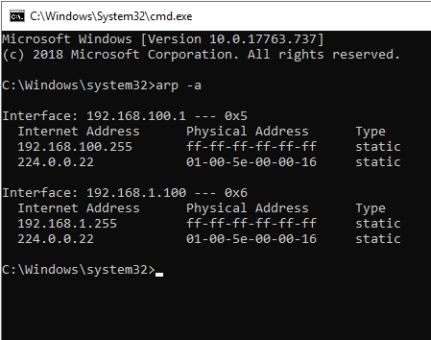
By typing the command “arp-a” into command prompt, we are able to view the information of the machine’s Network Infterface Controllers (NIC’s)
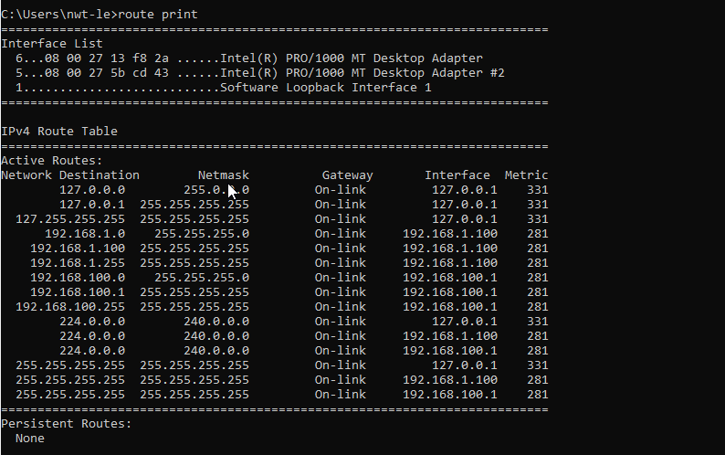
The command “Route print” shows even more information about what networks the host is connected to

Task 2: Deploy core services (FTP Server)

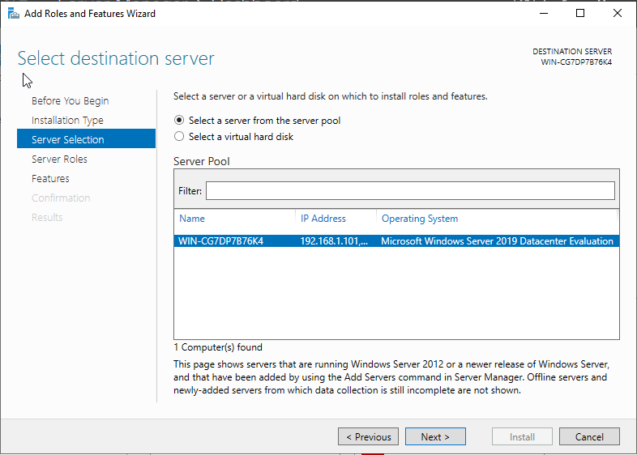
To begin installing FTP, the add roles and features option on Windows Server is selected. Bringing up the above machine. After choosing the server the role will be configured on, “next” is selected
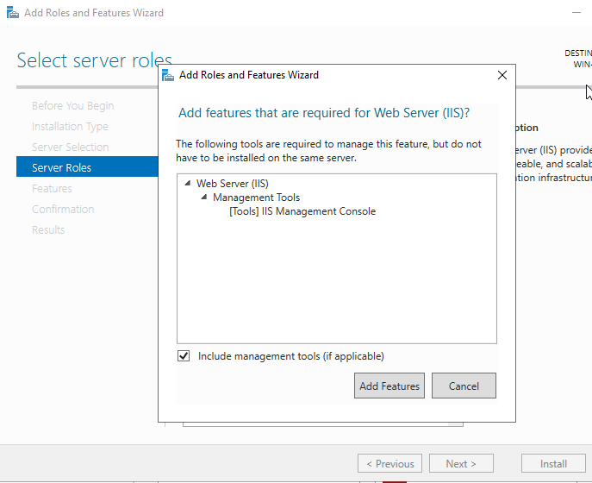
The “web server (IIS)” option must be selected as it’s within this feature that FTP is found
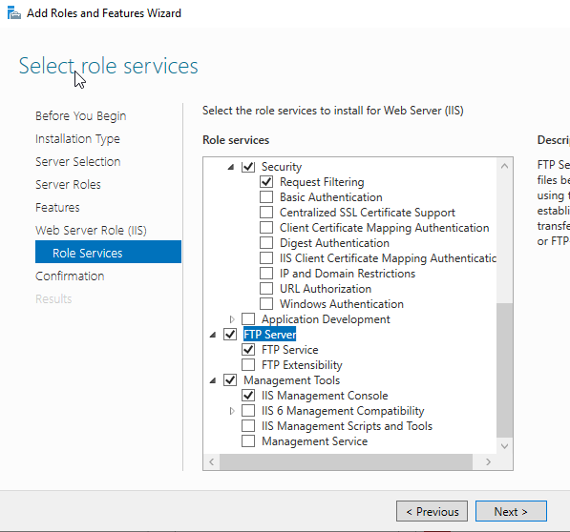
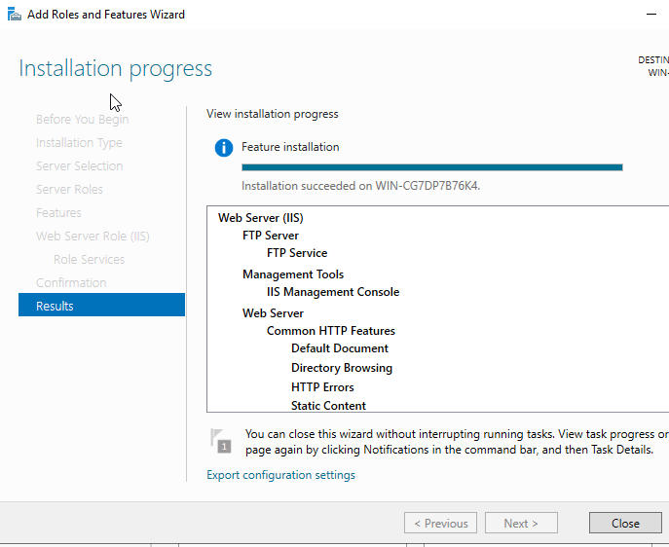
After the appropriate options have been selected, installation can begin.

Once the FTP service is installed, the FTP options must then be configured. First, a user account must be created. A user called “FTPUser” is created
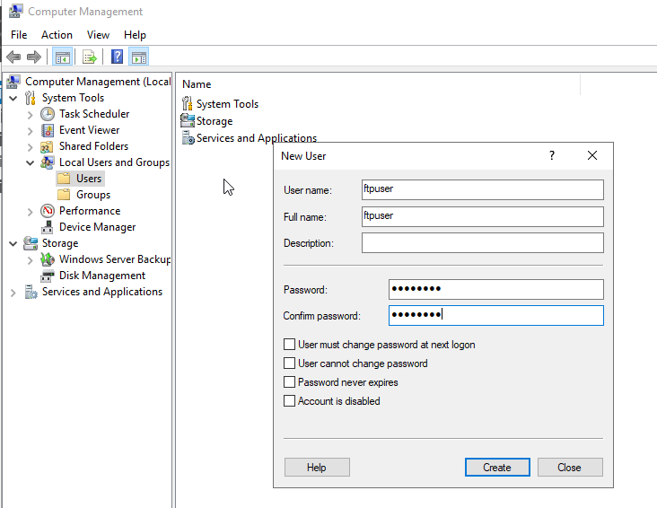

A new FTP site must then be created within the IIS manager. A site called “1STFTPSITE” is created
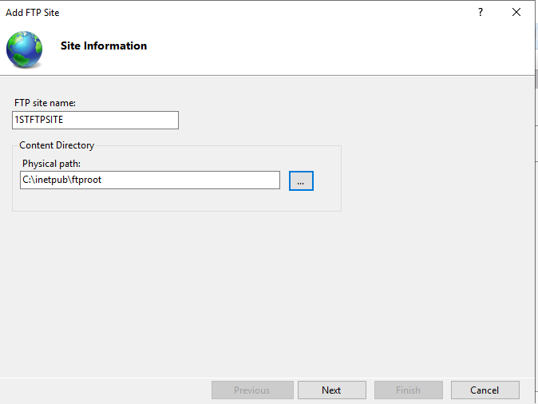

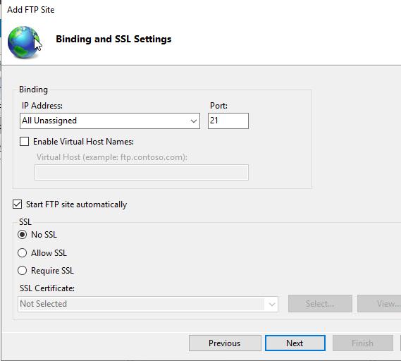
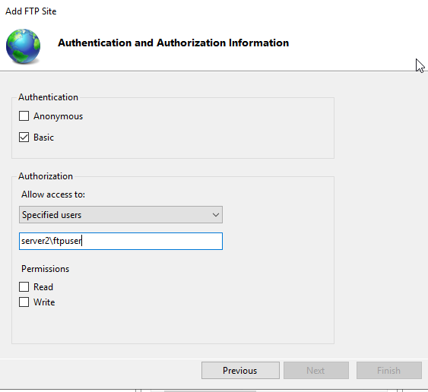
A banner message can also be configured, so when authorised users connect to the FTP service, they will see a message, notifying them everything is working as expected and they are connected to the correct FTP service
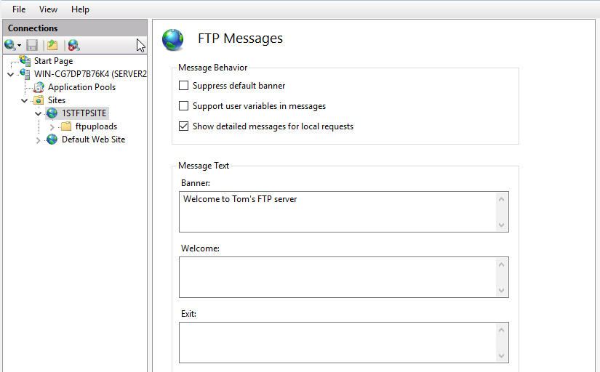
The final configuration to check is the security on the C:\Inetpub folder
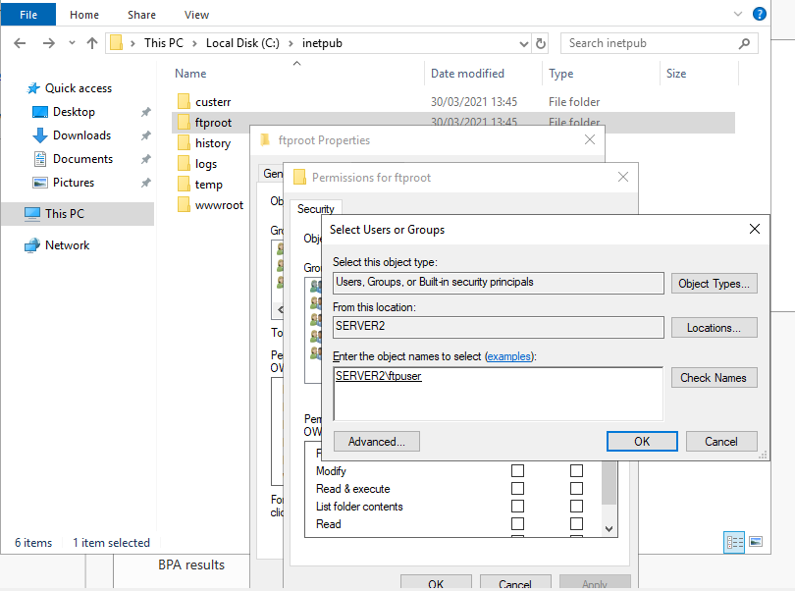
Once all this configuration is complete, the FTP service can then be tested

First, a folder is created called ftpfiles and within this, a .txt file is created called ‘ftpfile2upload.txt’


By using command prompt, the ftp service can then be connected to.
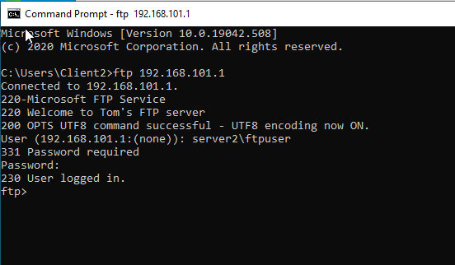
As seen above, we can see the configured FTP banner message, along with confirmation of a successful log in by “ftpuser”
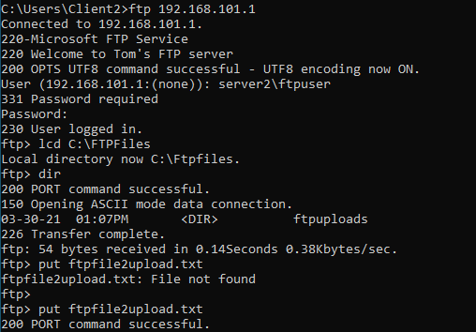
After changing the directory to the FTP folder and using the ‘put’ command, the file is uploaded.
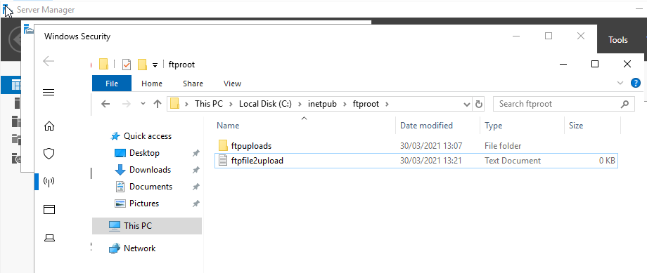

Task 3: Installing and configuring the Routing and Remote Access Service

Next, the routing and remote access role must be installed and configured. Again, this is done through the “Add role and features” wizard on Windows Server.

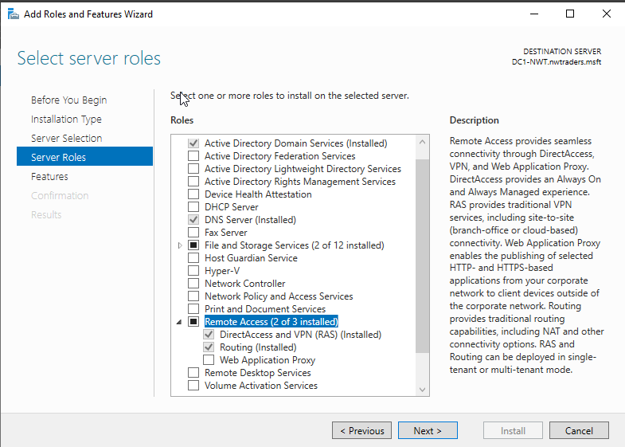
Once the installation is complete, configuration can then begin
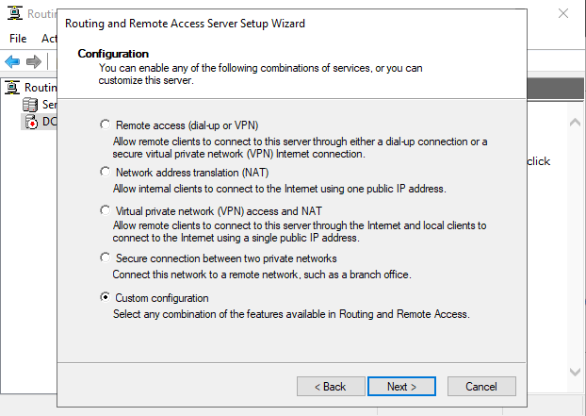
Custom configuration allows a variety of options to be specifically tailored.
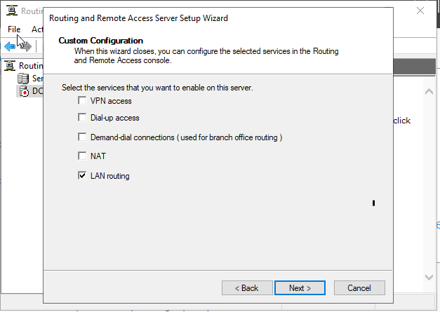
As it is routing we are configuring, “LAN routing” is chosen.
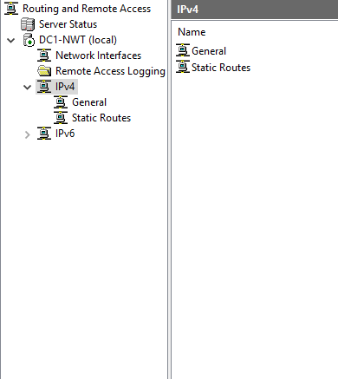
Right clicking on “general” within the IPV4 option allows us to create the new protocol ‘RIP’
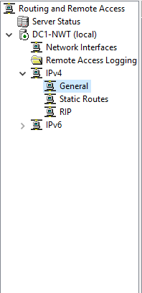
Once this is created, the interfaces can be added to the routing protocol
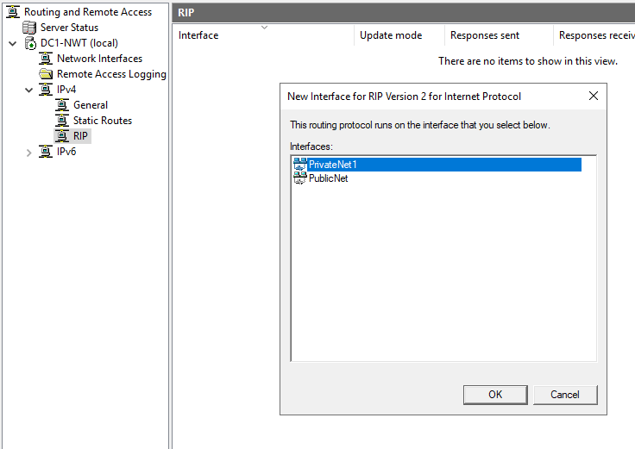
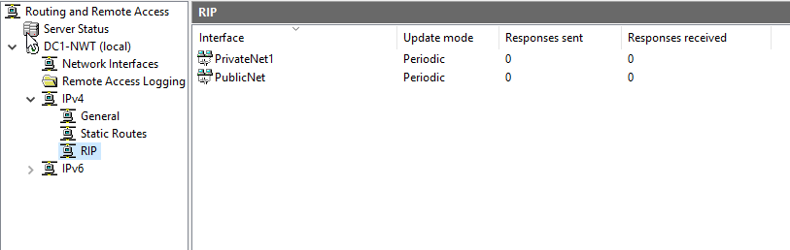
The above steps are then repeated on the second server. Once this is complete, connectivity can be verified by the below PING command
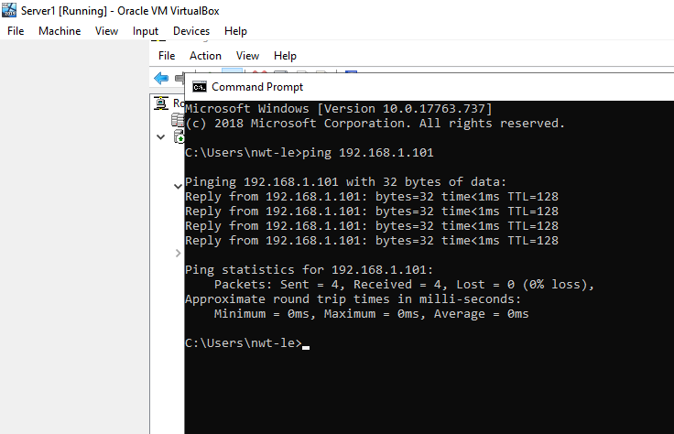
The PING is successful, verifying connectivity of the routers.
Task 3a) Record your observation
Routers communicate between themselves using protocols to share routing information. Router port’s are configured with a routing protocol applicable with it’s function. A router port that connects to the Internet has gateway routing protocols. If a router port connects to an organisation's internal networks it must learn the how the organisation's network is configured to efficiently route traffic throughout the organisation. Protocols that serve this purpose are called "interior routing protocols" and have names such as Enhanced Interior Gateway Routing Protocol ("EIGRP"), Interior Gateway Routing Protocol ("IGRP"), Open Shortest Path First ("OSPF"), Routing Information Protocol I and II ("RIP"/"RIP II") [1]
Task 4: IP Packet Filtering
Filter 1:
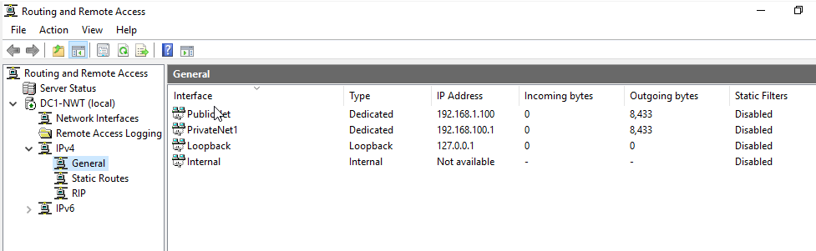
Filters can now be applied, either inbound or outbound, that can allow and block network traffic depending on a pre-defined rule. The first filter blocks anyone within “Privatenet1” from pinging the router firewall service.
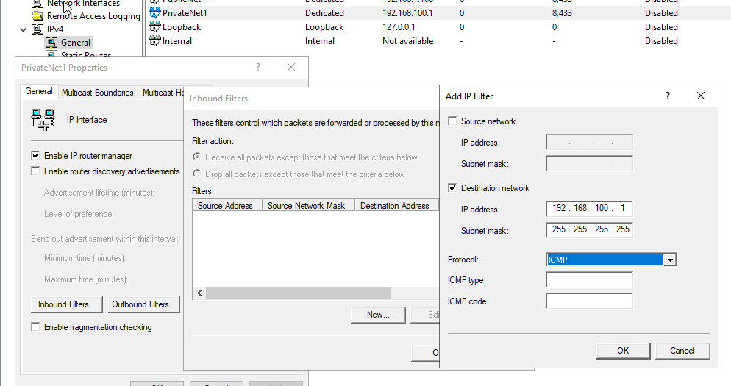
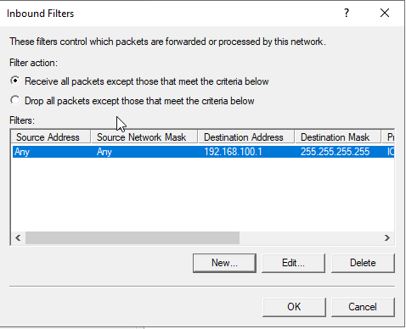

Filter 2:
Filter 2 restricts access to the FTP service running on Server2 to only the hosts within “Privatenet2”
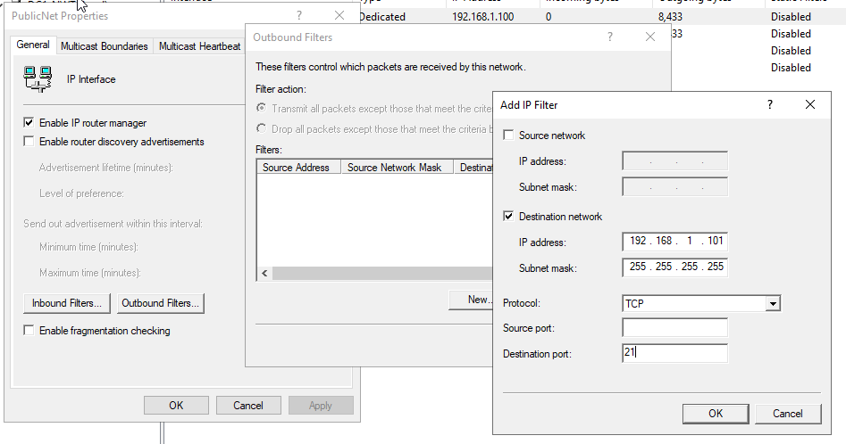
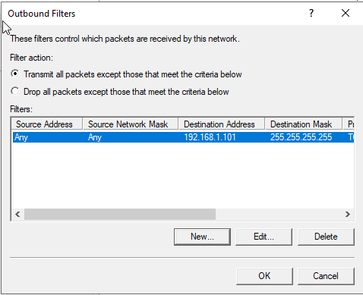

Filter 3:
The final filter allows only specified hosts within “Privatenet1” to access the FTP service on Server2

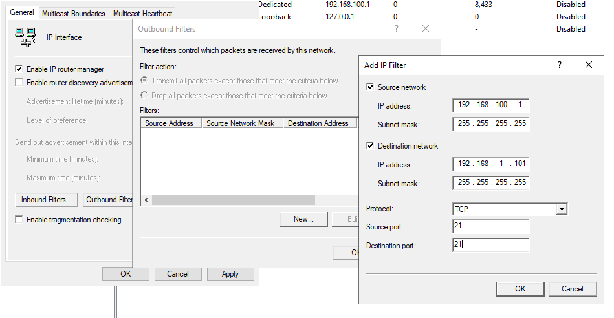
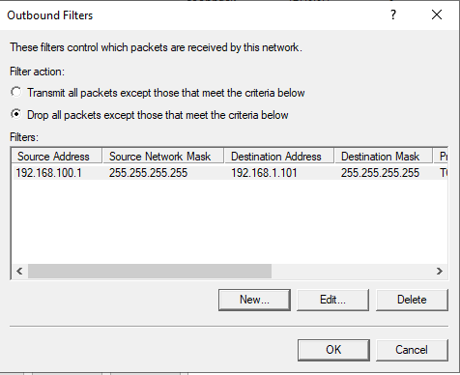

Part 2 – Observational tasks
Task 5: Failover Clustering for high availability systems/services
Implementing high availability for systems and services in an organisational environment offers a number of benefits, but careful consideration needs to be given, as these environments can often be complex and include many separate aspects that need to work in conjunction with each other. High availability systems allow for parts of a systems infrastructure to be interrupted, whilst ensuring the overall system remains functional. Interruptions can come in many forms, from power loss, hardware failure, natural disasters to planned outages, such as replacing/upgrading hardware or rebooting hardware to apply security patches
i) Benefits of HA systems
As mentioned above, the main benefits with HA are related to the ability of systems and services to tolerate partial interruptions without having any noticeable effect on the end-user being able to continue utilising the resource. Resources are shared across multiple nodes, all working together in a cluster. Each node is aware of the other, and they all work together to provide a system or service. In the case of one of these nodes experiencing interruption, the other nodes in the cluster can pick up the slack and compensate for the loss.
ii) Active/Passive Cluster
There are two recognised configurations when it comes to HA and the first of these is ‘Active/Passive’. In an active/passive cluster, one node is responsible for providing a service. In the event of an interruption, another node would quickly take over the responsibility for providing this service, with no interruption to the availability. Often, this is done by moving an I.P address to a standby node or by implementing tools such as load balancers to re-direct network traffic away from the failed node [2]
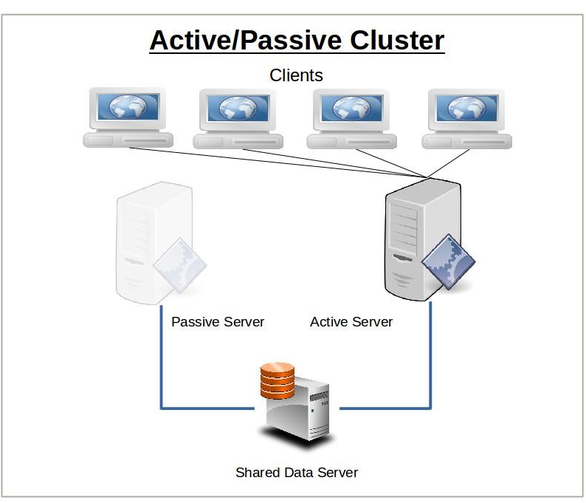
Figure 1 - https://www.freecodecamp.org/news/high-availability-concepts-and-theory/
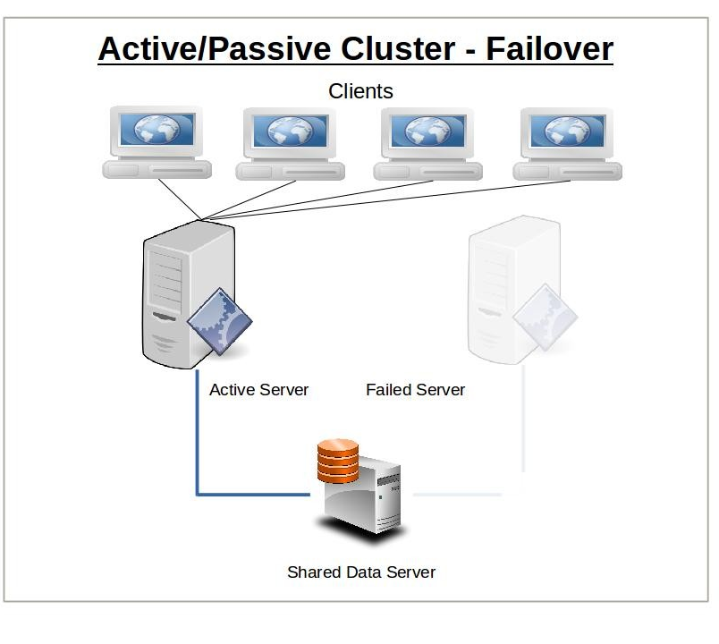
Figure 2 https://www.freecodecamp.org/news/high-availability-concepts-and-theory/-

ii) Active/Active Cluster
Active/active is the second of the recognised configurations for high availability. This differs from the first in the sense that the nodes in the cluster are all configured identically and will all serve resources. In the event that a node fails, then the clients will connect to the other node/s in the cluster, continuing to access the resource, as long as there is enough capacity for the remaining node/s to provide the resource. If the failed node then recovers, clients will then begin connecting back to it. Which node in a cluster a client connects to is determined by a load balancer, using a pre-determined algorithm [2]
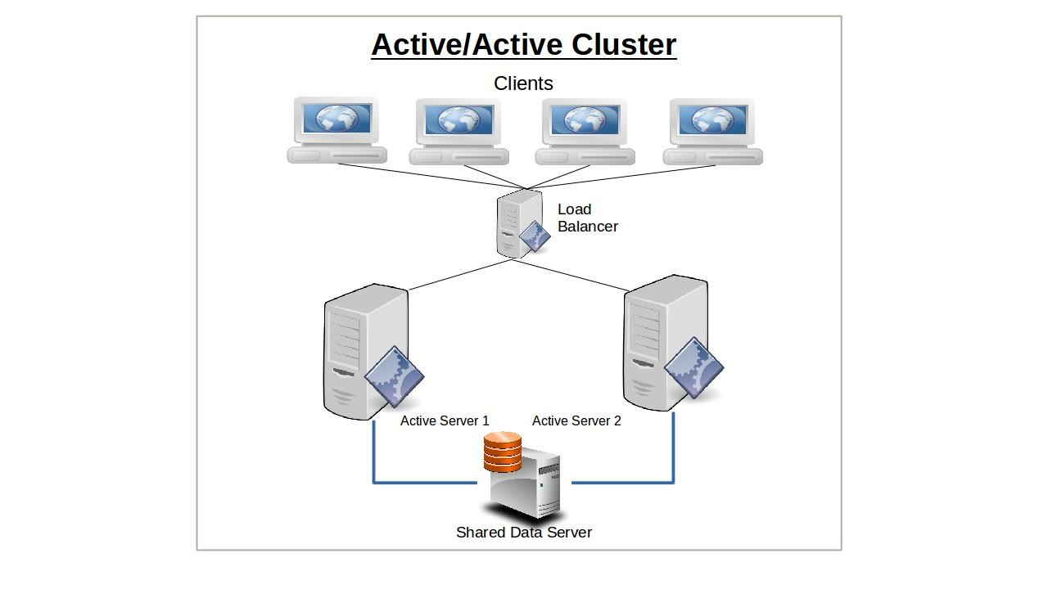
Figure 3 - https://www.freecodecamp.org/news/high-availability-concepts-and-theory/
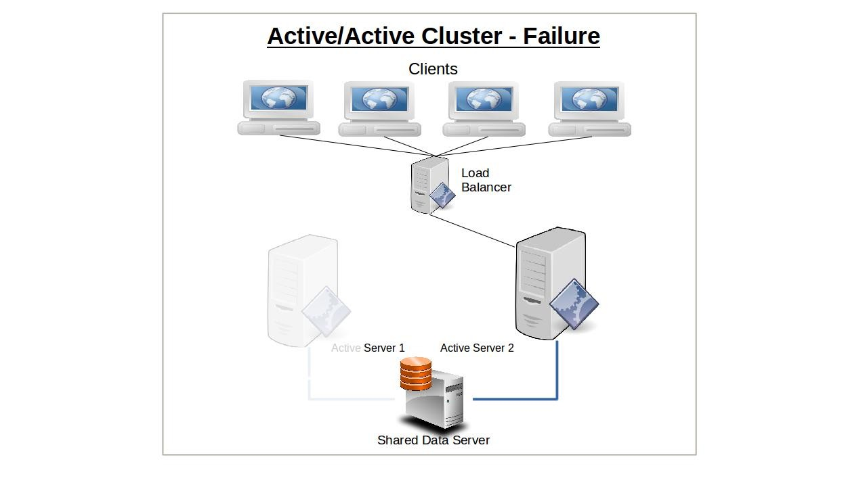
Figure 4 - https://www.freecodecamp.org/news/high-availability-concepts-and-theory/

iv) HA considerations
Depending on the configuration of high availability, there are a number of considerations to bear in mind. If we were to consider Microsoft’s Hyper-v, The following would need to be considered:
- Host hardware requirements: Whilst all nodes would not need to be identical, Microsoft recommend a number of considerations for maintaining a manageable cluster, such as using hosts with the same processor manufacturer. Using different processor manufacturers would stop features such as ‘Live migrate’ or ‘Quick Migrate’ from working [3]
- Networking requirements: A hyper-v cluster needs the following 3 IP networks. Host management, Cluster communications and iSCI. A fourth network for live migration traffic is also recommended [4]. Networks must have the bandwidth and capacity to handle all of these separate networks and their associated traffic. There is no point in configuring a cluster to failover to a separate site if the link between those sites is so insufficient that the failover takes too long for the resource to continue with no interruption.
In general, there are other considerations to bear in mind. The cost of purchasing back up equipment to remove single points of failure can mount up. Each component in an environment needs a backup component in the case of failure, down to power supplies, networking equipment and servers. Configuring these environments also takes expertise. Complex environments often require careful planning and any slight mistakes in network configuration can cause major issues in automated failovers working as expected.
v) Failover clustering in Microsoft Server
Microsoft server can be configured with failover clustering. Microsoft allows servers such as SQL, exchange and Hyper-v to all be clustered to allow for failover. Clustering in Hyper-V is a widely used form of HA used in organisational environment. A maximum of 64 nodes, supporting up to 8,000 VM’s, can all be clustered together [5]. In the event one, or even a number of these nodes fail, the VM’s running on them can be migrated to other nodes with no loss of service (depending on capacity).
The failover clustering feature is a feature that can be installed on Windows Server
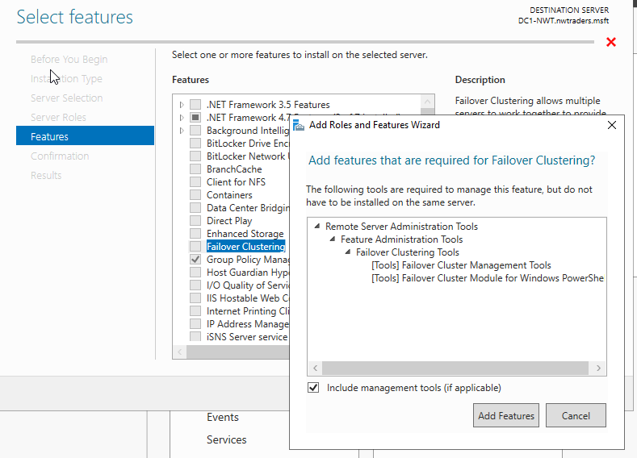
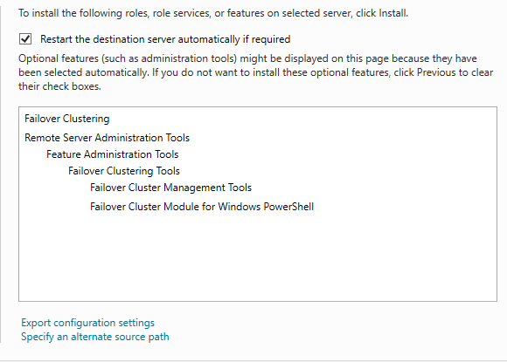

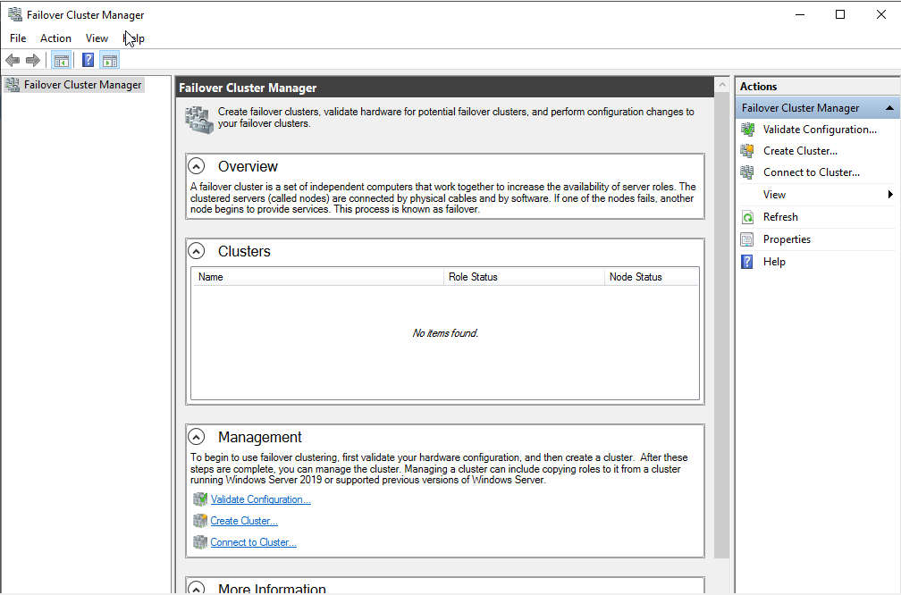
After installation of the feature, “Failover Cluster manager” becomes available on Windows Server. Here, as the name suggests, clusters can be created and managed, allowing management of all the following clusters:
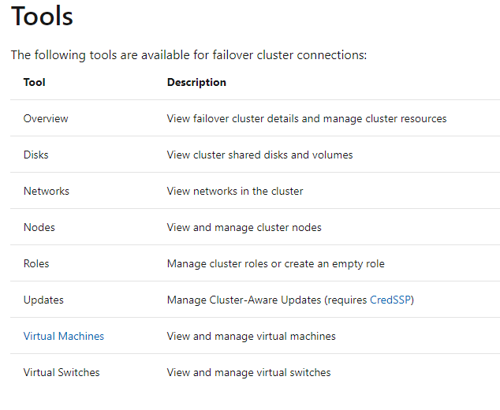
Figure 5 - https://docs.microsoft.com/en-us/windows-server/manage/windows-admin-center/use/manage-failover-clusters

Task 6 – Network Policy

Bibliography

[1] | i. s. -. routers. [Online]. Available: https://www.uhcl.edu/computing/information-security/tips-best-practices/routers. [Accessed 24 04 2021].
[2] | D. Clinton, "high-availability-concepts-and-theory," 23 07 2019. [Online]. Available: https://www.freecodecamp.org/news/high-availability-concepts-and-theory/. [Accessed 22 04 2021].
[3] | M. -. Hyper-V, "Hyper-V," [Online]. Available: https://docs.microsoft.com/en-us/windows-server/failover-clustering/failover-clustering-overview. [Accessed 22 04 2021].
[4] | Altaro, "how-high-availability-works-in-hyper-v," [Online]. Available: https://www.altaro.com/hyper-v/how-high-availability-works-in-hyper-v/. [Accessed 22 04 2021].
[5] | "HighPerf_Storage_HyperV_Cluster_on_ScaleOut_IB.pdf," [Online]. Available: https://www.mellanox.com/related-docs/whitepapers/HighPerf_Storage_HyperV_Cluster_on_ScaleOut_IB.pdf. [Accessed 22 04 2021].

