How do you interpret the concept of “dark tourism”? How useful is the concept for helping understand and interpret contemporary heritage tourism? By Rhys Clark
Introduction
This critical discussion will attempt to see how useful concept dark tourism is in helping interpret modern day tourism and the heritage attached to it. This discussion will look at the various interpretations of dark tourism, which case studies are relevant to this discussion, and how they can be identified as dark tourist sites. The use of authenticity when looking at modern day heritage tourism sites with reference to dark tourism, and finally whether it is a positive or negative effect with regard to how people view sites. This can be regarded as dark tourism. How this concept is relevant to modern tourism in the 21st century, and how we may use this in order to inform ourselves of what may be considered ethical unethical or if these two concepts are too narrow and must be looked at with more depth.
What is “dark tourism”?
Describing what dark tourism is? It is exceedingly difficult, as the subject itself is rather nebulous as it can be applied to several different areas within the tourist industry and even then, it is only a matter of interpretation that separates dark tourism from a quiet walkthrough the churchyard. Using Seaton’s ‘Guided by the Dark: From Thanatopsis to Thanatourism,’ (Seaton p240 1996). Thanatourism literally refers to death tourism, wherein people go to places which directly involves death. Although much of dark tourism does involve sites that have directly or indirectly involved a great deal of death such as sites like Auschwitz, Church yards or 9/11 ground zero, Dark tourist sites can also refer to the interaction with the more macabre and scary side of life without actually directly interacting with death or even history involving death, as there are many tours which give an insight into the criminal underworld, or an insight into Religious practices which people in the ‘Industrial North’ may consider foreign and exotic, this being Anything out of their experience which they may find appealing or repent. The reason this could be considered dark tourism is it objectifies what is considered out of the subjective norm.
For the sake of consistency this essay will focus on dark tourism in its ‘Thanatourism’ form, looking at sites focused on death, tragedy and how people interact with these dark tourist sites whether it be in a positive or negative fashion.
What is considered as Dark Tourism destination? and what is the appeal?
When looking at Dark tourist destinations the onlooker must be looking at sites that have or still do involve, to a greater or lesser degree death in some capacity. In this section there are four case studies which will be used to explore dark tourism and how people have interacted with this concept and what appeals to them as well as looking at the motivation behind going to these sites whether it is not actually peeling at all but some other reason such As for example an obligation to pay ones respects or because it is a duty they feel they must uphold.
For the first case study Auschwitz is one of the most notorious concentration camps Of the Second World war, As it was responsible for over 1,000,000 deaths of men women and children from various ethnicities such as the Jewish and Romany peoples to homosexuals and political dissidents as well as other undesirables of in Nazi regime over 70 years As of 2019 have passed since the end of this period of human history and it still holds a macabre fascination profound sorrow the amount of lives that were lost to the various agendas of the Nazi regime.
Auschwitz has since become a tourist destination where tours take place taking people around the infamous concentration camp educating people on the suffering that took place there and other war crimes that were committed. There are many reasons to go to this destination. An example of such a reason can be going to a place of historical importance, another is that perhaps they are a member of one of the groups affected by these horrors.
The reason that this could be considered a site of dark tourism is rather obvious as it involves incalculable death, Keeping in the theme of ‘Thanatourism’, The appeal of going to this place of going to a place like this, If it can be called as such, can only be spoken of in broad terms as each individual has their own agenda, So in broad terms people could go to an area like this to pay respects to the dead as one would go to a church, synagogue or other place of remembrance. The more negative side of this Would be to go to a place nearly to view objects or areas of morbid nature in order to go look at them without embracing the seriousness of what they represent will be educated understand them such as the ‘Tuol Sleng Genocide Museum’ In Colombia which because of inappropriate behaviour requires in no smiling sign on the front before entering, which may be seen as insulting. (https://www.lonelyplanet.com/cambodia 2019)

Syrian Refugee mural in the Pitt-Rivers Museum in Oxford
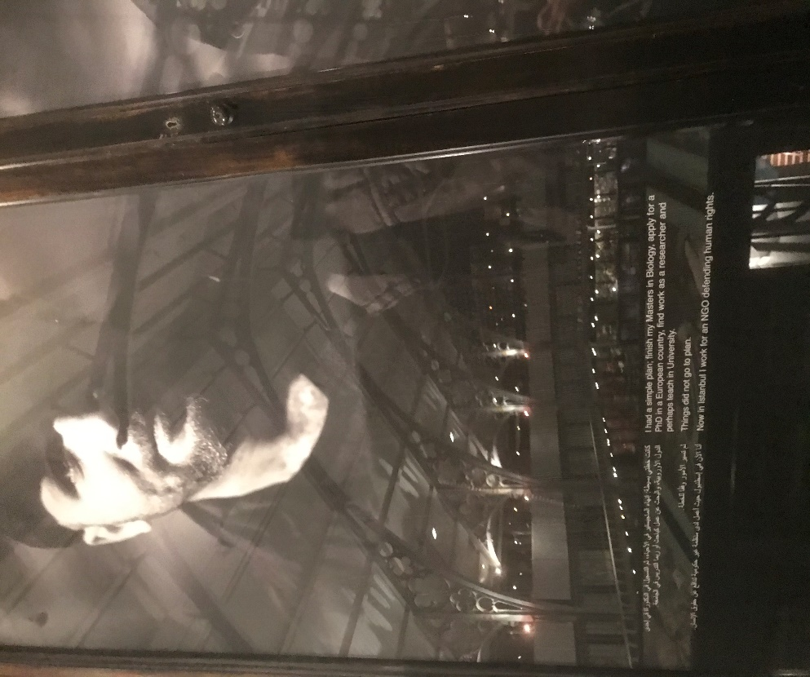
Pitt-Rivers Display on Syrian Refugees in Istanbul, an example of which can be seen in the photograph above, in the physical display in the museum proper in the highest tier of the museum each panel has the picture of individuals from Syria that have had to seek asylum. The pictures of each individual give a face to the quotes both in English and in their native language in order to help the viewer simplifies with the individuals.
This is dark tourism which has a much subtler and sympathetic feel to it, a museum is a place where one goes to view objects and help us understand who we are individually and who we are as humans, these reliefs tell us that there still pain going on in the modern world and that we should not ignore them. On the whole this is a very positive encouraging form of dark tourism not because of the subject matter but because of the message that it is trying to get through to the viewer.
Mexico-city and Pablo Escobar As seen in the Netflix documentary ‘dark tourist’ Looks it looks at the criminal past of Latin America have specifically looking at the organised criminal organisations ‘the cartels’ however it focused less on the past and more on how people are using people's fascination with the legend surrounding individual such as previously been alluded to Pablo Escobar leader of the Medellín Cartel During the late 70s and early 90s before he was killed. since his death a kind of cult following, because of the glamorisation which developed from his legacy to the point where people in the area and even member ex members such as John ‘Popeye’ Velásquez who is also seen on ‘dark tourist’, recreating for tourists who can play out scenarios, such as murdering other cartel members, in his criminal past for the entertainments of onlookers in the locations which they took place.
All of this Is important for looking at the appeal of dark tourism As it allows not only tourists to exploit and witness places and history with a darker more bit past but it also allows people in the local area where such events may have occurred to exploit it in order to boost areas of the otherwise low employment.
The London Ripper tours (London Jack the Ripper tours) Reform of tourism which exploits past looking at the Victorian serial killer Jack the Ripper, going through the areas in which Jack the Ripper supposedly stalked and killed multiple women. The appeal here is to walk in the footsteps of history to be inspired and enthralled as well as be repulsed and revile the actions of a monster from the past. Countless dramatizations and mentions of Jack the Ripper in media that it would be exceedingly rare to find someone who has not heard the name at least in the industrial North.
The appeals to tourists here are the fact that Tourists are being told that they are walking in the footsteps of one of history's greatest monsters with its own mythos surrounding it.
Dark Tourism and authenticity
When it comes to authenticity in dark tourism, one of the first questions that needs to be asked is: does someone on a dark tourist holiday actually want it to be real and whether or not the authenticity of an experience can actually be considered ethical or not.?
In the case of the London Ripper tours, many of the places where the historical serial killer walked, now no longer exists because of the natural passage of time. Even so, there are yearly ‘Ripper tours’ which take tourists through the environs of Whitechapel with many vivid descriptions of the grisly murders which took place in the late 19th century, which have in many ways become almost mythic in its horror. Authenticity in this circumstance can be taken either two ways: either it can be seen as unauthentic as the places where the actual murders took place are now built over or changed though thing such as the street are still there. The reason that authenticity needs to be looked at here is to understand how this impacts modern tourism. Most would say that they go to an area for an authentic experience, So the question is ‘why would someone go to an area that is largely modern tarmac and concrete buildings being told by someone about events that took place more than 100 years before. “It is also perverted. Belief in an efficacious “California- style” intimacy and solidarity is a fantasy of the terminally gullible.” (MacCannell, 2011)
Other places which are infinitely more dangerous even in the modern age they are considered dark tourism can be considered authentic because there is a very real danger to the people that explore such areas an example of this can be seen at Chernobyl The Russian nuclear disaster area. for decades this area was considered out of bounds, yet all the same people still went into the exclusion zone in order to get a glimpse of the impact of nuclear devastation and the impact it has on humans that lived within it. The effect this has on modern tourism in terms of authenticity is that there is a genuine danger that people we need to be aware of when exploring dark tourist sites which in many ways is an extremely negative aspect of dark tourism which has been on the CNN website ‘Chernobyl and the dangerous ground of 'dark tourism'’ . For even with its authenticity it is still self-destructive for any individual going into an area where there is a clear and present danger no contamination.
Limitations and Advantages of Dark tourism in understanding contemporary Heritage.
First looking at limitation when using dark tourism to understand heritage in a contemporary setting as previously stated is that it has such diverse and nebulous meanings and uses. It is because of this that it is hard to define. This is not entirely a drawback as it can be used in both a broad spectrum and specific heritage sites what other tourism venue.
As far as the advantages of Dark tourism in contemporary heritage. Dark tourism can be used to look at how people interact with places of a sensitive nature in either a positive or negative way. An example of negative dark tourism would be when someone goes to a destination that is particularly sensitive such as a concentration camp from World War 2, or the Boer wars, or the Jewish museum in Berlin, and then proceed to do something which may be considered disrespectful in the circumstances such as for example taking a selfie with a Camera Phone.
Analysis
This critical discussion has attempted to evaluate the relevance of dark tourism as a concept and its influence upon modern day heritage tourism. This discussion is started off by talking about what exactly dark tourism is and how it was going to be used in this essay, being in this circumstance focused more on death tourism or Thanatourism for the purposes of this discussion.
We continue to discuss what dark tourism destinations are hello and what could be considered dark tourism and how they appealed to people in the modern day. Using four separate dark tourist destinations those being Auschwitz, and the terrors of the Holocaust and how they are looked at today and how people visit this particular site.
The Pitt-Rivers museum and its murals depicting Syrian refugees and how people may use these images to sympathise with what we may consider normal people in terrible circumstances and have a face and personality to interact with and be educated by.
Pablo Escobar and tourism surrounding his legacy And how the glamour and fetishization surrounding the illegal activities which he perpetrated and how sites associated with him have now become popular tourist locations and even people associated with him, use this legend as a way of encouraging the tourism industry in areas of South America in which he operated.
Then there is the practice of London Ripper tours in Whitchurch London Which although does not hold the same aesthetic or authentic housing which Victorian London did, it does possess the use of emotive language and the Association of history through tours taken through the area. This is particularly interesting as it brought into question how authenticity is used in dark tourism.
Following on with this theme Looks into the aspects related to how people view dark tourism through the eyes of authenticity whether or not it's at how they feel before going in to the site or the actual experience of being there in a place which they know to be real.
Conclusion
In conclusion When interpreting what dark tourism is? It can be seen as, the fascination with the dark macabre aspects of the human experience especially referring to heritage where sites of manmade or natural disaster have occurred which may directly or indirectly the associated with death.
When looking at how useful is the concept of dark tourism can be in helping us understand and interpret in contemporary heritage tourism, it can be seen is affecting modern tourism in two main ways, even if the topic itself is a lot broader then these main themes.
First Dark Tourism can be seen as a positive, a site where a disaster or tragedy has occurred where people make congregate to sympathise or empathise with a human loss in one form or another. Where we can respect and honour the dead or the disenfranchised.
The second is where people go to a site of tragedy not to be respectful or educated but rather to be shocked and, or excited by the experience of being in a place which should invoke respect and in the more severe cases go to locations which may even do harm to the person going there, also they can experience a thrill.
When we think about heritage sites that are considered dark tourist destinations, we must be careful of the image that is presented and how tourists interact with these locations particularly in the sensitive environment of contemporary heritage tourism.

References
Bowman M.S. Pezzullo, P.C. 2009 'What’s so "Dark" about "Dark Tourism?’: Death, Tours and Performance,' Tourist Studies, vol 9 no 3, pp.187-202.
Clark, R,.2019. ‘Photograph taken of Syrian Refugee mural’. Pitt-Rivers Museum in Oxford.
Dark tourist, Episode 1, Latin America, 2018. Online, Netflix. 25th November 2019.
Fernandes, M. Jamadagni, R. 2018, ‘The Dark Tourist: An Insight into the Appeal of Dark Tourism’. ATITHYA: A Journal of Hospitality, Vol 4, no 2. pp 41-45.
Keil, C. 2005. ‘Sightseeing in the Mansions of the Dead,’ Social & Cultural Geography’, vol 6, no 4, pp. 479-494.
Knudsen, B. T. 2011' Witnessing Difficult Pasts,' Tourist Studies, vol 11 no 1, pp.55-72.
MacCannell, D. 2011 ‘Staged Authenticity Today’, The Ethics of Sightseeing vol no , pp. 13–34.
Reynolds D, 2016 'Consumers or Witnesses? Holocaust Tourists and the Problem of Authenticity,' Journal of Consumer Culture, vol 16 no. 2, pp. 334-353.
Seaton, A.V. 1996 ‘Guided by the Dark: From Thanatopsis to Thanatourism,’ International Journal of Heritage Studies’ vol 2 no 4, pp. 234–244
Sharpley, R. 1956- Stone, P. 2009. The darker side of travel: the theory and practice of dark tourism. Bristol: Channel View.
Zalewska, M. 2017. 'Selfies from Auschwitz: Rethinking the Relationship between Spaces of Memory and Places of Commemoration in the Digital Age,' Studies in Russian, Eurasian and Central European New Media (digitalicons.org), no 18, pp. 95–116.
CNN Travail. 2019, Chernobyl and the dangerous ground of 'dark tourism'. CNN. viewed 27 November 2019. <https://edition.cnn.com/travel/article/dark-tourism-chernobyl/index.html>.
Get Your Guide. 2019, London Jack the Ripper tours, Get Your Guide. viewed 26 November 2019. <https://www.getyourguide.com/-l57/ tc253/?cmp=ga&campaign_id=6476302249&adgroup_id=79189757713&target_id=aud-851240473327:kwd-1251233660&loc_physical_ms=1007437&match_type=e&ad_id=395197169196&keyword=london%20jack%20the%20ripper%20tour&ad_position=1t1&feed_item_id=&placement=&partner_id=CD951&gclid=EAIaIQobChMIpLzr4veI5gIVmK3tCh3IngRBEAAYASAAEgL7J_D_BwE>.
Lonely Planet. 2017, Tuol Sleng Genocide Museum, viewed 26 November 2019. <https://www.lonelyplanet.com/cambodia/phnom-penh/attractions/tuol-sleng-genocide-museum/a/poi-sig/441640/355881>.

