Student name: | Sophie Taylor | Student ID number: | 2432430
Programme: | CertHE Applied Leadership and Management Outreach
Module: | Problem Solving and Decision Making
Module code: | BMSK4014 | Contribution to Overall Module Assessment (%): | 100%
Lecturer: | Navdeep | Internal Verifier:
Lecturer Signature: |  | Date marked:
Assignment Title: | Problem Solving and Decision Making | Word count (or equivalent): | 3000
Submission deadline: | As agreed | Return date of provisional marks & written feedback:

Flight Disruptions and Cancellations in Airlines
Introduction
Airlines are complicated businesses that rely on many people, systems, and outside organizations to work smoothly. One of the biggest problems faced is flight disruptions and cancellations. An article by Ibssoftware (2021) called ‘Managing airline operations is complex, but it doesn’t have to be difficult’ explains this. A disruption happens when flights are delayed or cancelled because of reasons like bad weather, crew shortages, system errors, or air traffic control issues. These problems don’t just affect one flight; they often spread and cause chaos across an airline’s whole network and affecting many people that are involved. In this assignment, it will explain the problem, who it affects, and how, then use problem solving tools to look for causes. This assignment will also suggest solutions, choose the best option, and show how to put it into action with a clear plan.
Defining the Problem, Scope, and Impact
The Problem
Flight disruptions mean passengers cannot leave or arrive on time. Sometimes these delays are short, but when many flights are cancelled, the impact is huge. For example, Southwest Airlines cancelled over 16,700 flights in 2022 because their scheduling system was outdated (AP News, 2022). Also, about 200 passengers flying with Tui was left stranded in Gran Canaria for three and a half days unable to board a flight home after computer systems crashed (BBC News 2024). Another example would be that Air Canada had a global IT outage and had to cancel more than 5,000 flights. Causing huge impacts on everyone affected. (Sky News 2024). These cases show that disruptions are not small issues – they are serious, ongoing problems.
Scope
The problem affects many things:
- Passengers loose time and miss connections
- Passengers also will then spend money unexpectedly.
- Crew members deal with stress, fatigue, and sudden changes.
- Ground staff and operations teams have to manage rerouting and angry customers.
- Air traffic control has to handle congestion and reassign flights.
- Airline management and investors lose money and reputation.
- Regulators must make sure airlines follow safety and customer laws.
Impact
Financial Impacts
Unexpected expenses: Extra costs for meals, hotels, or transportation.
Lost bookings: Prepaid hotels, tours, or rental cars at the destination may be wasted.
Work-related losses: Missing business meetings, contracts, or job interviews.
Non-refundable connections: Train tickets, event tickets, or other linked reservations.
Additional rebooking costs: If the airline doesn’t fully cover changes, passengers may pay for new flights.
Emotional & Psychological Impacts
Stress & anxiety: Uncertainty about when they’ll reach their destination.
Frustration & anger: Especially if communication from the airline is poor.
Exhaustion: Long waits in airports and lack of rest.
Disappointment: Missing important life events (weddings, funerals etc).
Fear of recurrence: Some passengers may develop anxiety about future travel.
Practical & Logistical Impacts
Missed connections: Passengers may lose onward flights or transport (buses, trains, cruises).
Disrupted schedules: Family, colleagues, or friends expecting them may have to rearrange their own plans.
Visa or entry issues: If rescheduled flights alter travel dates, passengers may face problems with visas or entry requirements.
Health implications: Missed medical treatments or medications, particularly for those traveling for healthcare reasons.
Social & Relational Impacts
Strained family dynamics: Delays may cause stress if traveling with children or dependents.
Damaged professional relationships: Missing critical meetings can reduce trust or harm business deals.
Isolation: Being stranded in an unfamiliar place without support.
Airline Reputation & Trust
Loyalty impact: Passengers may lose trust in the airline and choose competitors.
Customer dissatisfaction: Leads to negative reviews and complaints.
Legal & Rights-Related Impacts
Compensation rights: In some regions (like the EU), passengers are entitled to compensation but claiming it can be complex.
Insurance disputes: Travelers may face difficulties getting reimbursed if insurers deny coverage.
Contract disputes: Tour operators, hotels, or employers may not accommodate the disruption.
Looking at Causes
To understand why these problems happen, different tools can be used.
Brainstorming
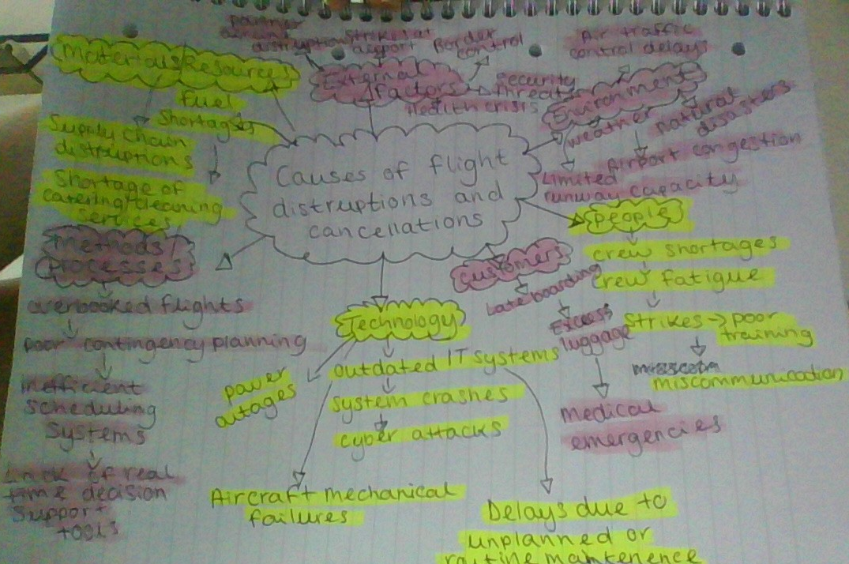
Fishbone (Ishikawa) Diagram 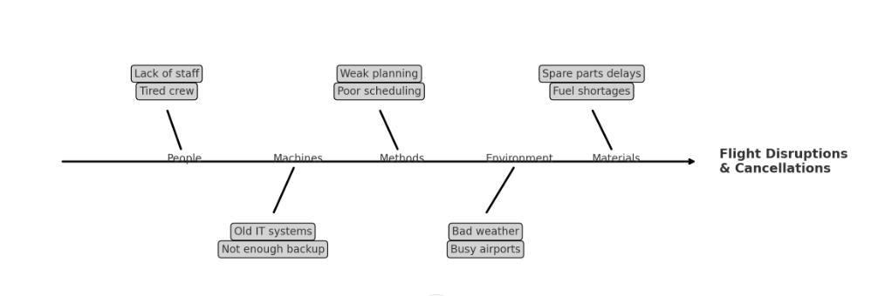
Alternative Solutions to Airline Cancellations and Reschedules
People (Staffing & Training)
Flexible Crew Rostering: Introduce AI-driven scheduling that adapts quickly to sickness or last-minute absences.
Reserve Crews: Keep “standby” staff in major hubs to step in when needed.
Wellness & Fatigue Management: Better rest rules, fitness programs, and monitoring to reduce fatigue-related issues.
Machines (Aircraft & IT Systems)
Upgrade IT Systems: Replace outdated scheduling and reservation software with real-time integrated platforms.
Backup Servers and Cybersecurity: Ensure data redundancy and security against system outages and cyberattacks.
Predictive Maintenance: Use sensors and AI to detect aircraft part failures before they happen.
Spare Aircrafts: Keep backup aircraft at major hubs to step in when aircrafts have issues.
Methods (Processes & Policies)
Flexible Ticketing Policies: Allow passengers to rebook without extra fees in case of major system-wide issues.
Shorter Turnaround Innovations: Invest in automation for boarding, fueling, and baggage loading.
Environment (Weather and Natural Events)
Advanced Weather Forecasting: Partner with agencies for more advances and real-time forecasts.
All-Weather Aircraft/Runway Tech: Invest in anti-icing technology, heated runways, and aircraft de-icing efficiency.
Alternative Airport Agreements: Have contingency plans to divert flights smoothly to nearby airports.
Materials (Fuel, Parts, Equipment)
Diversified Fuel Contracts: Avoid shortages by signing contracts with multiple suppliers.
On-site Spare Parts Stock: Store critical spares at major hubs to avoid delays waiting for shipments.
Extra Ground Handling Equipment: Lease additional equipment to handle peak loads.
Catering & Cleaning Resilience: Outsource or keep multiple suppliers.
External Factors (Security, Health, Political)
Health Screening Technology: Use faster screening and digital health passports to reduce delays during pandemics.
Security Partnerships: Work with airports to improve screening efficiency.
Customers (Passenger-Related Delays)
Automated Check-In & Bag Drop: Reduce boarding delays caused by long queues.
Digital Communication Apps: Push instant updates about gate changes, cancellations, and rebooking options.
Obstacles and Barriers to Solutions
High Costs
A big problem is money. Things like new IT systems, predictive tools, or keeping spare planes are extremely expensive. Airlines avoid doing this because they only focus on saving money in the short term.
Staff Resistance
Sometimes employees or unions don’t like changes. Pilots and cabin crew may not accept new schedules, cross-training, or extra duties because they think it could affect safety or make their jobs harder.
System Integration Issues
New systems are often difficult to connect with the old one’s airlines already use. If the systems don’t work together properly, it can make things even worse instead of solving problems.
Dependence on Others
Airlines rely on air traffic control, airports, and governments. Even if the airline improves its own systems, things like strikes or airport delays can still cause major disruption.
Supply and Resource Problems
Airlines sometimes can’t get the parts, fuel, or equipment they need on time. So even with better planning, shortages and supply chain problems can still block improvements.
Passenger Behaviour
Not all problems are caused by the airline. Some passengers ignore app alerts, arrive late, bring too much luggage, or cause boarding delays. This makes it harder for airlines to stay on schedule.
Regulations and Laws
Strict aviation rules can stop airlines from making certain changes. For example, according to European Commission, in Europe, EU261 rules mean airlines must pay passengers compensation, which makes them cautious about cancelling flights even when it might be the best choice.
Grid Analysis: Flight Disruptions and Cancellations
To decide on the best solution, comparing different options using Grid Analysis can help. It’s good to list possible solutions, chose some key criteria, gave each criterion a weight (how important it is), and then scored each solution out of 5. The total score helps show which solution is best.
Criteria (with weights)
Cost (weight 2) – How expensive it is to set up and run.
Speed (weight 3) – How quickly the solution can be put in place.
Long-Term Value (weight 4) – If the solution will keep helping in the future.
Effectiveness (weight 5) – How well it reduces cancellations and disruptions.
Solutions Compared
Upgrade IT Systems (new scheduling and backup systems)
More Reserve Crew (extra standby pilots and cabin crew)
Predictive Maintenance (AI to check aircraft health before failures)
Stronger Weather Forecasting Partnerships
Grid Analysis Table
 | Solution | Cost (2) | Speed (3) | Effectiveness (5) | Long-Term Value (4) | Total
 | Upgrade IT Systems | 3×2=6 | 3×3=9 | 5×5=25 | 5×4=20 | 60
 | Reserve Crew | 2×2=4 | 5×3=15 | 4×5=20 | 3×4=12 | 51
 | Predictive Maintenance | 4×2=8 | 3×3=9 | 5×5=25 | 5×4=20 | 62
 | Better Weather Forecasts | 5×2=10 | 4×3=12 | 3×5=15 | 3×4=12 | 49
Results
Predictive Maintenance (62 points) is the best option overall. It prevents mechanical failures, keeps planes in service, and gives strong long-term benefits.
Upgrade IT Systems (60 points) is also very good, especially for scheduling and communication.
Reserve Crew (51 points) helps with staff shortages but is less effective long term.
Weather Forecasting (49 points) is useful, but airlines can’t control the weather, so the impact is limited.
Best Choice: Predictive Maintenance is the strongest solution but combining it with IT upgrades makes an even better plan, since both technology and scheduling improvements work together to cut down cancellations.
Cost-Benefit Analysis (CBA) for Airline Solutions
When looking at how airlines can reduce cancellations and disruptions, it is important to weigh up the costs of each solution against the benefits. For this, comparing four options: upgrading IT systems, adding more reserve crew, using predictive maintenance, and improving weather forecasting.
By working out approximate yearly costs (investment and running costs) and compared them with the benefits (like saving money from fewer cancellations, less EU261 compensation, and less rebooking and hotel costs). To measure this properly, there are two ratios used:
Benefit–Cost Ratio (BCR) = Benefits ÷ Costs
Return on Investment (ROI) = (Benefits – Costs) ÷ Costs × 100
Solution | Cost (M€) | Benefit (M€) | BCR | ROI %
Upgrade IT Systems | 25 | 60 | 2.4 | 140%
Reserve Crew | 15 | 30 | 2.0 | 100%
Predictive Maintenance | 30 | 80 | 2.67 | 167%
Better Weather Forecasting | 10 | 18 | 1.8 | 80%
From the table, Predictive Maintenance gives the highest benefit compared to cost, with a benefit cost ratio of 2.67 and ROI of 167%. Upgrading IT systems is also strong (return of investment 140%), especially for communication and scheduling improvements. Reserve Crew helps but it is more of a short-term fix. Better Weather Forecasting is the cheapest option but since airlines cannot control the weather, the benefits are lower.
The best option is Predictive Maintenance but combining it with IT system upgrades would give an even better balance, because it tackles both technical reliability and scheduling problems.
Identifying the Best Option
After looking at the grid analysis and cost-benefit analysis, it shows that the best solution is not always the cheapest one. Options like hiring more backup crew or improving weather forecasts cost less, but they don’t give the same long-term results. Weather causes about 20% of delays in Europe (Eurocontrol, 2022), and while better forecasts help airlines prepare, they can’t stop the delays completely. With an ROI of only 80%, it’s the weakest choice.
Predictive Maintenance is the best single option. It has the highest ROI (167%) and the best benefit–cost ratio (2.67). Even though it costs more at the start, it saves a lot more money later by stopping technical problems that often cause delays and cancellations. It also reduces emergency repairs and EU261 payouts (Forbes, 2022; IATA, 2023).
A better choice is combining Predictive Maintenance with IT System Upgrades. IT upgrades make scheduling smoother, help with passenger communication, and speed up rebooking. When added together, both technical issues and organisational problems are solved. Airlines with modern IT can deal with last-minute changes better and rebook passengers automatically (CAPA, 2021). This costs about €25 million, with ROI of 140%.
Adding extra standby pilots and crew can reduce cancellations from staff shortages. But it is expensive to keep staff who may not always be used. The UK Civil Aviation Authority (2023) showed that staff shortages caused big problems in 2022, so this helps in emergencies but is not a long-term fix.
Conclusion: Predictive Maintenance alone gives the strongest results but combining it with IT upgrades is the best overall solution. It costs more upfront but saves money long-term, reduces disruptions, and improves passenger satisfaction.
Action Plan for Implementation
To solve the problem of flight disruptions and cancellations, the airline will implement a combined solution of Predictive Maintenance and IT Upgrades. The aim is to reduce technical failures, improve scheduling, and enhance passenger communication.
Steps of Implementation
Project Planning – Set up a project team and timeline for both predictive maintenance and IT upgrades.
System Procurement – Purchase predictive maintenance software, sensors, and new IT infrastructure.
Staff Training – Train engineers on predictive systems and operations staff on the new IT tools.
System Integration – Install and test predictive maintenance systems on aircraft; update IT across scheduling and passenger systems.
Pilot Testing – Run trials on a small fleet of aircraft and one regional hub before full rollout.
Full Rollout – Deploy systems across the fleet and all operations.
Monitoring & Evaluation – Track results using performance indicators like reduction in cancellations, on-time performance, and passenger satisfaction.
aWhat Success Looks Like
-25–30% reduction in cancellations caused by technical issues.
-Improved passenger communication (automatic rebooking, real-time updates).
-Lower EU261 compensation costs due to fewer preventable disruptions.
-Positive staff feedback on new systems and smoother operations.
Gantt Chart – Implementation Plan
12-month timeline.
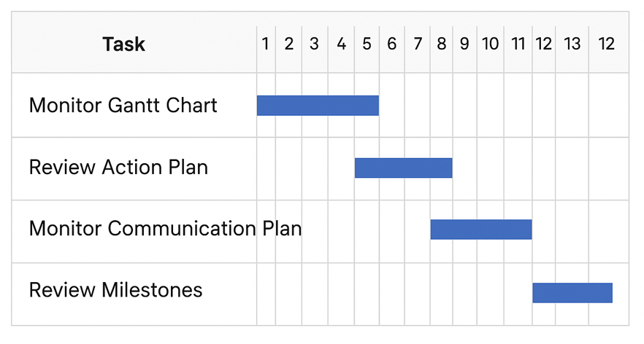
Identifying the Stakeholders
When looking at the problem of flight disruptions and cancellations, there are lots of people and groups who are affected, so they are important stakeholders. These stakeholders need to be kept informed, because without good communication, problems can get worse, and trust can be lost.
Passengers are the main group impacted. They need to know about changes as quickly as possible so they can plan their travel, rebook, or claim their rights. If passengers are not told in time, it can lead to stress and complaints (Budd et al., 2016).
Airline staff like pilots, cabin crew, ground staff, and maintenance teams are also key. They need clear information about flight schedules and technical issues. For example, if predictive maintenance identifies a repair, engineers must know immediately so they can act (Cook et al., 2012).
Airline managers and executives are another stakeholder group. They have to monitor the progress of solutions like predictive maintenance and IT upgrades, because they are responsible for safety, efficiency, and meeting regulations (Gillen & Morrison, 2015).
Regulators such as the Civil Aviation Authority or the European Aviation Safety Agency must also be kept updated. They check that airlines are following safety standards and passenger rights laws such as EU261 (European Commission, 2023).
Investors and shareholders want to know that the airline is handling disruptions properly. If flights are cancelled too often, it can hurt the airline’s reputation and profit, so they need reassurance that the new systems will save costs in the long run (Morrell, 2018).
Airports and air traffic control also need information, especially if schedules change. Without coordination, delays can spread across the network (Eurocontrol, 2022).
By keeping all these stakeholders properly informed, the airline can reduce problems, build trust, and make the solutions more effective.
Communication Plan
When putting predictive maintenance and IT upgrades in place, it’s really important that we keep everyone updated in the right way and at the right time. If people don’t get the information they need, things can get worse and trust is lost.
Passengers will always be told straight away when there are delays or cancellations. They will be contacted by email, text, and social media. This is because passengers need fast updates to reduce stress and help them plan (Budd et al., 2016).
Airline staff like pilots, cabin crew, and ground teams will get weekly updates through staff meetings, briefings, and emails. They need clear communication so they can work safely and stay organised (Cook et al., 2012).
Airline management will be updated every month with reports about progress, data from predictive maintenance, and IT system improvements. They also need regular meetings so decisions can be made quickly if something changes (Gillen & Morrison, 2015).
Regulators such as the Civil Aviation Authority and the European Aviation Safety Agency must be updated when required. They will get compliance reports and safety updates so the airline can show it is meeting rules such as EU261 (European Commission, 2023).
Investors and shareholders will be given information every three months during calls, reports, and meetings. They need to see that the new systems are improving reliability and saving money long term (Morrell, 2018).
Airports and Air Traffic Control (ATC) will be told about changes regularly. Airports will be updated weekly through emails and meetings, while ATC will be informed directly in real time when flights are disrupted. This helps avoid delays spreading (Eurocontrol, 2022).
This communication plan makes sure everyone knows what is going on, when they need to know it, and through the right channels. It helps build trust, reduces confusion, and makes sure the project runs smoothly.
Monitoring and Review Techniques
To make sure the predictive maintenance and IT upgrade plan goes the way it should, a few different monitoring tools will be used. The first one is the Gantt chart, which shows the timeline of each task. This makes it easier to see what has been finished and what is still left to do. If something is late, we can spot it quickly and sort it out before it causes bigger problems (Kerzner, 2017).
The second tool is the action plan. This clearly sets out who is meant to do each job and by when. By checking this, it makes sure the right people are working on the right tasks at the right time (Lock, 2020).
The third tool is the communication plan, which makes sure everyone – staff, passengers, regulators, and even investors – are kept informed. If problems come up, clear communication helps us deal with them faster and avoid confusion (PMI, 2021).
Monitoring progress means always comparing the plan with what is really happening. For example, if the Gantt chart shows that IT upgrades should be done by month six, but they aren’t, then we know we’re behind and can act straight away.
Also, adding clear milestones into the project, like when training is completed or when equipment arrives. These checkpoints let us pause, review, and confirm the project is on track. If something has slipped, we can act before it gets worse.
By using these techniques, it can keep the project under control, reassure stakeholders, and make sure the solution is delivered properly.
References
BBC News. (2024, August 26). TUI passengers stuck for days as flight cancelled.. https://www.bbc.co.uk/news/articles/cg640n1zw16o
Sky News. (2024, July 19). Outages latest: Airports, business and broadcasters experiencing issues worldwide. Sky News. https://news.sky.com/story/outages-latest-airports-business-and-broadcasters-experiencing-issues-worldwide-13180821
European Commission. (2024). Air passenger rights: Frequently asked questions. https://ireland.representation.ec.europa.eu/live-work-study-eu/air-passenger-rights-frequently-asked-questions_en
European Commission. (2023). EU Passenger Rights – Regulation (EC) No 261/2004. https://transport.ec.europa.eu
IATA. (2023). The cost of airline disruptions. International Air Transport Association. https://www.iata.org
Forbes. (2022). How predictive maintenance is changing aviation. Forbes. https://www.forbes.com
Budd, T., Ison, S., & Adrienne, N. (2016). Airline disruption management: Passenger perspectives on causes and effects. Journal of Air Transport Management, 55, 84–91. https://doi.org/10.1016/j.jairtraman
Eurocontrol. (2022). Challenges of air traffic management in Europe. Eurocontrol. https://www.eurocontrol.int
UK Civil Aviation Authority. (2023). Airline disruption and passenger rights report. https://www.caa.co.uk
CAPA Centre for Aviation. (2021). Technology upgrades in airline operations. Centre for Aviation. https://centreforaviation.com
Cook, A., Tanner, G., & Anderson, S. (2012). European airline delay cost reference values. Eurocontrol. https://www.eurocontrol.int/sites/default/files/publication/files/european-airline-delay-cost-reference-values-final-report-4-1.pdf?utm_source=chatgpt.com
Gillen, D., & Morrison, W. (2015). Foundations of airline finance: Methodology and practice. Routledge. https://www.pmi.org/standards/pmbok?utm_source=chatgpt.com
iFlight Differentiators. (2021, November 30). Managing airline operations is complex, but it doesn’t have to be difficult. IBS Software Blog. https://blog.ibsplc.com/airline-operations/managing-airline-operations-is-complex-but-it-doesn-t-have-to-be-difficult
Morrell, P. (2018). Airline finance (4th ed.). Routledge. https://en.wikipedia.org/wiki/Project_Management_Body_of_Knowledge?utm_source=chatgpt.com
Kerzner, H. (2017). Project management: A systems approach to planning, scheduling, and controlling. Wiley. https://books.google.co.uk/books/about/Project_Management.html?id=xlASDgAAQBAJ&redir_esc=y
Lock, D. (2020). Project management. Routledge. https://www.taylorfrancis.com/books/mono/10.4324/9781315245911/project-management-dennis-lock-dennis-lock?utm_source=chatgpt.com
Project Management Institute (PMI). (2021). A guide to the project management body of knowledge (PMBOK® Guide) (7th ed.). PMI. https://www.pmi.org/standards/pmbok/about?utm_source=chatgpt.com

