University of Wales Trinity Saint David
Wales Institute of Science and Art


Electronic Circuits Testing and Applications

Vehicle Electronics (ACHA4031)

Isabella Wratten
2405144

(04/2026)
Contents
Table of Figures 1
Table of Tables 1
1 Task 3 1
1.1 Scope Time Division Calculations (6) 1
1.2 Function Generator output square wave (6) 1
1.3 Capacitor charge and discharge wave marked at correct points. (6) 2
1.4 Basic Capacitor Calculations (6) 2
1.5 Capacitor discharge table (5) 3
1.6 Plot log(V) Gradient (5) 4
1.7 Gradient Calculations and Compare (8) 4
1.7.1 Gradient Calculations 4
1.7.2 Comparison table 5
1.8 Capacitor Uses (5) 5
1.9 Inaccuracies Question (4) 6
1.10 Risk Question (10) 6
2 References 7

Table of Figures
Figure 1 - Square Wave on a Function Generator 1
Figure 2 - Peak Voltage and other values 2
Figure 3 - Scope Wave across the Capacitor Output 2
Figure 4 - Wave Marker Voltage 2
Figure 5 - Graph depicting ln voltage against time 4

Table of Tables
Table 1 - Table of data for gradient calculations 3
Table 2 - Comparison of all Capacitance Calculations 5

Task 3
This task investigates capacitors and how they work through the making of an RC circuit using an Arduino Breadboard, whilst using a Function Generator and Oscilloscope to input the data onto the Hantek 6022-BE software.
This task then goes on to analyse the data so that the results can be compared against previously calculated outputs and explain where inaccuracies may have arose.
This report will also look at where capacitors are used in different engineering disciplines. Before finally discussing the risk that vehicles now face from cybersecurity attacks.

Scope Time Division Calculations (6)
Calculating the time constant,
$$R=100Ω$$
$$C=1μF$$
$$τ=R ×C=100 ×1 × {10}^{-6}=100μS$$
Therefore, calculating for 40-time constants,
$$40τ=40×1 × {10}^{-4}=4mS$$
From this the time division to be calculated,
$$No of Divisions=10$$
$$Time Division= \frac{4×{10}^{-3}}{10}=4×{10}^{-4}$$
This result was then rounded to 500μS, as it is closest to the calculated result in the Time/Div selection within the Hantek software.

Function Generator output square wave (6)

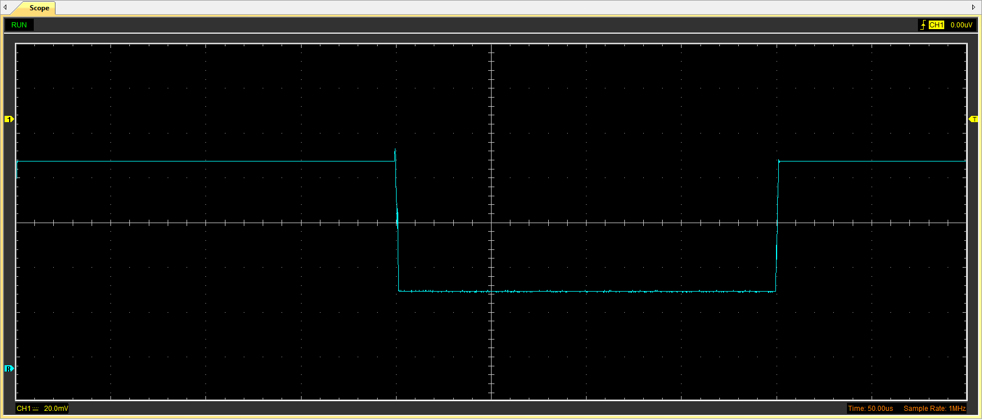
Figure 1 - Square Wave on a Function Generator
Figure 2 - Peak Voltage and other values
Figure 1 shows a square wave form as generated by a function generator, with a peak voltage of 2.91V (Figure 2).

Capacitor charge and discharge wave marked at correct points. (6)
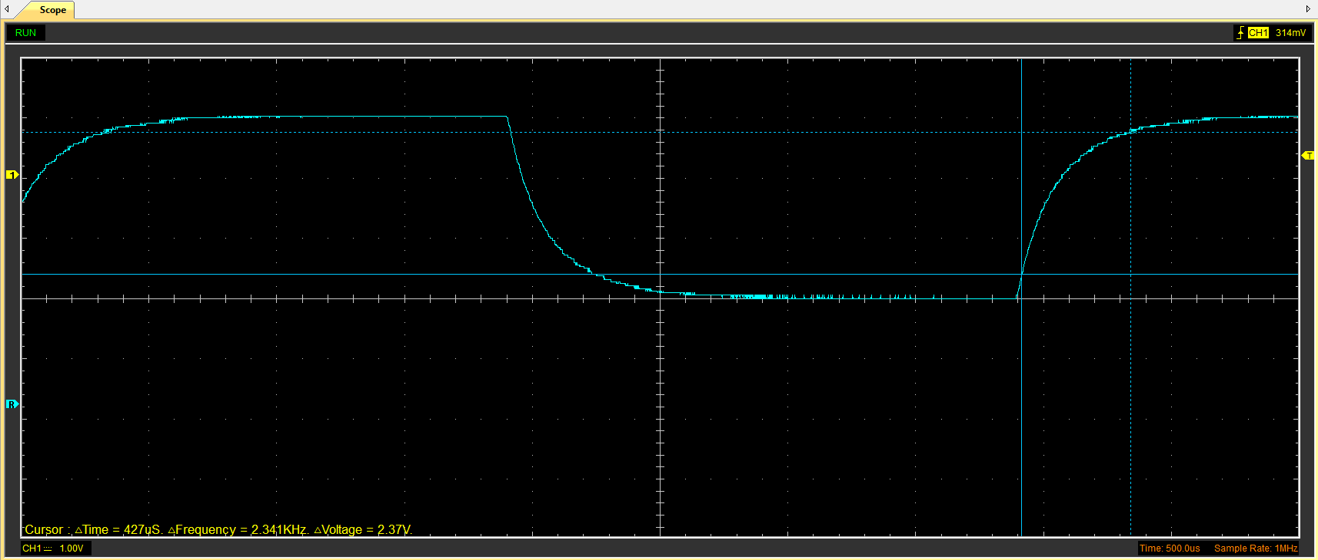
Figure 3 - Scope Wave across the Capacitor Output
Figure 4 - Wave Marker Voltage
Figure 3 shows the charge and discharge wave of the capacitor.
For the following calculation the start is taken as the midpoint between the start and peak voltage. In this case the voltage start point would be 1.455V
To calculate the capacitor wave marker when charging,
$$(Peak\left(V\right)-Start(V)×63.2\%+Start\left(V\right)=V top cursor$$
Therefore,
$$2.91\left(V\right)-1.455\left(V\right)×63.2\%+1.455\left(V\right)=V top cursor$$
Meaning the wave marker is at
$$V top cursor= 2.37 V$$

Basic Capacitor Calculations (6)
To calculate the capacitance measured
$$C= \frac{τ}{R}$$
Taking τ as the time in figure 4,
$$τ=427μS=0.000427 S$$
And R as 100 Ω,
$$\frac{0.000427}{100}=0.00000427$$
$$C=4.27µF$$

Capacitor discharge table (5)
Table 1 below shows the analysed results from the data collected.
Table 1 - Table of data for gradient calculations
Time (s) | Voltage (V) | ln (V) | dy = y2 – y1 | dx = x2- x1 | dy/dx
Time (s) | Voltage (V) | ln (V) | dy = ln(V)2-ln(V)1 | dx = Time2 – Time1 | dy/dx
0.000694 | 4.6118 | 1.528618 | x | x | x
0.000727 | 4.0157 | 1.390212 | -0.13840656 | 0.000033 | -4194.13812
0.00076 | 3.5451 | 1.265566 | -0.12464531 | 3.3E-05 | -3777.13061
0.000793 | 3.2314 | 1.172915 | -0.09265089 | 0.000033 | -2807.60268
0.000826 | 2.9804 | 1.092058 | -0.08085796 | 3.3E-05 | -2450.24122
0.000859 | 2.7608 | 1.01552 | -0.07653703 | 0.000033 | -2319.30385
0.000892 | 2.6039 | 0.95701 | -0.05851017 | 0.000033 | -1773.0355
0.000925 | 2.4471 | 0.894904 | -0.06210667 | 3.3E-05 | -1882.02034
0.000958 | 2.3529 | 0.855649 | -0.03925504 | 0.000033 | -1189.54667
0.000991 | 2.2588 | 0.814834 | -0.04081491 | 3.3E-05 | -1236.81549

Plot log(V) Gradient (5)

Figure 5 - Graph depicting ln voltage against time
Figure 5 shows the ln voltage (calculated in table 1) against time.

Gradient Calculations and Compare (8)

Gradient Calculations
To calculate τ from the gradient is,
$$τ=-\frac{1}{Gradient}$$
Taking the gradient from figure 5,
$$τ=-\frac{1}{-2340.4}$$
$$τ=427.28μS=0.000427.28 S$$
From here to get the capacitance is,
$$C=\frac{τ}{R}$$
With R as 100 Ω again,
$$\frac{0.00042728}{100}=0.0000042728$$
$$C=4.27μF$$

Comparison table
Table 2 - Comparison of all Capacitance Calculations
 | Capacitance | Delta | Percentage difference
Actual | 1 µF | x | X
Marker Calculation | 4.27µF | +3.27 | +327%
Gradient Calculation | 4.27µF | +3.27 | +327%

Capacitor Uses (5)
Capacitors are used to store electrical energy over a prolonged charging time (Kaiser, 1993), before going on to release them in short periods in a controlled manner (SARJEANT et al., 1999). As well as filtering signals and smoothing power supplies.
- Capacitors store electrical energy in the form of electric charge (EE Power, 2020) and can act as a temporary power supply for technology that requires a high amount of energy in a short time. An example of this is a camera flash, the stored energy allows for a high intensity flash to occur which a battery itself would not be able to deliver (Matsusada Precision, 2023).
- A similar principle is used in bug zappers (EE Power, 2020). The capacitor charges and when the insect makes contact it essentially shorts the system allowing the stored energy to be released.
- Capacitors are also used for noise filtering in audio devices (Matsusada Precision, 2023). (Paul McGowan, 2025), states that in audio circuits, they are used to filter any unwanted DC current that could damage speakers whilst still allowing the AC audio signal to flow.
- In touchscreen technology, capacitors play a key role. When a finger touches the screen it disturbs the capacitance in that specific area of the screen, allowing for an estimate to form of the touch position (Nam et al., 2021),(Electronics Direct, 2025).
- Capacitors are also used in solar panels and wind turbines, (Electronics Direct, 2025). They balance out the irregular power generated by using large capacitors so that any energy can then be released smoothly.
- (Kaiser, 1993) states that capacitors are often used to stabilise power supply. In vehicles for example, large voltage spikes occur when starting the engine. The capacitor in this instance manages this surge to help prevent fluctuations in power that may damage the electrical components in a vehicle (Eureka, 2025).
- In automotive safety systems, capacitors are used in airbag deployment circuits. When needed they can release the energy needed for deployment in a short space of time (Eureka, 2025) and due to them storing energy can still deploy even if the main power supply is interrupted.
- Capacitors are used in LED light circuits such as on cars or modern streetlamps, as (JEC, 2025), states that they are a good protection against overvoltage, filter any noise ensuring a stable current flow and work well under high temperatures.
- Capacitors are also important to the ignition system and many bikes run using a Capacitor Discharge Ignition Module (CDI), as they can produce the high voltage spark needed to ignite the air fuel mixture (EL-PRO-CUS, 2025) .
- Capacitors are also used in electric motors, they provide an initial phase shift in the current, creating a rotating magnetic field that allows the motor to start and operate smoothly (Maroti et al., 2022).

Inaccuracies Question (4)
As seen in table 2, there is a large discrepancy between the actual capacitance value and the measured marker and gradient calculations recorded. Typically, capacitors are manufactured with a tolerance variation of +- 5 to 10 percent (EIM Technology, 2025). The results in the table show a difference of +327% which shows there were inaccuracies along the way.
One source of error may be the capacitor used. If this was different the original time constant calculated meaning the wrong setting would have been used in Hantek affecting the results. Additionally, the function generators internal resistance can alter the resistance of the overall circuit, the same applies to the oscilloscope (Torriente-García et al., 2023). Both factors can affect the charge and discharge of the curve. Furthermore, external factors such as electrical noise, poor connections and parasitic capacitance from the wires or the breadboard can also influence the results. These combined factors can lead to a measured capacitance that differs noticeably from the expected value.

Risk Question (10)
The cybersecurity of vehicle Controller Area Network (CAN bus) systems is increasingly important due to the growing connectivity of modern vehicles. The ISO/SAE 21434:2021 standard provides a structured framework to address these risks (ISO/SAE 21434:2021, 2025). This standard adopts a risk-based approach, requiring manufacturers to carry out Threat Analysis and Risk Assessment (TARA) to identify potential vulnerabilities and evaluate their impact throughout vehicle lifecycle, from design to decommissioning (Security Analyst, 2025). By implementing a Cybersecurity Management System (CSMS), organisations can continuously monitor and respond to emerging threats, ensuring that risks are actively managed rather than treated as a one-time concern (UL Solutions, 2025).
However, vehicles present multiple cybersecurity entry points that attackers may exploit, including wireless interfaces such as Bluetooth, Wi-Fi, over-the-air (OTA) update mechanisms and physical access points such as the OBD port (DPV Transportation, 2025). These entry points can allow attackers to gain access to internal networks, including the CAN bus. The CAN bus itself has several inherent weaknesses, primarily because it was not designed with security in mind. It lacks message authentication, meaning any ECU can send messages pretending to be another and doesn’t use any encryption so data is transmitted as plain text and can be intercepted and or modified (Aldhyani and Alkahtani, 2022).
Additionally, its broadcast nature means all nodes on the network receive all messages, increasing the potential impact of an attack. Modern vehicle systems introduce further vulnerabilities, particularly through OTA updates and connected services (Dr. Vijey Thayananthan, 2023). If these updates are not properly secured with encryption and authentication, attackers may be able to install malicious software remotely. Similarly, weaknesses in backend servers or cloud-based services can provide indirect access to vehicle systems.
To mitigate these risks, (ISO/SAE 21434:2021, 2025), encourages several protective measures, including the use of secure gateways to separate critical and non-critical networks, implementation of message authentication and encryption where possible, intrusion detection systems to monitor abnormal activity and secure software update processes using digital signatures. Access control mechanisms, both physical and digital are also essential to limit unauthorised entry.

References
Aldhyani, T.H.H. and Alkahtani, H. (2022) ‘Attacks to Automatous Vehicles: A Deep Learning Algorithm for Cybersecurity’, Sensors, 22(1). Available at: https://doi.org/10.3390/s22010360.
Paul McGowan (2025) Capacitors – PS Audio. Available at: https://www.psaudio.com/blogs/pauls-posts/on-way-streets (Accessed: 17 April 2026).
DPV Transportation (2025) Cybersecurity in Autonomous Vehicles | DPV Transportation. Available at: https://www.dpvtransportation.com/cybersecurity-autonomous-vehicles/ (Accessed: 17 April 2026).
Dr. Vijey Thayananthan, A.S.D.A. (2023) ‘Autonomous network services using machine learning-based cybersecurity’, International Journal of Emerging Trends in Engineering Research, 11(6). Available at: https://doi.org/10.30534/ijeter/2023/041162023.
EE Power (2020) Energy Storage | Applications | Capacitor Guide. Available at: https://eepower.com/capacitor-guide/applications/energy-storage/# (Accessed: 17 April 2026).
EIM Technology (2025) Practical Voltage Divider: Measuring Internal Resistance. Available at: https://www.eimtechnology.com/blogs/articles/voltage-divider-internal-resistance (Accessed: 17 April 2026).
Electronics Direct (2025) How Capacitors Work: Everyday Applications You Didn’t Know About | Electronics Direct. Available at: https://www.electronics-direct.com/how-capacitors-work-everyday-applications-you-didnt-know-about/ (Accessed: 17 April 2026).
EL-PRO-CUS (2025) Capacitor Discharge Ignition System : Construction, Types & Working. Available at: https://www.elprocus.com/capacitor-discharge-ignition-cdi-system-working/ (Accessed: 17 April 2026).
Eureka (2025) What Makes Capacitors Crucial in Automotive Electronics? Available at: https://eureka.patsnap.com/article/what-makes-capacitors-crucial-in-automotive-electronics (Accessed: 17 April 2026).
ISO/SAE 21434:2021 (2025) ISO/SAE 21434:2021(en), Road vehicles — Cybersecurity engineering. Available at: https://www.iso.org/obp/ui/en/#iso:std:iso-sae:21434:ed-1:v1:en (Accessed: 17 April 2026).
JEC (2025) Ceramic Capacitors: Key Guardians of LED Lighting Systems. Available at: https://www.jeccapacitor.com/news/ceramic-capacitors:-key-guardians-of-led-lighting-systems.html (Accessed: 17 April 2026).
Kaiser, C.J. (1993) The Capacitor Handbook, The Capacitor Handbook. Available at: https://doi.org/10.1007/978-94-011-8090-0.
Maroti, P.K. et al. (2022) ‘The state-of-the-art of power electronics converters configurations in electric vehicle technologies’, Power Electronic Devices and Components. Available at: https://doi.org/10.1016/j.pedc.2021.100001.
Matsusada Precision (2023) Capacitor’s Roles and Mechanisms | Tech | Matsusada Precision. Available at: https://www.matsusada.com/column/capacitor.html (Accessed: 17 April 2026).
Nam, H. et al. (2021) ‘Review of Capacitive Touchscreen Technologies: Overview, Research Trends, and Machine Learning Approaches’, Sensors 2021, Vol. 21, Page 4776, 21(14), p. 4776. Available at: https://doi.org/10.3390/S21144776.
SARJEANT, W. et al. (1999) ‘Capacitors—Past, Present, and Future’, Handbook of Low and High Dielectric Constant Materials and Their Applications, pp. 423–491. Available at: https://doi.org/10.1016/B978-012513905-2/50023-6.
Security Analyst (2025) Threat Analysis and Risk Assessment. Available at: https://www.security-analyst.org/threat-analysis-and-risk-assessment/ (Accessed: 17 April 2026).
Torriente-García, I. et al. (2023) ‘Experimenting with RC and RL series circuits using smartphones as signal generators and oscilloscopes’, Revista Brasileira de Ensino de Física, 45, p. e20230143. Available at: https://doi.org/10.1590/1806-9126-RBEF-2023-0143.
UL Solutions (2025) Cybersecurity Management System (CSMS) | Resource | SIS. Available at: https://www.ul.com/sis/resources/cybersecurity-management-system-csms (Accessed: 17 April 2026).

