

APPLIED LEADERSHIP AND MANAGEMENT IN THE WORKPLACE
MODULE ASSIGNMENT SUBMISSION
STUDENT NAME: | NAPHTALI OJALA
STUDENT NUMBER: | 2431554
MODULE NO: | BMSK5013
MODULE TITLE: | KNOWLEDGE AND INFORMATION MANAGEMENT SKILLS FOR THE WORKPLACE
REPORT TITLE: | IMPROVING KNOWLEDGE COLLECTION, STORAGE AND APPLICATION WITHIN HMRC CUSTOMER AND COMPLIANCE CASEWORK
LECTURER: | PAUL TINKLER
WORD COUNT: | 3,899
SUBMISSION DATE: | 31/05/2026

Statement of Confirmation of Authenticity
I, Naphtali Ojala, declare by the act of making this submission, that this is my own work. The work has not, in whole or in part, been knowingly presented elsewhere for assessment, or where assessment has been built on a previous assessment, this has been identified. Where materials have been used from other sources it has been properly acknowledged. If this statement is untrue, I acknowledge that an assessment offence has been committed.
Attention is drawn to the plagiarism and unfair practice policies of both the University and of ILM.

Contents
Introduction 1
1. Concept and Importance of Knowledge Management 1
2. Current Workplace Knowledge Position 3
3. Current Systems for Storing and Using Information 4
4. Business Case for Collecting and Distributing Knowledge 6
5. Strategic Knowledge Management Culture Framework 7
6. KPIs and Business Information Needs 10
7. Protection, Governance and Ethical Management of Information 11
Conclusion 13
References 13

Introduction
This report develops a strategic plan for the collection, storage and implementation of knowledge within HM Revenue and Customs, with a focus on customer and compliance casework. HMRC is a knowledge-intensive public organisation because its work depends on accurate records, internal guidance, legislation, staff expertise, customer information and secure digital systems. In this setting, knowledge is not only used for task completion. It also supports fair decision-making, service quality, consistency, accountability and public trust.
The central issue is that HMRC already holds large amounts of data, information and workplace knowledge, but these only create value when they are captured, organised, shared, protected and applied effectively. Poor knowledge management can lead to inconsistent decisions, repeated errors, slower case progression, weak learning and risks to confidentiality. Strong knowledge management can help staff access reliable guidance, learn from experience, improve accuracy and make better decisions.
The report first evaluates the concept and importance of knowledge management, including the relationship between data, information and knowledge, and between individual and organisational knowledge. It then examines HMRC’s current knowledge assets and information systems before setting out a business case for improved knowledge collection and distribution. Finally, it proposes a knowledge management culture framework, supported by KPIs and systems for protecting confidentiality, integrity and availability of information.
The plan is practical rather than purely theoretical. It uses knowledge management concepts to assess how information and staff experience can be turned into more reliable workplace knowledge. This matters because HMRC’s work involves both routine processes and judgement-based decisions. Staff need accurate guidance, but they also need systems that support learning from repeated issues, customer contact and casework experience. The report therefore treats knowledge management as both a performance issue and a governance issue, aiming to improve consistency, reduce risk and support better service delivery.

1. Concept and Importance of Knowledge Management
Knowledge and information management is concerned with how an organisation collects, organises, stores, shares, protects and uses knowledge to support its work. Davenport and Prusak (1998) define knowledge as a mix of experience, values, context and expert insight that helps people evaluate information and make decisions. This means knowledge is not simply stored data. It becomes valuable when staff can apply it to real workplace situations.
Knowledge management is therefore the planned process of creating, capturing, sharing and applying knowledge to achieve organisational aims. Hislop et al. (2018) link knowledge management to organisational learning, decision-making and performance. In HMRC, this is important because staff rely on legislation, internal guidance, customer records, case notes, training, systems and professional judgement. If this knowledge is accurate and accessible, it supports better decisions. If it is unclear or outdated, it can lead to inconsistency, delay and error.
Data, information and knowledge are related, but they are not the same. Data refers to raw facts, such as dates, figures, payment records, customer details or case activity. Information is created when data is organised and given meaning. For example, payment records become useful information when they show whether a taxpayer has met a deadline. Knowledge goes further because staff use information, experience and judgement to decide what action should be taken. The DIKW model explains this movement from data to information, knowledge and wisdom (Ackoff, 1989). Choo (1998) also suggests that organisations use information to make sense of situations, create knowledge and support decision-making.
Figure 1 shows the DIKW model. However, the model should not be treated too simply. Knowledge does not always move in a neat step-by-step way. Staff often use experience, context and judgement when interpreting information. Two cases may contain similar data, but the correct response may differ because of the customer’s circumstances, case history or risk level. This means knowledge management must include human judgement, not only digital storage.
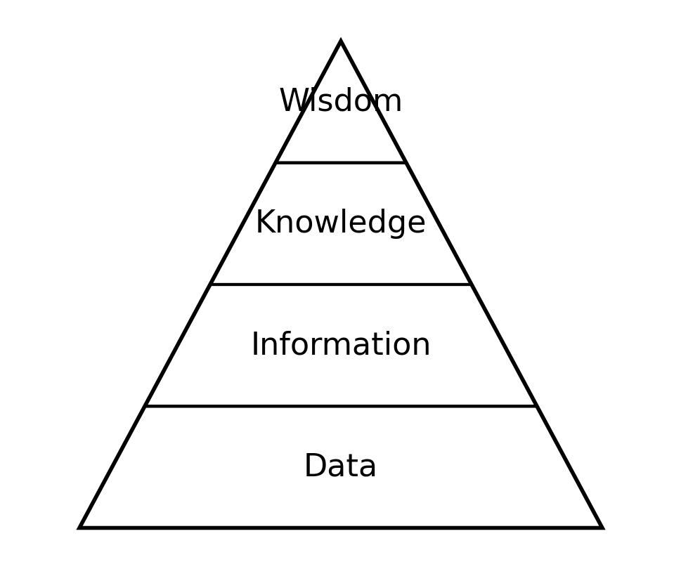
Figure 1: DIKW model
Adapted from Ackoff (1989).
Another important distinction is between tacit and explicit knowledge. Explicit knowledge can be written down, stored and shared, such as guidance, procedures, training materials and case notes. Tacit knowledge is harder to capture because it comes from experience, practice and judgement (Nonaka & Takeuchi, 1995). In HMRC, tacit knowledge may include knowing how to explain complex rules, handle difficult customer contact, or recognise when a case needs further review.
Individual knowledge is held by employees, while organisational knowledge is captured in systems, guidance, records, training and procedures. This matters because HMRC cannot depend only on what individual staff know. If useful knowledge remains only with experienced staff, it may be lost when they move roles or leave. Effective knowledge management should therefore connect individual and organisational knowledge by capturing useful experience through mentoring, team briefings, updated guidance and knowledge articles.
Overall, knowledge management turns information into practical workplace value. In HMRC, it supports accuracy, consistency, efficiency, compliance, customer service and organisational learning. The challenge is not simply to collect more information. It is to manage knowledge so staff can find it, trust it and apply it correctly while protecting confidentiality and public trust.

2. Current Workplace Knowledge Position
HMRC’s work depends heavily on knowledge. In customer and compliance casework, staff use guidance, records, professional judgement and experience to decide what action is appropriate. This makes HMRC a knowledge-intensive workplace, where service quality depends on how well knowledge is managed.
One major knowledge asset is formal organisational guidance, including internal procedures, legislation, policy instructions, training materials and standard processes. These are forms of explicit knowledge because they are written down and shared. Explicit knowledge supports consistency by helping staff follow the same rules, apply the same standards and explain decisions clearly. This reduces reliance on informal habits or personal interpretation alone.
A second knowledge asset is customer and case information. This includes customer records, previous contacts, payment details, case notes, correspondence and action history. It helps staff understand the background of a case rather than treating each interaction as isolated. When records are accurate, they support better decisions. If they are incomplete or outdated, staff may waste time checking details or make weaker decisions. This shows that knowledge quality matters as much as availability.
A third important asset is staff experience. Experienced staff often hold practical knowledge that is not fully captured in formal guidance. This may include knowing how to explain complex rules, identify common errors, manage difficult conversations, or recognise when a case needs review. This is tacit knowledge because it is built through practice and is harder to write down fully (Nonaka & Takeuchi, 1995). From a resource-based view, knowledge can become a valuable organisational asset when it supports performance and is difficult for others to copy (Barney, 1991).
Training and mentoring are also knowledge assets. Formal training gives staff the basic knowledge needed for their role. Mentoring, shadowing and team support help staff apply that knowledge in real situations. This matters because written guidance alone does not explain every workplace judgement. Polanyi’s (1966) view that people know more than they can fully explain helps show why staff experience is difficult to capture completely.
Performance information is another key asset. HMRC can use data on call handling, case progression, accuracy, customer feedback, training completion and error rates to understand how well knowledge is being used. When interpreted properly, this can show where staff need support, where guidance is unclear, or where processes cause delays. This links to the DIKW model because raw data only becomes useful when it is organised, interpreted and used to improve action (Ackoff, 1989).
Overall, HMRC has strong knowledge assets, but their value depends on how effectively they work together. Formal guidance gives structure. Customer records give context. Staff experience gives practical insight. Training supports learning. Performance data helps identify gaps. If these are disconnected, knowledge becomes fragmented and harder to apply confidently. The strategic challenge is therefore to keep knowledge accurate, current, accessible, secure and usable. A stronger knowledge management approach would help HMRC capture staff experience, improve consistency, reduce repeated errors and support better service delivery.

3. Current Systems for Storing and Using Information
HMRC relies on several information systems to collect, store and use workplace knowledge. These systems matter because knowledge management depends on people, processes and technology working together. Information systems help organisations gather, maintain, analyse and distribute data to improve workflow and decision-making (Laudon & Laudon, 2020). In HMRC, they help staff access customer information, apply guidance, record actions and monitor performance. Alavi and Leidner (2001) argue that knowledge management systems support the creation, storage, retrieval, transfer and application of organisational knowledge.
One key system is the customer and case management system. This stores customer records, case notes, contact history, actions taken and relevant case information. It acts as a central source of information for staff handling customer or compliance work. When records are complete and accurate, staff can understand the history of a case and avoid asking the customer for the same information repeatedly. However, the system depends on the quality of information entered by staff. If case notes are unclear or incomplete, the system may store information but still fail to support effective knowledge use.
HMRC also uses internal guidance platforms. These contain rules, procedures, policy instructions and operational guidance. This is a major form of explicit organisational knowledge because it is written down and available to staff. Internal guidance helps staff apply rules consistently and reduces dependence on informal interpretation. However, guidance must be easy to search, clearly written and regularly updated. If staff struggle to find the correct guidance quickly, knowledge exists but is not fully usable.
Training systems store e-learning, induction materials, role-specific training and compliance learning. These systems help convert organisational knowledge into staff capability, especially for new staff. They also support accountability because completion can be tracked. However, training alone is not enough. Staff may complete modules but still need mentoring, feedback and examples to understand how knowledge applies in real cases.
HMRC also uses performance and management information systems. These may track call handling, case progression, accuracy, workloads, response times, training completion and customer feedback. Such information can help managers identify knowledge gaps and operational problems. Repeated errors in one area may show that guidance is unclear or that staff need extra support. This reflects the value of management information systems, which turn operational data into useful information for decision-making (Laudon & Laudon, 2020). The risk is that performance data may be used too narrowly if it focuses only on speed or volume rather than quality and learning.
Communication tools such as email, Teams meetings, team briefings and shared updates also support knowledge sharing. They allow staff to ask questions, share updates and discuss common issues. However, informal communication can create problems if important updates are not captured properly. Knowledge shared in a meeting or chat may be lost unless it is recorded in an accessible system.
Overall, HMRC has a strong base of information systems, including case management records, guidance platforms, training systems, performance dashboards and communication tools. The main issue is not simply whether systems exist, but whether they are integrated, reliable and easy to use. These systems must help staff find, trust and apply the right knowledge at the right time. A stronger knowledge management plan should therefore focus on record quality, guidance access, knowledge sharing and feedback between systems.

4. Business Case for Collecting and Distributing Knowledge
A strong business case for knowledge management in HMRC is based on the need to improve accuracy, consistency, efficiency and public trust. HMRC handles large amounts of customer, tax and casework information, but this only creates value when it is organised, interpreted and applied correctly. Davenport and Prusak (1998) argue that knowledge becomes useful when it supports action. For HMRC, knowledge should help staff answer queries, progress cases, apply guidance and make reliable decisions. Wiig (1993) also argues that knowledge must be organised and made usable if it is to support effective action.
The first business benefit is consistency. HMRC staff often deal with similar issues across different customers and cases. If staff rely only on individual interpretation, decisions and explanations may vary. Shared guidance, standard procedures, knowledge articles and team updates reduce this risk by helping staff apply the same rules consistently while still using judgement where circumstances differ.
The second benefit is efficiency. Poor knowledge management can lead to repeated questions, duplicated work and slower case handling. Staff may spend unnecessary time searching for guidance, checking with colleagues or correcting errors. A well-managed knowledge system reduces this waste by making reliable information easier to find and use. This supports the view that knowledge management improves performance by helping employees access and apply what the organisation already knows (Hislop et al., 2018).
Knowledge management also supports staff learning. Much useful workplace knowledge is tacit and developed through practice. In HMRC, this may include knowing how to explain complex information, recognise common errors or deal with difficult customer contact. If this knowledge is not shared, newer staff may take longer to develop confidence. Nonaka and Takeuchi (1995) argue that organisations create knowledge when tacit knowledge is converted into explicit forms. This supports mentoring, team discussions, knowledge articles and lessons learned from casework.
A further business benefit is risk reduction. HMRC handles sensitive personal and financial information, so knowledge must be managed securely. Poor knowledge distribution can create risks if staff use outdated guidance, access information they do not need, or fail to record decisions properly. Better knowledge management supports confidentiality, integrity and availability by keeping information accurate, protected and available only to authorised staff.
Knowledge management also improves service quality. Customers benefit when staff can access accurate guidance quickly and explain matters clearly. Good knowledge management reduces inconsistent answers and improves customer contact. It also supports case progression because staff can understand previous actions and avoid repeating work.
However, the business case should recognise limitations. Collecting more knowledge does not automatically improve performance. Too much information can create overload if systems are difficult to search or guidance is unclear. Knowledge can also become outdated if it is not reviewed regularly. HMRC therefore needs knowledge governance, not just knowledge sharing. Knowledge should be current, relevant, easy to access and clearly owned by responsible teams.
Overall, the business case is strong because knowledge management supports HMRC’s core responsibilities. It can improve consistency, reduce errors, support staff learning, protect sensitive information and improve service quality. The strategic aim should be to move from storing information to actively managing knowledge as a workplace asset.

5. Strategic Knowledge Management Culture Framework
A strategic knowledge management culture in HMRC should focus on how knowledge is created, shared, stored, protected and applied in daily work. It is not created only by digital systems. It also depends on staff behaviour, leadership, training, trust and clear routines for sharing learning. Senge (2006) argues that learning organisations develop when people learn continuously, reflect on practice and improve together. This matters in HMRC because staff need both formal guidance and practical learning to handle customer and casework issues well.
The first priority is capturing tacit knowledge. In HMRC, this may include knowing how to explain complex rules, manage difficult customer contact, interpret guidance in unusual cases, or recognise common errors. This knowledge supports judgement, but it can be lost when experienced staff leave, move teams or are unavailable. Nonaka and Takeuchi (1995) argue that organisations need to convert tacit knowledge into explicit knowledge so it can be shared more widely. HMRC therefore needs regular ways for experienced staff to share practical lessons.
This could be done through team briefings, mentoring, case discussions and short “lessons learned” notes. These activities would help staff understand how guidance works in real situations. Where a common customer issue keeps appearing, the team could record the issue, the correct process, the common mistake and the recommended response. This would help newer staff learn faster and make workplace knowledge less dependent on individuals.
The second priority is stronger use of explicit knowledge, including written guidance, procedures, training materials, knowledge articles, case notes and policy updates. Davenport and Prusak (1998) argue that knowledge has little value if people cannot access and use it when needed. In HMRC, outdated or hard-to-find guidance can slow staff down and increase inconsistency. The strategic plan should include regular review of knowledge articles, clear ownership of guidance areas and simple routes for staff to report unclear content.
The SECI model in Figure 2 provides a useful structure. Socialisation happens when staff share tacit knowledge through discussion, mentoring and shadowing. Externalisation happens when practical knowledge is written down in guidance notes, FAQs or case examples. Combination happens when explicit knowledge is brought together, such as guidance, performance data and customer feedback. Internalisation happens when staff apply this knowledge through training, casework and reflection (Nonaka, 1994). This shows that knowledge management is a cycle, not a one-off activity.
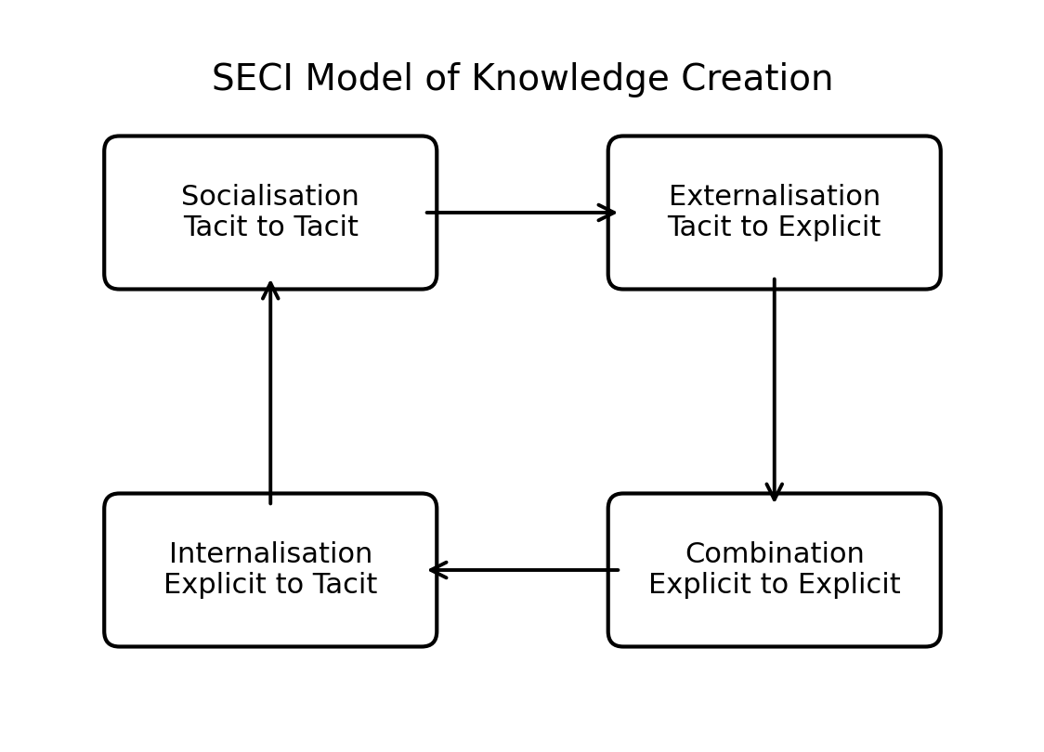
Figure 2: SECI Model of Knowledge Creation
Adapted from Nonaka (1994).
Leadership is also important. Managers and team leaders should encourage learning rather than blame. If staff fear criticism, they may avoid asking questions or sharing mistakes. Team leaders should therefore promote safe discussion of errors, common issues and improvements. Hislop et al. (2018) suggest that knowledge sharing depends on culture and trust, not only on technology.
The framework also needs feedback loops. HMRC already holds performance information, such as accuracy issues, call outcomes, training completion, customer feedback and case progression data. This should be used to identify knowledge gaps. If many staff make the same error, the issue may be unclear guidance, weak training or a process problem. Using performance data in this way supports continuous improvement.
Knowledge governance is also required. HMRC handles sensitive personal and financial information, so knowledge must be shared carefully. Staff should only access information needed for their role. Guidance and knowledge articles should be accurate, approved and reviewed. Foss (2007) explains knowledge governance as policies and practices that ensure knowledge is managed and used responsibly. Poor knowledge sharing can create risks around confidentiality, accuracy and misuse of information.
Overall, the framework should combine people, processes and technology. People share experience and judgement. Processes ensure knowledge is captured, reviewed and applied. Technology stores knowledge and makes it accessible. The aim is to build a culture where useful knowledge is shared, trusted, protected and used to improve service quality. This should be supported through refresher training, coaching, peer learning and guidance updates. For HMRC, it would support more consistent decisions, stronger staff confidence, faster learning and better protection of public information.

6. KPIs and Business Information Needs
KPIs are needed to show whether knowledge management is improving workplace performance. Without measurement, HMRC may store information without knowing whether it is useful, accurate or applied properly. KPIs connect knowledge management to outcomes such as accuracy, efficiency, staff learning, customer service and compliance.
HMRC also needs clear business information to operate effectively. This includes customer records, case history, contact notes, payment information, policy guidance, training data, performance data and security information. Such information helps staff understand customer circumstances, apply guidance correctly and identify trends such as repeated errors, delays or unclear guidance.
The KPI table below follows the required structure.
Table 1: Workplace KPIs for Knowledge Management in HMRC
Information system | Trackable element | KPI name | KPI description | Target value
Case management system | Case note quality | Case note accuracy rate | Measures the percentage of case notes that meet required quality and completeness standards | 90% accuracy
KMS / guidance platform | Knowledge access | Guidance retrieval time | Measures how quickly staff can locate relevant guidance for common queries or case actions | Under 3 minutes
KMS / guidance platform | Knowledge quality | Updated guidance rate | Measures the percentage of key guidance reviewed and updated within the required review period | 95% reviewed on time
Training system | Staff learning | Mandatory knowledge training completion | Measures the percentage of staff completing required knowledge, compliance and system training | 100% completion
Performance dashboard / MIS | Operational learning | Repeated error reduction | Measures reduction in repeated errors linked to unclear guidance or knowledge gaps | 15% reduction
CRM / customer contact system | Customer service quality | First contact resolution rate | Measures the percentage of customer queries resolved without unnecessary repeat contact | 75% resolution
KMS / team learning records | Knowledge sharing | Lessons learned submissions | Measures how many useful lessons, updates or case learning points are recorded and shared monthly | 5 per month
Security/access system | Information protection | Access compliance rate | Measures whether staff access only the information required for their role | 98% compliant

These KPIs measure whether knowledge is helping staff work better, not just whether activity is taking place. Guidance retrieval time shows whether stored knowledge is accessible. Case note accuracy shows whether staff record knowledge properly. Repeated error reduction shows whether the organisation is learning from mistakes. This links with the view that performance information should support organisational learning, not only control (Laudon & Laudon, 2020).
However, KPIs must be used carefully. If HMRC measures only speed, staff may prioritise quick handling over accuracy. If it measures only training completion, it may miss whether staff can apply what they have learned. The KPI framework should therefore balance efficiency, quality, learning and security.

7. Protection, Governance and Ethical Management of Information
Information protection is central to knowledge management in HMRC because the organisation handles sensitive personal, financial and casework information. Knowledge must be shared enough to support effective work, but it must also be controlled carefully. This requires protection of confidentiality, integrity and availability. Information should only be accessed by authorised staff, remain accurate and complete, and be available for legitimate work purposes.
Confidentiality means protecting information from unauthorised access or disclosure. In HMRC, this is essential because staff work with taxpayer details, payment information, correspondence and case records. Careless disclosure can harm individuals, damage public trust and create legal risk. GDPR requires personal data to be processed lawfully, fairly and securely, with appropriate limits on access and use (ICO, 2024). Staff should therefore only access information needed for their role, supported by access controls, passwords, audit trails and clear handling procedures.
Integrity means keeping information accurate, complete and reliable. Poor-quality information can lead to weak decisions. Unclear case notes, outdated guidance or inaccurate customer records may cause delays, repeated contact or inconsistent treatment. HMRC should therefore maintain clear standards for record keeping, guidance updates and case note quality. Foss (2007) links knowledge governance to policies and practices that ensure knowledge is accurate, accessible and used responsibly.
Availability means staff can access the right information when needed. Knowledge that is secure but difficult to find has limited value. Staff need reliable access to guidance, case records, training materials and updates. However, not every member of staff needs access to every type of information. A strong knowledge management system should therefore balance access with restriction.
Ethical management is also important. Knowledge should not be used unfairly, carelessly or outside its proper purpose. In HMRC, ethical knowledge use means respecting privacy, applying guidance consistently, recording decisions honestly and avoiding misuse of customer information. Nolas (2007) argues that ethics in knowledge management concerns how knowledge is created, shared and used.
Governance should therefore be built into the plan through clear policies, staff training, access controls, retention rules, breach reporting and regular review of knowledge assets. Overall, information protection is not separate from knowledge management. HMRC needs knowledge to be useful, lawful, accurate and secure. A strong governance approach would help staff use knowledge confidently while protecting taxpayers, supporting compliance and maintaining public trust.

Conclusion
This report has presented a strategic plan for the collection, storage and implementation of knowledge within HMRC customer and compliance casework. It has shown that knowledge management is important because HMRC depends on accurate information, secure systems, staff expertise, internal guidance and clear decision-making. In this context, knowledge is not only something that is stored. It must be understood, shared and applied correctly.
The report has argued that HMRC already holds strong knowledge assets, including customer records, case notes, policy guidance, training materials, performance data and staff experience. However, these assets only create value when they are accurate, current, accessible and protected. The main strategic challenge is therefore to connect individual knowledge with organisational knowledge by capturing useful staff experience, improving access to guidance, strengthening training and using performance data to identify knowledge gaps.
The proposed framework focuses on people, processes and technology. It recommends better sharing of tacit knowledge, clearer ownership of explicit knowledge, regular review of guidance, stronger feedback loops and balanced KPIs. These actions would support accuracy, consistency, efficiency, customer service and organisational learning. At the same time, the plan recognises that knowledge sharing must be governed carefully because HMRC handles sensitive personal and financial information.
Overall, effective knowledge management would help HMRC move beyond simply storing information. It would support better decisions, reduce repeated errors, improve staff confidence and protect public trust. The strongest priority is to develop a knowledge culture where information is reliable, knowledge is shared responsibly, and staff are supported to apply it well in daily work.

References
Ackoff, R. L. (1989). From data to wisdom. Journal of Applied Systems Analysis, 16(1), 3–9.
Alavi, M., & Leidner, D. E. (2001). Review: Knowledge management and knowledge management systems. MIS Quarterly, 25(1), 107–136.
Barney, J. (1991). Firm resources and sustained competitive advantage. Journal of Management, 17(1), 99–120.
Choo, C. W. (1998). The knowing organization: How organizations use information to construct meaning, create knowledge, and make decisions. Oxford University Press.
Davenport, T. H., & Prusak, L. (1998). Working knowledge: How organizations manage what they know. Harvard Business School Press.
Foss, N. J. (2007). Knowledge governance: Processes and structures. Academy of Management Review, 32(1), 348–351.
Hislop, D., Bosua, R., & Helms, R. (2018). Knowledge management in organizations: A critical introduction (4th ed.). Oxford University Press.
Information Commissioner’s Office. (2024). UK GDPR guidance and resources. https://ico.org.uk/for-organisations/uk-gdpr-guidance-and-resources/
Laudon, K. C., & Laudon, J. P. (2020). Management information systems: Managing the digital firm (16th ed.). Pearson.
Nonaka, I. (1994). A dynamic theory of organizational knowledge creation. Organization Science, 5(1), 14–37.
Nonaka, I., & Takeuchi, H. (1995). The knowledge-creating company: How Japanese companies create the dynamics of innovation. Oxford University Press.
Nolas, S.-M. (2007). The ethics of knowledge management. International Journal of Knowledge Management, 3(1), 1–9.
Polanyi, M. (1966). The tacit dimension. University of Chicago Press.
Senge, P. M. (2006). The fifth discipline: The art and practice of the learning organization (Rev. ed.). Doubleday.
Wiig, K. M. (1993). Knowledge management foundations: Thinking about thinking: How people and organizations create, represent, and use knowledge. Schema Press.

