

LCBB4003
Introducing the Modern Workplace

Assessment 1 – Organisational Structure & Culture

Lecturer: Dr. Anupam Mazumdar

Student Name- Cezar-Daniel Totora
Student ID- 2028347@student.uwtsd.ac.uk

Table of Contents
Introduction 3
An overview of “Amazon” 4
1. Influence of “Amazon” structure, cultures, and behaviour have in its 44% sales and 220% profit increase in the first quarter of 2021. 5
2. Various factors that influence individual behaviour towards “Amazon” and their mammoth sales and profit 9
Conclusion 12
References 13

Introduction
Businesses must employ a variety of criteria to sway general shoppers toward a brand in order to succeed in online purchasing. These aspects also contribute to the company's sales and total profit generating. Although many businesses experience massive losses, some businesses such as “Amazon” experience massive increases in sales and profit. “Amazon” is expecting that its growth will continue since the global delivery network will increase a couple of times more in the next few quarters. This report will discuss the influence of “Amazon” structure, culture and behaviour on its massive jump in sales and profit. It will also include individual behaviour towards “Amazon” mammoth sales and profit (Sadq, et al, 2018).

An overview of “Amazon”
In terms of market capital “Amazon” is one of the top five companies in the world. It was founded in 1994 by Jeff Bezos in Washington DC, USA. “Amazon” is doing business worldwide with its different ventures such as – “Amazon Prime”, “Amazon.com” etc. “Amazon” has an employee base of over 1.5 million worldwide and its biggest campus is located in India (Klaus, 2013).

Figure: Official logo of “Amazon” (Koo, et al, 2017).
Mission
To offer a vast range of products at the lowest price possible.
Vision
To become the fastest delivery company in the world

1. Influence of “Amazon” structure, cultures, and behaviour has in its 44% sales and 220% profit increase in the first quarter of 2021.
Every business develops its own strategies according to its organizational structure, and customer behaviour that fits with all of these three criteria’s. Because, the strategies those companies will develop, need to support by these factors. If one factor does not support that then the whole strategy might end up losing the company millions of dollars. “Amazon” also develops such strategies that support its organizational structure and culture and its target customers take it positively. This strategy of “Amazon” supports the company to achieve a 44% increase in sales and a 220% increase in profit in the first three months of 2021 (Lee, et al, 2018).
The strategy that “Amazon” follows contains three factors and these factors are –
- Lower price;
- Fastest delivery;
- The vast range of product selection.
Now, how these three strategies of “Amazon” support the company to achieve a 44% increase in sales and 220% increase in profit are described below –
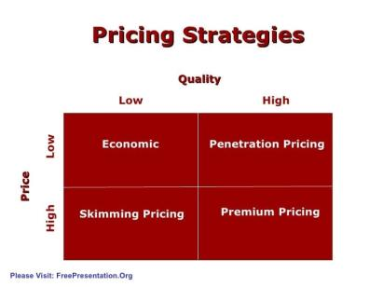
Figure: Pricing strategy (Schultz, et al, 2015).
Lower price
During the pandemic time, almost all types of businesses were standstill and many people lose their jobs which forces people to search for options that offer a lower price in products. “Amazon” is very little company that offers top quality products at a very lower price (Castelli, et al, 2017).
“Amazon” lower pricing strategy and the economic condition of people match the moment and general customers jumped into “Amazon” products and it increases “Amazon” business and results in a 44% increase in sales and 220% increase in profit (Heng, et al, 2018). Furthermore, people are drawn to the brand by "Amazon's" quick delivery method and affordable costs. "Amazon" has also built a strong organisational structure and culture to support this large product range and provide consumers with their chosen items (Klaus, 2013).
Another reason for “Amazon” mammoth increase in sales and profit is it offers in different festive seasons. For example, “Amazon” has a massive market share in the Indian market and during the festive season in India, “Amazon” offers massive discounts products that attract customers. In some products “Amazon” even provides over 50% off discounts which attracts customers like crazy (Javadi, et al, 2012).
People start buying when they get these massive discounts and they buy more products for the lower price of “Amazon”. All these actions support “Amazon” to increase its sales 44% and profit up to 220% in the first three months of 2021 and “Amazon” is expecting that at the end of 2021 “Amazon” will do record number of businesses and its sales will increase in future as well because people are getting normal with online shopping (Lim, et al, 2016).
Fastest delivery
Another reason for “Amazon” massive increase in sales and profit is its fastest delivery techniques. “Amazon” is committed to delivering products within 24 hours and in some cases “Amazon” offers 3 hours delivery options that other online shopping sites can’t provide. This attracts more customers towards “Amazon” (Jusoh, et al, 2012).
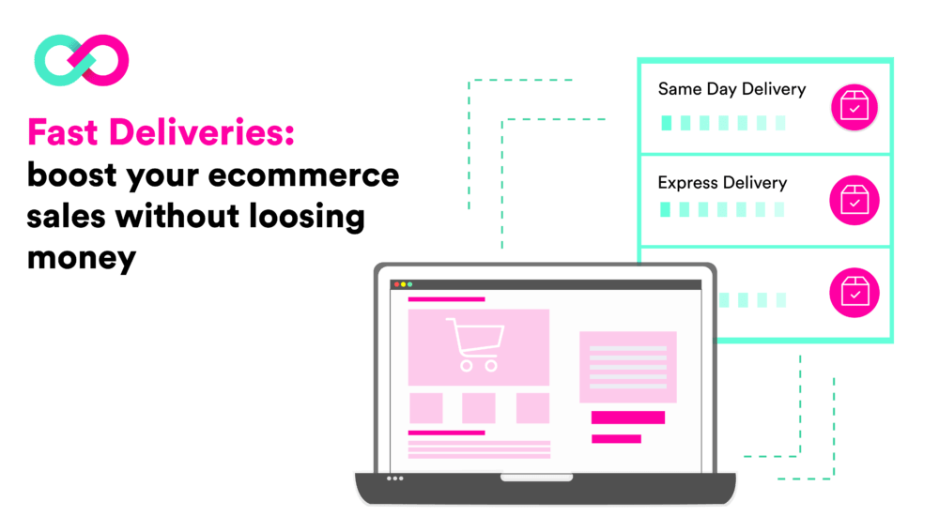
Figure: Fast delivery system (Lee, et al, 2018).
Delivering products quickly is not an easy task. For that companies need to create a proper organizational structure and culture that supports the fastest delivery system. “Amazon” is very successful in the development of such organizational structure and culture that fulfil customer’s preference of fastest delivery (Klaus, 2013). In general, internet companies provide consumers with a wide choice of product alternatives; however "Amazon" provides more product possibilities than its rivals, giving the firm a competitive advantage over its competitors. Millions of small and medium-sized companies collaborate with "Amazon," allowing "Amazon" to provide a large product variety to consumers. Every year, millions of new vendors join "Amazon" (Koo, et al, 2017).
“Amazon” is also planning to provide 1-hour delivery services with the help of drone technology and if “Amazon” makes this possible then its sales will increase dramatically and it will gain massive market share over its competitors. In the current online market, general customers prefer the fastest delivery and most of the competitors of “Amazon” are not able to provide this service. That’s why customers are preferring “Amazon” over its competitors and it increase “Amazon” sales by 44% and profit by 220% in just three months of 2021 (Sadq, et al, 2018).
Fastest delivery is not the only reason behind “Amazon” massive increase in sales and profit. “Amazon” always ensure that customers get the right products at the right time. Take the example of India. In the Indian market, there are many online companies that are working currently and many customers companied that they do not get the product that they were ordering which creates trust issues for those companies. But “Amazon” is always focused on this fact and ensure that customer gets the right product that he or she orders. This move of “Amazon” increase customer satisfaction and increase its sales and profit (Schultz, et al, 2015).

A vast range of product selection
Generally, online businesses offer a huge range of product options to the customers but “Amazon” offer more products options than its competitors which gives the company a better competitive edge compared to its competitors. Millions of small and medium-sized businesses work with “Amazon” which give “Amazon” the flexibility to offer massive product selection offering to the customers and every year millions of new vendors is added with “Amazon” (Koo, et al, 2017).
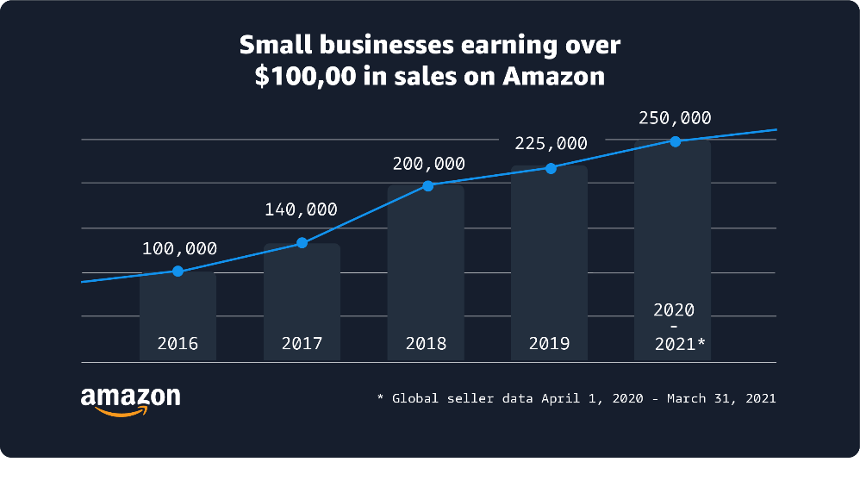
Figure: Small and medium businesses that do business with “Amazon” (Jusoh, et al, 2012).
“Amazon” has products for every type of customer that its competitors don’t have. Customers of every age, gender, profession, and choice will get their preferred products on “Amazon”. Moreover, “Amazon” fast delivery system and lower prices attract customers towards the brand. “Amazon” also develop such a strong organizational structure and culture that support this massive product line and satisfy the customers with their preferred products (Klaus, 2013).

2. Various factors that influence individual behaviour towards “Amazon” and their mammoth sales and profit
To gain success in online shopping, businesses need to use different factors that influence general customers towards the brand. These factors also contribute to sales and overall profit generation of the company. “Amazon” follows different factors to influence customers towards the brand and increase their overall sales and profit. Factors that “Amazon” use to influence individual behaviour towards the brand are discussed below –
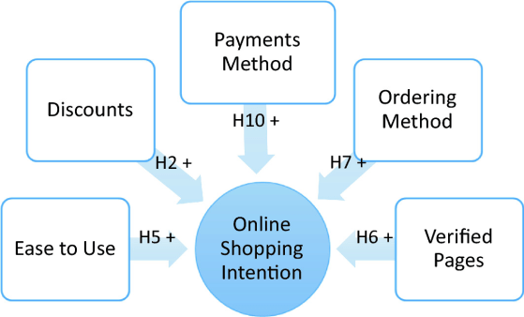
Figure: Factors that influence individual behaviour towards online shopping (Sadq, et al, 2018).
Ease of use
The first thing that influences an individual’s behaviour in online shopping is the ease of usage of the site. When customers feel that the site is difficult to use, they subconsciously move to other sites. “Amazon” understands this behaviour of customers very well and develops its site in such a way that customers can easily get their preferred items (Schultz, et al, 2015).
Besides, the artificial intelligence of the “Amazon” site is so advanced that it can recommend customers products that they may like based on their previous search. All these factors make the website of “Amazon” so satisfying that customers visit their site every time and order their preferable items which results in a massive improvement in sales of 44% and profit of 220%. “Amazon” is still working on how they can make the site more user friendly and give customers the best experience in their online shopping (Lee, et al, 2018).
Security
Security is a concerning issue in online shopping since customers provide their sensitive information such as – bank account detail, address, credit card detail to the online websites. If they do not maintain the security properly then it might be a disaster for the customers. That’s why “Amazon” develops their own data storage system where they store all sensitive information of its customers and “Amazon” is very committed to ensuring the security of its customer's data (Schultz, et al, 2015).
Product presentation
Customers do not get the option to check the product by themselves like physical shopping in online shopping. That’s why customers prefer high-quality images and proper descriptions of products. Most online shopping websites can’t ensure all that and because of that, they lose customers trust. But “Amazon” is very aware of that and ensures that the pictures that “Amazon” uploads are high quality and contains proper detail on them (Klaus, 2013).
Besides, “Amazon” also creates options for customers to put the review any products based on their experience on that product. Every company creates its own strategy based on its organisational structure and consumer behaviour that meet all three requirements because these variables are required to support the plans that those firms will design. If one aspect fails to support this, the whole plan might result in the corporation losing millions of dollars. This helps customers to make better decisions and force the sellers to increase the quality of their products as well. This way “Amazon” increase customers trust in their business (Sadq, et al, 2018).
Shopping time and cost
Another reason why people prefer online shopping over offline shopping is in online shopping they can save time and money. Besides, online shopping gives them the flexibility to shop any time that physical stores can’t provide. To reduce customer’s time on shopping “Amazon” use artificial intelligence which recommends customers products based on their previous purchases. This saves customers lots of time and “Amazon” also has options to choose price options that support customers to save money as well (Koo, et al, 2017).

Trust signals and transparency
Most of the online shopping websites have trust issues and lack transparency on product information and customers do not get the chance to contract with the producer directly. This creates trust issues and “Amazon” focuses on this factor. Almost all sorts of enterprises came to a halt during the epidemic, and many individuals lost their employment, forcing consumers to look for alternatives that provide reduced product prices. "Amazon" is a small corporation that sells high-quality things at a cheap cost (Castelli, et al, 2017).
For example, "Amazon" has a huge market share in India, and during the festival season, "Amazon" gives huge discounts on items to entice consumers. In certain cases, "Amazon" offers discounts of up to 50% off, which draws buyers like crazy (Javadi, et al, 2012). Products that “Amazon” offers to its customers have every detail about the products and the producers of that product. “Amazon” is also aware that customers might have questions about the product that why “Amazon” has a separate team to answer customer questions and make them satisfied with their purchases (Schultz, et al, 2015).

Conclusion
The global delivery market will surpass 350 billion dollars by the end of next year and “Amazon” will be a major player in this segment. “Amazon” should improve its delivery quality and try to provide delivery services faster than ever and offer more products to the customers so that “Amazon” can target every age’s customer. It's not simple to provide items rapidly. Companies must build an organisational structure and culture that promotes the quickest delivery mechanism in order to achieve this. Besides, “Amazon” need to provide customers with more product knowledge so that their buying decision improves and the overall sales and profit of “Amazon” increase more and more (Lee, et al, 2018).

References
Castelli, M., Manzoni, L., Vanneschi, L. and Popovič, A., 2017. An expert system for extracting knowledge from customers’ reviews: The case of amazon. com, inc. Expert Systems with Applications, 84, pp.117-126.
Heng, Y., Gao, Z., Jiang, Y. and Chen, X., 2018. Exploring hidden factors behind online food shopping from Amazon reviews: A topic mining approach. Journal of Retailing and Consumer Services, 42, pp.161-168.
Javadi, M.H.M., Dolatabadi, H.R., Nourbakhsh, M., Poursaeedi, A. and Asadollahi, A.R., 2012. An analysis of factors affecting on online shopping behavior of consumers. International journal of marketing studies, 4(5), p.81.
Jusoh, Z.M. and Ling, G.H., 2012. Factors influencing consumers’ attitude towards e-commerce purchases through online shopping. International Journal of Humanities and Social Science, 2(4), pp.223-230.
Klaus, P., 2013. The case of Amazon. com: towards a conceptual framework of online customer service experience (OCSE) using the emerging consensus technique (ECT). Journal of Services Marketing. Mejbah
Koo, W. and Park, H., 2017. Critical atmospheric cues in designing online stores: the case of Amazon. com. International Journal of Marketing Studies, 9(1), pp.37-45.
Lee, S.G., Trimi, S. and Yang, C.G., 2018. Perceived usefulness factors of online reviews: a study of Amazon. com. Journal of computer information systems, 58(4), pp.344-352.
Lim, Y.J., Osman, A., Salahuddin, S.N., Romle, A.R. and Abdullah, S., 2016. Factors influencing online shopping behavior: the mediating role of purchase intention. Procedia economics and finance, 35, pp.401-410.
Sadq, Z.M., Sabir, H.N. and Saeed, V.S.H., 2018. Analyzing the Amazon success strategies. Journal of process management. New Technologies, 6(4).
Schultz, D.E. and Block, M.P., 2015. US online shopping: Facts, fiction, hopes and dreams. Journal of Retailing and Consumer Services, 23, pp.99-106.

