

Module Name: Academic Skills in the Digital Era
Module Code: BMSW4013
Assessment 1: E-Portfolio
Student Name: Amina Constantin
Student Number:2513615
Lecturer: Scott James
Deadline: Friday 21st November 23:59PM

AI Acknowledgement
I confirm that I have not presented any AI generated materials as my own work.
I confirm that I have copies of my drafts, notes, and other resources I used, which I may be asked to provide in evidence.

Contents
Component 1 – Research and Planning Template 4
Source Exploration 4
Key Challenge for Students 4
Key Opportunity for Students 4
Planning Your Report 5
Component 2 – Answering the Question 6
Introduction 6
Challenges Students Face 6
Opportunities Digital Tools Provide 6
How Students Can Adapt 7
Conclusion 7
Component 3 – Reflective Presentation 9
Slide 1 (Overview) 9
Slide 2 (Research) 10
Slide 3 (Planning & Writing) 11
Slide 4 (Challenges) 12
Slide 5 (Successes) 13
Reference List 14

Component 1 – Research and Planning Template

Source Exploration
The book that I choose is titled The Study Skills Handbook 6th edition by Stella Cottrell published by Bloomsbury Academic in the UK in 2024 , is a comprehensive, practical book designed to help students at all levels to develop the essential skills that they need to develop at university, and to help them build confidence.
The main point related to digital tools in The Study Skills Handbook is: students need to be able to effectively leverage new technologies for online, hybrid, or distance learning, and to develop collaborative skills in a digital environment. For example, students can work together using online platforms for learning.
I choose this book The Study Skills Handbook because it is recent, and directly covers both sides of the main question (challenges and opportunities) as it is applicable to the students in the higher education of the digital era. I have use the 5w’s to find out more about the author of the book.
This book will assist me in answering the key question as it will be able to provide evidence of what the students encounter (the challenges) and what they can obtain (the opportunities), and this also contribute to strategies in my report.

Key Challenge for Students
One of the major challenges that students experience in using digital tools is wellbeing and time management Cottrell (2024). Navigating to modern life students can face a variety of pressure. Wellbeing and managing their time is a challenge that students face using digital tools. Any aspect of wellbeing can impact capacity to learn leading to stress, anxiety , and resilience.
I personally think that this challenge wellbeing is very important especially when you face a technical issue like outdated system or even glitches it can very stressful and lead to delay of learning. The fact that students can’t control their own wellbeing is a significant obstacle and a key challenge that can lead to procrastination, and even lose interest. In my experience, studying through online mediums, it is difficult not to open numerous tabs, visit social media, or put off work since the classroom organisation is lacking (Voronkova et al., 2023). This issue is significant, since despite the promises of digital tools being free and easy, when students have no control over their time, attention, and effort, the advantages will not be achieved. Another challenge that student face using digital tools is managing online distractions. The digital environment ,while offering many learning benefits, also presents numerous temptations that can make it hard for students to stay focused, manage time effectively and maintain concentration Cottrell (2024).

Key Opportunity for Students
One of the major benefit offered by the digital tools is enhanced opportunities for collaboration and the ability to access a vast and a range of resources engaging in flexible, personalized learning from almost anywhere Cottrell (2024).Smart technologies permit adjusting to the progress of the students, give feedback, and learn at the own pace.
In my case, the interactive app that is adjusted to my learning pace allowed me to go through the areas where my learning strategies were challenging and aid the ones where I was sure of my understanding this saved me time and enhanced my knowledge (Zhu and Jiang, 2025). I think this is a great opportunity since students can learn at their own pace and not to be limited by the classroom time that suits all students. This flexibility is particularly a plus to the students who may have other commitments (work, family) or have a different learning style.

Planning Your Report
In the case of Component 2, I will also pay equal attention to challenges and opportunities since it is important to get equal attention with both of them to be able to offer effective advice on adaptation.
I will incorporate examples of digital tools adaptive learning and collaboration tools like Microsoft Team, Google calendar.
My report will have the following structure: Introduction, Challenges, Opportunities and How Students Can Adapt, Conclusion.
Timeline:
- Finish research: 30 October 2025
- Draft first section: 14 November 2025
- Complete first draft: 16 November 2025
- Final editing: 21 November 2025

Component 2 – Answering the Question

Introduction
In the 21st century, digital learning has revolutionised the sphere of education. Due to the development of online resources, online classrooms, and artificial intelligence, students now interact with the technology practically in all areas of their studies.
This electronic transformation has brought out some spectacular possibilities as well as great challenges. Although digital tools allow learning to be flexible, personalised, and accessible, they may also cause distraction, access inequalities, and inabilities to self-regulate their own learning. It is important for students to understand both the benefits and difficulties.
Knowing the advantages and the disadvantages of the digital learning is a key to performance of the students in this evolving world. This report will review two principal challenges and two opportunities in the digital era and the propose of 3 viable ways through which students can be able to adjust effectively.

Challenges Students Face
Time Management and Organisation is one of the challenges that many student face. Struggling to maintain balance between workload and personal commitments, we note that attention management is one of the aspects that students cannot manage when they study on their own and this may result in procrastination and reduced productivity.
According to Cottrell (2024) wellbeing can by affected by the pressure of academic responsibility leading to stress ,anxiety and mental health she also mention about the need to build study stamina and concentration and manage stress. Personally, I have experienced that online studying can lead to the use of various tabs and applications, and it can be distracting.
This difficulty is noteworthy since learning cannot be achieved effectively without a long period of concentration, in this case, the understanding and memorisation of information reduce.
An other challenge is disparity in access to technology. Not every student has access to good internet, advanced equipment and a peaceful study environment. Students with low income or in rural settings reported experiencing challenges with taking part in online learning during the pandemic because of limited digital resources (Ismail et al., 2023). This is a problem as it increases the educational gap and excludes some learners to gain the full benefit of digital innovations.

Opportunities Digital Tools Provide
These problems notwithstanding, digital tools generate also potent opportunities, that digital tool provide an flexibility and accessible learning ,giving student access to online platform, breaking down the barriers of time and physical location allowing students to access course material ,e-books, academic journals ,and lectures from almost anywhere, at any time.
Digital tools also facilities the interaction among students and teachers through online forums, discussing board, and collaborative platforms, which in turns helps students develop crucial teamwork skills for their future careers. This increases their motivation and makes the students able to revisit a challenging concept and therefore gain mastery with time.
The second chance is international cooperation and availability of resources. Online databases, video conferencing, and discussion forums are examples of digital tools that can allow students to interact with other students, teachers, and professionals globally. In accordance these tools make learning extend beyond the classroom and expose students to a wide range of ideas (Qolamani and Mohammed, 2023). When responsibly used, they can make students learn to work as a team, communicate, and be digitally literate, which will benefit them in their academic and professional lives.

How Students Can Adapt
In order to adapt and thrive in the digital learning environment, students must consider some of these 3 practical strategies that are easy to practise:
- Apply time management digital applications. Such applications as Notion, Google Calendar assist students in structuring their tasks, creating reminders, and planning dedicated studying time (Thompson, 2021). In order to avoid procrastination, I have use the Pomodoro method and the Eisenhower Matrix that help them to prioritise the tasks .

- Grow into critical digital literacy. Students are to be taught how to assess the information they find online, compare the sources, and apply AI tools wisely. Ng (2022) states that critical analysis of online materials is a way to avoid misinformation and assure academic integrity.

- Make use of online support groups. Being a member of virtual study group or participating in digital skills workshops allow students to be motivated and develop confidence in using new tools. Learning remotely can make a person feel isolated, which can be minimised through collaborative tools, such as Microsoft Teams or Discord communities.
Appling these 3 strategies students can improve their learning using digital tools.

Conclusion
Time management, wellbeing,and unequal access, on the one hand, and personalised learning and collaboration with the rest of the world, on the other hand, are becoming the challenges that many student face.
As a way to adjust, the students are expected to plan their time, create a high level of digital literacy, and participate in online learning communities. The issue of digital adaptation does not only involve being able to use digital tools efficiently, but rather, it is a matter of getting the discipline and critical thinking to employ the tools effectively. With the ever-changing nature of digital learning, the learners who are ready to adopt these skills will stand in the best position to gain academic and career success.

Component 3 – Reflective Presentation

Slide 1 (Overview)
The influence of AI platforms, e-learning applications, and online collaboration on the education process is given. In the discussion, Alenezi (2023) identifies two significant issues, distraction and inequality, and two opportunities, personalisation and global learning.
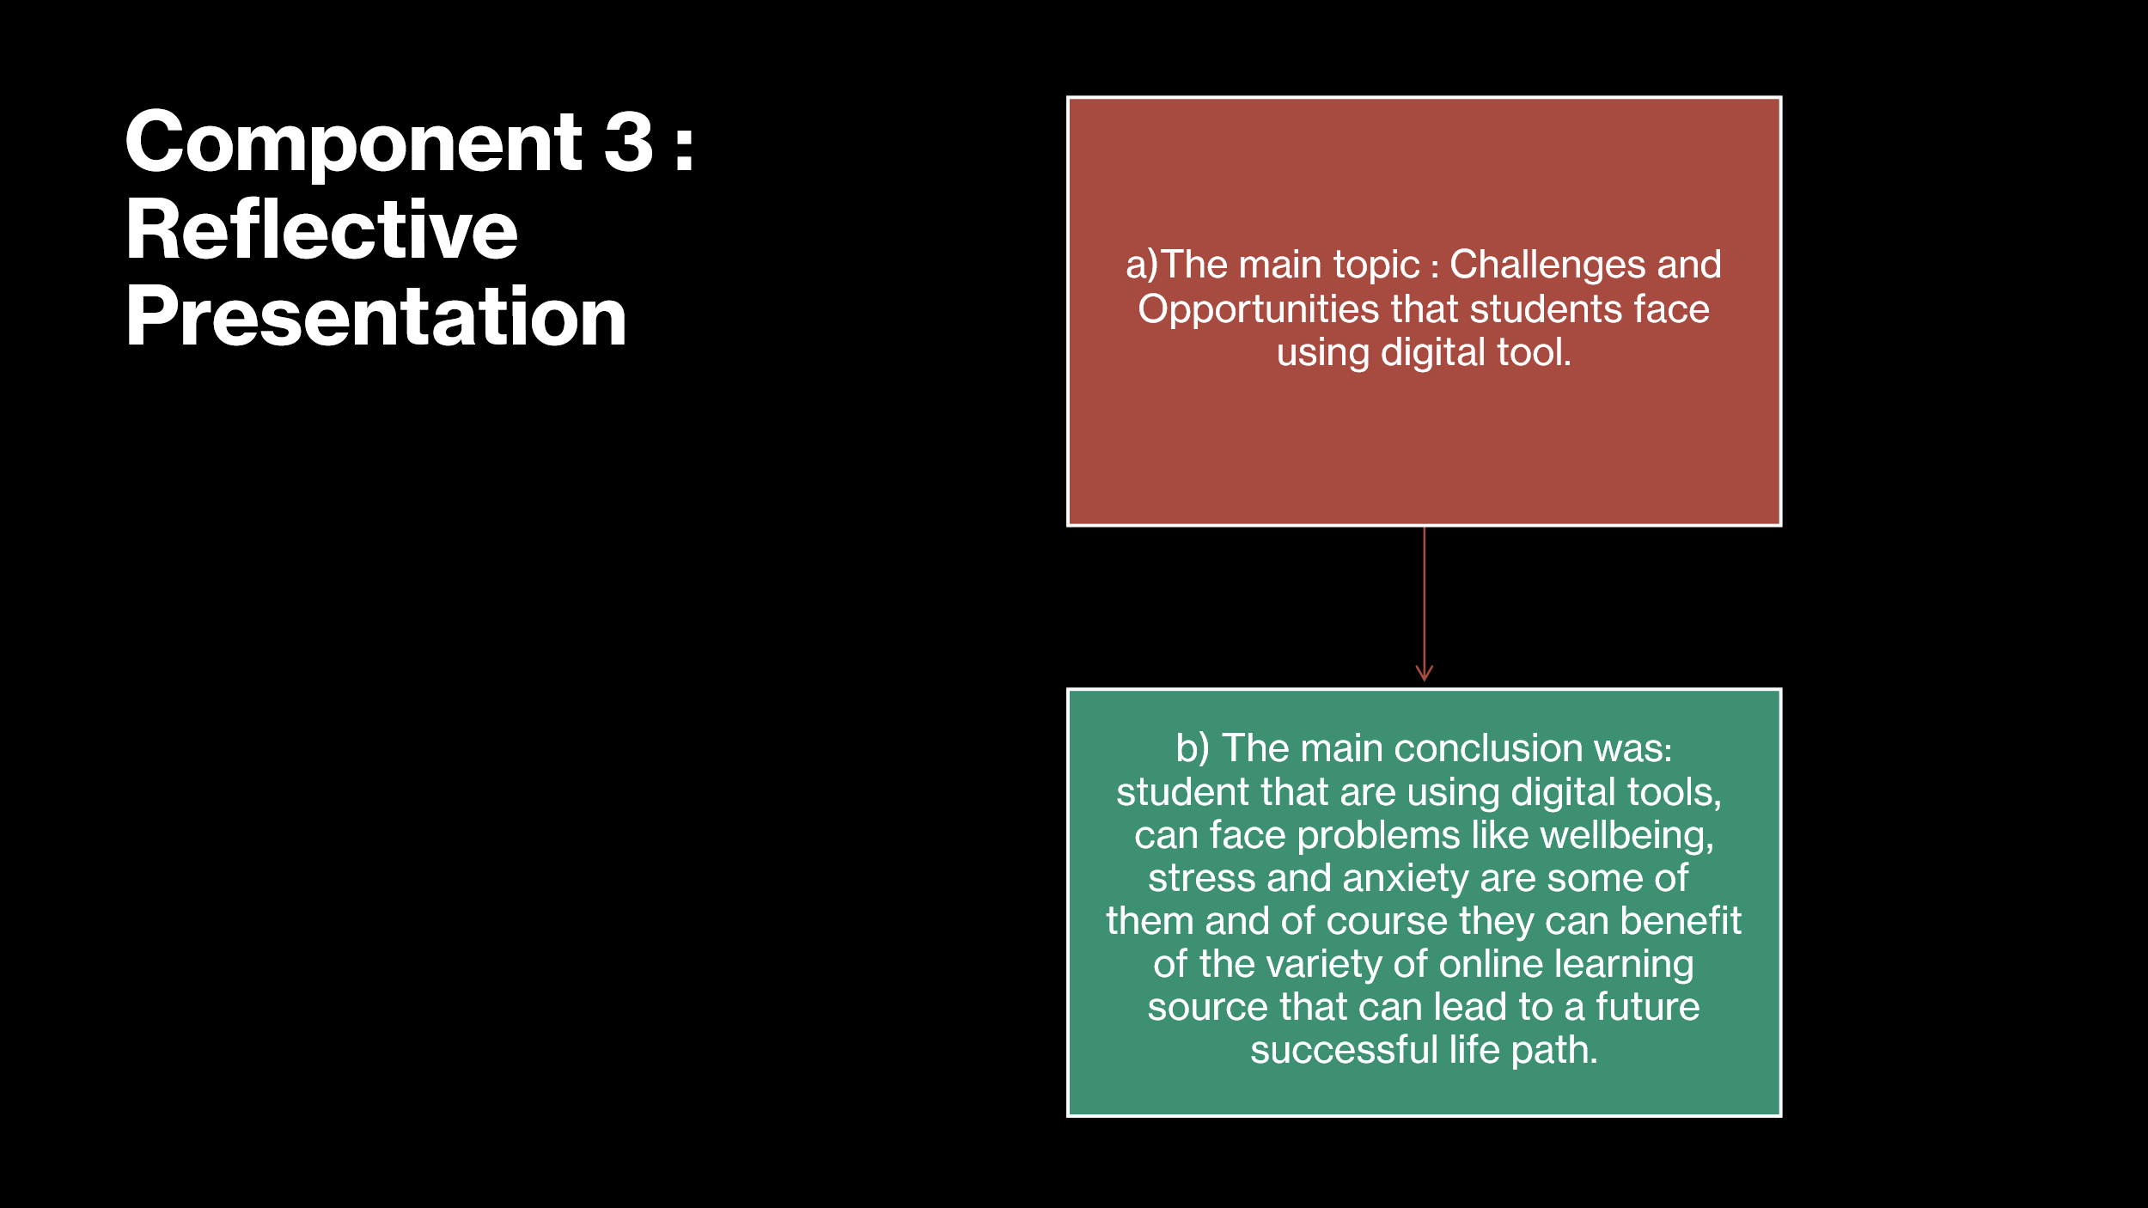

Slide2(Research)
Google Scholar, PubMed and institutional library databases were the main search tools. One of the issues I encountered was to find out the credibility of the source and this how managed through CRAAP test. The finding was that online tools improve the engagement of the students but they might also cause to much overload. Also, the results of Alenezi et al. (2023) suggest that distraction is the primary challenge among 65 percent of online learners when they use digital learning technologies 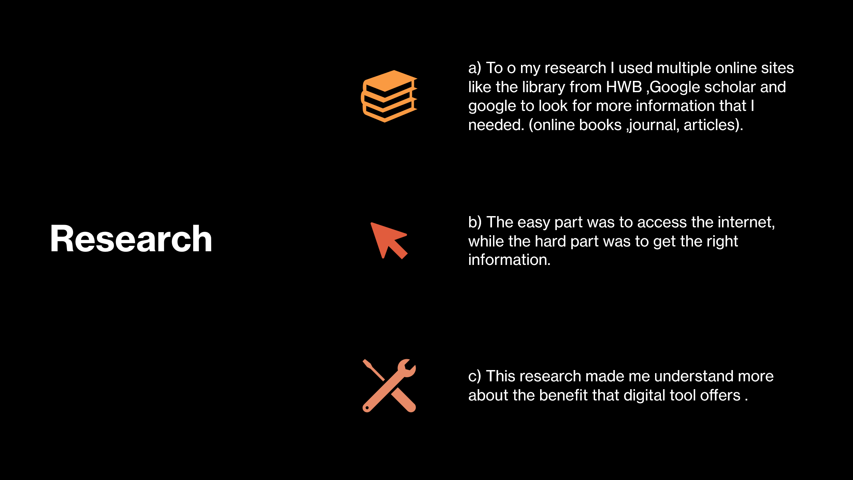 Google Scholar, PubMed and institutional library databases were the main search tools. One of the issues I encountered was to find out the credibility of the source and this how managed through CRAAP test. The finding was that online tools improve the engagement of the students but they might also cause to much overload. Also, the results of Alenezi et al. (2023) suggest that distraction is the primary challenge among 65 percent of online learners when they use digital learning technologies.

Slide 3 (Planning & Writing)
CiteThisForMe (Birla, 2023) was utilised in the Harvard-style referencing to achieve academic accuracy. This report was written in a logical order starting with the introduction after which the challenges, opportunities, and conclusion.
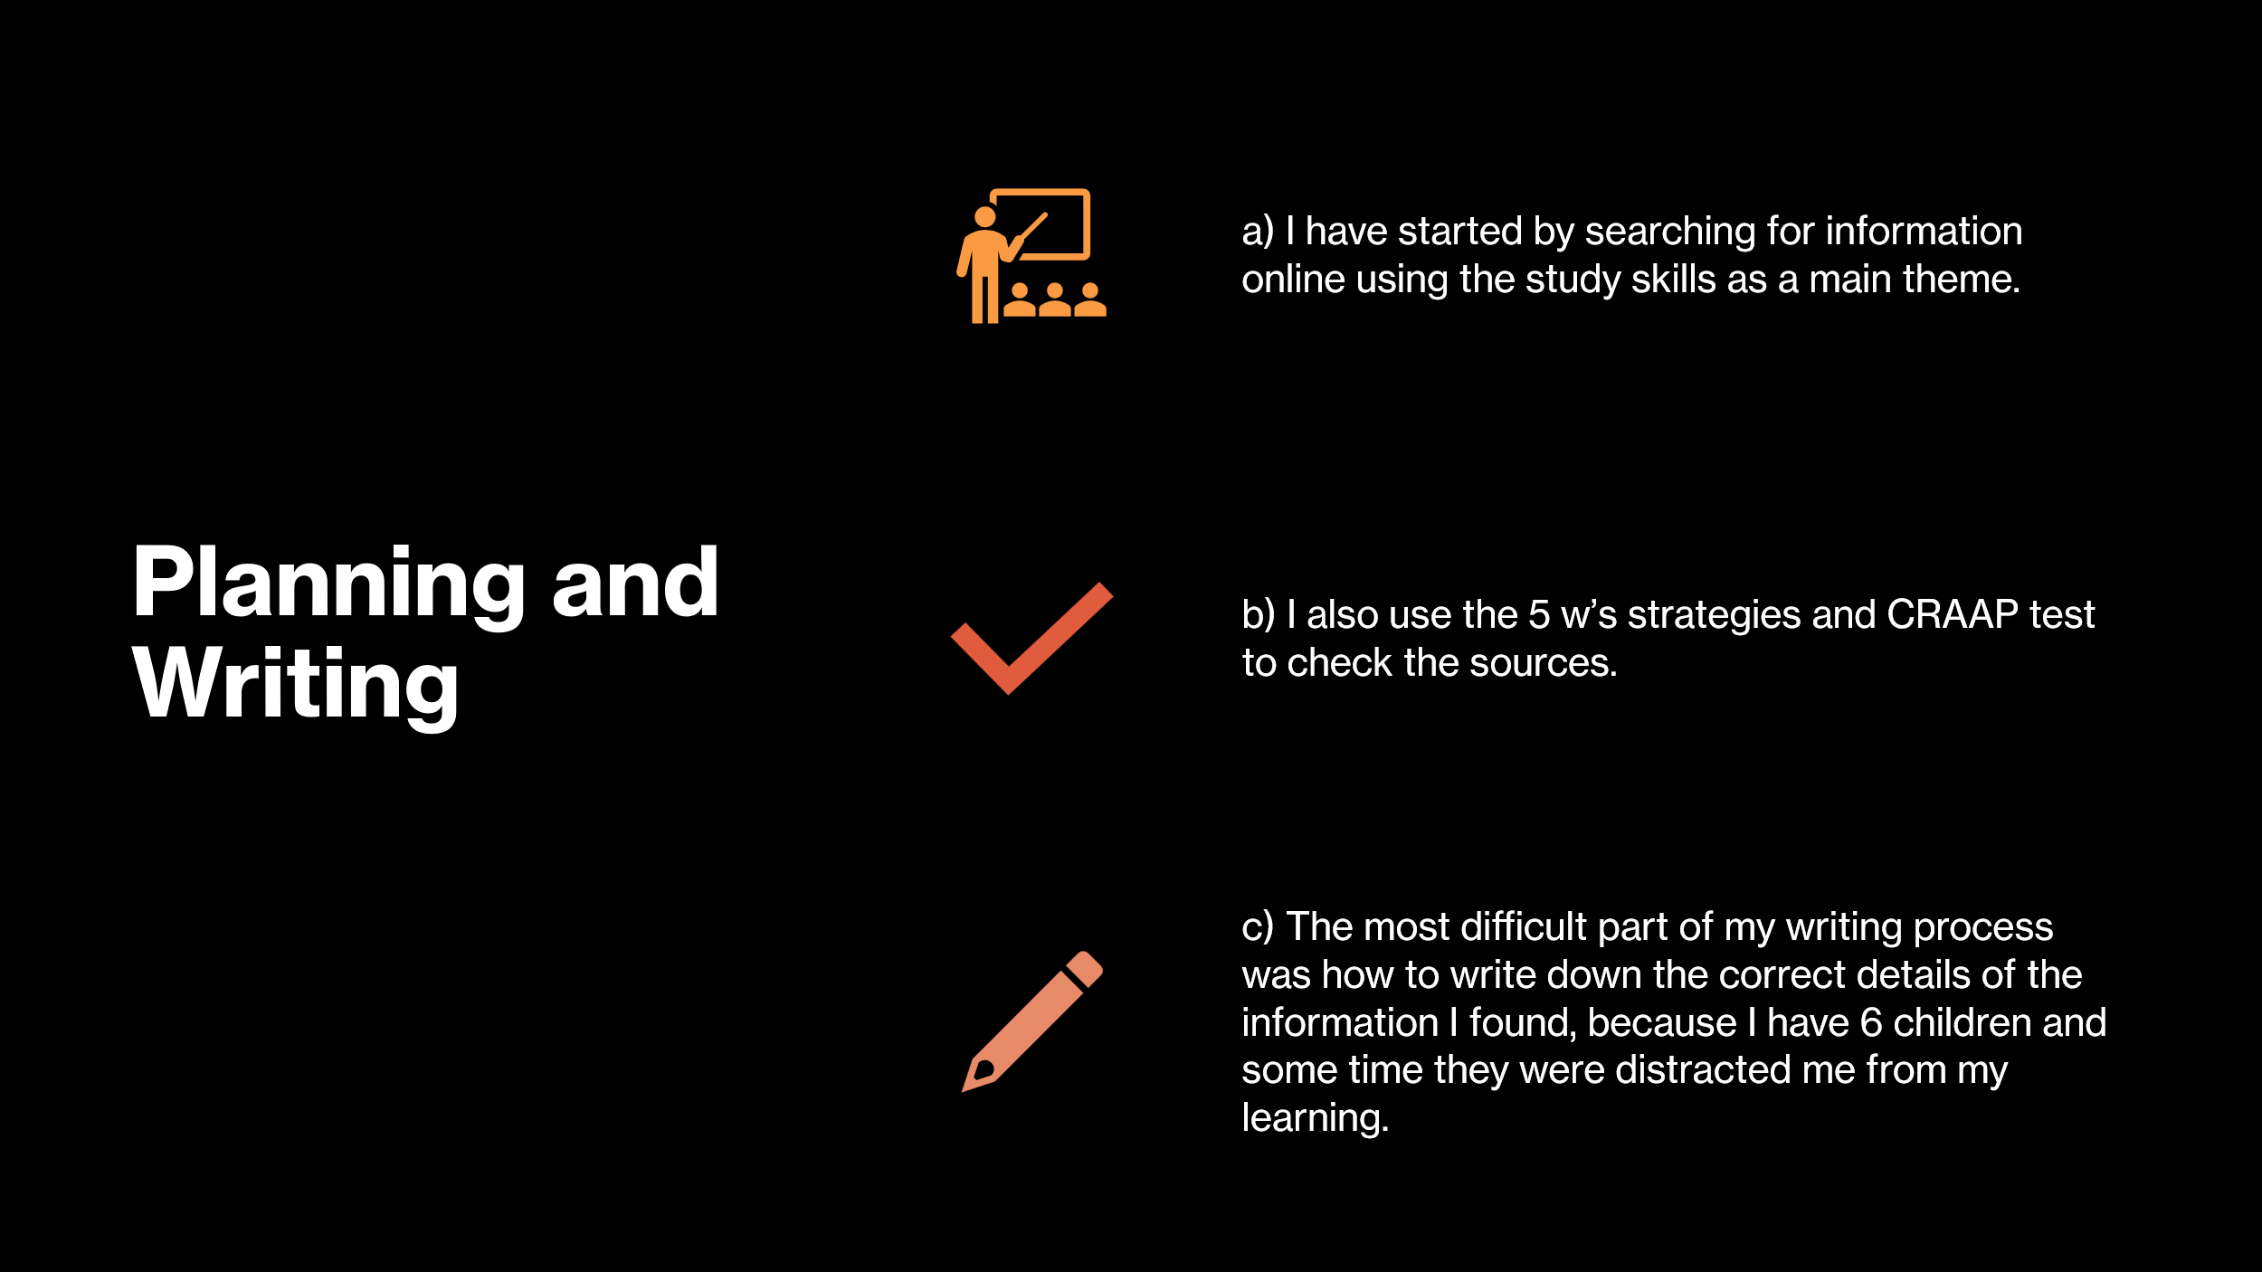

Slide 4 (Challenges)
The issue of time management was also not easy--the initial draught took me several days to do research. To address this challenge, it was possible to develop summary tables that reduce the number of results and that are recommended by Bygstad et al. (2022).

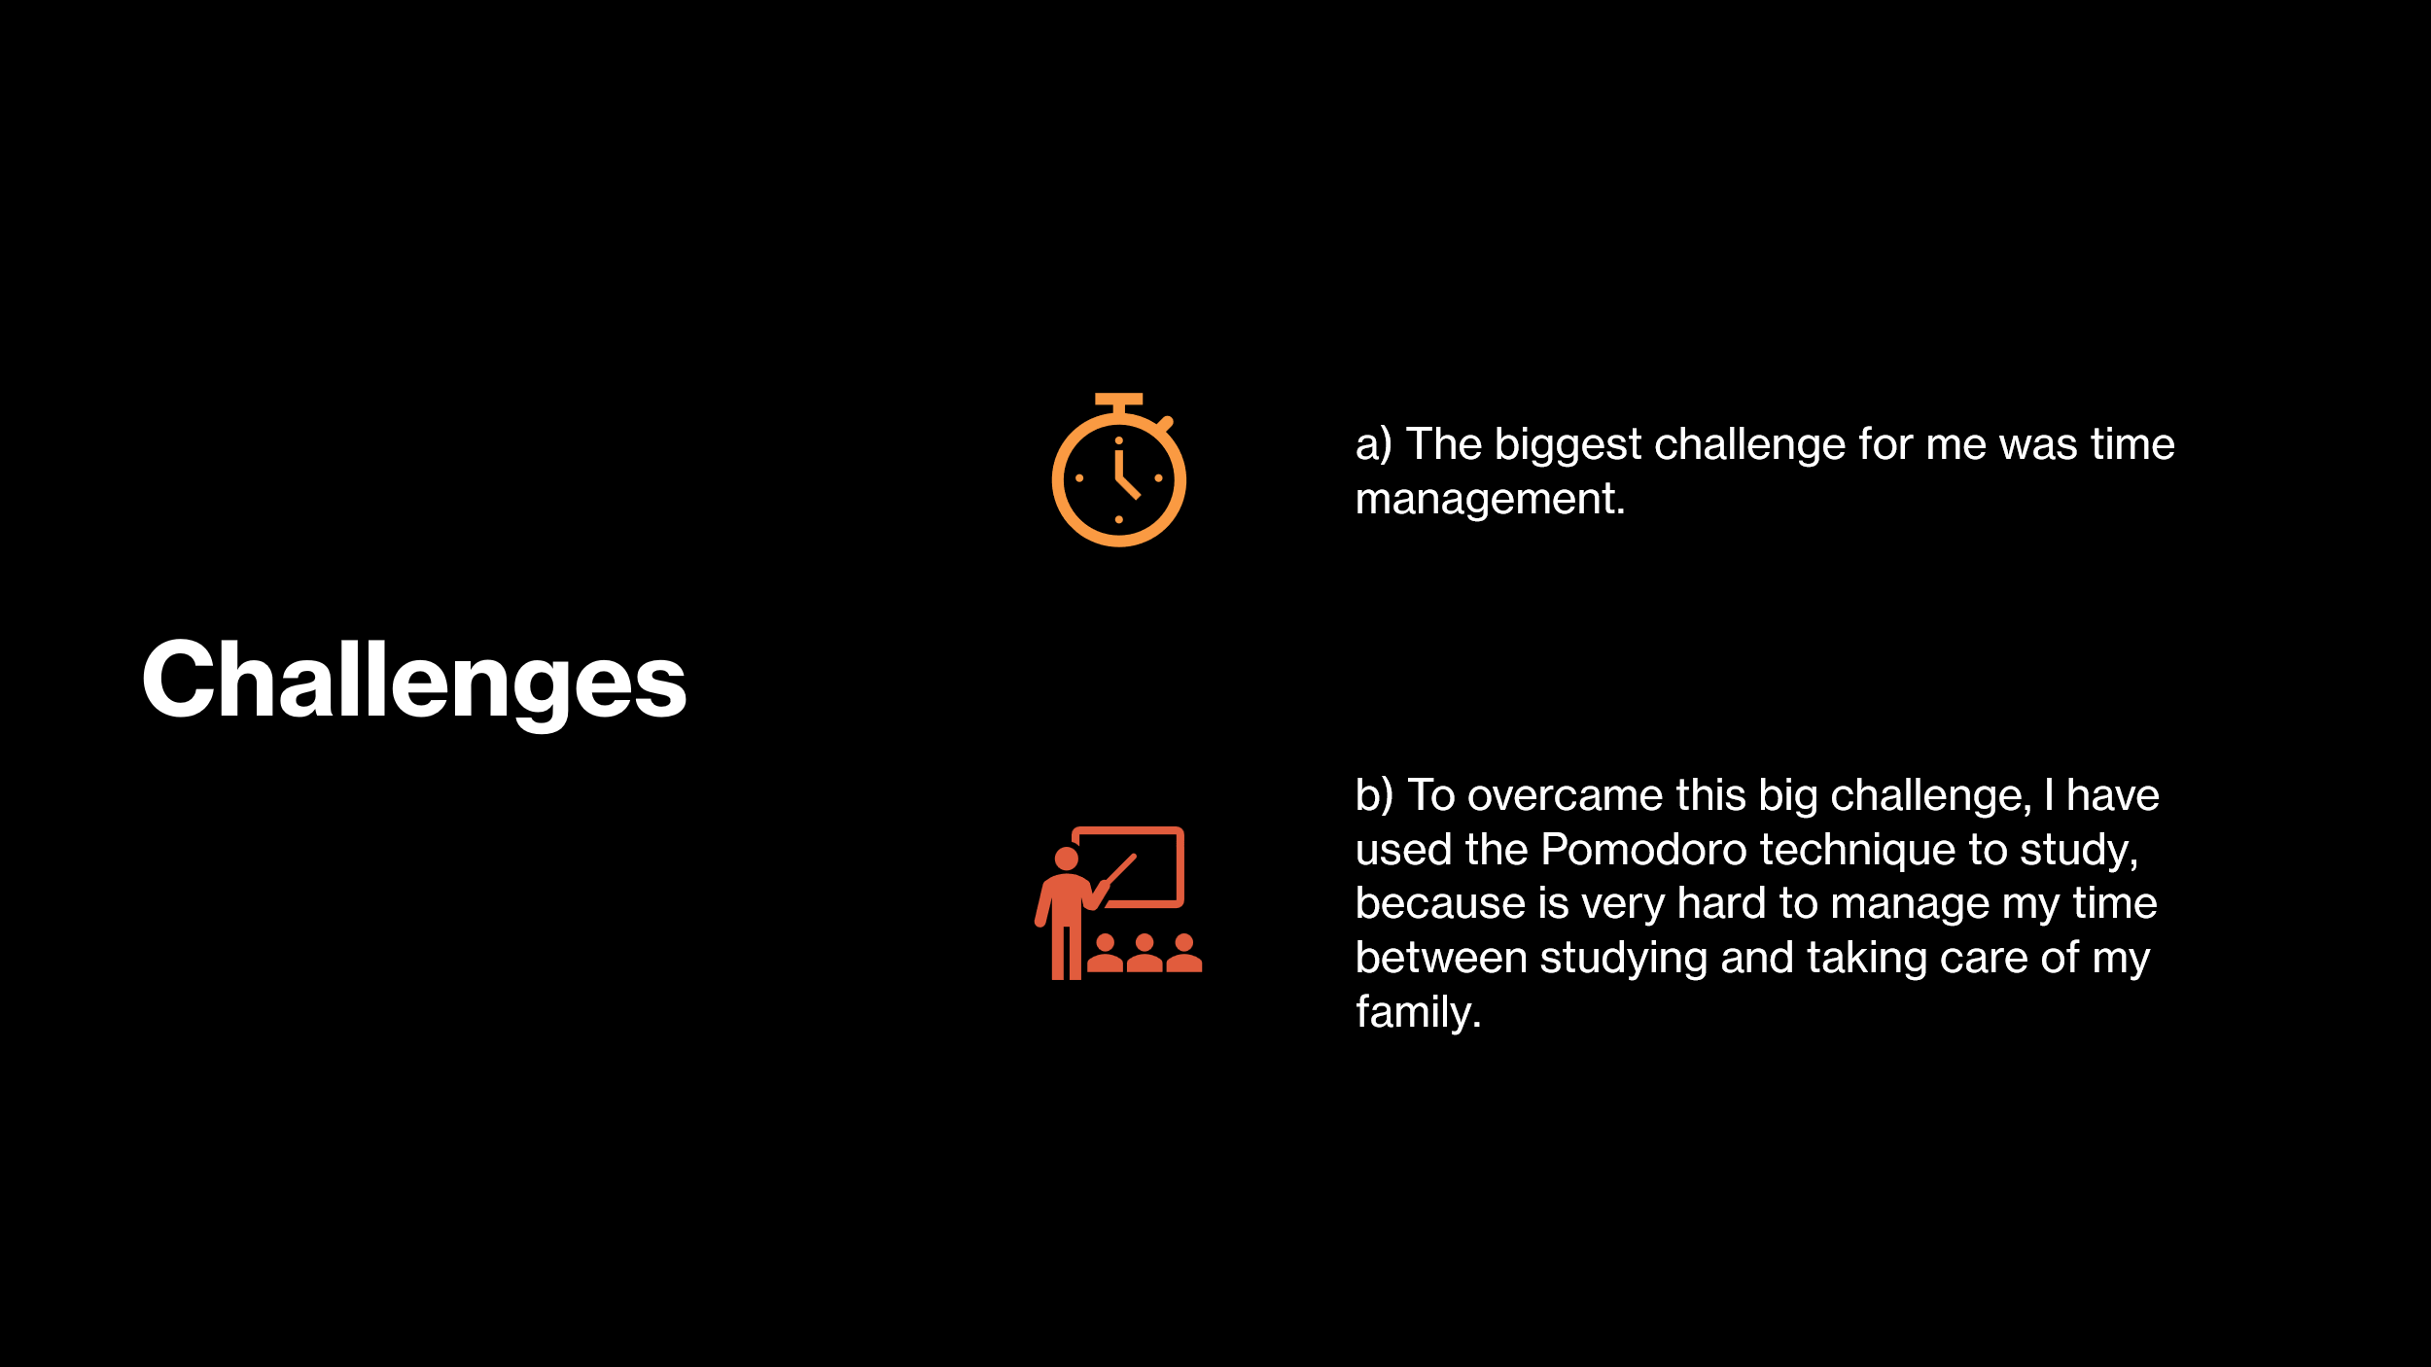

Slide 5 (Successes)
I have developed skills in my academic writing, referencing and self-discipline which are evident in the process. One of the strategies that I implemented to improve my productivity include Pomodoro technique. This exercise developed my faith in the judgement of viable scholarly studies. Supportive evidence by Cope and Phillips (2025) indicates that 76% of students who utilise planning tools indicate increased productivity which is in line with my individual learning outcomes.

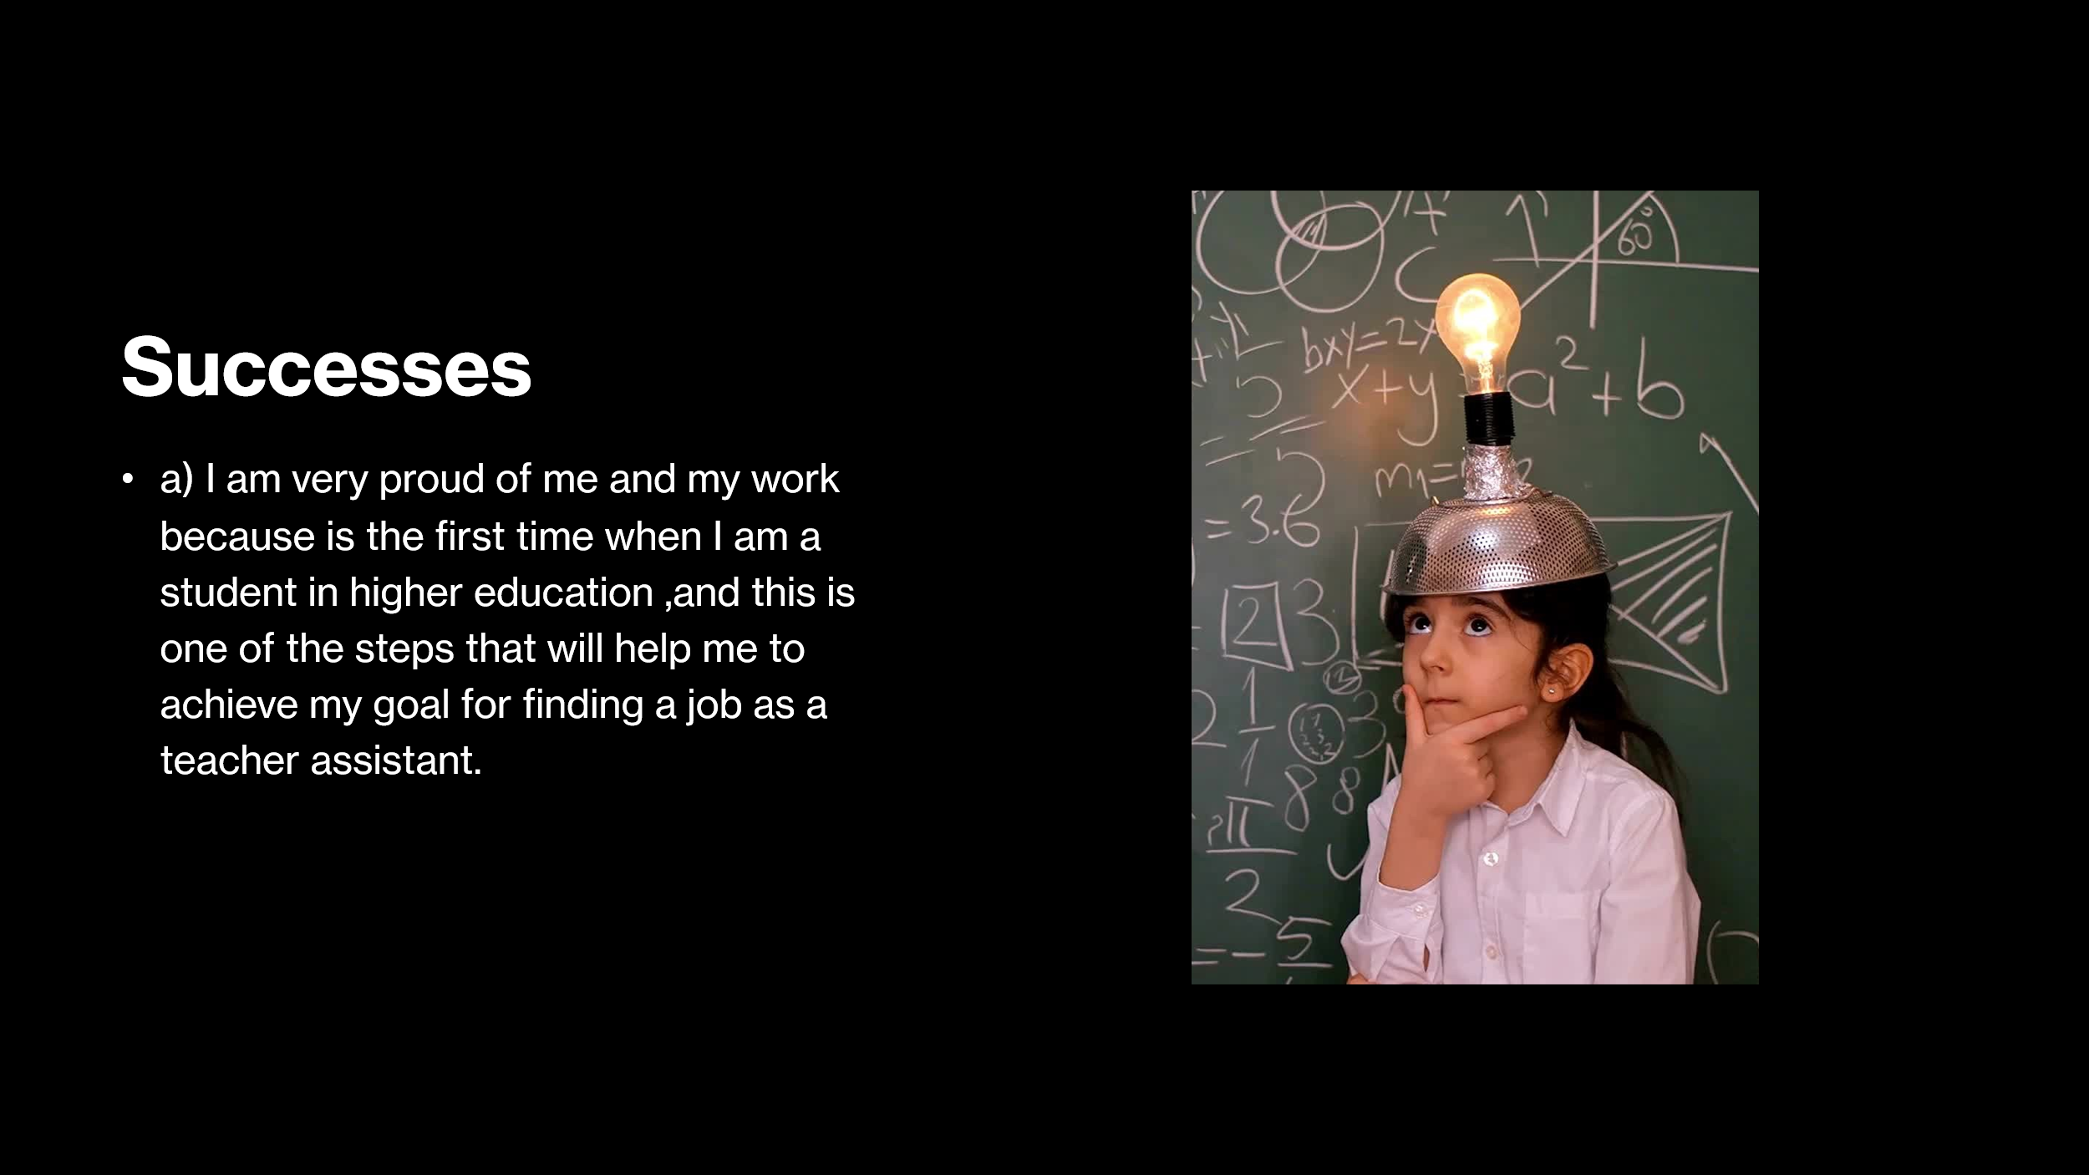

Reference List
Cottrell, S. (2024). The study skills handbook (Sixth edition.). Bloomsbury Academic, Bloomsbury Publishing Plc.
Alenezi, M., (2023). Digital learning and digital institution in higher education. Education Sciences, 13(1), p.88.
Alenezi, M., Wardat, S. and Akour, M., (2023). The need of integrating digital education in higher education: Challenges and opportunities. Sustainability, 15(6), p.4782.
Birla, R., (2023). The challenges of media education in the digital era. Journal of Communication and Management, 2(04), pp.281-288.
Bygstad, B., Øvrelid, E., Ludvigsen, S. and Dæhlen, M., (2022). From dual digitalization to digital learning space: Exploring the digital transformation of higher education. Computers & Education, 182, p.104463.
Cope, B. and Phillips, A. eds., (2025). The future of the book in the digital age. Chandos Publishing.
Ismail, A., Hidajat, T., Dora, Y.M., Prasatia, F.E. and Pranadani, A., (2023). Leading the digital transformation: Evidence from Indonesia. Asadel Publisher.
Qolamani, K.I.B. and Mohammed, M.M., (2023). The digital revolution in higher education: Transforming teaching and learning. QALAMUNA: Jurnal Pendidikan, Sosial, dan Agama, 15(2), pp.837-846.
Thompson, J.B., (2021). Book wars: the digital revolution in publishing. John Wiley & Sons.
Voronkova, V., Vasyl’chuk, G., Nikitenko, V., Kaganov, Y. and Metelenko, N., (2023). Transformation of digital education in the era of the fourth industrial revolution and globalization.
Zhu, Y. and Jiang, H., (2025). Revolutionising education: the evolution, current landscape and future of digital learning. International Journal of Smart Technology and Learning, 4(3), pp.278-295.

