Utilising the Entrecomp Framework, critically evaluate your own creativity and enterprise and consider how you might be able to develop the creative and enterprising skills of primary learners through your own pedagogy.

“Creativity and enterprise are central features of modern life that should be developed and extended throughout a school career” (Donaldson, 2015, p.28) but what are creativity and enterprise and how can these prepare children for a “modern life”? Creativity is not easily defined, with some theorists saying that it cannot be defined (Robinson and Aronica, 2015). However, others (Beetlestone, 1998, Cropley, 2008 and Desailly, 2016) believe that creativity can be described as the process of developing unique ideas that have value through self-expression and communication. Creativity was not central to education in the United Kingdom (Beetlestone, 1998) until the 1999 National Curriculum was introduced in 2000 which stated the importance of children “thinking creatively and critically, to solve problems and to make a difference for the better” (DfEE/QCA, 1999). Additionally, Desailly (2016, p.3) promotes a number of definitions with one description from educational theorists stating that creativity in education is categorised into three distinct parts being “teaching creatively, learning creatively and teaching to develop creativity”. Creative teaching aims to challenge, engage and motivate learners through finding patterns, researching, hypothesising and generalising to become creative.
To further explore the element of creativity, Jeffrey and Woods (2009, p.13) identify four characteristics of creative learning and teaching as “relevance, control, ownership and innovation”. Relevance is the learning of social values including knowledge of other identities and cultures. Thus, linking to Donaldson’s (2015) recommendation for creating “ethical, informed citizens” who are understanding of different cultures in the world. They identify that a creative learner will take control and responsibility for their own learning to motivate themselves and are not guided by another source. This links closely to learners taking ownership of their own knowledge by learning for themselves, using the teacher as a facilitator in their learning rather than somebody who imparts knowledge. As a result of applying the three characteristics of relevance, control and ownership, in turn, the final characteristic “innovation” takes place allowing a “greater chance of creative learning” where something new is created; thus, creating a “transformation” in the pupil (Jeffrey and Woods, 2009, p.13). This explores the concept that a child will develop independence and responsibility for their learning as a result of the creative approaches that are implemented. It suggests that the learner will become more resilient and be able to persevere with tasks as they will be equipped with the skills to enable them to tackle tasks creatively through the use of this approach. However, this approach is not universal and perhaps will not be able to be applied to all learners. As well as this, it is important to consider that the creative teaching and learning approach needs to be implemented successfully; using modelling and scaffolding strategies to begin with; to physically show learners how to access the curriculum in a ‘creative’ and ‘independent’ way. Facilitators cannot expect learners to become creative or independent without showing them how to do it first.
Enterprise skills are developed through applying “creative ideas and innovations to practical solutions” (Jarman, 2018). The process equips pupils with the capability to generate ideas and skills and influence their creativity, flexibility and the innovation process for application to their later working lives (Penaluna, 2018). Once again, this links closely with Donaldson (2015, p.15) who claims that we should equip children with the necessary skills to be able to be successful “lifelong learners” in the real world. Enterprise skills adapt a constructivist approach known as heutagogy where learners are centred around the learning. Pupils are encouraged to contribute to and create their own knowledge through researching and developing ideas and creating unique innovations. It has been claimed that heutagogical learning should not be planned, it should follow the needs of the learners. The teacher acts as a facilitator supporting pupils when required, but the primary source of knowledge should be from the pupils’ determination to achieve their own goals (Davis, 2018). This is in opposition to the more familiar pedagogy approach where learning is delivered by the teacher providing information to ensure pupil knowledge and rewarding pupils to motivate them (Broodryk, 2015). Bacigalupo et al, (2016, p.10) created a framework aimed to develop children’s “participation in society, to manage their own lives and careers and to start value-creating initiatives” through conceptualising entrepreneurship as a competence (EntreComp). The EntreComp framework “aims to establish a bridge between the worlds of education and work” (Bacigalupo et al., 2016) whilst meeting the European goal for all children to receive “practical entrepreneurial experiences” before leaving education (J. A. Europe, 2018, p.6). The implementation of the creative approach; which has been found to improve independence and perseverance, should, therefore, enable children to use these skills and become used to managing their own learning whilst taking more responsibility for their learning and ultimately, use and apply these skills to become successful during ‘entrepreneurial experiences’. However, the skills needed to tackle and complete entrepreneurial tasks need to be clearly modelled and scaffolded to ensure that all learners are secure and competent in these skills.
The EntreComp framework was developed with consideration of teaching methods and numerous learning outcomes being met through a school dedication to conceptualising entrepreneurship skills as a competence. In addition, another focus was to improve the relationship between children and teachers (Bacigalupo et al., 2016 and J. A. Europe, 2018). During professional teaching experience (PTE) close relationships were developed with all pupils to ensure all pupils felt supported and were eager to engage in lessons. Evidence of the relationship formed between children and staff can be found in a summative assessment shown in Appendix 1 which states that “[I] formed good relationships with the children”. Developing relationships with the learners meant that children were more willing to complete tasks as they felt that they were able to ask questions to develop their thinking and were able to ask for help if they were unclear on a task. Furthermore, research by Birch and Ladd (1997) supports the importance of developing close relationships between students and staff as they provide support for young children in school, placing them in a safe environment where they are happy and ready to learn.
The framework aims to meet a key policy objective set out for the European Union through the development of children’s ‘entrepreneurial capacity’. This is because the skills, knowledge and attitudes that are developed through entrepreneurial tasks will “benefit individuals and society as a whole” (Bacigalupo et al., 2016, p.5). It is suggested that employers and organisations “prioritise the essential skills” of “communication, creative problem solving, self-management and collaboration” during employment (Enabling Enterprise, 2018, p.37). Therefore, in order to give pupils the best chance of employment in their futures, Bacigalupo et al, (2016), Penaluna (2016), Cowley (2005) and other theorists all support the importance for developing children’s enterprise skills from a young age to best prepare them for the world of work. In addition to this, the EntreComp framework (Bacigalupo et al., 2016) has related closely to Donaldson’s (2015) Successful Futures report and promotes an increased imperative to develop enterprising characteristics from the early years of learning. This aims to meet Donaldson’s (2015, p.29) belief to develop children as “enterprising, creative contributors, ready to play a full part in life and work”.
Whilst there are benefits to the implementation of the EntreComp framework (Bacigalupo et al., 2016) to the teaching profession and learning, it does have some limitations. With the framework being completed and published in 2016, it has not yet been implemented into many schools. Therefore, it has not been tested and proven to be of benefit to pupils. Bacigalupo et al, (2016, p.9) do however acknowledge this in that “the framework has not yet been adapted to or tested in real settings” to ensure the benefits of the framework. As a result, I believe it will be important that implementations in my future practice are evaluated and assessed regularly to ensure pupil progression as a result of the framework. If it is found to be of no benefit, other strategies must be put in place until other methods are introduced to the classroom. A further limitation is the lack of involvement between education systems and the labour market in good-quality training and support for teachers implementing the framework (J. A. Europe, 2018). Without good quality training and support, teachers are less able to deliver confidently as creative and enterprising education requires “a balance between teaching knowledge and skills, and encouraging innovation” (N.A.C.C.C.E., 1999, p.6). Therefore, training should provide educators with a sound understanding of the framework and how they are expected to deliver this in the classroom to allow pupils to achieve their full potential at becoming enterprising contributors. Furthermore, teacher’s having secure subject knowledge is also essential in the delivery of a lesson as well as in the framework that is being followed. It has been essential during PTE that my personal subject knowledge is up to date to be able to deliver effective lessons and to be able to answer questions or to address misconceptions. It has been noted that subject knowledge is a strength of mine and I have tried to ensure that I have an in-depth knowledge of a skill or topic before the delivery of all lessons. This is evidenced in Appendix 2 showing an assessment from PTE where the tutor has stated “excellent subject knowledge”.
It is evident that a creative approach to learning enables learners to access the curriculum in an engaging and motivating way. Craft (2000), Cowley (2005), Robinson and Aronica (2015) and many other theorists support the idea that children learn best through active and constructive involvement in their learning. Additionally, Vosniadou (2001, p.26) explains the necessity for teachers to create “engaging and challenging environments” with real-life links to motivate pupils in their learning, encouraging them to deepen their understanding and progress. Enterprising lessons will naturally involve a real-life approach to develop pupils’ creative skills and experience “ready to play a full part in life and work” (Donaldson, 2015, p.29) inspiring children to actively engage with their learning. During PTE, I have kept in mind that lessons require engagement and challenge in order to motivate pupils’ learning. This was evident in a year one class on PTE2 during a lesson in the forest after reading ‘The Lighthouse Keeper’s Lunch’ by Ronda and David Armitage (2001) where pupils were challenged to recreate the part of the story where a lunch bag had to be delivered from the cottage to the lighthouse via a ‘pully’ system. This lesson ensured active participation from all pupils, which, Dykstra Steinbrenner and Watson (2015) define as essential for pupil engagement. A personal level six in “mobilising others” within the EntreComp framework is believed to have been met during this lesson. By inspiring the engagement of others, this challenge inspired pupils to solve the problem “despite challenging circumstances” (Appendix 3) (Bacigalupo et al., 2016, p.30). A personal reflection of this lesson (Appendix 4) shows evidence for meeting this thread for “mobilising others” and engagement of pupils. It would be beneficial to develop these skills into future practice during lessons that are not so interesting or engaging to pupils. It would be important to maintain the momentum of the class by providing a positive attitude towards the work with a growth mindset to help overcome the challenge. This would help in the progression to a level seven of ‘mobilising others’ through ‘maintaining momentum’ of the pupils when involved in challenging situations. Penaluna (2018, p.11) supports the idea of ensuring engagement as part of the development for enterprise skills in that the "educator should contribute to the enhancement of student engagement” to enable students to achieve the desired outcomes.
During this lesson, pupils demonstrated a range of examples for meeting a level two to three of the ‘mobilising others’ thread of the EntreComp framework (Appendix 5). All children were enthusiastic towards the challenge and became “actively involved” in finding a solution to the problem, therefore, meeting a level two proficiency. However, others were able to access a level three as they were not “discouraged by difficulties” (Appendix 6) (Bacigalupo et al., 2016, p.30). For example, there were elements of challenge within this lesson as the learners were encouraged to create a ‘pully’ system with nothing to stop it from moving from one end to the other. However, some children found difficulty in this and the lunch box would stop in the middle of the string (Appendix 7). The learners were encouraged to collaborate and talk to overcome this problem. With encouragement, the pupils who encountered difficulties did not give up and they were eager to find a solution. This is evident in Appendix 8 where pupils can be seen finding a solution to the problem by tightening the string.
In addition, this lesson also gave the pupils the opportunity to show a level two proficiency for using initiative by “taking responsibility in shared activities” to overcome a problem (Appendix 9) (Bacigalupo et al., 2016, p.31). Pupils were able to responsibly carry out the task within their groups without being reminded to carry on with the task in hand. Penaluna (2018), Donaldson (2015, p.69) and Florez and Sammons (2013, p.6) agree on the importance of allowing children to have responsibility in organising themselves and “for their own learning”. This relates to the “self-awareness and self-efficiency” competence of the EntreComp framework which aims to give learners the chance to “believe in [themselves] and keep developing” (Appendix 10) (Bacigalupo et al., 2016, p.27). Donaldson (2015), Florez and Sammons (2013), and Jeffrey and Woods (2009) argue that children should take control and responsibility for their own learning. This could be carried out through the use of assessment for learning (AfL) strategies through self-assessing their work. This allows pupils to reflect upon their understanding and performance to “identify things [they were] good at and things [they were not] good at” meeting a level one / two proficiency of the EntreComp framework (Appendix 11) (Bacigalupo et al., 2016, p.27). However, upon reflection, I did not provide the class with the opportunity to meet this competence during this lesson as I did not plan the use of any AfL strategies to self-assess. In future practice, it would be beneficial to use questioning strategies in the classroom to receive qualitative self-assessment from pupils. This would be carried out by encouraging children to use higher-order thinking skills by asking them to share their thought process for the activity and identify and address any misconceptions and difficulties they came across without worrying about giving an incorrect answer (MacPhail and Halbert, 2010, DfEs, 2007 and Webb and Jones, 2009). Higher order thinking allows opportunities to encompass critical and creative thinking. This activity would allow the teacher to focus on pupils’ critical thinking as they will have to reflect on their task and “draw conclusions based on their critical thinking” (Miri et al., 2007, p.355) and is a competence stated within the EntreComp framework (Bagicalupo et al., 2016, p.2) as well as being supported by Penaluna (2018) and Richmond (1993).
Creative thinking and problem-solving allow pupils to develop divergent and convergent modes of thinking. Penaluna (2018, p.22) demonstrates that creative and innovative enterprise skills should be adopted by children through “employing both convergent and divergent approaches” to solve a problem. During the divergent thinking stage, pupils generate multiple creative solutions for a problem. Divergent thinking explores a range of possible solutions in a small amount of time by drawing unexpected connections together and are a necessary component of creative learning (Guilford, 1942 and Kharkhurin, 2007: p176). Divergent thinking occurs when in an ‘alpha’ brain frequency which is the state of being relaxed where ideas are free-flowing. Divergent thinking should take place in a stimulating environment where an appropriate amount of time is given for ideas to generate. Convergent thinking requires pupils to use logic to generate a ‘correct’ answer to standard questions requiring little creativity (Guilford, 1942). It is often used as a tool in problem-solving to follow a set of steps to arrive at the one best solution (Kemp and Schwaller, 1988). Convergent thinking occurs when in a ‘beta’ or ‘gamma’ brain frequency when in an alert and active state of mind. Whilst Guilford (1942) suggests that divergent and convergent are independent modes of thinking, Nusbaum and Silvia (2011, p.41) argue against Guilford stating that “divergent thinking is more convergent than modern creativity theories presume”. Thus, suggesting that perhaps, one mode of thinking does not happen without the other. Rather, the two modes go hand in hand with the thinking process starting divergently, generating multiple ideas, before the convergent process narrows these thoughts down to arrive at a logical or sometimes ‘correct’ solution.
In future practice, to facilitate the development of children’s enterprise skills for developing ideas for creativity, a challenge could be carried out. The challenge would allow the opportunity for pupils to design, develop and deliver a product (appropriate to the age group) that can be sold to stakeholders and the wider community. Thus, following a similar approach to the EntreComp conceptual model following the three areas of “ideas and opportunities”, “resources” and “into action” (Bacigalupo et al., 2016, p.12-13). For example, pupils in the Foundation Phase (FP) may design a product as a class (with modelling and potential scaffolding from the teacher) such as a bauble which they will develop through creating a painting or unique design onto, before selling it to parents or other stakeholders to create a profit for the class. In Key Stage Two (KS2) classes, pupils could plan, design and build their own toy or ornament including unique ideas to develop or improve it. This challenge will allow opportunities for FP children to develop creative and purposeful ideas which create value for others. Therefore, achieving a level two proficiency for “develop[ing] ideas” in the creativity competence of the EntreComp framework (Appendix 12) (Bacigalupo et al., 2016, p.24). KS2 pupils will be able to access higher levels of proficiency through carrying out research with ‘end users’ such as parents or governors to “involve stakeholders in finding and developing” their ideas before creating their product. Thus, achieving a level six proficiency for creativity within the EntreComp framework (Appendix 13) (Bacigalupo et al., 2016, p.24). The idea of having to sell their end product will encourage the pupils to think more creatively as they will “engage their sense of possibility” giving them the confidence to try. This is known as an ‘extrinsic’ form of motivation which creates “risk-taking, independent judgement, commitment and resilience” contributing to the creative potential of children (N.A.C.C.C.E., 1999 and Craft et al., 2001). This challenge combines the previously mentioned teaching approaches of heutagogy and pedagogy. The heutagogical approach becomes evident more in the Key Stage Two setting, as the pupils are using the teacher as a facilitator when they require support in researching, designing and creating their product. In this example, both Foundation Phase and Key Stage Two are being encouraged to produce a product at the end of the planning, designing and building stages. This is a beneficial experience as the children are motivated by the fact they are being rewarded once the product is complete as a user will ultimately pay for it, and a monetary reward is received for the class. Throughout the challenge, AfL strategies would be put in place to give pupils opportunities to reflect upon their own and each other’s products allowing chances for reflection and refinements to be made to improve their products. Black and William (1998) support that assessment should be carried out throughout a session, or in this case, throughout the creation, as the results should be used to inform the child of any improvements that could be made in order for them to adjust what they are doing whilst still working, not at the end when adjustments will not be able to be made.
Word Count – 3300.

Reference List
Armitage, R. and Armitage, D. (2001) The Lighthouse Keeper's Lunch. London: Scholastic Ltd.
Bacigalupo, M., Kampylis, P., Punie, Y., Van den Brande, G. (2016) EntreComp: The Entrepreneurship Competence Framework. Luxembourg: Publications Office of the European Union; EUR 27939 EN; doi:10.2791/593884
Beetlestone, F. (1998). Creative children, imaginative teaching. Buckingham: Open University Press.
Birch, S. and Ladd, G. (1997) The Teacher-Child Relationship and Children's Early School Adjustment. Journal of School Psychology, 35(1), pp.61-79.
Black, P. and Wiliam, D. (1998) Inside the Black Box. Raising Standards Through Classroom Assessment. London: Phi Delta Kappa International.
Broodryk, J. (2015) Pedagogies that support Flexible Learning Environments. Melbourne: Palmerston North.
Cowley, S. (2005) Letting the Buggers Be Creative, London: Continuum.
Craft, A. (2000) Creativity Across the Primary Curriculum, Abingdon: Routledge.
Craft, A., Jeffrey, B. and Leibling, M. (2001) Creativity in Education. Continuum International Publishing Group Ltd.
Cropley, A. (2008) Creativity in education & learning. London: Routledge Falmer.
Davis, L. (2018) Heutagogy Explained: Self-Determined Learning in Education. [online] Schoology.com. Available at: https://www.schoology.com/blog/heutagogy-explained-self-determined-learning-education [Accessed 18 Jan. 2019].
Desailly, J. (2016) Creativity in the primary classroom. Los Angeles: SAGE.
DfES (Department for Education and Skills). (2007) Assessment for learning: 8 schools project report. London: DfES Publications.
DfEE/QCA (Department for Education and Employment / Qualification and Curriculum Authority). (1999) The National Curriculum: Handbook for Primary Teachers in England: Key Stages 1 and 2. London: DfEE.
Dykstra Steinbrenner, J. and Watson, L. (2015) Student Engagement in the Classroom: The Impact of Classroom, Teacher, and Student Factors. Journal of Autism and Developmental Disorders, 45(8), pp.2392-2410.
Enabling Enterprise (2018) Primary schools. A complete approach to building essential skills. London: Skills builder for schools.
Florez, M. and Sammons, P. (2013) Assessment for Learning: Effects and Impact. Berkshire: CfBt Education Trust.
Guilford, J.P. (1942) Fundamental statistics in psychology and education. London. McGraw-Hill Book Company, Inc.
J. A. Europe. (2018) ICEE (Innovation and Research Entrepreneurship Education). ICEE PROGRESSION MODEL: From EntreComp to Practice in Schools. [online] Erasmus+ Programme of the European Union. Available at: http://icee-eu.eu/index.php?option=com_attachments&task=download&id=647:ICEE-Progression-Model [Accessed 18 Jan. 2019].
Jarman, D. (2018) What is enterprise education and how does it work in the UK?. [online] Entrepreneur Handbook. Available at: https://entrepreneurhandbook.co.uk/enterprise-education-about-for-or-through/ [Accessed 15 Jan. 2019].
Jeffrey, B. and Woods, P. (2009) Creative learning in the primary school. London: Routledge.
Kemp, W. and Schwaller, A. (1988) Instructional strategies for technology education. Mission Hills, Calif.: Glencoe.
Kharkhurin, A. (2007) The Role of Cross-Linguistic and Cross-Cultural Experiences in Bilinguals’ Divergent Thinking. Cognitive Aspects of Bilingualism, pp.175-210.
MacPhail, A. and Halbert, J. (2010). ‘We had to do intelligent thinking during recent PE’: students’ and teachers’ experiences of assessment for learning in post‐primary physical education. Assessment in Education: Principles, Policy & Practice, 17(1), pp.23-39.
Miri, B., David, B. and Uri, Z. (2007) Purposely Teaching for the Promotion of Higher-order Thinking Skills: A Case of Critical Thinking. Research in Science Education, 37(4), pp.353-369.
N.A.C.C.C.E. (National Advisory Committee on Creative and Cultural Education). (1999) All our futures: creativity, culture and education. London. DfEE.
Nusbaum, E. and Silvia, P. (2011) Are intelligence and creativity really so different? Fluid intelligence, executive processes, and strategy use in divergent thinking. Intelligence, 39(1), 36-45.
Penaluna, A. (2018) Enterprise and Entrepreneurship Education: Guidance for UK Higher Education Providers. Gloucester: Quality Assurance Agency.
QAA. (2012) Enterprise and entrepreneurship education: Guidance for UK higher education providers, QAA, available at: http://www.qaa.ac.uk/en/Publications/ Documents/enterprise-entrepreneurship-guidance.pdf [Accessed 15 Jan. 2019].
Richmond, B. (1993) Systems thinking: critical thinking skills for the 1990s and beyond. System Dynamics Review Journal, 9(2).
Robinson, K. and Aronica, L. (2015) Creative Schools: The Grassroots Revolution That’s Transforming. New York: Viking Publishing.
Vosniadou, S. (2001) Educational Practices. How children learn. Geneva: IAE (International Academy of Education).
Webb, M. and Jones, J. (2009) ‘Exploring tensions in developing assessment for learning’. Assessment in education, 16(2), 165-184.
Woods, P. (1990) Teacher Skills and Strategies. London. Falmer.

Appendices
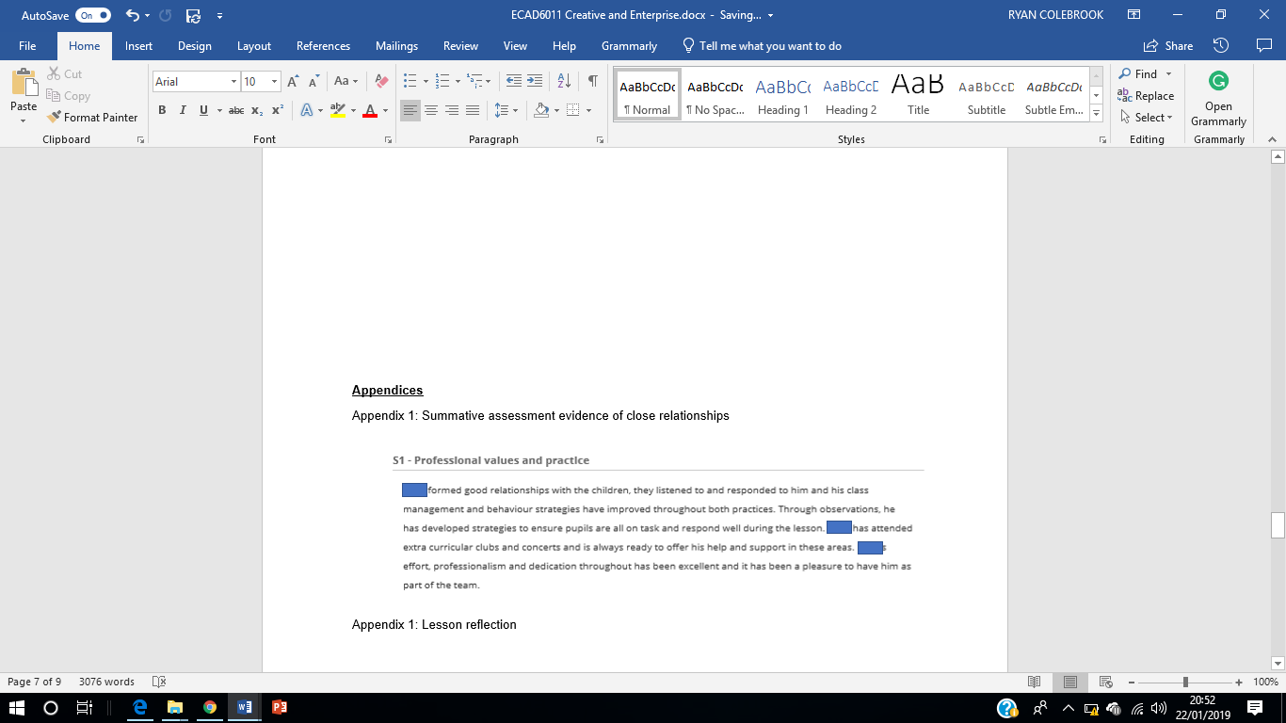
Appendix 1:

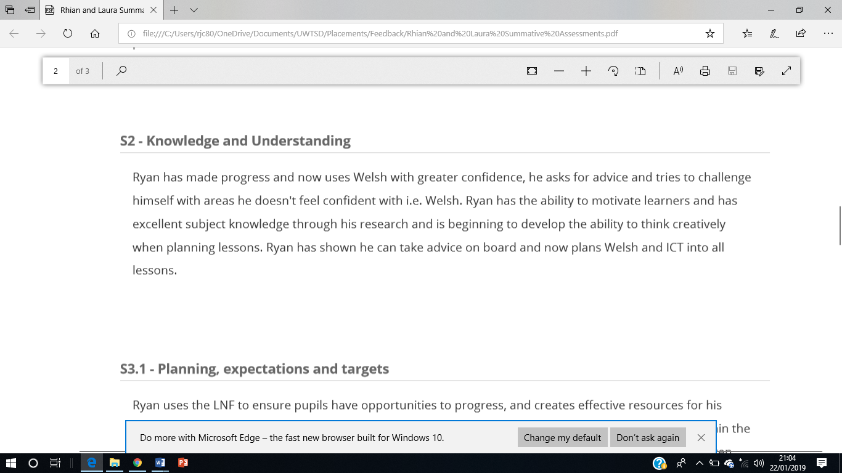
Appendix 2:

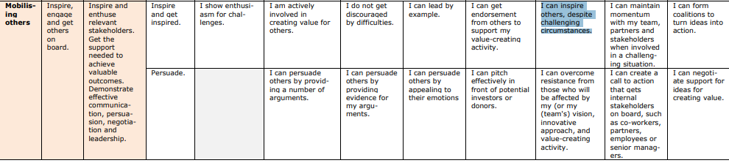
Appendix 3:

Appendix 4:
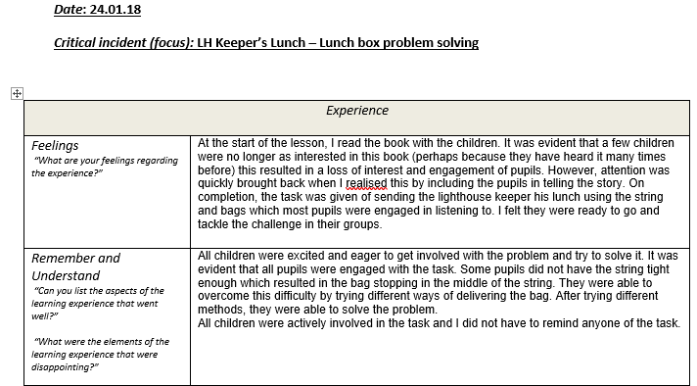

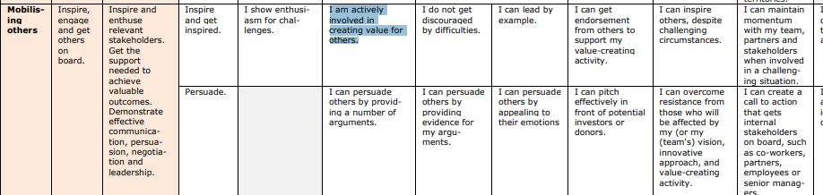
Appendix 5:

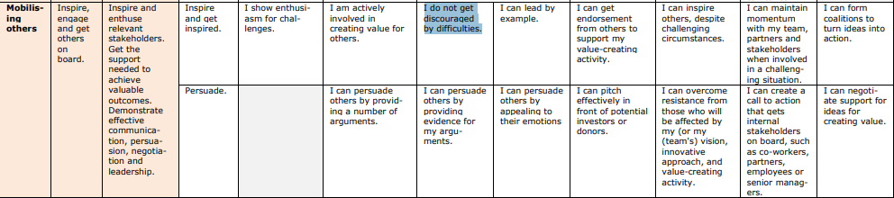
Appendix 6:
Appendix 7: 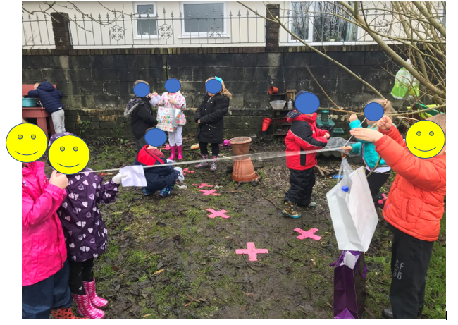
Appendix 8: 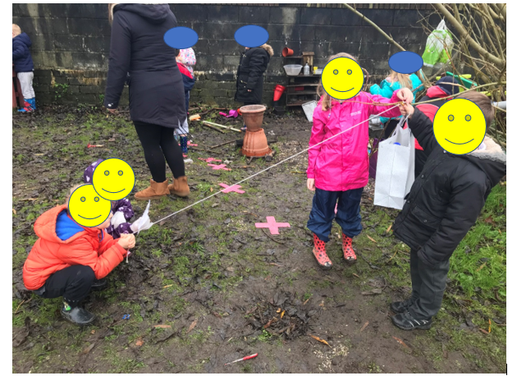
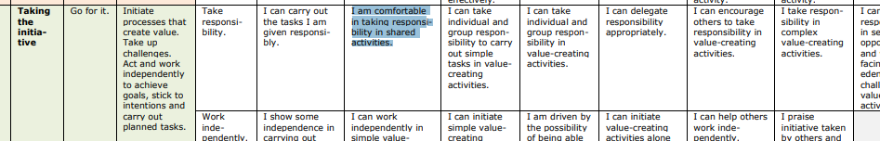
Appendix 9:

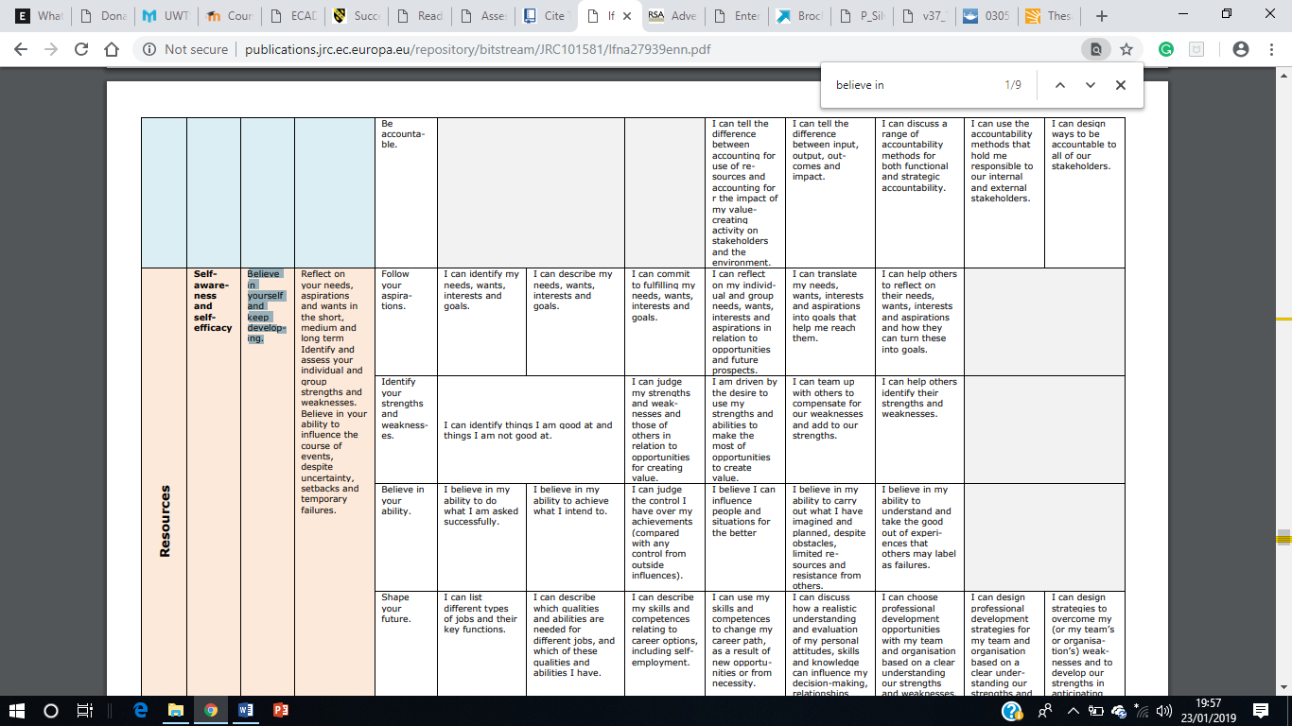
Appendix 10:

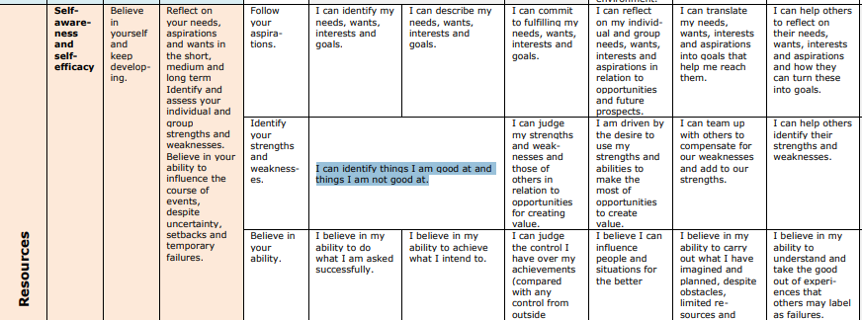
Appendix 11:

Appendix 12:
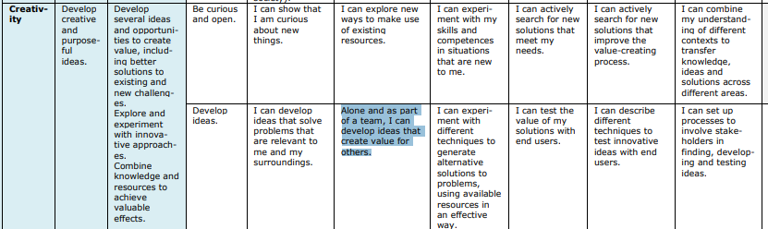

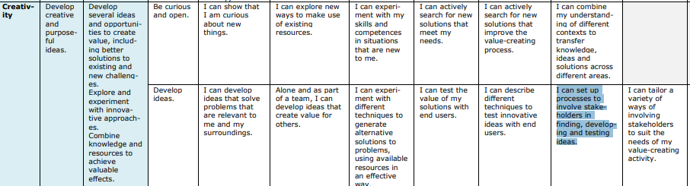
Appendix 13:

