Jon Jones (2310528)
ACCA4022 computer Architecture & OPERATING SYSTEMS Assignment

DDA Computing

Contents
Task 1 Key functions of general Operating Systems 2
Process management. 3
Memory management 5
System Security 6
Device Management 8
File Management 9
Task 2 Use of Widows OS CLI commands 10
Task 3 Use of Linux OS CLI commands 17
Task 4 Use of windows OS Scripts 21
Task 5 Use of Linux OS Scripts 27
Conclusion 33
Reference List 34
Appendices 36
OS Types 36
Engagement with online certified course 39

Task 1 Key functions of general Operating Systems

The computer operating system [OS] is a vital part of modern computers, it acts as an interface between the user, the software you are going to use and the hardware components that make up the computer.
The OS can be broken down into two parts:
The System software – This is the software that the user uses to instruct the computer what to do.
The Kernel – This is also system software; however, this communicates between the computer applications and the hardware components such as the CPU, memory, graphic cards etc. [1]
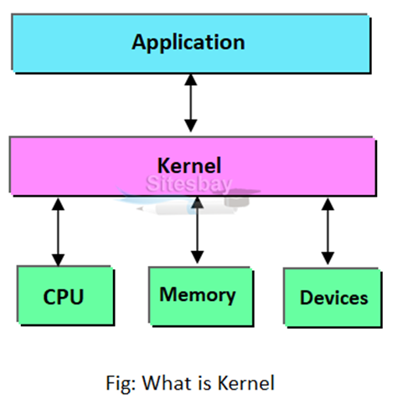

The key functions of the OS can be broken down into the following:
Process Management
Memory Management
System Security
Device Management
File Management

Process management.

When a computer is running, there can be many processes running in the background. Each of these processes may require certain actions to be carried out including,
- CPU time
- Access to memory
- Carrying out input output actions
- Using storage.
The OS manages and schedules these actions. By carrying out these actions effectively, the use of the system can be optimised, the computer runs more stable and provides the user with a better experience. [2]

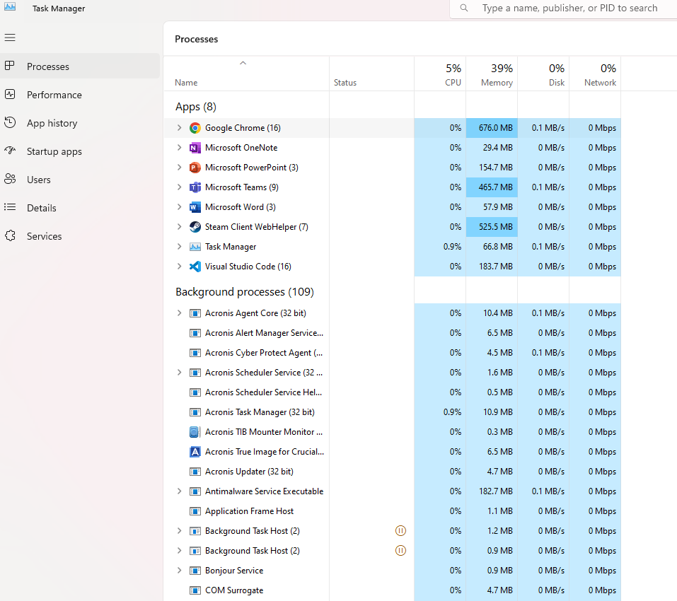
Windows O/S provides Task manager. It is a tool that allows you to see what applications/processes are running. It allows you to see how much each of these programs/process’ are using CPU and memory. [3]

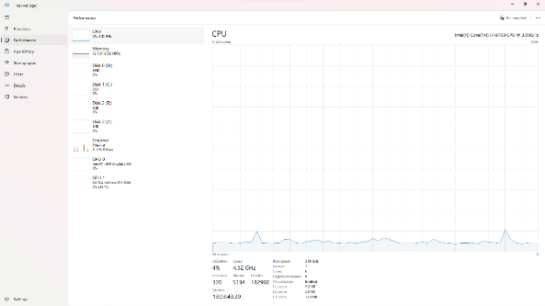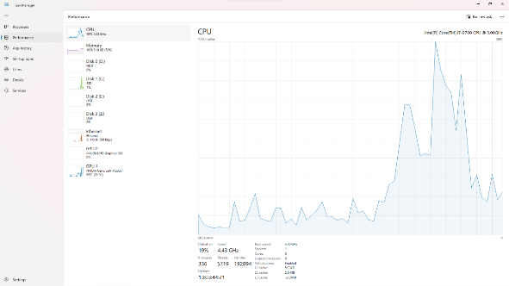
CPU usage prior to starting a game CPU usage after starting a game

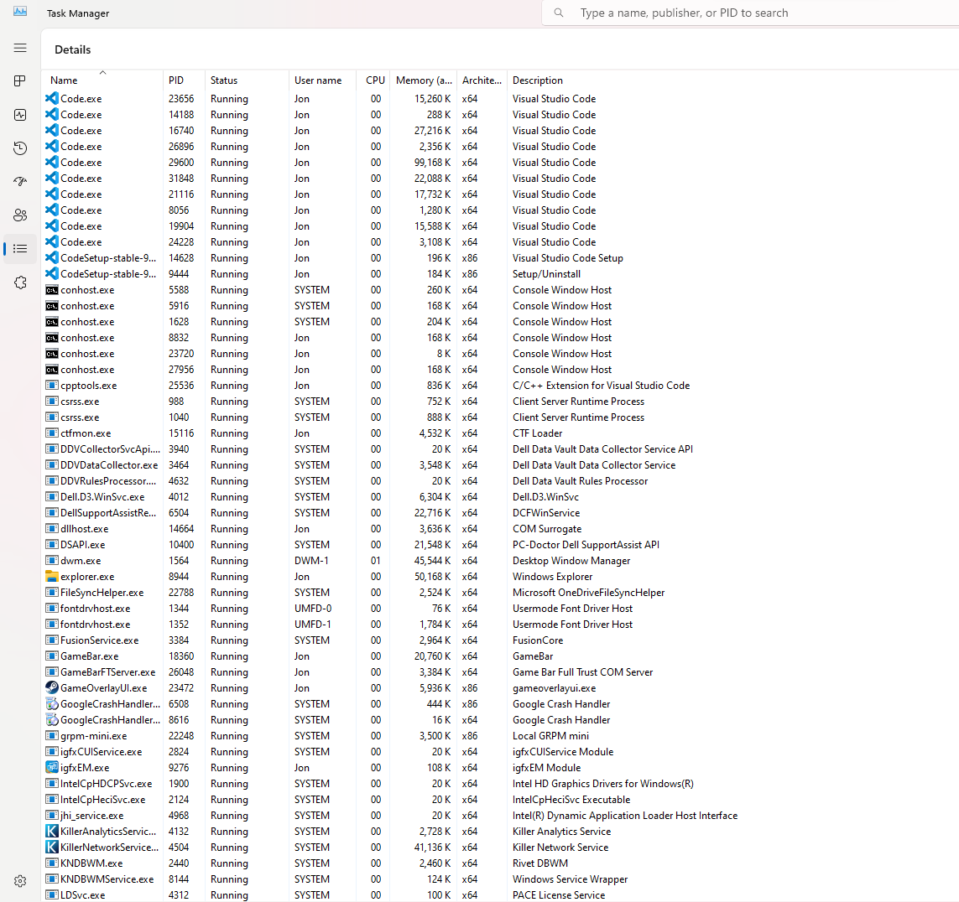
Expanded look at processes giving more information.

Memory management
The OS manages the memory (both free and used) of the computer both in its physical and logical locations. [4]
It allows it to be shared between processes which require to use it.
It also reallocates memory when no longer needed for other processes that do.
Resource Monitor is a utility provided for windows computers. It allows you to deep dive into what the CPU, disk, network are memory are doing. A very handy to trouble shoot issues.
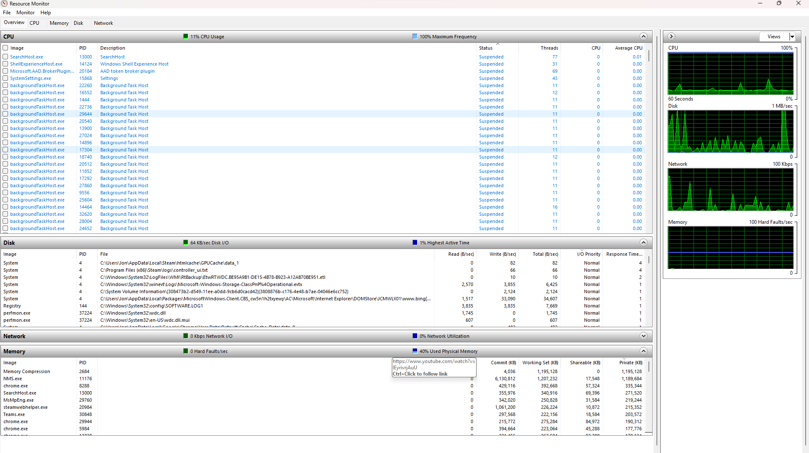

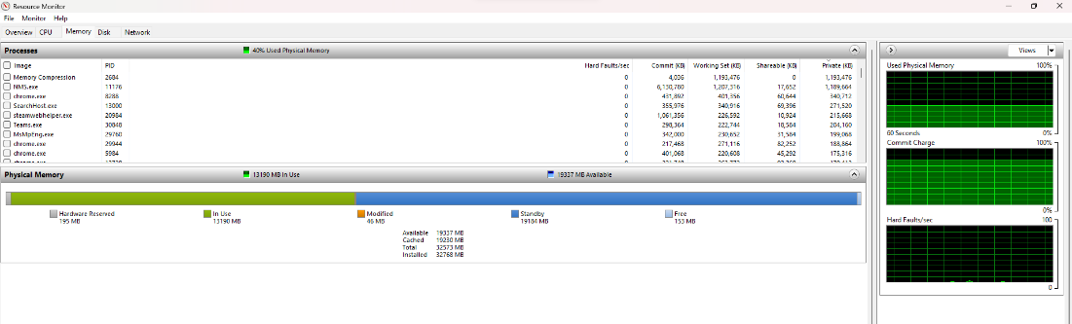

System Security
The intent of system security is to protect from threats, ensure confidentially of data on the computer and along with allowing the system to be highly available.
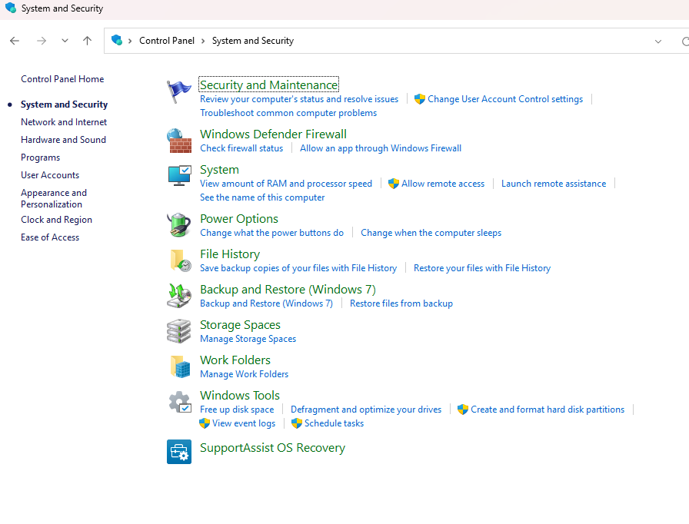

Some examples of how this security is implemented include:

Providing regular updates
Updates to address new known new threats are vital. Windows as an example issue monthly security updates on the second Tuesday of the month to address vulnerabilities found in drivers etc. [5]

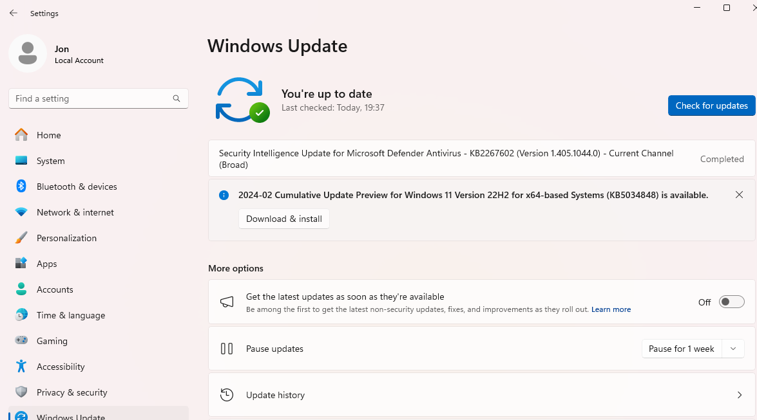

Authorisation
Authorisation to make sure those trying to access the computer are in fact allowed to. This could be by a password, Multifactor authentication or by using some biometric data.
https://www.benchpartner.com/access-authorization-and-authentication-in-operating-system

Network Firewalls and Anti-Virus protection
A network firewall assesses traffic network traffic coming into and leaving your computer. Rules can be set up to decide what traffic is allowed to enter/leave your computer. As examples these rules could be IP address, the classification of traffic it is or which port it is being sent from/to.
Antivirus protection Is a program that can identify, quarantine, and remove any malicious code that is on your computer. Windows comes with Windows Security [6]
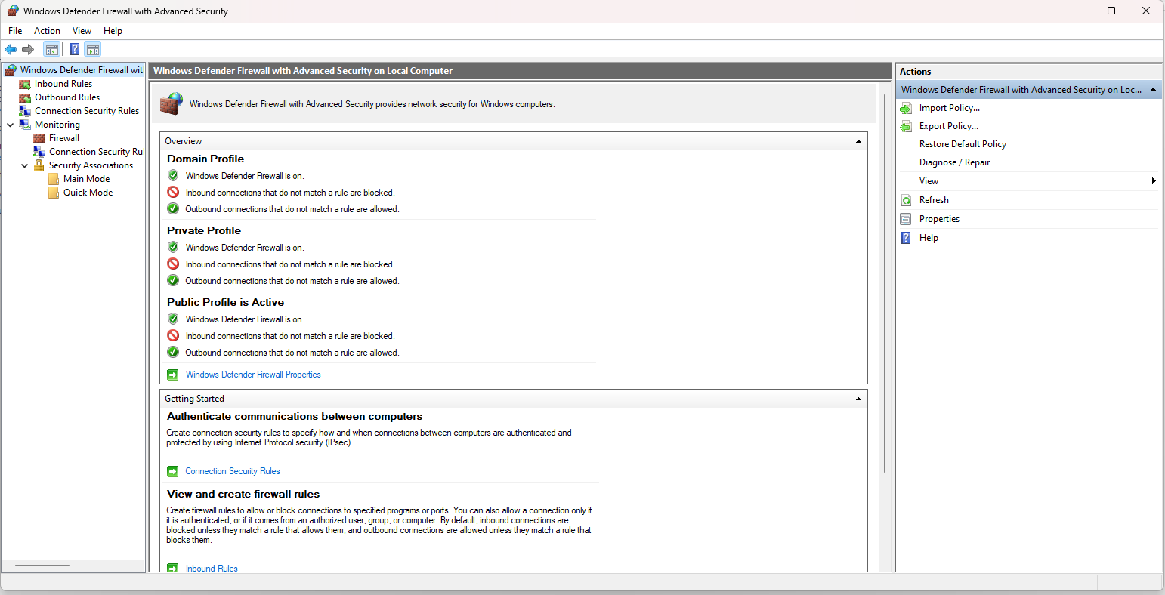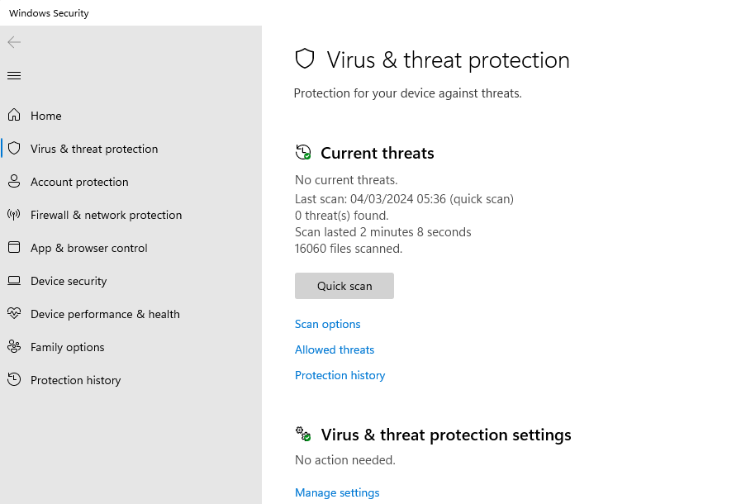

Device Management
Whilst the motherboard and CPU make up the most important part of a computer, they still require other components to make it usable and useful to a user. Many of these components are not necessarily just manufactured to work for one operating system. To get around this issue, software programs known as drivers are written for each specific operating system. This allows the same hard disk (as an example) to be used in computers which maybe running Windows, Mac or Linux.
The OS will communicate with the driver to ensure that whatever is required from the component takes place.
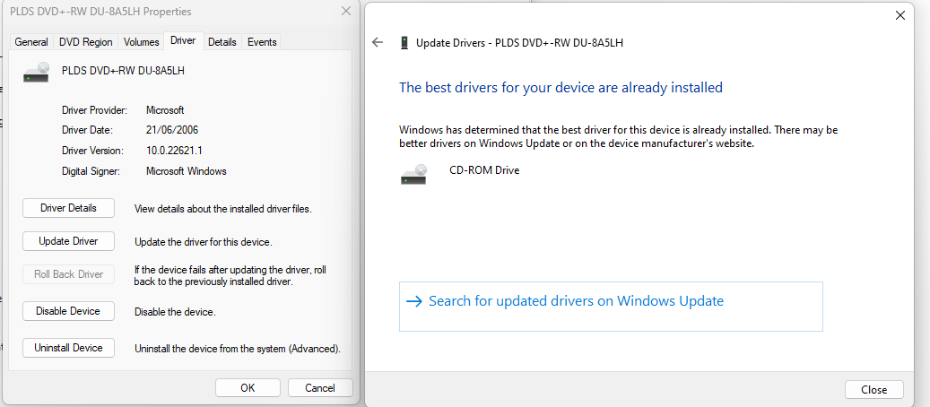

File Management
The computer OS will allow us to create, read, update, and delete data. These are structured as files and stored in folders/directories.
The OS must ensure that these actions are only provided to those who have permission to. For example, a file maybe set for a certain user to read the file but not be able to amend the file or in fact may not be able to access the file at all. [7]

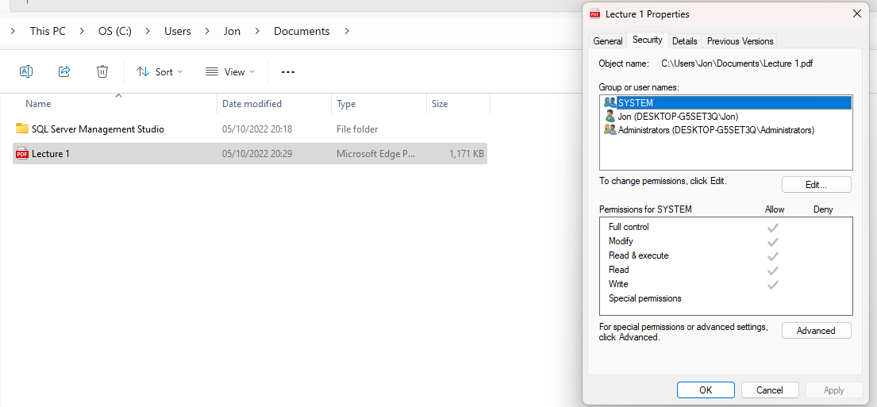

Task 2 Use of Widows OS CLI commands

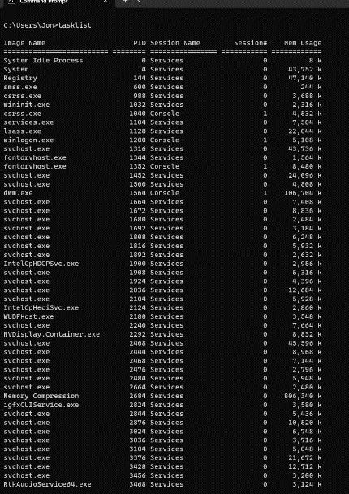
Earlier we looked at Task Manager, where one of its features was showing what processes/task were running. tasklist, is the batch command that does that for you within the CLI.
A list of process with a unique Process ID, what kind of session, how many sessions of that task are running and its memory usage.

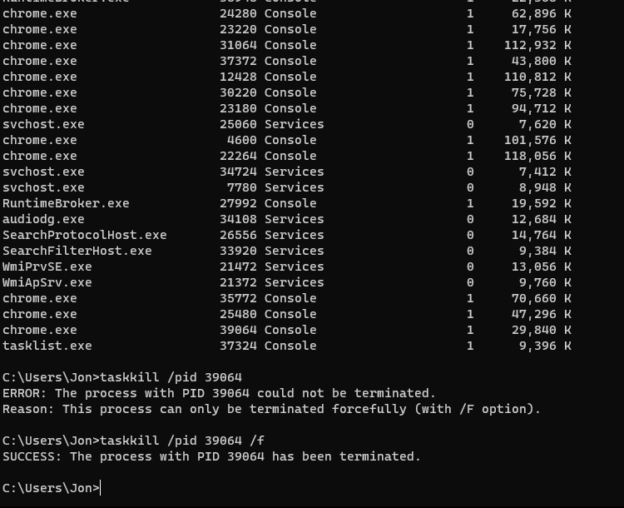
Sometimes a program you are using may not shutdown properly and is left ‘hanging’. This may be due to a task which the program is dependent on has stopped will not finish.
taskkill allows you to shut this down. The example given here uses the PID of the test to shut it down. By adding /f to the end of the command forces the program to shut down

CLS simply clears the existing text from the shell. It helps to declutter the screen when you have run several commands, and the screen looks messy.

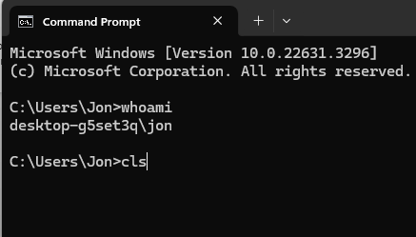
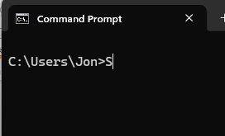

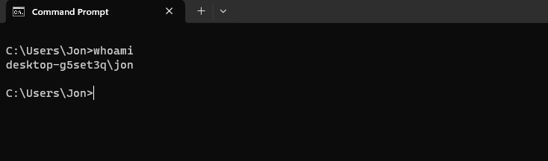
whoami, will provide you with what domain/workgroup and the user that is currently logged in.

Ping tests a network connection from the computer it is ran from to another computer with an accessible network.
The addition of /t will send a continuous ping request. This can be used to know when a virtual machine is back online after being restarted.

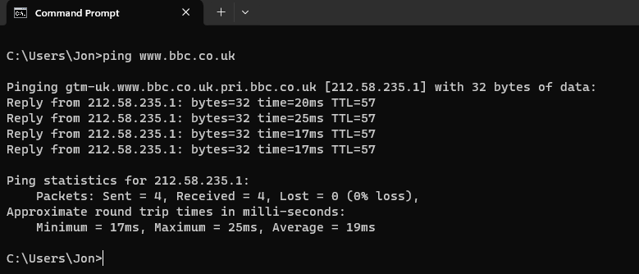

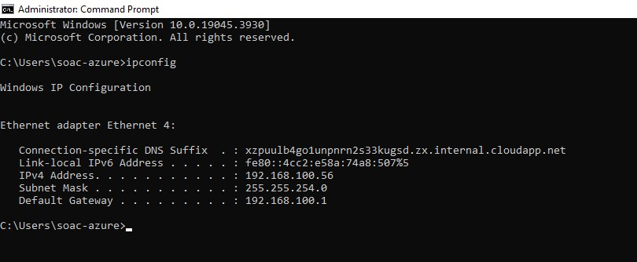
Ipconfig
Another networking command, ipconfig will display your computers network set up including:
- ipv4 address
- ipv6 address
- Default gateway
- subnet mask

Dir will display the files, folders, and subfolders of the current directory.
With the example shown 15 folders with the C:\users\soacazure.directory.
No files exist in this directory.
It also shows the time and date that folder was last amended.
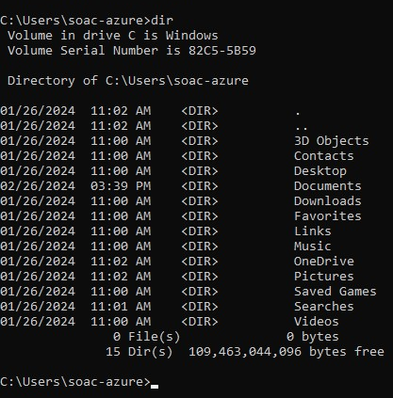

Cd allows the user to change the current working directory.
Using CD without any other options will display the current working directory. [8]

cd.. will move the user up on directory.
The example shown moves the user form c:\users\soac-azure to c:\users
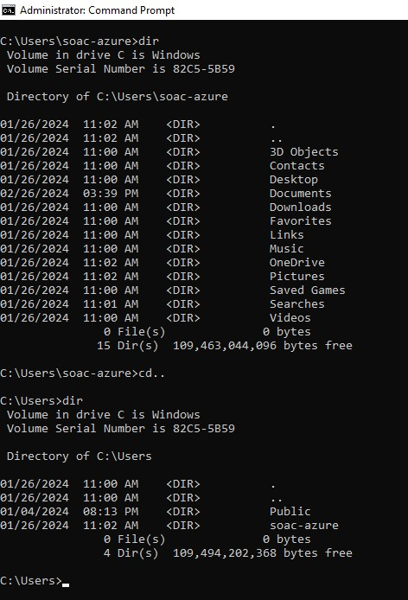
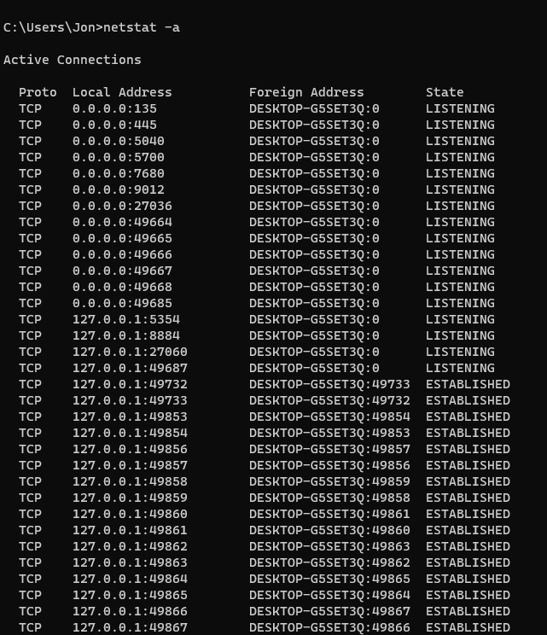
Netstat is a command that monitors the traffic on a network
This can be useful for trouble shooting networking problems
Netstat -a will list all connections and listening ports
In the example shown there are 16 established connections all using the TCP protocol. [9]

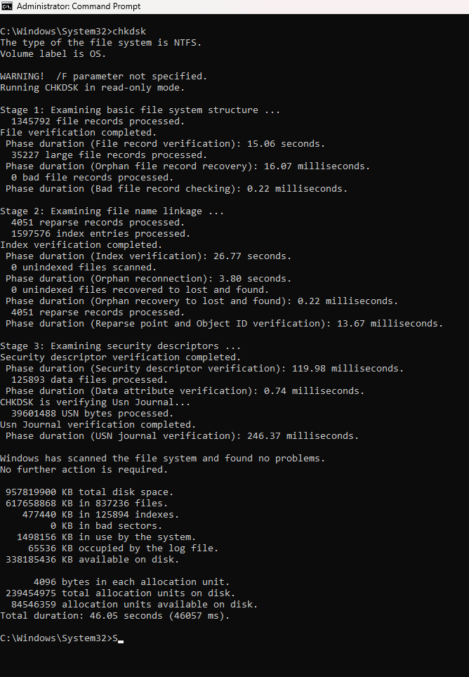
Chkdsk is a tool to check a computer disk.
It can scan and repair errors keeping the disk in good working order and can help free up space.

The chkdsk was run in this example which found no problems. Had there been problems found the command would have given options to repair the errors.

Task 3 Use of Linux OS CLI commands
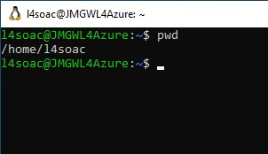
Pwd stands for print work directory. This dates to when output from computers was printed out rather than displayed on screen. It displays the current working directory.

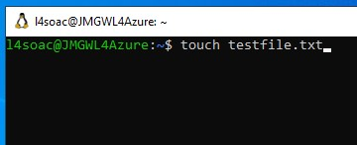
Whilst Touch is primarily for amending time stamps on files, it can also be used to create a file. In the example a file called testfile.txt

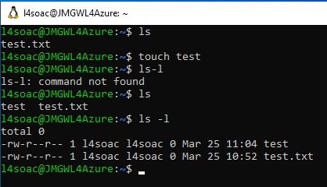
Ls lists the contents of the current directory, used on its own it produces a list of the contents.
Adding -l provides much more information. [10]

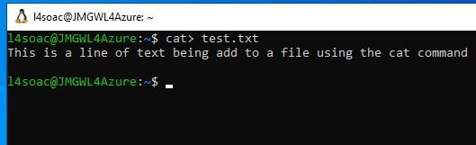
Cat is for concatenating a file. When it’s used on an empty file it will write to it also.
Cat > filename allows you to write to the file.
Cat filename will show the contents of the file. [11]
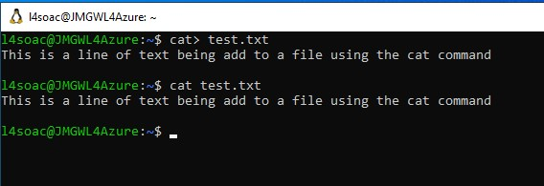

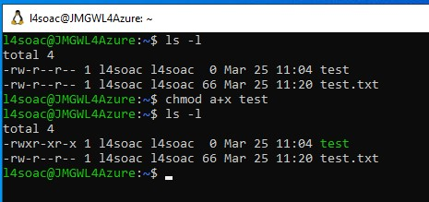
Chmod
Chmod is used to amend the privileges assigned to a file in the first example test file has -rw-r—r meaning the owner can read/write the file, whilst the group and any other users can read only.
Using chmod a+x test
The test file now allows all users to execute that file.

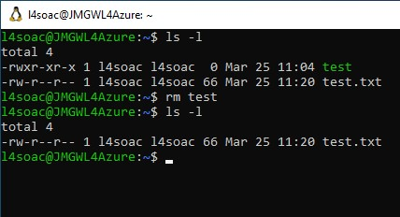
Rm
Deletes a file/directory.

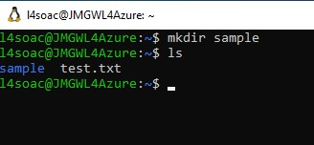
Mkdir
Makes a new directory.

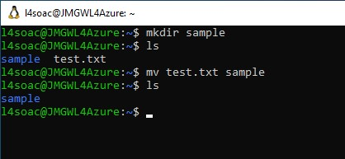
Mv moves a file from one directory to another.
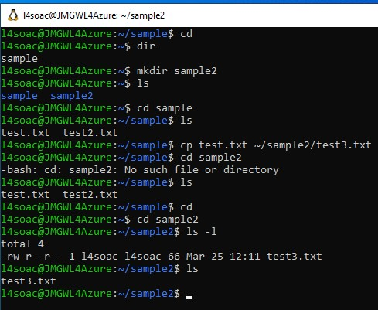
Cp
Copies a file. Provide the file to be copied and then the name of the new file.

You can also copy a file to a new directory b adding ~/ in-between the files names.

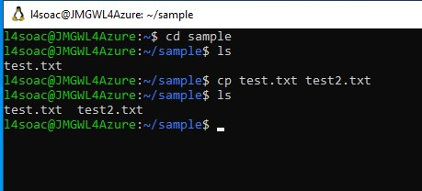

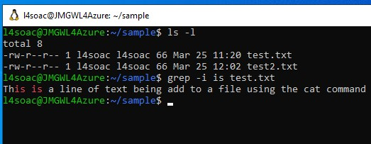
GREP stands for global regular expression print.
It searches for text within files.
The first example searches for is in the test.txt file -i is added to exclude case sensitivity.
The second example searches for this in all files. This used by using a wildcard *

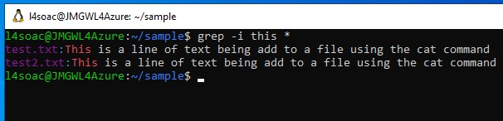

Task 4 Use of windows OS Scripts
The bash script created is a menu giving the user three options
- To Ping a server
- Display the IP configuration
- Start a counting program
This section is called the :menu section The CLI will wait for an input. Once the user provides an input, the value is stored in a variable called option
The program will then check that value against a list of IF options. If option has a value of 1 goto a section of the program called option1

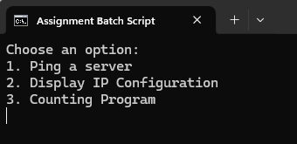
Choosing option 1 (the :option1 section) the user is taken to a new screen and asked to provide a website they wish to ping. That website is stored in a new variable and added to the end of the ping command Provided the website is a valid website, the ping results are displayed
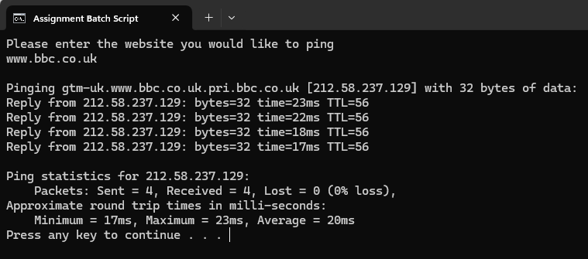
A new screen is started asking if they user wants to return to the menu or exit (called the :retry section). Their answer will send them to two separate areas either: menu section or the :goodbye section
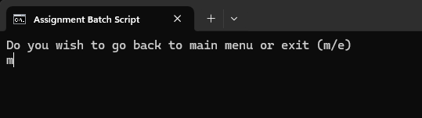
Menu was selected and went and selected number 2 (:option2 section). A new screen was opened and displayed the IP configurations using the command IPCONFIG.
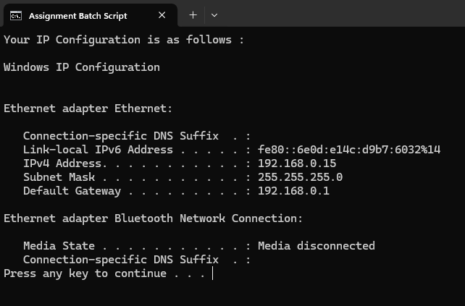
This time the third option was chosen (:option3) which is a counting program a number of variables are input by the user a starting number, a finishing number and what increment it is to be counted in.
Using a loop and an if statements the number pattern is iterated.
Attention is drawn to an issue found regarding getting the loop to work. The command setlocal enabledelayedexpansion needs to be added to make the loop to work. I found an article which helped me overcome this issue [12].
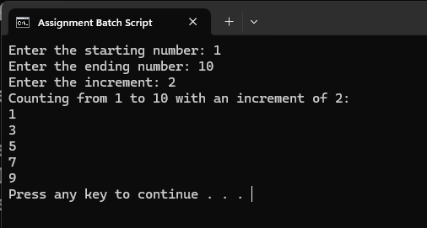
Error handling was addressed with regards to choosing which option. If any value that is not a 1,2 or 3, an error message is displayed, and the user is sent to: menu section of the program to select again.
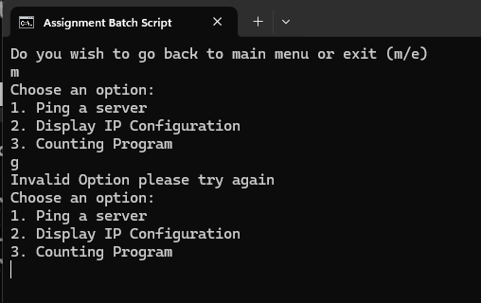

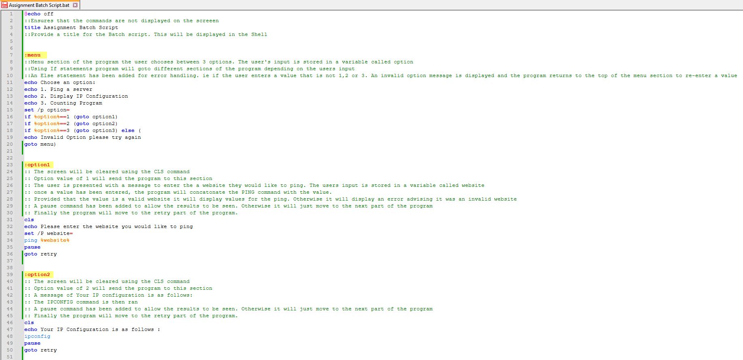
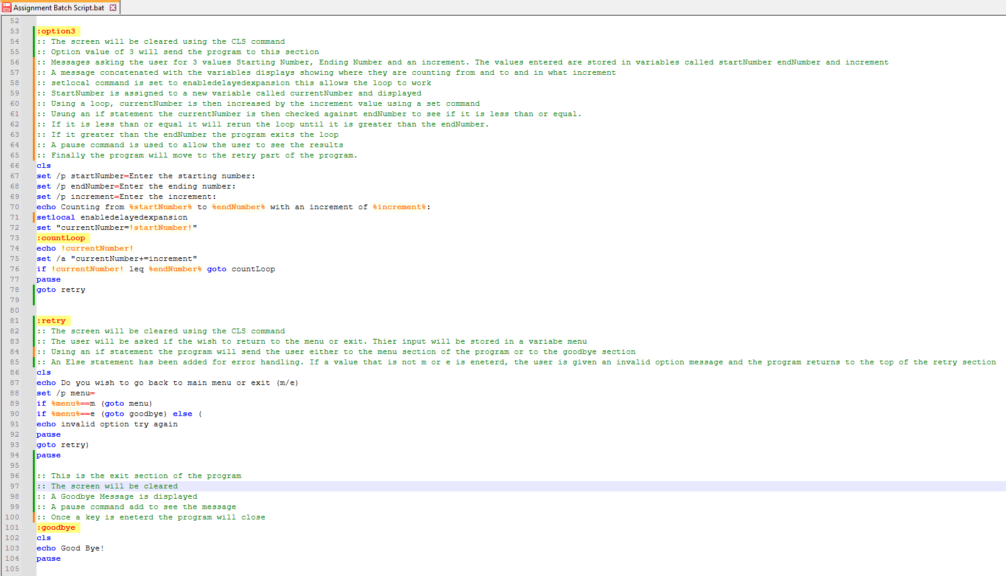

Task 5 Use of Linux OS Scripts
The script displayed below is a basic calculator allowing to add, subtract, divide and multiply two numbers. An additional option has been added that will let you enter numbers into an array and the program will give you the total and whether the number is even or not.

A Menu function was made to enter your option. Using a case statement each option will take you to a new function to carry out the calculation required.
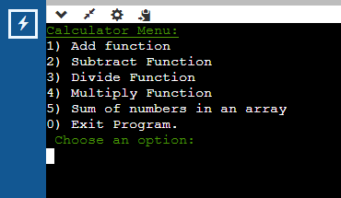

Option 1 – Function ADD called upon. This calls in another function numberInput as this is used in majority of calculations. The numbers are stored as variables, and the add function adds numbers and outputs the results. A further function is then called on returnToMenu. This allows a key to be pressed which will clear the screen and return to the menu.
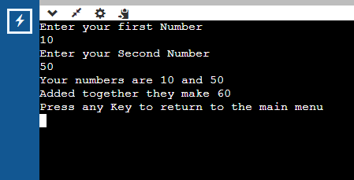

Option 2 – Function sub called upon and follows the same routine as the previous option apart from subtracting.
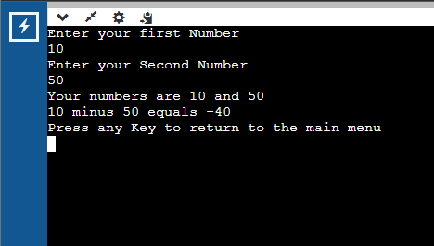

Option 3 Function div called upon. Same as above but divides.
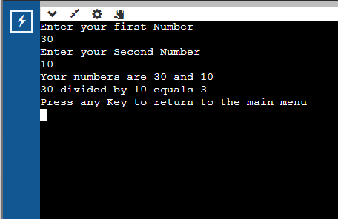

Option 4 Function mult called upon. As above, but divides.
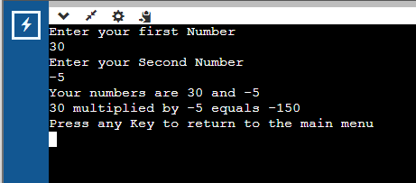

Option 5 This calls on a function called arraySum. A variable called tot is initialised to 0. The reason this is important is that if you repeat the calculation, it will still hold the value from the last time the calculation was carries out. Next an array was declared. The user’s input is then entered into an array.
Using a for loop the array is iterated taking the current array value and adding it to a variable called tot. The tot variable is then displayed. Using an if/then statement the tot variable is checked to see if it is odd or even. That is done by using the modulo operator. I struggled to get this working and had to search for this online. [13]

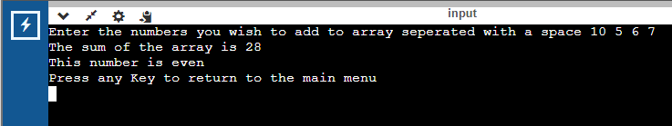

The diagram below shows what happens if the user enters an invalid input. They are sent to the invalid function. Which advises that they entered something invalid and then returned to the menu through the menu function.
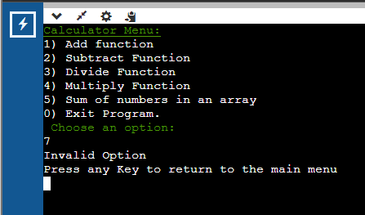

Finally, if 0 is chosen the are sent to the Exit function and the program is then exited.
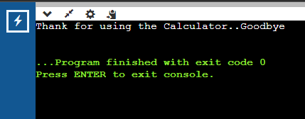

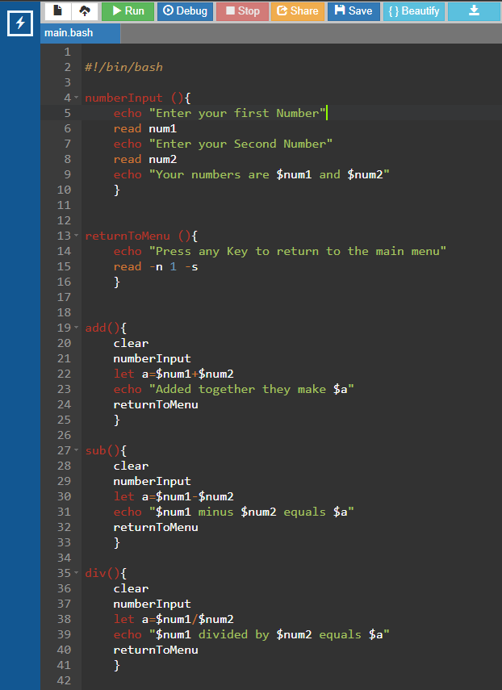

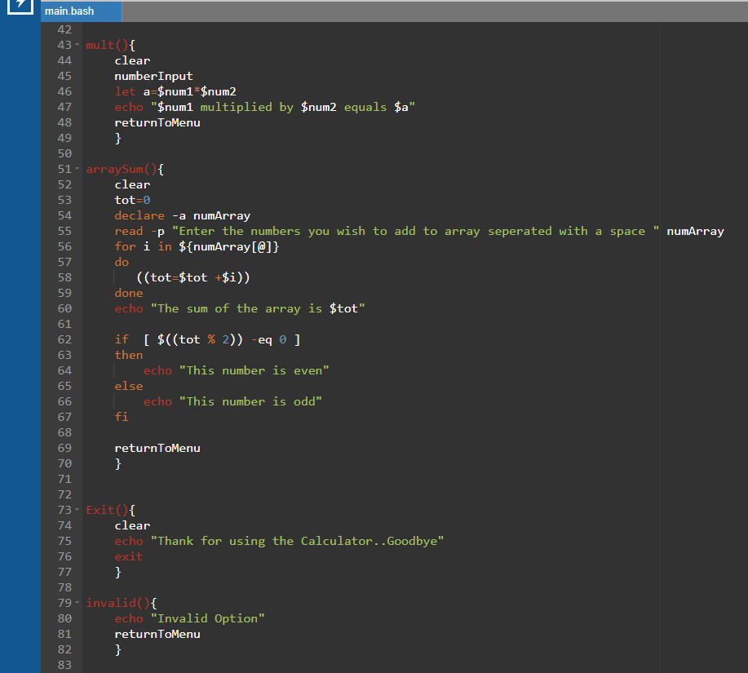

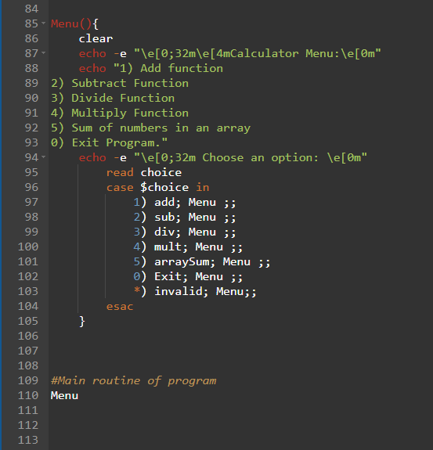

Conclusion
In conclusion the OS can be seen as an essential part of any computer. There are many types of OS that are suitable for different uses cases. The OS can be accessed both by a GUI or a command line. With the help of scripts, many tasks can be automated.

Reference List
[1] "What is Kernel and Its main Functions." https://www.sitesbay.com/index. https://www.sitesbay.com/os/os-kernel-and-its-functions-in-operating-system (accessed 02-04-).
[2] "Process Management in Operating Systems." www.studysmarter.co.uk. https://www.studysmarter.co.uk/explanations/computer-science/computer-systems/process-management-in-operating-systems/ (accessed 02-04-).
[3] C. Hoffman. "Windows Task Manager: The Complete Guide." https://www.howtogeek.com. https://www.howtogeek.com/405806/windows-task-manager-the-complete-guide//405806/windows-task-manager-the-complete-guide/ (accessed 02-04-).
[4] "Memory Management in Operating System." https://www.geeksforgeeks.org. https://www.geeksforgeeks.org/memory-management-in-operating-system/ (accessed 02-04-).
[5] M. Branscombe. "Everything you need to know about Windows updates." https://www.techrepublic.com. https://www.techrepublic.com/article/everything-you-need-to-know-about-windows-updates/ (accessed 02-04-).
[6] "What is an antivirus product? Do I need one?" https://www.ncsc.gov.uk. https://www.ncsc.gov.uk/guidance/what-is-an-antivirus-product#:~:text=An%20antivirus%20product%20is%20a,and%20the%20data%20on%20them. (accessed 02-04-).
[7] D. Goodwin. "Operating Systems File Management." https://warwick.ac.uk/. https://warwick.ac.uk/fac/sci/physics/research/condensedmatt/imr_cdt/students/david_goodwin/teaching/operating_systems/l5_filemgt2013.pdf
[8] "cd." https://learn.microsoft.com. https://learn.microsoft.com/en-us/windows-server/administration/windows-commands/cd (accessed 02-04-).
[9] "Netstat explained." fasthosts.co.uk. https://help.fasthosts.co.uk/app/answers/detail/a_id/1552/~/netstat-explained (accessed 02-04-).
[10] "ls Command in Linux." https://www.geeksforgeeks.org. https://www.geeksforgeeks.org/ls-command-in-linux/ (accessed 02-04-).
[11] R. Saive. "How to Use the Cat Command in Linux [22 Useful Examples]." https://www.tecmint.com. https://www.tecmint.com/cat-command-linux/ (accessed 02-04-).
[12] S. Sheppard, "EnableDelayedExpansion", https://ss64.com, https://ss64.com/nt/delayedexpansion.html (accessed 02-04-2024).
[13] A. Yekeen. "Examples of the Modulo Operator in Bash." https://www.baeldung.com. https://www.baeldung.com/linux/bash-modulo-operator (accessed 02-04-).
[14] "Desktop Operating System Market Share Worldwide
Mar 2014 - Mar 2024 ." https://gs.statcounter.com. https://gs.statcounter.com/os-market-share/desktop/worldwide/#monthly-201403-202403 (accessed 02-04-).
[15] K. &. M. Mingis Sean. "The evolution of macOS (and Mac OS X)." https://www.computerworld.com. https://www.computerworld.com/article/1622131/evolution-of-macos-and-mac-os-x.html (accessed 02-04-).
[16] "Open Source - Linux Kernel." https://www.codecademy.com. https://www.codecademy.com/resources/docs/open-source/linux-kernel (accessed 02-04-).
[17] "What is Edge Computing?" https://aws.amazon.com. https://aws.amazon.com/what-is/edge-computing/ (accessed 02-04-).

Appendices

OS Types

Operating systems (OSs) play a pivotal role in computing, offering platforms tailored to diverse needs across personal devices, servers, and specialized environments. Here are a few examples:
Windows:
Among the most widely recognised OS’s is Windows, developed by Microsoft. Known for its user-friendly interface, extensive software compatibility, and widespread adoption in the desktop market, Windows has become the go to for personal computing needs. [14]
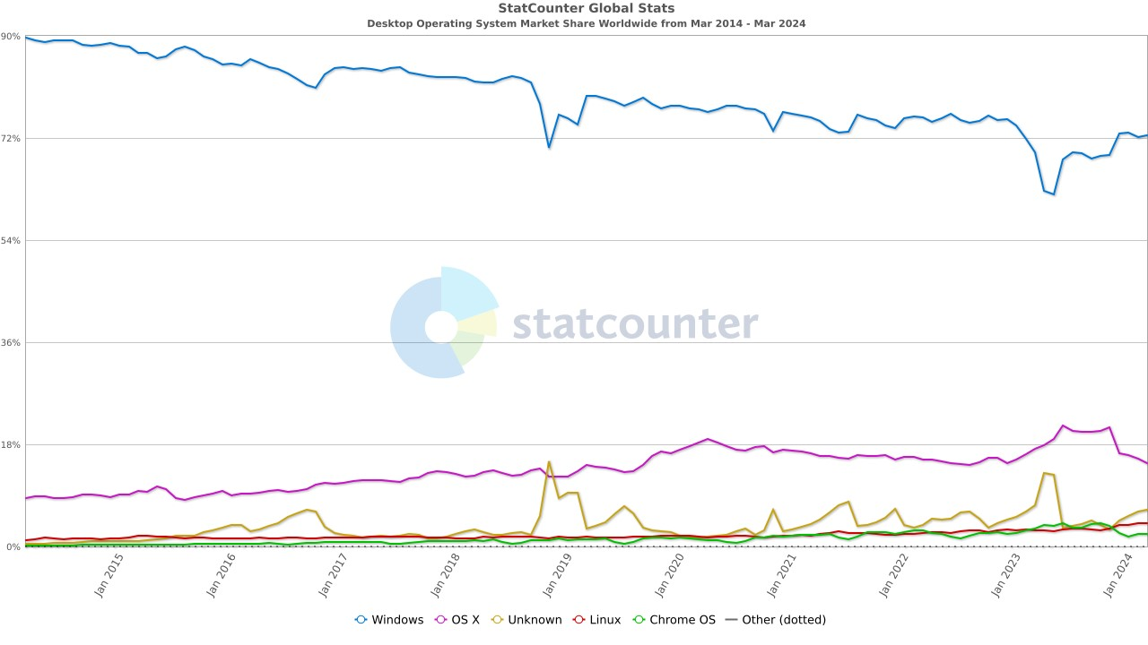
macOS:
Crafted by Apple, macOS (previously known as Mac OS X and OS X) is celebrated for its sleek design, stability, and seamless integration within the Apple ecosystem. It appeals to users seeking a cohesive experience across their devices, offering a range of productivity and multimedia features.[15]

Linux:
Linux, an open-source kernel, underpins a multitude of distributions, each with its unique strengths. Renowned for its flexibility, security, and community-driven development, distributions like Ubuntu, Fedora, and Debian cater to various preferences and requirements. [16]

iOS:
iOS, developed by Apple, dominates the mobile market with its seamless user experience, stringent security measures, and deep integration with Apple's services. It is favoured by users invested in the Apple ecosystem for its reliability and ecosystem integration.

Android:
Android, developed by Google, is known for its customisability, vast app ecosystem, and broad device compatibility. As the most widely used mobile OS globally, Android offers users a diverse range of devices and customisation options.

Chrome OS:
Chrome OS, developed by Google, offers a streamlined experience optimised for web-based applications, particularly on Chromebooks. It targets users with lightweight computing needs, such as students and business professionals, providing efficient access to cloud-based services and applications.

UNIX:
UNIX and its derivatives remain prevalent in server environments, prized for their stability, security, and robust performance. While less common on personal computers, UNIX variants are widely used in enterprise-grade infrastructure for their reliability and scalability.

Edge OS:
Edge operating systems cater for the Internet of Things (IoT) landscape, offering efficient real-time processing and connectivity at the network edge. These OSs prioritise efficiency, reliability, and seamless integration with IoT devices and services. [17]
Enterprise OS:
Enterprise-grade OSs like Windows Server and Red Hat Enterprise Linux deliver centralized management, scalability, and security features tailored to the demands of business environments. They provide robust infrastructure solutions for large organizations, ensuring reliability and performance across diverse computing environments.
Conclusion
In essence, the diverse landscape of operating systems offers users a multitude of choices, each catering to specific needs and preferences across personal computing, mobile devices, and enterprise-grade infrastructure.

Engagement with online certified course

As part of the module, I took the NDG Linux Unhatched course.
https://www.netacad.com/courses/os-it/ndg-linux-unhatched
Attached are a few screenshots showing my engagement with the course.



