

Assignment 1

Name: Brigitta Horváth
Student ID: 2213952
Module code: LCBB4004
Module name: Marketing Fundamentals
Lecturer: Dr. Piyumika Kithulgoda Gamage

Table of content

Tommy Hilfiger background 3
Marketing Strategy 4
Demographic Segmentation 4
Targeting 4
Positioning 7
4P Strategy 8
Product stategy 8
Price strategy 9
Place strategy 9
Promotion strategy 10
SWOT Analisys 11
Strengths 11
Weaknesses 12
Opportunities 12
Threats 13
References 14

Tommy Hilfiger background



In 1985, Thomas Jacob Hilfiger set up Tommy Hilfiger Co. in New York. It is an American luxury fashion brand also known as Tommy Hilfiger Inc. The brand has four diffusion lines but the core line is Tommy Hilfiger sportswear. They started with only one men’s collection but now they are also producing clothes for women and kids, footwear, eyewear, accessories, home furnishings, and fragrances. This business was his second try, the first one; People's Place was bankrupt in 1975 despite the company used to have 10 stores (Telegraph, 2015).
The brand is available in more than 90 countries and has more than 1400 retail shops, so it is pretty much all over the world. In 2010 the brand has been sold to PVH Co. (Phillips-Van Heusen Corporation) who already has more famous labels such as Calvin Klein. Thomas Hilfiger, the founder remained the principal designer and he is controlling the whole creative process within the company (Wikipedia, n.d.). This business has won many awards so far e.g. the British GQ’s design legend of the year in 2020 (Wightman-Stone, 2021).

Marketing Strategy

Demographic Segmentation

The demographic segmentation has broken down to income, age, and gender. The brand's core style is Tommy Hilfiger sportswear however, the Tommy Jeans line (until 2018 it was called Hilfiger Denim) is growing big as well. Meanwhile the Tommy Hilfiger line focuses on the 25-40 age group, the Tommy Jeans is targeting a younger generation; 18-30 years. As the Tommy Hilfiger line assumes higher income from the aim age group, the products are in between $29,50-$390, in contrast the Tommy Jeans thread is slightly cheaper, the goods are in between $49-$150 (Sprinks, 2022).

Targeting

The company has a wide collection for everyone from kids to the elderly customers. The main target is the 25-40 years old people because they want to keep the brand young, fresh and cool however they want to make people know that Tommy Hilfiger is for everyone. Basically, the company has four style line. The absolute baseline is the TOMMY HILFIGER sportswear. It is internationally known that the style wants to keep up the classic American cool spirit. The collections recreate the timeless basics with a little Hilfiger twist, injecting optimism and individuality throughout the style. The target is on the 25-40 age group (Tommy Hilfiger Global, n.d.).
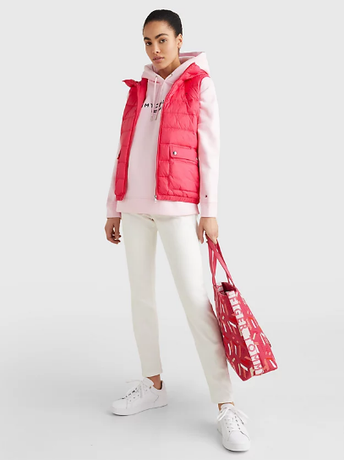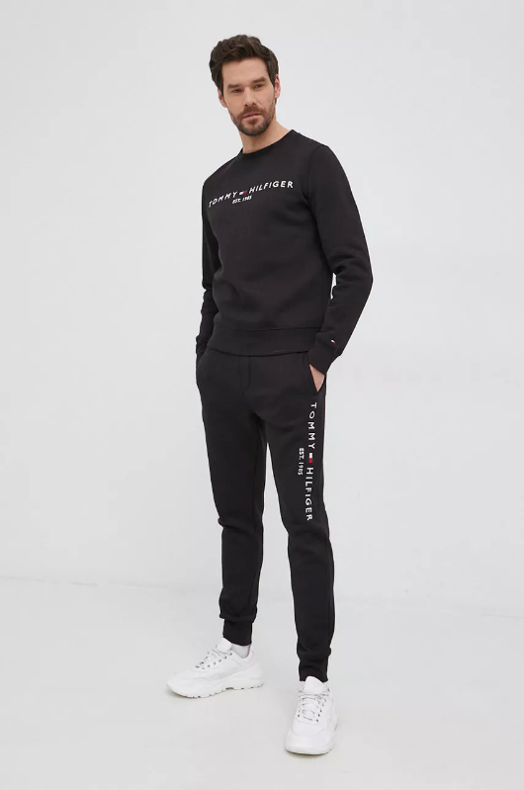

The TOMMY JEANS line has been inspired by the American unique pieces, they want the represent ordinariness and cleanness. The men's and women's collections add a youthful vibe and sassy twist to our legacy, with a focus on premium denim. This time the target is on the young generation, age between 18-30 (Tommy Hilfiger Global, n.d.).
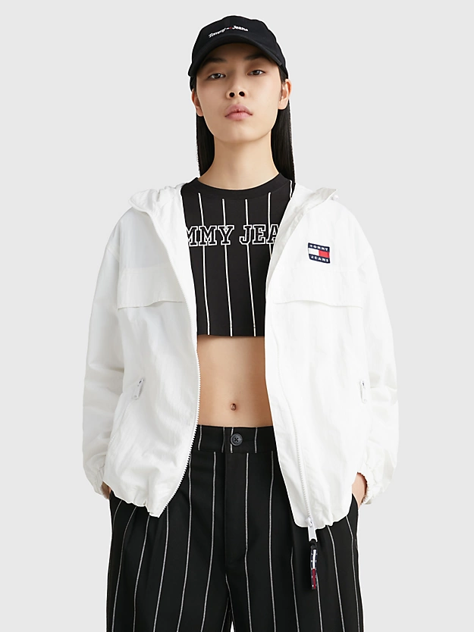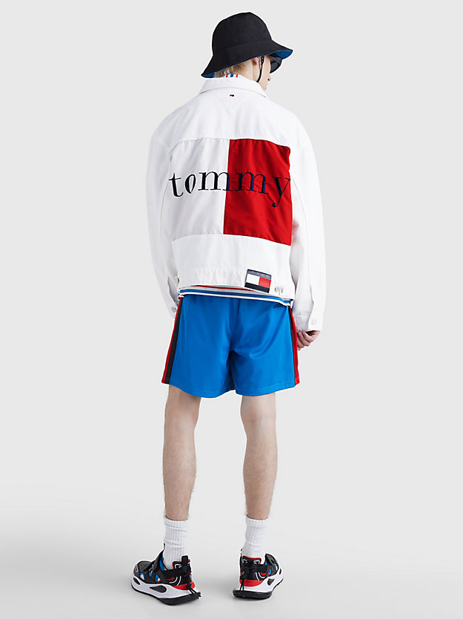

The HILFIGER COLLECTION is the apex of the Tommy Hilfiger product line. It combines the brand's American legacy with modern influences and a fun fashion edge. Historical classics are updated for the present, and the carefully chosen collection of famous pieces is creatively mixed and matched for an easy-going look that is contemporary, self-assured, and casual. It targets the age of 25-40 years (Tommy Hilfiger Global, n.d.).

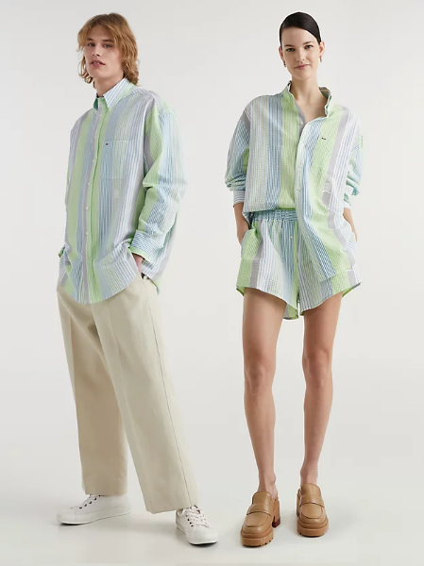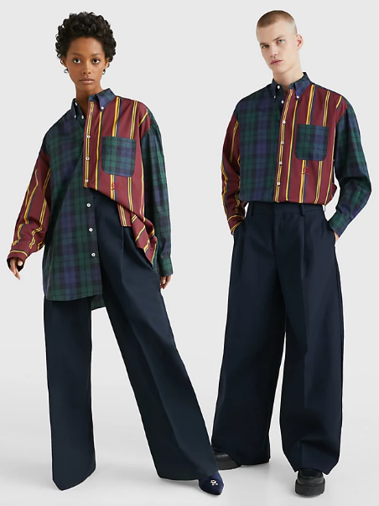

The fourth line is the TOMMY HILFIGER TAILORED. It is blending the brand's American roots with an elegant, smooth appearance. The classic pieces are represented with perfect fit, quality materials, rich colours, trendy cuts, and luxurious decorations plus, a little bit of Hilfiger's twist is essential. The result of this is fitting to every situation from structured suiting to any casual apparel. The target is on the 25-40 age group again (Tommy Hilfiger Global, n.d.).
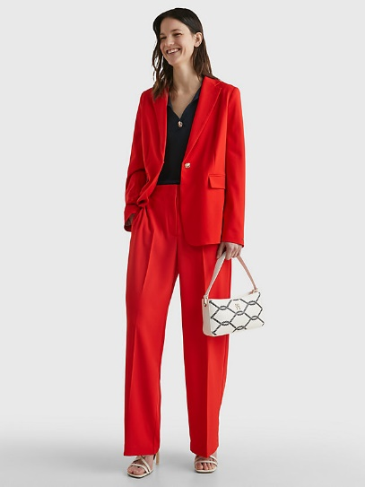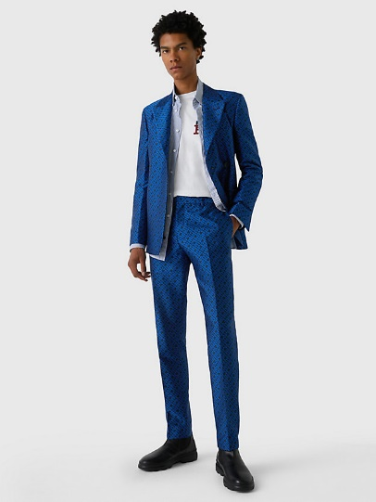

Positioning

In this industry Tommy Hilfiger is performing incredibly well. They are one of the top designer companies and holds a distinctive position among the elite designer brands. To increase the brand recognition they have a great and wide selection of products. The products are men's and women’s clothing (which is very well advertised), as well as eyewear, footwear and many more thanks for the continuous innovations. The company’s global retail sales were $7.4 billion in 2017. Tommy Hilfiger produces high-quality, fashionable designer clothes and the people want to connect with it (Bhasin, 2019).

4P Strategy

Product strategy

As a leading fashion brand, Tommy Hilfiger has a large and wide selections of clothing and a significant number of global followers. Tommy Hilfiger provides a range of high-end fashion and leisure products. They offering to the buyers style, quality and value with a modern version of the American traditional designs. It provides numerous product categories in its marketing mix which are the following: clothing, jeans, footwear, accessories (bags, watches, eyewear), fragrances and home design.
The company has four labels within the brand, which helps them to reach a wider audience while comprehending the various fashion preferences of each segment. The target market for Tommy Hilfiger's main product range (with mostly clothing and accessories) is 25 to 40-year-old consumers. It offers collection in 25 different categories plus; they have a whole Tommy Hilfiger selection for children between 0-16 years. The Tommy Jeans features are more edgy and casual styles. It is marketed to younger people aged 18-30 years old. The Tommy Hilfiger tailor serves businessmen’s sharp and elegant styles meanwhile, the Hilfiger Collection largely caters the women's elegant design with high-quality luxury materials made in Italy. Furthermore, the brand does not intend to use real fur or skin in any of its products. Since 2021 as part of their innovation, they offer a developed fashion line for the gender-neutral person too (MBA Skool Team, 2022).

Price strategy

Although Tommy Hilfiger is a greater fashion brand and charges a premium for its items, its prices are lower than those of rivals like Ralph Lauren or Lacoste. In the 1990s during their peak golden period, this has reduced the company image within consumers. During the bigger off-peak seasons, as part of their marketing mix, they use a discount-based pricing also runs product sale. As they have a modern spin on the traditional American style and they have collections that has been inspired by the pop music culture, Tommy Hilfiger is still the brand with what the people want to be identify. This allows to the business to stay in the premium market. The product's prices are high because of the brand value as well as the New York Fashion Week stage designs. This last one allows them to keep the prices higher. In a similar fashion, the Tommy Hilfiger Tailored range keeps up the premium pricing based on value-based pricing and personalized fit. The brand is well known for its relatively upscale pricing due to its exceptional level of producing clothes. The majority of the clothing costs about $10 to $500 (MBA Skool team, 2022).

Place strategy

Thanks for its extensive chain of physical locations and online stores, it has a presence all over the world and it is already a worldwide organization. Tommy hifiger serves diverse range of clients, there are currently more than 1400 Tommy Hilfiger stores worldwide, spread over more than 90 nations. The base of the company is in Amsterdam, in Neatherland. The business uses both a franchise-based approach for retail and its own outlets. It has flagship stores located in the large cities all around world- New York, London, Paris, Tokyo, Los Angeles and Düsseldorf. The shops interiors are reflected by the brand's design and the traditional American vibe. The items also can be purchased online though the company's website and some other e-commerce websites. The Tommy Hilfiger website is offering variety of languages, among others English, Spanish, Portuguese, German, French, Italian, Japanese, Dutch, Turkish in the interest of easier communication with worldwide buyers. The company is well represented online via media platforms, content creation, online advertisements, and other channels (MBA Skool Team, 2022). Thomas Hilfiger thinks it is really important to them to be present on online platforms. ‘They could go to Tommy.com, our e-commerce site, and see everything. They can go to Instagram and see special items we're doing or a new release or something we co-design with a celebrity.’ – he said (McGinn, 2019).

Promotion strategy

The company uses many platforms to efficiently sells to its target audience. It has helped to increase the brand awareness. Billboards, newspaper ads, and magazine ads are all used by the company to advertise. Thomas Hilfiger expressed in an interview with McGinn (2019) how important is being presented in the social media "We have embraced social media from the very beginning and I think it's been very successful for us as a result of being a part of the conversation and making it work for us on a global scale.". Moreover, the slogan "For the People" and famous people serving as brand ambassadors are used. Tommy Hilfiger has used to work with ambassadors since the beginning. He said in an article: 'I was dressing Puff Daddy for his tours. I was dressing Biggie Smalls. I was dressing Tupac.' when they were talking about how the brand achieved its first successes (Wolfson, 2023). The supermodel Gigi Hadid serves as its current brand spokesperson and this is what Thomas Hilfiger stated about it " After two years she had 35 million. So I think we helped each other, but we tapped in to her fan base in a big way." (McGinn, 2019). They offer discounts of roughly 10% to 15% on all product lines during the off-season or on special occasions is one way to promote sales. Also, it makes advantage of point-of-sale advertising by designing the layout of its stores to match the preppy clothing it sells. The structure of the Tommy Hilfiger shops is intended to represent the forever coolness of the American style. In 2015, they offered an extraordinary experience with an immersive virtual store and the people loved it. From the front row, the costumers could explore the 2015 Fall Hilfiger Collection in 360-degree 3D virtual world and immediately purchase items what they wanted. However, only just a few major shop and branch locations had the opportunity for this. The company has online promotions and provides exclusive deals on its website. Additionally, for its subscribers, it sends updates on new arrivals via email.

SWOT Analysis

Strengths

Tommy Hilfiger is well known as an incredibly successful international fashion brand that sells luxury apparel. The company has more than 1400 stores all over the world so, the business has a very huge worldwide supply chain. The company presents Thomas Hilfiger's own stylish, American-inspired designs. Popular celebrity sponsorships and partnerships have contributed to the brand's massive growth throughout time. ‘Obviously, influencers have a lot of social-media followers, and their followers basically listen to what they say in terms of what to wear, what to eat, where to go.’ – this is what Thomas Hilfiger said about celebrity sponsorship (McGinn, 2019). The brand popularity is boosted by commercials as well as visibility through TV ads, print articles, web forums, and online marketing. The company has received many honours and achievements on a worldwide basis. Last but not least, the leadership qualities, creative vision, and Thomas Hilfiger's never-say-die attitude have made the company what it is today. In New York, in his birthplace he started with modifying and reselling clothes what he had bought. He gained great business skill from his first company named People's place and just few years later he created this worldwide know company (MBA Skool Team, 2022).

Weaknesses

The brand is already massive, so it does not too much weakness, but there is always some. There are many well know rivalry company and for that reason the option of brand changing is high. Also, protecting and maintaining a big worldwide known business like Tommy Hilfiger costs a lot of money (MBA Skool Team, 2022). The company has long been considered eccentric and iconic. The company adapted this and reinforced it in their marketing. This was helping them a lot to develop. Although still have to a spend a lot of money to keep up the fame of the brand.

Opportunities

According to the location and culture, the growing can be achived by innovating the appearance and clothing and Tommy Hilfiger has always been good at innovations. To develop the brand, adding fresh products and offerings may assist to Tommy Hilfiger. In addition, shoppers always have very precise expectations, because of this many specialised categories have developed as a response to these requirements. For instance, there are numerous types of jeans, including skin fit, loose fit, tailor cut, and many more. These are all possible new sectors for companies like Tommy due to the presence of these categories. Furthermore, in emerging economies, the increase in disposable income can benefit from geographic expansion (MBA Skool Team, 2022).

Threats

The global recession and crisis could be harmful to the company because it could result in decreased demand for the luxury products. Also, the rapidly shifting fashion trends can possibly cause stocking problems for a huge company like Tommy Hilfiger. Furthermore, the sequential rivalry between the intetrnational brands may result in a reduction in the company's income. The biggest competitors are Ralph Lauren, Wrangler, Lee, Levis, Nike, and Adidas. Finally, the number of internet sellers has exploded, and many of these businesses sell their own products too next to the Tommy Hilfiger items. This makes them be a possible competitor to Tommy Hilfiger. (MBA Skool Team, 2022).

References

Bhasin, H. (2019) Marketing Strategy of Tommy Hilfiger – Tommy Hilfiger Marketing Strategy. Available at: https://www.marketing91.com/marketing-strategy-of-tommy-hilfiger/ (Accessed: 29 May 2019).

MBA Skool Team (2022) Tommy Hilfiger Marketing Strategy & Marketing Mix (4Ps). Available at: https://www.mbaskool.com/marketing-mix/products/17309-tommy-hilfiger.html#product (Accessed: 24 Jan 2022).

MBA Skool Team (2022) Tommy Hilfiger SWOT Analysis, Competitors & USP. Available at: https://www.mbaskool.com/brandguide/lifestyle-and-retail/2644-tommy-hilfiger.html (Accessed: 24 Jan 2022).

McGinn, D. (2019) Tommy Hilfiger explains how social media is driving the fashion industry today: Fashion designer Tommy Hilfiger discusses how social media affects retailers and consumers, and how to keep up in an age of instant gratification. Available at: https://www.proquest.com/blogs-podcasts-websites/tommy-hilfiger-explains-how-social-media-is/docview/2382323257/se-2?accountid=130472 (Accessed: 3 June 2019).

Spinks, A. (2022) Tommy Hilfiger Vs Tommy Jeans: How Do These Brands Differ?. Available at: https://chicpursuit.com/tommy-hilfiger-vs-tommy-jeans/#:~:text=The%20history%20of%20Tommy%20Jeans%20The%20Tommy%20Jeans,the%20same%20clothing%20for%20the%20same%20target%20market. (Accessed: 19 July 2022)

Telegraph (2015) Flashback: Tommy Hilfiger remembers his first shops. Available at: https://web.archive.org/web/20151117032313/http://fashion.telegraph.co.uk/article/TMG8913801/Flashback-Tommy-Hilfiger-remembers-his-first-shops.html (Accessed: 17 Nov 2015).

Tommy Hilfiger Global (n.d.) Tommy Hilfiger. Available at: https://global.tommy.com/en_int/about-us-brands (Accessed: n.d.)

Whightman-Stone, D. (2021) BFC to honour Tommy Hilfiger with outstanding achievement award. Available at: https://fashionunited.com/news/people/bfc-to-honour-tommy-hilfiger-with-outstanding-achievement-award/2021100742652 (Accessed: 7 Oct 2021).

Wikipedia (n.d.) Tommy Hilfiger (company). Available at: https://en.wikipedia.org/wiki/Tommy_Hilfiger_(company) (Accessed: n.d.)

Wolfson, S. (2023) ‘It was a perfect storm. I was dressing Tupac’: Tommy Hilfiger on fashion, race and aspiration. Available at: https://www.proquest.com/blogs-podcasts-websites/was-perfect-storm-i-dressing-tupac-tommy-hilfiger/docview/2777982131/se-2?accountid=130472 (Accessed: 20 feb 2023).

