Reflective Report on Learning Modules
JUDY LEE 2028008

Academic And Employability Skills BMSW4001 WEEKEND

Lecturer Adesewa Ajayi
21st August 2021
Index
Introduction …..………………………………………………………………………….…Pg 3
Method…..….….………………………………………………………………..……….....Pg 3
Reflection on Referencing………………………………….………………………….….Pg 4 - 5
Reflection on Online Learning Experience …………………………….……………….Pg 6 -8
Reflection on Time Management/OrganisingStudy ……………………………………Pg 8 – 10
References………………………………………………………………………………….Pg 11
Appendices …………………………………………………………………………………Pg 12-20

INTRODUCTION

This report is based on personal reflection on topics covered in our class modules. Analyzing the experiences before and after the lessons, and what I felt was positive and negative. I will also discuss what I found challenging, and what I did to overcome them. This will help me identify the challenges, improve future situations, and prepare, and what skills do I need to develop and improve on.

Method

For this report I will be using Gibbs Model of reflection on three topics I have chosen in the modules during the first term.
Chosen topics: -
- Referencing
- Online Learning Experience
- Time Management / Organising Study
Gibbs Reflective Model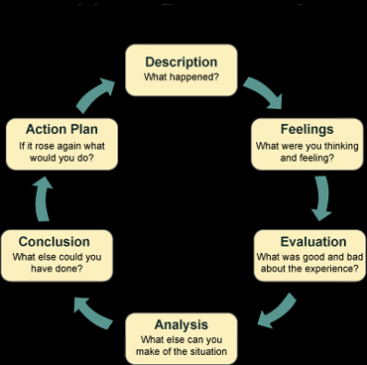
Reflection on Referencing

Description

The lesson was focusing on referencing to support academic assignments, beforehand I read the University’s reference handbook and tried to complete a task quiz. This was a challenge for me, one of the reasons why I put off further studies. We had a few activities to complete during the lesson, I found the experience stressful and confusing at times. The class had to identify the difference between, book, article, or website references, and how to cite in-text and write a full reference.

The aim was to be more confident and accurately reference work, and practice implementing it whilst writing the assignment and not adding them in after completing the work, therefore it needed to be a natural process.

Feelings

I found the whole experience overwhelming as there was so much text to consider. I felt deflated due to honest feedback, so I backtracked to see my errors. I kept persevering and asked a lot of questions to clear my confusion, but I still did not feel confident in understanding what, where and why it is done this way.

Evaluation

Even though I found the lesson challenging, rushing creates anxiety, that is why I made these errors, but practicing more makes the experience bearable.

After lessons I looked at more referencing examples and I completed the last class activity taking my time and was able to identify the correct sources, by adjusting them in line with the referencing guide and then put them in alphabetical order.

Analysis

Attempting these activities helped me recognise what I was doing wrong, this is an important factor because I understood what can be improved, and how to pace my reading to minimise errors. By self-reflecting, I understood that fear and rushing is my weakness, and I needed to break down the steps, first to identifying which are books, articles and websites then order accordingly.

Taking onboard the lecturers advise, habitually adding in-text referencing whilst writing my assignment, and not adding them in at the end, became easier.
Conclusions

Overall, I completed all the activities during the lessons but most importantly I have identified my fears and worked on them which is breaking down the texts and re-organising them.

To overcome my dislike of referencing, practice makes the process easier and reduces my fears, this was a positive experience for me. Using the Harvard handbook and online library sources such as Senate House Library, (2018) helped me understand in-text citing and full reference lists.

Action Plan

I am practicing what I have learnt in class, continuously looked at the referencing handbook and implementing them on my assignments. Also completing and practicing worksheets such as, Harvard UTS referencing exercises online, is helping me immensely. (See Appendix C pg 21)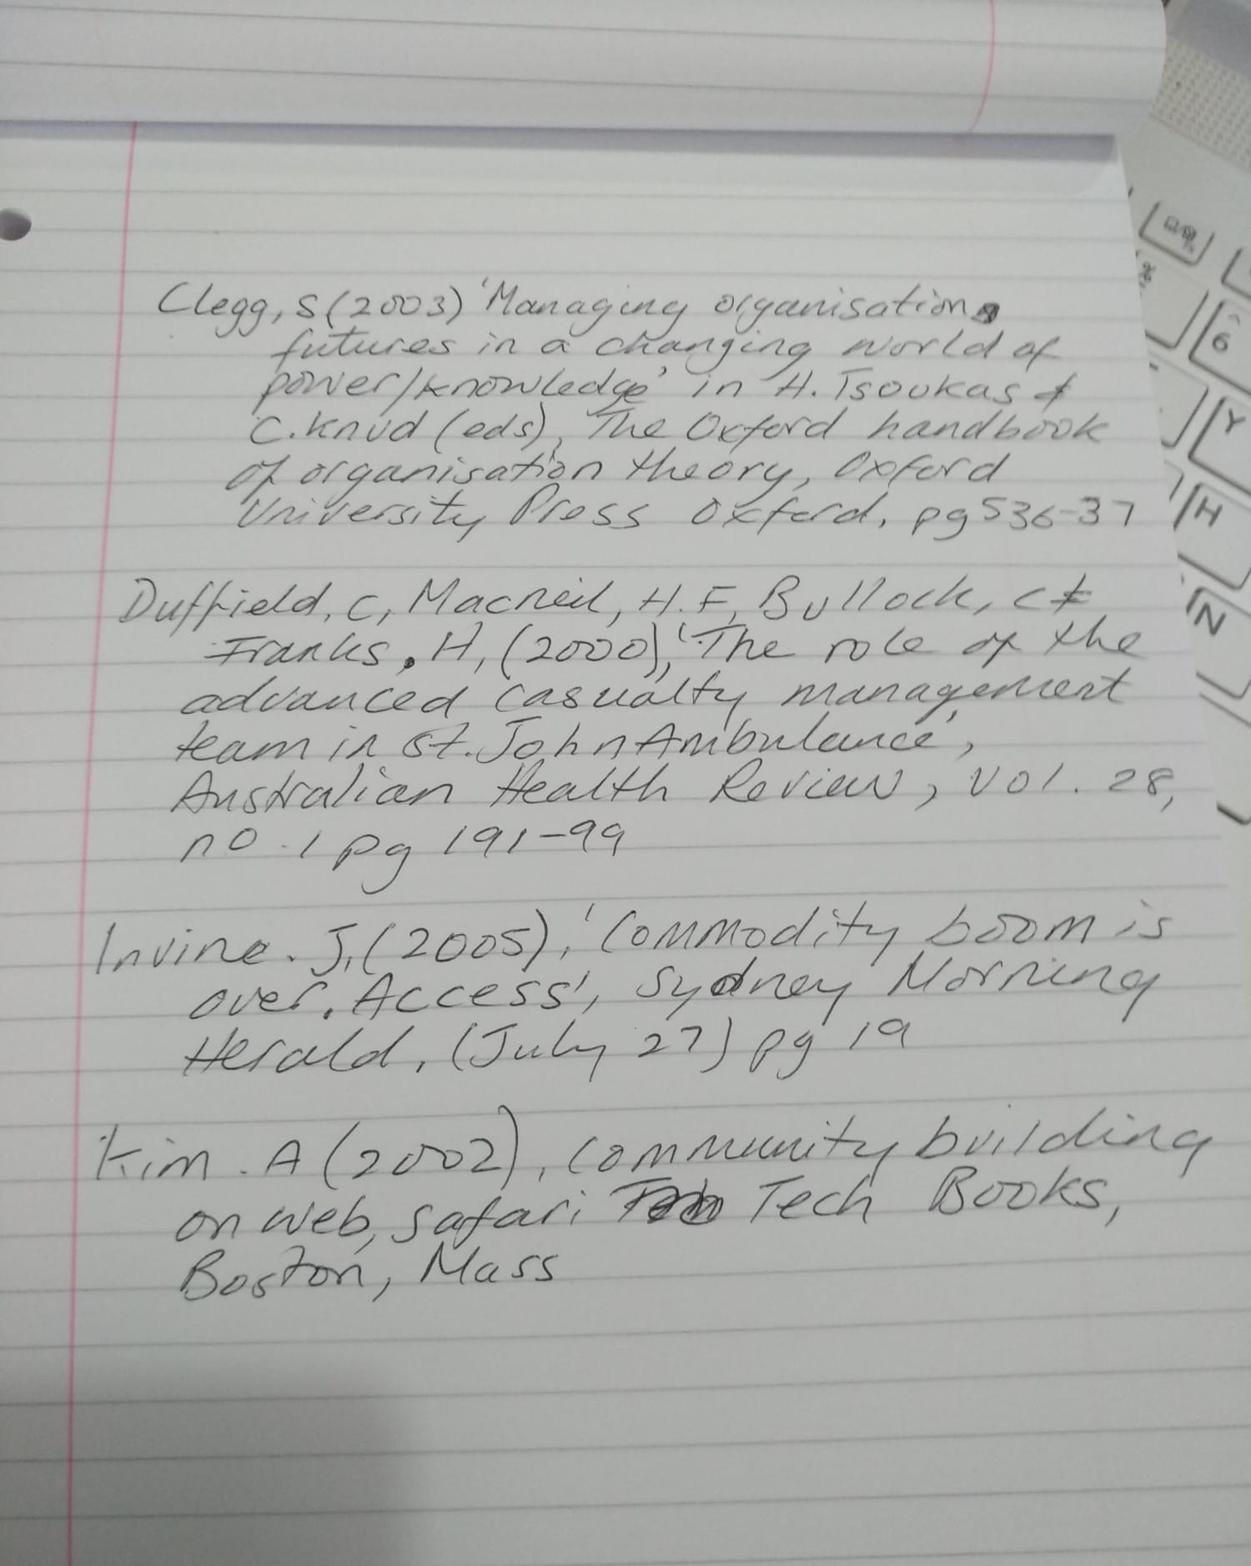

Reflection on Online Learning Experience

Description

Due to social distancing of Covid, many education establishments resulted to online delivery of lessons, this was my case. I had to rely on my rusty IT skills, logging online weekly to Microsoft Teams connecting to lecturers and peers. Practicing discipline, to be punctual, conduct in a professional manner and give full attention, same curtesy as face to face on campus.

The first week I found the situation very chaotic, due to errors in sorting out the registers and people turning up late. Whilst waiting for the 9 am start, I still notice my peers not being considerate in turning off their cameras and muting themselves. It is easily done, being mindful because you are in the comfort of your own home, but I certainly do not want to repeat what I heard.

Besides this I found online learning very convenient, I can go about my day after lessons without the stress and costs of travelling and food, not to forget the childcare cost as well. As a busy mum and work during the week, like my peers, the course was ideal for me. The only negative aspect is the copious amount of information on Moodle, extremely overwhelming, and been thrown in at the deep end with my IT skills. I can navigate the software but need refreshing.

Feelings

Before enrolling onto the course, I was skeptical, having doubts and feeling ‘am I too old for this?’ ‘Can I manage learning and delivering essays and assignments in a fast pace Twenty First century?’ a lot of my concerns is fear, finance, and commitment to the course.

I was nervous meeting my class, but excited that I am finally starting something to improve my skillset. I can associate that we all started with different stages of life, and everyone has contrasting skills and experiences, therefore, everyone’s input is invaluable and helpful. The class was willing to engage in lessons, like myself, some had struggles with their IT skills but as the weeks went by, I felt at ease. In addition, English for some, was not their first language so understanding and communicating back can be challenging. The IT errors did disturb the class as it delayed the learning, and it made me stressed.

I felt our lecturer was on point with delivering the topics, she used humor and sarcasm which made the lessons more enjoyable. The negative side was the enormous amount of literature and information available on Moodle, too overwhelming. For example, the Librarian joined us online and delivered so much information on referencing and research sites etc. it seemed impossible to retain everything.

Evaluation

In general, the delivering of the lessons on Microsoft Teams worked well, implementing house rules, giving students option to turn camera off if needed and lecturer muting whilst presenting her notes, she had complete control of the lessons. I felt cameras should be on compulsory unless told differently, because on occasions, someone appeared on camera who I have never seen before, and it was quite alarming. I noticed many colleagues not appearing on camera for weeks and not contributed to discussions, and naturally I felt they have never existed. Being more consistent would be beneficial to the group, this would ensure we know that everyone is focused and in professional conduct within the lessons.

There were some technical issues which I found disruptive, especially with internet connection and people not using suitable devices. Another issue was people using the same technical problems as an excuse and it delayed the teaching.

Analysis

I felt that the overall experience of online learning was a positive one since, personally it was convenient, cost effective in terms of travelling expenses and I generally felt at ease learning from the comfort of my own home.

The negative experience was, no class atmosphere, face to face interaction, having chats between each other and generally feel isolated.

Conclusion

Overall, I enjoyed online learning, it helped strengthen my IT skills, I use Microsoft daily to ensure competency and ability to navigate the software. It has also helped with my concentration and thinking skills as supported by Raiyn J (2016), it improves the ‘High Order Thinking Skills’, I feel more confident but still slow. To improve my speed, this course will help because I need to use it daily to complete activities, assignments and interact in group work online.

Being strict on housekeeping rules is vital and keeping consistency is the key factor in every online lesson. In addition, Brills (1984) states that the visual environment for learning is important, therefore learning environment at home needs to be clutter free, this needs to reflect in the background whilst online. This is communicated every lesson by our lecturer such as lateness, etiquette, and professionalism.

Action Plan

Pending whether we are still learning online, the fundamental key factors of professionalism such as muting the microphone if taking a call, eating, drinking or still lying-in bed, will be actioned.

Continuing reading, researching after class, and watching videos that the lecturer has linked on Moodle, has become a habit for me. This ensures that information is fresh in my mind, and I am more motivated to understand information better.

Reflection On Time Management/Organising Study

Description

First topic covered in week one, managing time productively and effectively, we identified the number of hours we spent on tasks that we do daily. Whether we felt we could improve this, and if our organisation of study time can fit in with our daily chores and responsibilities.

We were given activities such as writing down the hours we spent on each task in the last 24 hours and shared them with the group. We used SWOT analysis, Personal Developments Plans, and self-reflection templates to work on. Everyone was very open and honest about their answers, and I noticed majority of people had busy parental responsibilities such as myself.

Others had job commitments, and it was interesting to see that many had fears of commitment and finance issues for studying the course.

Feelings

Before the activity I felt confident, I am generally an organised person, if I committed to something I would see it through, and I felt the activity was quite straight forward.

After the activity I realised I was not honest with two aspects of my life and felt guilty for not sharing. I do spend at least two hours watching my favorite television programs, my guilty pleasure, this is my time when my kids are asleep. The other, to save myself time and stress, I cook and prepare meals for the whole week in the evening. This saves me a lot of time and stress as I prepare many one pot meals the night before and put this in a slow cooker before work, when I get home, dinner is ready.

Many peers admitted to spending many hours on social media and were very honest about it, some because of networking and some just to socialise.

This activity was productive because it identifies what things you spend too much time on, and what things you can cut down on. The objective is, with the time saved you would dedicate this to organinsing your studies and be mindful of what is priority and what can be done at a later stage.

Evaluation

The lesson and the activities were very useful, ability to pinpoint all aspects of your time, and I was able to organize, prioritise and manage my day productively. For example, using the SWOT Analysis I was able to identify my weakness such as focusing too much time on something and according to Thompson et al., (2007) SWOT Analysis is a simple tool, it can identify challenges and threats. By practicing these templates, I was able to prioritise my time, and foresee any difficulties in the future.

The only drawback to this exercise is being honest with oneself, and the tediousness of filling in these sheets for every day. My peers participated and the some also gave tips and ideas on managing time which I took on board, especially about copy and pasting text which saves time and effort redoing the same thing again.

Analysis

The purpose of the lesson was to take responsibility for our learning, ensuring we have the tools to be organized and prioritise our schedules, we all have busy lives and there is no excuse for not completing assignments and successfully completing the course. Consequently, using the Swot Analysis to understand your strengths and weakness to first handle challenging or easier tasks, and Personal Development Plan enables us to use time wisely and productively.

(See Appendix A)
(See Appendix B)

This topic was delivered at the right time frame, at the beginning of the module. It serves as a warning and a tool for us to understand and practice early on, so we prioritise and organise our workload.

Conclusion

I was able to prioritise, organise and be productive with my time. Gaining tools and skills to identify our strengths and weaknesses to help us improve our management of time. By completing these worksheets and activities I can identify my habits and rectify the problem and put this into practice. The template activities were mundane, but it has created productivity of my day.

Action Plan

I have now incorporated these worksheets into my daily, weekly, monthly, and yearly plans to complete. I can action these tick lists, whilst traveling to and from work from my phone so it becomes a habit. I can change anything to reschedule or things that happen unexpectedly.

References

Amazon, (2018) Impact of Technology On Amazon’s Business Strategy www.ukessays.com/essays/businss-strategy/impact-of-technology-on-amazons-business-strategy.php?

Brill, M., Margulis, S., & Konar, E. (1984). Using office design to increase productivity, Vol. I. Buffalo, NY. Workplace Design and Productivity, Inc. Brill, M., Margulis, S., & Konar, E. (1985). Using office design to increase productivity, Vol. II. Buffalo, NY: Workplace Design and Productivity, Inc

Harvard-UTS, (n.d), Referencing Handout-Activity.pdf, https://www.uts.edu.au/sites/default/files/Harvard-UTS%20Referencing%20Handout%20-%20Activity.pdf,

Jarman, D., Webb, L. and Chan, T.C. (2004). “A beautiful school is a caring school”, School Business Affairs, available at: www.sba_june_04_beautiful_school.pdf/”

Raiyn J (2016) The Role of Visual Learning in Improving Students ‘High Order Thinking Skills https://files.eric.ed.gov/fulltext/EJ1112894.pdf

Senate House Library, (2018), University of London https://onlinelibrary.london.ac.uk/support/information-skills/organising-and-citing-your-references/referencing-styles-harvard
.
Thompson J, Scott M, Martin F (2014) Strategic Management: Awareness and Change (7th Edition) Hampshire Andrew Ashwin

Promote your school (2020 February 2nd), The effect of the visual environment on pupil wellbeing https://www.promoteyourschool.co.uk/blog/the-effect-of-the-visual-environment-on-well-being

Appendices

A Swot analysis …………………………………………………………………………….Pg 13-14
B Personal Development Plan ……………………………………………………………Pg 15-17
C Referencing Exercises…………………………………………………………………...Pg 18-20

 Appendix A

SWOT Analysis (Personal)

Name……………………Judy Lee…………………………………..................... Student ID……2028008…………………………………

Strengths  Calm  Organised  Good at time management  Artistic  Creative  Warm  Friendly  Good listener  Helpful | Weaknesses  Spend too long on one goal  No patience  Like things done a certain way  Do not like stress
Opportunities  New learning skills  New course  Better myself  New hobby  Upgrade to new home | Threats  Finance  Childcare responsibilities

Appendix B
Personal Development Plan
 | Short-Term Time Frame  What do I want to  accomplish in the next  three to six months? | Mid-Term Time Frame  What do I want to  accomplish in the next  six months to two years? | Long-Term Time Frame  What do I want to  accomplish in the next  two to three years?
Section 1 - My Goals  What are my overall goals that I want to accomplish in this time period?  Example: become a Student Affairs Officer; learn computer graphics | Settle into my new flat and financially able to cope and all financial situation challenge to be stable.  Settled into my course be confident and proficient in all apps ie uploading sharing and doing my work | Start my online catering business.  Complete and pass my course.  Enrol to do my BA in Business and Management | Have money saved from my new business and start purchasing a property of my own
Section 2 - Skills and Knowledge to be  Learned  What specifically do I need to learn? What project do I need to work on?  Example: Student advising;  Banner; Dreamweaver; develop a procedures manual | Navigating and using my software consistently  Get my license for food and hygiene level 2  Get registered local council. | Food and inspection date to book  Designing menu and researching prices  Start promoting my brand. | Budgeting, seriously not spending on necessities. Keeping receipts and consciously saving £500 per month in separate account.  Cut down on online shopping and unnecessary trends in beauty care and gadgets.
Section 3 - Next Steps  How am I going to acquire the skills and knowledge? How am I going to do this project?  Example: take Dreamweaver class; do an  informational interview; set up a project outline | Research competitors  Create website.  Online sites on comparison prices  Questionnaires on local people opinions | Student finance in place for affordability | Contact estate agents  Start viewing properties
Adapted from: http://www.hr.ucdavis.edu/sdps/forms/IDP%20Final%2010.14.11.pdf

 | Short-Term Time Frame  What do I want to  accomplish in the next  three to six months? | Mid-Term Time Frame  What do I want to  accomplish in the next  six months to two years? | Long-Term Time Frame  What do I want to  accomplish in the next  two to three years?
Section 4 - Resources  What resources do I need?  Example: free time; funding | Preparing my assignments on PowerPoint and word. Been reading a lot of links and researching on reflection. Online sites and have enrolled in an IT course.  Setting aside at least 3 hours per day structuring my report and presentations. | Looked at different universities for BA Business and Management courses.  Looked at local universities comparable to other areas. Most importantly is the commuting.  Enquired about student finance for this course. | Saving money monthly setting it aside.  Opened a new account and have already started saving.
Section 5 - Time Schedule  What is my time schedule? | 4 weeks | 9 months | 2 years
When will I start? | Already started | Already started | Already started
When do I expect to finish? | 4 Weeks | 9 months – 1 years’ time | Its ongoing but by 2 years I will have a significate amount saved
Section 6 - Completion  When have I completed each  step? | □__________  Date  □__________  Date  □___15’08/21_______  Date | □__________  Date  □__________  Date  □___March 2022_______  Date | □__________  Date  □__________  Date  □___12/2023_______  Date
Adapted from: http://www.hr.ucdavis.edu/sdps/forms/IDP%20Final%2010.14.11.pdf

Appendix C

REFERENCING EXERCISE

Exercise 1
Six publications of various formats are described below.
Try expressing the reference details for each in the Harvard style and putting them into alphabetical order in a reference list.

- A book with the title: 'Occupational health and safety', published in Sydney in 2004 by McGraw-Hill, with authors M. Stewart and F. Heyes. This is the second edition.

- A book with the title: 'Internal control and corporate governance', with authors K. Adams, R. Grose, D. Leeson and H. Hamilton, published in Frenchs Forest, NSW by Pearson Education Australia in 2003.

- An article by M. Scardamalia and C. Bereiter, called 'Schools as knowledge-building organizations', published in 1999 in a book edited by D. Keating and C. Hertzman, called 'Today's children, tomorrow's society' in New York by Guilford as pages 274 to 289.

- An article by J. R. Savery and T. M. Duffy, called 'Problem based learning: an instructional model and its constructivist framework', published on pages 31 to 38 in the journal 'Educational Technology', volume 35, number 5, in 1995.

- An article called 'Integration and thematic teaching: integration to improve teaching and learning' by S. Lipson, S. Valencia, K. Wixson and C. Peters, published in 1993 in the journal 'Language Arts', volume 70, number 4, pages 252 to 263.

- A videorecording of a television documentary called 'Embers of the sun', produced in 1999 by the Australian Broadcasting Corporation in Sydney.

Referencing Correction Harvard Style alphabetical in order

Adams K, Grose R, Leeson D and Hamilton H,( 2003). 'Internal control and corporate governance' published in Frenchs Forest, NSW by Pearson Education Australia
(1999) 'Embers of the sun', by the Australian Broadcasting Corporation in Sydney.
Lipson S, Valencia S, Wixson K, and Peters C, (1993) 'Integration and thematic teaching: integration to improve teaching and learning', 'Language Arts', volume 70, number 4, (pg 252 -263).

McGraw-Hill, Stewart M, Heyes F, (2004) ‘Occupation Health and Safety’ Published in Sydney 2nd Edition
Savery J.R and Duffy T. M, (1995) 'Problem based learning: an instructional model and its constructivist framework', published (pg 31-38) 'Educational Technology', (volume 35, number 5)
Scardamalia M and Bereiter C,(1999) 'Schools as knowledge-building organizations', published (edited by Keating D and Hertzman C, 'Today's children, tomorrow's society' in New York by Guilford (pg 274-289)

Harvard Online worksheet



